Module: Population Health and Digital Health Promotion
Module code: LCHS7009
Student ID: 2433934
Name : Himalaybhai Sureshbhai Mandanaka
Lecturer Name : Dr Besty Jose

Blog 1: Diabetes prevention
Promise and Pitfalls of AI-based Mobile Apps to Curb Type 2 Diabetes
Diabetes as a Major health concern
Type two diabetes has become a major concern in public health, and the lifestyle challenges, obesity, and ageing population greatly invest it. According to the International Diabetes Federation, IDF (2025), 537 million individuals aged 20 to 79 years were living with diabetes in 2021, representing a 46% increase in the likelihood by 2045, as reported by Magliano, Boyko and Committee, (2021).
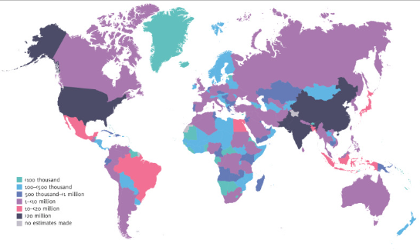
Figure 1: Estimated numbers of Adults in 2021
(Source: Magliano, Boyko and Committee, 2021)
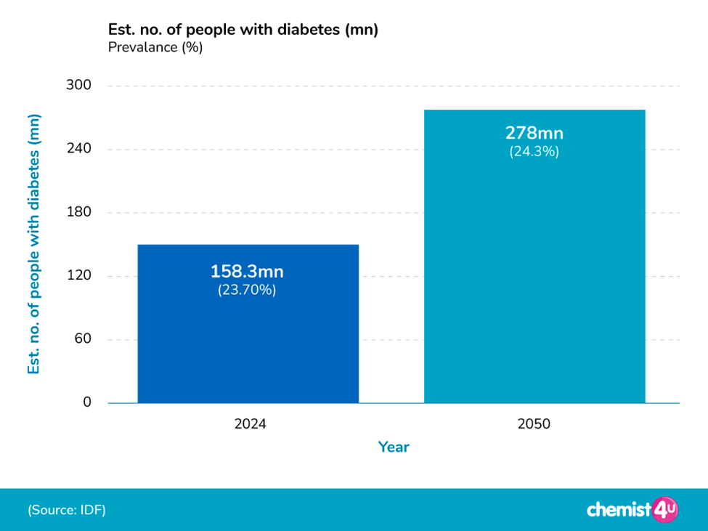
Figure 2: Estimated number of people with diabetes in the UK with future oprediction
(Source: Murphy, 2025)
NHS Diabetes Prevention Programme – digital stream
The digital technologies of NHS Diabetes Programme named Digital Stream is one of the most effective way to address these issues and manage the factor across all addictions while also supporting lifestyle changes (England NHS, 2025). The application of this innovation apps has developed as a promising intervention to deliver education and self-monitoring with the knowledge to improve their lifestyle for controling their condition and managing it effortlessly for the individuals at risk of type 2 diabetes.
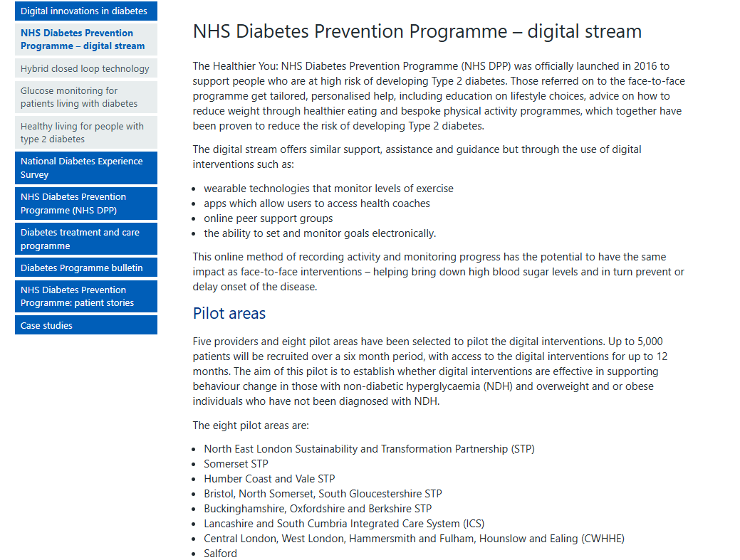
Figure 3: Details of NHS Diabetes Programme
(Source: England NHS, 2025)
Evidence from the Literature
A systematic review by Emonena and Ojo, (2022) found that digital assitance for the self-care for diabetes patients can significantly reduce haemoglobin glycation and provide specific reports. Ni and Jia, (2025) have also stated that a digital education program is a landmark for a controlled trial for risk education benchmark. The NHS, (2025) stated that more than 549,000 people in the UK is having diabetes type 2 within a year. Especially, for the 216,440 people under the age of 40 has been diagnosed with diabetes in 2023.
Critical evaluation
Critically, the impact of these apps needed to be addressed in terms of their limitations and strengths. The programme can easily help the patients with diabees for their daily life mainbtainence (Magliano, Boyko and Committee, 2021). However, there is a requirement of developping the infrastructure issues due to the lack of early intervention detection systems that can reduce the effects and the intensity of the challenges.
Addressing the shortfall
To address these shortfalls, it is essential to maintain trust and engagement through explainable AI, which integrates features that clearly communicate the need to personalise recommendations (Adetunji and Evah, 2022). Motivating the healthcare system with human coaching support can easily boost this kind of credibility and engagement while also reducing digital exclusion through multiplatform delivery, such as voice or SMS.
Advantages and Disadvantages
The advantage of this kind of program is in its reach and in the delivery of personalised health maintenance content to overcome cultural and traditional issues (Oyeniyi, 2024). However, the magnitude of the effect, as evaluated statistically, may not always be effective for individual health journeys (Ni and Jia, 2025). Additionally, sustained engagement is required to achieve equal digital literacy among individuals.
Conclusion
Collectively, these analysis represent that it is possible to control the progression of the type 2 diabetes off individuals with digital technology and risk-factor modification. The utilisation of digital stream helps monitor personalised issues and provide relevant information in terms of lifestyle or dietary changes.

Reference List
Adetunji, O. and Evah, P.T., (2022). Developing personalized diabetes management plans using artificial intelligence and machine learning. World Journal of Advanced Research and Reviews, 27, pp.605-624. https://www.researchgate.net/profile/Oluwemimo-Adetunji/publication/395018537_Developing_personalized_diabetes_management_plans_using_artificial_intelligence_and_machine_learning/links/68b052a17984e374acec2233/Developing-personalized-diabetes-management-plans-using-artificial-intelligence-and-machine-learning.pdf
England, N. (2024) NHS England » NHS identifies over half a million more people at risk of type 2 diabetes in a Year. Available at: https://www.england.nhs.uk/2024/06/nhs-identifies-over-half-a-million-more-people-at-risk-of-type-2-diabetes-in-a-year/. (Accessed 29 October, 2025)
Emonena, H. and Ojo, O., (2022). The efficacy of tele-monitoring in maintaining glycated haemoglobin levels in patients with type 2 diabetes mellitus: a systematic review. International Journal of Environmental Research and Public Health, 19(24), p.16722. https://www.mdpi.com/1660-4601/19/24/16722
England NHS. (2025) NHS England » Digital innovations in diabetes. Available at: https://www.england.nhs.uk/diabetes/digital-innovations-to-support-diabetes-outcomes/nhs-diabetes-prevention-programme-digital-stream/ (Accessed 29 October, 2025)
IDF (2025). International Diabetes Federation and Boulton, A. (2021) Annual Report 2021. Available at: https://idf.org/media/uploads/2023/05/attachments-29.pdf. (Accessed 29 October, 2025)
Magliano, D.J., Boyko, E.J. and Committee, I.D.A. 10th E.S. (2021) Global picture. Available at: https://www.ncbi.nlm.nih.gov/books/NBK581940/. (Accessed 29 October, 2025)
Murphy, J (2025). UK Diabetes Statistics. Available at: https://www.chemist-4-u.com/guides/diabetes/diabetes-statistics/ (Accessed on 30th October, 2025)
Ni, Y. and Jia, F., (2025, May). A scoping review of AI-Driven digital interventions in mental health care: mapping applications across screening, support, monitoring, prevention, and clinical education. In Healthcare (Vol. 13, No. 10, p. 1205). MDPI. https://www.mdpi.com/2227-9032/13/10/1205
Oyeniyi, J., (2024). The role of AI and mobile apps in patient-centric healthcare delivery. World Journal of Advanced Research and Reviews, 22(1), pp.1897-1907. https://www.researchgate.net/profile/Johnson-Oyeniyi/publication/380290941_The_role_of_AI_and_mobile_apps_in_patient-centric_healthcare_delivery/links/6633d94d06ea3d0b74237ad6/The-role-of-AI-and-mobile-apps-in-patient-centric-healthcare-delivery.pdf

Blog 2: Cancer Prevention
Prevent-C: A Digital Roadmap to Lung Cancer Prevention
Current Statistics stand as a public health concern
In the recent era, cancer has become one of the biggest challenges of the healthcare industry. In July, 2025 236,263 people in the UK received diagnosis or ruled out and 21,633 patients have stated receiving treatment (NHS, 2025). A survey by the World Health Organisation (2025), conducted in 115 countries, found that the majority lack a proper framework for health care coverage. The observation of the global cancer trajectory represents a fundamental type of cancer and collectively influences two-thirds of the new cases of death globally in 2022 (El-Osta et al., 2021). The report by WHO stated that lung cancer is the most commonly occurring cancer worldwide, followed by cases of female breast cancer and prostate cancer, stomach cancer and so on. It is also estimated that a majority of cancer cases across different regions are the result of increased use of tobacco, poor diet, HPV or hepatitis infection, and air pollution (Zhang et al., 2023).
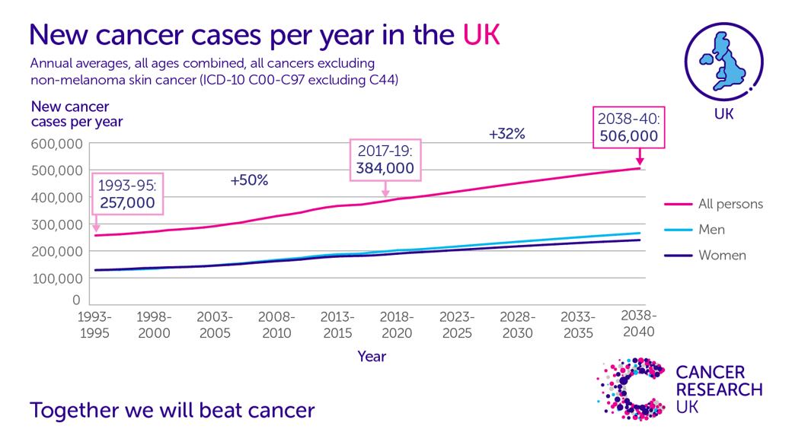
Figure 4: cancer Cases per year in the UK
(Source: radiotherapy.org.uk, 2023)
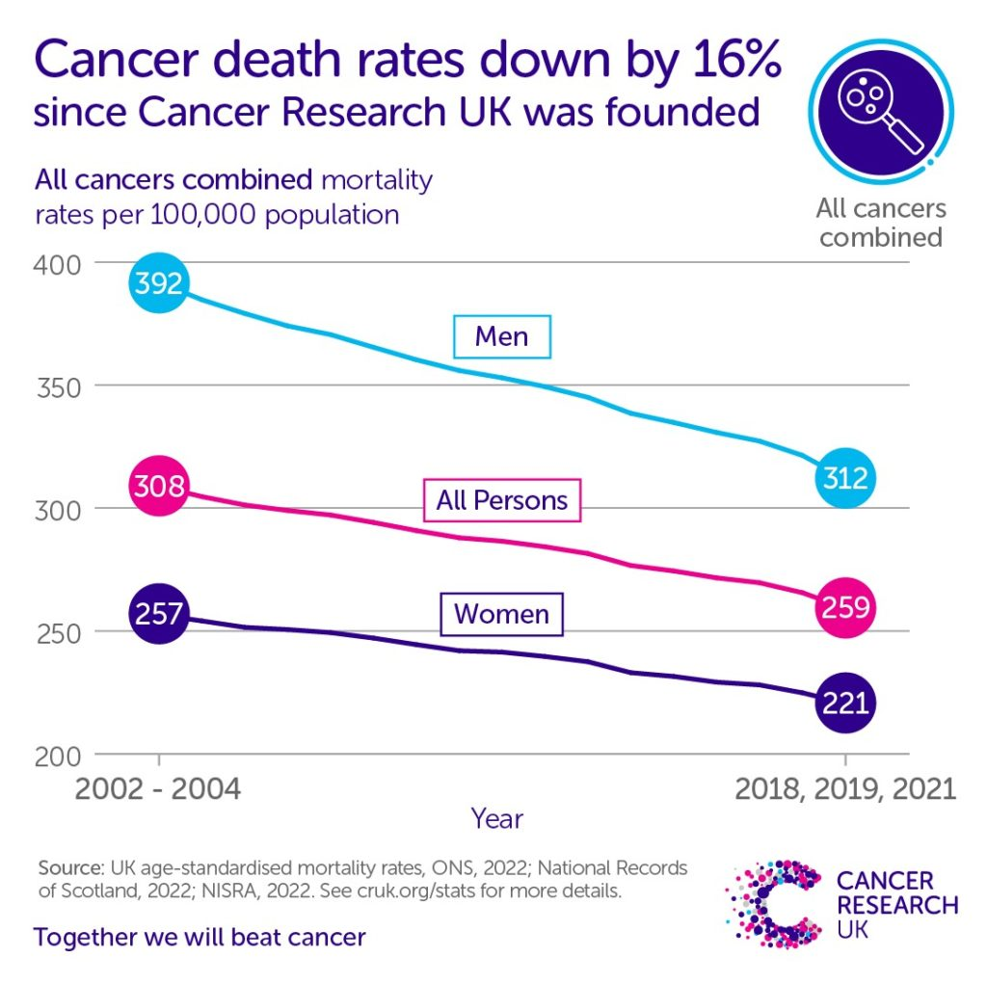
Figure 5: Death Rates Drop From Cancer in the UK over the years
(Source: Wedekind, 2022)
Digital technology design of Prevent-C
With the target of particular modifiable risk behaviour and high screening of the lung cancer by adressign the regular life style of the people having poor diet and smoking habbits these diseases (Zhang et al., 2023). Previously the AI powered tools in the UK have helped in stretamlining the reduction in smoking habbits as mentioned in El-Osta et al., (2021). The current approach can be named Prevent-C and aims to raise awareness and guide individuals in adopting a healthy diet and engaging in physical activity while alos reducing smoking habbits.
Compare and contrast of the smilar Interventiosn (Prevention-C vs MySunrise)
The core elements of the design will include integrating artificial intelligence, implementing data monitoring principles across various devices, and an EHR system for tracking lifestyle information and a history of health issues. Presiously MySunrise have proven the capacity through the technology to support the patints dutring their diosanosis live at at Royal Cornwall Hospital (NHS, 2025).. The target for the web search will focus on personalised, targeted promotional messages that will encourage individuals to take part in this journey (Zhang et al., 2023).
Opportunities and Challenges
The advantage of this application lies in its scalability and cost-effectiveness, specifically for populations with smart access, through a personalised prevention strategy that focuses on their regular lifestyle (Adetunji and Evah, 2022). Literacy is also not equally distributed among the users, and without a smartphone, individuals with this issue can be easily excluded from the plan which needs targated intervention.
Addressing the shortfalls
This kind of applications are capable to maintain engagement as these are helpful for lifestyle maintainence of the cancer patients (Crosby et al., 2022). To address the shortfalls like unequal distributions, the Prevent-C will also include an offline voice-call-based percentage.
Conclusion
This will support a better understanding of users' everyday lives through digital health technology. However, there are disadvantages, such as inequitable access among the users, particularly for individuals in rural areas. There is a possibility that a hybrid application of mobile and web can encourage lifestyle modification through diagnosis.

Reference list
Adetunji, O. and Evah, P.T., (2022). Developing personalized diabetes management plans using artificial intelligence and machine learning. World Journal of Advanced Research and Reviews, 27, pp.605-624. https://www.researchgate.net/profile/Oluwemimo-Adetunji/publication/395018537_Developing_personalized_diabetes_management_plans_using_artificial_intelligence_and_machine_learning/links/68b052a17984e374acec2233/Developing-personalized-diabetes-management-plans-using-artificial-intelligence-and-machine-learning.pdf
Crosby, D., Bhatia, S., Brindle, K.M., Coussens, L.M., Dive, C., Emberton, M., Esener, S., Fitzgerald, R.C., Gambhir, S.S., Kuhn, P. and Rebbeck, T.R., (2022). Early detection of cancer. Science, 375(6586), p.eaay9040. https://www.science.org/doi/pdf/10.1126/science.aay9040
El-Osta, A., Hennessey, C., Pilot, C., Aumran Tahir, M., Bagkeris, E., Akram, M., Alboksmaty, A., Barbanti, E., Bakhet, M., Vos, V., Banarsee, R., and Majeed, A., (2021). A digital solution to streamline access to smoking cessation interventions in England; findings from a primary care pilot (STOPNOW study). Public Health in Practice, 2, 100176. https://doi.org/10.1016/j.puhip.2021.100176
England, N. (2025) NHS England » Record number of cancer checks and treatments Available at: despite strikes. https://www.england.nhs.uk/2025/09/record-number-cancer-checks-treatments-despite-strikes/. (Accessed 29 October, 2025)
NHS (2025) Useful apps for people with cancer. Available at: https://www.royalberkshire.nhs.uk/media/cfzk1cob/apps-for-cancer_apr23.pdf. (Accessed 29 October, 2025)
radiotherapy.org.uk, (2023). RADIOTHERAPY: AN ANALYSIS OF HOW RADIOTHERAPY SERVICES IN THE UK COMPARE WITH OTHER COUNTRIES. Available at: https://radiotherapy.org.uk/wp-content/uploads/2023/06/International-comparisons-full-report-140623.pdf (Accessed on 30th October, 2025)
Wedekind, S. (2022). 20 years on: how we’ve decreased cancer death rates. Available at: https://news.cancerresearchuk.org/2022/12/17/20-years-on-how-weve-decreased-cancer-death-rates/ (Accessed on 30th October, 2025)
World Health Organisation: (2025). Global cancer burden growing, amidst mounting need for services. WHO. Available at: https://www.who.int/news/item/01-02-2024-global-cancer-burden-growing--amidst-mounting-need-for-services#:~:text=WHO%20also%20published%20survey%20results,not%20just%20linked%20to%20cancer. (Accessed 29 October, 2025)
Zhang, Y.B., Pan, A., Wang, J., Pan, X.F., Chen, J., Li, H., Cao, A. and Liu, G., (2023). Investigating the Relationship Between Lifestyle and Environmental Factors with the Incidence and Prevalence of Cancer. Clinical Cancer Investigation Journal, 12(6-2023), pp.38-42. https://ccij-online.org/storage/files/article/00d8ad55-c0f6-46ed-8a1a-ba1ffe3acca2-x3b8vN1Xt2JN16Pc/7f8xLFSTprxCDeh.pdf

