
ACCA4025 - Learning in the Digital Era
Assignment 1: e-Portfolio
Shannon Saint (2618474) | Teacher: Fazli Wahid

Table of Contents
No table of contents entries found.

e-Portfolio
https://sites.google.com/view/shannonsaint-2618474/home
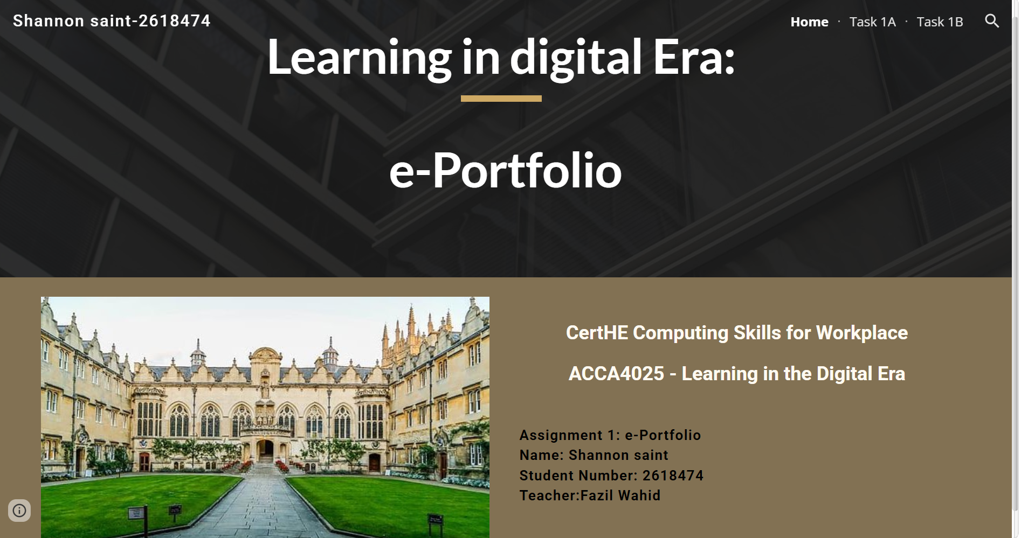

Task 1A:
https://sites.google.com/view/shannonsaint-2618474/task-1a

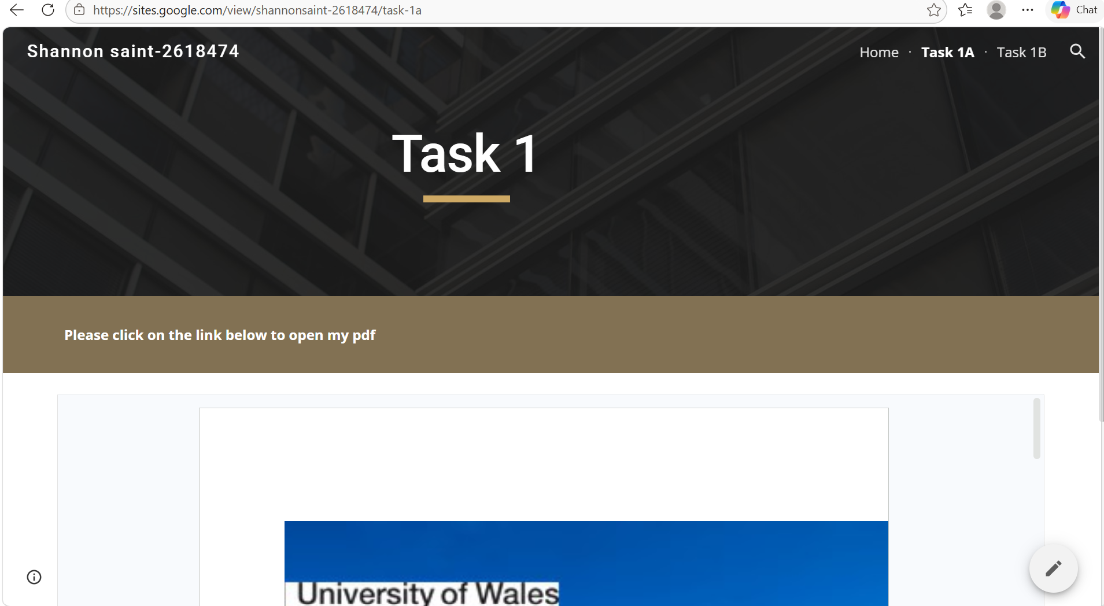

Task 1B
https://sites.google.com/view/shannonsaint-2618474/task-1b


