Learning in the Digital Era (ACCA4025_BIRM)
My Presentation
Made by Valentin Blazhev
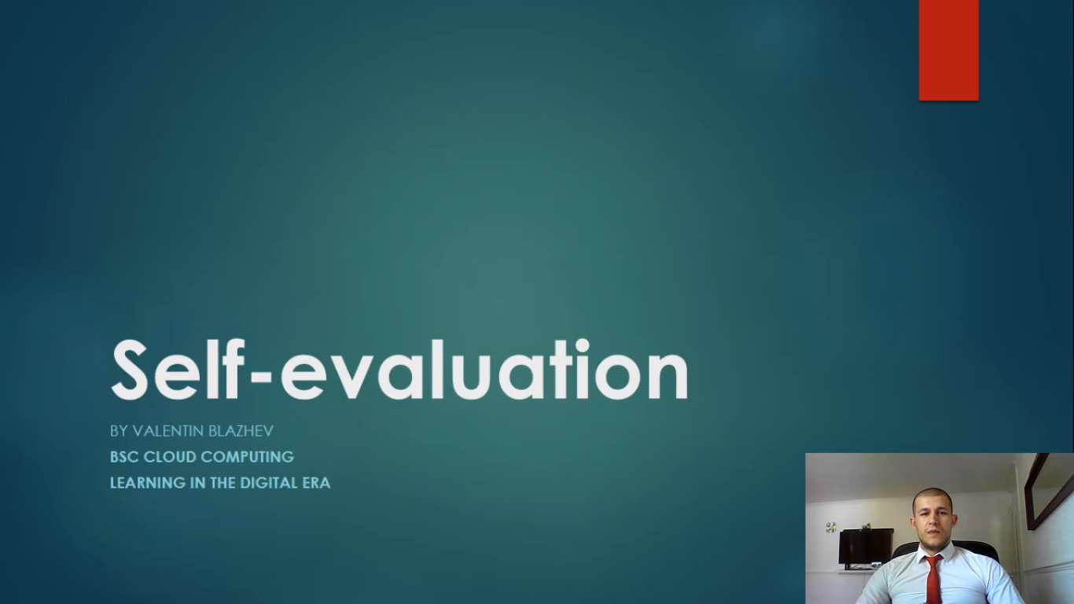
You can find my presentation at YouTube link Below.
LINK
https://youtu.be/AN9RuDJ50HQ

