

Effective Team Working and Communication
Assessment 2 – Individual Report

BMSW 4002_LON: Effective Team Working and Communication
Student Name | Elena Ruseva
Student Number | 2008341
Lecture’s Name | Diya Ganguly
Submission Deadline | 30thApril 2021
Number of words | 2176

Contents

Introduction 3
Models of Communication 3
- The Communication Model of Shannon-Weaver 3
- Communication model of Schramm 4
- Berol’s Model of Communication 4
Communication Skills 6
Example of Different Case Studies 7
- Case Study of Pedro and Maria 7
- Case Study of the Professor 7
Examples of Poor Communication in the Workplace 8
- Case Study of ER (EGG Case) 8
- Daily observation case…………………………………..………………………………………8
Suggestions for Improvements 9
Conclusion 9
References 10
Appendix A……………………………………………………………………………………………....12
Appendix B……………………………………………………………………………………………....13
Appendix C………………………………………………………………………………………….……14
Appendix D……………………………………………………………………………………………....15
Appendix E……………………………………………………………………………………………....16

Introduction
Communication is the act of transferring information from one place or person to another. It is also defined as the act in which ideas or feelings are shared or conveyed successfully. This might be through writing, speaking or any other means of passing information. Communication is a very important tool in the workplace which allows for effective working as well as promoting productivity by boosting the morale of the employees and promoting commitment(Skills You Need, 2019).
Models of communication
1. The Shannon Weaver Model(SWM) is a linear communication theory developed in 1948. The model is made up of six concepts including the receiver, the sender, the message, the noise which is the disturbance arising from the environment or the people, or any other source, decoder which converts the signals, the channel which is the medium used to transmit the message, and the encoder which refers to the machine used by the sender and coverts the message to signal(Businesstopia, 2018).
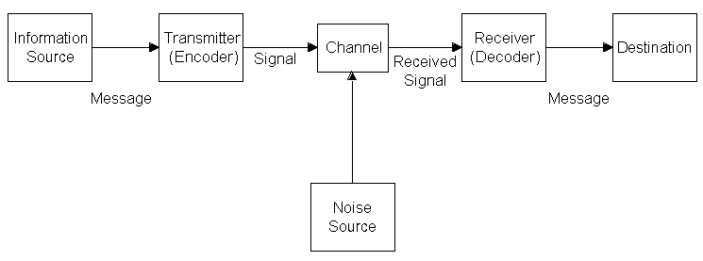
(Nikulescu, 2011)
In this linear theory, the message is sent by the sender through an encoder, through a channel where it is decoded at the other end with an aim of making sense to the receiver, however the concept of noise may arise which might distort the message therefore making it hard to decode it and might affect the communication process thereby making the message to be misunderstood(Mortensen,1972).
The model did not provide a way of dealing with the problem of noise at the beginning, and the sender and the recipient have to devise a way of reducing or eliminating the noise to promote effective communication(Businesstopia,2018). The concept of noise was introduced later.
2. Schramm’s model(SM) was proposed by Wilber Schramm in the year 1954. SM majorly aims at explaining how meaning is transferred between the parties. The model views communication as a process which occurs between the sender and the recipient. The communication process in this model is made up of a message and channel where the communication happens. A means of feedback can be in place to ensure that feedback is acquired with an aim of understanding if the receiver received and whether they understood the message or not(Blythe, 2009,pp.178-180).
SM has its roots to the SWM but has various differences from it. It highlights that information cannot be important unless it is put into the right format and conveyed to others. With the SWM not paying much attention to the feedback, SM is circular in nature and pays close attention to feedback. In addition, Schramm states that the communication between the sender and the recipient is incomplete unless the sender receives feedback from the recipient accordingly(Musherure,2018).
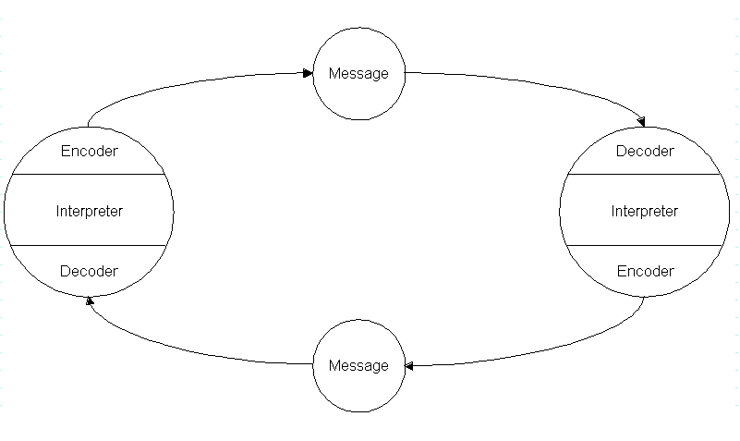(Nikulescu, 2011)
Encoding and decoding processes are both very important in this model. Encoding is very central as it initiates the whole communication process through the conversion of thought into content. On the other hand, decoding is also crucial in the process. As information reaches the recipient, they should understand what the speaker or sender wishes to convey. Here feedback is a very important communication component which must always be given or seeked(Juneja, 2015).
3. Berlo’s model(BM) of communication is made up of six stages: the source, the message being encoded, the message itself, the mode of delivery, the process of decoding and the receiver. It is a linear communication model without any feedback in it. It majorly focuses on the emotional aspect of the message which differentiates it from the other models of communication. The model operates making use of the SMCR model in its major components(Juneja, 2019).

Some of the major components include:
Source-Also referred to as the sender where the message originates from. The source transfers the message to the recipient through the help of the various skills of communication, culture, social system, attitude and knowledge.
Message-This is the element which is sent towards the receiver. This can be text, video, picture, audio or any other form which can be understood. The message is affected by various factors such as elements, content, code, treatment and structure.
Channel-This is the medium in which the information being sent. From the general communication, the channels of communication are represented by the five senses of human beings such as hearing, taste, smelling, touching and seeing.
Receiver-This is the party which gets the message or information. The receiver must also have some skills and knowledge in terms of communication. Both the sender and the receiver must also be from the same social and cultural background for the communication to be effective(Juneja, 2019).

Communication skills
Good communication is a important component of every workplace which ensures that productivity is maintained while good working relationships are formed. It promotes team work, innovation, growth and good management. Some of the important communication skills in Health and Social Care include active listening, verbal and non verbal communication skills, and empathetic listening. Verbal and non-verbal aspects of communication as well as empathy are known to have an important impact on the medical encounter (Vogel, Meyer, M. & Harendza, 2018).
1.Verbal Communication
Verbal communication is a way of communicating with others by using language, it refers to the words that we choose, and how they are heard and understood. This can happen anywhere by using any device. The sender and receiver can easily understand this way of communication when they know the same language. Although most people use the concept of verbal communication to describe only spoken communication, it can also be in written form. Speaking clearly, focused, and following etiquette, or organisational guidelines, can help with better verbal communication. In one of our class activities, we had to break bad news to someone. The activity is presented in Appendix A and shows how important it is to use appropriate language, communication channel and the guidelines provided by the workplace in difficult situations.
2.Non-Verbal Communication
For non-verbal communication, we use facial expressions, the tone of the voice, gestures and the body language, and the physical distance to the other person, to influence what we are saying. These non-verbal signals can give additional information and meaning to verbal communication. Understanding body language can help improve communication (Guilbeault, 2021). Our class activity about interpreting body language was incredibly interesting.(Appendix B)
3.Active Listening
Listening is a very important skill for good communication. Being a good listener can increase your professional performance. We listen to get the information, before responding. In order to understand the message someone is trying to tell us, we need to listen carefully and focus on the conversation. That way we can respond to the speaker and let them feel comfortable about the delivery of the speech.(Mind Tools, n.d.) Good listening skills are important in the workplace when a person is trying to influence, persuade and negotiate. This can be helpful to avoid conflicts and misunderstandings in the workplace.
4.Empathetic Listening
Empathic listening is a communication technique which can help to better understand the sensitive and intellectual meaning behind a message. It is a form of active listening, where a person listens to the communicator patiently and carefully. The listener should also pay attention to emotional meaning behind the message, which helps with understanding and later responding to the message. This type of communication technique can be useful to solve conflicts in the workplace.

Example of Different Case Studies

1.Case Study of Pedro and Maria (Appendix C)
Summary: The case of Pedro and Maria is an everyday conversation. Even though it is short, a misunderstanding happens - a good example about how easily a communication can be disrupted.
Analysis: In the case study of Pedro and Maria we see that both faced a misunderstanding because of a miscommunication over phones. The SWM of communication can be used here, where the feedback has less priority and disruption happens because of noise. The sender in this case is Maria, and Pedro is the receiver. The channel they use in their communication is the mobile network and the decoder and encoder are their phones. Pedro falsely hears the word “kitchen” instead of “chicken” because of surrounding noise. Using the SWM it can be said that the noise creates disruption in message.
Way to remove the misunderstanding: The communication between Pedro and Maria was not an effective one. But it could be if the noise would have been removed. Unlike the way of the SWM, SM says that interference can be removed by asking for feedback. Therefore, another option would be for Pedro to have called Maria again and recheck what she said but that did not happen. A good possibility would be if they pick a different canal of communication. Something perfectly covered by BM of communication.
2.Case Study of the Professor (Appendix D)
Summary: In this case we see the professor have intellectual differences with the villagers. One day he had an accident, he tried to ask the villagers to help him using his way of communication. And he suffered because no one understood and responded to his message.
Analysis: The villagers, having different level of knowledge, skills and culture didn’t understand the professor’s message. Here we can see a reflection mainly of BM. Where the encoding of the professor put him in danger because he never thought of passing the message in a way understandable by the villagers.

Way to remove the misunderstanding: The professor could simply change the language of the message and say, “My house is on fire, please help me.” Rather he asked for help in his way. The case here refers to BM. Familiarity with the subject of the message makes the communicated message more effective(Businesstopia, 2018). An option is for the professor to ask for feedback seeing that people are not responding, which could be supported by SM.

Examples of Poor Communication in my Workplace

1.Case Study of the egg (Appendix E)
Summary: Here ER as a wellbeing leader receives a message to provide the members of the staff with eggs for Easter. She therefore gets surprised and confused since the message includes information that does not seem logical. ER being a Bulgarian follows the Orthodox traditions. She thought the Head of Wellbeing told her to give a chicken egg to everybody. But what was meant was chocolate eggs.
Analysis: Gartenstein(2019), highlights that cultural differences can lead to poor communication in the workplace. People with varying cultures and backgrounds sometimes fail to communicate effectively. This case study reflects on BM and SM of communication as well. BM of communication can explain the misunderstanding that happens based on ER’s cultural background as a receiver, which is different from the cultural background of the source.
Way to remove the misunderstanding: Analysing the case based on SM of Communication, ER did the right thing asking her Manager about the message. That is why the communication is much more effective when feedback is given. On the other hand, the channel of communication used was a letter which contributed to ER’s confusion. If another channel was used such as phone call, ER would have had an opportunity to seek clarification immediately and avoid the confusion. This is reflection on BM of communication.

2. I work in a care home as an Administrative Team Leader. I have witnessed many cases of poor communication in my workplace. According to Gamil and Abdul(2019), there are various factors which obstruct effective communication in the workplace and one of them is the physical environment. Everyone who is working in Learning disabilities division knows that the distractions during the working process could be a big problem. The distraction could be dealing with a client’s behaviour, physical noise, problems with the reception. This has sometimes led members of staff, including me, missing, or misunderstanding important messages from various parties. Referring to Gamil and Abdul(2019), the channel used for communication such as verbal and written messages, or even mass media, can affect the effectiveness of the communication. In our workplace, phone calls are the major channels used for communication. Answering the phone calls in a busy and loud environment is a challenge. Very often I must ask for repetition. This case reflects to all models of communication we have learnt in this course.

Suggestions for improvement: Asking for feedback, which I often do, is an essential part of SM of communication. Dealing with the noise and the busy environment is covered by the SWM of communication. Looking for a different channel for communication, such as asking for the message to be repeated in an email, is a good example for using BM of communication.

Conclusion
Communication is a very important aspect of every workplace. Good communication can improve relationships within the organisation, by building and maintaining trust, while promoting productivity. Some of the good communication practices include active listening, verbal and non-verbal communication, as well as using the presented models to improve communication in the workplace and are very important for the organisation to function smoothly. Factors that can lead to ineffective communication, include noise, bad channel of communication, cultural differences, and poor communication skills. Every organisation should work on ensuring that it follows good communication practices and offers trainings for good communication skills.

References

- Blythe, J. (2009). The Schramm model of communication. In Key concepts in marketing (Pp. 178-180). London. SAGE Publications Ltd.
- Businesstopia, (2018). "Berlo’s Model Of Communication," in Businesstopia, [Online] Available at: https://www.businesstopia.net/communication/berlo-model-communication [Accessed 17th April 2021]
- Businesstopia, (2018). "Shannon and Weaver Model Of Communication," in Businesstopia, [Online] Available at: https://www.businesstopia.net/communication/shannon-and-weaver-model-communication [Accessed 17th April 2021]
- Gamil Y. and Abdul I., (2019.) Assessment of Cause and Effect Factors of Poor Communication in Construction Industry, Materials Science and Engineering 601, 012014 IOP Publishing doi:10.1088/1757-899X/601/1/012014
- Gartenstein, D. (2019) What are the causes of poor workplace communication [Online] Available at: https://smallbusiness.chron.com/causes-poor-workplace-communication-20827.html [Accessed 17th April 2021]
- Guilbeault, L. (2021). 22 Body Language Examples And What They Show [Online] Available at: https://www.betterhelp.com/advice/body-language/22-body-language-examples-and-what-they-show/ [Accessed 16th April 2021]
- Juneja, P. (2015). Schramm’s Model of Communication [Online] Available at: https://www.managementstudyguide.com/schramm-model-of-communication.htm [Accessed 16th April 2021]
- Juneja, P. (2019). Berlo’s Model of Communication [Online] Available at: https://www.managementstudyguide.com/berlo-model-of-communication.htm [Accessed 18th April 2021]
- Mind tools, (n.d.). Active Listening. Hear What People Are Really Saying. [Online] Available at: https://www.mindtools.com/CommSkll/ActiveListening.htm [Accessed 16th April 2021]
- Mortensen, C. D. (1972). Communication: The Study of Human Communication. New York. McGraw-Hill [Online] Available at: https://anammuzamill.files.wordpress.com/2012/11/anammuzamill_mcom310_model.pdf[Accessed 16th April 2021]

- Musherure, B. (2018). Shannon & Weaver, Schramm and Barnlund transaction models of communication [Online] Available at: https://baltzermusherure.wordpress.com/2016/11/04/shannon-weaver/ [Accessed 17th April 2021]
- Niculescu, A. (2011). Conversational interfaces for task-oriented spoken dialogues: design aspects influencing interaction quality.[Figure] Available at: https://www.researchgate.net/figure/The-Schramms-model-of-communication_fig3_254860573 [Accessed 16th April 2021]
- Skills You Need, (2019). Communication and its importance [Online] Available at: https://www.skillsyouneed.com/ips/what-is-communication.html [Accessed 16th April 2021]
- Vogel, D., Meyer, M. & Harendza, S., (2018) Verbal and non-verbal communication skills including empathy during history taking of undergraduate medical students. BMC Med Educ 18, 157. [Online] Available at: https://doi.org/10.1186/s12909-018-1260-9 [Accessed 16th April 2021]

Apendix A
Breaking bad news class activity
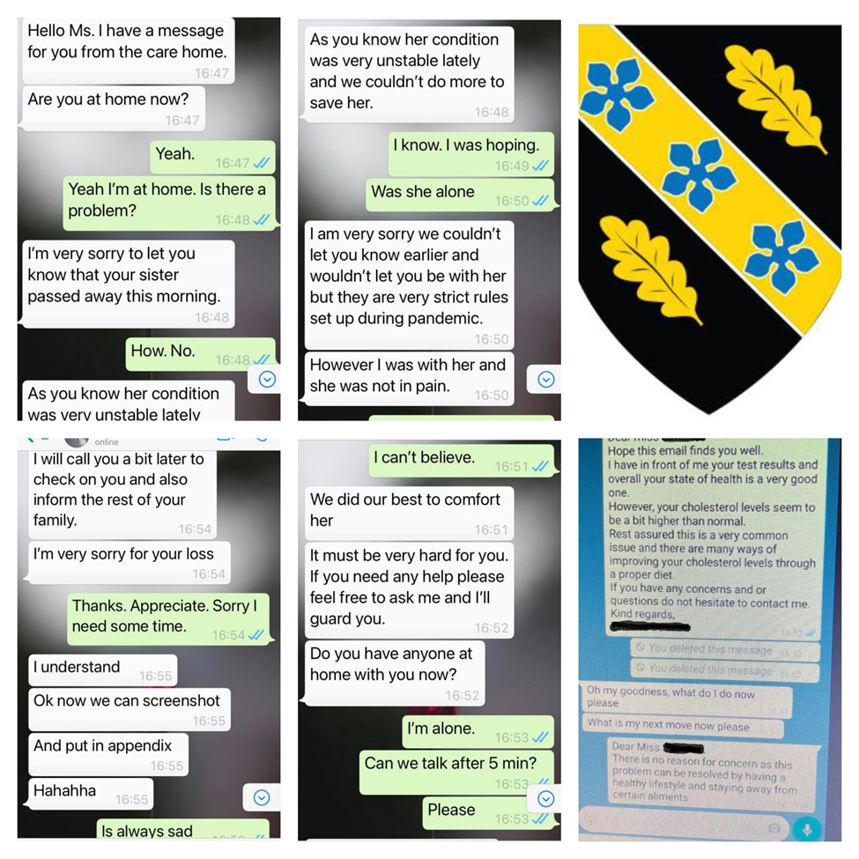

Appendix B
Interpreting body language

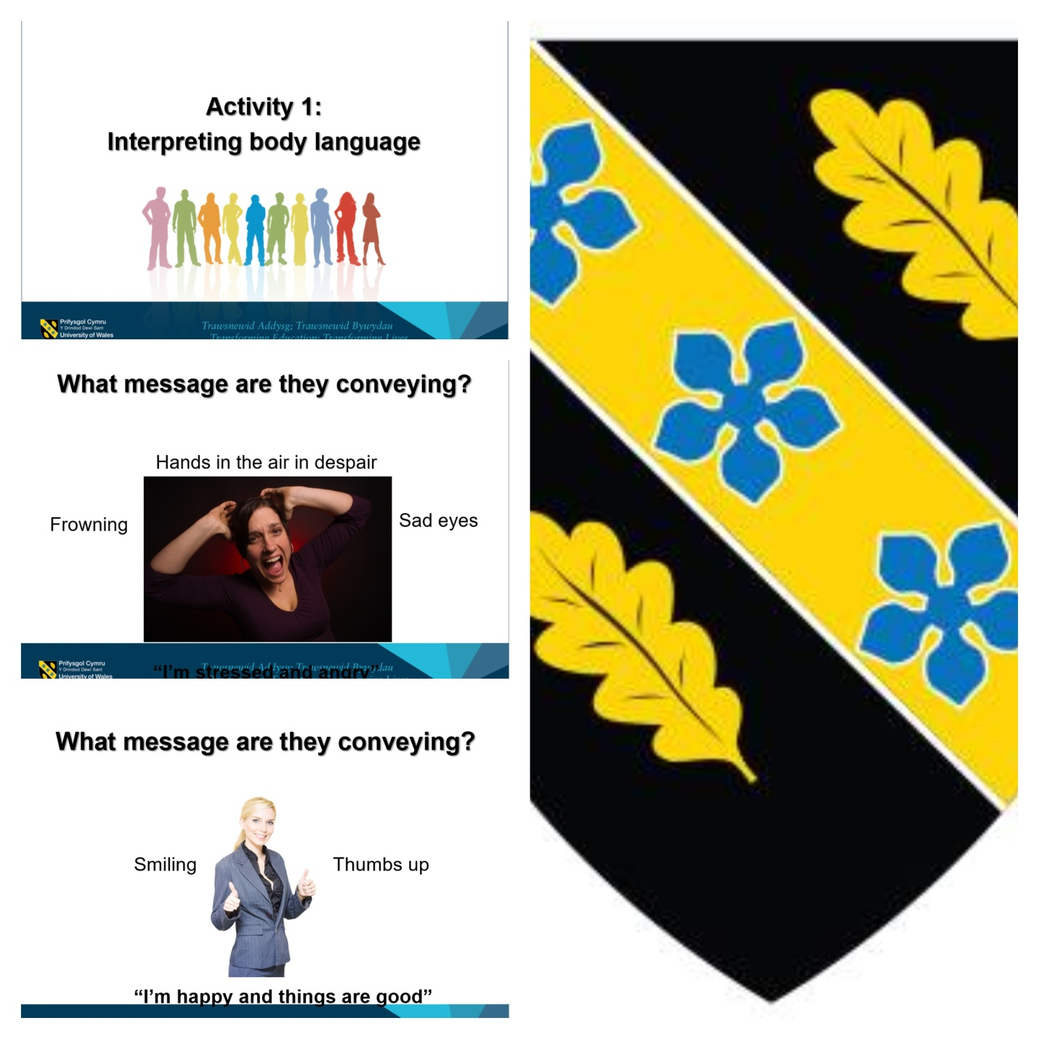

Appendix C

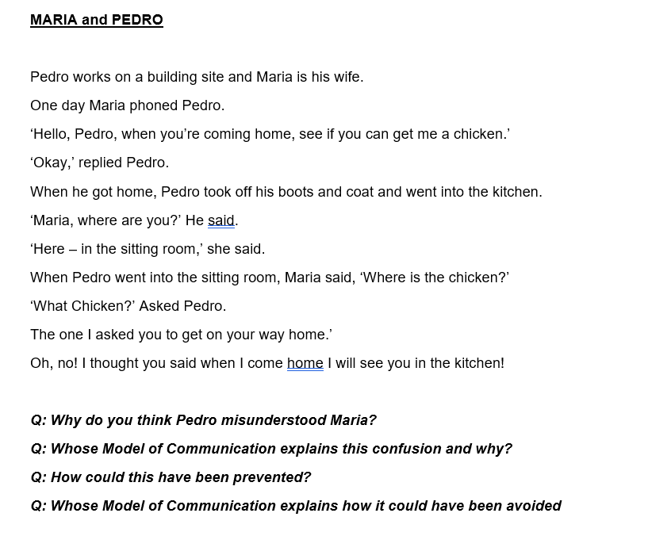

Appendix D
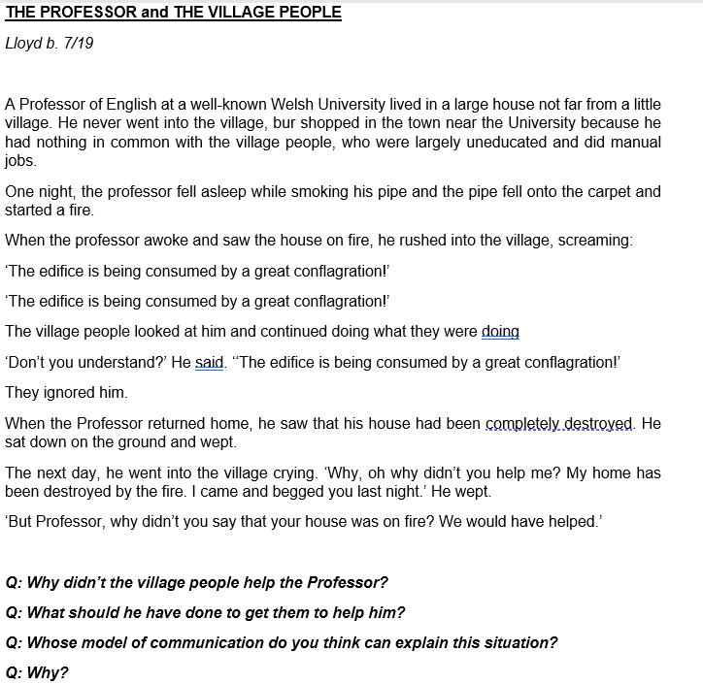

Appendix E
The egg case.
ER is a Bulgarian (where the main religion is Eastern Orthodox Christianity). One tradition during Orthodox Easter is to give dyed eggs (mainly red) to children and friends, as a symbol of faith and health. ER has lived in the UK for more than 6 years but continues to celebrate Easter in line with her faith's traditions.
This year, the company she works for decided to give everyone a little treat for Easter. She works as an administrative team leader for a big company based in London. Ms ER is also the wellbeing leader at her workplace - one of the company's many sites. On…… she received a letter from the Head office with a request to provide one Easter egg for each staff member. One of the requirements is that the price of the Easter eggs should be between £3 and £3.50. ER was really confused, because she couldn’t understand why she would have to buy and give a single egg to each co-worker, and how would she manage to spend £3 per egg. All her colleagues from other company sites were very excited about the idea, with happy messages overflowing her inbox, which contributed further to ER's confusion. At this point ER decided to ask her manager (Mr CA) about the meaning behind the "egg initiative". Mr CA seemed very surprised by the question, which made ER feel awkward. ER jokingly asked her Manager if the company is going to give the staff Faberge eggs, as the price of £3 per egg seems extreme. Furthermore, according to the other wellbeing leaders' reaction it seems that this present is supposed to be something very precious. Mr AC then explained to ER, that the Head office meant chocolate eggs, not chicken eggs.

