C:\Users\igbin\Downloads\0b5ed9d7-df92-4e82-8b03-d2f7a469dff5.mp3  Programme: | BSc Health and Social Care
Module: | Changemakers: Creativity and Value Creation
Module code:  Name  Student number | BMHP5014  kate igbinigie  2334466

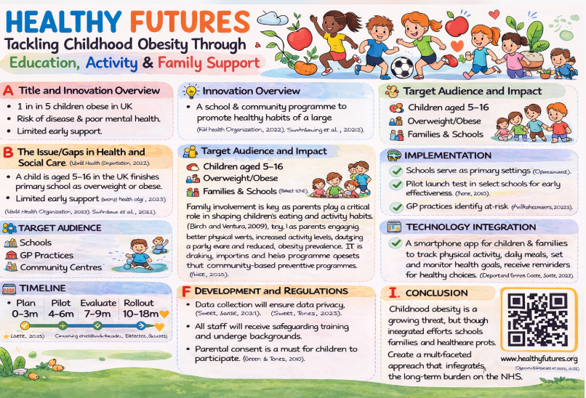

Healthy Futures: Tackling Childhood Obesity in the UK
Title and innovation overview
In This campaign I will be discussing about children healthy futures tackling childhood obesity in the UK, by using this new innovative app to help track and monitor risk factors of children with obesity in the UK.
Childhood obesity is one of the most urgent public health challenges in the United Kingdom, with long term consequences for both children and the healthcare system (). Rising obesity rates in children increase the likelihood of chronic conditions such as type 2 diabetes, cardiovascular disease, and musculoskeletal disorders, while contributing to psychological issues including low self-esteem and social stigma (Public Health England, 2019; NHS Digital, 2023).
The Healthy Futures programme is an innovative health promotion initiative designed to address childhood obesity through education, community engagement, and technology supported interventions. By focusing on children aged 5-16, the programme encourages healthier behaviours through improved nutrition, increased physical activity, and stronger family involvement. Prevention and early intervention are central to the programme, as habits established in childhood often continue into adulthood (World Health Organization, 2022). By integrating schools, families, and healthcare professionals, Healthy Futures promotes sustainable lifestyle changes to reduce obesity rates and improve long term health outcomes ().
The Issue/Gaps in Health and Social Care
Despite increasing awareness of childhood obesity, current health and social care services often prioritise treatment over prevention, leaving gaps in early intervention (). National statistics indicate that approximately one in five children in the UK are overweight or obese by the end of primary school (NHS Digital, 2023). Obesity during childhood significantly increases the risk of developing chronic illnesses (Public Health England, 2019) and contributes to social challenges such as low self-esteem and stigma. Coordination between schools, healthcare providers, and community services is frequently limited, leading to missed opportunities for prevention. Innovative, community based programmes are needed to address these gaps and provide practical support for families to adopt healthier lifestyles (Swinburn et al., 2011).
Target Audience and Impact
The Healthy Futures programme targets children age 16 who are overweight, obese, or at risk of obesity. The programme also recognises the critical role of parents, carers, and schools in shaping children’s behaviours. Research shows that family environments and parental behaviours significantly influence children’s dietary habits and physical activity levels (Birch and Ventura, 2009). By engaging families and schools, Healthy Futures creates supportive environments that encourage sustainable behavioural change. Expected outcomes include improved physical health, increased physical activity, better nutritional knowledge, and enhanced psychological wellbeing. Over time, these interventions may reduce obesity prevalence, improve population health, and support broader public health strategies that prioritise early prevention (Department of Health and Social Care, 2020).
Implementation
Successful implementation requires collaboration between multiple stakeholders in the health and social care system. Schools function as the primary delivery setting, providing structured access to children. Educational workshops are led by healthcare professionals, including dietitians, school nurses, and public health practitioners, delivering evidence based guidance on nutrition and healthy lifestyles. General practitioners may identify children who would benefit from the programme and provide referrals for additional support. Community centres will host physical activity sessions and family focused workshops. This multiagency approach reflects best practice in health promotion, as coordinated efforts improve engagement, outcomes, and community participation (NICE, 2015).
Timeline
The Healthy Futures programme follows a structured timeline to ensure effective planning and evaluation. The initial three month phase focuses on programme design, staff training, and stakeholder engagement, during which educational resources are developed and partnerships with schools and healthcare providers are established. The second phase involves a pilot programme in selected schools for three to six months, enabling early evaluation of intervention effectiveness and refinement of delivery (Green and Tones, 2010). Participant feedback, engagement levels, and health outcomes will inform adjustments before the programme expands to additional schools and communities over twelve to eighteen months, ensuring scalability and adaptability.
Development and Regulations
The Healthy Futures programme complies with legal and ethical frameworks within the UK health and social care system. Data collected through digital platforms must follow GDPR principles, ensuring information is securely managed and confidential. Safeguarding policies are strictly followed, with staff required to complete training and DBS checks. Ethical considerations such as informed consent and confidentiality are essential, with parental consent required for participation (Care Quality Commission, 2023).
The programme also aligns with current UK policies addressing childhood obesity. Regulations include restrictions on advertising foods high in fat, sugar, and salt (HFSS), including a ban on junk food adverts before 9pm and online from 2025 (Department of Health and Social Care, 2024). Policies limiting price promotions on unhealthy foods and strengthening the Soft Drinks Industry Levy aim to reduce sugar consumption (Department of Health and Social Care, 2025). Local authorities can restrict fast-food outlets near schools, promoting healthier environments (UK Parliament, 2025). The National Child Measurement Programme continues to monitor obesity trends and inform interventions (NHS Digital, 2024).
By aligning with these policies, Healthy Futures remains legally compliant, supports safeguarding, and contributes to improving children’s health outcomes.

Technology Integration
Digital technology plays a central role in enhancing engagement, self-monitoring, and behaviour change within the Healthy Futures programme. A dedicated mobile application is used by children, parents, and healthcare professionals to support the adoption of healthier lifestyles. The app enables users to track daily physical activity, monitor dietary intake, and set personalised health goals, encouraging consistent self-reflection and accountability. Evidence suggests that mobile health (mHealth) technologies are effective in promoting sustained behaviour change, particularly when they incorporate goal setting, feedback, and interactive features (Dennison et al., 2013; NICE, 2015).
In addition, the application provides accessible educational resources, including healthy recipes, physical activity suggestions, and wellbeing guidance, helping families make informed lifestyle choices. The inclusion of reminders, progress tracking, and motivational feedback further enhances user engagement and supports long-term adherence to healthy behaviours (World Health Organization, 2022). Importantly, the app facilitates communication between families and healthcare professionals, allowing for ongoing monitoring, early intervention, and personalised support where needed (Department of Health and Social Care, 2020).
By integrating digital tools into everyday routines, the Healthy Futures programme extends beyond the school environment and promotes continuous health improvement in home and community settings. This approach aligns with current public health strategies that emphasise prevention, accessibility, and the use of technology to improve health outcomes and reduce inequalities.

Dissemination: How the Innovation Will Be Promoted
Effective dissemination is essential for programme uptake. Healthy Futures will be promoted through partnerships with schools, healthcare organisations, and local authorities. Schools will share information via newsletters, parent meetings, and events, while healthcare professionals may introduce the programme during routine health checks. Public health campaigns on social media platforms will raise awareness among parents and communities. Research highlights the importance of community engagement and effective communication in successful public health interventions (Glanz, Rimer and Viswanath, 2015). Posters, websites, and QR codes will provide easy access to further information and facilitate participation.
Conclusion
Childhood obesity presents a complex challenge for health and social care systems in the UK. Rising obesity rates increase the risk of long term physical and mental health conditions and place pressure on healthcare services. The Healthy Futures programme offers an innovative, preventative purposeful on early intervention, education, and community collaboration. By targeting children aged 5-16 and engaging families, schools, and healthcare professionals, the programme encourages sustainable lifestyle changes that promote healthier eating and increased physical activity. Integration of digital technology, structured implementation strategies, and strong safeguarding measures strengthens its impact. Overall, Healthy Futures demonstrates how coordinated, community based initiatives can reduce obesity prevalence, improve health outcomes, and support a healthier future for children in the UK.

Reference
Birch, L.L. and Ventura, A.K. (2009) ‘Preventing childhood obesity: what works?’, International Journal of Obesity, 33(S1), pp. S74–S81.
Care Quality Commission (2023) Regulation and safeguarding guidance for health services. London: CQC.
Dennison, L., Morrison, L., Conway, G. and Yardley, L. (2013) ‘Opportunities and challenges for smartphone applications in supporting health behaviour change’, Journal of Medical Internet Research, 15(4), e86.
Department of Health and Social Care (2020) Tackling obesity: empowering adults and children to live healthier lives. London: DHSC.
Department of Health and Social Care (2024) Restricting advertising of unhealthy food and drink to children. London: DHSC.
Glanz, K., Rimer, B.K. and Viswanath, K. (2015) Health behaviour: theory, research and practice. 5th edn. San Francisco: Jossey-Bass.
Green, J. and Tones, K. (2010) Health promotion: planning and strategies. 2nd edn. London: Sage.
NHS Digital (2023) National Child Measurement Programme, England 2022–2023. Leeds: NHS Digital.
NHS Digital (2024) National Child Measurement Programme, England 2023–2024. Leeds: NHS Digital.
NICE (2015) Obesity: identification, assessment and management. London: National Institute for Health and Care Excellence.
Public Health England (2019) Childhood obesity: applying All Our Health. London: PHE.
World Health Organization (2022) Obesity and overweight. Geneva: WHO.

