University of Wales Trinity Saint David

Wales Institute of Science & Art

BEng Manufacturing Systems Engineering

Module: Six Sigma Green Belt (ACMA5005)

Assignment Title: Undertaking a Green Belt Project

Name: Mathew Soroka
Student ID: 2406846
Date: May 2026

Table of Contents
Table of Figures 3
Table of Tables 3
1. Introduction 4
2. Define 6
2.1 Project Statement 6
2.2 Project Scope and Metrics 7
2.3 Process Mapping 8
2.4 Voice of the Customer (VoC) and Critical to Quality (CTQ) 9
2.5 Project Charter 10
3. Measure 12
3.1 Measurement Variation 12
3.2 Data Type 13
3.3 Data Collection Plan 13
3.4 Measurement System Analysis 16
3.5 Data Collection and Process Capability 16
4. Analyse 18
4.1 Process Analysis Methods 18
4.2 Review of Analysis Methods 18
4.3 Graphical Analysis Tools 21
4.4 Identify Sources of Variation 23
5. Improve 26
5.1 Improve FMEA Phase 26
5.2 Cost / Benefit Analysis 27
5.3 Should-Be / Future State 28
5.4 Validate Improvements 28
6. Control 30
7. Conclusion 33
8. References 36
9.Appendices 38
9.1 Appendix A1 – Measurement System Analysis 38
9.2 Appendix A2 – Asana Dock Heat Escalation Project 39

Table of Figures
Figure 1 - Process Mapping 9
Figure 2 - Heat Sensor locations 14
Figure 3 - BMS Zone Temperature sensors locations (Amazon CWL1 BMS, 2026) 15
Figure 4 - BMS Zone Sensor DPMO 19
Figure 5 - Heat Escalation Pareto (Sev2 and Sev3) 20
Figure 6 - Pareto Heat Map for IT Heat Sensors and BMS Zone Sensors 21
Figure 7 - Sev 3 Heat Escalations (<17°C or >27°C) 22
Figure 8 - Sev 2 Heat Escalations (<13°C or >30°C) 22
Figure 9 - Dock Door Air Curtain Initial Condition 23
Figure 10 - Failed Dock Door Air Curtain 24
Figure 11 - BMS run chart for Outbound Dock showing 7‑day temperature variation 25
Figure 12 - BMS Sensor DPMO Validation 29
Figure 13 - Dock Door Air Curtain Maintenance Checks (Source: Amazon CMMS, 2026) 30
Figure 14 - Dock Door Air Curtain and Seal Condition Before and After Corrective Work 31
Figure 15 - Dock TDR Process (Source: Amazon WHS TDR Process EU, 2026) 31
Figure 16 - Voice of the Associate (Customer) 34
Figure 17 - Gas usage October 2025 - May 2026 34
Figure 18 - Gas Usage October 2025 - May 2026 35

Table of Tables
Table 1 - Sev2 and Sev3 Temperature Escalations (2018 - 2026) 7
Table 2 - Voice of the Customer and Critical to CTQ (CTQ) 10
Table 3 - Six Sigma Project Charter 11
Table 4 - Summary of temperature variation sources and their impact on process stability 12
Table 5 - Data collection plan 13
Table 6 - Measurement System Analysis 16
Table 7- Top 3 BMS DPMO Contributors 19
Table 8 - Improve-phase FMEA and associated RPN values 26
Table 9 – Cost / Benefit Analysis of Improve‑Phase Interventions 27
Table 10 - HVAC Remedials Action Tracker 28

1. Introduction

Amazon operates one of the world’s largest fulfilment networks, with more than 175 fulfilment centres (FCs) globally and 31 within the United Kingdom (Amazon, 2019). These facilities depend on stable and well-controlled environmental conditions to support high-volume order processing, maintain workforce wellbeing, and ensure compliance with operational and safety standards. Amazon CWL1 in Swansea is a major regional FC where temperature stability has become a recurring operational concern, prompting the need for a structured improvement project to understand and reduce the frequency of escalation events.
Historical data from 2018–2026 show persistent hot and cold temperature escalations across multiple operational zones. These deviations automatically generate trouble tickets (TTs) for the Reliability, Maintenance and Engineering (RME) team and are categorised by severity thresholds: cold Sev3 events occur below 17°C and Sev2 below 13°C, while hot Sev3 events occur above 27°C and Sev2 above 30°C (Amazon Environmental Standards, 2025). The recurrence of these events indicates systemic variation rather than isolated equipment faults, suggesting that multiple interacting factors influence thermal performance within the building.
Maintaining appropriate thermal conditions is essential for both safety and productivity. The UK Health and Safety Executive (HSE, 2025) identifies 13°C as the minimum acceptable temperature for physically active industrial work and recognises excessive heat as a workplace hazard requiring risk control measures. Research also shows that indoor temperatures outside the 21–25°C comfort band negatively affect cognitive and physical performance. Seppänen et al. (2003) found that productivity decreases by approximately 2% for every degree outside this range, highlighting the operational impact of thermal instability in high-throughput environments such as fulfilment centres.
Temperature control in large industrial buildings is influenced by HVAC capability, building envelope performance, external climate, equipment heat loads, and operational practices such as door usage and shift patterns. Addressing recurring deviations therefore requires a structured, data-driven approach rather than reactive maintenance. The Six Sigma DMAIC methodology provides a rigorous framework for reducing variation and improving process performance through the Define, Measure, Analyse, Improve, and Control phases (Antony et al., 2017).
This project applies DMAIC to identify the root causes of temperature instability at CWL1, quantify their impact, and implement targeted improvements. The objective is to reduce the frequency and severity of temperature escalation events, supporting workforce comfort, regulatory compliance, operational resilience, and energy efficiency. The following sections present each DMAIC phase in detail, beginning with the Define phase, which establishes the foundation for systematic improvement.

2. Define

The Define phase establishes the strategic foundation of a Six Sigma project by clarifying the problem, identifying stakeholder requirements, outlining process boundaries, and setting improvement objectives. Its purpose is to ensure that the issue is accurately understood, appropriately scoped, and aligned with organisational priorities before progressing to measurement and analysis (Trubetskaya et al., 2023). A project charter was developed to formalise the problem, scope, and objectives, ensuring that all stakeholders share a consistent understanding of the project’s direction and expected outcomes.

At Amazon CWL1, the Define phase was initiated in response to recurring temperature escalation events observed consistently over multiple operational years. These events triggered automated trouble tickets (TTs) and required intervention from the Reliability, Maintenance and Engineering (RME) team. A structured, data-driven approach was adopted to validate the problem and understand its operational context, supporting a shift from reactive issue resolution to proactive process improvement. This ensured that the project was grounded in verified operational data rather than assumptions or isolated incidents, enabling a more accurate and sustainable improvement strategy.

2.1 Project Statement
Historical escalation data from 2018 to 2026 indicate a total of 3,463 temperature-related events across Sev2 and Sev3 categories. This dataset was reviewed to validate the scale and persistence of the issue, ensuring that the problem definition was based on objective evidence rather than anecdotal reports. A summary of Sev2 and Sev3 temperature escalation events between 2018 and 2026 is presented in Table 1, highlighting the distribution of hot and cold events across the nine-year period.

Table 1 - Sev2 and Sev3 Temperature Escalations (2018 - 2026)
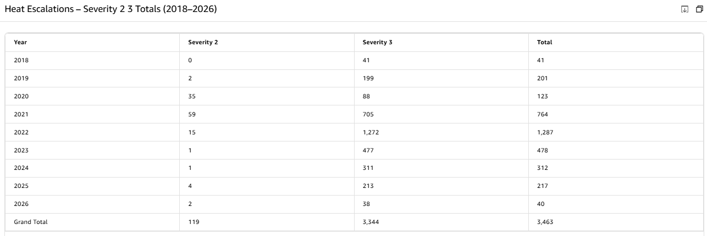

Although annual volumes fluctuate, the continued presence of both hot and cold escalation events demonstrates that thermal instability is a recurring operational condition rather than a seasonal anomaly. This pattern indicates that the underlying causes are systemic and require a structured improvement approach. Clearly defining the problem at this stage is essential, as inadequate problem definition is a common cause of failure in Six Sigma initiatives (Chakravorty, 2009). By establishing a clear and evidence-based problem statement, the project ensures that subsequent phases focus on the most relevant sources of variation.

The problem statement therefore centres on the need to reduce the frequency and severity of temperature escalation events across CWL1 by identifying the operational, environmental, and system-level factors contributing to temperature instability.

2.2 Project Scope and Metrics
The scope of this project focuses on temperature control within operational areas of Amazon CWL1, specifically relating to Sev2 and Sev3 temperature escalation events. The project includes the BMS-controlled HVAC system, environmental influences, and operational factors affecting temperature stability. This ensures that the project remains focused on areas where meaningful improvements can be achieved without requiring major capital investment.

In Scope
- BMS-controlled HVAC systems and associated control logic
- Temperature sensors, set points, and deadband parameters
- Operational zones including Pick, Pack, Stow, ICQA, Dock, and Office
- Environmental factors such as external temperature and equipment heat loads
- Operational behaviours including door usage, shift patterns, and airflow obstructions

Out of Scope
- Major infrastructure redesigns or capital-intensive building modifications
- External environmental factors beyond operational control
- Non-temperature-related environmental conditions (humidity, lighting, noise)

The primary metric for this project is the number of Sev2 and Sev3 temperature escalation events, as these directly reflect failure to maintain temperature stability. Secondary metrics include deviation from the target temperature range (17-27°C), response time to escalation events, recurrence frequency within specific zones, and HVAC energy consumption. Establishing clear and measurable performance indicators at this stage aligns with best practice in Six Sigma project definition (Antony et al., 2017). These metrics will guide the Measure phase and provide a baseline for evaluating the effectiveness of improvement actions.

2.3 Process Mapping
Process mapping was used to develop a clear understanding of the temperature control system and its associated workflows. This provides visibility of process flow, control points, and potential sources of variation without introducing detailed analysis prematurely. Mapping the process at this stage ensures that the project team has a shared understanding of how temperature is monitored, controlled, and escalated within the building.

Temperature management at CWL1 is controlled by the Building Management System (BMS), which operates as a closed-loop system. Temperature sensors continuously collect environmental data, which is compared against predefined set points using a ±1°C deadband. When temperatures fall outside this range, heating or cooling is activated to return conditions to the set point. The process operates continuously, with real-time monitoring and automated adjustments.
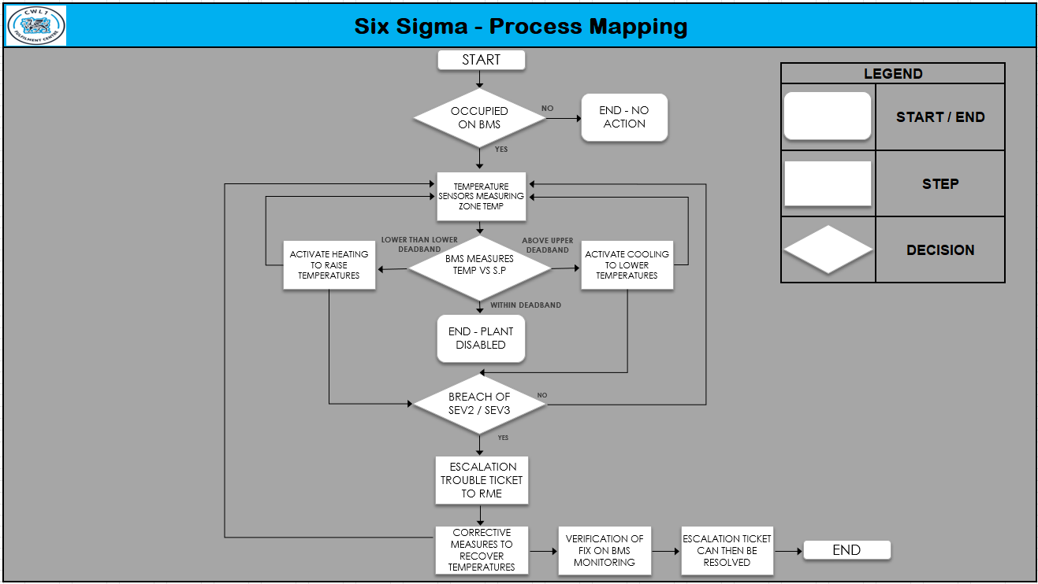
When deviations persist, escalation mechanisms are triggered, requiring coordinated intervention from RME, WHS, and Operations teams. Understanding process flow at this stage ensures that subsequent measurement activities focus on the most critical areas influencing temperature stability, reflecting the importance of process visibility in Six Sigma projects (Kumar et al., 2023). This mapping also highlights potential bottlenecks, delays, or inconsistencies in the escalation process that may contribute to prolonged temperature deviations (Figure 1).
Figure 1 - Process Mapping

2.4 Voice of the Customer (VoC) and Critical to Quality (CTQ)
The Voice of the Customer (VoC) was captured to ensure that the project reflects stakeholder requirements and real operational conditions. A temperature-focused Gemba was conducted across all operational departments, allowing associates to raise concerns relating to thermal comfort, airflow, and recurring temperature issues. Conducting the Gemba across both day and night shifts ensured that feedback captured variation in operational conditions and avoided bias toward a single operating period. Voice of the Associate (VoA) feedback was also reviewed to validate findings and identify recurring themes. These qualitative insights were triangulated with escalation data to increase confidence in identified concerns. Key stakeholders include associates, Operations, WHS, and RME teams, each with distinct requirements relating to comfort, safety, workflow efficiency, and system reliability (Table 2).
Table 2 - Voice of the Customer and Critical to CTQ (CTQ)

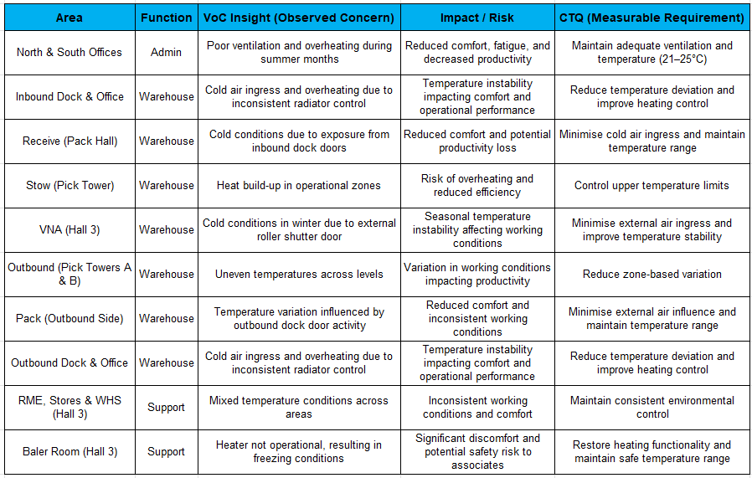
These requirements were translated into Critical to Quality (CTQ) characteristics to convert qualitative needs into measurable performance criteria (Patel and Desai, 2018). The primary CTQ is maintaining temperature within the target range of >17 and <27°C, supported by additional CTQs relating to escalation frequency, duration, response efficiency, and visibility of recurring issues. Recognising that perceived thermal comfort varies between individuals, the CTQs focus on measurable environmental performance rather than subjective perceptions.

2.5 Project Charter
A project charter was developed to formally define the problem, scope, objectives, and key stakeholders, ensuring alignment and providing a structured framework for the project. The charter serves as a reference point throughout the DMAIC process to maintain focus and prevent scope drift. A summary of the project charter is presented in Table 3, consolidating the key elements defined in this phase and providing a clear foundation for progression into the Measure phase.

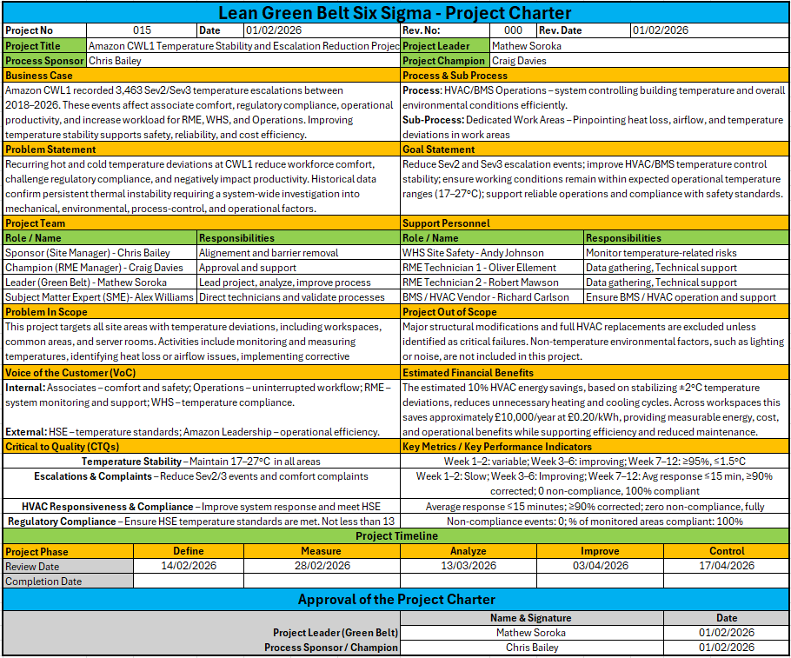
Table 3 - Six Sigma Project Charter

3. Measure

The Measure phase establishes a quantitative and statistically reliable baseline for temperature performance within Amazon CWL1. Building on the CTQs identified in the Define phase, this stage focuses on translating stakeholder requirements into measurable variables and validating the integrity of the data used for decision-making. A structured measurement approach was adopted to ensure that the data collected reflects true operational behaviour and provides a robust foundation for subsequent analysis (Sreedharan et al., 2018). Establishing this baseline is essential for determining whether the temperature control process consistently meets the CTQ requirement of maintaining temperatures above 17°C and below 27°C.

3.1 Measurement Variation
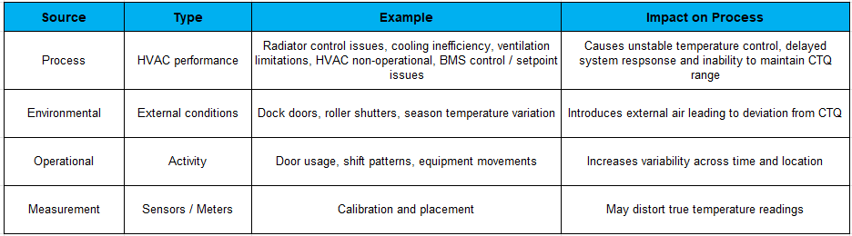
Understanding variation is fundamental to distinguishing between normal system behaviour and abnormal conditions requiring intervention. Temperature variation at CWL1 may arise from environmental exposure, operational practices, equipment performance, and limitations within the measurement system. Categorising these sources supports structured interpretation and highlights that variation is influenced by both controllable and uncontrollable factors. These sources of variation are summarised in Table 4, which outlines the main categories and their impact on temperature stability.
Table 4 - Summary of temperature variation sources and their impact on process stability

In line with established quality management principles, variation was further classified into common cause and special cause categories. Common cause variation reflects inherent system behaviour, such as minor fluctuations in HVAC response, while special cause variation arises from abnormal events such as prolonged door opening, equipment malfunction, or extreme weather conditions (Habidin et al., 2016). Distinguishing between these types ensures that improvement efforts focus on eliminating abnormal conditions rather than reacting to expected system behaviour.

3.2 Data Type
Two primary data types were used to characterise temperature performance: continuous temperature readings and discrete escalation events. Continuous temperature data enables detailed assessment of variation relative to CTQ limits and supports identification of trends, shifts, and fluctuations that may not be visible through discrete metrics alone (Rejikumar et al., 2018). Discrete escalation data, consisting of Sev3 and Sev2 alarms, provides a direct measure of process failure. Escalation events follow a defined hierarchy: a Sev3 alarm represents the initial breach of CTQ limits, while a Sev2 escalation indicates that the deviation has persisted or worsened. Because a Sev2 cannot occur without a preceding Sev3, these alarms do not represent independent defects but rather stages of the same event. This distinction is essential for accurate capability assessment and ensures that escalation data is interpreted correctly within the context of process performance.

3.3 Data Collection Plan
A structured data collection plan was developed to ensure that the dataset was representative, unbiased, and aligned with CTQ requirements. The key data types, their sources, collection frequency, and purpose are summarised in Table 5 to provide a clear overview of how temperature-related information was gathered during the measurement period.
Table 5 - Data collection plan
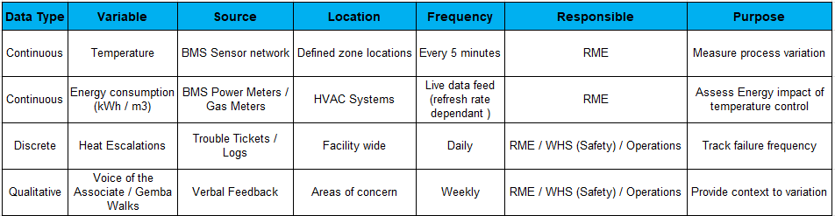

Temperature data was collected through two complementary sensing systems, each supporting a different CTQ metric. The first system is the IT Heat Sensor network, which provides site-wide coverage and records Sev2 and Sev3 heat escalations. These escalation counts form the primary CTQ metric for assessing the number of temperature-related alarms on site, and their spatial distribution is illustrated using a heat map (Figure 2).
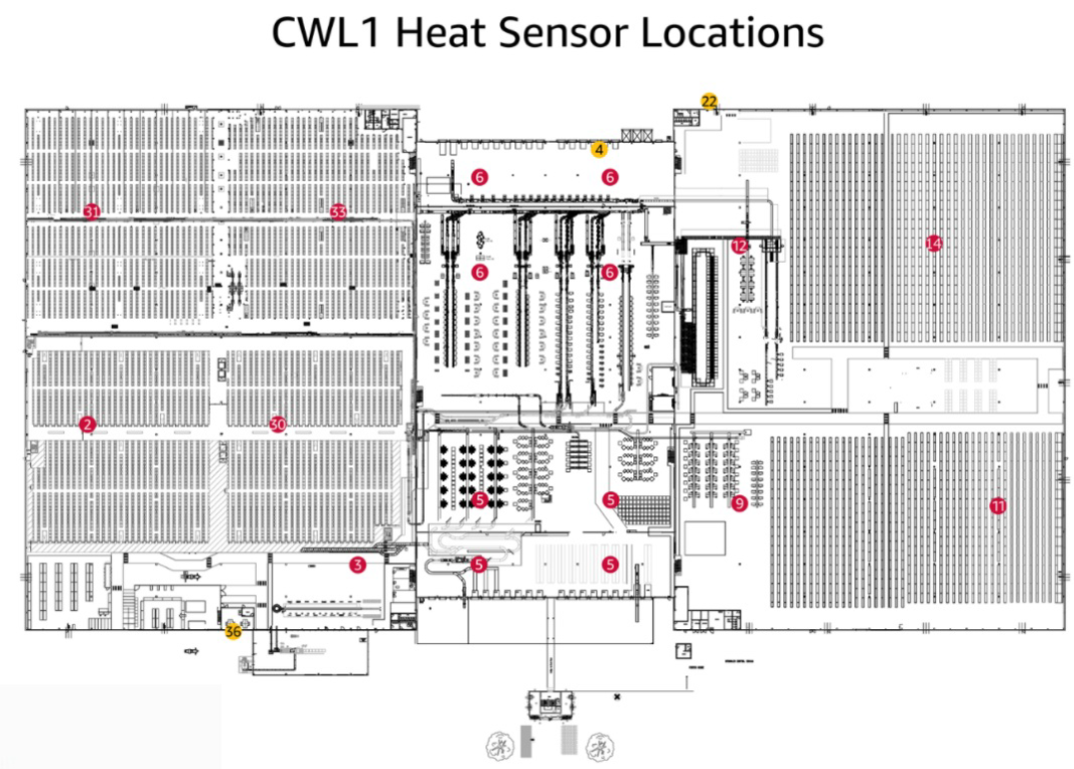
Figure 2 - Heat Sensor locations

The second system is the Building Management System (BMS) zone sensors, which provide continuous temperature readings every five minutes. With 20 sensors recording 288 readings per sensor per day, this equates to 5,760 measurement opportunities daily. This high-resolution sampling frequency enables detection of deviations that may not be visible at longer intervals and supports calculation of DPMO to quantify the duration and extent of out-of-tolerance conditions.

Data collection occurred across all shifts and operational conditions to ensure representativeness, while qualitative insights from VoA feedback and Gemba observations supported interpretation of quantitative data. Sensors are positioned strategically throughout both office and operational zones to ensure comprehensive spatial coverage and capture variation across different process areas (Figure 3).
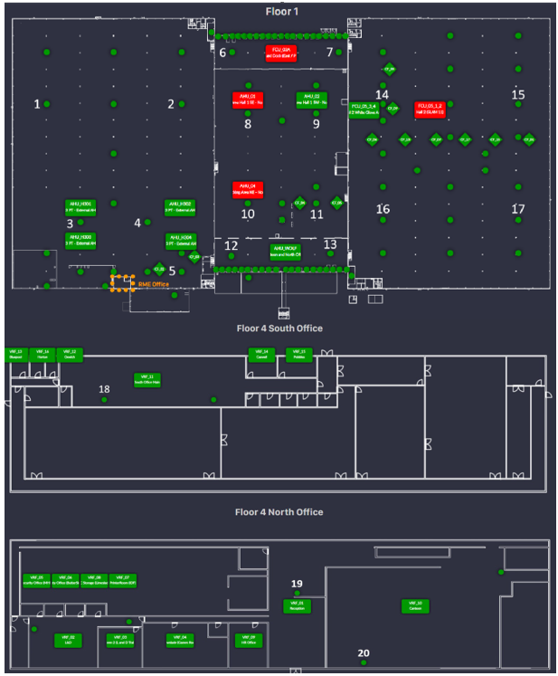
Figure 3 - BMS Zone Temperature sensors locations (Amazon CWL1 BMS, 2026)

3.4 Measurement System Analysis
Measurement System Analysis (MSA) was conducted to ensure that collected data accurately reflects process performance rather than measurement error. Gauge Repeatability and Reproducibility (Gauge R&R) principles were applied to assess the reliability of the temperature measurement system (Alhuraish et al., 2017). Annual calibration of both BMS and IT sensors ensures measurement accuracy, while automated data capture minimises operator-related variation. Cross-zone comparisons confirmed reproducibility across sensors, and time-based checks demonstrated stability of readings over repeated intervals. Although the IT sensors are calibrated in their installed locations, their escalation outputs require validation against the Heat Index dashboard to confirm alignment between alarm triggers and actual temperature conditions. A summary of key MSA checks is presented in Table 6, while the full verification table, including detailed evidence and risk assessment, is provided in Appendix A1.

Table 6 - Measurement System Analysis
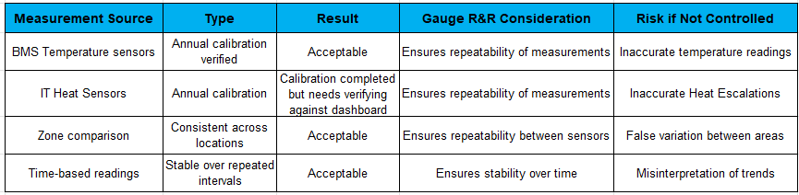

This validation confirms that observed variation reflects actual process conditions and that the measurement system is suitable for supporting statistical analysis.

3.5 Data Collection and Process Capability
Process capability was assessed using two complementary measurement systems aligned with the CTQ limits of >17°C and <27°C. Escalation performance was measured using the IT Heat Sensor system, which recorded 85 Sev2/Sev3 heat escalations across the measurement window. These escalations were visualised using a heat map to illustrate where temperature-related alerts occurred within the building.

To establish a reliable capability baseline, continuous temperature data from the BMS zone sensors were analysed across 20 monitored locations, generating 699,500 total readings. Of these, 49,819 fell below the lower CTQ limit, resulting in a site-level DPMO of approximately 71,270. Most sensors recorded either zero defects or only minimal dips, while a small number contributed most out-of-spec readings. This confirms that temperature variation is concentrated rather than widespread and provides a clear, data-driven baseline for the Analyse section, where the underlying patterns and sources of variation will be examined in detail.

4. Analyse

The Analyse phase examined continuous BMS temperature data alongside discrete IT Heat Sensor escalation events to identify the underlying drivers of variation. Multi-vari analysis was selected as it separates positional, temporal, and cyclical sources of variation, a key requirement when diagnosing environmental instability in warehouse operations (Adeodu et al., 2023). This enabled the investigation to determine whether temperature deviation was linked to specific zones, operational timing, or recurring activity cycles.

4.1 Process Analysis Methods
Correlation and regression screening were applied to explore whether temperature defects were influenced by operational factors such as door-open duration, external temperature, or HVAC load. These methods help distinguish meaningful relationships from background noise and are widely used in Lean Six Sigma projects to identify operational contributors to process instability (Nguyen et al., 2025).

Pareto analysis was used to prioritise the most significant contributors to temperature defects, reflecting the typical “vital few” pattern observed in environmental and operational datasets. Heat maps and run charts were incorporated to visualise spatial clustering and temporal drift, enabling rapid identification of hotspots and recurring deviation patterns. An operational diagnostic review of dock-door air curtains complemented the statistical analysis by validating whether physical infrastructure issues were driving the variation observed in the data.

4.2 Review of Analysis Methods
The BMS dataset consists of continuous temperature readings captured every five minutes across 20 sensors, with 34,975 opportunities per sensor. As shown in Figure 4, most sensors recorded zero defects, while three contributed disproportionately: Outbound Dock West (DPMO 618,000), Inbound Dock West (DPMO 397,000), and Outbound Dock East (DPMO 393,500). This aligns with research showing that localised environmental exposure, particularly at building openings, is a primary driver of thermal deviation and energy loss in operational facilities (Goubran et al., 2017). Pareto analysis was therefore appropriate for highlighting the extreme imbalance in defect contribution.

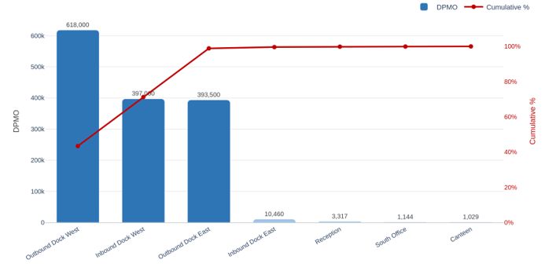
Figure 4 - BMS Zone Sensor DPMO

Table 7 provides a deeper breakdown of these high-impact zones, showing the operational severity behind the DPMO values. Outbound Dock West recorded 21,614 out-of-spec readings and a minimum temperature of 8.9°C, while Inbound Dock West and Outbound Dock East each exceeded 13,700 defects. This granularity reinforces the earlier Pareto finding by showing not only how often these zones failed, but also how far temperatures deviated from the CTQ, strengthening the case for prioritising the Dock areas in the Improve phase.

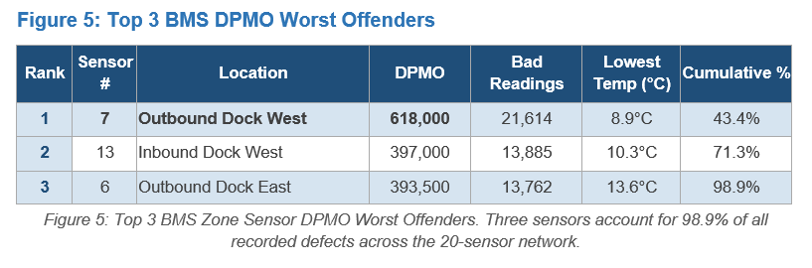
Table 7- Top 3 BMS DPMO Contributors

The IT Heat Sensor escalation dataset is event-based and categorical, making it suitable for frequency analysis and Pareto prioritisation. As represented in Figure 5, Outbound Dock East (18),

Customer Returns/MHE (14), and the IT Office (12) accounted for most Sev2/Sev3 events. This concentration confirmed that escalation activity was not evenly distributed and required targeted investigation.

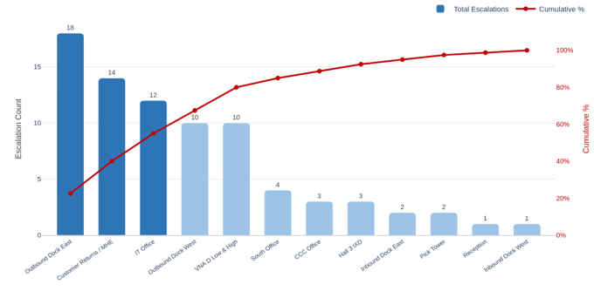
Figure 5 - Heat Escalation Pareto (Sev2 and Sev3)
A mixed-method approach was required to fully understand the problem: event-based data identified where alarms occurred, while continuous data analysis quantified the duration and severity of temperature deviation. This combination provided a complete picture of both the frequency and impact of temperature instability. Crucially, the two datasets captured different dimensions of the same failure mode, escalations revealed acute breaches that triggered operational disruption, whereas continuous readings exposed chronic underperformance that would otherwise remain hidden. Integrating both perspectives enabled a more robust diagnosis of localised thermal instability, strengthened the validity of the findings, and ensured that subsequent root-cause analysis targeted the true drivers of variation rather than isolated symptoms.

4.3 Graphical Analysis Tools
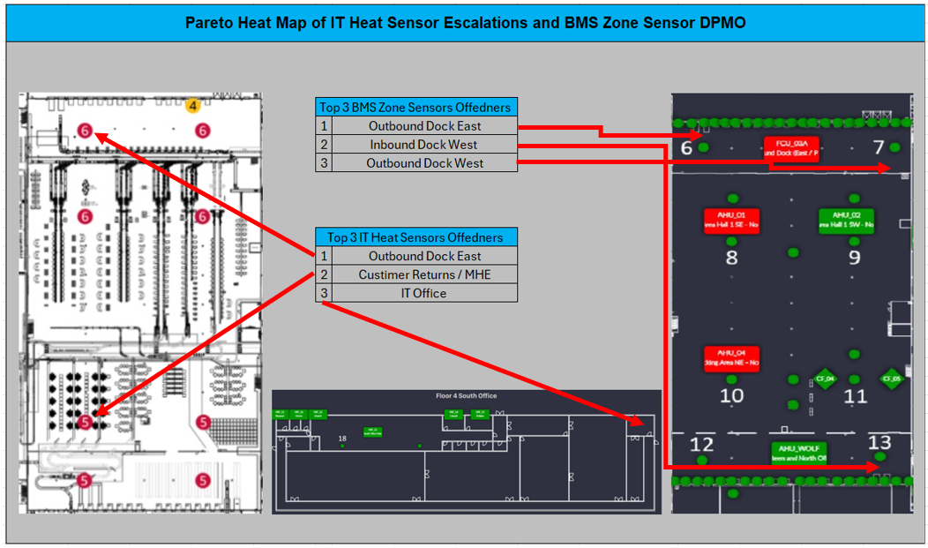
A heat map visualised the distribution of Sev2/Sev3 heat escalations and BMS zone sensor DPMO, highlighting spatial clustering in Inbound Dock, Outbound Dock, Customer Returns and the IT Office (Figure 6). This provided immediate visual confirmation of hotspot zones
Figure 6 - Pareto Heat Map for IT Heat Sensors and BMS Zone Sensors

Pareto charts were used to separate Sev3 and Sev2 escalation conditions, allowing the two failure modes to be examined independently. Sev3 escalations showed a broad distribution of instability across multiple zones, but the highest counts were concentrated in Outbound Dock East, the IT Office, and Customer Returns/MHE. When the Sev2 thresholds were applied (<13°C or >30°C), only two locations triggered alarms, indicating extreme temperature deviation. Importantly, these Sev2 breaches occurred in the same high-risk zones identified by the Sev3 Pareto, confirming) that the most severe failures are not random but are consistently linked to the top three offenders (Figure 7-8). This alignment strengthens the case for targeted intervention in these areas during the Improve phase.

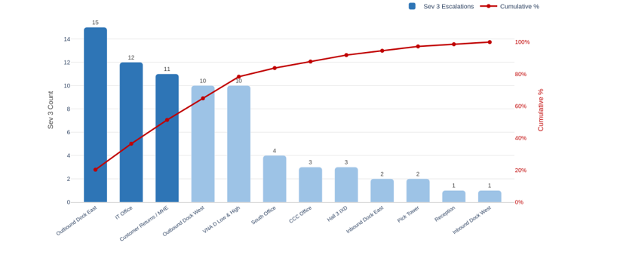
Figure 7 - Sev 3 Heat Escalations (<17°C or >27°C)

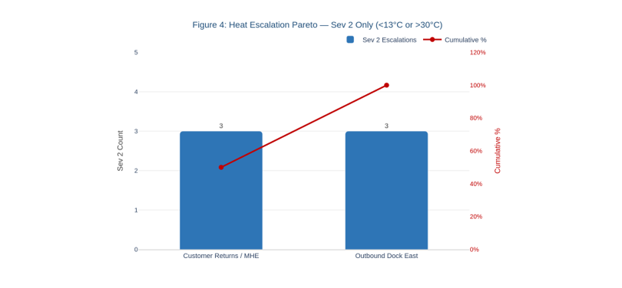
Figure 8 - Sev 2 Heat Escalations (<13°C or >30°C)

Viewed collectively, the two Pareto charts validate the reliability of the diagnostic findings by showing that independent datasets converge on the same high-risk areas.

4.4 Identify Sources of Variation
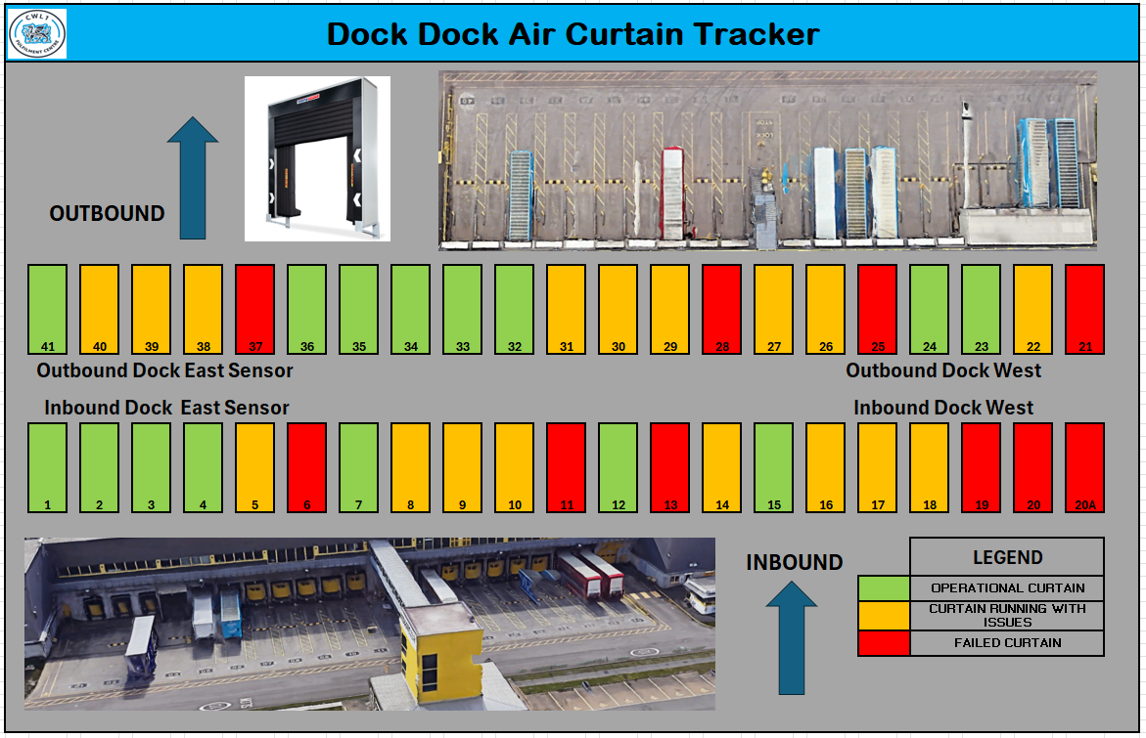
Positional variation was the dominant source. Three dock sensors accounted for nearly all BMS defects, while 17 sensors recorded zero. This clear separation demonstrated that temperature variation was highly localised and driven by environmental exposure, door usage, and airflow disruption in the dock area. A detailed operational review was conducted using an Asana project software package to capture evidence on door activity and HVAC infrastructure, shown in Appendix A2. A full assessment of all 42 dock-door air curtains was recorded in the Dock Door Air Curtain Tracker (Figure 9). Only 15 doors (35.7%) were fully operational, 17 (40.5%) were running with issues, and 10 (23.8%) had failed. With 64.3% of air curtains degraded or non-functional, the thermal barrier during trailer operations was significantly compromised. Research confirms that degraded air curtains increase infiltration rates and weaken the aerodynamic barrier at building openings (Goubran et al., 2017).
Figure 9 - Dock Door Air Curtain Initial Condition
Specific issues included water ingress preventing full inflation (Door 26), curtain snagging that restricted seal integrity (Door 27), air-curtain fan failure (Door 18), and fire-alarm integration faults causing uncontrolled door opening (Door 20A). Door-open duration logs showed a clear relationship between prolonged openings and sharp temperature drops, confirming external air ingress as the primary driver of the lowest recorded temperatures (8.9–13.6°C). Figure 10 represents an example of a poor dock air-curtain condition, showing visible gaps in the dock-shelter seal during trailer loading. This defect allows uncontrolled external air ingress, directly undermining the thermal barrier and contributing to the temperature deviations recorded by BMS and IT heat sensors in the dock zones. The image reinforces the diagnostic findings by illustrating how physical deterioration at the dock interface translates into measurable thermal instability within the building.
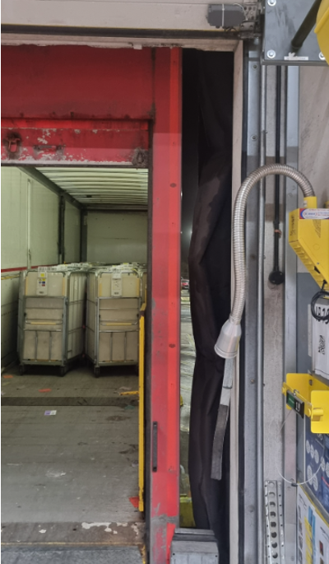
Figure 10 - Failed Dock Door Air Curtain

Temporal variation was observed through run-chart analysis, with deviations occurring during periods of high operational activity. Cyclical variation aligned with Critical Pull Time (CPT) windows, the fixed departure deadlines by which outbound trailers must leave site to meet customer delivery promises. During CPT, multiple dock doors are opened simultaneously to load trailers under time pressure, significantly increasing exposure to external air. This operational surge amplifies thermal loss at the docks precisely when the building is most vulnerable, resulting in the sharp temperature drops shown in Figure 11.
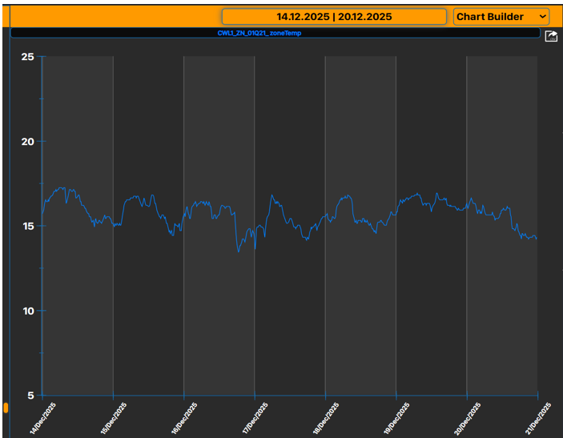
Overall, the Analyse phase confirms that temperature variation is driven by positional, temporal, and cyclical factors, with dock-door operation and air-curtain condition emerging as the dominant root causes.
Figure 11 - BMS run chart for Outbound Dock showing 7‑day temperature variation

Whilst the above analysis focused on heat loss at the dock interface, the BMS run chart also highlights a heat-recovery issue within the building. During CPT windows, temperatures drop cyclically as multiple dock doors open, but the system then fails to recover because several gas heaters and spot coolers in the dock zones were identified as non-operational. This reduced heating capacity represents chronic process variation, limiting the building’s ability to restore temperature after predictable cyclical disturbances. With these root causes now clearly defined, the Improve phase can focus on targeted interventions that address both heat-loss pathways and weakened heat-recovery capability.

5. Improve

The Improve phase focused on developing practical solutions to the main causes of temperature instability. Heat-recovery failures were identified, including non-operational heaters and failed spot coolers. Heat-loss issues were also present at the dock doors, driven by prolonged door-open periods and inconsistent air-curtain performance. The air curtains were already automated, but their operation required corrective action to ensure consistent activation. Based on the Analyse findings, a set of improvement actions was defined. These actions included heater repairs, spot-cooler replacement, air-curtain performance restoration and CPT-specific door-management controls. Each option was assessed for CTQ impact, feasibility, cost and sustainability. This structured selection approach aligns with Lean Six Sigma guidance that effective option evaluation strengthens the Improve phase (Chiarini and Kumar, 2020).

5.1 Improve FMEA Phase
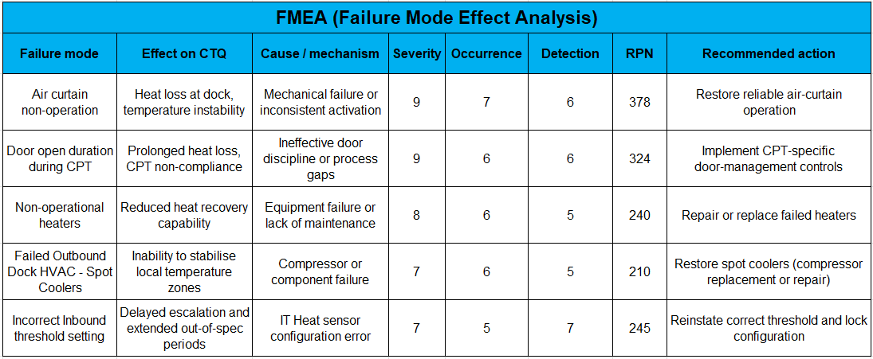
An Improve phase FMEA was conducted to prioritise risks and ensure that improvement actions targeted the most critical failure modes. Heat-loss mechanisms produced the highest RPN values, particularly air-curtain non-operation and extended door-open duration during CPT, due to their high severity, energy loss implications and frequent occurrence. Heat-recovery failures, including non-operational heaters and failed HVAC spot coolers, also scored highly as they reduced the building’s ability to recover from temperature disturbances (Table 8).
Table 8 - Improve-phase FMEA and associated RPN values

An incorrect Inbound alarm threshold was identified as a detection-related failure mode because it prevented timely escalation. Severity reflected the seriousness of the impact, Occurrence represented how often the failure was likely to happen, and Detection indicated how difficult it was to identify the failure before it affected the CTQ. Recommended actions included heater repair, spot-cooler restoration, air-curtain performance correction and reinstating the correct threshold.

5.2 Cost / Benefit Analysis
The cost/benefit analysis demonstrated that heat-loss improvements delivered high impact at low to medium cost, while heat-recovery improvements required moderate investment but provided substantial operational benefit (Table 9). Air-curtain performance correction was the primary medium-cost heat-loss intervention and delivered a significant reduction in infiltration. Door-management protocols required no financial investment yet prevented prolonged door-open periods during CPT. Heater repairs and spot-cooler restoration carried higher costs but were essential for restoring heat-recovery capability. Correcting the Inbound threshold required no cost but significantly improved detection accuracy. Power-metering data confirmed reduced heater runtime and lower energy consumption following the improvements, strengthening the overall cost–benefit justification. Overall, the combined improvements offered a strong return on investment by reducing energy waste, stabilising temperatures, and preventing CTQ failures.

Table 9 – Cost / Benefit Analysis of Improve‑Phase Interventions
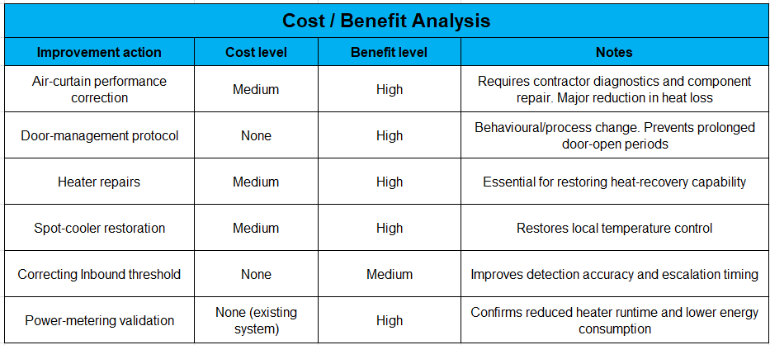

5.3 Should-Be / Future State
The future state aims to enhance temperature-control monitoring by integrating DPMO-style defect tracking into the BMS. This functionality is not currently available, but the concept originates from similar defect-monitoring work within Amazon’s Material Handling Equipment programmes. In the proposed future state, the BMS would calculate and display DPMO values for each monitored zone, providing real-time visibility of defect rates, early indicators of performance decline, identification of potential under capacity HVAC and insight into recovery time following a breach. This would enable earlier intervention, reduce reliance on reactive escalations and support a more predictive, data-driven approach to maintaining stable temperature performance across the site.

5.4 Validate Improvements
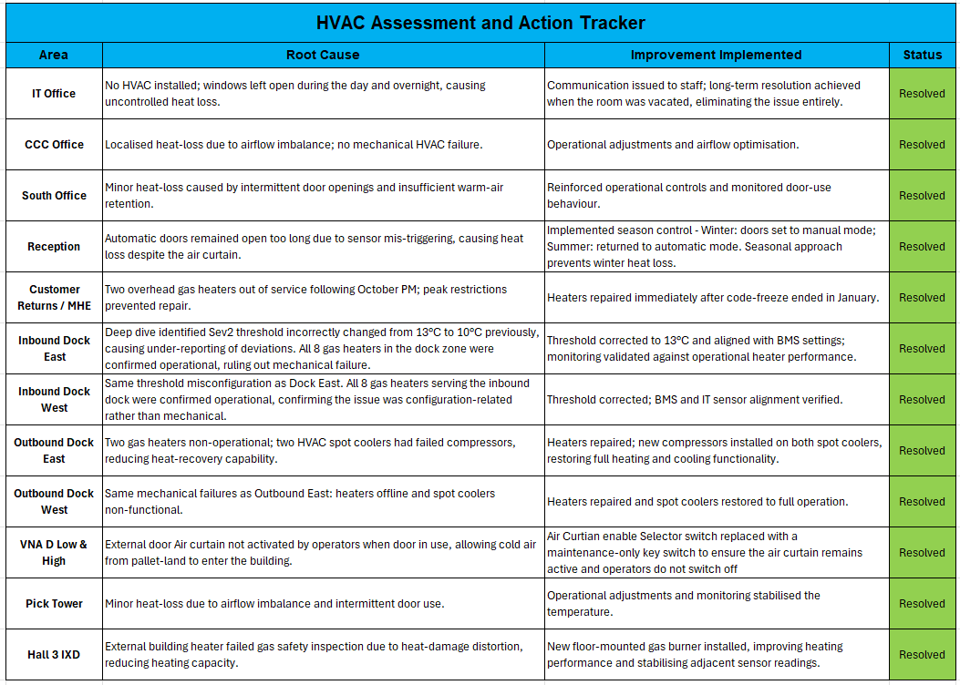
The HVAC tracker summarises all identified temperature-related issues, the root causes, and corrective actions across CWL1, demonstrating full resolution and validating that improvements were comprehensive, targeted, and operationally effective (Table 10).
Table 10 - HVAC Remedials Action Tracker
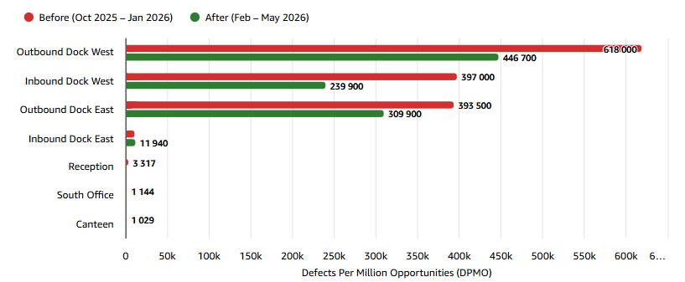
Post-improvement BMS data showed substantial reductions in heat-loss-driven deviations across the dock zones. Outbound Dock West decreased from 618,000 to 446,700 DPMO (27.7%), Inbound Dock West from 397,000 to 239,900 DPMO (39.6%), and Outbound Dock East from 393,500 to 309,900 DPMO (21.2%). South Office, Reception and the Canteen all fell to zero DPMO, confirming full resolution, while Inbound Dock East showed only a minor rise from 10,460 to 11,940 DPMO (Fifteen of twenty sensors recorded zero defects, demonstrating a significant reduction in heat-loss-driven instability. Despite the transition to the new IT monitoring platform, which made escalation data less readily accessible, no Sev2 heat escalations were recorded, down from six previously, further evidence strengthened temperature-control capability.
Figure 12 - BMS Sensor DPMO Validation

6. Control

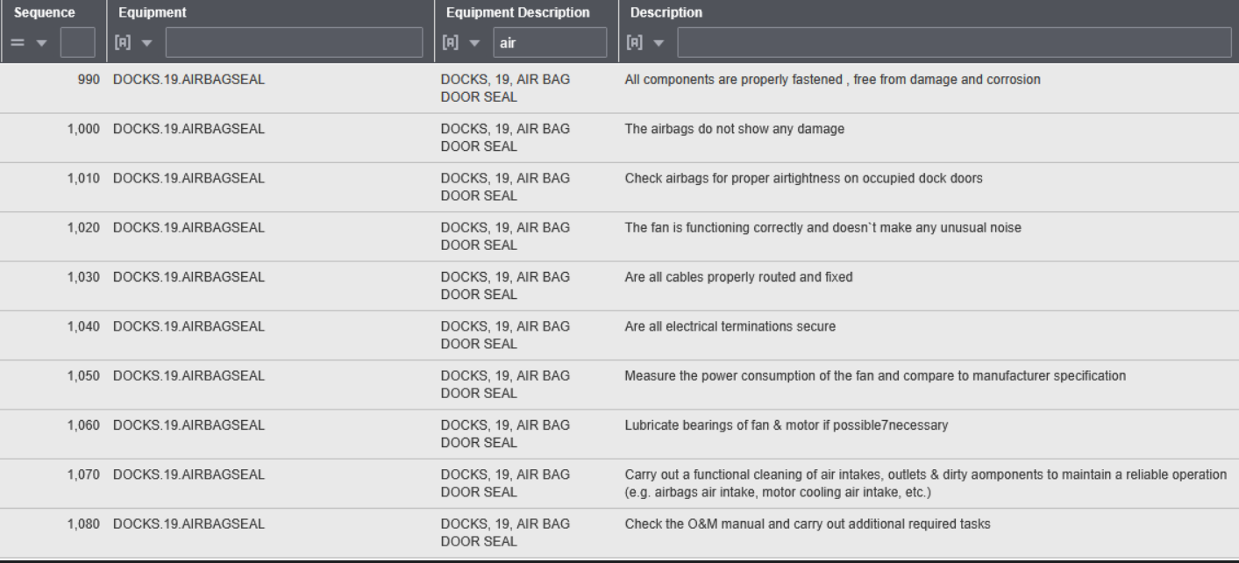
The Control phase ensures that the improvements achieved during the project are sustained and that the process does not revert to previous performance levels. This aligns with Monday (2022), who emphasises that the purpose of the Control phase within DMAIC is to maintain the gains achieved in the Improve phase through structured monitoring, standardisation and early-warning mechanisms. A critical weakness identified during the investigation was that bay-level maintenance checks are only completed every six months (Figure 13).
Figure 13 - Dock Door Air Curtain Maintenance Checks (Source: Amazon CMMS, 2026)
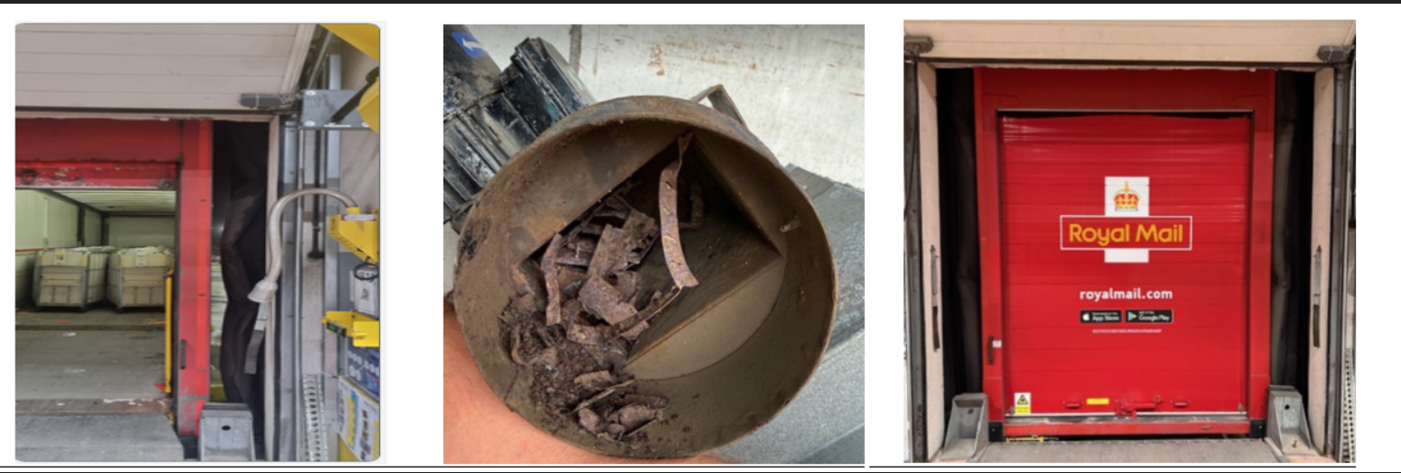
For a high-throughput dock environment operating under continuous mechanical load, this interval is excessively long. The uploaded maintenance checklist for the air-bag door seal shows that inspections focus on fastening, airtightness, fan operation, electrical terminations and cleaning, but these tasks are only triggered during the scheduled maintenance cycle. The condition of one of the bays, shown in Figure 14, demonstrated how deterioration can accumulate and remain undetected for months. Prior to intervention, the bay exhibited visible gaps in the seal, misalignment between the trailer and dock interface, and weakened air-barrier performance, all of which contributed to significant heat-loss instability. Corrective work carried out by RME included replaced an excessively corroded and non-operational Dock fan motor. Following these repairs, the bay returned to stable operation, with improved seal contact and reduced infiltration during loading. This before-and-after contrast illustrates how defects can escalate unnoticed under a six-month maintenance cycle and reinforces the need for operational controls that detect deterioration far earlier than scheduled inspections allow.
Figure 14 - Dock Door Air Curtain and Seal Condition Before and After Corrective Work
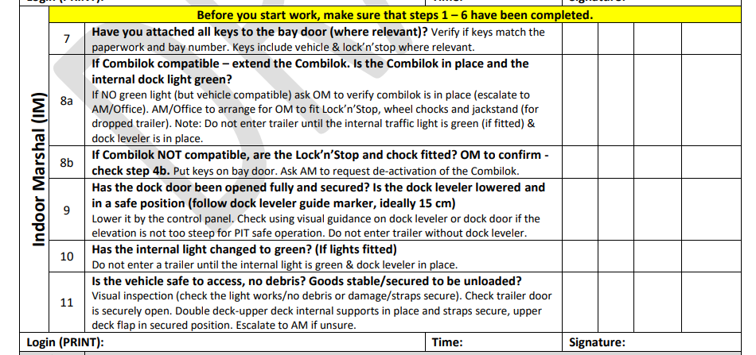
A further gap was identified within the existing Transportation Dock Release (TDR) process. The uploaded TDR checklist contains no reference to air-curtain integrity, meaning operators are not required to verify whether the air curtain is functioning before the dock door is used (Figure 15). As a result, failures can persist unnoticed until a temperature deviation is detected by the BMS and IT Heat sensors, creating a reactive rather than preventive control environment. The TDR process is the formal readiness check completed at every dock door before loading begins, ensuring that the trailer is secured, the dock interface is safe, and the equipment is in a suitable condition for CPT activity. Integrating an explicit air-curtain check into the future-state TDR process ensures that deterioration is identified far earlier than the six-month maintenance window would allow.
Figure 15 - Dock TDR Process (Source: Amazon WHS TDR Process EU, 2026)
Operational controls now focus on daily BMS checks by the Facilities team to ensure HVAC operation and to verify that dock interfaces function as intended during CPT activity, including the new air-curtain verification step. Real-time BMS monitoring routes temperature deviations directly to Facilities, with any breach of CTQ limits triggering rapid escalation. Weekly DPMO trend reviews and power-metering data provide ongoing validation that heat-loss and heat-recovery controls remain balanced. By implementing these controls, the Control phase ensures that the process shifts from reactive detection to proactive stability management, reducing the likelihood of unnoticed deterioration and maintaining thermal performance within specification.

7. Conclusion

This Six Sigma project applied the DMAIC methodology to diagnose and reduce temperature instability within Amazon CWL1, addressing a long-standing operational issue that had generated recurring Sev2 and Sev3 escalation events. Through a structured and data driven approach, the project demonstrated that temperature deviation was not the result of isolated equipment failures, but a combination of positional, temporal and cyclical variation concentrated primarily in the dock areas. The Measure phase established a robust baseline using 699,500 BMS readings and escalation data, confirming that three dock sensors accounted for the majority of defects and that temperature variation was highly localised rather than sitewide.

The Analyse phase identified two dominant root causes. Heat loss was driven by degraded dock door air curtains and prolonged door open periods during CPT, while heat recovery limitations were caused by non-operational heaters and failed spot coolers. The air curtain assessment showed that only 35.7 percent of units were fully functional, significantly weakening the thermal barrier at the building envelope. These findings were reinforced by run chart evidence showing cyclical temperature drops during CPT windows and slow recovery due to reduced heating capacity.

Targeted improvements were implemented in the Improve phase, including heater repairs, spot cooler replacement, restoration of air curtain performance and operational controls to reduce unnecessary door open duration. These actions were prioritised using FMEA to ensure that the highest risk failure modes were addressed first. The Control phase established sustainable mechanisms to maintain gains, including daily BMS checks, real time escalation routing, weekly DPMO reviews and the introduction of an air curtain integrity check within the TDR process.

A key indicator of success was that dock temperatures stabilised to the point where associates began requesting that heating be reduced, demonstrating a complete reversal of the original problem (Figure 16). This closes the loop on both Critical to Quality requirements and the Voice of the Customer, confirming that the improvements delivered meaningful and measurable benefits to site operations.

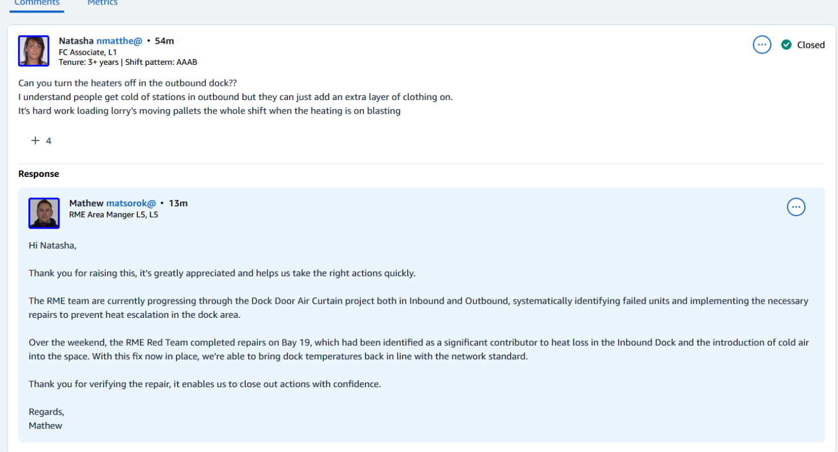
Figure 16 - Voice of the Associate (Customer)
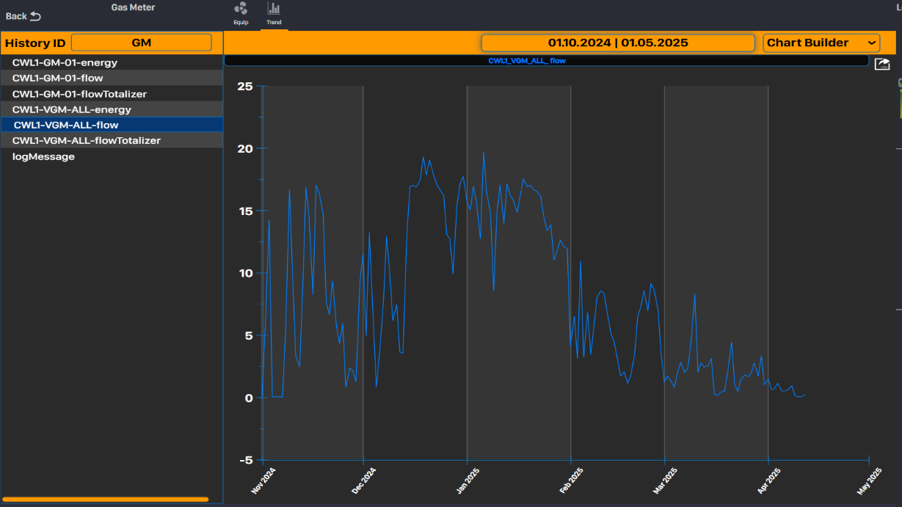
Analysis of gas-flow data from BMS across 2024–2026 showed the expected seasonal heating pattern, with higher demand during winter and lower demand in spring. Importantly, there was no increase in gas consumption following the heater repairs, air-curtain restoration and door-management controls. This indicates that the improvements stabilised heat-loss pathways without creating additional energy demand, demonstrating that temperature recovery capability was restored without negative impact on energy performance (Figures 17-18).
Figure 17 - Gas usage October 2025 - May 2026
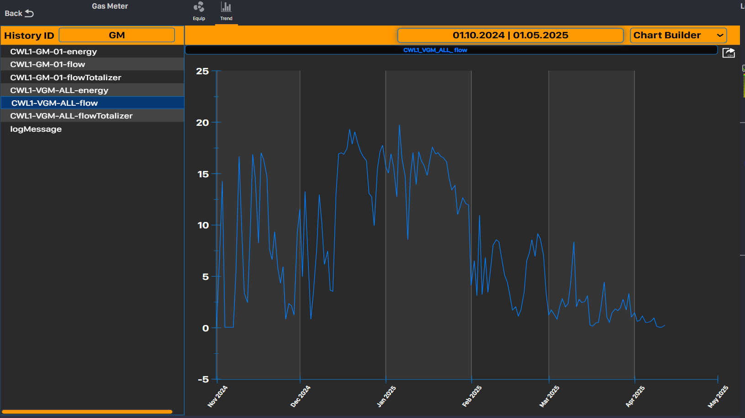
Figure 18 - Gas Usage October 2025 - May 2026
The analysis was limited by the transition to the new IT monitoring platform in February 2026, which reduced IT Heat Sensor Sev3 escalation visibility, though BMS data remained sufficient to validate improvement impact. Overall, the project strengthened temperature control capability, reduced exposure to thermal deviation and enhanced operational resilience through sustainable, evidence-based improvements.

References

Adeodu, A., Maladzhi, R., Katumba, M.G.K.-K. and Daniyan, I. (2023). Development of an Improvement Framework for Warehouse Processes Using Lean Six Sigma (DMAIC) approach. a Case of Third Party Logistics (3PL) Services. Heliyon, [online] 9(4), p.e14915. doi:https://doi.org/10.1016/j.heliyon.2023.e14915. [Accessed 10 Apr. 2026].

Alhuraish, I., Robledo, C. and Kobi, A. (2017). A Comparative Exploration of Lean Manufacturing and Six Sigma in Terms of Their Critical Success Factors. Journal of Cleaner Production, [online] 164, pp.325–337. doi:https://doi.org/10.1016/j.jclepro.2017.06.146. [Accessed 4 Mar. 2026].

Amazon (2019). Why Amazon Warehouses Are Called Fulfilment Centres. [online] Amazon UK. Available at: https://www.aboutamazon.co.uk/news/operations/why-amazon-warehouses-are-called-fulfilment-centres [Accessed 1 Mar. 2026].

Amazon Environmental Standards (2025) Internal Policy. WHS Hot and Cold Stress Policy EU. Unpublished internal operational policy, Amazon EU Temperature Severity Thresholds

Amazon (2026) Internal Policy. WHS Vehicle Loading Dock Safety Procedure EU, 2026. Unpublished internal operational policy, Amazon EU

Antony, J., Gijo, E.V. and Vinodh, S. (2017). Lean Six Sigma for Small and Medium Sized Enterprises : a Practical Guide. [online] Boca Raton: Crc Press. Available at: https://scholar.google.com/scholar?hl=en&as_sdt=0%2C5&q=978-1-4822-6008-3&btnG= [Accessed 2 Mar. 2026].

Antony, J., Snee, R. and Hoerl, R. (2017). Lean Six Sigma: yesterday, Today and Tomorrow. International Journal of Quality & Reliability Management, [online] 34(7), pp.1073–1093. doi:https://doi.org/10.1108/ijqrm-03-2016-0035. [Accessed 14 Mar. 2026].

Chakravorty, S.S. (2009). Six Sigma programs: an Implementation Model. International Journal of Production Economics, [online] 119(1), pp.1–16. doi:https://doi.org/10.1016/j.ijpe.2009.01.003.
Chiarini, A. and Kumar, M. (2020). Lean Six Sigma and Industry 4.0 Integration for Operational Excellence: Evidence from Italian Manufacturing Companies. Production Planning & Control, [online] 32(13), pp.1–18. doi:https://doi.org/10.1080/09537287.2020.1784485. [Accessed 20 Apr. 2026].

Goubran, S., Qi, D. and Wang, L.L. (2017). Assessing Dynamic Efficiency of Air Curtain in Reducing Whole Building Annual Energy Usage. Building Simulation, [online] 10(4), pp.497–507. doi:https://doi.org/10.1007/s12273-017-0349-0. [Accessed 11 Apr. 2026].

Habidin, N.F., Mohd Yusof, S. and Mohd Fuzi, N. (2016). Lean Six Sigma, Strategic Control systems, and Organizational Performance for Automotive Suppliers. International Journal of Lean Six Sigma, [online] 7(2), pp.110–135. doi:https://doi.org/10.1108/ijlss-04-2015-0013. [Accessed 2 Mar. 2026].

Health and Safety Executive (2025). Temperature in the Workplace. [online] www.hse.gov.uk. Available at: https://www.hse.gov.uk/temperature/employer/index.htm [Accessed 1 Mar. 2026].

Mittal, A., Gupta, P., Kumar, V., Owad, A.A., Mahlawat, S. and Singh, S. (2023). The Performance Improvement Analysis Using Six Sigma DMAIC methodology: a Case Study on Indian Manufacturing Company. Heliyon, [online] 9(3). doi:https://doi.org/10.1016/j.heliyon.2023.e14625. [Accessed 15 Mar. 2026].

Monday, L. (2022). Define, measure, analyse, improve, Control (DMAIC) Methodology as a Roadmap in Quality Improvement. Global Journal on Quality and Safety in Healthcare, [online] 5(2), pp.44–46. doi:https://doi.org/10.36401/jqsh-22-x2. [Accessed 28 Mar. 2026].

Nguyen , H.K., Van, N.T.A., Khuu, D. and Nguyen, T.M.H. (2025). Applying Lean Six Sigma Methodology to Improve Productivity: Case Study at a Mooncake Production Enterprise. Management and Production Engineering Review. [online] doi:https://doi.org/10.24425/mper.2025.154933. [Accessed 10 Apr. 2026].

Patel, M. and Desai, D.A. (2018). Critical Review and Analysis of Measuring the Success of Six Sigma Implementation in Manufacturing Sector. International Journal of Quality & Reliability Management, 35(8), pp.1519–1545. doi:https://doi.org/10.1108/ijqrm-04-2017-0081. [Accessed 15 Mar. 2026].

Raju, R., Sunder M., V. and Antony, J. (2019). Assessment of Lean Six Sigma Readiness (LESIRE) for Manufacturing Industries Using Fuzzy Logic. International Journal of Quality & Reliability Management, [online] 36(2), pp.137–161. doi:https://doi.org/10.1108/ijqrm-09-2017-0181. [Accessed 3 Mar. 2026].

Rejikumar, G., Aswathy Asokan, A. and Sreedharan, V.R. (2018). Impact of data-driven decision-making in Lean Six Sigma: an Empirical Analysis. Total Quality Management & Business Excellence, [online] 31(3-4), pp.1–18. doi:https://doi.org/10.1080/14783363.2018.1426452. [Accessed 11 Mar. 2026].

Seppanen, O., Fisk, W.J. and Faulkner, D. (2003). Cost Benefit Analysis of the night-time Ventilative Cooling in Office Building. [online] Escholarship.org. Available at: https://escholarship.org/uc/item/3j82f642 [Accessed 2 Mar. 2026].

Sreedharan V., R., G., S. and Raju, R. (2018). Development of a Green Lean Six Sigma Model for Public Sectors. International Journal of Lean Six Sigma, [online] 9(2), pp.238–255. doi:https://doi.org/10.1108/ijlss-02-2017-0020. [Accessed 19 Mar. 2026].

Trubetskaya, A., McDermott, O. and Ryan, A. (2023). Application of Design for Lean Six Sigma to Strategic Space Management. The TQM Journal, [online] 35(9), pp.42–58. doi:https://doi.org/10.1108/tqm-11-2022-0328. [Accessed 2 Mar. 2026].

9. Appendices

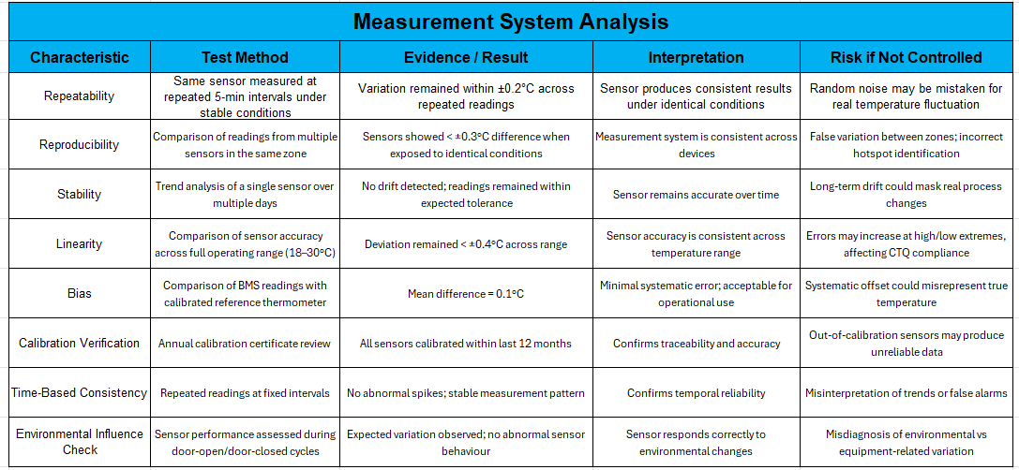
9.1 Appendix A1 – Measurement System Analysis

9.2 Appendix A2 – Asana Dock Heat Escalation Project



