COACHING AND MENTORING SESSION

STUDENT NAME: Aniko Farago
STUDENT ID:2133195
WORDS: 2587
DATE:24.04.25

Table of Contents
Introduction 3
Coaching and Mentoring: Definitions and Advantages 3
The Top 10 Effective Coaching Skills 5
Situations Where Coaching is Needed in the Workplace 6
Explanation of the GROW Model 7
Reflection on Coaching & Mentoring Session 9
Conclusion 10
References 11

List of Figures
Figure 1: Top 10 Effective Coaching Skills 6
Figure 2: GROW model 9
Figure 3: Gibbs reflective cycle model 11

Introduction
Coaching and mentoring have become more than just an important developmental tool, they are essential in the dynamic workplace where people can tap into their potential decipher all sorts of challenges to even improve on their performance. Mentoring is long term guidance that evolves you both professionally and personally. Whereas coaching is short term, goal oriented to achieve and provide a set of assistance. This report will explore about the importance of these practises, they were used where in the professional world and also their effectiveness in actual scenarios the workplace.
This report aims to investigate the central concepts, the merits and the types of coaching and mentoring in view of the GROW model and ten top coaching skills. Additionally, it includes a reflective analysis, which is based on classroom coaching sessions.
This report calls on the real-life practises of Google as a company widely recognised for having coaching and mentoring as one of its cultures. To promote leadership development, well-being, and continuous learning, Google creates and provides internal coaching programmes. For instance, its Career Guru mentoring programme links workers with mentors from other departments.
Modern organisations like Google depend on coaching and mentoring to retain talent, increase positivity and enhance learning and encourage innovation in a constantly evolving environment.

Coaching and Mentoring: Definitions and Advantages
Coaching is a specific process including a structured short term and focused on performance development, in which an individual can improve specific skills, attain goals as well as overcome challenges. It tends to be goal oriented and uses measurable outcomes to help in support of professional performance, leadership development, or skill enhancement. Generally, coaching is non-directive that means the coach works using active listening and powerful questioning instead of giving direct answers (Armour, 2021).
Coaching is defined as a key feature that includes a clear focus on performance improvement, use of models like GROW (Goal, Reality, Options, Will), regular feedback, and progress evaluation. Coaching in the workplace is quite relevant for leadership development, addressing performance gaps, supporting professional development and preparing employees for new roles.
Benefits of coaching are better results, more self-awareness, better problem-solving ability as well as greater motivation. It also fosters independence in employees who rightfully claim to own their development.
An example is that a team leader faces a new project and a deadline at the same time. They work with a coach who helps clarify goals, assess the present state of affairs, ponder strategies and create a plan (Bachkirova, Jackson, and Clutterbuck, 2021). As the team leader gets time to deliver results more efficiently, he or she is able to become more and more confident, manage time more effectively and deliver results more efficiently.
Mentoring however is a long-term, relationship based developmental approach where an individual (mentor) of higher status to another one (mentee) is involved. Mentoring actually is much more informal than coaching and it largely aims at development of the whole person – morale, confidence, career progression.
Mutual trust, open communication, emotional support are key features. Mentoring in the workplace is very effective in the onboarding of new employees, nurturing future leaders or supporting underrepresented groups. Mentoring has the advantage of ensuring enhanced employee retention, improved job satisfaction, and development of leadership pipelines. It promotes belonging and succession planning.
For example, a new graduate is hired in a large financial firm and is placed under the supposed 'mentor' of the company some years senior (Fishman, 2021). Regular meetings with the mentor over provide advice regarding culture within corporate, career planning, as well as personal development. In time the mentee will gain more confidence and be prepared for internal promotion opportunities.

The Top 10 Effective Coaching Skills
Listening: Active listening is also a foundation coaching skill, which is the ability for the coach to listen to the coachee without interruption to fully understand the coachee’s perspective. It stands in the name of trust and respect (Garvey and Stokes, 2021). If I was in a class coaching session, an example might be listening to a peer talk through their anxiety of public speaking and the deeper fear of judgement of the audience.
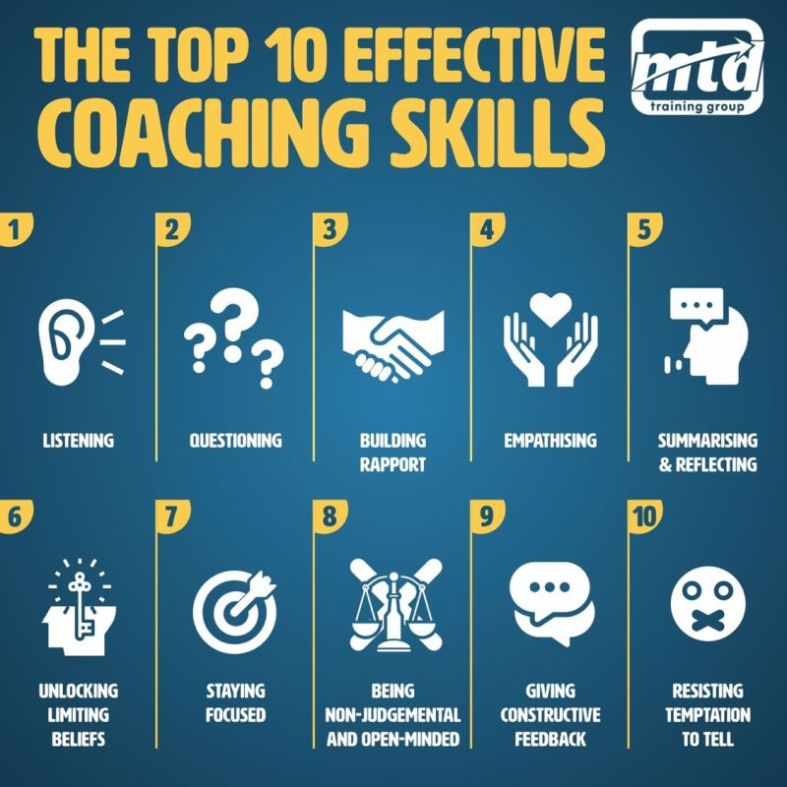

Figure 1: Top 10 Effective Coaching Skills
(Source: Hussey and Campbell-Meier, 2021)
Questioning: This aide uses other means that help the coachee look inside themselves: It utilises multimedia support. Open ended questions such as “What do you think is stopping you?” lead deeper thought. One such example involved a colleague unsure about switching roles and who responded positively to being asked, “What are the pros and cons of staying versus moving?”
Building Rapport: Open communication only occurs if we first strive to create a relationship of trust and respect. Building rapport with coaches means maintaining eye contact, exhibiting empathy, being approachable and so on. I started with informal conversation in a mentoring role and picked from there to get the mentee more personal.
Empathising: This enables the coach to relate emotionally to experiences and emotions of the coachee. For instance, when a fellow colleague mentioned the struggle, she was facing balancing her work life with her childcare life, I gave my share of solidarity and talked about how others rose to the occasion and surpassed it.
Summarising & Reflecting: Summarising what the coachee says means that the coachee has the same understanding, and the coachee begins to hear the coachee’s own thoughts more clearly. I repeated back what the coachee shared to validate their experience and fill in the mental blanks of their goals during a class session.
Unlocking Limiting Beliefs: There are many limiting beliefs that many coachees hold, such as 'I'm not good enough to lead a team'. These thoughts are identified and challenged by coaches. In one situation, I collaborated with a fellow who felt they were not confident enough to present and, with a little reframing and encouragement, they began to understand their power.
Staying Focused: Coaches need to stay focused during sessions and keep it goal oriented. Drifting into unrelated topics is easily done (Hussey and Campbell-Meier, 2021). In another class example, I had a peer start talking about gossip about work that wasn’t relevant to the session objective, I introduced distractions by discretely and gently redirecting the conversation back to the objective.
Being Non-Judgemental & Open-Minded: Non-Judgement & Open Minded. At some point, a colleague shared with me personal issues which were affecting their performance and I stayed neutral with them, listened in a supportive way so that they felt heard, and were not criticised.
Giving Constructive Feedback: Feedback Should be Specific and Useful, Provide Positive Feedback, and Focus on Improvement. For instance, I conveyed a friend that he communicated well but the next time he could summarise the points better within time.
Resisting the Temptation to Tell: Good coaches keep the coachee in charge of finding solutions instead of offering solutions. A peer asks, “What do I do?” In order to empower them, I answered with, 'What options are available?'

Situations Where Coaching is Needed in the Workplace
In particular, coaching is very efficient whenever employees encounter difficulties caused by personal problems related to professional or personal issues. Using real life workplace scenarios, the use of coaches for supporting needs is and models like GROW and core coaching skills are shown to be valuable.
An example is a demotivated employee who has worked for over three years not having been financed. The GROW model can be used for this kind of a situation. Since the initial course was ELI2, the employee would be able to define their Goal (promotion or raise), determine their Reality (lack of recognition for good performance), and propose Options (talking with management, looking at internal opportunities), and be committed to Will (schedule a meeting with HR) (Kuan and Abu Bakar, 2023). Listening and summarising are two key coaching skills that are helpful to the employee to make him feel valued and supported.
Being a stressed employee living the life of balance may cause the person feeling overwhelmed. This person may need coaching to help them put responsibilities in perspective, establish boundaries, and work some hours more flexibly. Employers can use empathy and non-judgemental listening to allow the employee to vent emotions safely and work through the ways through which they can cope up.
For those individuals who are anxious about technology, it is coaching that will bring out limiting beliefs, such as ‘I cannot keep up’. Here, the coach can reframe this mindset and promote learning successes in the past, along with developing a learning plan to upskill.
This is because, when team conflict occurs due to personal relationships like a broken relationship that has lowered team morale, coaches can guide what the involved team member cannot see -- emotion and performance separate. This is how the coach can use the questioning to help regain focus and maybe propose the work adjustment such as remote work if it’s appropriate.
Finally, for someone who is disappointed in losing out on a promotion, coaching helps them to analyse the situation objectively and develop a plan to develop more readiness for future opportunities.
In any case, coaching in all respects ontological, invites awareness of self, clarity as to what problem needs to be solved and proactive solving of those problems in a non-directive, scaffolding based environment.

Explanation of the GROW Model
The GROW model is a conventional coaching framework that helps individuals structure conversations, clarify issues and make decisions. The GROW stands for Goal, Reality, Options and Will and it is developed by Sir John Whitmore, which guide the coachee from the identification of a problem to commitment to an action.
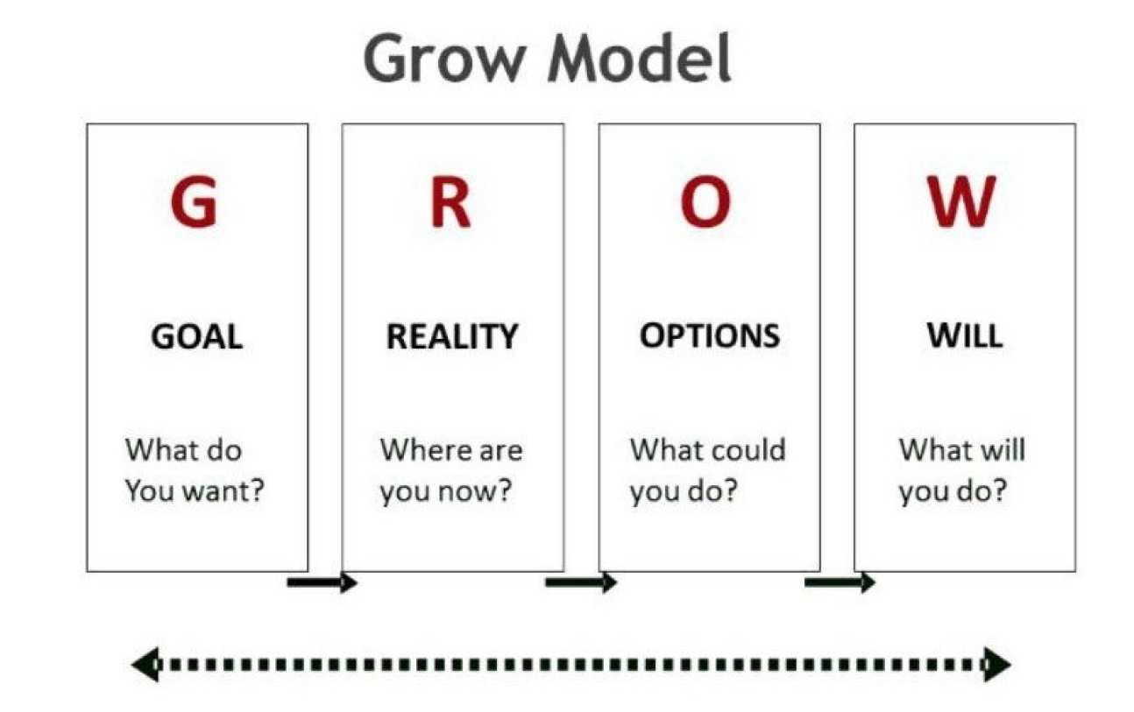

Figure 2: GROW model
(Source: Garvey and Stokes, 2021)
G – Goal
This is the first stage in which the coachee imagines the result they want to achieve. Specific, measurable, and achievable goals are what it should be. Once, I coached another peer in time management in one class session (Mwawasi, 2022). The goal was defined as: ‘Complete assignments one week before deadline for the following two months.’ This gave our session direction and the objective is clear and time bound.
R – Reality
The coach in this stage explores the current situation, challenges the coachee with and sort out the problems that they are facing. The coach asks the coachee with open ended questions such as “what’s currently getting in your way?” to explore barriers and resources. In the same session my peer came forward that they had issues with procrastinating since the distractions at home lead to this and prioritising tasks was a hard task. Talking about this reality showed us what made their performance happen, so to say.
O – Options
Then, the coach encourages the coachee to come up with potential strategies that can be applied to eliminate the challenges they have just identified. This is a creative and collaborative stage. There were quite a few other things that we explored: the Pomodoro technique, going to the library, making a weekly planner, setting reminders. I recommended that my peer explore the benefits and drawbacks of each approach and select they preferred the ones that seemed more practical and inspiring.
W – Will
All the steps would lead up to the final stage in which you would make a commitment to take action. The coachee chooses what they will, by when, and possibly what support they might require. The third day is when my peer decided to try out studying in the university library three days a week, provided she used a planner to schedule daily tasks. They agreed to launch the plan and to go over the results after one week.
The session was structured and productive by using the GROW model. It allowed my peer to own their development and me, the coach, to have a structured means with which to lead the conversation successfully.

Reflection on Coaching & Mentoring Session
Description: The coaching role play activity we participated at in a recent class session. I assumed the role of the coach and my peer became the coachee. In the scenario, my peer was overwhelmed because he had high workload and bad time management. It was for the purpose of enabling them to use the GROW model to explore the situation and strategise how to handle time better. There was maybe about 15 minutes for the coaching session.
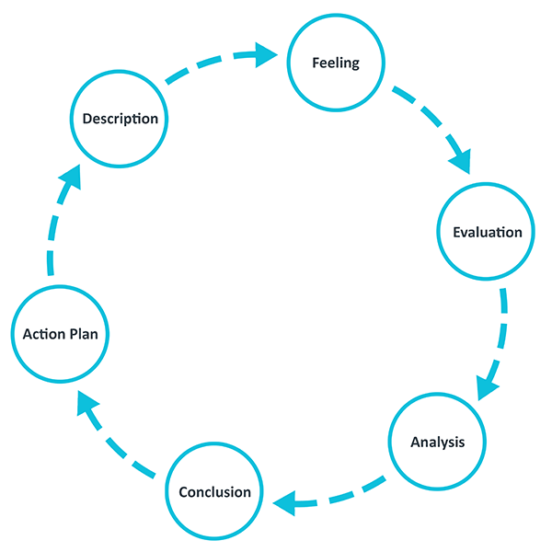

Figure 3: Gibbs reflective cycle model
(Source: Gibbs, 1988)
Feelings: Confident but slightly anxious at first, feeling whether I could make the coaching techniques work. As time went on, I got relaxed enough to be presence. I wanted to give advice that would allow my peer to help themselves, rather than pushing my opinion onto someone else.
Evaluation: One of the things that went well was that I used it to use active listening. I kept eye contact with them, nodded and summarised their concerns, which was building rapport and helping the coaching feel heard. I also asked open ended questions like ‘What has been stopping you from planning your week in advance?’ to encourage reflection (Osman, Khazaei, and Kanesan, 2025).
Analysis: This session helped me understand the practical application of several coaching skills, particularly listening, questioning, and empathising. Using the GROW model, I guided my peer to define a clear goal (to manage workload better), assess their current reality (lack of structure and procrastination), explore options (use of a planner, reducing distractions), and commit to a specific action (creating a weekly schedule). The model provided a clear framework, which helped keep the session structured and purposeful. I also realised the importance of being non-judgemental and resisting the temptation to tell—skills that are critical in helping the coachee feel empowered.
Conclusion: Based on this experience, I can say that coaching is more of coaching themselves rather than providing the right guidance. To coach is a matter of patience and focus, with the trust that the coachee knows to find their own answers. I also appreciated the value of structuring conversations with models similar to GROW and applying the art and skill of coaching to develop a productive one.
Action Plan: In the future, I will take further measures to give time to each part of the GROW model. In addition to that, I also hope to further improve on my knack of staying in a coachee mindset by asking rather than telling as well as more reflective prompts. My proficiency will be refined with practise with my peers and I will gain confidence in real life coaching scenarios.

Conclusion
Workplace personal and professional development has a role for coaching and mentoring. While coaching is a short-term strategic enhancement, mentoring is a long-term career development through personal connexions. Both approaches contribute in improving employee performance, motivation and engagement.
Primarily, such development and application of the coaching skills in creating meaningful conversations that stir positive change are key. Furthermore, organised planning approaches such as the GROW model offer a step-by-step process for people to determine goals, appraise present obstacles, examine choices, and decide to act. This model is meant to keep coaching attention focused on purposeful and results oriented activities.
With all of my classroom coaching and mentoring sessions, I have further learnt these skills and learned how to use them in real life rather than just learning them for the sake of this module alone. As someone who has learnt to have confidence in helping to facilitate reflective dialogue, professional development has included an understanding of the importance of empowering others rather than providing the answers. The lessons I learned: Communication, empathy and problem solving. These skills I will continue to hone in other leadership roles.

References
Al Achkar, M., Rogers, T.S., Weidner, A., Seehusen, D.A. and South-Paul, J.E., 2023. How to sponsor, coach, and mentor: a qualitative study with family medicine department chairs. Family medicine, 55(3), p.143.
Armour, A., 2021. Discovering the'modern maestro': The importance of a professional industry pedigree and aspects of coaching and mentoring within the supervision of music undergraduates. International Journal of Evidence Based Coaching & Mentoring, 15.
Bachkirova, T., Jackson, P. and Clutterbuck, D., 2021. Coaching and Mentoring Supervision: Theory and Practice, 2e. McGraw-Hill Education (UK).
Fishman, J.A., 2021. Mentorship in academic medicine: competitive advantage while reducing burnout?. Health Sciences Review, 1, p.100004.
Garvey, R. and Stokes, P., 2021. Coaching and mentoring: Theory and practice.
Gibbs G (1988). Learning by Doing: A guide to teaching and learning methods. Further Education Unit. Oxford Polytechnic: Oxford.
Hussey, L. and Campbell-Meier, J., 2021. Are you mentoring or coaching? Definitions matter. Journal of Librarianship and Information Science, 53(3), pp.510-521.
Karinov, A., Smagulov, Z., Takirov, S. and Zhumagulov, A., 2023, November. Implementation of coaching and mentoring methods in teaching Kazakh literature to the secondary school students. In Frontiers in Education (Vol. 8, p. 1279524). Frontiers Media SA.
Kuan, C.M. and Abu Bakar, H., 2023. Managerial coaching to improve on organizational performance: A case study of a multinational company. Global Business Management Review (GBMR), 15(2), pp.1-19.
Mwawasi, S.M., 2022. Leveraging knowledge sharing to achieve sustainable competitive advantage in organizations. Journal of Strategic Management, 6(1), pp.71-77.
Osman, D.W.D.A., Khazaei, H. and Kanesan, T., 2025. The effect of business coaching on the performance of small medium enterprises in Malaysia: moderating role of competitive advantage. Cogent Business & Management, 12(1), p.2469769.

