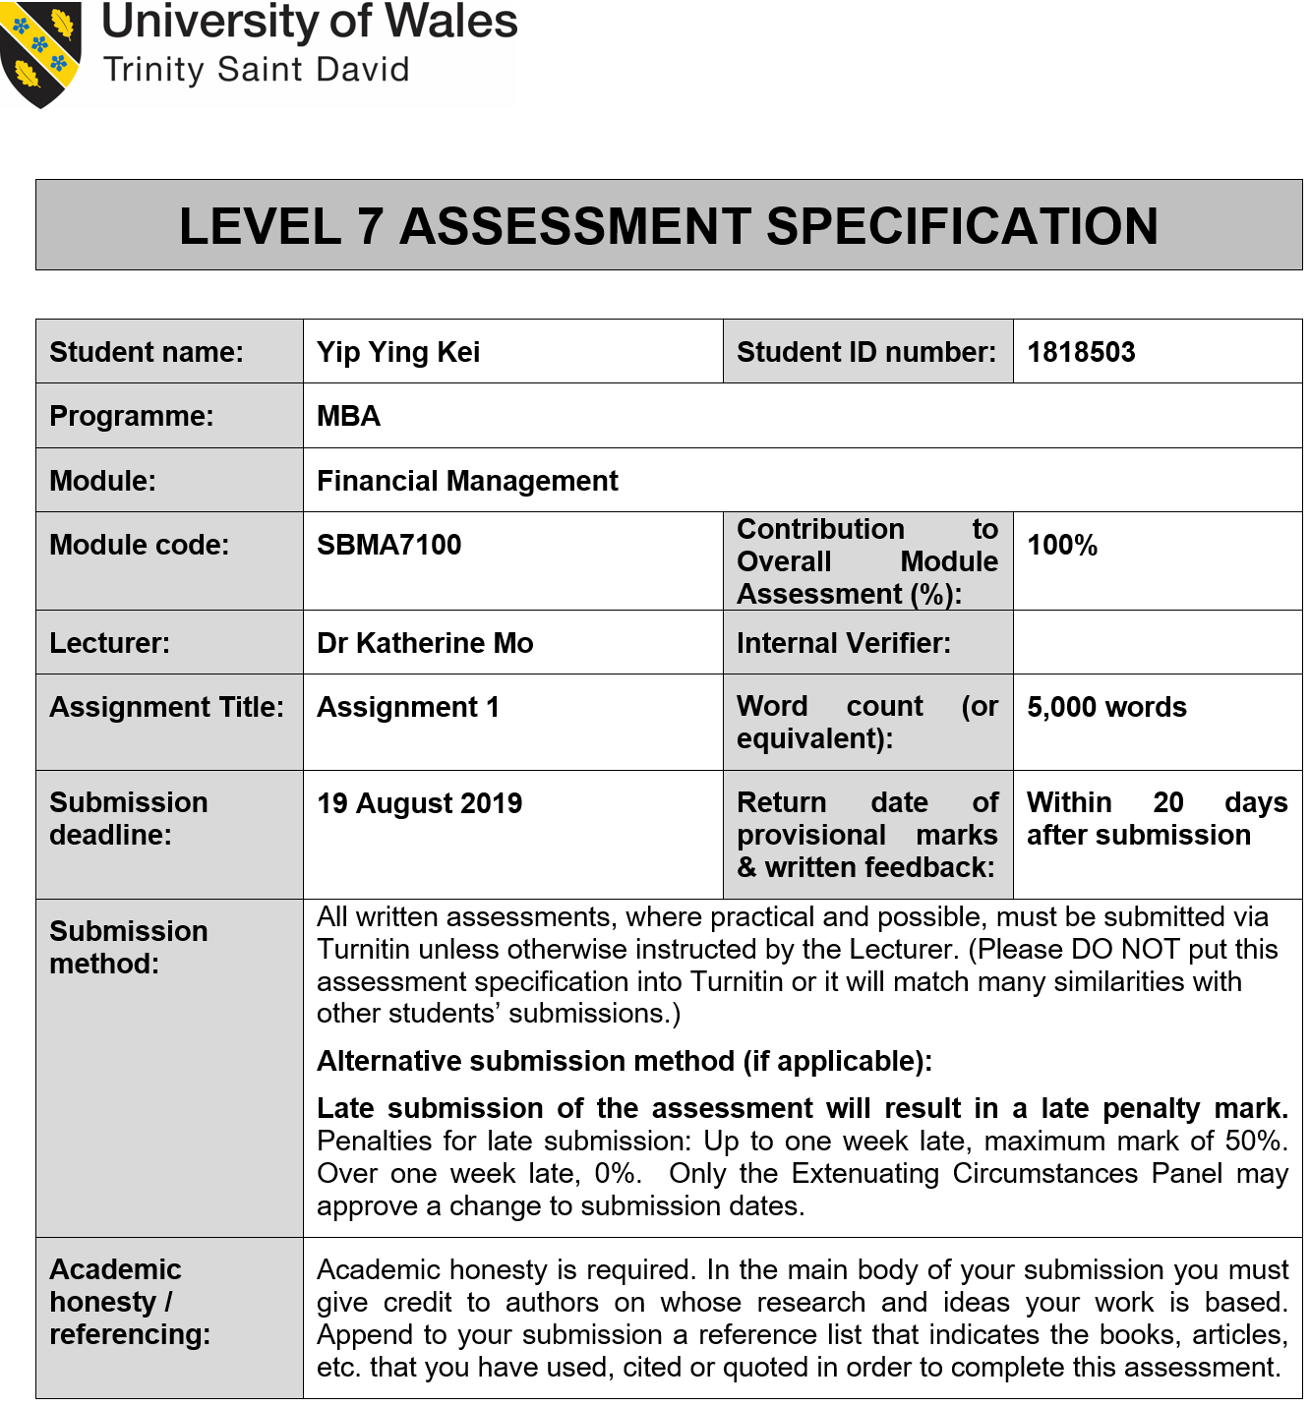

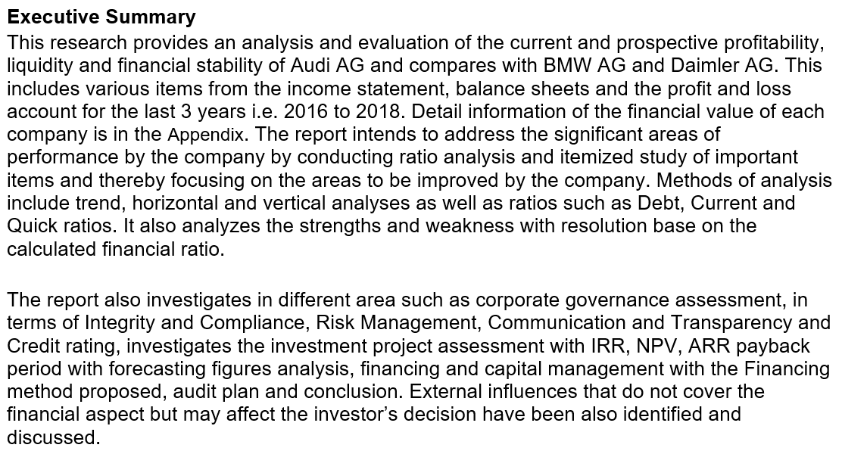
Table of Content
Executive Summary ii
Table of Content iii
Table of Figures iv
1. Introduction 1
1.1 Operating Business Overview 1
1.2 Today's Business Environment 1
1.3 Company Structure 2
1.4 Research comparison company information 2
1.4.1 BMW AG 2
1.4.2 Daimler AG 2
2. Audi’s financial analysis 3
2.1 Altman Z-Score analysis 3
2.2 Financial structure 4
2.3 Paying debt ability 5
2.4 Sales Performance 7
2.5 Operating expenses 9
2.6 Profitability 10
2.7 Growth ability 11
2.8 Stock Market Prospects Analysis 13
2.9 Conclusion 13
3. Corporate Governance assessment 13
3.1 Integrity and compliance 14
3.2 Risk Management 15
3.3 Communication and Transparency 16
3.4 Credit rating 16
4. Investment project assessment 16
4.1 Project Items information 17
4.2 Computing Tax Costs 17
4.3 Cash Inflows & Outflows, NPV, ARR, IRR, ROI 18
4.4 Cash flow and payback period 19
4.5 Conclusion 19
5. Financing and Capital management 19
5.1 Financing Methods for analyzing 20
5.2 Financing method proposed 20
6. Audit Plan and Recommendation 21
6.1 Audit plan 21
6.2 Recommendation 21
7. Conclusion 22
8. References 23
9. Appendix 26

Table of Figures
Figure 2.1 Sales Revenue by Audi AG, BMW AG and Daimler AG group by Year………………………7
Figure 2.2 Total Sales Revenue by Audi AG, BMW AG and Daimler AG (2016-2018) …………………8
Figure 2.3 Net Profit Growth Rate by Audi AG, BMW AG and Daimler AG (2017-2018) ……………….8
Figure 3.1 Audi AG integrity and compliance………………………………………………………………..14
Figure 3.2 Audi AG “Three Lines of Defense” model……………………………………………………....15

1. Introduction
Audi AG develops, manufactures, sells and distributes luxury cars and is an automotive company in German. Audi is a subsidiary company of the Volkswagen Group based in Ingolstadt, Bavaria, Germany. Its branded vehicles are produced worldwide in nine manufacturing centres.

Audi AG is involved in developing, manufacturing and selling vehicles. It works across the sections of Automotive and Motorcycles. The Automotive section includes the creation, manufacture, installation and delivery of Lamborghini and Audi brands ' cars and delivery of other Volkswagen Group brands ' cars such as the associated spare or equipment components company. The company was founded on 16 July 1909 by August Horch and is based in Ingolstadt, Germany (Audi, 2019).

1.1 Operating Business Overview
There is a radical upheaval in the automotive industry. As Audi move into a new age of innovation, the Audi team is also in the phase of redefining itself for the future and serving an important part in influencing the transition.

The Audi group pursues definite objectives - it seeks not only to ensure its own long-term competitiveness but also to satisfy the requirements of its stakeholders by undertaking its company in a value-oriented way and remaining ready for the future. The group-wide threat leadership and regulatory leadership schemes act as leading values for our company activities in relation to legislation, inner regulations and ethical norms. The staff always participate fully in the growth of the company (Audi, 2019).

1.2 Today's Business Environment
In the first three months of 2019, the worldwide environment rose robustly - although speed fell. Average growth in gross domestic product (GDP) development was smaller in both developed and emerging economies than in the prior-year era. Increasing international trade conflicts have resulted in a significant increase in business uncertainty (Audi, 2019a).

GDP began to increase slightly in Western Europe between January and March 2019, but year-on-year development momentum decreased (International Monetary Fund, 2019). Increased global pressure and weakness of global supply included factors influencing this growth. In the publication era, the region of Central and Eastern Europe as a whole recorded strong economic growth. Compared to the previous half, growth in the U.S. industry was robust as a consequence of strong customer request growth. Although from a small foundation, Brazilian GDP also improved further. The People's Republic of China once again recorded very elevated GDP development on a global basis, partially owing to actions made by the Chinese government and the central bank to promote the economy.

Global supply for cars decreased from January to March 2019 by -5.6% to 19.9% (21.1million vehicles). While Western Europe, North America, Asia-Pacific and the South America region saw a decrease the fresh registrations, vehicle revenues have risen significantly in Eastern and Central Europe (Audi, 2019a).

1.3 Company Structure
Audi AG Corporate management relies on their leadership and skills to advance the goals from their clients, their shareholders over 90,000 staff worldwide (Audi, 2018). Audi's executives create the foundation as accountable leadership of the company.

The Management Board handles AUDI AG's business and the Articles of Incorporation and Bylaws of AUDI AG and the Supervisory Board's Rules of Procedure by rule. Corporate governance also provides owing regard to shareholder objectives within the Volkswagen Group and shared interests.

Supervisory Board is made up of ten employee representatives and ten shareholder representatives as authorized by law. The annual general meeting elects the shareholder officials. Employee officials are chosen by German operations staff of the Audi AG. For five years, representatives of the supervisory board are usually appointed.

1.4 Research comparison company information
This study is used for contrast by Daimler AG and BMW AG as they have the same company character with Audi AG and market share is very comparable.

1.4.1 BMW AG
Bayerische Motoren Werke Aktiengesellschaft (BMW) produces and markets global luxury automobiles and motorcycles. From convertible sport vehicles to luxury sedans to travelling motorcycles with big displacement motors, the company generates everything. BMW provides clients with services worldwide (BMW Group, 2018).

1.4.2 Daimler AG
Daimler AG is developing, manufacturing, distributing and selling a broad variety of automotive products such as passenger vehicles, trucks, vans and trains. The Company also offers its automotive companies with economic and other facilities (Daimler, 2018).

The high-level comparison between Audi AG, Daimler AG and BMW AG is shown below.
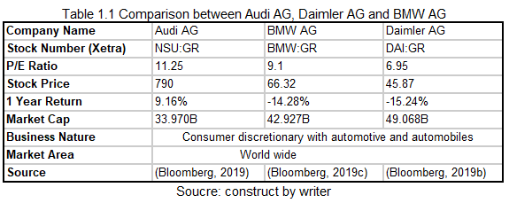
Audi AG has the largest P/E ratio and one year return according to the chart. Generally speaking, an elevated P/E percentage implies shareholders anticipate that in the close future the business will have greater development.

2. Audi’s financial analysis
The part is the financial analysis to assess the efficiency and suitability of companies, initiatives, expenditures and other economic institutions. The ratios and analysis are made use of information taken from cash flow statement, balance sheet and income statement which publish by Audi, BMW and Daimler. Below table is showing which financial statements had used in this analysis.
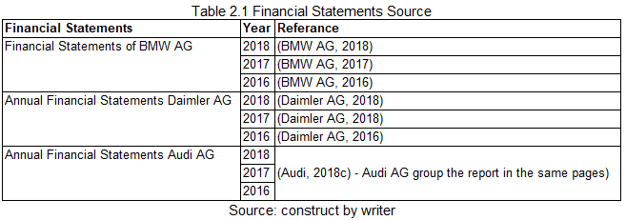

The objectives are based on assessing the company's economic aspects to assess company efficiency in terms of profitability, solvency, liquidity and stability.

2.1 Altman Z-Score analysis
This rating is the result of the credit-strength study for help to gage a publicly listed manufacturing company's probability of bankruptcy. It's focused on 5 main economic proportions discovered and calculated from the quarterly study of a company. Z-scores show to statistics and analysts whether a rating is typical of a collection of information or is typical of a collection of information. (Altman, 1968)

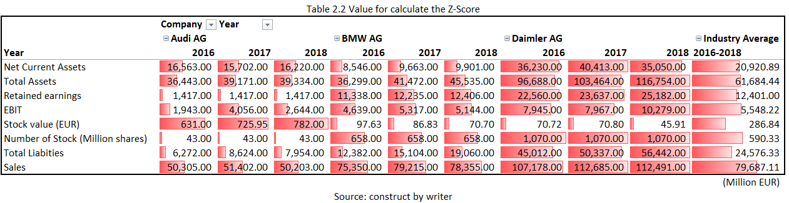

The formula for calculating the Z-score is below:
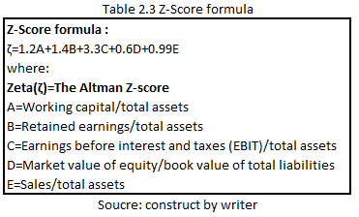

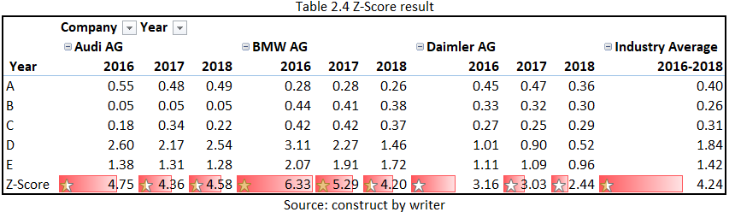
Typically, a rating below 1.8 shows a business is probable to head for or be below the bankruptcy weight. In contrast, firms that rank more than 3 are less probable to face bankruptcy. The Audi AG Z-score type had 4.58 above the industry average of 4.08. Furthermore, BMW and Daimler's tendency is declining and Audi is more stable.

2.2 Financial structure
Financial structure relates to the debt-to-equity combination used by a business to finance its operations. Below is the calculated financial ratio analytical basis.

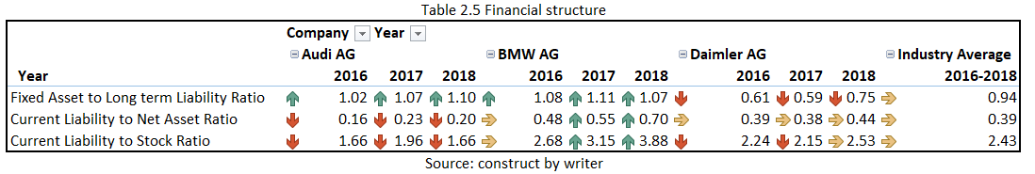
Fixed Asset to Long term Liability Ratio
This ratio is used to evaluate the solvency of a company. Fixed assets often secure long-term debts of a company that is why investors are keen on this proportion. Audi's recent ratio is 1.10, comparable to BMW 1.07 and large than Daimler 0.75. It indicates that Audi AG better handles its interest expenses.

Current Liabilities to Net Asset Ratio
This ratio shows the debt on equity is being paid. This is one of the solvency measures of the company and should not reach 60%. Higher percentages indicate considerable stress for future cash flows. The ratio for Audi is 20% which is lower than the average of 49%. It shows that Audi AG has stronger cash flow performance.

Current Liabilities to Stock Ratio
This ratio is intended to indicate a dependence on the accessible debt account inventory and is one of a company's solvency measures. The latest Audi AG's ratio is 1.66 which is lower than BMW 3.88 and Daimler 2.53. It indicates Audi AG has a stronger inventory management utilization.

Based on this data, Audi's financial structure with its rivals is above par.

2.3 Paying debt ability
The capacity to paying the debt is the key section in this financial analysis. Below table is for analysis the ability to pay off debt.
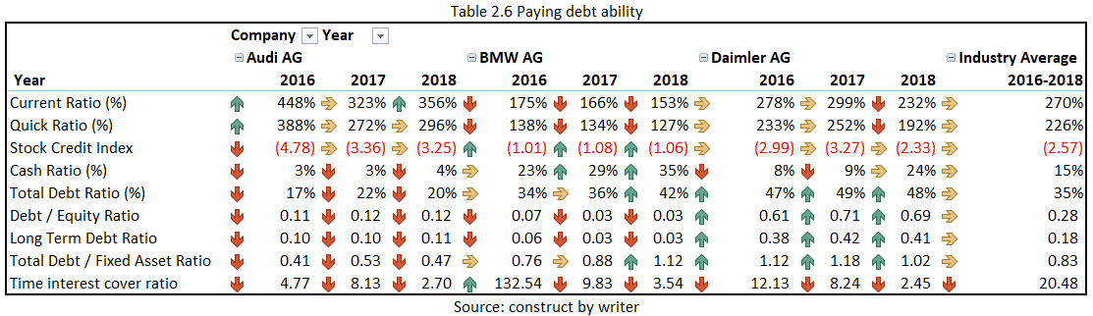
Current Ratio
This is a liquidity ratio that estimates a company's capacity to cover within one year of short-term commitments or obligations. It informs individuals how a business can improve its current assets on its balance sheet to fulfil its other payables and current debt (Johnson, 1970). The latest ratio of Audi AG is 356% which is higher than the rest of the company. It indicates Audi AG have a better assets performance but executives may not make efficient use of their assets.

Quick Ratio
This ratio is indicate the short-term liquidity position of a company and estimates the capacity of a company with its most liquid assets to fulfil its short-term obligations. The latest ratio of Audi AG is 296% which is greater than the industry median 226%. It indicates Audi AG have a better company's liquidity and financial health.

Stock Credit Index
This index is talking about the inventory performance of the company, Audi AG has the best index (-3.25) which is better than the industry average. Audi had in an appropriate position in terms of stock credit index.

Cash Ratio
This ratio is a measure of the liquidity of a company, in particular, the ratio of the cash equivalents and total cash of a company to their current liabilities. It calculates the capacity of a company with near-cash or cash assets to repay its short-term debt (Largay and Stickney, 1980). The latest ratio of Audi AG is 4% which is lower than the industry median 15%. It indicates that the cash on hand for pay off short-term debt is insufficient and Audi AG need to improve in this area.

Total Debt Ratio
This ratio can be described as the debt-financed proportion of a company's wealth. A ratio below 1 reflects the reality that a larger part of the assets of a company is financed through equity. More than 1 indicates that a significant part of the debt is financed by equity. The latest ratio of Audi AG is 20% which is lower than the industry median 35%, it indicates Audi AG has enough assets than the debt which is a good signal.

Debt / Equity Ratio
This is a metric of how much debt versus wholly-owned funds business is financing its activities. The latest ratio of Audi AG is 0.12 which is lower than the industry average 0.28. It shows Audi AG with lower risk to shareholders compares with Audi's competitor.

Long Term Debt Ratio
This ratio is indices that evaluate a company's amount of control and contrast it with other businesses to examine that specific company's total threat knowledge. The latest ratio of Audi AG is 0.11 which is lower than the industry average 0.18. It indicates that Audi AG has a powerful firm's finances and that the debt would reduce the company's threat.

Total Debt / Fixed Asset Ratio
It is a metric that represents the proportion of long-term debt-funded assets of a corporation that includes debts or other debt obligations that last more than a year. The ratio of Audi AG is 0.47 which is lower than the industry average 0.83. A ratio of less than 0.5 is generally regarded as great, it indicates Audi have a "healthy" signal.

Time Interest cover ratio
This measure is a ratio of the capacity of a company to pay interest. That interest coverage ratio is a measure of how many times a company with its EBIT could pay interest on its debt. The latest ratio of Audi AG is 2.7 which is between the BMW 3.54 and Daimler 2.45, moreover, the trend of 3 company are going down obviously. If the interest coverage ratio of a company is only 1.5 or smaller, it may be dubious about its capacity to satisfy investment costs. These 3 Company also need to prevent the trend keep going down.

Base on these information, the ratio from Audi is above average with the competitors in terms of the Paying debt ability.

2.4 Sales Performance
In this part, the following visual are showing the sales performance which is the measurement of sales activity and indicates how much money received per year.

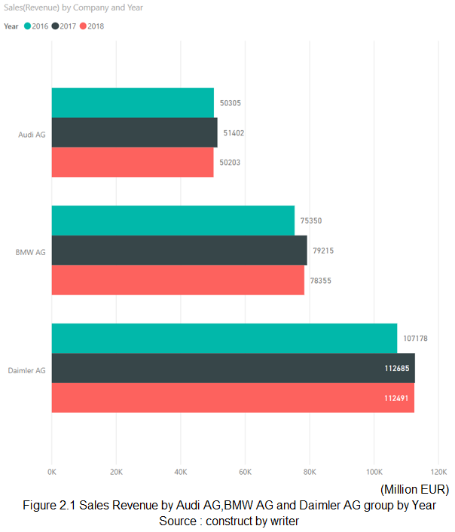
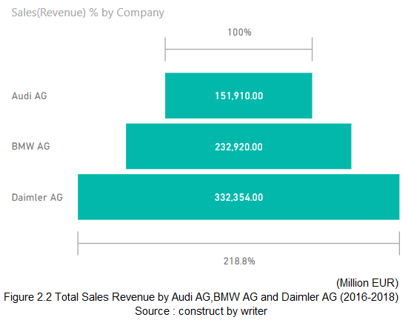
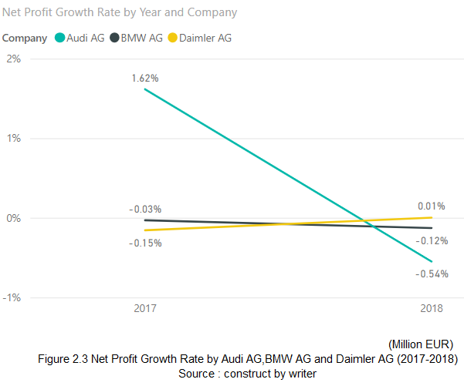

It indicates the total revenue form year 2016 to 2018 of Audi AG is 151.91K which is apparently lower than BMW AG 232.92K and Daimler AG 332.35K and the trend of net profit growth rate is going down. Therefore, Audi AG needs to improve its sales strategy to improve the revenue generation.

Base on these information, the ratio from Audi is below average with the competitors in terms of the sales performance.

2.5 Operating expenses
It is a cost incurred by a company through its ordinary activities. One of the typical duties that management has to face is to determine how to decrease operating expenses without influencing the capacity of a firm to compete with its rivals considerably.

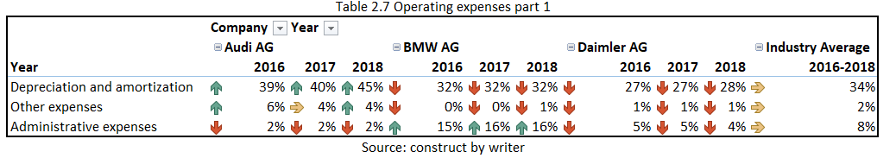
Depreciation and amortization
It is a non-cash expense, but as a clause, it requires to be established as assets have specific lives and need to be substituted in the owing course if the company does not want to loose its productivity of labour (Mears, 1966). The latest ratio of Audi AG is 45% which is apparently high than industry average 34%. It indicates Audi AG need to reduce the ratio such as change the depreciation method.

Other expense
This is the expenses that do not relate to a company's main business. The other expenses of Audi AG are 4% which is apparently higher than the industry average 2%. Audi needs to decrease the expenses such as track the spending.

Administrative expense
It is the expenses incurred by an organisation that is not solely linked to a particular task. The ratio of Audi is 2% which is lower than the industry average 8% and Audi need to keep this good ratio continuously.
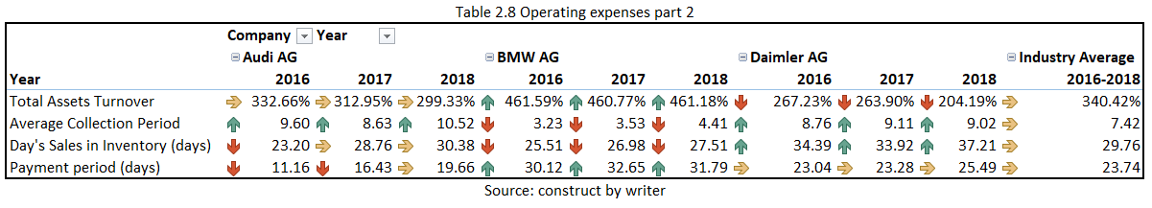
Average Collection Period
This is the amount of period it requires a company to obtain payments due to its customers in terms of receivable records. The ratio of Audi is 10.52 which is adobe the industry median 7.42. Audi needs to enhance it as the organisation receives payments quicker indicates a low average collection period.

Day's Sales in inventory (DSI)
The DSI is a financial ratio that shows the median period a business requires in days to transform its inventory into revenues, including products that are an ongoing job. The ratio of Audi is 30.38 which is higher than BMW AG 27.51 and lower than Daimler AG 37.21. A smaller DSI is generally favored because it shows a smaller length to clear the inventory and Audi need to improve on it since the trend of the ratio is going up.

Payment Period (days)
It is a solvency ratio that estimates the average number of days a company requires to charge its suppliers for credit-based transactions. It's the average length of time a company needs to pay off accounts payable credit. The latest payment period of Audi is 19.66 which is under than the industry average 27.73. Although cash should also raise as the payment period rises, working capital stays the same. Audi can maintain its larger vendors to impress with this low ratio and potentially benefit from trade discounts.

Base on these information, the ratio from Audi is below average from the competitors in terms of the operating expenses.

2.6 Profitability
Profitability is the measure always had to determine the extent of the profit of a company relative to the volume of the company.

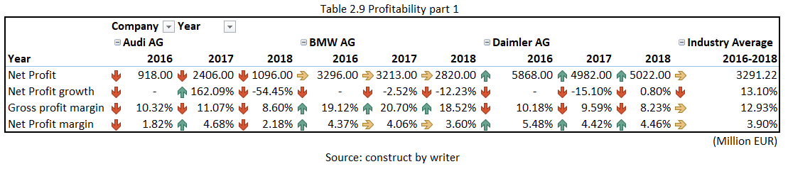
Net Profit and Net Profit growth
It reflects the amount of remaining retail dollars after all tax, operating expenses, preferred stock dividends and interest and the Net Profit growth is represent the net profit growth rate. The latest net profit and net profit growth of Audi are 1096 and -54.45% which is apparently lower than the industry average 4200.17 and -7.26. It indicates Audi need to spend extra effort on how to draw more profit.

Gross Profit margin
It is a ratio used to evaluate the business model and financial safety of a company by showing the amount of cash remaining over from sales after the cost of goods sold is deducted. The ratio of Audi is 8.6% which is lower than the competitor average 14.39%. It indicates Audi need to improve the cost of materials/Labor and pricing strategy.

Net Profit margin
It is the ratio of a business or company segment's total profit to revenue. The latest ratio of Audi AG is 2.18% which is lower than the competitor average 4.4%. It shows that Audi needs to enhance on it as it is one of the most significant indices of the financial health of a company and can evaluate whether current procedures are revenue-based gains that work and forecast (Freeman, 1983).

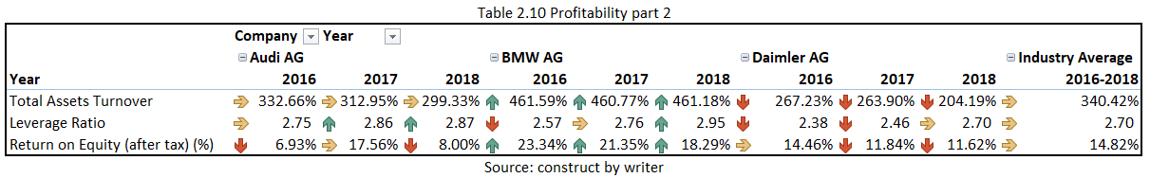
Total Assets Turnover
The ratio is an effectiveness ratio that estimates the capacity of a company to produce revenues from its assets by comparison net revenues with total assets on average. It demonstrates how effectively revenues can be generated by a business using its assets (Edmister, 1972). The latest ratio of Audi is 299.33% which is lower than BMW AG 461.18% but higher than Daimler AG 204.19%. It indicates Audi is generating 2.9 dollars of revenues per every dollar spent in assets which are not bad compared with Daimler but need to improve for comparing with BMW.

Leverage Ratio
The ratio is one of several financial measures that examine how much money falls in the type of debt (loans) or evaluates a company's capacity to fulfill its financial obligations. Too much debt for a business can be hazardous (Chen and Shimerda, 1981). 3 companies also had a similar rate of the leverage ratio. Nevertheless, if the operations of a company can produce a higher level of return on its debts than the interest rate, then the debt will help boost earnings growth. Therefore, Audi needs to improve the total assets turnover to draw more profits.

Return on Equity (after tax) (%)
ROE is a ratio that gives investors understanding into how effectively a company handles the money that shareholders have contributed to it and estimates a company's profitability in comparison to the equity of the shareholders (Damodaran, 2007). Audi has the worst ratio of 8% which is lower than the industry average 14.82%. High ROE means that the management of a company generates growth and revenue more efficient from its equity financing and Audi needs to improve its net income to increase the ROE.

Base on these information, the ratio from Audi is below average from the competitors in terms of the profitability.

2.7 Growth ability
The growth ability is used to measure the company health to avoid financial distress and prevent being over-leveraged.
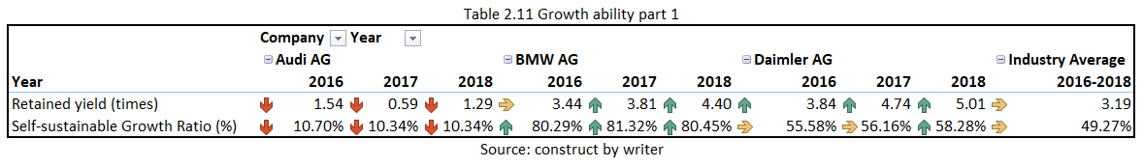

Retained yield
It is the net income yield remaining over to the company after paying its shareholder dividends. The ratio of Audi is 1.29 which is the worst compared with the industry average 3.19. It is a big concern for the investor who is looking to invest in Audi.

Self-sustainable Growth Ratio (%) (SSGR)
It is the growth rate that a business can attain from its earnings without depending on extra causes such as dilution of equity or debt. A strong self-sustainable growth rate business can proceed to demonstrate high growth rates without affecting its capital structure. The latest SSGR of Audi is 10.34% which is apparently lower than the competitor average 68.68%. Same as the Retained yield, It is also a big concern for the investor who is looking for invest in Audi.
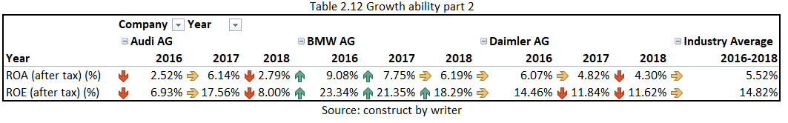
ROA (Return on Assets)
It is a measure of how lucrative a business is in relation to its total assets. The latest ratio of Audi is 2.79% which is the lowest ROA compare with industry average 5.52%. It also indicates that Audi does not use its assets efficiently to generate revenue.

ROE (Return on Equity)
It is a metric of how efficiently management uses the assets of a company to generate profits. Audi have a lowest ROE 8.00% compare industry average 14.82%. It is indicate Audi is not effectively using their assets to create profits.

Base on these information, the ratio from Audi is below average from the competitors in terms of the growth ability.

2.8 Stock Market Prospects Analysis
Below is the information base on their stock market performance.

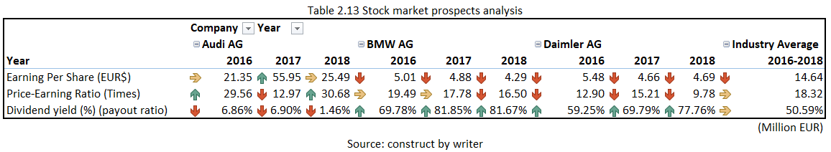
Earning Per Share
It is calculated as the profit of a company divided by its common stock outstanding shares and acts as an indication of the profitability of a company. Audi have the highest earning per Share 25.49 which is unanimously above the industry average 14.64. It indicate Audi have a very good stock market prospects to attract investor.

Price-Earning Ratio
It is the ratio for valuing a company that measures its current share price relative to its per-share earnings (EPS). A high P/E percentage generally implies investors expect stronger growth in the future. Audi have the highest P/E 30.68 which is unanimously better than the industry average 18.32. It also indicate Audi have a very good stock market prospects to attract investor.

Dividend yield (%) (Payout ratio)
The dividend yield is an assessment of a stock investment's dividend-only return. Even the dividend yield of Audi is 1.46% which is apparently lower than the industry average 50.59%, but this is not important, if the dividend is not increased or reduced, the yield will increase when the stock price drops and fall when the stock price rises. Because of the dividend amount shifts with the price of the stock, stocks that fall rapidly often look exceptionally high.

Base on these information, the ratio of Audi is above average from the competitors in terms of the Stock Market Prospects.

2.9 Conclusion
Audi had a great Z-Score performance, financial structure, Paying debt ability and Stock Market Prospects Analysis, conversely the Sales Performance, Operating expenses, Profitability, Growth ability is their main weakness.

3. Corporate Governance assessment
Corporate governance are the scheme of mechanisms, laws and procedures that directs and controls a company through. Corporate governance fundamentally includes managing the concerns of the many stakeholders of a company, such as shareholders, managers of top leadership, clients, vendors, government, financiers and society. In this section, the Audi Corporate Governance Strategy will be introduced based on studying Audi's report (Audi, 2018b).

3.1 Integrity and compliance
Audi's commercial operation is based on integrity and compliance with legislation and regulations and has the highest precedence in the Audi AG. Audi shapes the foundation with a strong reputation, with the confidence of clients and company associates, with employee well-being as well as for viable economic achievement, which should not be reduced by the threat of elevated financial harm arising from penalties, reduction of gain, compulsory penalty checks or criminal lawsuits.

Audi Group differentiation between integrity and enforcement
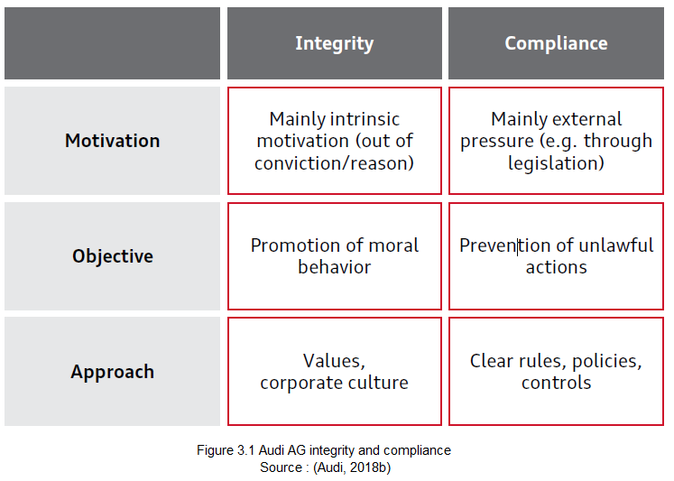
Audi has identified six focus areas shared within the Volkswagen Group though. Their corporate culture is of major significance to Audi. Culture means the total sum of all the values that they work together according to. How individuals, groups and divisions treat each other and collaborate within the business is obvious. Audi thinks that every business requires not just ideals, but mutual social values as well. Audi's four corporate values provide the basis: openness, appreciation, responsibility and integrity. Their program of integrity is intended to further strengthen Audi's corporate culture. It puts the focus on an integrity topic discussion. Audi intends to encourage the company's open exchange of thoughts, propagate a trust-based commercial environment and strongly embed Audi's personal, value-based behavior.

3.2 Risk Management
Audi Group is subjected to a vibrant setting as a business with worldwide activities. In addition, the automotive industry is experiencing an extensive change cycle that brings with it altering client needs, price systems and business models. This scenario continuously presents them with possibilities and threats that are varied and new.

The “Three Lines of Defense” model
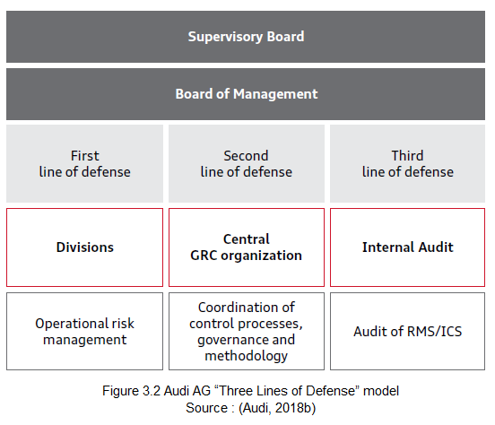
The individual risk owners of the participation and divisions of the AUDI AG are responsible for the report on the operational management of risks. They constitute the defense of the first line.

Central GRC organisation brings over the basic features of the RMS/ICS and the CMS in the second row of defense. Core actions include monitoring system efficiency and submitting to the Supervisory Board and the Management Board's Audit Committee an aggregate study the risk scenario. This guarantees compliance with the statutory demands for premature risk detection and RMS/ICS efficiency.

Internal Audit explore an impartial unit investigates the regularity, financial performance and security of the functional operations and RMS/ICS structural in the third row of defense.

In addition, each row of defense submits reports at least ad hoc to the Supervisory Board of AUDI AG and the full Board of Management independently.

3.3 Communication and Transparency
Open dialogue and transparency are essential components of Auto industry financial and capital market communications. Audi offers well-founded information and background reports on their operational and strategic corporate development as well as access to their financial publications on the Audi website. In the financial calendar, Audi announces significant release schedules as well as the date of the Annual General Meeting of Audi AG. These can be accessed at any time on Audi homepage. Besides, Audi provided institutional investors, analysts, shareholders and other stakeholders with timely information about the current economic development and planned future direction of their company.

3.4 Credit rating
The credit rating is a financial measure for debt securities prospective investors. Moody's assign these to reflect the company's quality by credit rating agencies.
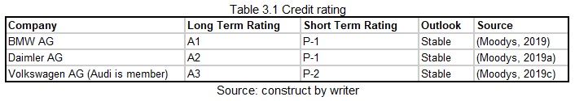
Audi AG's long-term rating (a member of the Volkswagen group) is A3 and short-term ranking is P-2 which is lower than Daimler AG and BMW AG. Even the rating is lower than the competitor, indicating that the firm also has a powerful ability to fulfill its financial obligations and that the business is very stable.

Base on these information, Audi have a very good status in terms of the corporate governance.

4. Investment project assessment
Audi AG has a huge amount of spending on the research and development activities on every year such as electrification, sustainability and efficiency, automated driving, artificial intelligence and driver assistance systems. One of the most important projects is "Expansion of model Audi R8 Coupe". In this section, it will base on the project information to create an investment appraisal.

4.1 Project Items information
Below is the initial investment information for the new project.
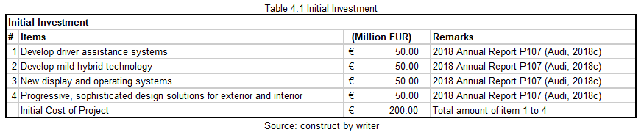
Below is the Key Metric use for calculate the project value.
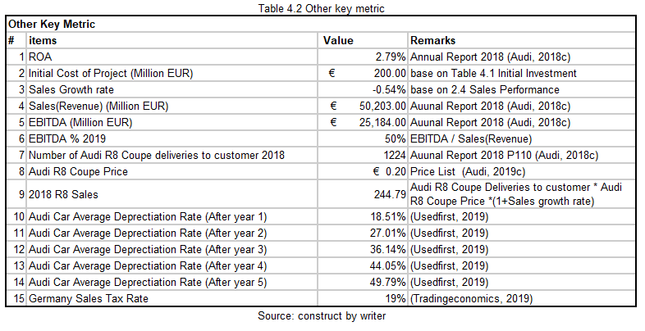

4.2 Computing Tax Costs
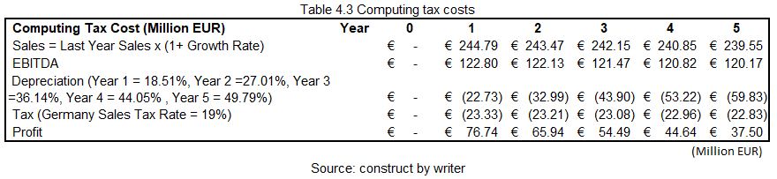

4.3 Cash Inflows & Outflows, NPV, ARR, IRR, ROI
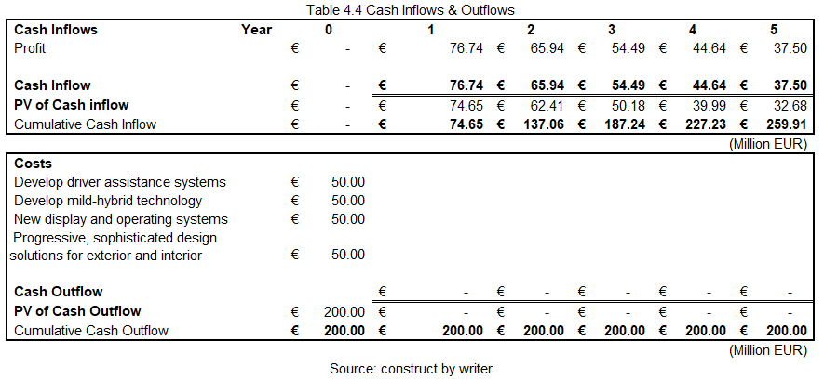
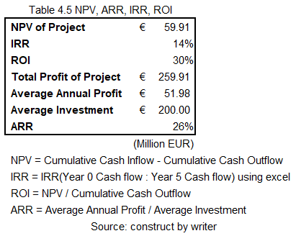

4.4 Cash flow and payback period
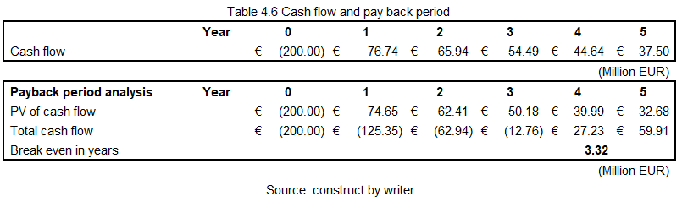

4.5 Conclusion

- NPV - 60, in capital budgeting, NPV is used to compare projects based on their anticipated revenue over time, required investment and expected rates of return (Mugeraya, 2005). Hence, based on the outcome of NPV the project is acceptable.

- ARR - 25.99 %, ARR is determining the annual percentage rate of return of a project. A positive value means the project can create income.

- ROI - 29.96%, Return on investment (ROI) is a measure used to assess the performance and effectiveness of an investment or to examine the effectiveness of a number of different investments. ROI attempts to evaluate the number of returns on a specific investment directly compared to the cost of the investment. Since the ROI is a positive value and it is worthwhile to invest.

- IRR - 14.18%. The internal rate of return (IRR) is a measurement used in capital budgeting to predict potential investment profitability (Mugeraya, 2005). Hence, the project is appropriate depending on the results of the IRR.

- Payback period 3.32 year, the payback period relates to how long it lasts to recover an investment's cost. Base on the result, the project cost can be recovered after 3.32 years which more the project is attractive to investors.

Taking all the above-mentioned factors and results into consideration, it is determined that the plan fulfills all the elements essential to accept any project.

5. Financing and Capital management
For the new Audi's investment, it needs 200 million which is around 2% of the total assets. In this section, it will analyze the various methods for Audi on how to manage the capital is the best methods.

5.1 Financing Methods for analyzing
Below is methods which can consider by Audi AG to get the funding to start the project.
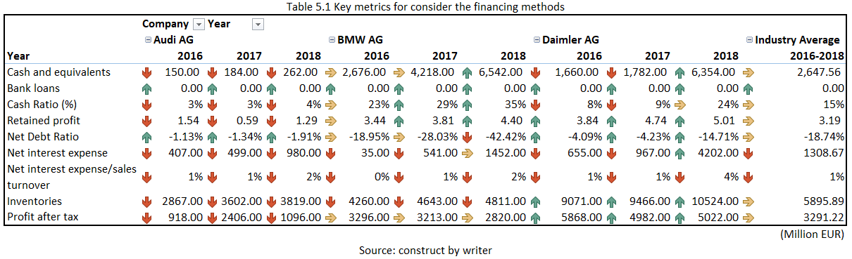
Cash payments
Audi AG has the worst cash and equivalents compare with the industry average even the trend is keep going up. Particularly, the cash cannot cover the interest. Also, Audi AG has the worst cash Ratio 4% compared with the industry average is 15%. It indicates the cash of Audi is less than the competitor. Moreover, the project cost is 200 million which 76% of Audi cash is. Audi should look for another method to get the funding.

Sell inventories
The latest inventories of Audi AG have 3819 which is apparently more than the cash, as most of the inventories are finished goods and products, Audi AG can consider selling their inventories to generate more cash. But since it still needs to negotiate with dealer or customer, hence, this methods is not feasible.

Issued share capital fund-raising
It is simply the monetary value of the stock issued to investors by a company. But need to consider Audi AG also need to pay the dividend to the investor which the dividend rate in 2016 is 6.86% which is very high. Also, when a company uses shares to increase equity, its influence and ownership over the company is efficiently reduced.

Bank loan financing
Germany’s bank lending rate was reported at 2.120 % pa in May 2019 which is a very low rate to invest a project. Especially for Audi, they don't have too much cash, Audi should seeking for a 5-year bank loan for support the project cost as the ROI of the project has 29.96%. Also, Audi AG has enough profit after tax to cover the loan and interest.

5.2 Financing method proposed
Base on the result, Audi should get a 5 years bank loan program for the 200 Million EUR with annual interest on 2.12%. Below is the Main financial data to evaluate Audi finance performance for return the loan.
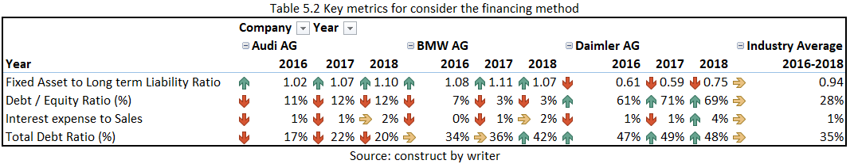
According to the table, It means Audi assets can cover the debt with lower risk to shareholder and Audi AG has more assets than the debt which mean Audi AG don't have a major impact for return the bank loan. Audi should go for the bank loan financing methods to getting the funding.

6. Audit Plan and Recommendation
From above table and outcomes following audit plan and recommendation can be made.

6.1 Audit plan
The following audit plan is suggested to be implemented for the coming years in an attempt to improve internal control, evaluate and improve the efficiency of risk management, monitoring and governance procedures.

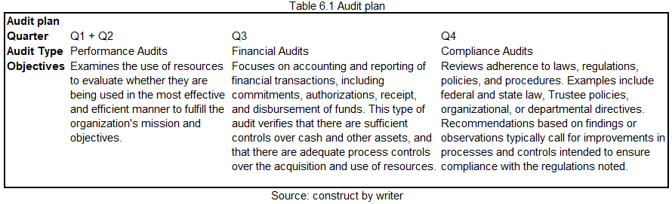
The purpose of these assessments is to identify how well risk is handled, including whether the correct processes are in place and whether accepted procedures are being followed.

6.2 Recommendation

- Depreciation and amortization - the trend of the ratio from Audi keep growing and it is larger than the industry average. Audi should review the depreciation procedure such as the restate the Lifetime, Change the Depreciation Method or increase Salvage Value.

- Cash Ratio - The cash ratio is extremely low compared with competitor and it means Audi may have not enough cash to invest other project or to pay off short term debt, Even if the business has conditions that skew its balance sheets, such as efficiently managed inventories, very little credit given to its clients and longer than normal credit terms with its suppliers, it may not be poor news (Largay and Stickney, 1980). A reasonable cash ratio is easier to maximize the potential benefit such as pay the cost for a new project rather than loan the money from a bank.

- Revenue - The prospective and current investor may be bothered by the fact that the company was unable to grow at a pace anticipated by the company of such capacity and size also compared with the rival. The revenue has decreased marginally by -0.54 % that doesn't seem so amazing in the last 3 years. The company was also unable to grow at many paces in terms of profit. Audi can do some promotion such as marketing event, discount or better interest rate on the car loan.

- Gross Profit Margin - The first level of profitability, gross profit, informs investors how great a business is comparative to its rivals in producing a product or offering a service. Higher or more effective premium companies see greater profit margins. Audi can try to integrate new products, reduce direct costs of goods, increase prices or services to increase the GP margin.

- ROE - As the ROE from Audi is low and it is essential because it demonstrates how great the management of the company is in generating returns from the money that its shareholders have received. Audi can try to raise the price of the product, reduce labour costs and operating expense, or negotiate with suppliers to reduce the cost of goods sold (Damodaran, 2007).

- Other expense – Since the expense is high, Audi should identify how to decrease the other expenses for saving money and the cash ratio is low such as track expenses diligently, manage variable costs.

- Operational Governance - Board of Directors and the Supervisory Board must give close consideration to the documentation of the German Corporate Governance Code, which includes internationally and nationally recognized standards for responsible management (Deutscher Corporate Governance Kodex, 2019). Audi should follow the rules in different areas such as "cooperation between Supervisory Board and Management Board", "Conflicts of Interest", "Management Board" and "Shareholders and the General Meeting".

7. Conclusion
It feels like the company has been prepared to keep and sustain the business it operates in Germany after studying the above factors. Audi has maintained its collection of income and the company's profit demonstrates well-managed generally. The new project is worth to invest and the corporate governance of Audi also has a great procedure for internal control and risk management. Even some financial ratio is lower than the competitor, this analysis might help in identifying issues in the association and implementing proper steps to recover the gap with the competitor in the year 2016 to 2018 and growth in the future.

8. References
Altman, E.I. (1968) Financial Ratios, Discriminant Analysis and the Prediction of Corporate Bankruptcy. The Journal of Finance, 23(4), p.589.

Audi. (2018a) Company | audi.com. Available at: https://www.audi.com/en/company.html (Accessed 2 Aug. 2019).

Audi. (2018b) Corporate Governance | audi.com. Available at: https://www.audi.com/en/company/investor-relations/capital-market-compliance-and-corporate-governance/corporate-governance.html (Accessed 2 Aug. 2019).

Audi. (2018c) Annual Reports | audi.com. Available at: https://www.audi.com/en/company/investor-relations/reports-and-key-figures/annual-reports.html.

Audi (2019a) Quarterly Report Q1/2019. Audi. Available at: https://www.audi.com/en/company/investor-relations/reports-and-key-figures/interim-reports.html (Accessed 2 Aug. 2019).

Audi. (2019b) Audi.com – the international Audi website | audi.com. Available at: https://www.audi.com/en.html.

Audi. (2019c) The new Audi R8 | audi.com. Available at: https://www.audi.com/en/experience-audi/audi-sport/r-rs-serial-models/r8.html (Accessed 2 Aug. 2019).

Bloomberg. (2019a) BMW:Xetra Stock Quote. Available at: https://www.bloomberg.com/quote/BMW:GR (Accessed 2 Aug. 2019).

Bloomberg. (2019b) DAI:Xetra Stock Quote. Available at: https://www.bloomberg.com/quote/DAI:GR (Accessed 2 Aug. 2019).

Bloomberg. (2019c) NSU:Xetra Stock Quote. Available at: https://www.bloomberg.com/quote/NSU:GR (Accessed 2 Aug. 2019).

BMW AG. (2016) FINANCIAL STATEMENTS OF BMW AG. Available at: https://www.bmwgroup.com/content/dam/bmw-group-websites/bmwgroup_com/ir/downloads/en/2017/GB/2016-BMW-AG-Financial-Statement.pdf (Accessed 6 Aug. 2019).

BMW AG. (2017) FINANCIAL STATEMENTS OF BMW AG. Available at: https://www.bmwgroup.com/content/dam/bmw-group-websites/bmwgroup_com/ir/downloads/en/2018/Gesch%C3%A4ftsbericht/BMW-AG17_en_ONLINE.pdf (Accessed 6 Aug. 2019).

BMW AG. (2018) FINANCIAL STATEMENTS OF BMW AG. Available at: https://www.bmwgroup.com/content/dam/bmw-group-websites/bmwgroup_com/ir/downloads/en/2019/gb/BMW-AG18_en_190313_ONLINE.pdf (Accessed 6 Aug. 2019).

BMW Group. (2018) BMW Group. Available at: https://www.bmwgroup.com/en.html (Accessed 2 Aug. 2019).

Chen, K.H. and Shimerda, T.A. (1981) an Empirical Analysis of Useful Financial Ratios. Financial Management, 10(1), p.51.

Daimler. (2018) Daimler. Available at: https://www.daimler.com/en/ (Accessed 2 Aug. 2019).

Daimler AG. (2016) Annual Financial Statements 2016 Daimler AG. Available at: https://www.daimler.com/documents/investors/reports/annual-report/daimler/daimler-ir-annualfinancialstatementsentity-2016.pdf (Accessed 6 Aug. 2019).

Daimler AG. (2017) Annual Financial Statements 2017 Daimler AG. Available at: https://www.daimler.com/documents/investors/reports/annual-report/daimler/daimler-ir-annual-financialstatements-entity-2017.pdf (Accessed 6 Aug. 2019).

Daimler AG. (2018) Annual Financial Statements 2018 Daimler AG. Available at: https://www.daimler.com/documents/investors/reports/annual-report/daimler/daimler-ir-annual-financialstatements-entity-2018.pdf (Accessed 6 Aug. 2019).

Damodaran, A. (2007) Return on Capital (ROC), Return on Invested Capital (ROIC) and Return on Equity (ROE): Measurement and Implications. SSRN Electronic Journal.

Deutscher Corporate Governance Kodex. (2019) German Corporate Governance Code. Available at: https://www.dcgk.de/en/home.html (Accessed 2 Aug. 2019).

Edmister, R.O. (1972) Financial Ratios as Discriminant Predictors of Small Business Failure. The Journal of Finance, 27(1), p.139.

Freeman, R.N. (1983) Alternative Measures of Profit Margin: An Empirical Study of the Potential Information Content of Current Cost Accounting. Journal of Accounting Research, 21(1), p.42.

International Monetary Fund. (2019) World Economic Outlook (April 2019) - Gross Domestic Product (GDP) Available at: https://www.imf.org/external/datamapper/datasets/WEO/1 (Accessed 2 Aug. 2019).

Johnson, C.G. (1970) Ratio Analysis and the Prediction of Firm Failure. The Journal of Finance, 25(5), p.1166.

Largay, J.A. and Stickney, C.P. (1980) Cash Flows, Ratio Analysis and the W.T. Grant Company Bankruptcy. Financial Analysts Journal, 36(4), pp.51–54.
Mears, P.K. (1966) Discussion of Financial Ratios As Predictors of Failure. Journal of Accounting Research, 4, p.119.

Moodys. (2019a) Bayerische Motoren Werke Aktiengesellschaft Credit Rating - Moody’s. Available at: https://www.moodys.com/credit-ratings/Bayerische-Motoren-Werke-Aktiengesellschaft-credit-rating-96038 (Accessed 2 Aug. 2019).

Moodys. (2019b) Daimler AG Credit Rating - Moody’s. Available at: https://www.moodys.com/credit-ratings/Daimler-AG-credit-rating-219700 (Accessed 2 Aug. 2019).

Moodys. (2019c) Volkswagen Aktiengesellschaft Credit Rating - Moody’s. Available at: https://www.moodys.com/credit-ratings/Volkswagen-Aktiengesellschaft-credit-rating-146500 (Accessed 2 Aug. 2019).

Mugeraya, S. (2005) TrueIRR - IRR and NPV Redefined. SSRN Electronic Journal.

Tradingeconomics. (2019) Germany Sales Tax Rate - VAT. Available at: https://tradingeconomics.com/germany/sales-tax-rate (Accessed 2 Aug. 2019).

Usedfirst. (2019) Audi Depreciation. Available at: https://usedfirst.com/cars/audi/ (Accessed 2 Aug. 2019).

9. Appendix
‌ 

