University of Wales Trinity Saint David

School of Engineering



2D Transient Heat Equation Solved with the Explicit Finite Difference Method

Computational Methods

ACMA6012

Rachel Williams

2208603

February 2026

Contents

Table of Contents
Contents 2
1.1 Table of Contents 2
1.2 Table of Figures 3
2 Introduction 4
3 Governing Equation 5
4 Finite Difference Method 6
5 Initial Condition, Boundary Conditions and Analytical Solution 9
6 Codes’ Details and Explanations 10
7 Validation of the Model 14
8 Sensitivity Analysis of Key Numerical Parameters 18
8.1 Grid Refinement Study 18
8.2 Time Step Refinement Study 19
8.3 Convergence Criterion Refinement Study 21
9 Limitations of the Numerical Model 23
10 Suggested Improvements and Future Developments 25
11 Conclusion 26
12 Bibliography 27
13 Appendices 28
13.1 Appendix 1 28
13.2 Appendix 2 32
13.3 Appendix 3 32
13.4 Appendix 4 32

Table of Figures
Figure 1 – Numerical and Analytical Temperature Distributions for a Square Plate 14
Figure 2 – Absolute Error at Each Grid Node for a Square Plate 15
Figure 3 – Numerical and Analytical Temperature Distributions for Plate Elongated in X Dimension 15
Figure 4 – Absolute Error Distribution for Plate Elongated in X Dimension 16
Figure 5 – Numerical and Analytical Distributions for a Plate Elongated in the Y Direction 16
Figure 6 – Absolute Error Distribution for a Plate Elongated in the Y Direction 17
Figure 7 - Effect of Adjusting Grid Spacing on Time to Reach Equilibrium 18
Figure 8 – Effect of Adjusting Grid Spacing on Absolute Error 19
Figure 9 - Effect of Adjusting Grid Spacing on RMSE 19
Figure 10 – Effect of Adjusting the Time Step on the Time Taken to Reach Thermal Equilibrium 20
Figure 11 – Effect of Adjusting the Time Step on the Absolute Error 20
Figure 12 – Effect of Adjusting the Time Step on the RMSE value 21
Figure 13 – Effect of Adjusting the Convergence Criterion on the Total Time Required to Reach Thermal Equilibrium 21
Figure 14 – Effect of Adjusting the Convergence Criterion on the Absolute Error 22
Figure 15 – Effect of Adjusting the Convergence Criterion on the RMSE Value 22

Introduction
Transient heat conduction is fundamental to many engineering applications, including thermal management, energy analysis, and material processing. As analytical solutions only exist for simplified geometries and boundary conditions, numerical methods are essential for analysing practical heat transfer problems.
The aim of this report is to validate a numerical model for two-dimensional transient heat conduction in a rectangular plate, using an explicit finite difference method (EFDM). The numerical approach employs second-order central difference schemes for spatial derivatives and a first-order difference scheme for time.
Within the report the heat equation and numerical formulation are presented, followed by a description of its implementation within the model. The numerical results are then validated against the analytical solution and analysed through sensitivity studies, with a final discussion on the limitations of the model and potential methods of improvement.

Governing Equation
According to Narasimhan (1999) the heat equation originated in the early nineteenth century, in the work of Joseph Fourier, who formulated a mathematical description of heat conduction in his 1822 publication Théorie Analytique de la Chaleur. The heat equation has become fundamental to thermal analysis within materials science, geophysics, and biomedical engineering, where accurate prediction of temperature evolution is essential.
The heat equation is a partial differential equation that models the diffusion of thermal energy within a domain over time. Haque et al. (2025) describe the equation as an essential tool for analysing transient heat conduction problems, enabling engineers to predict temperature distributions in practical applications. Examples of which include the cooling of electronic components, design of thermal insulation, and materials processing. For a two-dimensional geometry with no internal heat source, the heat equation is given by Equation 1.
Equation 1 – 2D Heat Equation (Haque et al., 2025)
$$\frac{∂T(x,y,t)}{∂t}=α\left(\frac{∂^{2}T}{∂x^{2}}+\frac{∂^{2}T}{∂y^{2}}\right)$$
Where, $T$ represents the temperature of the medium, at coordinates $(x$, $y)$ and at time $t$, $α$ represents the thermal diffusivity of the medium, which characterises the rate at which heat spreads through the medium (Ali et al., 2025). Thermal diffusivity is dependent upon the material properties of the medium and is defined by Ali et al. (2025) in Equation 2.
Equation 2 – Thermal diffusivity (Ali et al., 2025)
$$α=\frac{k}{ρc_{p}}$$Where, $k$ represents the thermal conductivity of the material, $ρ$ is the density, and $c_{p}$ is the specific heat capacity at constant pressure.

Finite Difference Method
Garcia et al. (2025) explain that the purpose of Taylor series expansions is to provide an approximation of functions expressed as a polynomial with a provided margin approximation for the error. This is useful as polynomials are easy to work with in terms of determining their derivatives or integrals. The Taylor series expansion of a function f(x) is shown in Equation 3.
Equation 3 – Taylor Series Expansion
$$f\left(x\right)=f\left(x_{i}\right)+\left(x-x_{i}\right)f^{'}\left(x_{i}\right)+\frac{{(x-x_{i})}^{2}}{2!}f^{''}\left(x_{i}\right)+\frac{{(x-x_{i})}^{3}}{3!}f^{'''}\left(x_{i}\right)+…$$
Garcia et al. (2025) explain that Taylor series expansions are only exact at an infinite number of terms are included in the expansion.
Equation 4 – Taylor Series Expansion for 3 Terms
$$f\left(x\right)=f\left(x_{i}\right)+\left(x-x_{i}\right)f^{'}\left(x_{i}\right)+\frac{{(x-x_{i})}^{2}}{2!}f^{''}\left(x_{i}\right)+\frac{{(x-x_{i})}^{3}}{3!}f^{'''}\left(x_{i}\right)+O(Δx^{4})$$
Garcia et al. (2025) present Equation 4 for a Taylor series expansion, where $O(Δx^{4})$ represents the truncation error order.
Welt et al. (1997) explain that the spatial domain of the plate is discretised by dividing it into a two-dimensional cartesian grid composed of uniformly spaced nodes in both the x- and y- directions. For plate dimensions of X and Y metres, a uniform grid spacing of h is created, such that the domain is split where grid points along the x-direction equal X/h+1, and the number of grid points in the y- direction equal Y/h+1. Each grid point is identified by the indices (i,j), where i denotes the row, and j denotes the column.
The temperature at each grid point is represented by the discrete variable $T_{i,j}$, which approximates the continuous temperature field $T(x,y)$ at that location. Boundary nodes correspond to the edges of the plate and are treated separately to enforce the prescribed boundary conditions, while interior nodes are updates using the numerical scheme.
The time domain is similarly discretised into uniform time steps of size $Δt$. The temperature field is advanced in time from an initial condition using discrete time levels indexed by the superscript n, such that $T_{i,j}^{n}$ represents the temperature at grid point (i,j) at time $t^{n}=nΔt$. The explicit time-marching scheme updates the temperature at each interior node from time level n to n+1 using values from the previous time level only.
Recktenwald (2004) explains, this discretisation of both space and time transforms the governing heat equation from a continuous partial differential equation into a set of algebraic update equations defined at discrete grid points and time levels, forming the basis for the explicit finite difference method implemented in the solver, in Appendix 1.
The governing equation for two-dimensional transient heat conduction is seen in Equation 5.
Equation 5 – Heat Equation
$$\frac{∂T}{∂t}=α\frac{∂^{2}T}{∂x^{2}}+\frac{∂^{2}T}{∂y^{2}}$$The temperature grid at point (i,j) and time level n is denoted by $T_{i,j}^{n}$. The time derivative is approximated using a forward difference scheme, given by Equation 6.
Equation 6 – Forward Difference Scheme
$$\frac{∂T}{∂t}|_{i,j}^{n}≈\frac{T_{i,j}^{n+1}-T_{i,j}^{n}}{Δt}$$
The second derivatives in space are approximated using central difference schemes, as seen in Equations 7 and 8.
Equation 7
$$\frac{∂^{2}T}{∂x^{2}}|_{i,j}^{n}≈\frac{T_{i,j+1}^{n}-2T_{i,j}^{n}+T_{i,j-1}^{n}}{h^{2}}$$
Equation 8
$$\frac{∂^{2}T}{∂y^{2}}|_{i,j}^{n}≈\frac{T_{i+1,j}^{n}-2T_{i,j}^{n}+T_{i-1,j}^{n}}{h^{2}}$$
Substituting Equations 7 and 8 into the governing heat equation yields the explicit finite difference form seen in Equation 9.
Equation 9
$$\frac{T_{i,j}^{n+1}-T_{i,j}^{n}}{Δt}=α(\frac{T_{i,j+1}^{n}-2T_{i,j}^{n}+T_{i,j-1}^{n}}{h^{2}}+\frac{T_{i+1,j}^{n}-2T_{i,j}^{n}+T_{i-1,j}^{n}}{h^{2}})$$
The Fourier number represents the ratio of thermal diffusion over a single time step to the thermal energy stored within a grid cell, as shown in Equation 10.
Equation 10 – Fourier number
$$F_{0}=\frac{αΔt}{h^{2}}$$
​
Substituting this definition into Equation 9 yields the compact explicit finite difference method, seen in Equation 11.
Equation 11
$$T_{i,j}^{n+1}=F_{0}(T_{i,j+1}^{n}+T_{i,j-1}^{n}+T_{i+1,j}^{n}+T_{i-1,j}^{n}-(4-\frac{1}{F_{0}})T_{i,j}^{n}$$
In this formulation, the Fourier number directly controls the rate at which thermal information propagates through the numerical grid. For EFDM, numerical stability is conditional, and for a two-dimensional problem the Fourier number must satisfy $0<F_{0}≤0.25$. This stability condition imposes a restriction on the allowable time step, linking temporal resolution directly to the spatial discretisation. This stability criterion was derived using von Neumann stability analysis, as explained by Neelan (2023) and Balsara (1995).

Initial Condition, Boundary Conditions and Analytical Solution
To ensure adequate assessment of numerical accuracy, the initial boundary conditions were selected to correspond with the analytical solution. This enables direct comparison between numerical and analytical results and provides a reliable method of validating the model.
The initial condition applied to the plate assumes a uniform temperature of 0°C throughout the domain at time t=0. This condition represents a plate that is initially unheated prior to the application of the boundary temperature.
Dirichlet boundary conditions are imposed along east, west and south boundaries of the plate, while the north boundary is set at a constant temperature, T0.
$$T\left(x,Y,t\right)=T_{0}, 0<x<X$$
$$T\left(0,y,t\right)=T\left(X,y,t\right)=T\left(x,0,t\right)=0, 0<y<Y$$
The corners of the domain inherit the 0°C condition. This boundary value configuration represents a plate that is heated uniformly along its top edge while heat is continuously dissipated through the other boundaries.
The boundary conditions were chosen based on the availability of a steady-state analytical solution for these conditions, as provided by Press et al. (2007). By selecting boundary conditions that mirror those required for the analytical solution, allows for direct and meaningful comparison of the numerical and analytical solutions.
The corresponding analytical solution is obtained by solving Laplace’s equation for steady-state heat conduction using separation of variables. The resulting solution is expressed as a Fourier sine series in the x-direction with hyperbolic functions in the y-direction.
By employing these specific initial and boundary conditions, the numerical and analytical solutions describe the same physical problem. This allows discrepancies between the two solutions to be attributed solely to the numerical effects such as truncation and round-off errors, rather than modelling inconsistencies. The chosen boundary conditions provide a robust method for validating the numerical model and assessing its performance across varying plate geometries.

Codes’ Details and Explanations
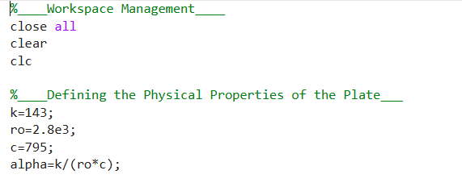
This section initialises the MATLAB environment and defines the physical properties of the plate.
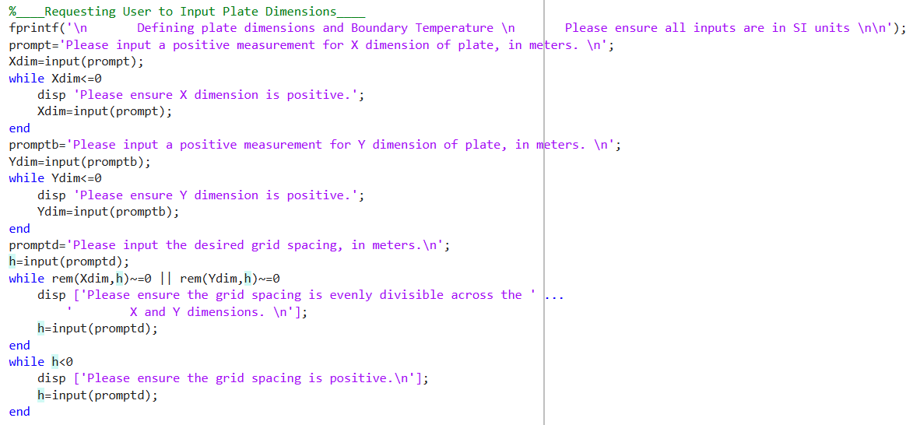 The user is prompted to define the plate dimensions and grid spacing. Input validation loops ensure that all values are positive and that the grid spacing divides evenly into both dimensions.
A constant temperature is prescribed along the north boundary of the plate. The remaining boundaries are set to 0°C, forming Dirichlet boundaries, aligning with the analytical solution.
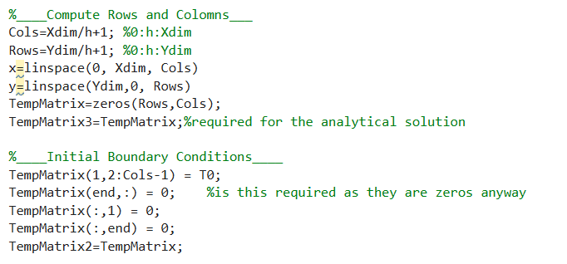
This section constructs the computational grid based on the specified geometry and grid spacing. Temperature matrices are initialised to zero, representing the initial condition of the plate prior to heat diffusion. Boundary conditions are explicitly imposed. These conditions are maintained throughout the simulation and define the steady-state solution.
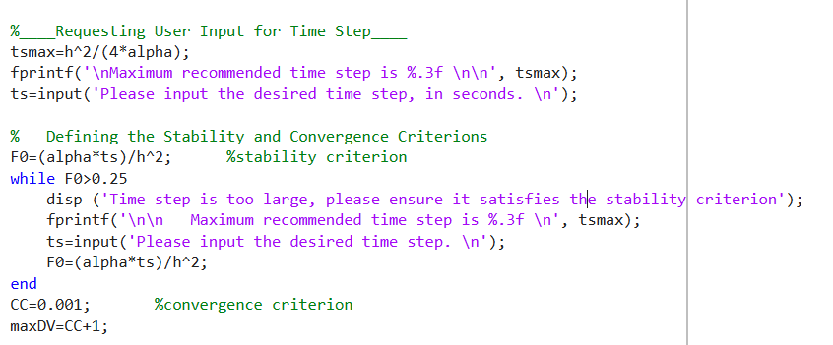 The maximum stable time step for the explicit scheme is computed using the Fourier number stability criterion. User input for the time step is validated to ensure numerical stability by enforcing $0<F0≤0.25.$
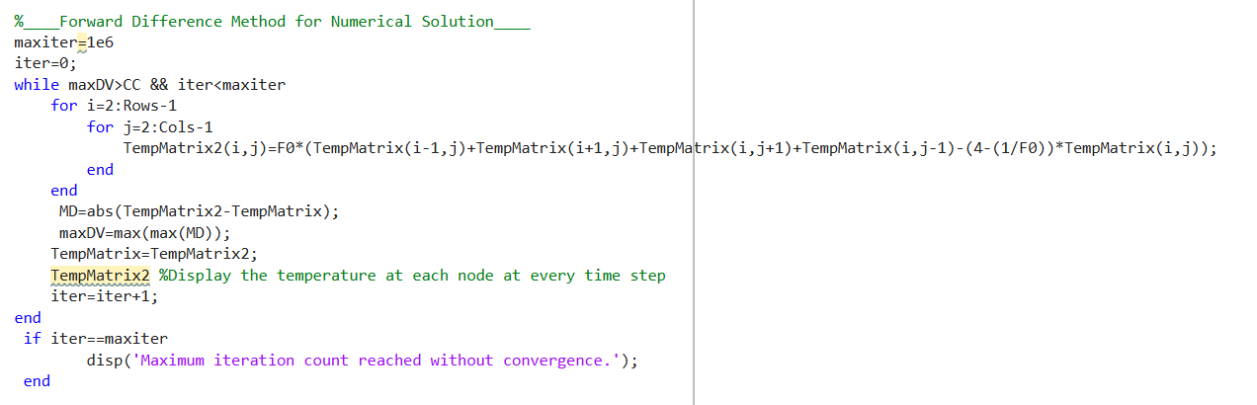The two-dimensional heat equation is solved using Equation 11. The temperature field is advanced iteratively in time until convergence is achieved, defined by a maximum change threshold between successive iterations. Convergence is monitored by the maximum nodal temperature change between iterations. Once the convergence criterion is satisfied, the time required to reach equilibrium is calculated and reported in appropriate units.
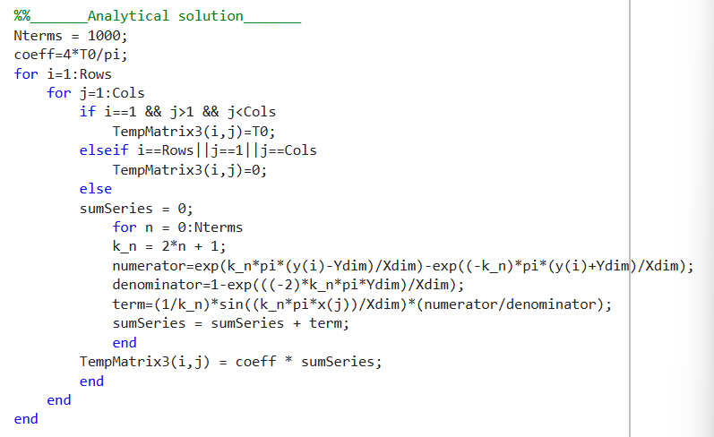An analytical steady-state solution is computed using a truncated Fourier series that satisfies Laplace’s equation and the imposed boundary conditions.
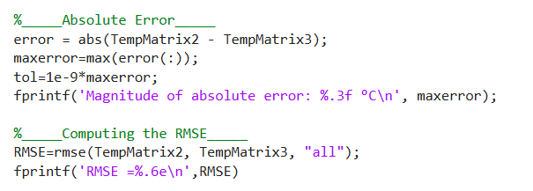
The absolute error and RMSE are computed by comparing the numerical and analytical solutions. These metrics quantify both localised and overall discrepancies, providing an assessment of solver accuracy.

Validation of the Model
Using the solver presented in Appendix 1, simulations were conducted for varying geometries, all with a boundary temperature of 50°C. The results of these simulations were then compared to the analytical solution to assess the accuracy, stability, and performance of the model.
For a square plate with dimensions 12m x 12m with a grid spacing of 1m and time step of 3600s. The numerical and analytical temperature distributions are shown in Figure 1.
The maximum absolute error was 0.370°C, which is small relative to the boundary temperature and indicates numerical accuracy. The RMSE for this case was 8.26e-02°C, significantly smaller than the maximum error, indicating that the error is localised rather than distributed throughout the domain.
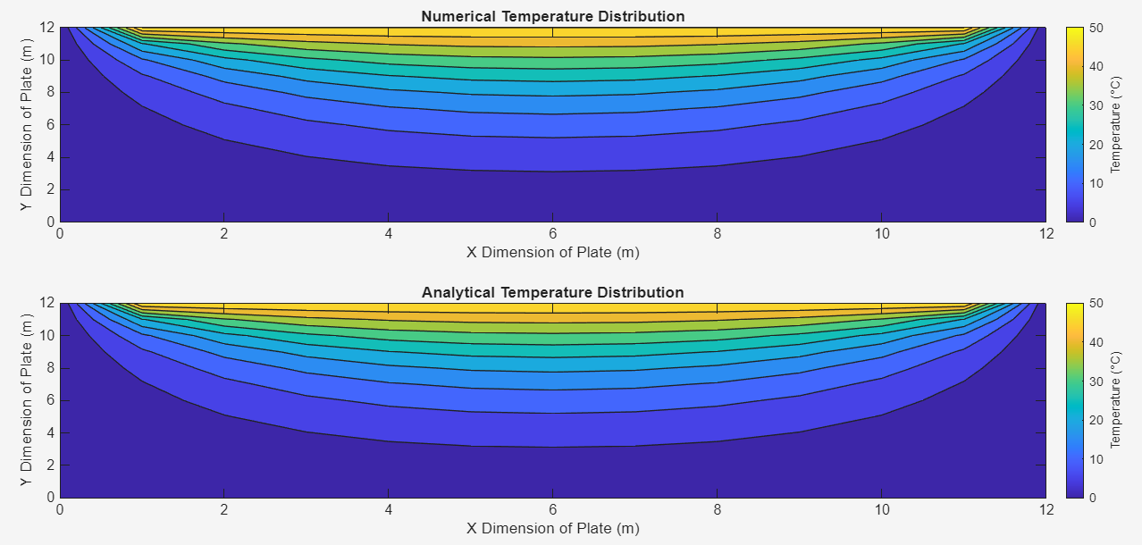
Figure 1 – Numerical and Analytical Temperature Distributions for a Square Plate
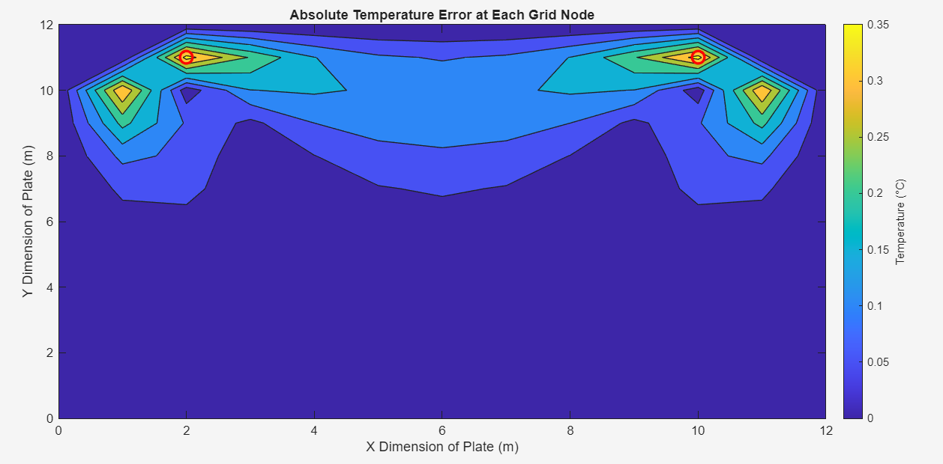
Figure 2 – Absolute Error at Each Grid Node for a Square Plate
To investigate the effect of geometric aspect ratio, a second simulation was performed for a 12m x1m plate using a grid spacing of 0.5m. A time step of 500 seconds was used to advance the solution toward equilibrium. The results for the numerical and analytical solutions for this plate size can be seen in Figure 3.
The maximum error for this case was 0.421°C, with an RMSE of 8.21e-2. Although the maximum error increased slightly, the RMSE remained comparable to the square plate case, indicating that errors remain confined to localised regions and that the solver maintains stability for elongated domains.
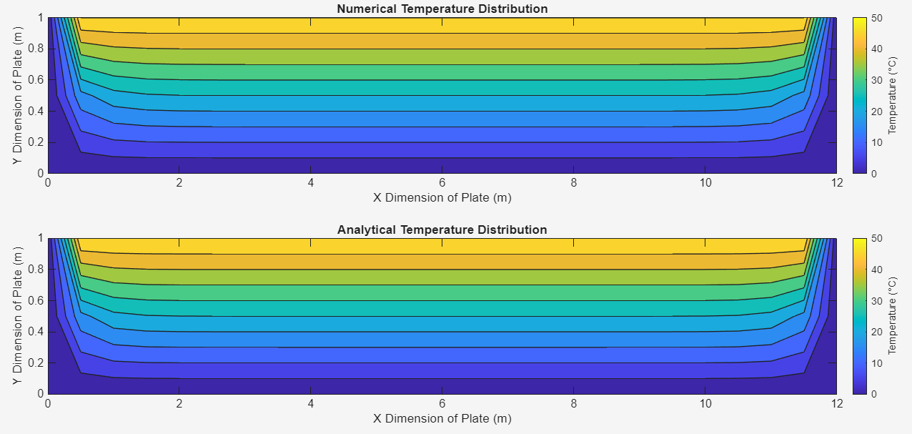
Figure 3 – Numerical and Analytical Temperature Distributions for Plate Elongated in X Dimension
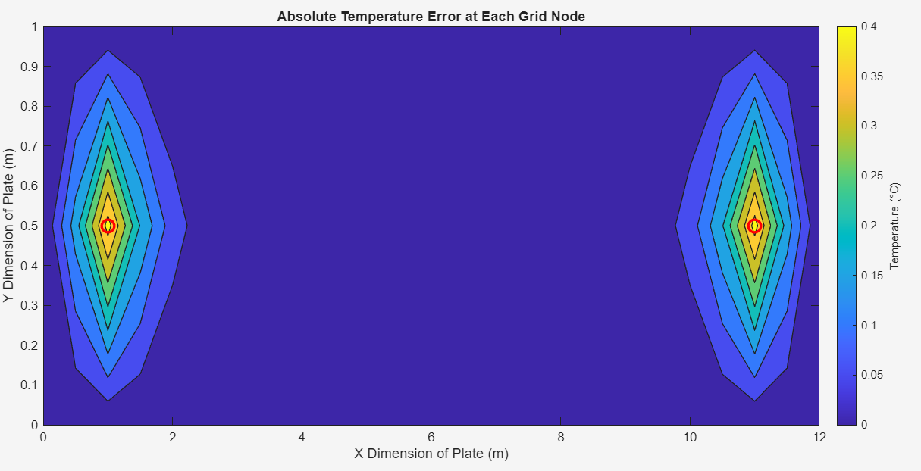
Figure 4 – Absolute Error Distribution for Plate Elongated in X Dimension
Finally, considered was a plate 1m x 12m, with a grid spacing of 0.5m and a time step of 500s. The numerical and analytical distributions are displayed in Figure 5. The maximum absolute error increased to 0.839°C, as shown in Figure 6, while the RMSE rose to 1.15e-1. This increase is attributed to steeper temperature gradients associated with the geometry, which intensify local discretisation errors. Nevertheless, the RMSE remained substantially smaller than the maximum error, confirming that inaccuracies are localised and that the numerical solution remains stable.
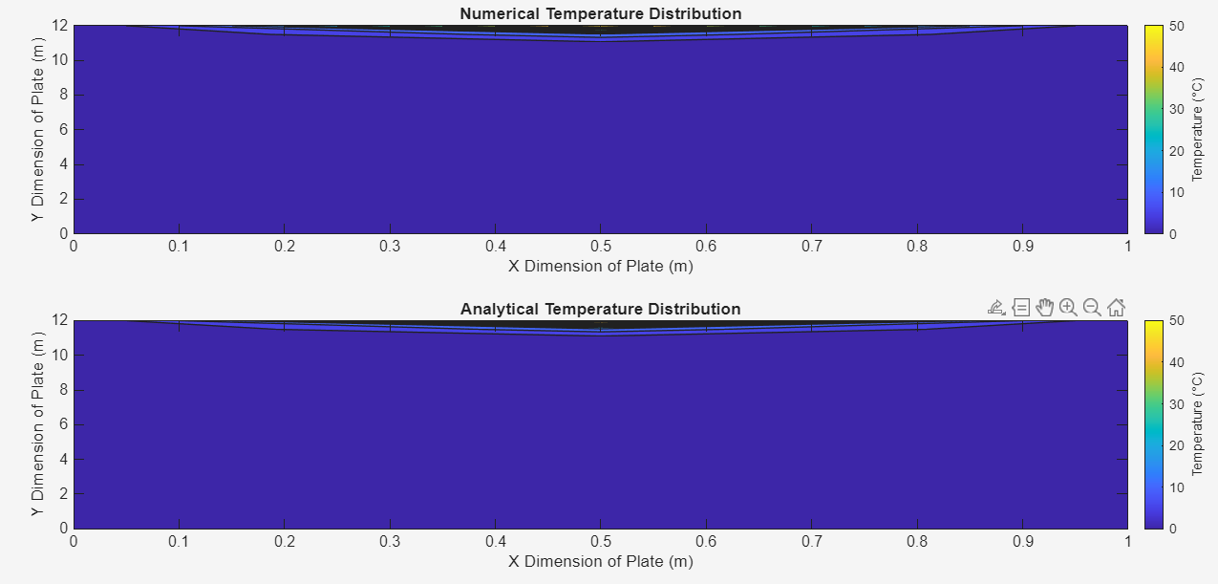
Figure 5 – Numerical and Analytical Distributions for a Plate Elongated in the Y Direction
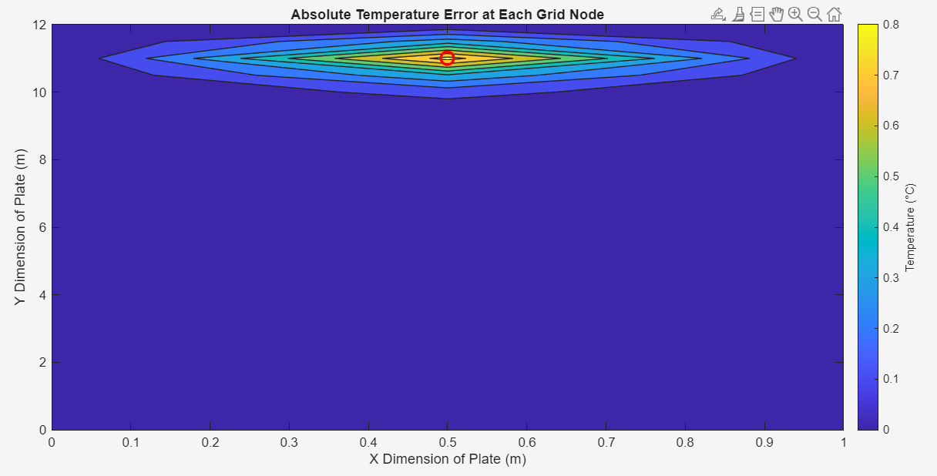
Figure 6 – Absolute Error Distribution for a Plate Elongated in the Y Direction

Sensitivity Analysis of Key Numerical Parameters

Grid Refinement Study
Figure 7 shows that increasing grid spacing leads to a modest increase in the time required for the numerical solution to achieve thermal equilibrium. This is attributed to the reduced resolution of the grid, which limits the solver’s ability to accurately resolve temperature gradients. There is a clear deviation from this trend at a grid spacing of 4 metres, it is theorised that this may be due to an insufficient number of nodes within the domain.
Figures 8 and 9 visualise the effect of grid spacing on numerical accuracy. For a second-order spatial discretisation, Recktenwald (2004) states that the truncation error is expected to scale as $O(h^{2})$, implying that halving the grid spacing should reduce the absolute error by a factor of four. However, this behaviour is not observed for any of the evaluated grid spacings, indicating that spatial truncation error is not the dominant source of error in these results
An unexpected observation is shown in Appendix 2, where the absolute error decreases from 1.262°C for a grid spacing of 3 metres, to 1.09°C for a grid spacing of 4 metres. This unexpected value is attributed to the insufficient number of computational nodes within the domain, leading to an over-smoothed temperature field causing misleading error estimates.
Figure 9 supports this conclusion, showing that the RMSE increases significantly for a grid spacing of 4 metres. As the grid is refined, errors become more localised, resulting in lower RMSE values but relatively unchanged peak errors.

Figure 7 - Effect of Adjusting Grid Spacing on Time to Reach Equilibrium

Figure 8 – Effect of Adjusting Grid Spacing on Absolute Error

Figure 9 - Effect of Adjusting Grid Spacing on RMSE

Time Step Refinement Study
The effect of time-step size on model output is shown in Appendix 3. Figure 10 visualises the relationship between time-step and time required for convergence, the graph shows that increasing time steps reduces the time required for equilibrium. This behaviour is expected, as larger time steps reduce the temporal resolution of the solution, limiting the model’s ability to capture the gradual reduction of temperature differences as it approaches equilibrium.
Figure 11 shows that smaller time steps result in increased absolute error. As the forward difference time discretisation is first order accurate, as explained by Recktenwald (2004), the truncation error is expected to scale linearly with the time step, this behaviour is not observed. This indicates that temporal truncation error is not the dominant source of error.
The elevated errors at small time steps suggest increased sensitivity to the convergence criterion. As the time step decreases, temperature changes between iterations decrease, causing premature convergence. For time steps between approximately 800-2000s, the absolute error remains stable, indicating a suitable balance between temporal resolution, stability, and convergence behaviour. RMSE trends, shown in Figure 12, mirror the absolute error, suggesting that errors at smaller time steps are also more widespread through the domain.

Figure 10 – Effect of Adjusting the Time Step on the Time Taken to Reach Thermal Equilibrium

Figure 11 – Effect of Adjusting the Time Step on the Absolute Error

Figure 12 – Effect of Adjusting the Time Step on the RMSE value

Convergence Criterion Refinement Study
Appendix 4 shows the results for the convergence criterion refinement study. Figure 13 shows that decreasing the convergence criterion increases the time required to reach thermal equilibrium, this is expected as additional iterations are required to satisfy a decreased convergence tolerance. Figures 14 and 15 demonstrate that decreasing the convergence tolerance reduces both the maximum absolute error and the RMSE value. This is consistent with theoretical expectations, as the analytical solution assumes true steady state. An increased convergence criterion allows premature convergence, leaving residual transient error distributed through the domain.

Figure 13 – Effect of Adjusting the Convergence Criterion on the Total Time Required to Reach Thermal Equilibrium

Figure 14 – Effect of Adjusting the Convergence Criterion on the Absolute Error

Figure 15 – Effect of Adjusting the Convergence Criterion on the RMSE Value

Limitations of the Numerical Model
Although the explicit finite difference model demonstrates stable behaviour and reasonable agreement with the analytical solution, the sensitivity analysis highlights several important limitations that limit its accuracy.
An obvious limitation arises from spatial truncation error. Although the spatial discretisation is second order accurate in theory, the grid refinement study shows that this behaviour is not seen for the grid spacings evaluated within this study. The lack of agreement between the theoretical expectation and the results gathered indicate an issue within the implementation of the numerical solution. Another potential reason for the disagreement could be an alternative source of error masking the truncation error, meaning the change in truncation error is masked.
The sensitivity analysis also exposes the influence of grid-induced smoothing on numerical error. Grid spacings that are overly large may artificially suppress local temperature gradients, leading to misleading reductions in peak error while simultaneously increasing global error measures. This demonstrates that error magnitude alone is insufficient to assess solution quality.
A further limitation arises from the explicit time integration scheme, which imposes strict stability constraints and limits temporal accuracy. Although first-order temporal truncation error would theoretically decrease with time step refinement, the time step study shows that reducing the time step increases the absolute error. This indicates that at smaller time steps non-truncation error sources are being amplified.
This behaviour is closely linked to round-off error accumulation and convergence sensitivity. As the time step decreases, temperature changes between iterations are also reduced, increasing the model’s susceptibility to numerical noise and causing the convergence criterion to be satisfied prematurely. This interaction between time discretisation and convergence logic, limits the effectiveness of time step refinement and introduces a dependency between numerical parameters that is not captured by truncation error theory alone.
The numerical definition of thermal equilibrium itself represents an additional limitation. Equilibrium is identified within the model by comparing temperature fields set apart temporally by $Δt$, against a fixed tolerance. The convergence criterion study shows that this approach can permit premature convergence, particularly when combined with small time steps, resulting in residual transient error. This indicates a disconnect between numerical convergence and the physical steady-state assumption used by the analytical solution.
Finally, the model is limited by its structured grid formulation and simplified boundary conditions. While suitable for validation against an analytical solution, this restricts model’s capability to utilise complex geometries, irregular boundaries, or non-homogenous materials, restricting its applicability to realistic engineering problems.

Suggested Improvements and Future Developments
While EFDM offers simplicity, the sensitivity analysis highlights several of its limitations, particularly in relation to stability constraints, truncation error behaviour, and geometric flexibility. A range of alternative numerical methods exist that can overcome these limitations and provide improved accuracy, robustness, and applicability to more complex thermal problems.
Recktenwald (2004) claims the Crank-Nicolson scheme possesses many benefits, including providing time-accurate solutions. Recktenwald (2004) explains that the truncation order for the scheme is $O\left(t^{2}\right)+O\left(h^{2}\right)$, a drastically reduced truncation error in comparison the forward difference approximation.
Another method of improvement would the use of a more robust definition of thermal equilibrium. Equilibrium may be identified through the monitoring of the norm of the time derivative or the energy balance of the system, as discussed by Bulíček et al. (2019). This would allow for the numerical solution to better approximate the plates temperature at steady state, through avoidance of premature convergence.

Conclusion
Presented in this report is the development and validation of an explicit finite difference model for two-dimensional transient heat conduction in a rectangular plate. Sensitivity analyses revealed that the accuracy of the model is strongly influenced by grid spacing, time-step size, and the convergence criterion. The predicted truncation error was not observed within the grid spacings analysed. The disagreement with the theoretical truncation error may indicate an issue with the implementation of the numerical solution or the presence of an alternative source of error. Overall, the results show the effectiveness and limitations of explicit finite difference methods, emphasising the importance of careful parameter selection.

Bibliography
Ali, Z., Addepalli, S., & Zhao, Y. (2025). Effective Thermal Diffusivity Measurement Using Through-Transmission Pulsed Thermography: Extending the Current Practice by Incorporating Multi-Parameter Optimisation. Sensors, 25(4). https://doi.org/10.3390/s25041139
Balsara, D. (1995). von Neumann Stability Analysis of Smoothed Particle Hydrodynamics Suggestions for Optimal Algorithms. Journal of Computational Physics, 121, 357–372.
Bulíček, M., Málek, J., & Průša, V. (2019). Thermodynamics and Stability of Non-Equilibrium Steady States in Open Systems. Entropy, 21(7). https://doi.org/10.3390/e21070704
Garcia, J. A., Störiko, A., Pittman, J., & Lanzafame, R. (2025). Taylor Series Expansion. In Modelling, Uncertainty and Data for Engineers (MUDE) Textbook (Numerical Modelling). Delft University of Technology. https://mude.citg.tudelft.nl/book/2025/numerical_methods/4-taylor-series-expansion.html?utm_source=chatgpt.com
Haque, M. N., Akter, R., & Mojumder, M. S. H. (2025). An Efficient Explicit Scheme for Solving the 2D Heat Equation with Stability and Convergence Analysis. Journal of Applied Mathematics and Physics, 13(07), 2234–2244. https://doi.org/10.4236/jamp.2025.137127
Narasimhan, T. N. (1999). Fourier’s heat conduction equation: History, influence, and connections. Reviews of Geophysics, 37(1), 151–172. https://doi.org/10.1029/1998RG900006
Neelan, A. G. (2023). Von Neumann Stability Analysis for Multi-level Multi-step Methods. http://arxiv.org/abs/2310.08274
Press, W., Teukolsky, S., Vetterling, W., & Flannery, B. (2007). Numerical Recipes: The Art of Scientific Computing (3rd ed.). Cambridge University Press.
Recktenwald, G. W. (2004). Finite-Difference Approximations to the Heat Equation.
Welt, B. A., Teixeira, A. A., Chau, K. V., Balaban, M. O., & Hintenlang, D. E. (1997). Explicit finite difference methods for heat transfer simulation and thermal process design. In Journal of Food Science (Vol. 62, Number 2, pp. 230–236). Blackwell Publishing Inc. https://doi.org/10.1111/j.1365-2621.1997.tb03974.x

Appendices

Appendix 1
%____Workspace Management____
close all
clear
clc

%____Defining the Physical Properties of the Plate___
k=143;
ro=2.8e3;
c=795;
alpha=k/(ro*c);

%____Requesting User to Input Plate Dimensions____
fprintf('\n Defining plate dimensions and Boundary Temperature \n Please ensure all inputs are in SI units \n\n');
prompt='Please input a positive measurement for X dimension of plate, in meters. \n';
Xdim=input(prompt);
while Xdim<=0
disp 'Please ensure X dimension is positive.';
Xdim=input(prompt);
end
promptb='Please input a positive measurement for Y dimension of plate, in meters. \n';
Ydim=input(promptb);
while Ydim<=0
disp 'Please ensure Y dimension is positive.';
Ydim=input(promptb);
end
promptd='Please input the desired grid spacing, in meters.\n';
h=input(promptd);
while rem(Xdim,h)~=0 || rem(Ydim,h)~=0
disp ['Please ensure the grid spacing is evenly divisible across the ' ...
' X and Y dimensions. \n'];
h=input(promptd);
end
while h<0
disp ['Please ensure the grid spacing is positive.\n'];
h=input(promptd);
end

%___Requesting the User to Input the Desired Boundary Temperature____
promptc='Please input the desired boundary temperature along North boundary, in degrees celsius.\n';
T0=input(promptc);

%____Compute Rows and Colomns___
Cols=Xdim/h+1; %0:h:Xdim
Rows=Ydim/h+1; %0:h:Ydim
x=linspace(0, Xdim, Cols);
y=linspace(Ydim,0, Rows);
TempMatrix=zeros(Rows,Cols);
TempMatrix3=TempMatrix;%required for the analytical solution

%____Initial Boundary Conditions____
TempMatrix(1,2:Cols-1) = T0;
TempMatrix(end,:) = 0;
TempMatrix(:,1) = 0;
TempMatrix(:,end) = 0;
TempMatrix2=TempMatrix;

%____Requesting User Input for Time Step____
tsmax=h^2/(4*alpha);
fprintf('\nMaximum recommended time step is %.3f \n\n', tsmax);
ts=input('Please input the desired time step, in seconds. \n');

%___Defining the Stability and Convergence Criterions____
F0=(alpha*ts)/h^2; %stability criterion
while F0>0.25
disp ('Time step is too large, please ensure it satisfies the stability criterion');
fprintf('\n\n Maximum recommended time step is %.3f \n', tsmax);
ts=input('Please input the desired time step. \n');
F0=(alpha*ts)/h^2;
end
CC=0.001; %convergence criterion
maxDV=CC+1;

%____Forward Difference Method for Numerical Solution____
maxiter=1e6
iter=0;
while maxDV>CC && iter<maxiter
for i=2:Rows-1
for j=2:Cols-1
TempMatrix2(i,j)=F0*(TempMatrix(i-1,j)+TempMatrix(i+1,j)+TempMatrix(i,j+1)+TempMatrix(i,j-1)-(4-(1/F0))*TempMatrix(i,j));
end
end
MD=abs(TempMatrix2-TempMatrix);
maxDV=max(max(MD));
TempMatrix=TempMatrix2;
TempMatrix2 %Display the temperature at each node at every time step
iter=iter+1;
end
if iter==maxiter
disp('Maximum iteration count reached without convergence.');
end

%____Defining the Units to be Displayed____
ttotals=iter*ts;
ttotalm=ttotals/60;
ttotalh=ttotalm/60;
ttotald=ttotalh/24;
if ttotals<60
fprintf('\nEquilibrium achieved in %.6f seconds.\n', ttotals);
elseif ttotals>=60 && ttotals<60*60
fprintf('\nEquilibrium achieved in %.3f minutes (%.6f seconds).\n',ttotalm,ttotals);
elseif ttotalm>=60 && ttotalm<24*60
fprintf('\nEquilibrium achieved in %.3f hours (%.6f seconds).\n',ttotalh, ttotals);
elseif ttotalh>=24
fprintf('\nEquilibrium achieved in %.3f days (%.6f seconds). \n',ttotald,ttotals);
end

%____Plotting the Numerical Distribution____
figure('Name','Temperature Fields');
tiledlayout(2,1);
nexttile;
contourf(x,y,TempMatrix2);
cb = colorbar;
ylabel(cb,'Temperature (°C)');
title('Numerical Temperature Distribution');
xlabel('X Dimension of Plate (m)');
ylabel('Y Dimension of Plate (m)');

%%_______Analytical solution_______
Nterms = 1000;
coeff=4*T0/pi;
for i=1:Rows
for j=1:Cols
if i==1 && j>1 && j<Cols
TempMatrix3(i,j)=T0;
elseif i==Rows||j==1||j==Cols
TempMatrix3(i,j)=0;
else
sumSeries = 0;
for n = 0:Nterms
k_n = 2*n + 1;
numerator=exp(k_n*pi*(y(i)-Ydim)/Xdim)-exp((-k_n)*pi*(y(i)+Ydim)/Xdim);
denominator=1-exp(((-2)*k_n*pi*Ydim)/Xdim);
term=(1/k_n)*sin((k_n*pi*x(j))/Xdim)*(numerator/denominator);
sumSeries = sumSeries + term;
end
TempMatrix3(i,j) = coeff * sumSeries;
end
end
end

%_____Plotting the Analytical Distribution_____
nexttile;
contourf(x,y,TempMatrix3);
cb = colorbar;
ylabel(cb,'Temperature (°C)');
title('Analytical Temperature Distribution');
xlabel('X Dimension of Plate (m)');
ylabel('Y Dimension of Plate (m)');

%_____Absolute Error_____
error = abs(TempMatrix2 - TempMatrix3);
maxerror=max(error(:));
tol=1e-9*maxerror;

%____Plotting the Absolute Error____
figure('Name',('Absolute Error Field'));
contourf(x,y,error);
cb = colorbar;
ylabel(cb,'Temperature (°C)');
title('Absolute Temperature Error at Each Grid Node');
xlabel('X Dimension of Plate (m)');
ylabel('Y Dimension of Plate (m)');
xlim([0 Xdim]);
ylim([0 Ydim]);
drawnow
hold on
[row,col]=find(abs(error-maxerror)<tol);
fprintf('\n\n Location and Magnitude of Absolute Error \n');
fprintf('Number of locations with max error:%d\n',length(row));
for k=1:length(row)
xcoord=x(col(k));
ycoord=y(row(k));
fprintf('Location %d: x=%d, y=%d.\n',k,xcoord,ycoord);
plot(xcoord, ycoord, 'ro','MarkerSize',10,'LineWidth',2);
end
hold off
fprintf('Magnitude of absolute error: %.3f °C\n', maxerror);

%_____Displaying Temperature Distributions for review of Error____
TempMatrix2
TempMatrix3
error

%_____Computing the RMSE_____
RMSE=rmse(TempMatrix2, TempMatrix3, "all");
fprintf('RMSE =%.6e\n',RMSE)

%____Estimating the Round-Off Error____
TempMatrix_double = TempMatrix2; % your normal solution
TempMatrix_single = double(single(TempMatrix2)); % simulate single precision
roundoff_estimate = abs(TempMatrix_double - TempMatrix_single);
max_roundoff = max(roundoff_estimate(:));
fprintf('Estimated round-off error (max) = %.3e °C.\n', max_roundoff);

%____Estimating the Truncation Error____
truncerror=zeros(Rows,Cols);
for i=2:Rows-1
for j=2:Cols-1
dTdt=0; %steady state
d2Tdx2=(TempMatrix3(i,j+1)-2*TempMatrix3(i,j)+TempMatrix3(i,j-1))/h^2;
d2Tdy2=(TempMatrix3(i-1,j)-2*TempMatrix3(i,j)+TempMatrix3(i+1,j))/h^2;
truncerror(i,j)=dTdt-alpha*(d2Tdx2+d2Tdy2);
end
end
maxtruncerror=max(abs(truncerror(:)));
fprintf('The maximum value for the estimated local truncation error is %.6e °C.\n',maxtruncerror);

%____Plotting the Numerical Error Estimations____
figure('Name','Numerical Error Fields');
tiledlayout(2,1);
nexttile;
contourf(x,y,(abs(truncerror)));
cb=colorbar;
ylabel(cb,'Temperature (°C)');
title('Estimated Local Truncation Error');
xlabel('X Dimension of Plate (m)');
ylabel('Y Dimension of Plate (m)');
xlim([0 Xdim]);
ylim([0 Ydim]);
nexttile
contourf(x,y,roundoff_estimate);
cb=colorbar;
ylabel(cb,'Temperature (°C');
title('Estimated Round-off Error');
xlabel('X Dimension of Plate (m)');
ylabel('Y Dimension of Plate (m)');
xlim([0 Xdim]);
ylim([0 Ydim]);

Appendix 2
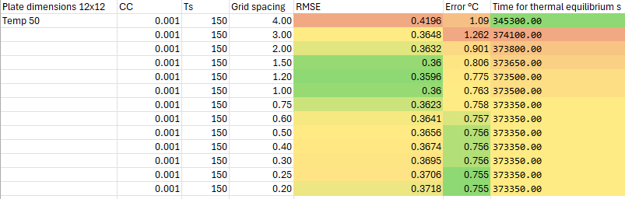

Appendix 3
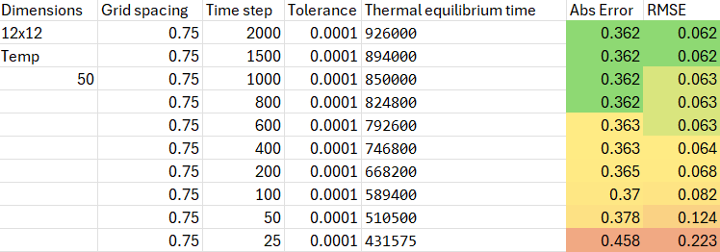

Appendix 4



