
Reflective Portfolio
Module CODE: BMSW 4005_BIRM
Costel andone 2027240
LECTURER: OLUBUCOLA ADEGBITE

Table of content
1. Abstract……………………………………………………………………………….….…...2
2. Skills evaluation using Johari Window method……………….………………………2
3.Personality Test…………………………………………………….….…………………….3
4.Theories and methods for learning.……………………………………………..............4
4.1. Honey and Mumford Learning Styles……………………………….….....................4
4.2 Kolb’s learning styles…………………………………………………………………….6
5. My learning styles…………………………………………….…………………………….9
6. Reflection on my own learning………………………………………………………….10
7.References……………………………………………………………………………….….13

1. Abstract
In this Reflective portfolio I will talk about the module I finished, which is called Personal Development Plans. I will assess my skills and competencies using Johari Window and Personality test, methods I have learned in this module. I will also talk about how I will evaluate my staff training and development where I will work as a manager in my organization.
2. Skills evaluation using Johari Window method (Figure 1).

Figure 1: Johari Window method.
1.OPEN SELF  Positive, Funny, intermediate level of English, Friendly. | 2.BLIND SELF  Not productive in groups.
3.HIDDEN SELF  Fear of closed spaces,  manipulative intentions,  I learn new things harder,  my hobby is photography and painting. | 4.UNKNOWN SELF

2.1. OPEN SELF
In Quadrant 1 also known as the area of free activity, there are information about me.

2.2. BLIND SELF
In Quadrant 2 is the blind area where there is information that a group has about the the person, but that person does not know about it.

2.3. HIDDEN SELF
In Quadrant 3 known and hidden area refers to what we know but others do not know. Is information and feelings about that person.

2.4. UNKNOWN SELF
This area is also called the unknown area where there is information, experience skills and feelings, unknown to the person himself and unknown to the other members of the group.

3. Personality Test
It is a tool that indicates a person's predisposition to behave and act in certain situations.
Below is the test I did, and my personality as a result is that of a Mediator (Figure 2).

FIGURE 2: Personality Test
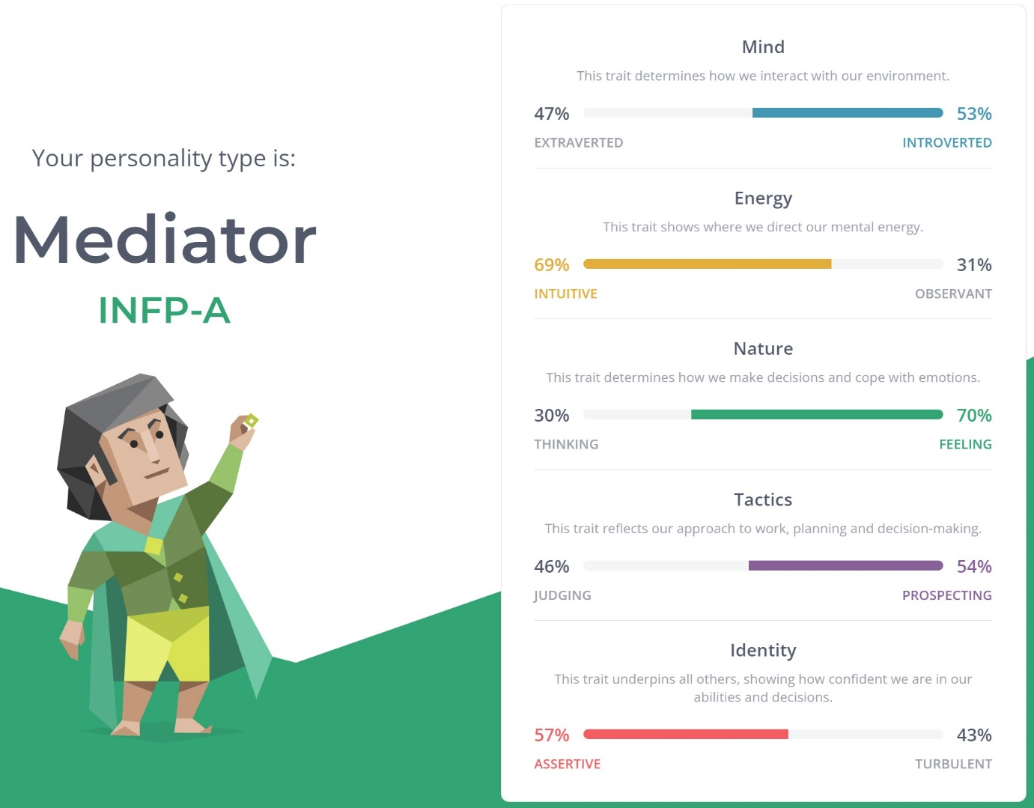
Source: https://www.16personalities.com/free-personality-test

4. Theories and methods for learning.
Learning styles are methods of contested and competing theories that aim to find out what those differences are in people's learning. Most theories say that people can be classified according to their learning style, it is certain that the methods in which styles should be defined, evaluated, and classified.

4.1 Honey and Mumford Learning Styles
Honey and Mumford have identified four different ways of learning that people prefer to learn.

They are:
a) activists,
b) reflectors,
c) theorists,
d) pragmatists.
These learning styles are like a continuum according to the two Mumford and Honey that a person moves through time (Figure 3).

Figure 3: Honey and Mumford Learning Styles
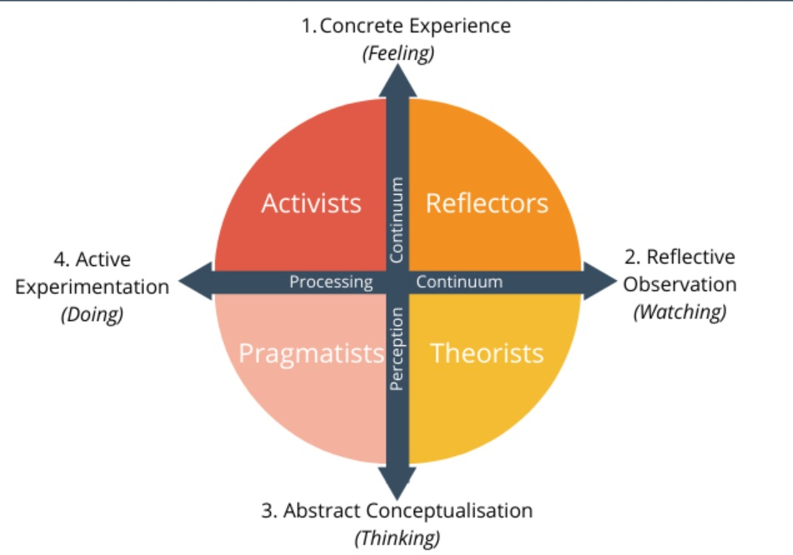
Source: https://expertprogrammanagement.com/2020/10/honey-and-mumford/

These Honey and Mumford learning styles are largely based on the Kold learning cycle.
The perception continuum is the vertical axis, it refers to how we emotionally feel about a task, how we feel or think about it.
They also created a questionnaire through which anyone can complete it and find out their personal learning style.
a) Activists
These activists learn best by doing things. They like to learn new things, get their hands dirty, and are very excited about doing things like this.
b) Theorist
Theorists are those who understand and learn the theory behind why a thing is the way it is. Facts and concepts are those methods that they need to learn effectively.
c) Pragmatist
These people like that what they learn can be applied in the real world. Look for ways to use and apply the ideas learned and even put them into practice immediately.
d) Reflectors
They are the people who learn best when they observe other people and then reflect on what they have noticed.
They would rather look inside than jump right in.

4.2 Kolb’s learning styles.
David Kolb published the Learning Styles Model in 1984. It is also known as the Experimental Learning Model.
His theory works on two levels: A cycle that has four stages followed by four different learning styles (Figure 4).

Figure 4: Kolb’s Learning Style.

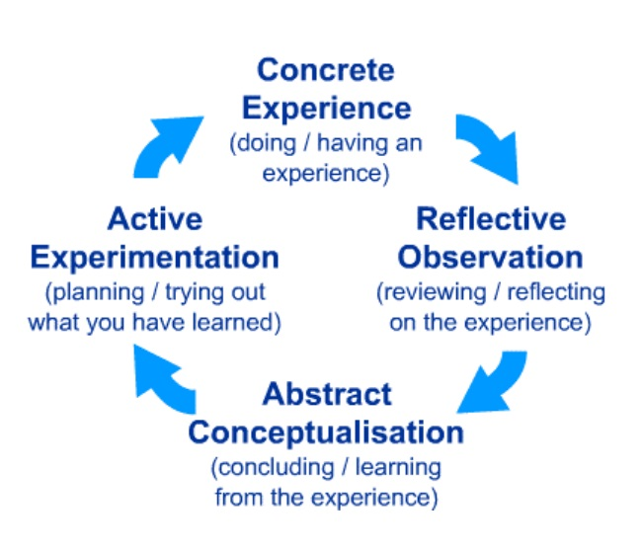
Source: https://midatlantic.compact.org/wp-content/uploads/large/sites/61/2021/04/Kolb-Learning-Styles-Website.pdf

a. Concrete Experience - A new situation or a common experience, a readjustment of the current experience.
b. Reflective Observation of the New Experience - this is about the importance of disagreement between experience and understanding.
c. Abstract conceptualization - the birth of a new idea following the reflection or a transformation of an existing concept.
d. Active experimentation - The ideas already existing the student tries to apply them to see what is happening.
Any individual learning style is a fusion of two favourite styles. Basically, the four learning styles are highlighted in this matrix which are: diverging, assimilating, and converging, accommodating (Figure 5).
Figure 5: Kolb’s Learning Style.

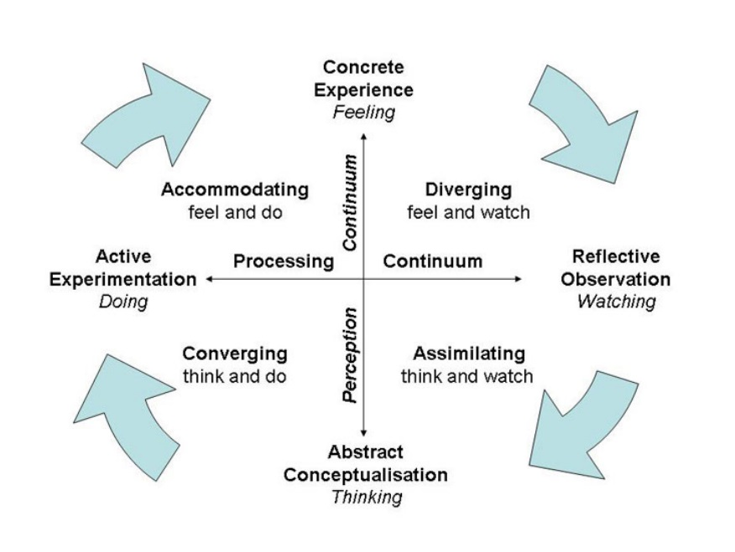
Source: https://midatlantic.compact.org/wp-content/uploads/large/sites/61/2021/04/Kolb-Learning-Styles-Website.pdf
Diverging
They can see things differently than others. They gather information and solve problems using their imagination.

Assimilating
These people want a clear explanation, and the ideas and concepts are much more important than the people. They are not attracted to approaches based on practical significance, but rather on logical and solid theories.
Converging
These people are more concerned with finding solutions to practical problems than they are with other people and some interpersonal issues. They like practical things and experiment with new ideas.
Accommodating
This learning style is based on intuition.
They do not like to make their own analyses of problems but rely on other people's information.
Attracted by new experiences and challenges as well as their completion.
5. My learning styles.
As a manager in my organization, I chose the two learning styles: Honey and Mumford and Kolb's Learning Style. After completing the questionnaire created by Honey and Mumford, I found my learning style to be Visual (Figure 6).

Figure 6: My personal Learning Style.
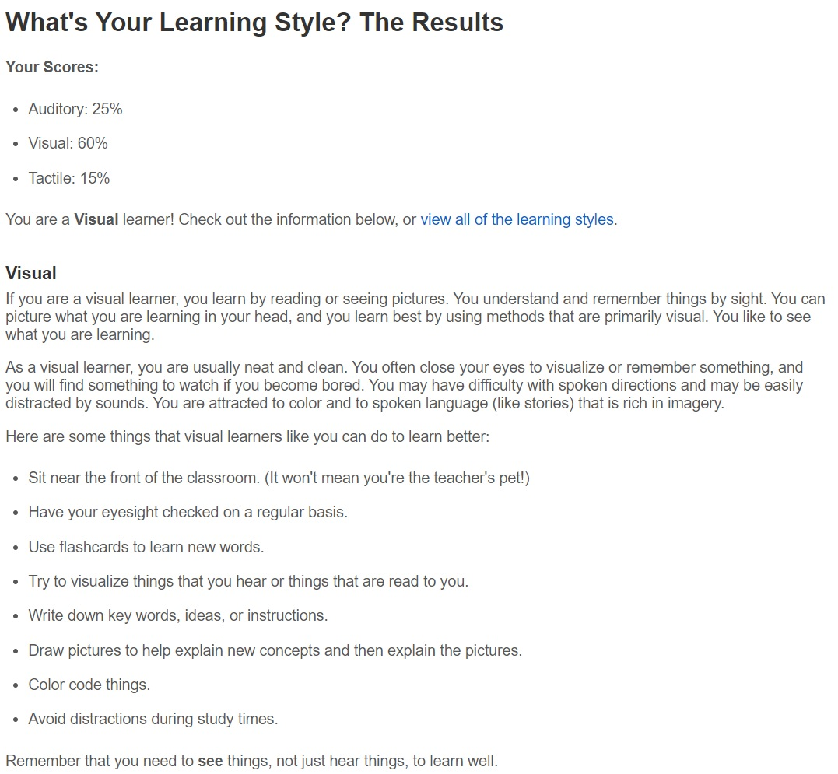

Source: http://www.educationplanner.org/students/self-assessments/learning-styles-quiz.shtml

6. Reflection on my own learning
Description
The purpose of this report on my own learning is to write down what happened to that mock interview model, which tested my skills and abilities to get a job as a forklift trainer.
At this interview, I applied for the position of forklift trainer, and the one who interviewed me was my university lecturer.
It is based on my observations this reflective report of what I did, and how I presented myself at that mock interview, and the answers I gave.

I have been working as a forklift driver for six years at a well-known company both in the UK and around the world, and I still work for it. I wanted to prepare very well for this mock interview.

To express my feelings, to describe what happened, I will use the reflection based on Gibbs Reflective cycle.
Feelings
My feelings before the interview were very positive because I prepared quite intensely, especially since I really wanted this job.
Another aspect to consider is the fact that I already knew the one who was going to interview me, a fact that gave me a little confidence but also anxiety because I didn't want to disappoint her.
We still have emotions, I didn't know how this interview would go, but the fact that I had already worked in this field for six years made me feel motivated and confident in my abilities.
After the interview I felt pretty good because from my point of view it was good, I answered almost all the questions well.

Evaluation
The evaluation of this mock interview was emailed to me by the lector who interviewed me after the meeting.
I'll start with what was good about this mock interview first, namely the positive parts.
PROS
I was decently and formally dressed, as required to attend such a meeting, I maintained eye contact throughout the meeting, and the posture, hands, and facial expressions were as natural as possible.
CONS
Some answers were not complete, due to emotions that were unfortunately quite high.
Another negative part that the person who interviewed me told me about is that I didn't use the STAR method often enough in this interview.
Yet another aspect is that the level of English speaking in my country is not quite advanced.
Analysis
In my opinion, this experience of the interview had positive and negative aspects.
I will continue to try to explain to understand why this interview had those positive parts but also the negative ones.
In my opinion, the fact that I have already been working in this field, that is, I have been working as a forklift driver for six years, had a good impact on the person who interviewed me, my motivated presence, the fact that I always had a smile on my face, and I answered all the questions, I think it had a positive impact in this interview.
Personally, I believe that due to my English-speaking level, this interview was not at the level that my interviewer expected.
In addition to this, the emotions were also present, which led to some not so complete answers from me and to have a good impact on the person who was interviewing me.
Another aspect to consider is that I didn't really use that well-known STAR method, which led to a lower score in this interview.

Conclusion
All things considered; I believe that what happened in this interview made me consider certain aspects that did not work as I would have liked.
After the experience I had in this interview, I learned that I must try to control my emotions, which do nothing but sabotage me in giving the right answers.
Secondly, the fact that my English conversation level is not at an advanced level means that my answers are not high enough.
All things considered, I think that to improve these negative aspects, first to improve my conversational level of English both written and read, as well as mastering emotions by speaking more often in front of other people, or group oral presentations at who have to speak in front of other colleagues.
I strongly believe that advancing to a higher level of English will give me the much-needed confidence in such an interview, and the emotions will not be the same as before.
Action Plan
As an action plan to improve my English language skills and my level of emotion, I will start by enrolling in intensive English speaking and writing courses offered by the university where I am a student, and as an action plan for controlling emotions I want to speak as much as possible in front of other people, group presentations and even scheduling various job interviews.
I will monitor all this through feedback from other colleagues and lecturers at the university, as well as the results offered after the job interviews.
If I had the opportunity to repeat this experience of the interview, I think I would be much better prepared for the answers I am going to say.

3.References

Buch, K. and Bartley, S., 2002. Learning style and training delivery mode preference. Journal of workplace learning.
Gibbs' reflective cycle (1988) as cited in Jasper (2013) shows that... Gibbs' reflective cycle is a seminal theory in reflective practice (Gibbs, 1988, as cited in Jasper, 2013).
Honey, P. and Mumford, A. (1992) The manual of learning styles. 3rd ed. Maidenhead: Honey.
Honey, P. and Mumford, A. (1995) Using your learning styles. 3rd ed. Maidenhead: Honey.
Kärtner, J. and Collins, W.A. (2012) The development of mirror self-recognition in different sociocultural contexts. Oxford: Wiley-Blackwell.
Lawrence, P. (2008) ‘Reflecting on events: PAT LAWRENCE uses the Gibbs reflective cycle to explain how the care he provides can be improved’, Emergency nurse, 15(9), pp. 16–18. doi:10.7748/en2008.02.15.9.16.c8175.
McLeod, S., 2017. Kolb's learning styles and experiential learning cycle. Simply psychology, 5.
Oliver, S. and Duncan, S. (2019) ‘Editorial: Looking through the Johari window’, Research for All, 3(1), p. 1–. doi:10.18546/RFA.03.1.01.
P.T. Ravindran and V. Gopakumar (2006) ‘Exploring the Conceptual Framework of Johari Window: Ingham and Luft’s Johari Window Model - for Self-awareness, Personal Development, Group Development and Understanding Relationships’, i-Manager’s Journal on Management, 1(3), p. 52–.
Ryan, T. (2018) ‘Johari Window’, The SAGE Encyclopedia of Educational Research, Measurement, and Evaluation.
Sadler-Smith, E., 1996. ‘Learning styles and instructional design. Innovations in Education and Training International, 33(4), pp.185-193.
Tran, X. et al. (2017) ‘Learning Styles, Motivation, and Career Choice: Insights for International Business Students from Linguistic Inquiry’, Journal of teaching in international business, 28(3-4), pp. 153–167. doi:10.1080/08975930.2017.1384949.

