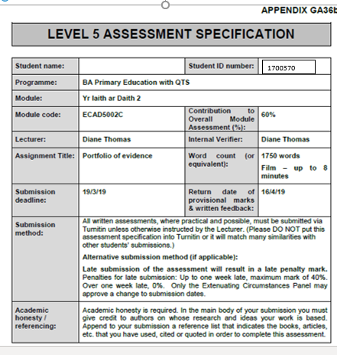

Portfolio of Evidence
Task 1 - Rationale
Numerous approaches to teaching and learning languages have been anticipated and applied in the classroom setting. However, the remaining question is that of which is the best approach to learning a language. During Professional Teaching Experience (PTE) I had the opportunity to promote children learning Welsh in a Year 2 class, I did this through the medium of a story. I chose the Fflic a Flac book ‘Parti’r Adar’ due to the fact that the children were familiar with the book series and it related to the animal topic that the children were undertaking in Welsh. The learning objective for my activity was to communicate by using pictures, words, phrases and short sentences; WAG (2015) states in the writing strand of the Foundation Phase Framework that children should be given the opportunity to ‘communicate through pictures, words, phrases and short sentences.’ Using language in the classroom promoted the school’s Welsh ethos, the school is currently working towards achieving the Bronze award in the Siarter Iaith Cymraeg Campus, so the more Welsh that the children were using on a regular basis meant that they were familiar with the language. ERW (2019) mentions that the aim of the Cymraeg Campus Language Charter is to ‘increase the use of Welsh in English medium schools.’ The activity promoted several language skills such as writing, as the children were writing several short sentences after we had practiced the sentence patterns. Reading skills were promoted due to the children reading the Fflic a Flac story which allowed them to become familiar with the book’s key words and oracy skills were promoted as the children were given opportunity to answer questions verbally in Welsh.

Task 2 – Activity Video
https://www.youtube.com/watch?v=W0Or0qqMOOc&feature=youtu.be

Task 3: A written reflection of task 2 (up to 1500 words)
The Welsh Language is the ‘essence of Welsh identity’ for many people in Wales (Davies, 2014). However, it is argued that there is an issue regarding the number of Welsh speakers in Wales today. Throughout the 20th Century, the census presented a ‘steep drop from just under a million Welsh speakers to around 500,000 in the 1990s. The number seems to have now stabilised’ (Somers, 2017). This perhaps hides the true decline of Welsh, even though the number of speakers has ‘stabilised’ and is not visibly decreasing, the population is increasing, indicating that the percentage of Wales that speaks Welsh is declining. The Cymreig 2050 - a Million Welsh Speakers (2017) sets out the Welsh Government’s aim to tackle the declining language by acquiring one million Welsh speakers by 2050. The strategy acknowledges the Education sector’s crucial role in ensuring that Wales meets its’ aim. Whilst on Professional Teaching Experience (PTE), I aimed to use Welsh with the children in my class regularly to familiarise them with the language. If children are practising Welsh frequently, it will benefit their language acquisition. Donaldson (2015) mentions how there are strong cognitive benefits for becoming bilingual.
According to the Welsh Government in ‘Evaluating the Foundation Phase Key Findings on Welsh Language’ (2014), 42% of classroom teachers agreed that the introduction of the Foundation Phase showed an improvement in children’s Welsh language skills.’ I chose to undertake my activity in this phase to see if it does in actual fact promote language learning opportunities. When considering the effectiveness of language learning approaches for children, reading stories appeared to be beneficial. In addition to the children being familiar with the story ‘Parti’r adar’ and the animal topic, stories can help children to discover and make sense of the World. Hood and Tobutt quote that ‘language learning should not happen in a vacuum, but should be connected to the class context in as meaningful way as possible’ (Hood, Tobutt, 2015: p.67). The story was relevant to the class’ animal topic which meant that learning was not meaningless. Reading stories can increase children’s knowledge and help them understand the world around them while also ‘promoting language acquisition’ (Horst, Price, 2016: p.5). Reading books is a familiar occurrence for many children, therefore introducing children to a Welsh story book was not too ‘out of the ordinary’. Learning a language can sometimes prove difficult for children, so promoting language learning through a medium which they are familiar with can help. Hood and Tobutt point out that we can mirror how we use stories in English with a second language (Hood, Tobutt, 2015: p.72). While reading with the children, I noticed how immersed they were with the storyline, even though they were not fluent in the language. Learning to read can also help children to connect with their culture and society. Consequently, reading in Welsh could make children subconsciously aware of the culture in Wales. Lightbrown and Spada support this by claiming that reading gives a ‘major boost to metalinguistic awareness’ (Lightbrown, Spada, 2013).
After identifying the colours of the birds in the story, I wanted to make sure that each child was confident in using Welsh vocabulary to describe the colours. I wrote each of the colours in Welsh and asked the children to identify what the colours were in English. Following this, I used a repetition strategy. By modelling the Welsh colours to the children, they were able to pick up on the pronunciation that I had used. This gave them chance to imitate the words, which in turn helped with their pronunciation. Garton states that ‘models are a form of assistance adults can provide for language learning children’ and that children are ‘expected to learn from the adults correct language use’ (Garton, 1995: p.49). At the beginning of the activity, some children were not familiar with all of the Welsh colours but by the end, their confidence and knowledge had improved, this may have been due to them being exposed to a variety of new words repetitively. Lieven and Tomasello (2008) support this by affirming that ‘children learn languages through their language experiences- there is no other way.’ If I had not modelled the pronunciation of the new words, then the children could have potentially used the words incorrectly. It could be argued that exposing children to new Welsh words can result in furthering their second language acquisition due to them being aware of new sets of vocabulary. The Welsh vocabulary used in the lesson can be seen in Appendix 1. Spada and Lightbrown state that ‘vocabulary grows at a rate of 1000 words per year’ (Spada, Lightbrown, 2013). Beforehand, the children were not aware of the Welsh words for white and black but by the end of the session they were confident. By asking the children to repeat the colours after me, it helped them to retain the new information and knowledge that they had acquired. Repetition is used as a strategy in the behaviourist theory. According to Pound (2006) the behaviourist approach is responsible for teaching methods which rely on word repetition. The Montessori Academy (2017) mentions how Montessori stated ‘repetition is the secret to perfection.’ Reflecting on my activity, I realised I had pronounced several words inaccurately which could have resulted in the children picking up on my incorrect language use. In future, it would be beneficial for me to make sure that my language use is correct, to avoid the children imitating improper vocabulary.
Another method of language learning that was implemented into my lesson was Task-based learning. The children matched cards together in pairs, using their Welsh vocabulary to help them complete the activity. The children matched pictures of colour birds with their corresponding colour word card. This activity was relevant to the children’s learning as they could use the Welsh vocabulary that they had acquired beforehand to help them to complete the task. Task based learning aims to ensure that all tasks are relevant. It promotes the children to learn through doing as there is a more hands-on approach. This is supported by constructivist Piaget as he ‘advocates learning as a construction’ and ‘encourages hands-on learning’ (Blake, Pope, 2008). While working in pairs or groups of three, I noticed that the children were learning from each other, putting each other’s knowledge together to match the cards. Working with other individuals can help pupils, as the child that they are working with may have knowledge that they themselves may not possess, this helps the children to not only complete the task co-operatively, gaining team work skills but also gain a new set of knowledge. This connects to constructivist Vygotsky’s concept of ‘Zone of Proximal Development’ (ZPD). According to Pound (2006), the ZPD is the gap between what a child can do by themselves and what they can do with the help of someone else, this being either an adult or a child. Children’s speech and communication skills can be advanced by working in pairs or small groups. This is in line with Vygotsky’s thinking, who states ‘talking is necessary to clarify important points but that talking to others helps us to learn more about communication’ (Pound, 2006: p.40)
Once the children had finalised the task of designing themselves as a bird and writing sentences such as what the name, age and colour they would be. This can be seen in Appendix 2. I asked questions to allow them to answer using familiar sentence patterns. I ensured that the children were comfortable answering questions as they will not learn if they are afraid of making mistakes. Barnes (2015) mentions that ‘questioning is part of the classroom culture’ and that ‘learning growth happens when children are not frightened to make mistakes. Asking children questions can be beneficial while learning a second language. As stated by Jafari (2014), questioning is one of the most vital skills in language learning. Jafari remarks that educators have long recognised how significant teacher’s questioning is and that it has an effect on children’s thinking skills. Whilst I was questioning, I was able to gain an insight on the children’s understanding of the work. Questioning is an element of Assessment for learning (AFL). The word ‘for’ in assessment for learning is crucial as the aim is to help the children with their next learning steps. Black and Wiliam (1998) were the first to come up with the phrase ‘AFL’, their aim was to raise children’s standards. By asking the children questions in Welsh, I was able to see the extent that they understood what had been taught. When I was able to see the level of understanding, I was to give feedback accordingly. On reflection, this aspect of the session was extremely teacher-dominated as I controlled asking the children questions. In order for children to gain passion able for the Welsh language, perhaps it is important to use Welsh in a social context while conversing with peers rather than in an apparent education situation. The Welsh in Education Action Plan (2017) aims to increase children’s use of Welsh in social contexts. Next time, I could encourage the children to ask each other questions.
To conclude, there were several benefits and weaknesses to the methods of teaching and learning languages that I used in my activity. Learning languages is complex and it is clear that there is not a single method that is completely effective. In future, I will make sure that my pronunciation and words are correct before modelling to the children to avoid them learning incorrect language. I will ensure that questioning techniques do not solely focus on my own questioning but involve the children too, promoting Welsh in a social context. I will continue to promote Welsh in schools using various methods, as learning languages is valuable to children. According to Estyn (2013) ‘language skills learned in one language should support the development of knowledge and skills in another’.

Reference List
- Welsh Government. (2015) ‘Foundation Phase Framework.’ Available at: https://learning.gov.wales/docs/learningwales/publications/150803-fp-framework-en.pdf (Accessed: 16th March 2019).
- ERW - Education through Regional Working (2019) ‘Cymraeg Campus Language Charter.’ Available at: https://www.erw.wales/schools/teaching-and-learning/language-charter/ (Accessed: 13th March 2019)
- Davies, J. (2014) ‘The Welsh Language- A History.’ Cardiff. University of Wales Press.
- Welsh Government (2017) ‘Cymraeg 2020: A million Welsh speakers: work programme 2017-21.’ Cardiff. Crown Copyright. Available at: https://beta.gov.wales/sites/default/files/publications/2018-12/cymraeg-2050-our-plan-for-2017-to-2021_0.pdf (Accessed: 13th March 2019)
- Donaldson, G. (2015) ‘Successful Futures.’ Crown Copyright. Available at: http://gov.wales/docs/dcells/publications/150317-successful-futures-en.pdf (Accessed: 12th March 2019)
- Welsh Government. (2014) ‘Evaluating the Foundation Phase- Key findings on Welsh Language.’ Available at: https://orca.cf.ac.uk/88991/1/140717-foundation-phase-welsh-language-en.pdf (Accessed: 9th March 2019)
- Hood, P, Tobutt, K. (2015) ‘Teaching Languages in the Primary School.’ Sage Publishing.
- Horst, J, Price, C. (2016) ‘An Open Book: What and How Young Children Learn from Picture and Story Books.’ Frontiers Publishing.
- Spada, N, Lightbrown, P. (2013) ‘How Languages are Learned 4th Edition.’ Oxford Handbooks for Language Teachers.
- Garton, A. (1995) ‘Social Interaction and the Development of Language and Cognition.’ East Sussex. Lawrence Erlbraum Associated Ltd.,Publishers
- Lieven, E, Tomasello, M. (2008) ‘Children’s First Language from a Usage Perspective.’ New York. Routledge.
- Pound, L (2006) ‘How children learn: Education theories and approaches from Montessori to Vygotsky- educational theories and approaches made easy.’ London. Practical Pre-school books.
- Montessori Academy. (2017) ‘Repetition and Child Development in Montessori Education.’ Available at: https://montessoriacademy.com.au/repetition-child-development-montessori/ (Accessed 16th March 2019)
- Blake, B, Pope, T. (2008) ‘Developmental Psychology: Incorporating Piaget’s and Vygotsky’s Theories in Classrooms.’ Available at: https://pdfs.semanticscholar.org/6c7b/9a7b4988df15c68a14434a5f162bef984723.pdf (Accessed: 15th March 2019)
- Barnes, J. (2015) ‘Cross Curricular Learning 3-14, Third Edition.’ London. SAGE Publications Ltd.
- Jafari, J. (2014) ‘The Role of Elicitation Questions in Language Learning.’ Hamburg. Anchor Academic Publishing.
- Black, P and Wiliam, D (1998) ‘Inside the Black Box: Raising Standards Through Classroom Assessment.’ London. GL Assessment.
- Welsh Government. (2017) ‘Welsh in Education: Action Plan.’ Cardiff. Crown Copyright. Available at: https://beta.gov.wales/sites/default/files/publications/2018-02/welsh-in-education-action-plan-2017%E2%80%9321.pdf (Accessed: 4th March 2019)
- Estyn. (2013) ‘Welsh Language Development in the Foundation Phase.’ Available at: https://www.estyn.gov.wales/sites/default/files/documents/Welsh%20Language%20Development%20in%20the%20Foundation%20Phase%20-%20January%202013.pdf (Accessed: 2nd March 2019)

Appendix
Appendix 1
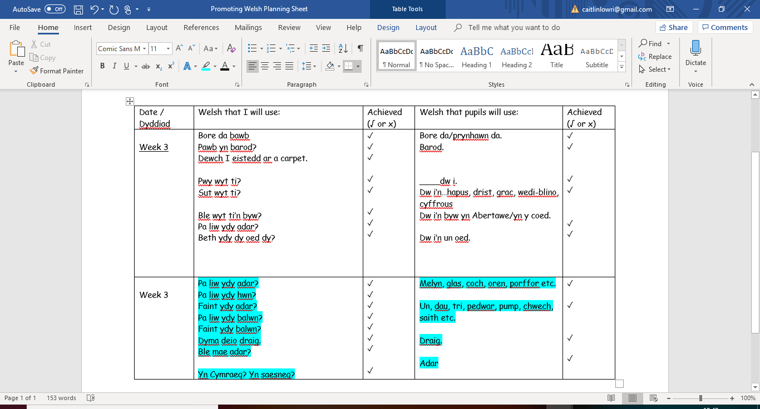
Appendix 2


