

NAME: SASI KIRAN NEELAM
STUDENT ID: 2126477
MODULE CODE: LCMB70001
MODULE: MARKETING MANAGEMENT
ASSESSMENT-1

TABLE OF CONTENTS

Introduction……………………………………………………………………………………………………………3
Company background…………………………………………………………………………………………….3
Communication Model…………………………………………………………………………………………..4
Shannon and weaver model…………………………………………………………………………………..5
Integrated marketing communication……………………………………………………………………6
Promotional strategy…………………………………………………………………………………………….7
Brand and Brand Equity………………………………………………………………………………………..9
Keller’s brand equity model…………………………………………………………………………………...10
Customer journey……………………………………………………………………………………………………12
Customer Touchpoints……………………………………………………………………………………………14
Customer Journey Map…………………………………………………………………………………………..16
Total engagement Model………………………………………………………………………………………..17
Conclusion and recommendation……………………………………………………………………………18
References……………………………………………………………………………………………………………..20

INTRODUCTION
The main aim of companies in this modern era has been changing and evolving from past years, in this competitive world, customers have a lot of alternatives and switching options. Recent trends have been observed Every Organization focuses on customer experience and touchpoints to maintain high standards to increase their customer satisfaction, customers mostly depends on direct or indirect contact, a good brand has shaped their customer experience by holding the fundamentals value in proportions by offering every single feature (Meyer, C Schwager A 2007) This report discusses and critically appraises the innovation in terms of marketing strategy and promotion, customer satisfaction, and brand awareness of Louis Vuitton and evaluating their Customer journey by different communication channels by fulfilling current and future requirements.

COMPANY BACKGROUND
In the year 1857 on the streets of the fashion capital Paris. Louis Vuitton from making luggage trunks and boxes to rule the luxury brand industry and setting up a category of high involvement products, especially in the fast-growing industry there are a lot of milestone activities taken Louis Vuitton to secure his brand identity from local duplications by attending the universal conference of fashion in 1857, in the early stages they opened their store in metropolitan cities like London in the year 1885 they expanded into various countries like India, USA.
Louis Vuitton has a history of 167 years of recognition as a status symbol of luxury items Hepburn’s speedy herself a fan of Louis Vuitton smart travel duffle, being an Oscar winner, it creates more impact on their accessories and people started noticing the brand in the emerging pop culture at that (Cassandra Gill 2021). LVMH owns Louis Vuitton and Dior, the topmost luxury brand with a conglomerate and a share of 59 billion USD by the year 2019. The current CEO of Louis Vuitton is Bernard Arnault stands in fourth of the world’s richest people and owns 74 brands and more than 17000 employees working around different corners of the world generating a revenue of 64 billion euros (2021) and more than 5500 + stores, having a strong share price of 693 euro with 75 mansions and 179 nationalities (www.lvmh.com)

COMMUNICATION

DEFINITION OF COMMUNICATION
The word “communication” is derived from the roots of Latin and has a meaning called “share” and to make “common” when we communicate we make things common the word communication related to sharing of opinions and thoughts through different types of mediums communication will be in both verbal, non-verbal, writing, along with that, different types of languages can be used in transferring the information the communication happens between one to one, one to group, and groups, (Karl Erik Rosengren 1999)
Communication is one of the most important things used as a tool to express our thoughts and words to build a strong relationship, and right communication builds a healthy environment in groups and in between two mutual persons.

SHANNON AND WEAVER’S COMMUNICATION MODEL
In the year 1994, the new age of communication has been taken place, on those years two persons named Claude Shannon and Warren Weaver mathematician and electrical engineer both are from the USA created and developed a most emerging model of communication and laid a stone for future communication models and this model gains a referral and called this model as MOTHER OF ALL models (David Ritchie 1986) in this modern era of 21st century some of the most important social media platforms like Facebook, Instagram, YouTube, Twitter, used as communication platforms, well coming to Shannon and Weavers model of communication it is a step by step process.
In the first step, the originator or creator of messages (sender) and then (encoder) turns that message into different signals parts, (decode) and it’s a reverse process for encoder collection of signals and turning them into a message for recipients, in between this process the disturbances will be happening called as (noise) at particular points and after the customers analyze the message and information inside and a response called feedback (David Ritchie 1986)

MESSAGE
RECEIVER
DECODE
ENCODER
SENDER

NOISE

FEEDBACK
RESPONSE

Source (David Ritchie 1986)

Most brands used this model for marketing to create a primary awareness of their products in the first step the sender (brand) or (advertiser) and the receiver is the market(audience or target market ) here the sender encodes the message and sent to the targeted market people via using various distribution channels called (radio, tv, social media, etc) and the targeted audience giving the response to that message that’s how communication works, but the drawback and the limitation here is huge noise.

INTEGRATED MARKETING COMMUNICATIONS
The rapid increase in media communications in this digital era increases in this 20th century leads to the emergence of IMC, the main reason for IMC is demand in technology, the companies use data collected from various types of customers engaging with them in various types of media platforms to communicate (Kitchen 2004)

This change made an impact and open a door for marketers and brands to reach their customers in more effective ways using various types of communication models there are new trends and new traditions observed in recent years, This method is highly effective reach out to the targeted audience and niche market (Kevin Lane Keller 2001) by using social media platforms and direct messaging or one to one emailing them to create an awareness of the current trends in the market to make them updated about their products, in the past years the traditional advertisements play a key role and now its new outbreak of electronic media most of the brands using websites and pop up messages and new billboard activities at popular crowded places (Kevin Lane Keller 2001)

Marketing communications is one of the main pillars while creating a promotion mix, the main aim is to create a strong niche market that has a loyal base of customers to establish their own identity, there are some specific tools used by companies to communicate with customers convincingly to establish a customer relationship, all the communication activities should be planned very well by company management to get a better results and feedback

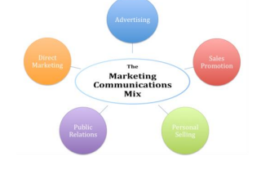
Source: (Kevin Lane Keller 2001)

NEW PROMOTIONAL STRATEGIES FOR LOUIS VUITTON GROUP

ONLINE PROMOTION:
In recent times the importance of digital media in the fashion industry showing a huge impact on consumer decision-making in terms of online availability, Louis Vuitton is facing issues and backwardness while providing quality output in the online portal the one-stop go policy is missing at various sections in the online platform. There are limited channels for distributing of goods in the online medium is one of the drawbacks, the counterfeit is the major problem facing by luxury industry, now new generations have adapted the internet more and likely to spend their money on luxury fashion majorly the age group of Millennials are the key targets for LV but at the end, there is an identical gap in online and offline because LV has high involvement products and the exclusivity and luxury showrooms all over the world people tends to believe the instore purchase is more elegant and more luxury when compared to online in below there are some ideas to promote Louis Vuitton to improve their digital marketing

Create a “luxuriant website” yes we all know that Louis Vuitton is a pioneer in instore experience giving huge luxury hospitality to customers and creating a luxury feel to the audience, here there is a mismatch in experience through online platforms the feel of shopping experience is decreasing in digital compare to other luxury brands Louis Vuitton is in back step, to improve this situation introduce Good UI experience for consumers making easy access and focus on different age groups and introduce the products for homes in website

Creating ONE TO ONE experience, having large brand fame to maintain the exclusivity of brand, create pre-booking session with fashion advisor and sales advisor to know better about the products, in this stage a New online shop meet that one stop for all questions like clothing perfume, Accessories, and footwear, to create a particular outfit from top to bottom. Creating a strong encrypted one to one video meet with company staff to get online customization, to ensure privacy and safety of the consumer, and it will decrease the company counterfeit problem this turns to advantage for the company.

Check-out
Meeting
Pre booking

Create a solid Virtual reality, in this particular step and introduce a strong virtual web application in that app each individual has created a virtual character that matches the physical appearance of the customer and the online designer staff suggests the greatest matches and creates a virtual 360-degree app to feel each corner of the store.`

OFFLINE PROMOTION
The in-store experience is the key factor that captures the customer’s attention for luxury goods it is more important because luxury goods are high price high cost like premium pricing only affordable by high society people so in that cases exclusivity play a key role every customer should feel special and unique while shopping in-store and create an extraordinary walk through from stores. Here are some of the offline promotional ideas I would suggest for Louis Vuitton

Followers of high-class fashion, have high expectations when choosing their shopping destinations keeping them loyal to luxury brands is possible through exceptional customer journey (Zsuzsa. K, 2022) even though Louis Vuitton doesn’t have a loyalty program surviving exceptionally in Global fashion market here is the idea to suggest for better offline experience Along with exclusivity increase the loyalty programs that increases long term relation with the customers for example create a tier levels based upon the purchase history of the customers and create a list of people from the past years who has more spenders and reward them with new products which is not available to other tier customers exclusively for tier1 customers which has lavish past purchase history and create separate lounge access or separate area for those high societal people within the store and all the products in those area or lounge doesn’t available either in online or offline stores, this prestigious option only for the top 50 spenders from the worldwide.

Creating effective campaigns, in recent times Louis Vuitton has a summer-spring campaign 2022 (LVMH.com, 2022) this is a bright campaign with star actors and mansion members from all over the world an exclusive collection of bags is a centre of attraction, and the advertiseme nt created by LV is unique and high production values and visual spectacular commercials, Louis Vuitton also focus on cultural importance advertisement from various parts of country, shoot them at various parts of global to increase the unity of fashion and diversity in culture meet them together in one commercial leads them a unique way of approaching a global audience. by watching these high-end commercials people tends to reflect themselves in those roles and feel some wanted desires about the particular products

The shopping experience in Louis Vuitton is always unique, because of the aura and the scented place with high fragrance and backend music makes the customers comfortable feel luxurious to shop and the giant trail rooms with a well fitted light source from each corner and organize a special shopping like giving them a well-mannered staff necessary suggestions and feedbacks, introduce a one-step portrait service to consumers who have high spending and give them a celebrity photoshoot to attract shop them again and again, invite the guests and give them a glass of LVMH champagne which was made by LVMH wines and spirits, and made them unique and feels the worth of their spending.

BRAND AND BRAND EQUITY:

BRAND:
A brand can be dined as “a name, term, sign, symbol, or design or combination of them which is tended to identify the goods and services of one seller or group of sellers and to differentiate them from those competitors (Keller, 1993) the identity and totality of the brand related to brand equity and it will interconnect to decision making of consumers in choosing the right product and brand is aware by the public at a conscious level and resonates with them in sub-conscious level, the brand is one of the strong benefits for any organization strong fame and strong quality of product creates a stronger identity (batey, 2012) brand creates identities and people create brand meaning by defining themselves and shaping their own identity and habits.

BRAND EQUITY
Brand Equity refers to, brand value or brand valuation, it defines a relationship between a brand and consumers, it is an intangible asset created by the companies to increase the choice of purchase based on quality and standards of products In the past years, consumer-based brand equity is a standard approach to brand equity due to their familiar strong, and favorable (Keller, 1993) nature easy to associate with them, and the attitudes and behavior patterns of the customers related to the brands which have an indirect significant impact on future profits and cashflows

Achieving a high brand strength is important to maintain a good relationship with customers a good brand has both positive and negative sides if the consumers have a favorite approach towards the company and products it shows a quicker absorption of new products in the market leads to generating of new financial profits in the similar way the brand has a negative impact the relationship with the consumers should see a drastic change in profits and leads to extensive costs in maintenance, for example, Louis Vuitton has strong positive brand equity in terms of the fashion industry because of their product quality, designs, premium pricing customer loyalty made them unique. Brand equity is one of the strongest intangible assets for Louis Vuitton, the decision of customers to choose a brand is based upon some of the intangible elements based upon name, fame, the value of the brand, heritage, and historical significance play a key role.

KELLER BRAND EQUITY MODEL:
The powerful brands create meaningful images in customers’ minds this theory is one of the most real contributions to the development of brand values, and certain theories were adopted by Kevin Lane Keller a professor in American discussing strategic brand marketing
This model shows the suitability and limitations of Keller’s customer-based brand equity model and the importance of why a company needs a brand identity and how consumers feel towards brand identity, if a company has a strong identity, it automatically gains a loyal base this model will help to know how to make strong brand identity and what makes a strong brand (Keller, 2001)

There are some sequences of steps to be considered in Customer based equity model each step should accomplish after the successful completion of each step there are four steps to accomplish this model here Keller uses a pyramid to segregate into four parts to create a strong brand image those are
- WHO are you? (About brand identity)
- WHAT are you? (Brand meaning)
- What about you? (response of brand )
- What about you and me (relationship with the brand)
This is a sequence of steps in a ladder manner like one should be accomplished to reach the next stage like we have to stick to the first step to create a strong identity

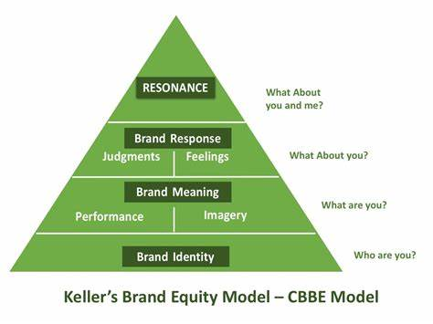
Source ( (Keller, 1993)

BRAND IDENTITY
Consumers should be aware and recognize or recall of brand is called brand identity, how frequently and instantly brand is evoked name at any circumstances many times brand identity linking with brand logo, symbol, name and hidden messages in the logo this will make a clear identification from the brands which were creating the same service of products from different categories (Keller, 2001) Louis Vuitton has a strong heritage background for the past 100+ years and they create a strong in the early days it says the name of the founder with eye catchy style letter L overlaps with V this monogram has strong identity symbolizes the power and money this logo (Maybatch, 2020)creates a huge all identity all over the world

BRAND PERFORMANCE:
This refers to how good the brand is performing, how effectively it will satisfy the customer needs, how people approach the brand, the product is the heart of the brand equity, and what consumers are hearing from others, consumer experience with the product must meet the product quality (Keller, 2001) we all know that Louis Vuitton product has exclusivity with premium quality lavish designs which satisfy the consumer need and desire, their innovations made them unique from others the LV has high primary characteristics and secondary features, products are durable, stylish and design, premium pricing BRAND IMAGERY,In 2016 Louis Vuitton partnered with UNICEF to support the vulnerable child (Haidar, 2016) around the world who are exposed to severe diseases and environmental responsibility and sustainability to reduce the emission of carbon (LVMH.com 20211)this will create the brand image of Louis Vuitton in the current market

BRAND RESPONSE: It refers to how the customers respond to the brand and its marketing activities it is based on brand judgments and responses and feelings, a judgment can be passed by customers based upon performance and imaginary associations (Keller, 2001) by going through various social media handles of Louis Vuitton the performance of brand is high based upon the responses in pages, most of the celebrities actor and actress wear LV designed wear for popular events like Oscars and red carpet and any premiers gains a huge response.

BRAND RELATIONSHIP: This is the final step of the model, a brand relationship which means the range of identification and personal emotional connection, nature of the relationship with the brand, and level of loyalty and repeats customers all these refer to brand relation (Keller, 2001) recently Louis Vuitton creates Customer relation management activity in Twitter called services, creating newsletters and initiated a phone call and messaging to customers called Icon and created a special event for high spending customers creating a trendy hashtag in social media platforms (Benjelloun, 2016) recently they launch a project of web experimental games to attract the younger consumers to experience the luxury (MCDOWELL, 2022)these all activities leads to a stronger relationship with the consumer.

ADVANTAGES AND DISADVANTAGES OF KELLERS BRAND EQUITY MODEL:
Some limitations will be raised like the emotional and self-experience don’t play a role in purchase decisions and the rest of them are quite useful for organizations that have been in the market for a long time it is very tough to apply those have been introduced into the market as a new entrant faces some problems in creating a strong pyramid (Bhasin 2016)

CUSTOMER JOURNEY:
In recent times the importance of the customer journey or customer experience increasing rapidly customer journey refers to the stages of the journey when a customer met with an organization it increases the customer experience, in the current time customer journey become an important tool for creating a strong relationship with customers, the effective nature of customer loyalty will be directly or indirectly influenced by brand attitudes ( (Kuehnl, 2019) through different channels of communications customers can interact with organizations by using different touch points and researchers has claimed that this customer journey is a new source of customer value in this 21st century (Lemon and Verhoef 2016) so every organization should develop a strong understanding of the importance of customer journey and customer experience

There are some stages in the customer journey where the sequence of steps to be threaded from step by step which is a strategical approach by turning the customers into strong promoters of a brand by focusing on promotion and choosing them to purchase products a

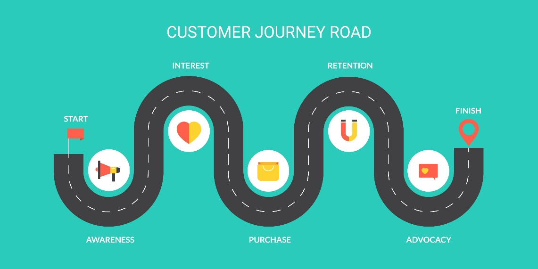

Creating interest:
In this stage where the buyers get to know about the products which are like creating a strong awareness to buyers about the products and brand, (bhasin, 2019) this will create an information like the product has been launched or the existence of products and the desire of customers about the products from a long time.

Information gathering: in this stage after the customer gets to know about the product he or starts collecting and gathering information about the product and then he/she tries too knows about the product and the facilities it was given and the features of the product. And how that product will add value and how good that product fits into their requirements

CONSIDERATION: In this third stage after gathering some information about the company the customers have an idea about the products and services of the company there is a chance of getting into the company website and social media pages to know more about the products this is the key step to be considered to grab the attention of the customer by providing valuable content about the and how they will relate to them.

Decision: In this stage where customers made a strong decision about their products and made decisions about purchasing products or services this is the key step where the organization maintains a hassle-free to do, this includes friendly natured staff and well-maintained web services about all the products in the organization including the products (bhasin, 2019)

LOYALTY: In this stage, the company has a chance to increase the loyalty relationship and convert them into repeated customers by giving strong customer satisfaction and outstanding service by gaining their trust (bhasin, 2019)

ADVOCACY: This is the last stage of the customer journey and considers the toughest stage to achieve, it mostly has Word-to-mouth benefits it will automatically increase customer advocacy in this stage each customer should share their reviews and opinions about products if the products gain the required response then the customers recommend the products to their well-known ones and family friends family.

CUSTOMER TOUCHPOINTS:
Customer touch points refer to a bridge that creates a connection between customers and the company that makes more interactions throughout the customers, and this interaction takes place at different levels those are before purchasing in the purchase and after purchase by different types of medium and maintaining consistency in touchpoints by means of language and communication and interaction behavior process this will move along with the customer to achieve a specific lifestyle goal and desire
The interaction will take place on various platforms like E-mail, phone, magazines, messages, and TV advertisement

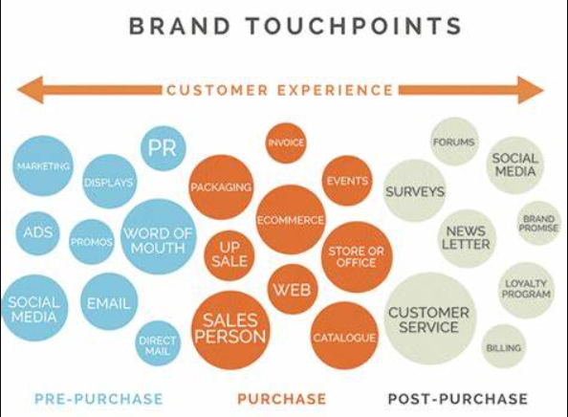

PRE-PURCHASE TOUCHPOINTS:
The shopping experience with Louis Vuitton is always unique when compared to other luxury brands they have a unique way of treating the customers like high societal people with high-income range the shopping experience of a 44-year-old billionaire named “shaza” will who wants to buy a new jacket for gift himself for his success on getting high turnover in profit for his company he wants to make it memorable and he has a strong taste in luxury fashion and then he came to know about the summer campaign of Louis Vuitton (1 touchpoint ) and he gets impressed with the uniqueness and high-quality design and innovation in products leads him to know more about the product by the website and this is (2 touchpoint) by getting clear views about the products and he straight away made a request to know where the closest store near to his current location by using LV app location finder (3 touchpoints)

PURCHASE TOUCHPOINTS:
Shaza gets into the LOUIS Vuitton store in his hectic day schedule, the atmosphere, and the scented air inside the room feel him more luxurious (4th touchpoint), and the service provided by the staff is too engaging which means they are polite genuinely caring and acknowledging him and listening patiently about his requirements (5th touchpoint) and giving him a strong brand experience like exciting store design and atmosphere and VIP service for customers with unique designs and making the customers feel special for what they are spending (6th touchpoint) a world-class luxury instore service makes the shopping experience more unique

POST-PURCHASE:
Shaza expected a thankyou message or any emails about the new releases after the purchase but he didn’t get any emails or return of contact from Louis Vuitton, sometimes it creates a negative impact on customers and Louis Vuitton has no loyalty program and relies on the third-party agency to deliver those it says that Louis Vuitton has a strong rule of high-level maintainance it is not ordinary like other luxury brands, but this not affect the Louis Vuitton purchase activities because in the purchase srage they created a strong base of creating an impact on customers it will automatically create a strong relationship with consumer and company (7th touchpoint) and the overall experience should be shared by shaza to their family members about the overall experience of Louis Vuitton ( 8th touchpoint)

CUSTOMER JOURNEY MAP
Most researchers find that the customer journey map is important for understanding the customer experience, it involves a series of steps involved from different stages of interaction with customers to give efficient service to consumers during their purchase process (Rosenbuam, 2017)
The series of steps involves seeing the advertisements of Louis Vuitton with high-end quality is the first step( awareness) and consumers search for products (discover) and purchasing of products either instore or online experience (purchase) in this section focuses on creating an end-to-end journey
Of Louis Vuitton.

Customer  Journey map | AWARENESS | DISCOVER | Purchase | SERVICE OR REVIEW | BOND  CREATION
WEBSITES |  | To know more about
MAGAZINES | Know about new releases of clothes
STORE |  |  | Purchase of product
SOCIAL MEDIA | New celebrity  Outfit trend | Recent trends and reviews on product
PRODUCT |  |  |  | Quality, and design  Of goods
WEB FORUM |  |  |  |  | review of products good or bad
WORD OF MOUTH |  |  |  | Sharing the experience of luxury instore

Strengths and weaknesses of the Louis Vuitton customer journey map :
Creating and advertising the high-end commercials and the cover page photos for the magazines is the major thing for creating awareness and consider this is one of the major strengths of Louis Vuitton and after that creating a unique luxurious instore experience for customers where shopping assistants take care of customers focus on quality and comfort of the consumers, so recruiting high-end professionals for handling the high-class society people and acknowledges the customers, along with that the strong counterfeit of their brand, logo like doesn’t encourage the fake products of a company is considered as strength, now every organization is focussing on online but Louis Vuitton doesn’t encourage, it seems that eCommerce is their second priority but recent news made by Louis Vuitton about the launching a new online portal exclusively for Louis Vuitton, that site is designed promoting a luxury lifestyle now this will reduce the online weakness of Louis Vuitton

TOTAL ENGAGEMENT MODEL:
This model is used to increase long-term connectivity and to build a good relationship with the customers by using the customer engagement model, it means the model which engages to build a relationship with customers to improve the business goals during this digital era the model will help more while creating a strong relationship employing technologies of multiple channel interaction there are some stages to understand while a customer goes how he engages with company and reasons like creating more awareness and growth through value creation, onboarding of new customers and retaining of new customers, promoting company culture and its products, and the below picture shows a clear map about excellent brand value and efficient communication of company values and the main role of employees is must develop the strategies and ideas for developing companies engagement model along with that good sale and profits( (Robert, 2010)

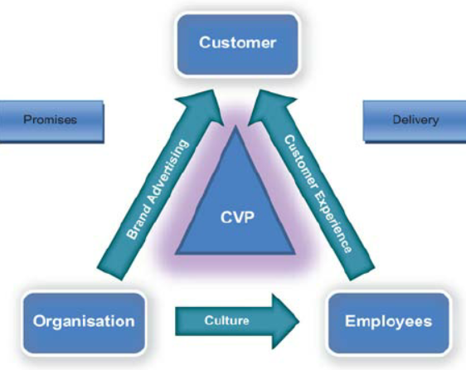

CONCLUSION AND RECOMMENDATION:
This report mainly focuses on improving the customer experience by using various tools and finding the weakness in customer mapping, and customer journey analysis to understand consumer behavior throughout the journey, and to improve the weakness in the map, along with that integrated marketing communication which helps to build a strong communication base with the company and kellers equity model for creating the brand values and understanding how important is brand value and it shows some new ideas for Louis Vuitton to improve their business at e-commerce along with maintaining the same luxury service which balances the instore experience for their customers

RECOMMENDATIONS
There are some recommendations to be mentioned to improve their marketing strategies and gain some profits for the organization
- Louis Vuitton is a leading brand in the luxury sector but at last, they are somewhat lagging in the technological field maybe they are more focused on the originality of treating their customers with luxury service
- The recommendation is to create a strong website exclusive with effective promotions creating strong interactive content and personalization online
- Introduce technology in-store while most the people wonder by watching how the organization uses technology and virtual reality
- Increase their celebrity count and focus on different countries’ celebrities to gain global involvement of Louis products in developing countries
- Create cultural commercials, along with that a create a strong classification of customers based on their expenses
- Introduce lobby access for high-end customer

REFERENCES:
- Abhijeet, P. (2018) Main competitors of Louis Vuitton. Available at:https://www.notesmatic.com/who-are-the-main-competitors-of-louis-vuitton/ (Accessed: 29 11 2021).

- Batey, M. (2012) Brand Meaning. Hoboken: Taylor and Francis.
- Bruijl, D. and Gerard, H.T., 2018. The relevance of Porter's five forces in today's innovative and changing business environment. Available at SSRN 3192207.

- Blythe, J, & Martin, J 2019, Essentials of Marketing, Pearson Education, Limited, Harlow.Available from: ProQuest Ebook Central. [16 August 2022].

- Blythe, Jim, and Jane Martin. Essentials of Marketing, Pearson Education, Limited, 2019. ProQuestEbookCentral, https://ebookcentral.proquest.com/lib/trinity/detail.action?docID=5731459

- Bhasin, H. (2018) Porter's five force model. Available at:https://www.marketing91.com/porters-five-forces-model/ (Accessed: 3 02 2020).

- Cassandra, G. (29 APRIL 2021) A century of Louis Vuitton and the celebs who wore it. Available at: https://nuvomagazine.com/style/louis-vuitton-through-the-decades (29 APRIL 2021).
- Chandler, D., 1994. The transmission model of communication. URL: http://www. aber. ac. UK/media/Documents/short/trans. html# Top (дата звернення: 24.07. 2013).
- Edrawmind. (2019) Porter's five force analysis tutorial. Available at:https://www.edrawmind.com/article/porters-five-forces-analysis-definition-and-examples.html (Accessed: 07 10 2017).

- Fosher, H., 2018. Understanding the Marketing and Management of trails using PESTEL Analysis (Doctoral dissertation, University of New Hampshire).

- Hithesh, B. (2019) swot analysis of Louis vuitton. Available at: https://www.marketing91.com/?s=swot+analysis+of+louis+vuitton (Accessed: 11 01 2019)
- https://turbologo.com/articles/louis-vuitton-logo/

- Karl Erik Rosengren (1999) Communication an introduction. Available https://dx.doi.org/10.4135/9781446221877 (May 31, 2012).
- Kevin lane, K. (2001) 'Mastering the marketing communication mix', Micro and macro perspectives of the integrated marketing communication mix , pp. 17:7-8, 819-847. Available at: DOI: 10.1362/026725701323366836
- Keller, K.L., 2001. Building customer-based brand equity: A blueprint for creating strong brands.

- Louis Vuitton. (2018) Louis Vuitton malletier A paris .[online] Availableat:https://uk.louisvuitton.com/content/dam/lv/online/other/allcountry/legalnotice/LV%20UK%20_%20Modern%20Slavery%20Act%20_%202019%20Signed%20Statement.pdf (Accessed: 30 12 2020).

- Loredana, E.M., 2016. The use of Ansoff matrix in the field of business. In MATEC Web of Conferences (Vol. 44, p. 01006).Nordmeyer, B., 2016. Advantages and disadvantages of SWOT analysis. Retrieved from Chron: http://smallbusiness. chron. com/advantages-ampdisadvantages-swot-analysis-41398. Html

- Meyer, C. and Schwager, A., 2007. Understanding customer experience. Harvard business review, 85(2), p.2.

- Perera, R., 2017. The PESTLE analysis. Nerdynaut

- Sabah AL-Fedaghi. (2012) 'A conceptional foundation of Shannon and Weavers', International journal for soft computing, Issue information, Page reference.

- Singh, M., 2012. Marketing mix of 4P’s for competitive advantage. IOSR Journal of Business and Management, 3(6), pp.40-45

- Tugba, Initial. (2015) research and expenditure of Louis vuitton 2008-2022. Available at:https://www.statista.com/statistics/410692/lvmh-group-randd-expenditure/ (Accessed: 04 02 2022).

- Tugba, S. (2019) total number of stores louis vuitton 2008-2022 . Available at:https://www.statista.com/statistics/245854/total-number-of-stores-of-the-lvmh-group-worldwide/ (Accessed: 28 01 2022).

- Valentin, E.K., 2001. SWOT analysis from a resource-based view. Journal of marketing theory and practice, 9(2), pp.54-69.
- www.strategiccoffee.chriscfox.com/2016/08/growth-ansoff-matrix
- Wood, L. (2000) ‘Brands and brand equity: definition and management, Management decision, 38(9), pp. 662–669. doi:10.1108/00251740010379100
- Perera, R., 2017. The PESTLE analysis. Nerdynaut.

