University of Wales: Trinity Saint David

E-Thesis Deposit Agreement

Details of the Work
I would like to deposit the following item in the digital repository maintained by the University, and/or in any other repository authorized for use by the University:

Title A study on marketing functions of corporate event management in the UK …………………………………………………………………………………………

This item is a product of my own research endeavours and is covered by the agreement below in which the item is referred to as “the Work”. It is identical in content to that deposited in the Learning Resources Centre, subject to point 4 below.

I agree that the University of Wales: Trinity Saint David may electronically store, copy or translate the Work to any approved medium or format for the purpose of future preservation and accessibility. The University is not under any obligation to reproduce or display the Work in the same formats or resolutions in which it was originally deposited.

UW: TSD Digital Repository
I understand that work deposited in the digital repository will be accessible to a wide variety of people and institutions, including automated agents and search engines via the World Wide Web.

I understand that once the Work is deposited, the item and its metadata may be incorporated into public access catalogues or services, such as national databases of electronic theses.

I agree as follows:
- That I am the author or have the authority of the author/s to make this agreement and do hereby give the University of Wales: Trinity Saint David the right to make available the Work in the way described above.
- That the electronic copy of the Work deposited in the digital repository and covered by this agreement, is identical in content to the paper copy of the Work.
- That I have exercised reasonable care to ensure that the Work is original, and to the best of my knowledge, does not breach any laws including those relating to defamation, libel and copyright.
- That I have, in instances where the intellectual property of other authors or copyright holders is included in the Work, gained explicit permission for the inclusion of that material in the Work, and in the electronic form of the Work as accessed through the open access digital repository, or that I have identified and removed that material for which adequate permission has not been obtained and which will be inaccessible via the digital repository
- That University of Wales: Trinity Saint David does not hold any obligation to take legal action on behalf of the Depositor, or other rights holders, in the event of a breach of intellectual property rights, or any other right, in the material deposited.
- That I undertake to indemnify the University of Wales: Trinity Saint David against all actions, suits, proceedings, claims, demands and costs occasioned by the University in consequence of any breach of this agreement

RAMNEEK SINGH

Signature ……………………………………………………….

13/06/2023

Date ………………

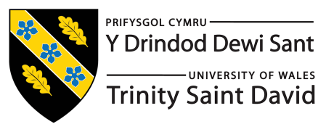
Master’s Degrees by Examination and Dissertation
Declaration Form.
1. This work has not previously been accepted in substance for any degree and is not being concurrently submitted in candidature for any degree.
Signed…RAMNEEK SINGH ….………………………………………………………………………...
Date …13/06/2023 ……………………………………………………………………………...

2. This dissertation is being submitted in partial fulfilment of the requirements for the degree of Master in Business Administration.
Signed ……RAMNEEK SINGH ……………………………………………………………………….
Date …13/06/2023 ………………………………………………………………..…………...
3. This dissertation is the result of my own independent work/investigation, except where otherwise stated.
Other sources are acknowledged by footnotes giving explicit references.
A bibliography is appended.
Signed candidate: RAMNEEK SINGH ……………………………………………….……………….
Date: 13/06/2023 ………………………………………………….……………………….

4. I hereby give consent for my dissertation, if accepted, to be available for photocopying, inter- library loan, and for deposit in the University’s digital repository
Signed (candidate RAMNEEK SINGH …………………………………….………….…………...
Date13/06/2023……………………………………………….…………….……………..
Supervisor’s Declaration.
I am satisfied that this work is the result of the student’s own efforts.
Signed: HUSAM ALHARAHSHEH……………………………………………………
Date:13/06/2023…………………………………………………………

.
A study on marketing functions of corporate event management in the UK
Student name - Ramneek singh
Student number – 2127179
Module name . Dissertation
Module number – LCMB7020_LON
Supervisor name – Husam Alharahsheh

Table of Contents
1. Introduction 3
1.1 Background of the story 3
1.2 Aims and objectives of the study 8
1.3 Research questions 9
2. Literature Review 9
2.1 History of corporate event management in the UK 9
2.2 Current state of corporate event management in the UK 11
2.3 The impact of marketing on corporate event management 14
2.4 Successful marketing strategies in corporate event management 16
3. Methodology 19
3.1 Research Philosophy 19
3.2 Inductive Research Approach 20
3.3 Data Collection 20
3.4 Convenience Sampling 22
3.5 Research Strategy 23
3.6 Research Ethics 24
4. Discussion 25
4.1 Marketing approaches used by event management in the uk using Case Study 25
4.2 Effectiveness of advertising strategy in achieving goals of the company using AIDA Model 28
4.3 Challenges faced by event management businesses in implementing advertising strategies using Fishbone Model 31
4.4 Identify marketing purposes of corporate event management businesses in UK 33
5. Results 36
6. Recommendation 41
7. Conclusion 45
8. References 47

Introduction

1.1 Background of the story
The UK is leading in adaptation of technology and innovation from many years. This includes industry event, it is that which is growing day by day in the field of innovation of new types of technology and adaptation of both imported technologies (Preston, 2019). Industry events does not happen without human resources. Instead of advanced technology, events are handled by people that includes human empathy and creativity that is provided by humans only. Britain plays an important role in a remarkable number of world events that are high profile from commercial, political, scientific, consumer exhibitions and educational conferences to sport events, music festivals and cultural (Preston, 2019).

The Event industry of the UK is now getting appreciation from the government and rising in benefits such as social, cultural, and economic. Corporate events whether trade exhibitions, meetings and association events, will lead to the growth in the economy, promote expertise and foreign direct exchange. Consumer shows, festivals and cultural music festivals help in initiating more investors, tourism, and business visitors (Preston, 2019). This encourages students to come to the UK for higher studies whether in the field of event management. Corporate events encourage research and intelligence and thought of leadership by sharing knowledge. The Event industry of the UK includes conferences, meetings, exhibitions and business events, whereas other events include music events, cultural events and sporting (Singh et al., 2020).

Marketing functions are all about raising awareness in the events. To create awareness in the corporate event of the UK , people have to stage a marketing flue, so that they can inform the attendees by advising then to start their journey towards buying ticket (Singh et al., 2020). People already aware about the event, then they can move towards the next stage that is purchase and sponsorship. The marketing functions in corporate event management in the UK, Early bird discounts, it is one of the marketing functions in corporate event management held in United Kingdom, the host has to generate excitement among people and give them reasons to register (now or later on) (Singh et al., 2020). The Early Bird feature may work by confusing ticket sales with price increases as the event approaches. The Another marketing activity of business event is to build up leads and create interest in people. (Kyere and Ausloos, 2020). Blogging is another marketing feature of enterprise event management. Blogs can post on social media platform to publicise events, and fuel up the pre-marketing event and give about the corporate events in United Kingdom. Blogs are sources to convince the people and also attain initial interest (Kyere and Ausloos, 2020). Many more social media platforms are available for posting blogs such as Instagram, Facebook, LinkedIn and twitter will remain significantly important for giving hints of events Thought leadership and guest post is another function asserts that blogging is important, but event management industry has to reach new audiences instead of finding new attendees. Best practice to perform this feature by displaying visitors or creating fragments of leadership (Kyere and Ausloos, 2020).

The corporate events that are held in United Kingdom includes conferences, business meetings generally it is for staff, stakeholders and clients of UK. E-mail is another tool of marketing in corporate event management (Cornwell, 2019). With the help of e-mail, invitation can send to the important attendees including. Through Eventbrite application, event manager can send automated and manual email to boost engagement by communicating to the staff members and stakeholders about venue of the event (Cornwell, 2019). The events have occurred as a particular segment of the British popular economy and the management of corporate events is an associated profession throughout the late 20th century. Although, it draws attention to the role of professional connotation to enhance the status of the UK corporate events sector also influences the values and practices of the corporate sector (Cornwell, 2019).

Events are part of social, economic, cultural business environment. Satisfaction of participants at the corporate events in UK involve complex collaboration with client’s event location, volunteers and staff. Building quality evaluation is a complex task, like the role and place in the organizational structure of administrations (Sheth, 20210. A precipitate development from the late 1990s in event administration mark programs that give rise to graduates into the labour market who had previously remained vague. There is a shift in procedure discourse. Municipal expenditure on actions are regularly acceptable in terms of employment formation, urban renaissance or other optimistic socio-economic results (Sheth, 2021). The recent study of business events in the United Kingdom appreciated the increasing speculative authority and events developed in the field of strategy.
Corporate events that are held by event industry of UK such as conferences, trade fairs, meetings, corporate outdoor events, performance improvement, and incentive travel (Sheth, 2021). Events of communities can play a crucial role in development of an individual profession includes performance improvement, charitable donations, personal enjoyment, celebrations and team building (Kumar et al., 2019). There are many legacies and benefits of corporate events that have impact on both leisure as well as business events, there is wider concept other benefits such as knowledge transfer, build networking, professional development, and opportunities of investment (Kumar et al., 2019). According to the estimation report of 2018, there were 1.48 million meetings and conferences in the UK. There are 95.3 million delegates office were presented in business events. An estimated 152.8 million representative days (Wright et al., 2019).

In 2018, 428 meetings and conferences were held in the UK , in 2016(419), the duration of events were 1.6 days (Kumar et al., 2019). In rankings of global ICCA, UK stands at the 5th position for congress international association. Two companies of UK, Informa and Reed, companies organize the top global ranking exhibition with high turnover as compare to other of companies. Government of the UK publish the industrial strategy in 2018 (Wright et al., 2019). The UK government is announcing various strategies for the UK's event industry to support the country's economic strength. (Buhalis, Lin and Leung,). According to a recent study, various customs are available by the event industry can support and achieve government objectives by increasing innovation and relativity worldwide. (Wright et al., 2019).

The UK is at the leading position in area of application and development of technology for the corporate event management. Event are comprising of development of new ideas and concepts driven by the various strategies, design to add brand in life in a fresh way (Buhalis, Lin and Leung, 2022). The trend of global growth and contribution of the UK have been assisted by three features. The event industry of the UK is at trend due to an increasing number of innovations. Second, because of the growing trend of British capital as an international technology centre. cultural events are at trend through adoption of technology (Buhalis, Lin and Leung, 2022).

The industry of event has a survey that is also known as talent taskforce. This survey can identify a shortage of skills in the workforce (Brown and Sharpley, 2019). These shortages were exiting in five consistent areas that are project management, client and technical handling, business and sales development. Although, 54% of respondents believe in majority of the absenteeism of these aids that can impact directly on the business. The vision of the United Kingdom government is to maintain leadership (Brown and Sharpley, 2019). Business events, and conferences are hosted by the European countries. To promote the event management industry, the government wants to help in developing new international events.. Various attracting events are held by the UK and recollecting those events that might be thoughtful about leaving (Brown and Sharpley, 2019).

The main objective is to outlines THE Action Plan for the provision of supporting the six different types of events in business sector (Liu et al., 2022). Business sectors such as financial support, welcome and arrivals, destination and marketing, government advocacy, government coordination and connectivity and capacity. The business events growth program provides support from three types such as International Delegate Progress to support the growth of dominant corporate events in the UK. (Liu et al., 2022). Government advocacy is to support the business events industry in the United Kingdom. The Government of the UK is also working with government of Cross-cultural to promote department such as culture, sport, media and digital (Liu et al., 2022).

Marketing and branding can support through International Great Britain Operations. Marketing campaign encourages the people from other countries and create interest in other people to do business, visit for studies and for investment purpose.(Silvers and O’Toole, 2020). The most ambitious campaign of government is to promote international campaign. The Global Prodigious Britain Operation that unites the public and private sector for generating jobs as well as for growth of Britain. Marketing agencies are working unitedly to create interest and stage successful events that is beneficial for communities (Silvers and O’Toole, 2020). VisitBritain focuses on raising awareness among organizers and buyers to look at the UK for corporate events. The key pillars of The British Visitor Authority can improve the productivity of corporate events that are held every year, especially events are high on the peak in the season of autumn and spring (Silvers and O’Toole, 2020). Capacity mapping can fill up the gap in period of occupancy in a more effective manner. Being an expert body, major focus of government of the UK are corporate events. They act as a catalyst for the Government's trade strategy and act as a catalyst for the investment and trade sector (Cabras, Lorusso and Waehning, 2020).

Destination marketing associations are often tourism and congress offices that can bring the destination to market and provide a single window to the conference (Cabras, Lorusso and Waehning, 2020). Other organization are now begun to redefine their determination. Public sector focuses on creating economic development association whose concern is not only about tourism, but also export, investment and attraction of talent and students. Identify those trends that make a difference which includes work-life balance, UK is promoting wellness with professional conferences and events. Focus on wellness is more important than proper diet, it’s about balancing Work-Life (Cabras, Lorusso and Waehning, 2020).

Event planners believe that keeping a healthy body as well as mind that helps enable the participants is to be more productive. Another strategy of the event industry is destination sector aligned by discussion bidding that is one of the most trending strategies in current years that is being adapted by cities of UK to align their request for events with the strength of local economy (Woodcock and Johnson, 2019). Clear intellect of place is another strategy that customers are adding value to their experiences by commenting through internet. Even event strategists also think about events that allow to explore and also allow for outdoor exploration and for adventure Woodcock and Johnson, 2019).

Corporate visits and partnership in events are an umbrella association represents leading in professional organization, trade, government agencies and also other influencers in economic growth of corporate event sector (Woodcock and Johnson, 2019). Business partners and business events are supporting those organization that have interest in sharing the economic benefits and expansion of meetings and conferences, trade fairs, ceremonies and exhibitions and other leisure events like sporting, festival events and cultural events which includes additional services provided to attendees and investors at events (O’Connor and Sealy, 2021). The main vision of BVEP is to support in the sustainable growth of event industry of United Kingdom. The mission of BVEP is to support the growth of entire sector via networking, advocacy and collaboration.
The importance of monetary impact on both leisure and corporate events, in terms of employ by contributors and organizers and number of jobs are supporting this activity, that has been an important message for those who are working in the event sector (O’Connor and Sealy, 2021). From recent years, are underlining to accrue staging and hosting such events. The recent study of three years shows that industry of Global Corporate Event is auxiliary wider agendas, particularly in building economies, knowledge, innovation and enhance well-being of community (O’Connor and Sealy, 2021). The report also identified barriers to achieve lasting inheritances, that are organizers are neglecting to set long-term aims, or look beyond goals of internal organizational. There are six golden rules to achieve the corporate events. First is involvement of stakeholders in setting-up legacy agendas, stakeholders are included for instance, global and local associations, industry leaders and government are within the conference organizers, venues and conference bureaux (Darvas and Wolff, 2021).

The next rule is to identify the issues of community and opportunities that is important in uniting stakeholders’ behinds initiatives of legacy. Another rule is set inheritance objectives, legacy objectives are necessary to set up so that plan has to be executed. It is necessary for conferences to yield legacies regardless whether planned or not. The next rule is to execute objectives which have been and to ensure the legacies there must be a plan. Evaluate the outcomes and different outcomes call for evaluation with different methods. Data collection methods and analyse it to set out the supplement of the statement. The last rule is legacy outcomes must be communicated widely (Darvas and Wolff, 2021). Types of corporate events such meetings which are generally held out of office and minimum 10 number of people can present. Meetings such as trainings and sales meetings. Conferences are a formal programme including speakers (Darvas and Wolff, 2021).

1.2 Aims and objectives of the study

Aim
This aim of this study is to observe the functions of marketing in corporate event management in the UK. This study is to classify various approaches of marketing utilized by the corporation of event association in the UK.

Objectives
1.To understand the various marketing approaches used by event management in the UK.
2. To identify the effectiveness of advertising strategy in achieving goals of the company .
3. To understand the challenges faced by event management business in implementing advertising strategies.
4. To identify marketing purposes of corporate event management in the UK.

1.3 Research questions
1. What are the various marketing approaches used by event management in the UK?
2. What are the effectiveness of advertising strategy in achieving goals of the company?
3. What are the challenges faced by event management business in implementing advertising strategies?
4. What are the marketing purposes of corporate event management business in implementing?

Literature Review

2.1 History of corporate event management in the UK
Corporate event management in the UK has a long and rich history that dates back to the earliest forms of trade fairs and exhibitions. Over the centuries, corporate events have evolved in line with social and economic changes, becoming increasingly sophisticated and diverse. This literature review will explore the history of corporate event management in the UK, from its earliest origins to the present day (Bladen et al., 2022).

The earliest forms of corporate events in the UK can be traced back to the medieval period, when trade fairs and exhibitions were held in market towns and cities. These events provided a platform for merchants and traders to showcase their products and services, and to connect with potential customers (Bladen et al., 2022). The most famous of these events was the Bartholomew Fair, which was held annually in London from the 12th century until the 19th century. The fair was a major social and cultural event, and attracted visitors from all over the country (Masterman, 2021).

The 1920s and 1930s marked the beginning of large-scale corporate events in the UK, with companies organizing exhibitions and trade shows to promote their products (Masterman, 2021). These events provided an opportunity for businesses to showcase their products to a large audience and generated significant interest in their offerings. The success of these events led to the emergence of event management companies that specialized in organizing and managing such events (Masterman, 2021).

During the Second World War, the role of corporate events shifted from marketing to supporting the war effort. Businesses organized events to raise funds for the war effort and to provide support to the troops. These events brought together people from different walks of life and provided a platform for businesses to demonstrate their social responsibility (Mehralian and Khazaee, 2022).

After the war, corporate events became an integral part of marketing strategies for businesses in the UK. The 1950s marked the beginning of large-scale corporate events that were designed to promote brands and products (Mehralian and Khazaee, 2022). The emergence of television as a powerful advertising medium led to the creation of events that were designed to be filmed and broadcast on television. These events generated significant interest in the brands and products being promoted and helped to establish them in the minds of consumers (Mehralian and Khazaee, 2022).

During the 18th and 19th centuries, the Industrial Revolution brought about significant changes in the UK's economy, and this was reflected in the development of corporate events (Mehralian and Khazaee, 2022). As manufacturing and trade expanded, new forms of exhibitions and trade fairs emerged, which focused on specific industries and products. For example, the Great Exhibition of 1851, which was held in London's Crystal Palace, showcased the latest developments in technology, industry and culture, and attracted over six million visitors (Mehralian and Khazaee, 2022).

The 20th century saw further changes in the UK's economy, with the growth of the service sector and the emergence of new technologies (Christophers, 2019). This was reflected in the development of new forms of corporate events, such as conferences, seminars, and product launches. These events were designed to showcase new products and services, to educate and inform customers, and to promote networking and collaboration within specific industries (Christophers, 2019).
In the 1960s and 1970s, the UK's events industry began to grow rapidly, as new technologies and techniques were developed to support the organisation and management of large-scale events (He and Harris, 2020). This was reflected in the growth of event management companies, which specialised in the organisation and delivery of events of all types and sizes. These companies provided a range of services, including event planning, venue selection, marketing and promotion, and on-site management (He and Harris, 2020).

In the 1980s and 1990s, the events industry in the UK continued to grow, driven by the increasing importance of branding and corporate image in the business world (He and Harris, 2020). This was reflected in the development of new types of events, such as corporate hospitality and incentive travel, which were designed to enhance the relationship between companies and their customers, employees, and other stakeholders (He and Harris, 2020).

The 1990s saw the emergence of the internet and the rise of the digital age, which had a major impact on corporate event management in the UK. With the internet, event planners were able to easily communicate with clients, manage their events more efficiently, and provide additional services such as online registration and ticketing (He and Harris, 2020).

2.2 Current state of corporate event management in the UK
The corporate event management industry in the United Kingdom is in a state of growth and development, with a strong focus on innovation and new technologies. The UK is home to a number of leading event management companies, from large multinationals to smaller local firms, all of which are striving to provide the best possible experiences for their clients (Allen et al., 2022).

In recent years, the corporate event management sector has seen a surge in demand. This is largely due to the fact that businesses are increasingly looking to host events, such as conferences, product launches, team building activities and award ceremonies, in order to boost their brand’s profile and increase engagement with their target audiences (Allen et al., 2022).

The demand for corporate event management services in the UK is being driven by a number of factors. Firstly, businesses are increasingly looking to use the latest technologies to enhance their events, such as virtual reality, augmented reality and artificial intelligence. These technologies are becoming increasingly accessible and cost effective, which has enabled businesses to create more engaging and immersive experiences for their guests (Akpan, Udoh and Adebisi, 2020).

Corporate event management in the UK has experienced significant changes in recent years, as businesses adapt to new technologies, changing consumer preferences, and the impacts of the COVID-19 pandemic. Here are some key trends and developments in the current state of corporate event management in the UK:

Hybrid and Virtual Events:
With the ongoing COVID-19 pandemic, hybrid and virtual events have become increasingly popular, as businesses seek to continue holding events while complying with social distancing guidelines. Virtual events have become more advanced, with improved production values, interactivity, and networking opportunities. Hybrid events are also becoming more popular, combining the benefits of in-person and virtual events, and allowing businesses to reach a wider audience (Akpan, Udoh and Adebisi, 2020).

Increased Emphasis on Sustainability:
There has been a growing emphasis on sustainability in corporate event management, with businesses looking to reduce their environmental impact and demonstrate their commitment to sustainability. This has led to initiatives such as reducing waste, using renewable energy sources, and sourcing local and sustainable food and drink (Belitski, Kalyuzhnova and Khlystova, 2021).

Personalisation:
It has become a key trend in corporate event management, as businesses seek to create more engaging and memorable experiences for attendees. This involves tailoring events to individual preferences, using data analytics to understand attendee behaviour, and incorporating interactive elements such as gamification (Belitski, Kalyuzhnova and Khlystova, 2021).

Emphasis on Health and Safety:
With the COVID-19 pandemic, health and safety has become a top priority in corporate event management. Businesses are taking steps to ensure that events are safe and hygienic, with measures such as social distancing, increased cleaning and sanitation, and mandatory mask-wearing (Belitski, Kalyuzhnova and Khlystova, 2021).

Embracing Technology:
Technology has become an increasingly important part of corporate event management, with businesses using tools such as event management software, mobile apps, and virtual and augmented reality to enhance the attendee experience. Technology has also been used to create more immersive and engaging virtual events (Belitski, Kalyuzhnova and Khlystova, 2021).

Diversification of Event Formats:
Businesses are exploring new event formats to keep attendees engaged and create new experiences. This includes events such as pop-up experiences, outdoor events, and more immersive and interactive events.

Increased Importance of Data Analytics:
It has become an important tool in corporate event management, as businesses seek to measure the success of events and understand attendee behaviour. This involves using tools such as RFID tracking, social media monitoring, and sentiment analysis to gather data and insights (Ahlstrom et al., 2020).

Use of Social Media:
It has become a key tool in corporate event management, allowing businesses to promote events, engage with attendees, and gather feedback. Platforms such as Twitter, Facebook, and LinkedIn have become important channels for event promotion and communication (Ahlstrom et al., 2020).

The corporate event management industry in the UK is highly competitive and there is a wide range of services available to businesses. Companies are increasingly looking for event management companies that can provide a full suite of services, from event planning and design to on-site execution and post-event analysis. Companies are also looking for event management firms that can provide a personalised and tailored approach, so that they can create events that are truly unique and memorable (Ahlstrom et al., 2020).

2.3 The impact of marketing on corporate event management
The impact of marketing on corporate event management in the UK is huge. Event management is a complex, multi-faceted endeavour, and marketing plays an essential role in every aspect of the process. It has the power to shape the success of an event, from initial planning to the final execution (Getz, 2022). Firstly, marketing plays an integral role in the initial planning stages of an event. It is essential for understanding the target audience, so that the event can be tailored to meet their needs and expectations. Market research is used to determine the type of event that will be most successful, and it is also important for developing effective messaging that will resonate with the intended audience (Getz, 2022).

Marketing is also essential for promoting the event, as it is the key to driving attendance and ensuring that it is successful. It is important to create awareness of the event and to generate interest amongst potential attendees. Effective marketing strategies may include a combination of advertising, social media campaigns, and collaborations with influencers or sponsors (Getz, 2022).

Marketing plays a significant role in corporate event management in the UK. It involves creating awareness, generating interest, and driving attendance for corporate events. In recent years, there have been several key developments in the impact of marketing on corporate event management in the UK.

Use of Social Media:
It has become an essential tool for marketing corporate events. Platforms such as Twitter, Facebook, and LinkedIn allow businesses to promote events, share updates, and engage with attendees. Social media has also become a valuable source of data for event marketers, allowing them to understand attendee behaviour and preferences (Urdea and Constantin, 2021).

Emphasis on Personalisation:
It has become an important trend in marketing corporate events. It involves tailoring event communications to individual preferences and using data analytics to understand attendee behaviour. This allows businesses to create more engaging and personalised event experiences, which can increase attendee satisfaction and drive attendance (Urdea and Constantin, 2021).

Increased Focus on Digital Marketing:
It has become an essential part of marketing corporate events, as businesses seek to reach a wider audience and generate interest. Digital marketing channels such as email marketing, search engine marketing, and display advertising are commonly used to promote events and generate registrations (Urdea and Constantin, 2021).

Use of Influencer Marketing:
It has become an increasingly popular way to promote corporate events in the UK. Businesses partner with social media influencers or industry experts to promote events to their followers, creating buzz and driving attendance (Urdea and Constantin, 2021).

Integration of Event Technology:
It has become an essential part of marketing corporate events. Businesses use tools such as event management software, mobile apps, and virtual and augmented reality to create engaging event experiences and drive attendance. From event management software to mobile apps, event organisers are using technology to streamline processes, improve the attendee experience, and create a buzz around their event. For example, mobile event apps can provide attendees with real-time updates, interactive maps, and networking opportunities, while virtual and augmented reality can create immersive experiences that engage attendees (Urdea and Constantin, 2021).

Importance of Content Marketing:
It has become an essential part of promoting corporate events in the UK. Businesses create and share valuable content such as blog posts, videos, and infographics to attract and engage potential attendees (Higgins-Desbiolles and Monga, 2020).

Importance of Branding:
It has become a critical factor in marketing corporate events. A strong brand can help businesses differentiate their events from competitors, create a memorable experience for attendees, and drive attendance. A strong brand identity helps to establish credibility for the event. A well-designed logo, tagline, and other branding elements create a professional image for the event and demonstrate that the organisers have put effort into creating a memorable experience (Higgins-Desbiolles and Monga, 2020).

Integration of Data Analytics:
It has become an essential tool in marketing corporate events in the UK. Businesses use data to understand attendee behaviour and preferences, measure the success of their marketing campaigns, and make informed decisions about future events. It can help event organisers measure the success of their marketing campaigns, identify areas for improvement, and make data-driven decisions about future events (Higgins-Desbiolles and Monga, 2020).

2.4 Successful marketing strategies in corporate event management
Corporate event management in the UK has grown significantly over the last few decades, with more and more companies opting for professional event management companies to handle their events. Corporate event management is a complex process requiring careful planning and execution. In order to be successful, it is essential to have an effective marketing strategy in place. This article will discuss some of the most successful marketing strategies for corporate event management in the UK (Crick and Crick, 2020).

First and foremost, it is important to create a strong and memorable brand image. This can be achieved through the use of powerful visuals, such as logos and slogans. Companies should also consider using the latest technologies and digital marketing tools to reach out to their target audience. Social media is a great way to engage with potential attendees and promote the event. Companies should also invest in a comprehensive website and invest in search engine optimization (SEO) to ensure their website is visible in search engine results (Crick and Crick, 2020).

Another important marketing strategy for corporate event management in the UK is to create a buzz and generate excitement about the event. Companies should consider using creative and engaging methods to promote their event, such as competitions, giveaways, and special offers. Companies should also use traditional marketing methods such as print and broadcast media, as well as online advertising platforms to reach a larger audience (Crick and Crick, 2020).

Marketing is a crucial component of corporate event management, as it plays a significant role in generating attendance and creating buzz around events. In the UK, successful marketing strategies for corporate event management should focus on reaching the right audience, creating engaging content, and leveraging technology to enhance the event experience.

Here are some successful marketing strategies for corporate event management in the UK:

Define Your Target Audience:
It is critical for successful event marketing. Understand the demographics, interests, and behaviour of your potential attendees, and tailor your marketing messages accordingly. This will help you create a more effective marketing campaign and ensure that your event is attracting the right audience (Crick and Crick, 2020).

Create Engaging Content:
It content is an essential aspect of marketing corporate events in the UK. Your content should be informative, educational, and provide value to your potential attendees. Use a variety of content formats such as blog posts, videos, and social media posts to create a diverse and engaging marketing campaign (Lüdeke‐Freund, 2019).

Use Social Media:
It is an excellent tool for marketing corporate events in the UK. Use platforms like Twitter, LinkedIn, and Facebook to promote your event, generate buzz, and engage with your audience. Use social media ads to reach a wider audience and promote your event to people who are not currently following your brand (Lüdeke‐Freund, 2019).

Leverage Influencers:
Partnering with social media influencers and industry experts can help you reach a broader audience and create buzz around your event. Look for influencers who align with your brand values and have a significant following in your target market. Work with them to promote your event and encourage their followers to attend (Lüdeke‐Freund, 2019).

Utilise Email Marketing:
It is an effective way to promote corporate events in the UK. Use email marketing campaigns to send personalised invitations, share event details and updates, and create a sense of excitement around the event. Use email automation to send timely reminders and follow-ups to encourage attendance.

Emphasise Personalisation:
It is key to successful marketing campaigns in the UK. Use data analytics to understand the preferences and behaviour of your potential attendees and tailor your marketing messages accordingly. Personalisation can help create a more engaging and relevant marketing campaign, resulting in higher attendance rates (Namugenyi, Nimmagadda and Reiners, 2019).

Use Event Technology:
Leverage event technology to enhance the attendee experience and create buzz around your event. Use tools such as event management software, mobile apps, and virtual and augmented reality to create a memorable and engaging event experience (Namugenyi, Nimmagadda and Reiners, 2019).

Emphasise Branding:
Branding is an important aspect of corporate event management in the UK. Use branding to create a consistent and recognisable image for your event, which can help differentiate it from competitors and create a memorable experience for attendees (Namugenyi, Nimmagadda and Reiners, 2019).

Measure Success with Data Analytics:
Data analytics can help you measure the success of your marketing campaign and make informed decisions about future events. Use data to understand attendee behaviour and preferences, measure the success of your marketing campaign, and make informed decisions about future events (Namugenyi, Nimmagadda and Reiners, 2019).

Methodology

3.1 Research Philosophy
Positivism is a research philosophy that claims that the social environment is objective and can be explored through scientific approaches that create empirical evidence. In a study on marketing roles in corporate event management in the UK, a positivist research philosophy would necessitate the use of quantitative data-gathering methodologies to create empirical proof. This strategy includes gathering data using surveys, questionnaires, and other standardized instruments to examine the attitudes, behavior, and perceptions of the target population.

To utilize a positivist research philosophy for the study of marketing functions in corporate event management in the UK, the first step would be to construct a hypothesis that describes the relationship between the marketing functions and the success of corporate event management. When a hypothesis has been formed, a structured research instrument, such as a survey or a questionnaire, would need to be built to obtain quantitative data that can be investigated using statistical methods. The research instrument would need to be pre-tested to assure that it generates trustworthy and accurate data. The second step would be to identify a representative sample of the target demographic, which in this case would be corporate event management organizations in the UK. The sample size would need to be substantial enough to assure that the data acquired is statistically significant. When the sample has been selected, the research instrument would be distributed to the participants, and the data obtained would be assessed using standard statistical techniques.

The outcomes of the data analysis would then be employed to create conclusions about the relationship between the marketing functions and the performance of corporate event management in the UK.

3.2 Inductive Research Approach
Inductive research is a data-collecting process that is used to create a hypothesis based on observations or empirical facts. This research technique is commonly employed in social sciences and is especially beneficial when little is known about a specific issue. For the study on marketing roles in corporate event management in the UK, an inductive research technique might be effective in examining and understanding the complicated interaction between marketing and event management. Inductive research includes gathering data via observation, interviews, surveys, and other techniques, then evaluating the data to uncover patterns and themes. This data is then utilized to build theories or hypotheses that may explain the observed patterns. Inductive research is a bottom-up strategy, where the data obtained from the participants is utilized to generate a theory or hypothesis. For the study on marketing functions in corporate event management in the UK, an inductive research technique might entail interviewing event managers and marketing experts to get insight into the link between marketing and event management. The interviews might be semi-structured or unstructured, enabling the participants to freely express their thoughts and ideas. The data obtained from these interviews may then be evaluated to find patterns and themes.

Another sort of data collection in an inductive research process is observation. The researcher could attend company events and evaluate the marketing methods and approaches implemented by event management. This may serve to uncover patterns and themes that may be exploited to develop a theory or hypothesis. In short, an inductive research approach could be beneficial in the study of marketing roles in corporate event management in the UK. The technique comprises acquiring data through observation, interviews, and surveys, then assessing the data to identify patterns and themes. This data is then exploited to develop a theory or hypothesis that may explain the observed patterns. This study approach is very effective when little is known about a given occurrence, and it may aid to develop fresh ideas and insights into the interplay between marketing and event management in the business sector.

3.3 Data Collection

Qualitative Data Collection Method
Qualitative data-gathering methods are used to get data that is non-numerical in nature, such as perspectives, attitudes, and experiences. These tactics are very effective in exploratory research and may be used to build hypotheses and construct theories. For a study on marketing functions in corporate event management in the UK, qualitative data-gathering approaches may be utilized to acquire insight into the viewpoints and experiences of event managers, marketing professionals, and other stakeholders. One popular qualitative data collection strategy is the use of interviews. Interviews may be done in person, over the phone, or utilizing video conferencing software. They may be organized, semi-structured, or unstructured, depending on the degree of supervision supplied to participants. Structured interviews involve a predefined set of questions, while semi-structured interviews allow for more leeway in the questions asked. Unstructured interviews are more free-form and empower participants to guide the discourse. Interviews may be time-consuming and necessitate skilled interviewers, but they offer the virtue of allowing researchers to dig deeply into participants' experiences and viewpoints.

Another qualitative data collection strategy is observation. This comprises the researcher monitoring the conduct of participants in a natural environment. For a study on marketing functions in corporate event management, observation may be utilized to evaluate how marketing methods are performed during events, or how attendees interact with marketing materials. Observation may be time-consuming and demands proper organizing, but it has the advantage of presenting a more objective view of participants' conduct. Focus groups are another qualitative data collection approach that may be implemented for a study on marketing jobs in corporate event management in the UK. Focus groups involve getting together a group of persons to discuss a given problem. A trained moderator controls the discourse, and participants are welcome to voice their experiences and viewpoints. Focus groups may be beneficial for analyzing the variety of opinions held by a particular set of members and may help researchers uncover common themes or difficulties. Finally, document analysis is another qualitative data collection strategy that may be applied to a study on marketing jobs in corporate event management in the UK.

Quantitative Data Collection Method
The quantitative data collecting technique is a research methodology that comprises the collection and analysis of numerical data to answer study goals. In the context of examining marketing functions in corporate event management in the UK, quantitative data-gathering techniques may be utilized to gain statistical data on different marketing functions such as market segmentation, pricing, advertising, sales promotion, and product creation. To do quantitative data collection, a researcher would generally utilize organized survey questions, experiments, or secondary data analysis. In the context of marketing functions in corporate event management in the UK, a survey questionnaire may be applied to acquire data from event management organizations and their clients. The questionnaire would consist of closed-ended questions that would allow respondents to choose pre-determined answer alternatives. For example, a question may be: "Which marketing functions do you view to be the most crucial in corporate event management?" Respondents can be presented with a list of marketing duties such as market research, product development, pricing, sales promotion, and advertising, and asked to grade them in order of priority. Further questions could be asked to obtain demographic information about the respondents, such as their age, gender, education level, and income.

The advantage of choosing a quantitative data-collecting strategy is that it permits for the collection of enormous amounts of data from a big sample size. This makes it easier to draw generalizations about the population being examined. The statistical analysis of the data may also give a clear understanding of the connection between different aspects, such as the relationship between marketing functions and event success.

3.4 Convenience Sampling
Convenience sampling is a non-probability sampling approach used in research to obtain data from a group of persons who are readily available and accessible to the researcher. This technique comprises recruiting participants based on their convenience and availability, rather than randomly selecting them from the community. For research on marketing functions in corporate event management in the UK, convenience sampling may be used to obtain data from event managers, marketing professionals, and other stakeholders who are easily available and willing to participate in the study. Convenience sampling is generally done in research when time and resources are limited, and the objective is to obtain data fast and efficiently. This technique may be useful when the community of interest is difficult to reach, or when the sample size required for the study is relatively small. Yet, convenience sampling has various limitations that must be considered when applying this strategy.

One concern with convenience sampling is that it could add to sample bias. This arises when the sample is not representative of the population of interest, consequently, the results of the study may not be generalizable to the greater community. For example, if event managers who are more experienced or aware of marketing are more likely to partake in the survey, the outcomes may not appropriately reflect the viewpoints and experiences of less experienced event managers. Another disadvantage of convenience sampling is that it could be difficult to prove that participants are not self-selecting. This means that those who are more interested in the subject or who have stronger views may be more willing to participate in the study, leading to an overrepresentation of certain viewpoints or experiences. Despite its disadvantages, convenience sampling may be a beneficial data collection approach for a study on marketing roles in corporate event management in the UK, particularly when time and resources are constrained. Yet, it is vital to be aware of the various biases that may emerge and to take efforts to mitigate these biases, such as ensuring that participants are recruited randomly from a list of eligible individuals, or applying alternative recruitment tactics to boost the diversity of the sample.

3.5 Research Strategy
The research strategy for data collection techniques in the study on marketing roles in corporate event management in the UK should begin with identifying the research objectives and aims. The next step would be to undertake a literature review to uncover current research and theories related to marketing responsibilities in corporate event management. This would aid to establish the research gap and develop research hypotheses. After identifying the study questions and aims, the next step would be to determine the suitable research design. In this case, a mixed-methods technique may be applied, which comprises both quantitative and qualitative data collection methodologies. This technique would allow for a more detailed grasp of marketing responsibilities in corporate event management in the UK.

The quantitative data may be gathered utilizing surveys, which would allow for the collecting of huge amounts of data from a wide range of persons. The survey could be done online or in person to participants and event organizers in the UK. The survey questions should be constructed to obtain data on marketing functions such as event promotion, branding, and audience interaction. The qualitative data could be gathered through interviews with event planners and marketers in the UK. The interviews could be done in person or over the phone, and the questions should be geared to collect particular information about marketing responsibilities in corporate event management. The qualitative data may also be gathered through focus groups, which would allow for a more in-depth assessment of marketing responsibilities in corporate event management. In general, the research design for the data collecting technique for the study on marketing roles in corporate event management in the UK should involve a mixed-methods strategy that incorporates both quantitative and qualitative data-gathering methodologies. This would allow for a more full knowledge of marketing jobs in corporate event management in the UK.

3.6 Research Ethics
Research ethics refers to a collection of ideas and criteria that assist researchers in conducting studies that are ethically acceptable and respectful of the rights and well-being of study participants. When it comes to data-gathering methods for research on marketing roles in corporate event management in the UK, there are numerous significant ethical issues to bear in mind. Initially, informed permission should be acquired from all participants in the research. This indicates that volunteers should be properly educated about the purpose of the study, what their involvement would entail, and any prospective dangers or rewards. Participants should also be provided the chance to withdraw from the research at any stage without penalty.

Moreover, researchers must assure that participant privacy is safeguarded. This indicates that any identifying information gathered during the study should be kept entirely confidential and not disclosed to anyone outside of the research team. This includes ensuring that any data gathered is securely preserved and that access to it is restricted only to those who need to see it. Thus, researchers must ensure that the study is structured in a way that minimizes any potential harm to participants. This involves ensuring that any questions answered or assignments supplied are not likely to produce undue anxiety or concern. Finally, researchers should be upfront about their funding sources and any potential conflicts of interest. Research ethics refers to the ideas, attitudes, and standards that researchers follow to ensure the protection of participants' rights and welfare while undertaking research. In the context of a study on marketing roles in corporate event management in the UK, ethical issues are vital to ensure that the data collection method is handled in a responsible and respectful manner. To begin with, the researcher must acquire informed consent from the individuals before data collection happens. Informed consent suggests that the participants are totally aware of the study's aim, their rights, and what is expected of them. The researcher should also ensure that the participants comprehend that their engagement is voluntary and that they may resign at any point without penalty. Secondly, the researcher must assure that the data collection technique is non-invasive and that participants' privacy and confidentiality are protected. This indicates that the researcher must apply correct approaches to obtain data, such as anonymous surveys, to preserve the participants' anonymity.

Also, the researcher must take care to limit the danger of damage to the volunteers. This involves taking attempts to avoid any physical or psychological harm that might come from their engagement in the study. The researcher must also offer help to the volunteers in case they face any discomfort or suffering during the study. Lastly, the researcher must verify that the data gathered is employed only for the purposes of the study and that it is stored securely to prevent unauthorized access or disclosure. In short, ethical issues are crucial for ensuring that the data collection method is handled in a responsible and respectful manner. Researchers must gain informed consent, safeguard privacy and confidentiality, reduce the danger of injury to participants, and assure that data is used only for the study's aims and maintained securely.

Discussion

4.1 Marketing approaches used by event management in the uk using Case Study
Event management is a crucial part of the UK's economy, with events of all types being held throughout the year. The success of an event largely depends on the marketing approaches used by the event management team. In this discussion, we will analyze various marketing approaches used by event management in the UK based on a case study (Guerrero, 2022).

Case Study
The case study will be analyzing the Edinburgh International Festival (EIF). The EIF is an annual festival of the arts that takes place in Edinburgh, Scotland. It was founded in 1947 and is now one of the most significant cultural events in the world, attracting visitors from all over the world (Thomasson, 2022).

Marketing Approaches
The marketing approaches used by the EIF have evolved over the years, with the festival constantly striving to attract new audiences while retaining its existing ones. Some of the marketing approaches used by the EIF include:

Branding: The EIF has a strong brand that is instantly recognizable. The festival's logo and branding have remained consistent over the years, which has helped to build a strong brand identity (Guerrero, 2022).

Targeted advertising: The EIF uses targeted advertising to reach its audience. For example, the festival advertises in arts and culture magazines, on social media, and in newspapers. The advertising is targeted at people who are interested in the arts, culture, and travel (Guerrero, 2022).

Partnerships: The EIF has partnerships with various organizations, including airlines, hotels, and travel companies. The partnerships help to promote the festival and attract visitors from all over the world (Thomasson, 2022).

Social media: The EIF has a strong social media presence, with active accounts on Twitter, Facebook, and Instagram. The festival uses social media to promote events, share photos and videos, and engage with its audience (Thomasson, 2022).

Email marketing: The EIF uses email marketing to keep its audience up to date with the festival's latest news and events. The festival sends out regular newsletters to its subscribers, which help to build engagement and anticipation for the festival (Stewart et al., 2022).

Influencer marketing: The EIF uses influencer marketing to reach a wider audience. The festival invites influential bloggers and social media users to attend events and share their experiences with their followers (Stewart et al., 2022).

Public relations: The EIF has a dedicated public relations team that works to promote the festival in the media. The team issues press releases, arranges interviews with festival organizers, and works to secure coverage in local and national media outlets (Stewart et al., 2022).

Content marketing: The EIF uses content marketing to engage with its audience. The festival produces a range of content, including videos, podcasts, and blog posts, that help to build anticipation for the festival and provide insights into its events and performers (Thomasson, 2022).

All these marketing approaches have helped the EIF to attract a diverse audience to its events. The festival's marketing team has been successful in attracting both local and international visitors, and the festival has become a significant contributor to Edinburgh's economy. So, event management in the UK relies heavily on marketing approaches to attract audiences to events. The Edinburgh International Festival is an excellent example of how effective marketing approaches can help an event to grow and succeed (Thomasson, 2022). The festival's marketing team has used a range of approaches, including branding, targeted advertising, partnerships, social media, email marketing, influencer marketing, public relations, and content marketing, to attract a diverse audience. These approaches have helped the festival to become one of the most significant cultural events in the world and a significant contributor to Edinburgh's economy (Thomasson, 2022).

In addition to the marketing approaches mentioned above, the Edinburgh International Festival also employs other strategies to enhance the festival experience for attendees. For example, the festival offers a range of ticket options, including discounted tickets for students and young people. It also offers a range of accessibility options for disabled attendees, such as wheelchair access and audio descriptions (Guerrero, 2022). The festival's organizers have developed a comprehensive sustainability plan that aims to reduce the festival's environmental impact. The plan includes measures such as reducing waste, promoting sustainable transport options, and sourcing local and ethical suppliers. Furthermore, the festival has also implemented digital technologies to enhance the attendee experience, such as a mobile app that provides information about events and allows attendees to book tickets and access exclusive content (Thomasson, 2022).

4.2 Effectiveness of advertising strategy in achieving goals of the company using AIDA Model

In today's highly competitive business environment, it is becoming increasingly challenging for companies to achieve their marketing goals without the proper advertising strategy. Advertising is one of the most important elements of any marketing campaign, and it plays a crucial role in helping businesses reach their target audience and generate leads (Brognara, 2022). The AIDA model is a commonly used framework for evaluating the effectiveness of advertising strategies in achieving the goals of a company. In this discussion, we will explore the AIDA model in more detail and examine how it can be used to measure the effectiveness of advertising strategies in the UK (Brognara, 2022).

The AIDA Model

The AIDA model is a four-step framework that describes the stages a customer goes through when making a purchasing decision. These stages are Attention, Interest, Desire, and Action. The model was first introduced in the late 19th century by American advertising and sales pioneer, E. St. Elmo Lewis. Since then, the AIDA model has become one of the most widely used models in marketing and advertising (Stewart et al. 2022).

Attention

The first stage of the AIDA model is Attention. At this stage, the primary objective of an advertising campaign is to capture the attention of the target audience. There are various ways to grab the attention of potential customers, such as using eye-catching visuals, compelling headlines, or memorable slogans. In today's digital age, social media platforms, email marketing, and search engine optimization (SEO) are also effective ways to attract the attention of the target audience (Armasta, Kastaman and Syahmurman, 2023).

Interest

Once the target audience's attention has been captured, the next stage of the AIDA model is Interest. At this stage, the advertising campaign should provide relevant and valuable information about the product or service. This information should be presented in a way that resonates with the target audience and encourages them to continue engaging with the brand. The goal of this stage is to create a sense of interest and intrigue among the target audience, which will keep them engaged with the brand and move them to the next stage of the AIDA model (Armasta, Kastaman and Syahmurman, 2023).

Desire

The third stage of the AIDA model is Desire. At this stage, the advertising campaign should create a strong desire for the product or service. This can be achieved by highlighting the benefits and features of the product or service and demonstrating how it can solve the target audience's problems. The advertising message should be persuasive and compelling, encouraging the target audience to imagine themselves using the product or service and experiencing the benefits it offers (Armasta, Kastaman and Syahmurman, 2023).

Action

The final stage of the AIDA model is Action. At this stage, the advertising campaign should encourage the target audience to take action and make a purchase. This can be achieved by providing a clear and compelling call-to-action (CTA), such as "Buy Now," "Sign Up Today," or "Book Your Appointment." The CTA should be prominently displayed and easy to follow, making it simple for the target audience to take the desired action (Karhiaho 2022).

Measuring the Effectiveness of Advertising Strategies

The AIDA model provides a useful framework for measuring the effectiveness of advertising strategies in achieving the goals of a company. By evaluating each stage of the AIDA model, businesses can identify areas where their advertising campaigns are succeeding and areas where they need to improve. The following are some of the metrics that can be used to measure the effectiveness of advertising strategies in the UK:

- Attention: The effectiveness of the advertising campaign in capturing the target audience's attention can be measured using metrics such as impressions, clicks, and website visits (Guerrero, 2022).

- Interest: The effectiveness of the advertising campaign in generating interest among the target audience can be measured using metrics such as time spent on the website, bounce rates, and engagement rates on social media (Guerrero, 2022).

- Desire: The effectiveness of the advertising campaign in creating desire for the product or service can be measured using metrics such as conversion rates, lead generation, and sales revenue (Guerrero, 2022).

- Action: The effectiveness of the advertising campaign in encouraging the target audience to take action can be measured using metrics such as click-through rates, conversion rates, and revenue generated from the campaign (Guerrero, 2022).

Once these metrics have been identified, businesses can use them to evaluate the effectiveness of their advertising campaigns and make adjustments as needed. For example, if the attention metrics are low, businesses may need to consider changing their visuals or headlines to make them more eye-catching. Similarly, if the desire metrics are low, businesses may need to revisit their messaging and value proposition to make it more compelling (Guerrero, 2022).

In addition to using metrics to measure the effectiveness of advertising strategies, businesses can also use qualitative feedback from customers to gain insight into how their advertising campaigns are resonating with their target audience. Surveys, focus groups, and customer feedback forms can all provide valuable information about how customers perceive a brand's advertising efforts and where improvements can be made (Armasta, Kastaman and Syahmurman, 2023).

So, advertising is a critical component of any successful marketing campaign, and the AIDA model provides a useful framework for evaluating the effectiveness of advertising strategies in achieving the goals of a company. By using metrics and qualitative feedback, businesses in the UK can measure the success of their advertising campaigns at each stage of the AIDA model and make adjustments as needed to improve performance (Brognara, 2022). Ultimately, the effectiveness of an advertising strategy is determined by how well it engages the target audience and motivates them to take action, whether that be making a purchase, signing up for a service, or simply engaging with the brand (Brognara, 2022).

4.3 Challenges faced by event management businesses in implementing advertising strategies using Fishbone Model

The event management manufacturing is a highly modest and stimulating field, particularly when it comes to publicity and marketing strategies. Here are several issues that can touch the achievement of an event organization business in the UK when applying advertising strategies, and these issues can be branded using the fishbone model. This model is also known as the Ishikawa drawing, and it helps to classify the root effects of a badly behaved or task by organizing them into sorts (Chokkalingam et al., 2021).

The fishbone model be made up of of a central spine that epitomizes the problem or contest being faced by the event super vision business. From this dominant spine, several kindling emerge, each in place of a different group of factors that can affect the achievement of public relations strategies. The groups are often talk about to as the 6 M's, which are Manpower, Machinery, Materials, Methods, Measurements, and Mother Nature. Let's explore each of these groups in more part and how they upset event management trades in the UK (Moeng and Luvhengo, 2022b).

Manpower
Manpower is a critical module of any successful public relations strategy. It take in having the accurate people in the accurate roles to make sure that the line of attack is applied properly. This take account of hiring the accurate people with the true skills, as well as training them to be effective in their roles. The people involved in a marketing strategy should understand the bull's eye audience, the item for consumption or service being promoted, and the penalty area and objectives of the crusade. They had better also be driven and abstain the required skills to progress and effect the plan (Wen et al., 2022).

Machinery
Machines includes any technical tools or kit used to help finish an advertising line of attack. This could take account of processers, software, or specialized policies that help degree customer answer or track the triumph of certain public relations campaigns. One more important bit of machinery is communal media financial records, which can be used to reach a broader audience than other additional out-of-date forms of public relations, such as television or hi-fi (Borsley, Leigh and Roberts, 2022).

Materials
Materials refer to the corporeal things used to create and mete out public relations campaigns. This possibly will include published materials, such as advertising material and prints, as well as digital resources, such as videos and web pages. The resources should be made-to-order to the target spectators and should carry the communication in a clear, brief, and convincing way (Liu et al., 2021).

Methods
Methods involve the strategies used to perform an advertising line of attack. This may well include using a range of channels to extent the target watchers, such as television, radio, print, or digital media. It also take in developing artistic and charming content that vibrates with the spectators (Piao et al., 2022).

Measurements
Measurements are vital for appraising the achievement of an advertising line of attack. This includes hunt down the amount of views, clicks, or be fond of that a drive generates, as in good health as the figure of sales or information that are made. This information can then be charity to type ups and downs to the line of attack or to regulate if it is fruitful (Elben et al., 2023).

Mother Nature Mother Nature refers to the random nature of the surroundings and the personal property it can abstain on public relations crusades. This includes eco-friendly features, such as climate, that can have an sway on the victory of an marketing line of attack. For instance, if a business is public relations an outdoor occasion, they may need to regulate their line of attack if the weather is bad. Additionally, communal and political ups and downs can affect the accomplishment of a movement, so it’s significant to stay up to date with current actions and adjust the plan accordingly (Takahashi et al., 2022).

Hence, the occasion management industry expressions several tasks when it hail from to implementing effective public relations and marketing line of attack. By using the fishbone model, Manpower, Machinery, Materials, Methods, Measurements, and Mother Nature are all significant components of an effective advertising strategy. Each of these elements should be carefully considered and assessed to ensure that the line of attack is effective and custom-made to the target spectators. Event running commerce in the UK can identify the root causes of these tests and develop strategies to address them. By addressing these tests, in management businesses can recover the effectiveness of their advertising and selling efforts, which can in the end lead to bigger success and viability (Kim et al., 2022).

4.4 Identify marketing purposes of corporate event management businesses in UK

The most significant marketing purpose for business event management commerce is to shape relations with potential clienteles. They do this by as long as valuable gratified, such as information and information, on their websites, blogs, and social media accounts. Moreover, they go to manufacturing events and conferences to network with potential clients. By engaging with potential customers, corporate event management businesses can build trust and establish themselves as a knowledgeable and reliable source of event planning services (Zhang et al., 2022).

Brand Awareness
One of the primary marketing purposes of corporate event management businesses in the UK is to create and upsurge brand consciousness. A well-planned and performed event can assistance a profitable build brand respect and establish a confident brand image in the awareness of the attendees. Business event management big business achieve this by crafty events that reproduce the make's values and assignment, which helps attendees understand the company's drive and philosophy (Liu et al., 2022).

Lead Generation
Business event management businesses in the UK also help governments produce leads by as long as a platform for big business to connect with probable customers. Actions offer a sole opportunity to glass case products and service area, interact with attendees and collect interaction details for continuation. By providing an environment conducive to networking, businesses can generate leads from individuals and companies interested in their products or services (Machová et al., 2022).

Product Launches
Business event management big business in the UK assist in creating and executing successful product launches. Product launches are an excellent opportunity for big business to showcase their new products and services to a targeted audience. The event can also help businesses treasure trove feedback on the item for consumption, which can be used en route for recover future contributions (Azmi et al., 2022).

Reputation Management
Business event management businesses in the UK as well help commerce manage their status by planning and implementing events that imitate positively on the corporation. Events such as charity money maker or community service accomplishments demonstrate the business's promise to social accountability, which can have a positive waves on the corporation's image (Blomster and Koivumäki, 2021).

Customer Retention
Business event management businesses in the UK can also help big business retain existing regulars by hosting events that establish thanks and gratitude for their loyalty. Such events can include exclusive product protest march or promotional telltale sign to show consumers how much they rate their business (Getz, 2022).

Thought Leadership
Business event management businesses in the UK also backing in starting a business as a assumed leader in its business. Events such as discussions or industry-specific trade shows be responsible for businesses with the opportunity to glass case their knowledge and facts, which can help establish them as a frontrunner in their field (Hancu and Modroiu, 2022).

Employee Engagement
Business event management businesses in the UK also benefit businesses engage with their workers by bring together team-building events and corporation retreats. These measures help staffs bond and build associations, which can lead to improved morale, greater than before productivity, and progressive job consummation (Moeng and Luvhengo, 2022).

Sales Promotion
Business event management businesses in the UK also help trades promote sales by making events that raise your spirits attendees to make buying. Events such as item for consumption sit-downs, pop-up shops, and public relations giveaways can motivate attendees on the way to make procurements and intensification auctions. Corporate event super vision businesses use a diversity of marketing methods to reach possible customers (Cezarino et al., 2022). They use outdated ways and means such as print ads, radio and small screen advertisements, and direct mail. They also use numerical methods such as search appliance optimization (SEO), pay-per-click (PPC) advertising, and communal media selling. These methods are used to endorse their service area and create mindfulness about the company (Azmi et al., 2022b).

Effectiveness
The effectiveness of corporation event management dealings' marketing hard work depends on their tactic. Some businesses focus proceeding outmoded methods, such as print ads and straight mail, while others opt for alphanumeric ways and means, such as SEO and PPC publicity. Each method has its own compensations and difficulties. Traditional ways and means are more exclusive and require more incomes, but they can reach a wide viewers (Carrillo de Albornoz, Sia and Harris, 2021). Digital methods are cheaper and additional beleaguered, but they require a greater understanding of the digital countryside. It is also noteworthy to consider the efficacy of the content shaped by corporate event running businesses. Content should be engaging, informative, and important to the target spectators. The content have a duty to also be couturier to the meticulous needs of the company, and should be updated on a regular basis (Rahman et al., 2022).

Improvement
There are more than a few ways in which business event super vision businesses can recover their advertising efforts. They can emphasis on creating gratified that is personalized to the precise needs of the company, and make sure it is regularly efficient. As well, they should create a complete digital marketing plan that take in SEO, PPC, and social media marketing. They should also consider presence manufacturing events and symposia to network with prospective clienteles. Finally, they have a duty to appraisal their selling strategies on a even basis to ensure they are up-to-date and nominal (Sahoo, 2021).

This case study has see the sights the marketing determinations of business event super vision commerce in the UK. It has explained the various promotion systems used by these big business, their effectiveness, and how they can be better-quality. Corporate experience super vision businesses can use a variety of line of attack to reach impending customers, including old and alphanumeric methods. They should also energy on creating charming and enlightening content, and attend business events and talks to network with potential customs. By following these strategies, company event super vision businesses can progress effective promotion plans and outpouring their purchaser base (Voola et al., 2022).

Results
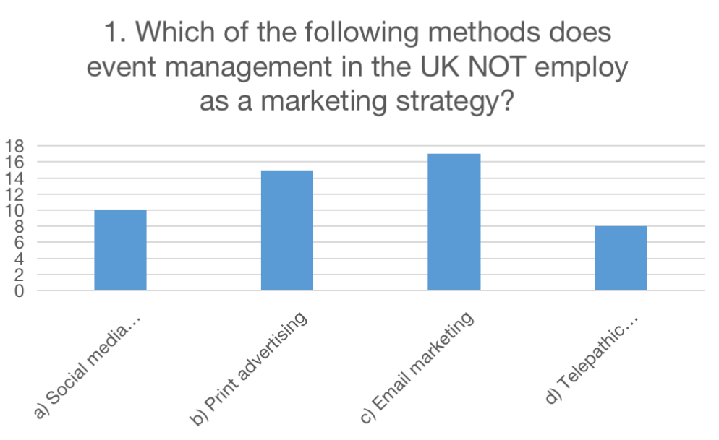
Figure 1: Telepathic communication.

The survey's findings suggest that "Telepathic communication" is not used as a marketing approach in event management in the UK. Only 8 people chose this response, which is a small number. 17 respondents, or the majority, said that event management in the UK uses "Email marketing" as a marketing technique. This shows that email marketing are often utilised throughout the nation to advertise business events.

15 respondents named "print advertising" as a marketing strategy employed by event management in the UK. This suggests that conventional print media, such newspapers or magazines, still assist in publicising business activities. Lastly, 10 people selected "Social media marketing." This indicates that UK-based event management businesses are aware of the value of using social media channels to interact with their target market and create excitement around their events.

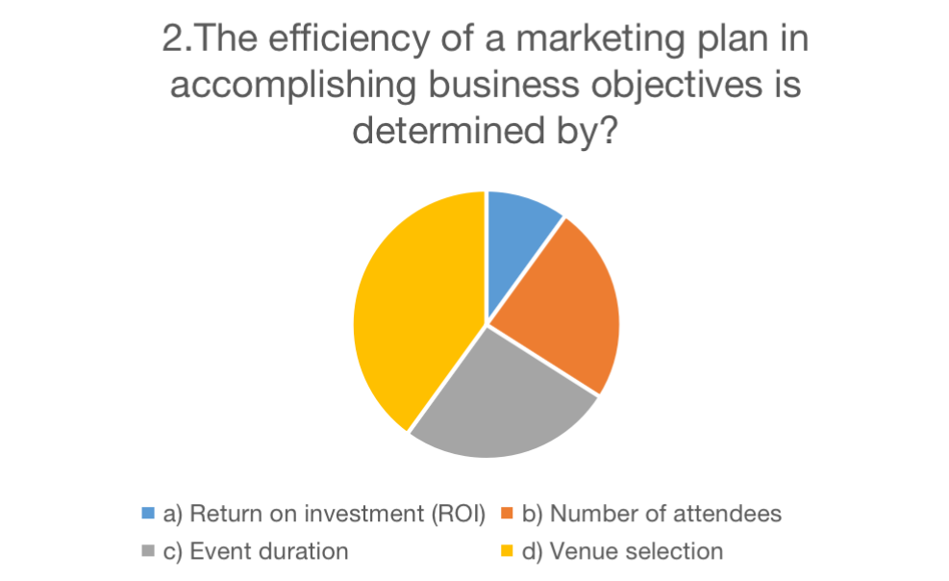
Figure 2: Marketing strategies.

The replies to the poll show that a variety of variables influence how well a marketing strategy achieves its organisational goals. The majority of respondents (20) who were given the option to do so emphasised the significance of venue selection. This shows that the effectiveness of the marketing campaign is greatly influenced by choosing the appropriate location for a business event. 13 responders, the second-highest number, named event length as a crucial element. This suggests that the duration of the event affects how successful the marketing strategy is. It implies that deliberately arranging the event's length might aid in reaching organisational goals.

In addition, 12 respondents emphasised the importance of the attendance. This suggests that the success of the marketing campaign depends on drawing a large number of people to the event. It implies that marketing initiatives should concentrate on publicising the event and luring people to attend. Finally, five respondents emphasised return on investment (ROI) as a criterion for a marketing plan's effectiveness. This emphasises how crucial it is to evaluate the financial results and advantages derived from marketing initiatives.

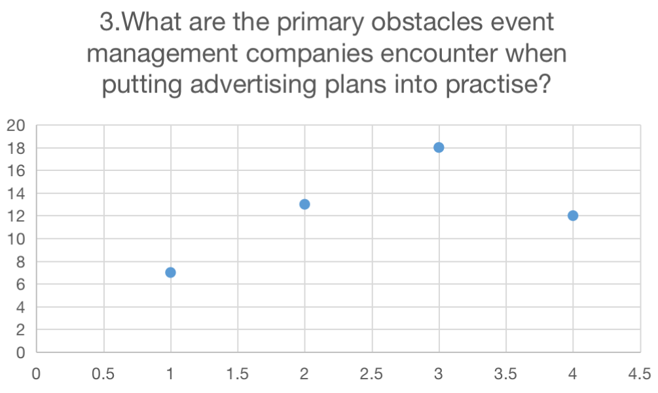
Figure 3: Limited event venue options.

With 18 people choosing it as a major barrier, option (c) "Limited event venue options" garnered the most answers of all the alternatives. This implies that UK event management businesses. frequently have trouble locating appropriate event locations, which may affect their marketing strategies. With 13 replies to option (b), "Lack of event planning experience," it is clear that many businesses struggle as a result of their lack of event planning expertise. This shows that increasing your event management knowledge may help you overcome challenges to successfully carry out your advertising goals.

With 12 replies, option (d) "Language barriers" clearly shows that certain event management businesses struggle to communicate with various audiences owing to linguistic hurdles. This emphasises how crucial it is to have bilingual employees or interpreters in order to guarantee successful marketing campaigns and good communication. The seven replies to option (a), "Budget constraints and limited resources," indicate that although these issues may be hurdles, they are considerably less important than the other possibilities.

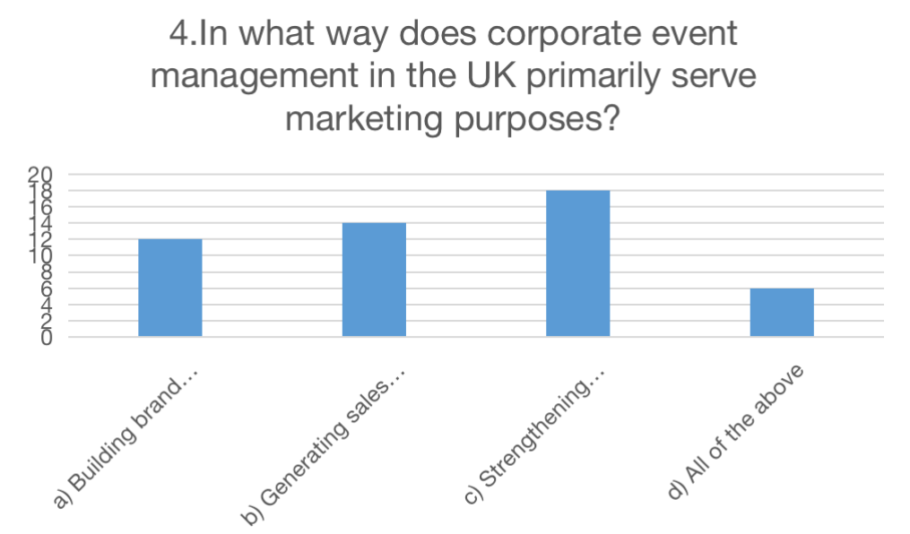
Figure 4: Findings of corporate event management.

It is clear from the study findings that corporate event management in the UK serves a variety of marketing objectives. The majority of respondents cited increasing brand recognition as one of the main ways that corporate events support marketing initiatives (12). Companies may promote their brand identity, values, and goods or services to a specific audience by arranging events. This increases brand awareness and exposure.

As a crucial marketing role of corporate event management, lead generation (14) was also emphasised. Events provide businesses the chance to interact with prospective clients, build connections, and create leads that might lead to sales. Businesses may pique the interest and attention of prospective customers via interactive activities, presentations, and networking occasions.

Another crucial component of corporate event management that has evolved is boosting staff morale (18). Employee engagement and motivation via well designed events not only raises their morale but also cultivates brand evangelists inside the company.

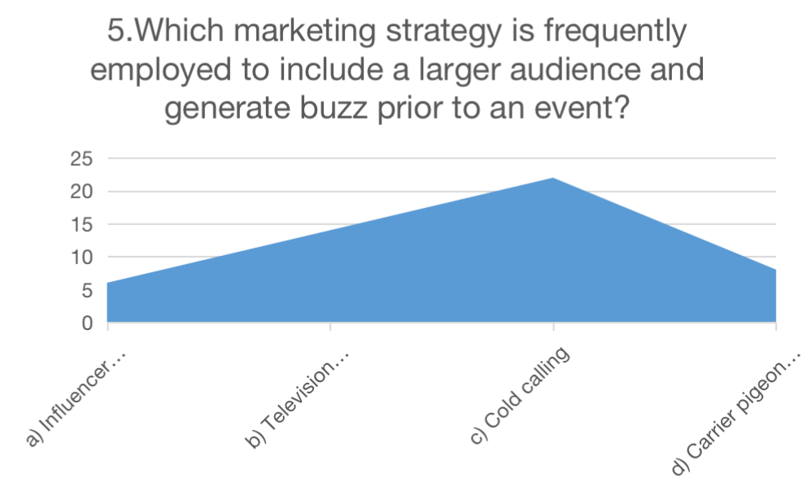
Figure 5: Marketing Strategies that frequently employed to include larger audience.

According to survey findings, respondents were questioned about the most popular marketing approach used to reach a bigger audience and create buzz before an event. Influencer marketing, television advertising, cold phoning, and carrier pigeon messaging were the options offered. The option that garnered the most responses—cold calling—was chosen as a marketing tactic by 22 respondents. Calling prospective attendees directly in an effort to spark interest and boost event attendance is known as cold calling.

With 14 responses, television advertising came in as the second-most popular option. By advertising their event on well-known TV channels, television ads are a conventional marketing strategy that enables event planners to reach a wider audience. Six comments were made on influencer marketing. In order to spread the word about the event to their audience on social media, this technique entails collaborating with well-known people who have a sizable following there. The influencers' reputation and reach may be used by event planners to increase attendance and create enthusiasm.

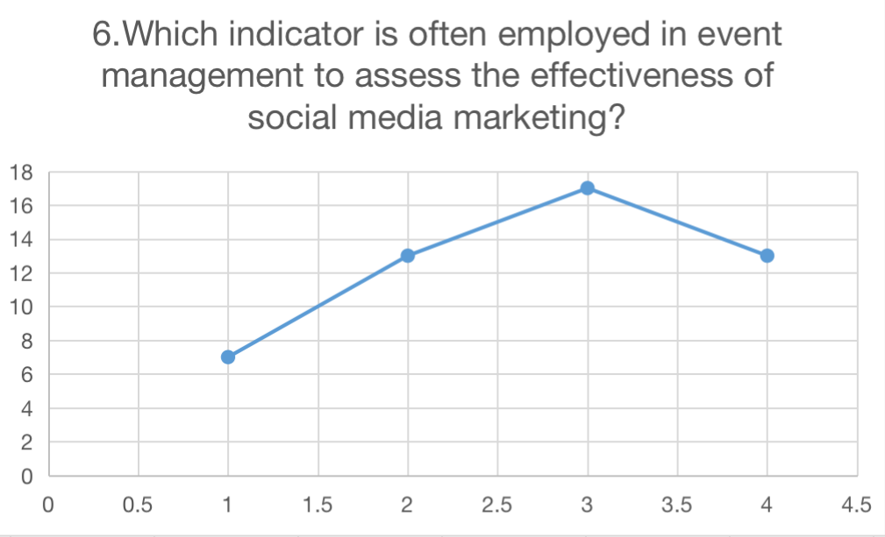
Figure 6: Effectiveness of social media marketing.

The survey findings show that respondents' views on the metric often used in event management to gauge the success of social media marketing were varied. The majority of respondents (17) chose "c) Cost per click (CPC)" as their favourite indication out of the available options. This shows that these people think that calculating the cost per click is a useful metric for determining how well social media marketing initiatives for events are working.

Options "b) Event revenue" and "d) Outdoor signage impressions" came in second and third, respectively, with 13 replies apiece. This suggests that a sizeable percentage of respondents see event revenue and outdoor signage impressions as key metrics for gauging social media marketing's success in event management.

The answer "a) Number of shares and retweets" received 7 replies, indicating that a lesser percentage of respondents see these social media engagement indicators as the main measure of efficacy.

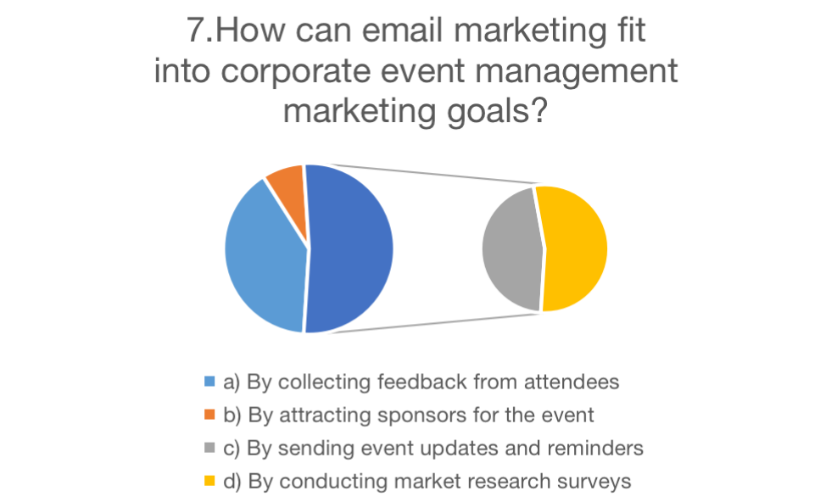
Figure 7: Marketing goals.

The survey's findings show that respondents' opinions on how email marketing may support corporate event management marketing objectives varied. The option that garnered the most responses—and was chosen by 20 participants—was gathering input from the audience. This suggests that event organisers may use email marketing to get insightful feedback from participants, giving them an understanding of their experiences and pointing out areas for improvement.

Only 4 participants chose the option to find sponsors for the event, which generated a rather low number of answers. This implies that although email marketing may be used to contact prospective sponsors and emphasise the advantages of supporting the event, it might not be the main focus of employing email marketing within corporate event management.

Twelve answers were received after sending updates and reminders about the event, proving the importance of email marketing in maintaining participants' interest. Finally, performing market research surveys resulted in 14 answers, demonstrating that email marketing may be used to collect market data and survey participants. By gathering information about attendees' tastes, demographics, and views, event planners are able to make educated choices and customise future events to better serve their target audience.

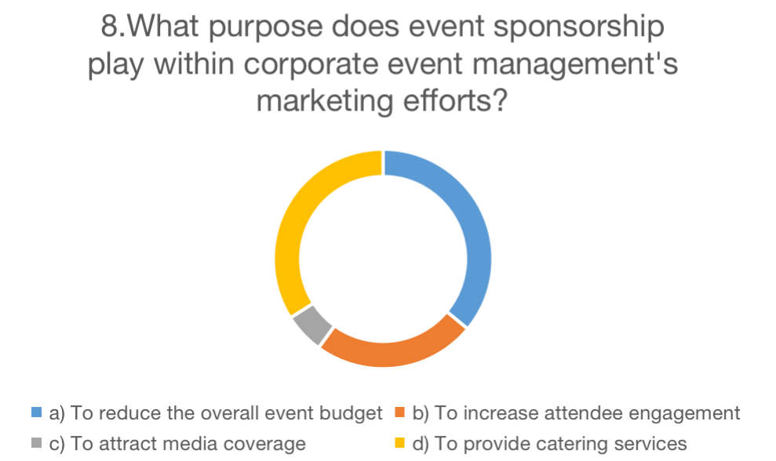
Figure 8: Marketing efforts.

The findings of the study showed that respondents' perceptions on the function of event sponsorship within corporate event management's marketing initiatives differed. The majority of respondents (18 in total) said that one benefit of event sponsorship is to lower the overall event costs. Furthermore, 12 respondents said that event sponsorship contributes to higher attendee involvement. This means that sponsors may provide engaging activities, marketing materials, or unique events that improve the overall event experience for visitors.

Only 3 respondents said that getting media attention was the main reason for event sponsorship. This shows that while if media visibility may be impacted by event sponsorship to some extent, it may not be the main goal for the majority of corporate event management teams. Surprisingly, 17 respondents said that offering catering services is related to event sponsorship. This may suggest that respondents believe sponsors often contribute to business gatherings by supplying food and drinks.

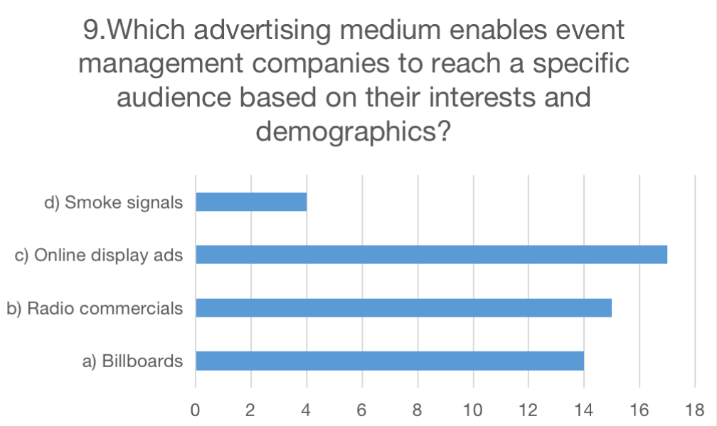
Figure 9: Specific audience based on the interests and demographics.

The survey's findings make it clear that online display advertisements, with 17 votes, garnered the most answers. Event management firms have the chance to successfully target a certain audience based on their interests and demographics thanks to online display advertisements. With 15 votes, radio advertisements also attracted a significant number of answers. Radio advertisements, albeit classic in style, may nonetheless be personalised to target certain demographics and interests via the use of carefully chosen radio stations and airtime.

Billboards garnered 14 votes, showing that they are still a viable way for event management firms to connect with their target market. In high-traffic locations, professionally positioned billboards may increase brand exposure and draw in onlookers.

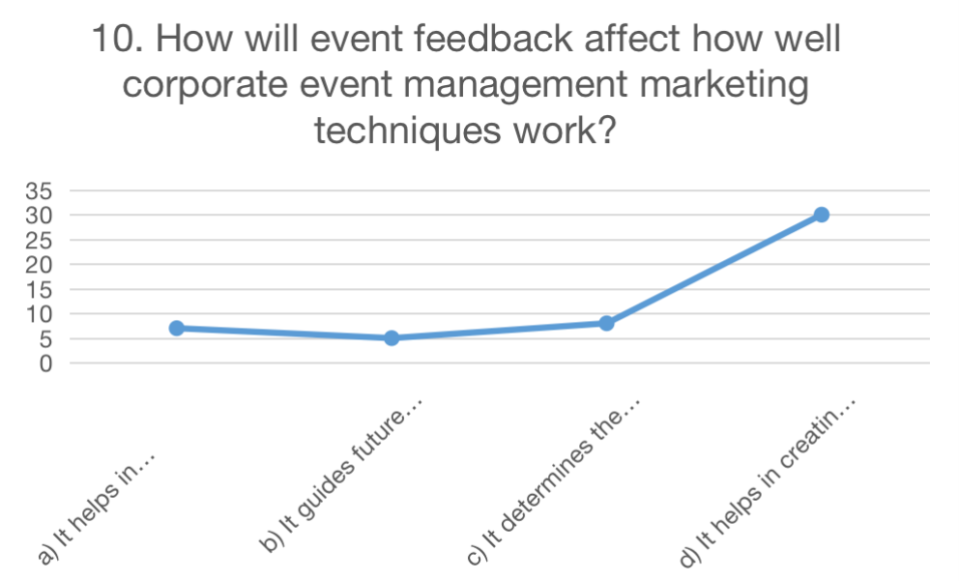
Figure 10: Marketing techniques work.

Results of the poll show that respondents think event feedback has a big influence on how well corporate event management marketing methods work. First of all, a significant portion of respondents (30) indicated that event feedback aids in the development of event products. This shows that feedback is important in determining participants' tastes and interests, enabling event planners to provide goods that are appropriate for their target market.

Second, a significant percentage of respondents (eight) said that ticket prices are determined by event feedback. Seven respondents said that event feedback is important in deciding where to hold the event. Event organisers may make wise selections when selecting sites that satisfy the expectations and preferences of their target audience by taking attendance' opinions about prior venues into account. Last but not least, a significant proportion of respondents (five) said that event feedback influences future event planning and enhancements.

Recommendation
- The COVID-19 pandemic has led to an increase in the popularity of hybrid and virtual events. These events have a number of benefits, including cost savings and increased accessibility (Bladen et al., 2022). Event management companies will need to modify their marketing strategies in line with the increasing number of hybrid and virtual events that we can anticipate in the coming years. The unique advantages of hybrid and virtual events, such as interactive online experiences and global reach, will need to be promoted by businesses. will need to be made just for digital platforms, like online event brochures and virtual event tours. Event management companies must also make investments in digital infrastructure and technology to guarantee that their virtual and hybrid events are of high quality and provide a seamless user experience (Bladen et al., 2022).

- In every aspect of their lives, including corporate events, customers are increasingly expecting personalized experiences (Bladen et al., 2022). Personalized event agendas and marketing messages are just two examples of personalization. It is likely that businesses will have a competitive advantage if they are able to provide personalized experiences. Event management companies will need to make investments in data analytics and devise methods for collecting and utilizing customer data to tailor event experiences. Advanced technologies like artificial intelligence and machine learning can also be used to analyze customer preferences and behavior and create event experiences that are more individualized (Allen et al., 2022).

- Event management companies need to think about how they can make their events more environmentally friendly because sustainability is becoming a more pressing concern for consumers (Allen et al., 2022). This includes minimizing carbon footprints, conserving energy, and reducing waste. Customers who place a high value on environmental issues are likely to patronize businesses that are able to demonstrate their dedication to sustainability. Event management companies will need to make sustainability a core value of their brand and include sustainability in their marketing messages (Allen et al., 2022).

- Event management companies should incorporate sustainability into their marketing strategies and messages because sustainable practices are becoming increasingly important to customers (Masterman, 2021). This includes minimizing carbon footprints, conserving energy, and reducing waste. Companies can also think about holding events in places that are good for the environment and use sustainable methods. Event management companies have an obligation to incorporate sustainable practices into their marketing messages and practices because sustainability has emerged as a crucial issue for customers. Events can have a negative impact on the environment in a number of ways, including the amount of waste produced, the amount of energy used, and the carbon footprint left behind (Masterman, 2021).

- Focusing on reducing waste is one strategy for event management sustainability. Reusable or biodegradable products can be used to accomplish this, as can digital communication options for reducing paper waste and ensuring proper waste disposal at the event (Masterman, 2021). The use of environmentally friendly decorations and packaging can also contribute to the reduction of waste and the improvement of the environment. Preserving energy is one more significant part of reasonable occasion the board. Events can be powered by renewable energy sources like hydroelectric power, wind turbines, or solar panels (Masterman, 2021).

- The sustainable event management, selecting an eco-friendly venue is also essential. Venues that use renewable energy, reduce waste, and minimize their impact on the environment are examples of this. Businesses can also think about how attendees can get there, such as by public transportation, carpooling, or cycling (Chien and Chi, 2019).

- Organizations that share a commitment to sustainability, such as environmental groups or green businesses, can also be partners for businesses (Chien and Chi, 2019). Utilizing materials that can be composted or reused, implementing recycling programs, and reducing food waste are all sustainable practices that the event management companies might want to consider incorporating into the event itself. They might also want to think about hosting events in places that are good for the environment and have used sustainable methods, like LEED-certified buildings or places that use renewable energy sources (Chien and Chi, 2019).

- Event management companies can also incorporate sustainability into their marketing messages, in addition to incorporating sustainable practices into the event itself (Dwivedi et al., 2020). This can incorporate featuring the reasonable components of the occasion, for example, the utilization of eco-accommodating materials or the decrease of fossil fuel byproducts. Organizations can likewise utilize their showcasing channels, like web-based entertainment or email bulletins, to advance maintainable practices and teach their crowd on the significance of maintainability.

- It important for the environment to incorporate sustainable practices into event management, but it can also benefit a business's reputation and bottom line (Dwivedi et al., 2020). Event management companies can attract clients who are concerned about the environment and contribute to a more sustainable future by forming partnerships with sustainable organizations, implementing sustainable practices at events, and promoting sustainability in marketing message (Dwivedi et al., 2020).

- In recent years, influencer marketing has gained popularity and is likely to continue to gain importance. Event management companies can promote their events and reach new audiences by utilizing influencers (Belanche et al., 2021). An event's buzz, excitement, and ticket sales can all be boosted by using influencers. To effectively engage with relevant influencers, businesses will need to identify and develop strategies.

- Event management is likely to become increasingly dependent on artificial intelligence. Event management tasks like ticketing, registration, and customer service can all be automated with AI. Also, AI can be used to look at customer data and get insights that can help with marketing plans (Belanche et al., 2021). In the market, businesses with a competitive advantage will be able to effectively utilize AI.

- For successful events, event management companies should work with partners and stakeholders, such as sponsors, vendors, and other organizations. This entails establishing connections with important stakeholders, spotting opportunities for cooperation, and making use of resources and expertise that are shared (Belanche et al., 2021).

- For successful events, event management companies must collaborate with partners and stakeholders. Diverse perspectives and abilities are brought to the table by collaboration, which helps to maximize the event's potential. Event management companies can gain access to specialized expertise through collaboration with sponsors, vendors, and other organizations that may not be available internally (Belanche et al., 2021). A catering company, for instance, might offer expertise in food and beverage service, while a lighting company might offer expertise in lighting design.

- Teaming up with accomplices and partners can help occasion the board organizations share assets, like gear, staff, and showcasing channels. This may assist in lowering expenses and increasing productivity. Event management companies can benefit from collaborating with partners and stakeholders to develop novel concepts and perspectives for their events (Sharma, Bikash Borah and Moses, 2020). Working with a diverse group of people can spur creativity and result in event designs that are more creative. The collaboration presents a chance to develop relationships with important stakeholders, which can assist event management businesses in enhancing their reputation and attracting new business.

- In order to provide their customers with a seamless experience, businesses need to make investments in digital infrastructure and cutting-edge technologies in light of the growing use of technology in event management. Event management software, data analytics instruments, and virtual and hybrid events are all part of this. In recent years, the importance of technology in event management has grown. In order to provide their clients with an engaging and seamless experience, event management companies need to make investments in cutting-edge technologies and digital infrastructure (Sharma, Bikash Borah and Moses, 2020).

- The ascent of remote work and social separating measures, virtual and half-breed occasions have become more well known. For these events to run smoothly, event management companies need to invest in the right technology. This includes platforms for virtual events, live streaming software, and tools for video conferencing (Sharma, Bikash Borah and Moses, 2020). Companies can use event management software to manage everything from registration and ticketing to scheduling and budgeting. Event managers may benefit from the efficiency and time savings offered by these tools.

- Versatile applications can assist participants with remaining drew in and informed during an occasion. Mobile apps can be used by event management companies to provide attendees with interactive maps, personalized schedules, and real-time updates. Event management companies can use data analytics tools to study attendee behavior and analyze attendee data. This data can be used to enhance future events and target marketing campaigns to specific audiences. Events can be promoted, attendees can be engaged, and buzz can be created through the use of social media platforms. To increase brand recognition and reach a larger audience, event management companies should invest in social media marketing.

- For successful events, event management companies should work with partners and stakeholders, such as sponsors, vendors, and other organizations. This entails establishing connections with important stakeholders, spotting opportunities for cooperation, and making use of resources and expertise that are shared (Bladen et al., 2022).

- Promoting events and interacting with attendees before, during, and after them can be accomplished effectively using social media platforms. Event management companies should make effective use of social media to promote their events and communicate with partners, sponsors, and attendees (Bladen et al., 2022).

Conclusion
The study of marketing functions in corporate event management demonstrates, in conclusion, the significance of successful marketing strategies for the success of corporate events. When it comes to spreading word about events, bringing in attendees, and making money, marketing is absolutely necessary. Event management companies must adapt their marketing strategies to meet consumers' needs and expectations as technology usage rises and consumer expectations shift. Providing customers with a seamless experience necessitates embracing technology, investing in digital infrastructure, and utilizing cutting-edge technologies. Due to the COVID-19 pandemic, virtual and hybrid events are becoming increasingly popular. Event management companies must modify their marketing strategies to highlight the distinct advantages of virtual and hybrid events, such as interactive online experiences and global reach. Event management companies should make investments in data analytics tools and devise strategies to collect and utilize customer data to personalize event experiences because personalization is becoming increasingly important to consumers. The technologies of artificial intelligence and machine learning can also be used to analyze the preferences and behavior of customers and create event experiences that are more individualized.

Promoting events and interacting with attendees, sponsors, and partners can be made easier with the help of social media platforms. Event management companies should use social media to build relationships with key stakeholders, engage attendees, and promote their events. Event management companies need to think about how they can make their events more sustainable because sustainability has become a major concern for consumers. Customers who place a high value on environmental issues are likely to patronize businesses that are able to demonstrate their dedication to sustainability. Event management companies should consider hosting events in eco-friendly venues that have implemented sustainable practices and incorporate sustainability into their marketing messages and practices. Marketing is an essential component of an event's success in event management. To reach the intended audience, a variety of marketing strategies, such as networking, flyers, brochures, questionnaires, advertisements, and internet marketing, are utilized. Using a theoretical framework and semi-structured interviews with five high-level representatives from event management companies, the purpose of this thesis was to investigate the significance of marketing in event management. The meetings were trying to organize, yet all the same useful and supportive. Managing risks pertaining to resources, budget, and time can be difficult during event planning and execution. The objectives of the event, the location, ticket prices, outsourcing, volunteers, and a backup plan must all be clearly understood by organizers. Analyzing participant feedback forms and determining whether the event was carried out to its full potential can help establish an event's level of success. There is a tier or hierarchy in the event management industry.

References
Preston, C. (2019). Event Marketing: How to Successfully Promote Events, Festivals, Conventions, and Expositions, 2nd Edition. Qmu.ac.uk. [online] Available at: https://eresearch.qmu.ac.uk/handle/20.500.12289/3348.
Singh, J., Crisafulli, B., Quamina, L.T. and Xue, M.T. (2020). ‘To trust or not to trust’: The impact of social media influencers on the reputation of corporate brands in crisis. Journal of Business Research, 119.
Kyere, M. and Ausloos, M. (2020). Corporate governance and firms financial performance in the United Kingdom. International Journal of Finance & Economics, [online] 26(2). Available at: https://onlinelibrary.wiley.com/doi/full/10.1002/ijfe.1883.
Cornwell, T.B. (2019). Less ‘Sponsorship As Advertising’ and More Sponsorship-Linked Marketing As Authentic Engagement. Journal of Advertising, 48(1), pp.1–12.
Sheth, J. (2021). New areas of research in marketing strategy, consumer behavior, and marketing analytics: the future is bright. Journal of Marketing Theory and Practice, 29(1), pp.3–12.
Kumar, V., Singh, D., Purkayastha, A., Popli, M. and Gaur, A. (2019). Springboard internationalization by emerging market firms: Speed of first cross-border acquisition. Journal of International Business Studies.
Wright, L.T., Robin, R., Stone, M. and Aravopoulou, D.E. (2019). Adoption of Big Data Technology for Innovation in B2B Marketing. Journal of Business-to-Business Marketing, 26(3-4), pp.281–293.
Buhalis, D., Lin, M.S. and Leung, D. (2022). Metaverse as a driver for customer experience and value co-creation: implications for hospitality and tourism management and marketing. International Journal of Contemporary Hospitality Management.
Brown, A.E. and Sharpley, R. (2019). UNDERSTANDING FESTIVAL-GOERS AND THEIR EXPERIENCE AT UK MUSIC FESTIVALS. Event Management, 23(4).
Liu, B., Hamdan, M., Whiteley, C. and Aminu, N. (2022). The Effect of Political Instability on the UK Stock Returns: Evidence from 2016 eferendum and the Major Events that Followed. Theoretical Economics Letters, [online] 12(6), pp.1648–1672. Available at: https://www.scirp.org/journal/paperinformation.aspx?paperid=121983.
Silvers, J.R. and O’Toole, W. (2020). Risk Management for Events. [online] Google Books. Routledge. Available at: https://books.google.com/books?hl=en&lr=&id=zuAIEAAAQBAJ&oi=fnd&pg=PT11&dq=types+of+business+events+in+uk&ots=kKEWbeUbY_&sig=8cIffFzGOrzhozPRkfk4mHVPH4o.
Cabras, I., Lorusso, M. and Waehning, N. (2020). Measuring the economic contribution of beer festivals on local economies: The case of York, United Kingdom. International Journal of Tourism Research.
Woodcock, J. and Johnson, M.R. (2019). Live Streamers on Twitch.tv as Social Media Influencers: Chances and Challenges for Strategic Communication. International Journal of Strategic Communication, 13(4), pp.321–335.
O’Connor, A. and Sealy, W. (2021). Is ‘Virtual’ the New ‘Reality’ For the Events Industry??. Journal On Tourism & Sustainability, [online] 5(1). Available at: https://ontourism.academy/journal/index.php/jots/article/view/110.
Darvas, Z.M. and Wolff, G.B. (2021). A green fiscal pact: Climate investment in times of budget consolidation. [online] www.econstor.eu. Available at: https://www.econstor.eu/handle/10419/251071.
Ahlstrom, D., Arregle, J., Hitt, M.A., Qian, G., Ma, X. and Faems, D. (2020). Managing Technological, Sociopolitical, and Institutional Change in the New Normal. Journal of Management Studies, 57(3), pp.411–437.
Akpan, I.J., Udoh, E.A.P. and Adebisi, B. (2020). Small business awareness and adoption of state-of-the-art technologies in emerging and developing markets, and lessons from the COVID-19 pandemic. Journal of Small Business & Entrepreneurship, 34(2), pp.1–18.
Allen, J., Harris, R., Jago, L., Tantrai, A., Jonson, P. and D’Arcy, E. (2022). Festival and Special Event Management, Essentials Edition. [online] Google Books. John Wiley & Sons. Available at: https://books.google.com/books?hl=en&lr=&id=fbIxEAAAQBAJ&oi=fnd&pg=PR3&dq=Current+state+of+corporate+event+management+in+the+UK&ots=yTc02Z9j_o&sig=WeJXO9AbYZhslntLy3X9wxp02y4 [Accessed 22 Mar. 2023].
Belitski, M., Kalyuzhnova, Y. and Khlystova, O. (2021). The Impact of the COVID-19 Pandemic on the Creative Industries: A Literature Review and Future Research Agenda. Journal of Business Research, 139, pp.1192–1210.
Bladen, C., Kennell, J., Abson, E. and Wilde, N. (2022). Events Management: An Introduction. [online] Google Books. Taylor & Francis. Available at: https://books.google.com/books?hl=en&lr=&id=rNqbEAAAQBAJ&oi=fnd&pg=PT19&dq=study+of+marketing+functions+in+corporate+event+management%C2%A0in%C2%A0the%C2%A0uk&ots=6N0X5qCg9Z&sig=oXDMu8lzrfl2Wic4bzvHN9rdaA0 [Accessed 22 Mar. 2023].
Christophers, B. (2019). The rentierization of the United Kingdom economy. Environment and Planning A: Economy and Space, p.0308518X1987300.
Crick, J.M. and Crick, D. (2020). Coopetition and COVID-19: Collaborative business-to-business marketing strategies in a pandemic crisis. Industrial Marketing Management, [online] 88, pp.206–213. Available at: https://www.sciencedirect.com/science/article/pii/S0019850120303758.
Getz, D. (2022). Event Management. [online] www.elgaronline.com. Edward Elgar Publishing. Available at: https://www.elgaronline.com/view/book/9781800377486/b-9781800377486.event.management.xml.
He, H. and Harris, L. (2020). The Impact of Covid-19 Pandemic on Corporate Social Responsibility and Marketing Philosophy. Journal of Business Research, [online] 116(1), pp.176–182. Available at: https://www.ncbi.nlm.nih.gov/pmc/articles/PMC7241379/.
Higgins-Desbiolles, F. and Monga, M. (2020). Transformative change through events business: a feminist ethic of care analysis of building the purpose economy. Journal of Sustainable Tourism, pp.1–19.
Lüdeke‐Freund, F. (2019). Sustainable entrepreneurship, innovation, and business models: Integrative framework and propositions for future research. Business Strategy and the Environment, 29(2).
Masterman, G. (2021). Strategic Sports Event Management. [online] Google Books. Routledge. Available at: https://books.google.com/books?hl=en&lr=&id=FehEEAAAQBAJ&oi=fnd&pg=PT17&dq=History+of+corporate+event+management+in+the+UK&ots=nZNIKoe8kl&sig=jMvI3pgSIehBcDoVLYo9QIISWmE [Accessed 22 Mar. 2023].
Mehralian, M.M. and Khazaee, P. (2022). Effect of Digital Marketing on the Business Performance of MSMEs during the COVID-19 Pandemic: The Mediating Role of Customer Relationship Management. [online] papers.ssrn.com. Available at: https://papers.ssrn.com/sol3/papers.cfm?abstract_id=4195985.
Namugenyi, C., Nimmagadda, S.L. and Reiners, T. (2019). Design of a SWOT Analysis Model and its Evaluation in Diverse Digital Business Ecosystem Contexts. Procedia Computer Science, [online] 159(159), pp.1145–1154. Available at: https://demo.dspacedirect.org/server/api/core/bitstreams/c5fcc52d-13fe-4a94-ae78-24f2a820a312/content.
Urdea, A.-M. and Constantin, C.P. (2021). Experts’ Perspective on the Development of Experiential Marketing Strategy: Implementation Steps, Benefits, and Challenges. Journal of Risk and Financial Management, [online] 14(10), p.502. Available at: https://www.mdpi.com/1911-8074/14/10/502.
Armasta, R.R.Z., Kastaman, R. and Syahmurman, F. (2023). STRATEGI BRANDING FAKUTAS TEKNOLOGI INDUSTRI PERTANIAN MELALUI PEMASARAN DIGITAL MENGGUNAKAN METODE AIDA (ATTENTION, INTEREST, DESIRE, ACTION). Mimbar Agribisnis : Jurnal Pemikiran Masyarakat Ilmiah Berwawasan Agribisnis, [online] 9(1), pp.1263–1274. Available at: https://jurnal.unigal.ac.id/index.php/mimbaragribisnis/article/view/9492 [Accessed 23 Mar. 2023].
Brognara, R. (2022). How and What Marketing Algorithms Think. [online] Google Books. Cambridge Scholars Publishing. Available at: https://books.google.com/books?hl=en&lr=&id=F_WZEAAAQBAJ&oi=fnd&pg=PR5&dq=2.Effectiveness+of+advertising+strategy+in+achieving+goals+of+the+company+using+AIDA+Model&ots=_0wEehHouX&sig=k3dCbr7PXlwF_sXximYEJjZmeqA [Accessed 23 Mar. 2023].
Guerrero, I. (2022). Fringe Shakespeare: Shakespeare as You’ve Never Seen It Before. Atlantis. Journal of the Spanish Association for Anglo-American Studies, 44(1), pp.37–54.
Jankhoteli, Z. (2023). Customer Persuasion and Branding Through Digital Communication During Covid-19. Digital Management in Covid-19 Pandemic and Post-Pandemic Times, pp.35–46.
Kaddoura, D. and Gemhed Magera, J. (2020). Take A Chance On Shock : Facilitating Effective Shockvertising. [online] www.diva-portal.org. Available at: https://www.diva-portal.org/smash/record.jsf?pid=diva2:1511574 [Accessed 23 Mar. 2023].
Karhiaho, S. (2022). Company X - social media strategy. [online] www.theseus.fi. Available at: https://www.theseus.fi/handle/10024/746937 [Accessed 23 Mar. 2023].
Stewart, H., Ali-Knight, J., Kerr, G. and Holmes, K. (2022). Covid & Innovation within Edinburgh’s Festivals: Post-Covid-19 Recovery, Innovation & Technology. napier-repository.worktribe.com. [online] Available at: https://napier-repository.worktribe.com/output/2874895/covid-innovation-within-edinburghs-festivals-post-covid-19-recovery-innovation-technology.
Thomasson, S. (2022). Culture Wars: The Festivalisation of Public Space. The Festival Cities of Edinburgh and Adelaide, pp.81–121.
Moeng, M.S. and Luvhengo, T.E. (2022). Analysis of Surgical Mortalities Using the Fishbone Model for Quality Improvement in Surgical Disciplines. World Journal of Surgery.
Rahman, Md.M., Masum, Md.H.U., Wajed, S. and Talukder, A. (2022). A comprehensive review on COVID-19 vaccines: development, effectiveness, adverse effects, distribution and challenges. VirusDisease.
Azmi, M., Shihab, M.S., Rustiana, D., Indra and Lazirkha, D.P. (2022). The Effect Of Advertising, Sales Promotion, And Brand Image On Repurchasing Intention (Study On Shopee Users). IAIC Transactions on Sustainable Digital Innovation (ITSDI), [online] 3(2), pp.76–85. Available at: http://www.aptikom-journal.id/index.php/itsdi/article/view/527/213.
Blomster, M. and Koivumäki, T. (2021). Exploring the resources, competencies, and capabilities needed for successful machine learning projects in digital marketing. Information Systems and e-Business Management.
Sahoo, S. (2021). Big data analytics in manufacturing: a bibliometric analysis of research in the field of business management. International Journal of Production Research, pp.1–29.
Getz, D. (2022). Event Management. [online] www.elgaronline.com. Edward Elgar Publishing. Available at: https://www.elgaronline.com/view/book/9781800377486/b-9781800377486.event.management.xml.
Hancu, G. and Modroiu, A. (2022). Chiral Switch: Between Therapeutical Benefit and Marketing Strategy. Pharmaceuticals, 15(2), p.240.
Voola, R., Bandyopadhyay, C., Azmat, F., Ray, S. and Nayak, L. (2022). How are consumer behavior and marketing strategy researchers incorporating the SDGs? A review and opportunities for future research. Australasian Marketing Journal, 30(2), p.144135822210794.
Allen, J., Harris, R., Jago, L., Tantrai, A., Jonson, P. and D’Arcy, E. (2022). Festival and Special Event Management, Essentials Edition. [online] Google Books. John Wiley & Sons. Available at: https://books.google.com/books?hl=en&lr=&id=fbIxEAAAQBAJ&oi=fnd&pg=PR3&dq=study+of+marketing+functions+in+corporate+event+management&ots=yTc03Xem5u&sig=QfcfAvJ13I08eNUSKWQkL2AAwCE [Accessed 23 Mar. 2023].
Belanche, D., Casaló, L.V., Flavián, M. and Ibáñez-Sánchez, S. (2021). Understanding influencer marketing: The role of congruence between influencers, products and consumers. Journal of Business Research, [online] 132(132), pp.186–195. Available at: https://www.sciencedirect.com/science/article/pii/S0148296321002307.
Bladen, C., Kennell, J., Abson, E. and Wilde, N. (2022). Events Management: An Introduction. [online] Google Books. Taylor & Francis. Available at: https://books.google.com/books?hl=en&lr=&id=rNqbEAAAQBAJ&oi=fnd&pg=PT19&dq=study+of+marketing+functions+in+corporate+event+management&ots=6N0X6oIda-&sig=jrw8DJX5VYyvTiD0dSOgEgXdtRU [Accessed 23 Mar. 2023].
Chien, L. and Chi, S. (2019). Corporate image as a mediator between service quality and customer satisfaction: difference across categorized exhibitors. Heliyon, 5(3), p.e01307.
Dwivedi, Y.K., Hughes, D.L., Coombs, C., Constantiou, I., Duan, Y., Edwards, J.S., Gupta, B., Lal, B., Misra, S., Prashant, P., Raman, R., Rana, N.P., Sharma, S.K. and Upadhyay, N. (2020). Impact of Covid-19 pandemic on information management research and practice: Transforming education, work and life. International Journal of Information Management, 55(102211), p.102211.
Journal of Security and Sustainability Issues. (2020). Available at: https://jssidoi.org/jssi/uploads/journals/Journal_of_Security_and_Sustainability_Issues_Vol9_No3_print.pdf#page=203.
Masterman, G. (2021). Strategic Sports Event Management. [online] Google Books. Routledge. Available at: https://books.google.com/books?hl=en&lr=&id=FehEEAAAQBAJ&oi=fnd&pg=PT17&dq=study+of+marketing+functions+in+corporate+event+management&ots=nZNILmk4ks&sig=22PgTaMkVjG12Xy0TXtq0rC8JI8 [Accessed 23 Mar. 2023].
Sharma, A., Bikash Borah, S. and Moses, A.C. (2020). Responses to COVID-19: The Role of Governance, Healthcare Infrastructure, and Learning from Past Pandemics. Journal of Business Research, 122.

Appendix

- Which of the following methods does event management in the UK NOT employ as a marketing strategy?
a) Social media marketing
b) Print advertising
c) Email marketing
d) Telepathic communication

- The efficiency of a marketing plan in accomplishing business objectives is determined by?
a) Return on investment (ROI)
b) Number of attendees
c) Event duration
d) Venue selection

- What are the primary obstacles event management companies encounter when putting advertising plans into practise?
a) Budget constraints and limited resources
b) Lack of event planning experience
c) Limited event venue options
d) Language barriers

- In what way does corporate event management in the UK primarily serve marketing purposes?
a) Building brand awareness
b) Generating sales leads
c) Strengthening employee morale
d) All of the above

- Which marketing strategy is frequently employed to include a larger audience and generate buzz prior to an event?
a) Influencer marketing
b) Television advertising
c) Cold calling
d) Carrier pigeon messaging

- Which indicator is often employed in event management to assess the effectiveness of social media marketing?
a) Number of shares and retweets
b) Event revenue
c) Cost per click (CPC)
d) Outdoor signage impressions

- How can email marketing fit into corporate event management marketing goals?
a) By collecting feedback from attendees
b) By attracting sponsors for the event
c) By sending event updates and reminders
d) By conducting market research surveys

- What purpose does event sponsorship play within corporate event management's marketing efforts?
a) To reduce the overall event budget
b) To increase attendee engagement
c) To attract media coverage
d) To provide catering services

- Which advertising medium enables event management companies to reach a specific audience based on their interests and demographics?
a) Billboards
b) Radio commercials
c) Online display ads
d) Smoke signals

10. How will event feedback affect how well corporate event management marketing techniques work?
a) It helps in selecting the event venue
b) It guides future event planning and improvements
c) It determines the ticket pricing
d) It helps in creating event merchandise



