University of Wales Trinity Saint David
School of Engineering
Motorsport Engineering BEng

Engine Performance Characteristics
Motorsport Technology (ACHA4012)

Priveshnan Soemani Segaran
2204879
March 2023

Contents
1. Introduction 3
2. Laboratory Session 6
2.1 Equipment 6
2.2 Methodology 9
3. Graphs and Analysis 10
4. Calculations 16
5. Conclusion 18
6. Evaluation 19
7. References 20

Introduction
An engine dynamometer, commonly referred to as a dyno, is a specialized instrument that is used to measure the power output of an engine. This is a crucial tool for any automotive or engine manufacturer, as it provides an accurate measurement of an engine's performance characteristics. A dynamometer is made to replicate different speed (RPM) and torque (Nm) requirements for chassis or engine applications. Power (HP or kW) can be derived from this data. In turn, this gives a quick picture of the chassis’ or engine's performance for comparison with the maker's requirements. A dynamometer often allows the operator to change the load delivered to the equipment being tested to imitate requirements. (Powertestdyno, 2023). The type of dyno featured in this report is an engine dynamometer. The engine dynamometer works by measuring the torque and rotational speed of the engine's crankshaft. These measurements are then used to calculate the engine's horsepower and torque output. There are two types of engine dynos which are the engine-in-the-loop (EIL) dyno and the engine-out dyno. In this report, the engine-out dyno is used. The engine-out dyno is used to measure the power output of the engine when it is removed from the vehicle. This type of dyno is often used by engine manufacturers and racing teams to test individual engine components and optimize engine performance. Engine dynamometers can assist facilities in troubleshooting by recognising intermittent performance and sensor faults as well as when an engine is overheated. Before vehicles are put to use, they also do control environment quality checks on builds, rebuilds, or repairs. There are several different types of engine dynos available, including water brake dynos, eddy current dynos, and hydraulic dynos. The Eddy Current (EC) dyno is used in this test. The eddy current dyno is an air-cooled, electrically controlled brake that generates load by creating a magnetic field within a rotating disc. Heat generated by the rotating disc is released into the atmosphere or into water. Power Test manufactures engine dynamometers with capacities up to 250 HP. The electromagnet is controlled using a computer, the process includes changing the magnetic field to match the power output. One of the advantages of eddy current dynamometers is that they are highly accurate. They are capable of measuring torque with a high degree of precision, making them ideal for research and development applications. There are several tests that are conducted when dyno testing which are steady state, sweep test and transient test. The engine dynamometer used in this report, measures power and torque directly from the engine's crankshaft or flywheel. This type of dyno does not account for power losses in the drivetrain such as the gearbox, transmission, and differential (Wikipedia, 2023). One of the very first dynamometer was invented by George Graham in 1719 hence giving it the name The Graham-Desaguliers Dynamometer. After years past the first eddy current dynamometer was invented in 1931 by Martin and Anthony Winther. The Winther brothers founded a company in called Dynamatic Corporation which manufactured dynamometers in Kenosha, Wisconsin. Starting in 1938, Heenan & Froude manufactured eddy current dynamometers for many years under license from Dynamatic and Eaton (Wikipedia, 2023).

The aim of this test is to understand the engine performance and characteristics of the Honda Civic Coupe CRX 1.6 L engine. In this test we will also gain further understanding on how a dynamometer functions and how to calculate data using a dyno machine. The model dyno that will be used in this test is the Technical Specification Eddy-Current Dynamometer W Series.

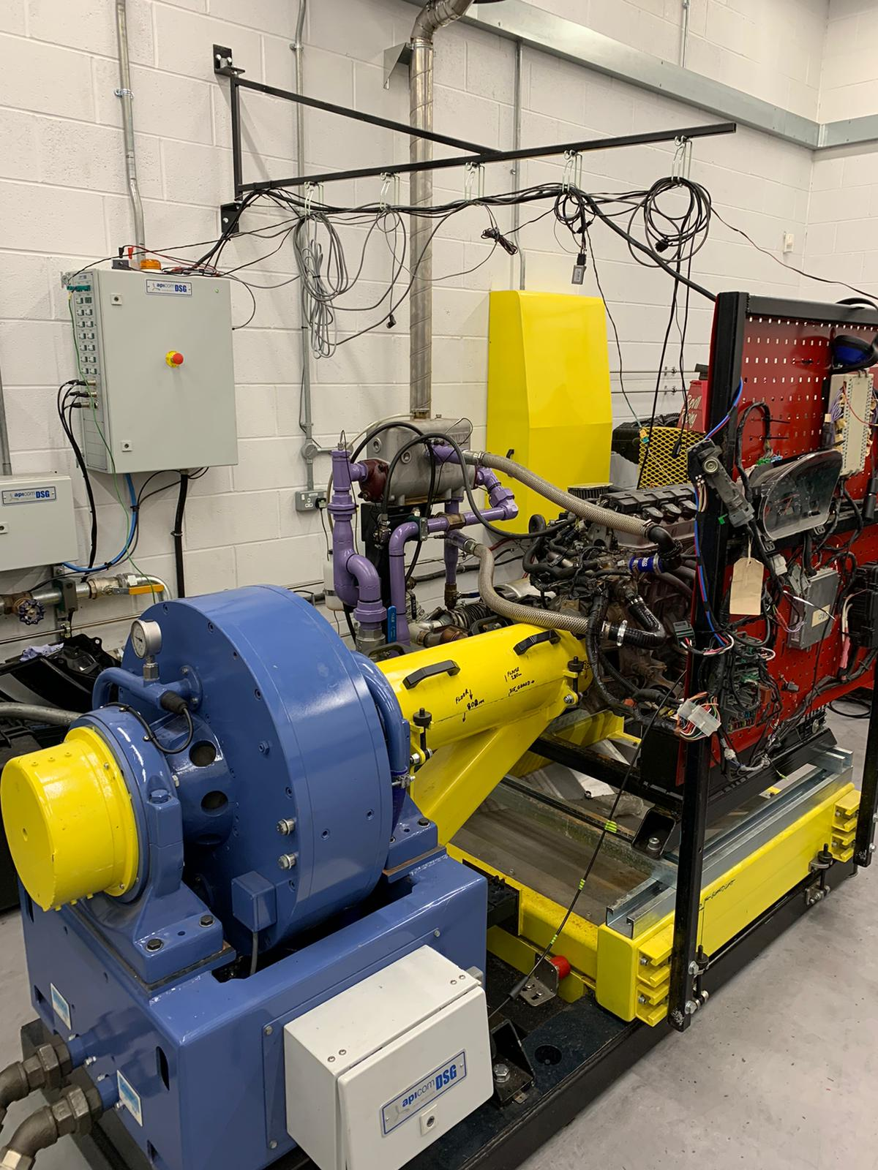
Figure 1: Engine Dynamometer in Dyno Lab
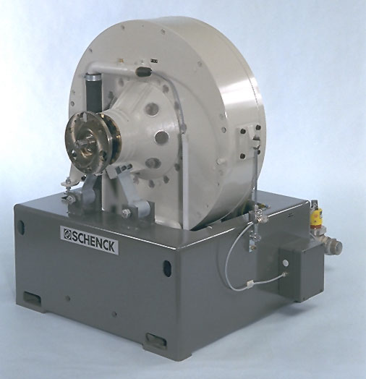
Figure 2: Technical Specification Eddy-Current Dynamometer W Series

Laboratory Session

Equipment

- Eddy Current Dynamometer
- Honda Civic Coupe CRX 1.6 L engine
- Torque Arm
- 20.3 kg weight
- Dyno Computing System

Figure 3: Eddy Current Dynamometer

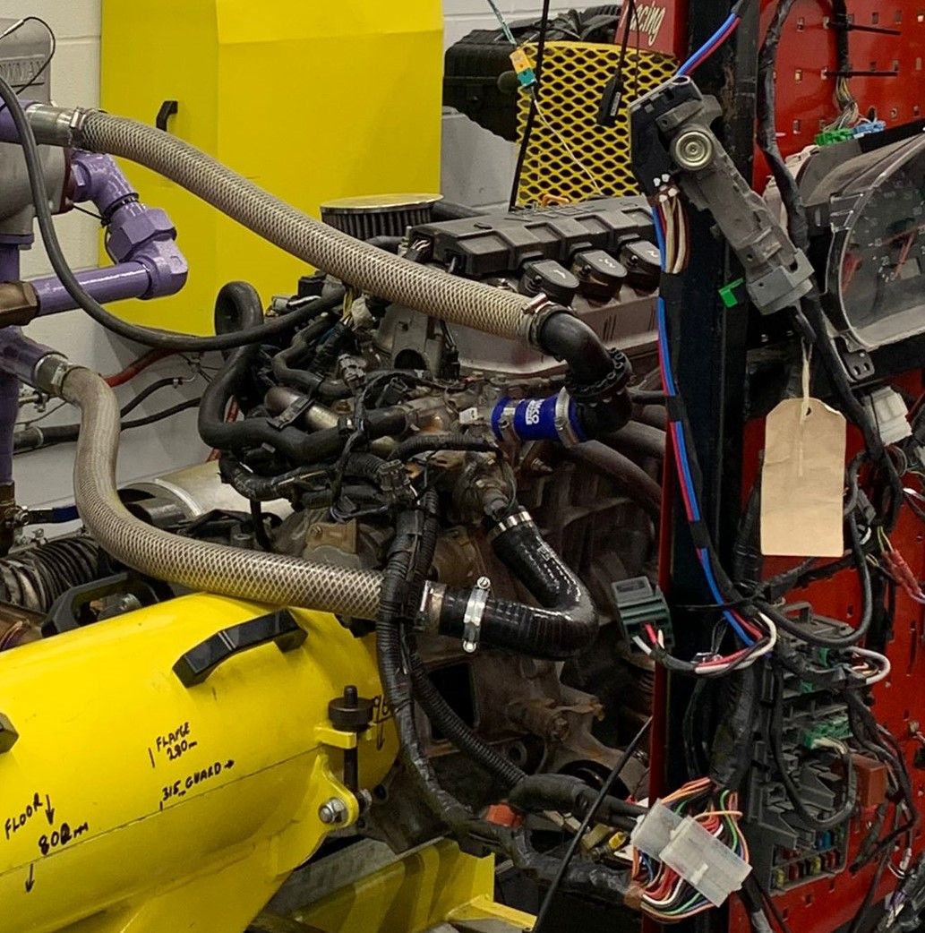
Figure 4: Honda Civic Coupe CRX 1.6 L engine

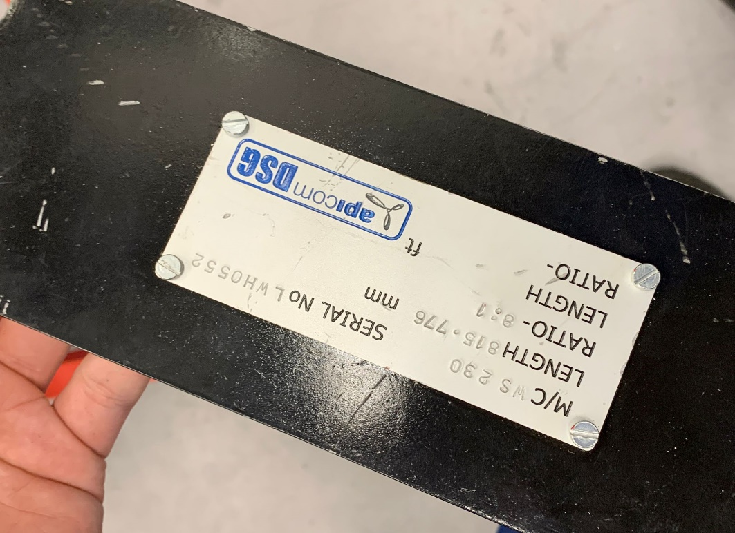
Figure 5: Torque Arm

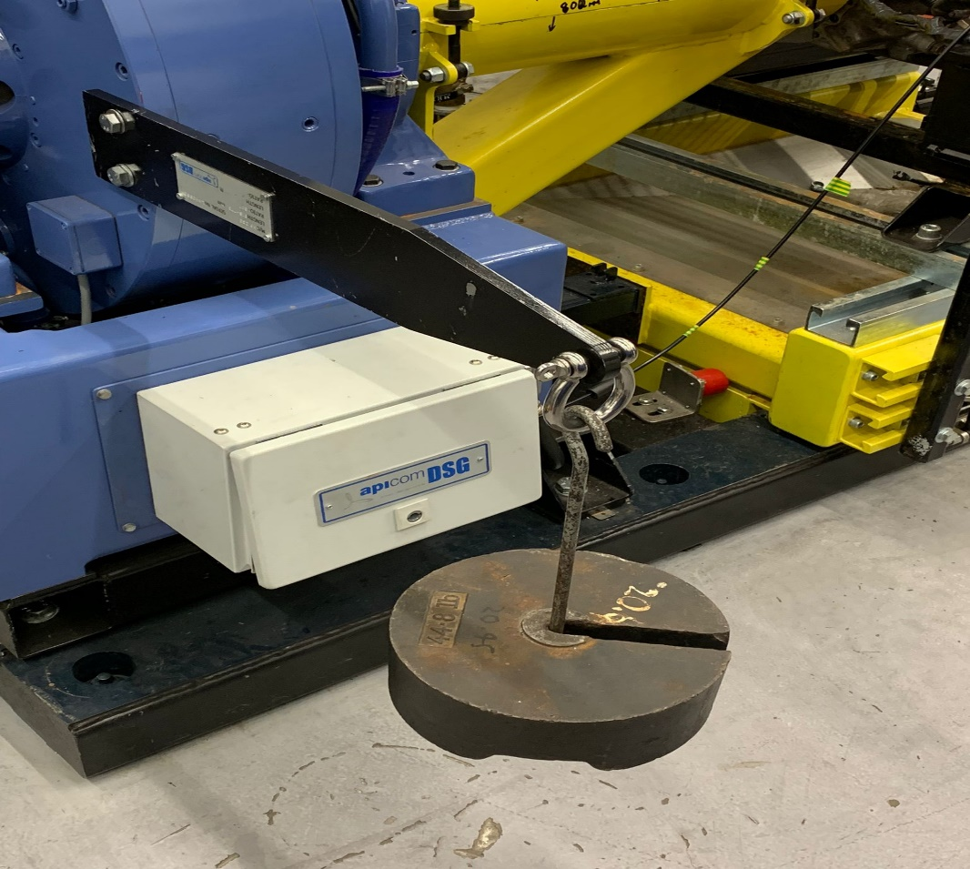
Figure 6: Torque Arm holding 20.3 kg weight

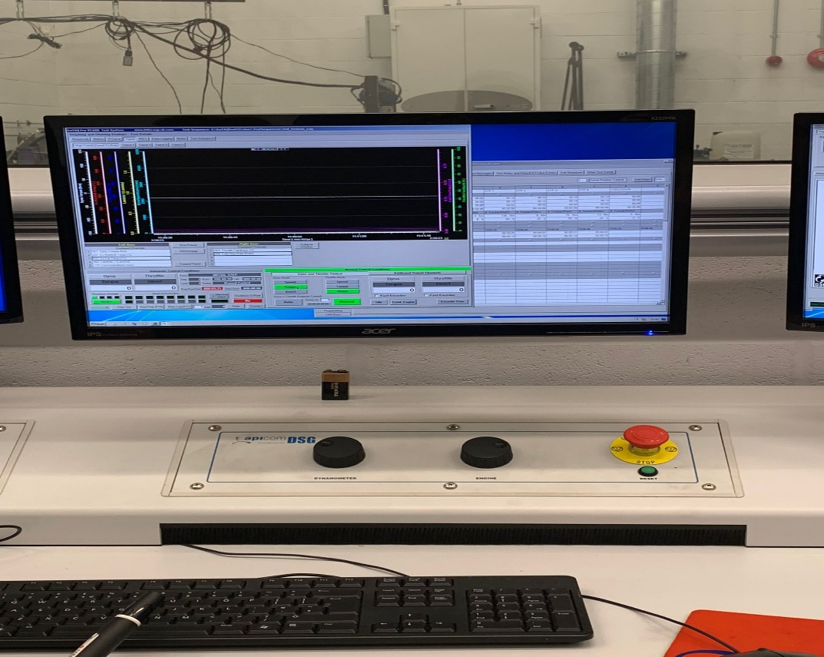
Figure 7: Dyno Computing System

Methodology
The dynamometer is set up and calibrated before the engine testing is begun. The steps involved in calibrating the dyno is first positioning both torque arms with the length of 815.776mm horizontally on both left and right side with the same distance from the centre axis to neutralize each other. Then a weight of 20.3 kg is hung from the torque arm to be able to calculate the torque applied around the centre axis. After the dynamometer is calibrated, we proceed to the computing room. There, the engine is started, and testing is done. The first test that was carried out is the manual test. The system is set to manual mode and the engine’s power can be controlled by using the two dials labelled dynamometer and engine. The engine dial controls the rpm, and the dynamometer dial controls the amount of current allowed in to produce a magnetic field to slow the engine down therefore producing torque. The monitors show the current state of the engine such for example the Lamba and amount of fuel. By controlling the two dials we are able to successfully perform the manual testing method and the data is recorded. The next method used is the sweep test. In this test the speed is controlled by the dyno automatically and the throttle is controlled manually with it being at 100. When the revs increase the test is then started. Once the engine goes back to idle, the test is completed, and the data is recorded.

Graphs and Analysis

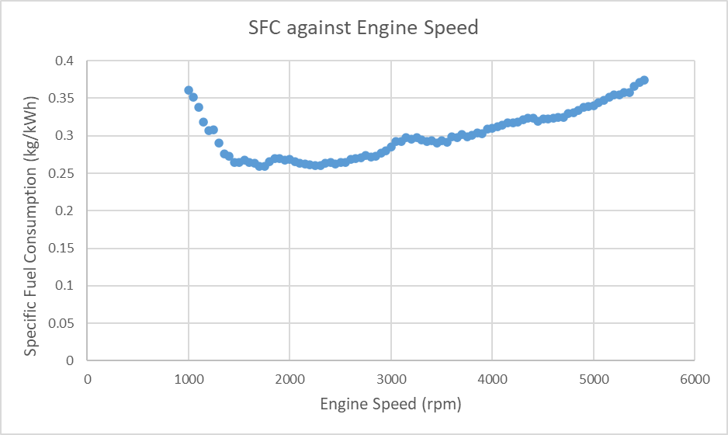
Figure 8: Specific Fuel Consumption plotted against Engine Speed

Engine speed, also known as engine RPM (revolutions per minute), is a critical aspect of any motorized vehicle. It refers to the number of times the engine's crankshaft rotates in one minute. The faster the engine runs, the more complete rotations it does per minute and the more power it produces (Charlie, 2022). The speed at which an engine runs has a significant impact on its performance, efficiency, and lifespan. The speed of an engine can be measured using a dynamometer to the optimum engine efficiency.
The quantity of fuel used by a vehicle for each unit of output is known as specific fuel consumption. (CollinsDictionary, 2023). SFC can also be defined as a metric that measures the amount of fuel consumed by an engine to produce a unit of power output. The formula used to calculate the value of the SFC in this graph is the following:
SFC = V * $(\frac{0.75*3600}{1000 })$ / P

From figure 8, it can be analysed that the graph of Specific Fuel Consumption (SFC) plotted against Engine Speed produces a gradient where when the engine speed increases the SFC gradually increases as well. The gradient initially decreases significantly at 1000 rpm, then slowly produces an incline when engine speed is further increased.

To answer the associated question, suggest reasons why the SFC varies as it does with engine speed. This is because at higher engine speed the engine requires more fuel to produce power output to overcome the additional increase in friction and kinetic energy. Another factor to why SFC varies with engine speed is the result of load on the engine, fuel flow rate and the fuel to air mixture. The engine requires more fuel to produce more power when the engine speed and load is increased thus resulting in an increase in SFC. In addition to that, at lower speeds the engine requires a richer fuel mixture to operate efficiently, while at higher speeds the mixture can be leaner. The varying in engine load can cause a struggle to maintain the optimum air fuel ratio which results in a differing state of SFC. The efficiency of combustion in the engine also affects the SFC. At higher speeds, the engine may not have enough time to fully combust the fuel before the next cycle begins. This can result in incomplete combustion, which lowers the efficiency of the engine and increases the SFC. The engine is a working part and is subjected to mechanical wear. The mechanical efficiency will vary with speed. At higher speeds, the engine may have greater mechanical losses and wear due to factors such as increased friction. This can lead to a decrease in efficiency and an increase in the SFC.

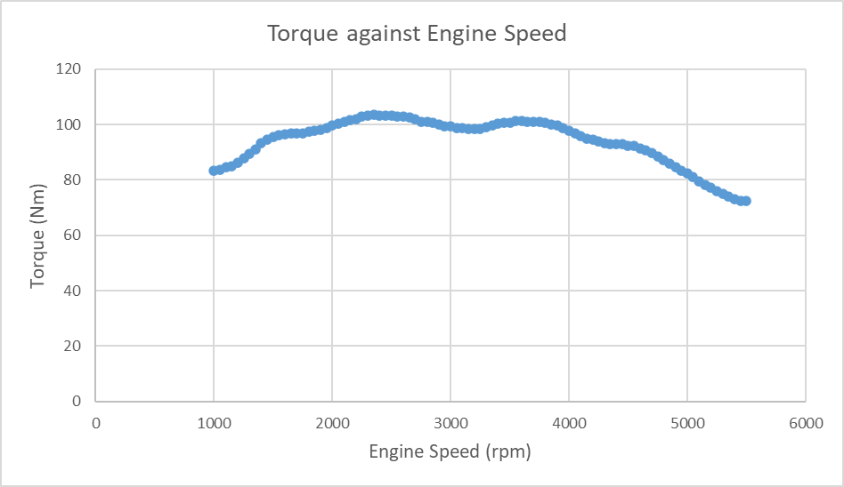
Figure 9: Torque Plotted against Engine Speed

Torque is a crucial aspect of vehicle performance. It refers to the amount of force that an engine can generate to rotate the wheels of a vehicle. Torque plays a significant role in determining a vehicle's acceleration and towing capacity. In simple terms, the definition of torque is the engine's rotational force. Torque is a twisting force usually measured in Newton metres (Nm) (AutoExpress, 2020). Torque for this test was calculated by using the formula :
T = WR

From figure 9, it can be seen that a rapid initial increase of torque from 1000 to 2000 rpm, after which the graph produces a declining gradient when the engine speed is further increased passed 2500 rpm where torque is decreasing. The decrease in torque can be linked to the engine operating beyond its maximum capacity and cannot continue to produce the same level of torque. Torque plotted against engine speed is a common graph used to analyse the performance of engines. The torque curve can be used to engine performance. The curve will rise as engine speed increases until the peak torque value is reached and will gradually fall after even when engine speed is still increasing. From this graph we know that the peak torque of this engine is somewhere at 2300 rpm.

Answering the associated question, suggest reasons why torque varies as it does with engine speed. The factors that can cause change in torque with engine speed are engine design and displacement. Factors such as the number of cylinders and the valve timing can influence the torque curve. The timing of the engine's valves affects the amount of air and fuel that can enter and exit the combustion chamber, which affects the torque output at different engine speeds. For example, an engine with aggressive camshaft timing may produce more high-end torque, while an engine with milder camshaft timing may produce more low-end torque. The intake and exhaust systems of an engine also have an impact on torque. For example, with the increase of engine speed, the engine requires more air flow to produce the optimum power output. This can be achieved by using more efficient intake systems. If an engine does not have the needed requirement to produce the output power, the engine will produce a similar result in figure 9 where the torque significantly decreases.

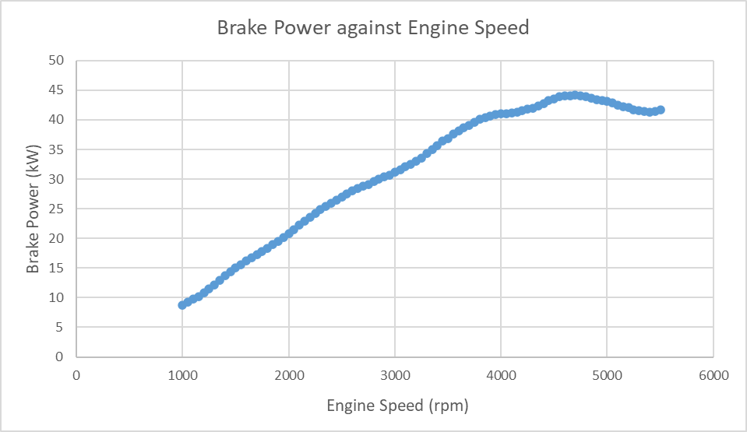
Figure 10: Brake power plotted against Engine speed

Brake power can be defined as the power actually delivered by the engine and is therefore the capacity of the engine. The brake power can be calculated using an engine-out dyno like the one in this test. The formula used to calculate brake power in this test was:
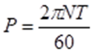

Figure 10 shows that brake power increases proportionally with engine speed until the 4500-rpm mark where the gradient begins to level off. This change in gradient indicates that the engine is reaching maximum power capacity. As the engine speed increases, the torque output also increases, leading to an increase in brake power until a maximum point is reached. The maximum brake power occurs at the engine speed where the torque output is highest, and this speed is often referred to as the peak torque speed.

To answer the associated question of suggest reasons why Brake Power varies as it does with engine speed. This is because, the engine efficiency is put to test. The efficiency of an engine is the ratio of the power output to the power input. At low engine speeds, the engine may not be operating at peak efficiency due to incomplete combustion of fuel, increased frictional losses, or a lack of air flow. As engine speed increases, the combustion process becomes more efficient, and the engine produces more power output. In real world on road scenarios, the brake power can significantly vary due to the frictional losses brought upon by engine, transmission, and drivetrain. These elements can reduce brake power output of the engine.

Calculations

Torque
T = WR
= 102.275 * 0.815776
= 83.43349 Nm

Power
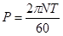
= (2 * PI * 1000 * 83.43349) / 60
= 8737.135 Watt / 1000 (to convert to Kw)
= 8.737134683 Kw

Corrected Power
$P_{s}$ = $\frac{1.01325}{Pa}$ $\sqrt{Ta/273}$ * P
= $\frac{1,011325}{1.0189}$ $\sqrt{300/273}$ * 8737.135
= 8791.862712 Watt / 1000 (to convert to Kw)
= 8.791862712 Kw

Brake Mean Effective Pressure (BMEP)
BMEP = $\frac{120*P}{L*A*N*n}$
= $\frac{120* 8791.862712}{0.09*0.0044179*1000*4}$
= 663356.876 Pa
Specific Fuel Consumption (SFC)
SFC = V * $(\frac{0.75*3600}{1000 })$ / P
= 1.173333333 * $(\frac{0.75*3600}{1000 }$) / 8.791862712
= 0.360333197 kg/Kwh

Overall Thermal Efficiency
$n_{t}$ = $\frac{P}{fuel rate*CV}$ * 100
= $\frac{8.737134683 }{0.00088*44000}$ * 100
= 22.56491396 %

Conclusion
Based on the analysis and testing performed on the dynamometer, it can be concluded that this equipment is an essential tool for measuring and analysing mechanical power and torque of various types of machines and engines. The dynamometer offers a high degree of accuracy and repeatability in its measurements, making it a reliable instrument for industrial and scientific applications. The dyno allows for greater degree of control over the variables being tested. This enables student to understand the processes and step used to identify values from the dyno because the steps can be slowed down and explain thoroughly through visual aid of the machine. For example, in the test conducted, the steps used were the manual test and sweep test.
During the testing, the dynamometer showed consistent results and was able to measure power and torque accurately within the specified range. The data collected using the dynamometer helped to identify the performance characteristics of the engine being tested, which can be used for further analysis and optimization of the machine. This report shows how an engine specification can be identified using a dyno. Overall, this report highlights how to find values such as the power, torque, BMEP, SFC, and Overall Thermal Efficiency using the data gathered from the dyno. Additionally, the dyno and the engine used does not require high maintenance, proving the dynamometer to be a valuable asset for student to gain experience and knowledge to later be used in industry.
To conclude, the dynamometer is an essential tool for engineers and researchers working in the field of engineering, providing accurate and reliable measurements of mechanical power and torque. Its ease of use, flexibility, and accuracy make it a valuable investment for any organization involved in designing, manufacturing, or testing machinery and engines.

Evaluation
The task for this assignment was to carry out a test to identify the engine performance and characteristic of a Honda Civic Coupe CRX 1.6 L engine using a dynamometer. The writer believes that the task in hand was performed successfully as all the necessary data was collected and the study objective of learning to use the dynamometer was achieved. That being said, the writer believes there are some portions of the test that could be improve from a personal standpoint. From example, the writer should have done more external research on the dyno machine and the engine being examined. In addition, the writer believes that further revision on the formulas and calculation method should have been done to clearly understand how the data is being calculated and processed. In regards to the general investigation, the writer believes that the engine used was subpar. To elaborate, at some points of the experiment the engine would fail to start up and would have to be manual checked by the technician. The engine also failed to deliver the correct reading required in some test performed. The reasoning behind this is because the engine is old and has been used many times hence having wear and tear subjected to it. This can cause the engine to lose power and performance over the years. One way to better this test is to completely switch out the old engine for a newer model.

References

Auto Express (2020) What is Torque? All about torque: definition, equations, and units [online] available at: https://www.autoexpress.co.uk/car-news/95110/what-is-torque-all-about-torque-definition-equations-and-units (accessed 22 March 2023)

BMW (2023) Torque in cars: what you need to know [online] available at: https://www.bmw.com/en/performance/torque-in-cars-explained.html (accessed 22 March 2023)

Britannica (2023) brake horsepower [online] available at: https://www.britannica.com/technology/brake-horsepower (accessed 22 March 2023)

Cars.com (2022) What Does RPM Mean in Cars? [online] available at: https://www.cars.com/articles/what-does-rpm-mean-in-cars-1420697442798/ (accessed 22 March 2023)

Collins Dictionary (2023) Definition of 'specific fuel consumption' [online] available at: https://www.collinsdictionary.com/dictionary/english/specific-fuel-consumption#:~:text=Specific%20fuel%20consumption%20is%20the,produce%20a%20unit%20of%20thrust. (accessed 22 March 2023)

Kia (2023) What Is Torque? [online] available at: https://www.kia.com/dm/discover-kia/ask/what-is-torque-in-a-car.html#:~:text=Simply%20put%2C%20torque%20is%20a,vehicle%20is%20beginning%20to%20start. (accessed at 22 March 2023)

Powertestdyno (2023) WHAT IS A DYNAMOMETER [online] available at: https://powertestdyno.com/what-is-a-dyno/ (accessed 15 March 2023)

Toyota (2021) What is Torque? [online] available at: https://www.toyota.ca/toyota/en/connect/3843/what-is-torque-in-cars (accessed 22 March 2023)

Welland (2022) What is the engines speed? What are engine revs? Can you hear the speed? [online] available at: https://support.wellandpower.net/hc/en-us/articles/360001847837-What-is-the-engines-speed-What-are-engine-revs-Can-you-hear-the-speed-#:~:text=What%20is%20its%20speed%3F,the%20more%20power%20it%20produces. (accessed 22 March 2023)

Wikipedia (2023) Dynamometer [online] available at: https://en.wikipedia.org/wiki/Dynamometer (accessed 15 March 2023)

