Appendices

Appendix A
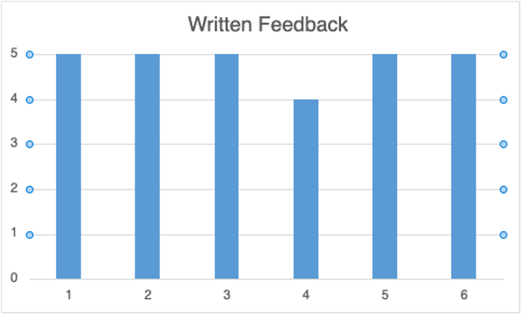
Graph which shows the answers from question 4, which asks pupils to rate Written feedback from 1-5. The Y Axis shows the score from 1-5. The X Axis shows the participant number.

Appendix B
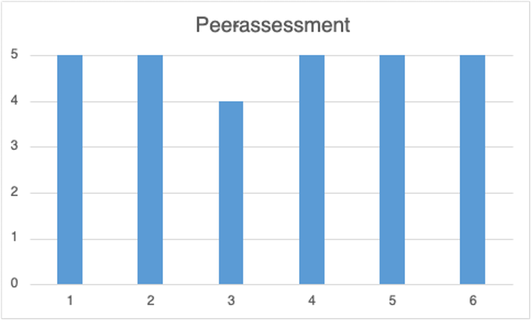
Graph which shows the answers from question 6, which asks pupils to rate peer-assessment from 1-5. The Y Axis shows the score from 1-5. The X Axis shows the participant number.
Appendix C
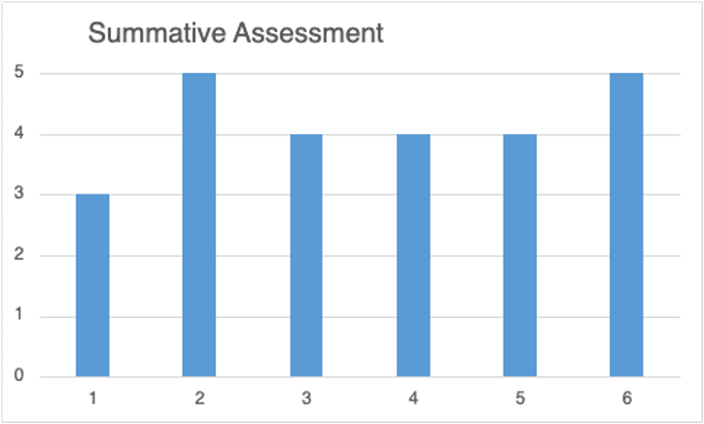
Graph which shows the answers from question 1, which asks pupils to rate Summative assessment from 1-5. The Y Axis shows the score from 1-5. The X Axis shows the participant number.

Appendix D
Participant 1 | Written- Because I like when I see her (teacher) write nice things about my work.
Participant 2 | Summative- I like having a grade/ mark to see how hard I've worked
Participant 3 | Written- I can see where I have gone wrong, to improve upon next time
Participant 4 | Peer- Fun, enjoy talking about other people's work, and gives me more understanding
Participant 5 | Peer- Fun, enjoy marking others work
Participant 6 | Verbal-Let's me know I can do it and I have done well

Table which shows participants answers from question 7. Which style of feedback is your favourite and why?

Appendix E
Participant 1 | Self
Participant 2 | Self
Participant 3 | Formative- I like being told at the end, like to give it a go first
Participant 4 | Self- Don't gain any further understanding
Participant 5 | Formative-Doesn't like showing answers and everyone else seeing, afraid of having the wrong answer. would rather answer in her book.
Participant 6 | Self- Teacher is better at marking than me

Table which shows participants answers from question 8. Which style of feedback is your least favourite and why?

Appendix F
Blank consent form, which was sent to parents.

CONSENT FORM

PROJECT TITLE: How do year 2 students perceive teacher feedback?

Name of Researcher: Bryn Ward

Please initial box

1.I confirm that I have read and understand the information sheet dated 15/04/24 for the above study.

2. I understand that my child’s participation is voluntary and that I am free to withdraw my child from the study at any time, without giving any reason.

3. I understand that my child can choose to withdraw at any time, without giving a reason.

4. I understand that the information given by my child will be used in a university assignment.

5. I understand that my child’s name will not appear at any time.

6. I agree for my child to take part in the above study.

_____________________ _____________________________ __________
Child’s name Parent signature Date

When completed, please return to Mr Ward by the end of the week 19.04.24

Thank you.

Appendix G
Blank copy of questionnaire.
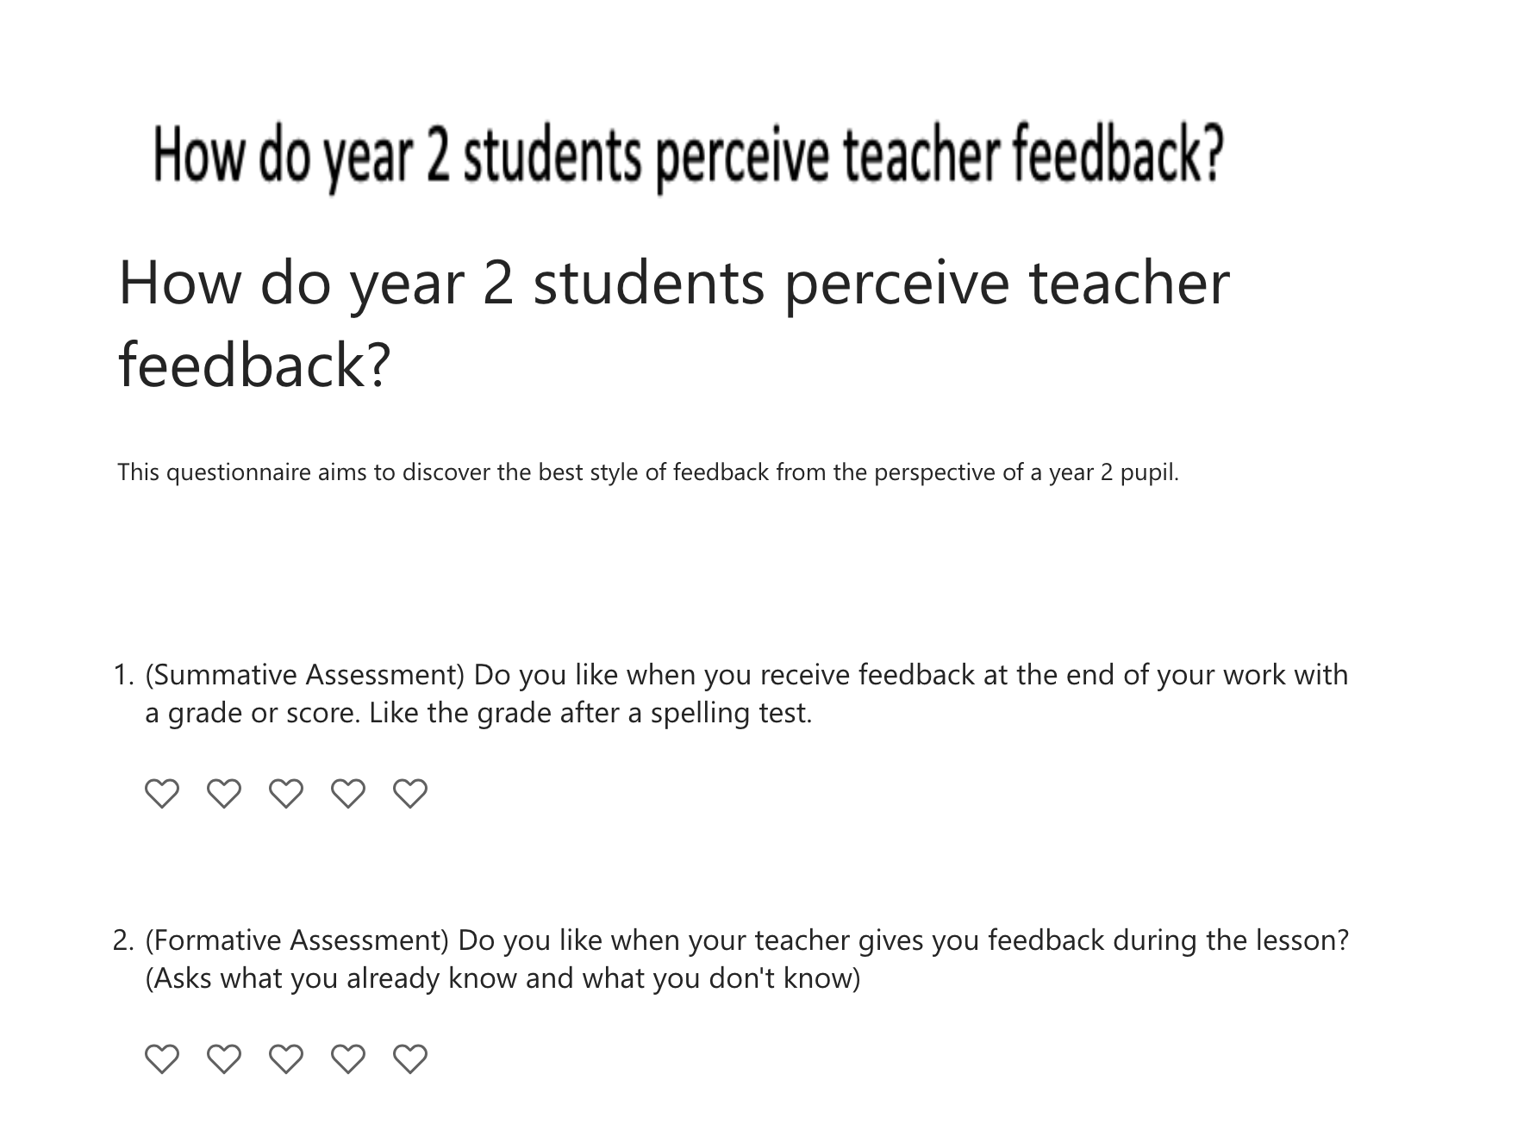
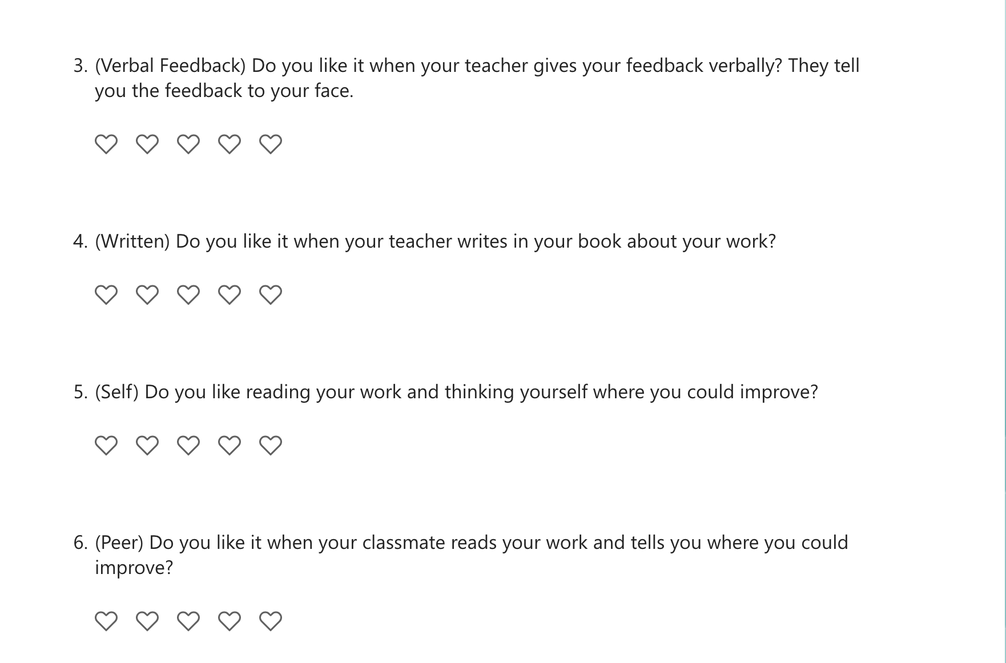

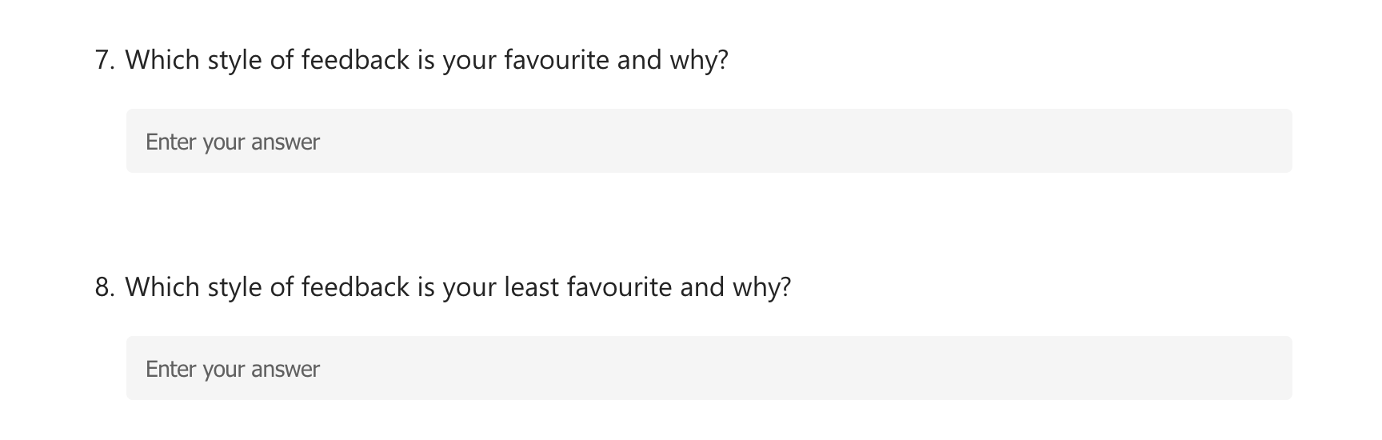

Appendix H


