Dementia Care and Provision in Wales
ECAP 6005

Overview
The Dementia Action Plan for Wales (2018–2022) aimed to establish Wales as a dementia-friendly nation, ensuring individuals with dementia feel valued and can live independently within their communities. Developed collaboratively with people with lived experience, carers, and service providers, the plan focused on raising awareness of dementia, enhancing assessment and diagnosis supporting independent living and providing support for carers (Welsh Gov, 2017). This portfolio is presented in two parts:

Part 1
Two examples of Dementia initiatives in Wales, demonstrating interventions and activities that specifically target those living with dementia in Wales.

Part 2


Exploring the impact of dementia on individuals and those that care for them, with empirical evidence to support.

Part 1


Tŷ Hapus

Barry Respite Centre
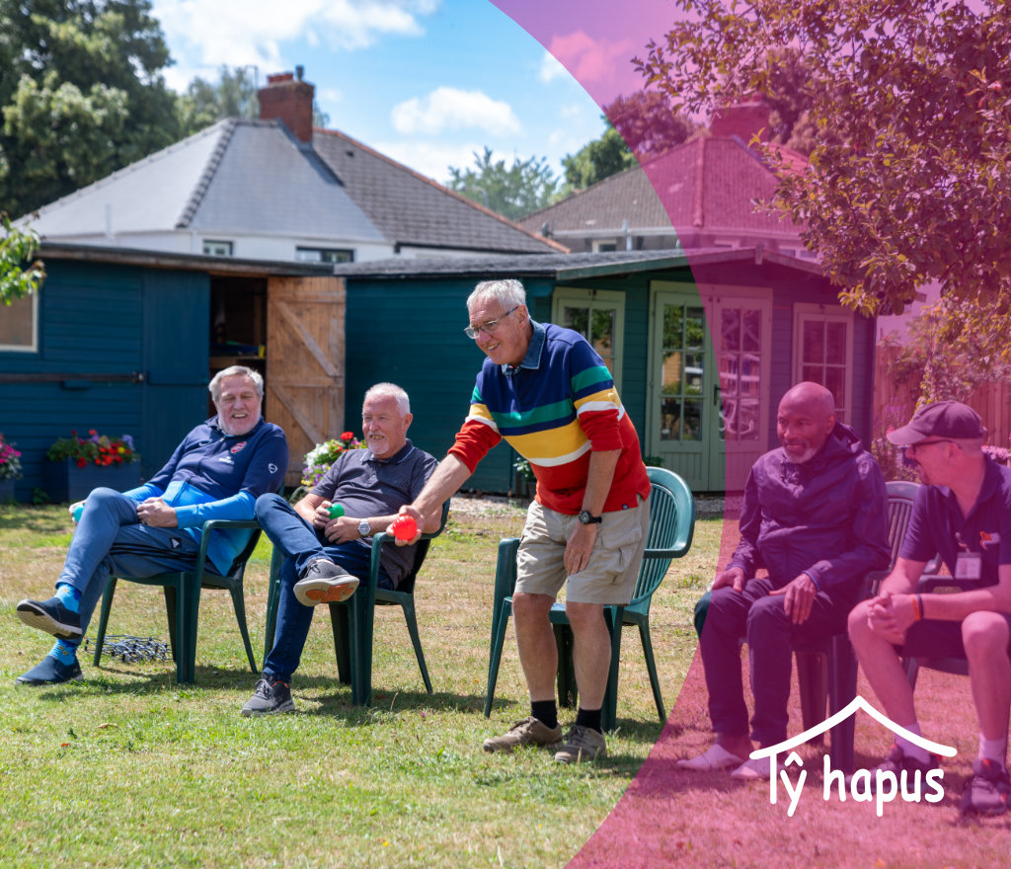
Respite service for young on-set dementia individuals based in Barry Island and Fairwater. The service in Barry offers a ‘Home-from-Home’ intimate environment for up to fifteen individuals to interact and get support in a safe environment. It offers activities such as trips and meals out, whilst offering a place to chat and make friends. They have a ‘Get Active’ service every Friday, exploring Tai chi, indoor hockey and other accessible physical activities. The service is free but has a suggested donation of £15 a day to help towards refreshments, lunch and days out. The charity specialises in supporting families and carers of those with dementia as well as the individuals themselves.

Tŷ Hapus meaning ‘Happy House’ is a registered charity supporting respite services for those with Young Onset dementia, as well as older patients.
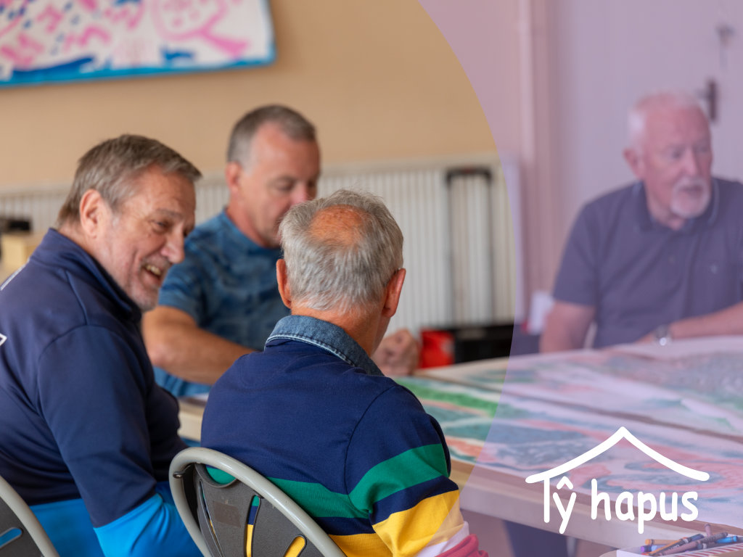

Community Outreach

Every Wednesday in the Sbectrwm centre in fairwater Cardiff, Tŷ Hapus offer a community outreach service, which involves organised activities and a daytime respite option.
“A Great place with loads of dedicated people offering their services to give people a lot of laughter and song in their lives. WELL DONE ALL” (relative of guest)

Counselling and Family Support
“Without the counselling support offered by Ty Hapus I would be in a very different place than I am now. Thank you”

Tŷ Hapus can offer 6 counselling sessions for family and friends of those with dementia. Counselling is delivered by a third year counselling student from the University of South Wales. Ty Hapus welcomes family, friends and paid carers to access the support on offer

Regular activities
Tuesday 1.15pm-3.00pm - Musical Memories.
A social music activity, looking at different genres of music, carers attend alongside.

Every Wednesday - Sbectrwm Centre
Daytime respite

Mon-Fri 9.30am-5.00pm - Ty Hapus Support
The Ty Hapus team are available at any tim during these hours to support those that care for individuals with dementia.


Community Links
Tŷ Hapus is linked to the Health and Social Care service teams.

The charity has also made a link with the university of South Wales Counselling and Psychotherapy department, offering counseling services to anyone who knows someone with dementia (service for over 14s).


Tŷ Hapus
The charity offers daytime respite services free of charge to the community and specialises in early onset dementia.
Support for early-onset dementia (also called young-onset dementia, affecting people under 65) is especially important because it presents unique challenges that differ from those faced by older individuals with dementia.
People with early-onset dementia are often still working, raising children or are still financially responsible for a household. Being diagnosed young can be very isolating. They often feel "out of place" in dementia services geared toward older adults. Tailored support helps them connect with others their age and reduces feelings of shame or loneliness.
Respite care is especially important for young-onset dementia because of the unique pressures it places on both the person living with the condition and their families or carers. In YOD, the primary caregiver is often a spouse or adult child, not someone who’s retired or prepared for a full-time caring role. Many carers are also juggling jobs, parenting, or even elder care—so the emotional and physical load is intense. Respite gives them time to rest, manage other responsibilities, and avoid burnout. There's grief, confusion, and a sense of lost future. Respite care offers time to process emotions, seek therapy, or just have a mental break—without guilt. Many carers of YOD individuals are still in the workforce. Respite can help them stay employed by covering gaps in care during work hours. Maintaining financial stability is often more critical at this stage of life.

Respite programs (like day centres or short stays) can give the person with dementia
a chance to socialize, try new activities, feel a sense of independence, which is vital for self-esteem, especially for younger people who may feel stripped of their identity.
Early intervention for dementia can act as a protective factor in several important ways.
People with dementia can learn new routines, coping strategies, or use assistive technologies while they still have insight. This leads to greater autonomy for longer, which is protective emotionally and practically. This protects against anxiety, depression, and identity loss, which are common after diagnosis but can be mitigated with the right support. This builds protective networks that buffer the stress and improve outcomes for everyone involved.


Forget Me Not Chorus

Singing and Music Therapy

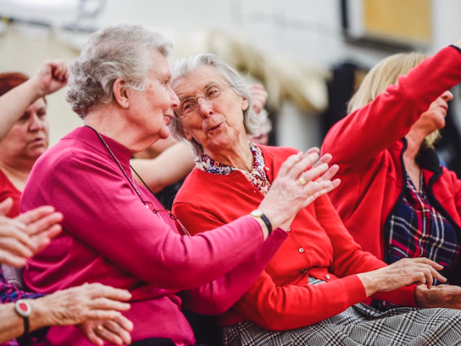
Forget-me-not Chorus is a UK-based charity that supports individuals living with dementia and their caregivers through the power of song. Founded in 2010 by mezzo-soprano Kate Woolveridge, the organization offers inclusive singing sessions as community choirs and music sessions in care homes, hospitals, and online platforms. These sessions aim to enhance well-being, foster social connections, and provide a sense of joy and accomplishment. With a repertoire that includes both familiar tunes and newly commissioned works, the charity reaches over 1,000 participants weekly across the UK. Their innovative approach has been described as a “spa for the soul”, emphasizing the therapeutic benefits of communal singing for those affected by dementia.

Community Choirs
Thornhill Church Centre, Cardiff: Tuesdays 6:30-8:30pm
Julian’s Baptist Church, Newport: Wednesdays 1-3pm
Charles Church, St Austell: Wednesdays 2-4pm
Elfred Ave United Church, Penarth: Thursdays 6:30-8:30pm
Bodelwyddan Village Hall, Denbeighshire: Saturdays 2-4pm
Online (Zoom): Thursdays 11am

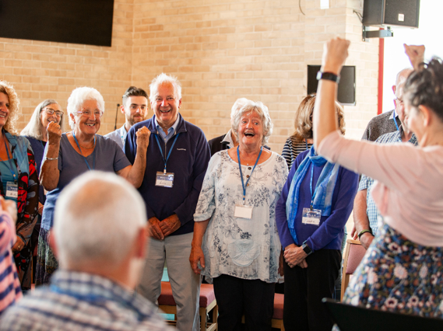
Care home sessions
In care homes, Forget-me-not Chorus delivers inclusive singing sessions tailored for individuals living with dementia, their families, and care staff. These sessions are designed to foster joy, connection, and well-being through music. Each session typically includes vocal warm-ups, gentle movement, and a diverse repertoire of songs—ranging from familiar tunes to newly commissioned pieces—led by trained music leaders. The emphasis is on participation and enjoyment, not musical perfection.

”Forget-me-not Chorus sessions are absolutely fantastic and of great benefit to our residents and their families. The interaction between everyone partaking is amazing to see, so professionally led but so inclusive of everyone”

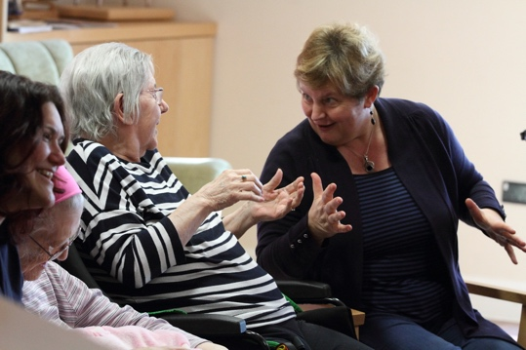
Hospital visits
In hospitals, Forget-me-not Chorus provides inclusive singing sessions designed to support individuals living with dementia, their families, and healthcare staff. These sessions aim to enhance well-being, foster social connections, and bring moments of joy through music.

Online sessions
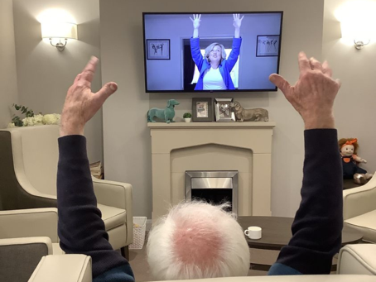
Care homes can access pre-recorded sessions via streaming, downloads, or DVDs, providing flexibility to integrate music into daily routines. Music facilitators also conduct live 45-minute choir sessions on Zoom, allowing participants from various locations to join in real-time singing activities.

”Forget-me-not Chorus has provided a place and time where we both can sing, laugh and interact with others in a safe and friendly environment. The sessions are led by people who show enthusiasm, warmth and joy in all that they do.”

Forget Me Not Chorus
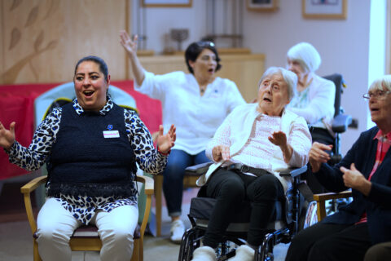
The Forget-me-not Chorus is an important intervention for individuals living with dementia because it offers a unique, person-centered approach that uses music to enhance well-being, communication, and emotional connection. Dementia often leads to social isolation, reduced cognitive engagement, and emotional distress—not only for those diagnosed but also for their families and caregivers. The Forget-me-not Chorus addresses these challenges by creating safe, joyful, and inclusive musical environments that help individuals reconnect with themselves and others.

Singing is a powerful cognitive and emotional activity. It activates multiple areas of the brain simultaneously, including those linked to memory, language, and emotion. Even in later stages of dementia, musical memory is often preserved. Through its regular singing sessions in care homes, hospitals, and online platforms, the Forget-me-not Chorus taps into this enduring strength. Participants are encouraged to engage without fear of judgment—no song sheets, no performance pressure—just the joy of shared music-making.

The impact goes beyond cognitive stimulation. These sessions provide emotional support and a sense of identity, reminding individuals that they are more than their diagnosis. Caregivers and family members also benefit, finding connection and respite in the shared experience. Staff in healthcare and care home settings report improved morale and greater understanding of those in their care.


Furthermore, the flexibility of FMNC’s delivery—ranging from in-person sessions to downloadable or streamed content—ensures accessibility for all, regardless of physical location or mobility. In a healthcare system often stretched for resources, offering a low-cost, high-impact intervention that complements clinical care with meaningful human connection.

By fostering dignity, joy, and a sense of belonging, the Forget-me-not Chorus transforms the experience of living with dementia. It is not just a charity—it is a lifeline, a community, and a celebration of the human spirit through song.

Part 2
Part 2

The impact of Dementia on individuals and those that care for them
Dementia is a chronic and progressive condition that impairs cognitive function, affecting memory, reasoning, communication, and daily living. As global life expectancy increases, the prevalence of dementia has risen sharply, with more than 55 million people currently affected worldwide (World Health Organization, 2021), with 982,000 diagnosed in the Uk at 2024 (dementiastatistics.org, 2025) Beyond the individual diagnosed, dementia exerts profound impacts on informal caregivers—often family members—who provide emotional, physical, and financial support.
Individuals living with dementia frequently experience a complex array of psychological and emotional challenges that profoundly affect their overall well-being and quality of life. In the early stages of the condition, heightened levels of anxiety are common, particularly as individuals become increasingly aware of their memory lapses and the progressive nature of the diagnosis (Pacas Fronza et al., 2022)). This self-awareness can lead to anticipatory grief and existential distress as individuals grapple with the implications of cognitive decline, including concerns about autonomy, identity, and future care needs (Clare et al., 2022). However it is important to consider individual differences in psychological responses. For instance, not all individuals experience insight into their condition at the same degree or rate, and some may remain largely unaware of their impairments (Martyr & Clare, 2018).
These feelings of sadness, hopelessness, and social disconnection are often linked to the loss of functional independence and reduced engagement in meaningful activities, which can result in social withdrawal and diminished self-esteem (Snowden et al., 2015). However, this perspective may oversimplify the emotional response to dementia. While these negative emotions are prevalent, they are not universally experienced, and some individuals may demonstrate resilience or continue to find meaning in relationships or activities. Furthermore, psychotherapeutic research has shown that diagnosis can have a heavy emotional burden upon the individual especially in the earlier stages of the disease where self-awareness remains (Cheston & Ivanecka, 2017).
As dementia progresses and cognitive decline becomes more pronounced, individuals often experience intense emotional responses such as frustration, anger, and irritability, particularly when faced with difficulties in performing previously routine tasks or communicating effectively. Additionally, the unpredictability of cognitive decline fosters fear and anxiety about the future—particularly in relation to increasing dependence, potential institutionalization, and the impact on interpersonal relationships (Edwards et al., 2018). Disorientation, including not recognizing familiar people or environments, may trigger episodes of panic and confusion, further exacerbating emotional instability. Together, these factors create a cycle of emotional vulnerability that significantly undermines psychological well-being (Tales & Basoudan, 2016), which highlights the need for dementia care strategies that are empathetic and person-centered.
In the middle to later stages of dementia, individuals often exhibit a range of behavioral and psychological symptoms which include hallucinations, delusions, agitation, aggression, anxiety, apathy, and disinhibition. Despite these challenges, research has demonstrated that individuals with dementia can still experience meaningful emotional connections and benefit significantly from empathetic communication, consistent emotional validation, and tailored psychosocial interventions (Alsawy et al., 2017; Brown et al., 2020.). Therapeutic approaches such as reminiscence therapy, music therapy, and validation therapy have been shown to reduce agitation, elevate mood, and enhance emotional well-being, even in those with severe cognitive impairment (Istvandity, 2017; Scales et al., 2018). These interventions not only support psychological resilience but also help maintain dignity and foster a sense of continuity and self-worth, highlighting the critical role of emotionally attuned care in later-stage dementia.
It is pertinent to consider the impact upon caregivers. Studies have shown that dementia caregivers have a higher prevalence of anxiety due to the uncertainty of the condition and its related burdens upon caregivers (Kaddour & Kishita, 2020) and many caregivers experience depression due to the responsibility of caregiving, interestingly this has been shown to be more significant in female caregivers (Collins & Kishita, 2020). It has been purported that females and males have different caregiving experiences when compared, with females experiencing more emotional responses to caregiving thus affecting their health and sleep patterns (Pillemer et al., 2018). However it could be argued that there are more factors to consider in relation to this such as socio-economic status, age of caregivers and dementia severity (Xiong et al., 2020), and cultural norms and role expectation. It is also important to consider that caregivers may feel a sense of loss or grief as they watch their loved one’s personality and abilities decline, which can contribute exponentially to caregiver’s well-being and mental health (Crawley et al., 2023). Caregivers of individuals with dementia often experience a profound sense of guilt, which can stem from multiple sources. They may feel guilty for experiencing frustration or resentment, particularly during moments of emotional or physical exhaustion. Guilt can also arise when caregivers believe they are not doing enough, even when they are already stretched beyond their limits. Additionally, difficult decisions—such as placing a loved one in residential care—can trigger feelings of failure or betrayal, despite being made in the best interest of the person with dementia (Gallego-Alberto et al., 2022; Prunty & Foli, 2019).
Isolation is a prevalent and concerning issue among caregivers of individuals with dementia, often resulting from the demanding and time-intensive nature of the caregiving role. As the disease progresses, caregivers may gradually withdraw from social interactions, either due to a lack of time, emotional exhaustion, or the unpredictable behaviors associated with dementia that can make public outings challenging (Lee et al., 2022). Over time, the cumulative effect of reduced social engagement can lead to significant feelings of loneliness, contributing to poorer mental health outcomes such as depression and anxiety (Greenwood et al., 2018). It is essential to consider how socio-economic status, cultural context, and available resources impact the degree to which caregivers experience isolation. For example, caregivers from lower socio-economic and minority cultural backgrounds may face additional barriers to accessing support services or social activities, exacerbating their sense of isolation (Lillekroken et al., 2023).
The physical effects experienced by dementia caregivers show that prolonged caregiving responsibilities often lead to chronic fatigue, sleep disturbances, and increased susceptibility to illness, largely due to sustained stress and inadequate rest (Song & Kim, 2021). Caregivers may also neglect their own health needs, such as skipping medical appointments or failing to maintain proper nutrition and exercise, as their focus shifts entirely to the care recipient. Research has shown that older caregivers are at risk of exacerbated frailty as a result of caring for a loved one with dementia (Dassel &carr, 2016).
Dementia caregiving often imposes significant financial burdens on informal caregivers, many of whom are family members who provide unpaid care. In addition, caregivers frequently reduce their working hours, take unpaid leave, or exit the workforce entirely to meet the demands of caregiving, leading to lost income and diminished long-term financial security (Zhang et al., 2023). This has been shown to be especially true in early-onset dementia where carers are often younger (Mayrhofer et al., 2021).
Despite the numerous challenges associated with dementia caregiving, many caregivers report experiencing positive aspects and personal growth, often referred to as "carer gain” (Quinn & Toms, 2019). These positive outcomes can include a strengthened emotional bond with the care recipient and a heightened sense of purpose. Additionally, the caregiving role can foster the development of new skills, greater empathy, and a deeper appreciation for life and build better relationship (Lloyd et al., 2016). Recognizing these positive dimensions is important, as they can be protective factors against stress and contribute to caregivers' overall well-being and sustained engagement in the caregiving role.
In conclusion, dementia presents a complex and multifaceted challenge, not only for those living with the condition but also for their caregivers. The psychological and emotional toll on individuals with dementia is significant, ranging from heightened anxiety and depression in the early stages to profound emotional distress and behavioral symptoms in the later stages. These challenges underscore the need for comprehensive care strategies that are empathetic, person-centered, and emotionally attuned, ensuring that individuals maintain dignity, self-worth, and a sense of continuity. Similarly, caregivers face a range of burdens, including anxiety, depression, guilt, isolation, and physical strain, which can significantly undermine their well-being. The financial, social, and emotional impacts on caregivers must be addressed through targeted interventions, such as respite care, financial support, and emotional counseling. Furthermore, fostering social connections and reducing stigma are essential in mitigating caregiver isolation. As dementia progresses, both the individuals affected and their caregivers require tailored support that considers their unique needs and experiences. Interventions such as therapy, peer support groups, and community-based programs are essential to enhancing the quality of life for both individuals with dementia and their caregivers. A holistic approach to dementia care, encompassing physical, emotional, social, and financial support, is critical to promoting resilience and well-being in this vulnerable population.

References
Alsawy, S., Mansell, W., McEvoy, P., & Tai, S. (2017). What is good communication for people living with dementia? A mixed-methods systematic review. International Psychogeriatrics, 29(11), 1785-1800.
Brown, E. L., Agronin, M. E., & Stein, J. R. (2020). Interventions to enhance empathy and person-centered care for individuals with dementia: a systematic review. Research in gerontological nursing, 13(3), 158-168.
Cheston, R., & Ivanecka, A. (2017). Individual and group psychotherapy with people diagnosed with dementia: a systematic review of the literature. International journal of geriatric psychiatry, 32(1), 3-31.
Clare, L., Gamble, L. D., Martyr, A., Quinn, C., Litherland, R., Morris, R. G., ... & Matthews, F. E. (2022). Psychological processes in adapting to dementia: Illness representations among the IDEAL cohort. Psychology and Aging, 37(4), 524.
Collins, R. N., & Kishita, N. (2020). Prevalence of depression and burden among informal care-givers of people with dementia: a meta-analysis. Ageing & Society, 40(11), 2355-2392.
Crawley, S., Sampson, E. L., Moore, K. J., Kupeli, N., & West, E. (2023). Grief in family carers of people living with dementia: A systematic review. International psychogeriatrics, 35(9), 477-508.
Cross, A. J., Garip, G., & Sheffield, D. (2018). The psychosocial impact of caregiving in dementia and quality of life: a systematic review and meta-synthesis of qualitative research. Psychology & health, 33(11), 1321-1342.
Cross, A. J., Garip, G., & Sheffield, D. (2018). The psychosocial impact of caregiving in dementia and quality of life: a systematic review and meta-synthesis of qualitative research. Psychology & health, 33(11), 1321-1342.
Dassel, K. B., & Carr, D. C. (2016). Does dementia caregiving accelerate frailty? Findings from the Health and Retirement Study. The Gerontologist, 56(3), 444-450.
Edwards, H. B., Ijaz, S., Whiting, P. F., Leach, V., Richards, A., Cullum, S. J., ... & Savović, J. (2018). Quality of family relationships and outcomes of dementia: A systematic review. BMJ open, 8(1), e015538.
Gallego-Alberto, L., Losada, A., Cabrera, I., Romero-Moreno, R., Pérez-Miguel, A., Pedroso-Chaparro, M. D. S., & Márquez-González, M. (2022). “I feel guilty”. Exploring guilt-related dynamics in family caregivers of people with dementia. Clinical Gerontologist, 45(5), 1294-1303.
Greenwood, N., Mezey, G., & Smith, R. (2018). Social exclusion in adult informal carers: A systematic narrative review of the experiences of informal carers of people with dementia and mental illness. Maturitas, 112, 39-45.
Istvandity, L. (2017). Combining music and reminiscence therapy interventions for wellbeing in elderly populations: A systematic review. Complementary therapies in clinical practice, 28, 18-25.
Kaddour, L., & Kishita, N. (2020). Anxiety in informal dementia carers: A meta-analysis of prevalence. Journal of Geriatric Psychiatry and Neurology, 33(3), 161-172.
Lee, J., Baik, S., Becker, T. D., & Cheon, J. H. (2022). Themes describing social isolation in family caregivers of people living with dementia: A scoping review. Dementia, 21(2), 701-721.
Lillekroken, D., Halvorsrud, L., Gulestø, R., & Bjørge, H. (2023). Family caregivers’ experiences of providing care for family members from minority ethnic groups living with dementia: A qualitative systematic review. Journal of Clinical Nursing, 32(9-10), 1625-1641.
Lloyd, J., Patterson, T., & Muers, J. (2016). The positive aspects of caregiving in dementia: A critical review of the qualitative literature. Dementia, 15(6), 1534-1561.
Martyr, A., & Clare, L. (2018). Awareness of functional ability in people with early‐stage dementia. International Journal of Geriatric Psychiatry, 33(1), 31-38.
Mayrhofer, A. M., Greenwood, N., Smeeton, N., Almack, K., Buckingham, L., Shora, S., & Goodman, C. (2021). Understanding the financial impact of a diagnosis of young onset dementia on individuals and families in the United Kingdom: Results of an online survey. Health & social care in the community, 29(3), 664-671.
Pacas Fronza, G., Liddle, J., Mitchell, L. K., Byrne, G. J., Pachana, N. A., & Dissanayaka, N. N. (2022). Phenomenology of anxiety in people living with mild to moderate dementia: A conceptual meta-ethnographic review. Dementia, 21(8), 2677-2699.
Pillemer, S., Davis, J., & Tremont, G. (2018). Gender effects on components of burden and depression among dementia caregivers. Aging & mental health, 22(9), 1162-1167.
Prunty, M. M., & Foli, K. J. (2019). Guilt experienced by caregivers to individuals with dementia: A concept analysis. International Journal of Older People Nursing, 14(2), e12227.
Quinn, C., & Toms, G. (2019). Influence of positive aspects of dementia caregiving on caregivers’ well-being: A systematic review. The Gerontologist, 59(5), e584-e596.
Scales, K., Zimmerman, S., & Miller, S. J. (2018). Evidence-based nonpharmacological practices to address behavioral and psychological symptoms of dementia. The Gerontologist, 58(suppl_1), S88-S102.
Snowden, M. B., Atkins, D. C., Steinman, L. E., Bell, J. F., Bryant, L. L., Copeland, C., & Fitzpatrick, A. L. (2015). Longitudinal association of dementia and depression. The American Journal of Geriatric Psychiatry, 23(9), 897-905.
Song, M. J., & Kim, J. H. (2021). Family caregivers of people with dementia have poor sleep quality: A nationwide population-based study. International Journal of Environmental Research and Public Health, 18(24), 13079.
Tales, A., & Basoudan, N. (2016). Anxiety in old age and dementia-implications for clinical and research practice. Neuropsychiatry, 6(4), 142-8.
World Health Organization. (2021). Dementia. https://www.who.int/news-room/fact-sheets/detail/dementia
Xiong, C., Biscardi, M., Astell, A., Nalder, E., Cameron, J. I., Mihailidis, A., & Colantonio, A. (2020). Sex and gender differences in caregiving burden experienced by family caregivers of persons with dementia: A systematic review. PloS one, 15(4), e0231848.
Zhang, J., Wang, J., Liu, H., & Wu, C. (2023). Association of dementia comorbidities with caregivers’ physical, psychological, social, and financial burden. BMC geriatrics, 23(1), 60.
Welsh Government. (2018, January 17). Dementia Action Plan for Wales. Retrieved April 17, 2025, from https://www.gov.wales/sites/default/files/publications/2019-04/dementia-action-plan-for-wales.pdf

