University Of Wales Trinity Saint David

Wales institute Of Science & Arts

Electric And Autonomous vehicles
Academic And Laboratory Skills

Daniyal Zafar
2501537
November 2025

Table of Contents
Table of Contents 2
Introduction 3
Contextual Information 4
Battery Technology 5
Sensors And Artificial Intelligence 6
Market Adoption 7
Conclusions 8
Bibliography 9

Introduction
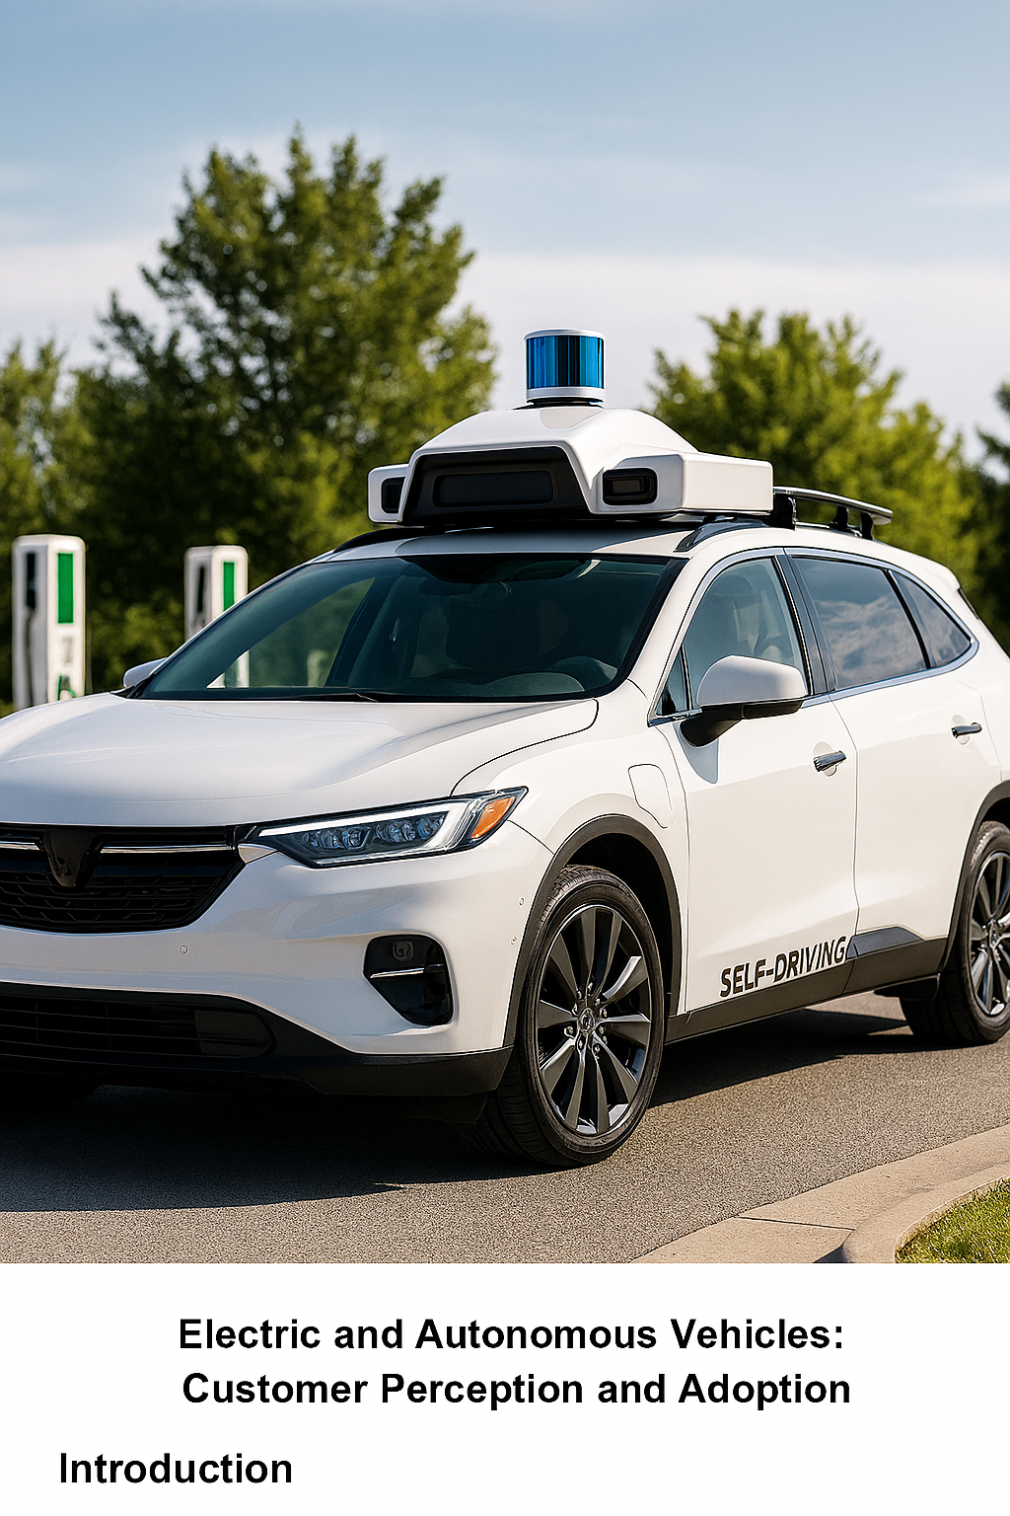

The transportation industry is undergoing a profound transformation driven by two revolutionary technologies: electric vehicles and autonomous vehicles. As concerns over climate change, urban congestion, and road safety intensity, these innovations offer promising solutions that could reshape mobility as we know it. Electric vehicles, powered by clean energy sources, are rapidly replacing internal combustion engines. Meanwhile, autonomous vehicles-equipped with advanced sensors, artificial intelligence, and machine learning algorithms-are poised to redefine the driving experience by enhancing safety, efficiency, and accessibility.
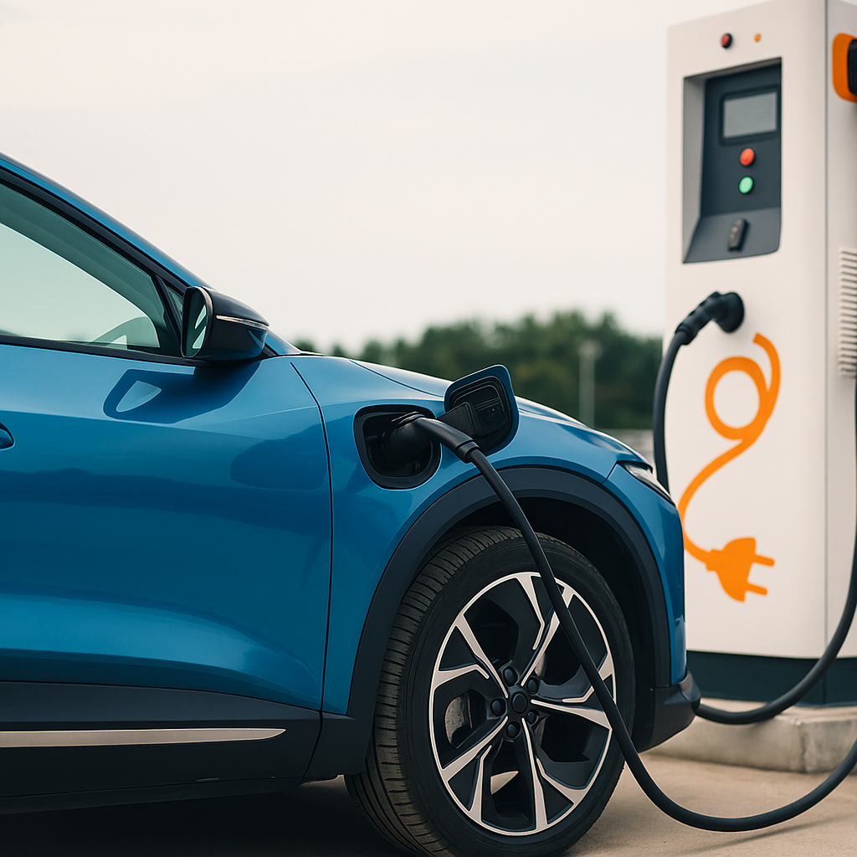
This report explores the convergence of electric and autonomous vehicles technologies, examining their development, benefits, challenges, and potential impact on society, and the global economy. By analysing current trends, regulatory frameworks, and the global economy. By analysing current trends, regulatory frameworks, and future projections, we aim to provide a comprehensive overview of how these innovations are steering us toward a more sustainable and intelligent transportation future.

Contextual Information

The story of electric vehicles stretches back to the early 19th century, when inventors Anyos Jedlik and Robert Anderson developed the first crude electric carriages. By the early 20th century, Electric vehicles were a third of all vehicles on US roads, before being eclipsed by mass-produced gasoline cars. Renewed interest followed in the 1970s oil crises, but it was not until the 2010s- heralded by lithium-ion battery advances, the rise of Tesla and Nissan Leaf, that’s where the era of electric vehicles began. (Matulka, 2014)

The autonomous Vehicles (AV) field, likewise, has evolved from early radio-controlled vehicles in the 1920s, through university research in the late 20th century, to the 21st century breakthroughs in sensors, AI and connected infrastructure. Landmark moments include Carnegie Mellon’s Navlab in the 1980s, the DARPA Grand Challenges of 2004-2007, and the launch of Waymo’s commercial robotaxi service in Phoenix in 2018.By 2025 AV pilots are active in dozens of cities, supported by substantial public and private investment.

Government Support and Global Policy are a central driver for both EV and AV uptake. The transition to electric and autonomous mobility is supported by a patchwork of fiscal incentives, regulatory mandates, and infrastructure investments:

EV Incentives and Targets:
- China: EVs from purchase tax, offers trade-in subsidies, and mandates aggressive local manufacturing quotas; plans for 60% of car sales to be electric by 2025.
- Europe: Direct BEV incentives are being rolled back in some mature markets, but a robust regulatory regime exits- such as 55% CO2 emission reduction targets, zero-emission zones, and increasingly stringent vehicle registration mix quotas. (Katanich, sep=2025)
- US: Provides up to $7,500 per new EV and $4,000 for used vehicles via the Clean Vehicle Tax Credit.
AV Regulation:
Recent years have seen landmark policy advances in China, Japan, California, and the UK, with clear paths for ¾ vehicles and structured frameworks for pilot deployments, liability, data access, and cybersecurity standards. Key government investments targets both AV infrastructure (V2X, 5G) and innovation clusters. (Zoting, Aug 2025)

Battery Technology
- Silicon Anode Innovations
- Silicon anodes are rapidly replacing traditional graphite, offering up to 10x capacity and a 20-50% boost in energy density. Breakthroughs from companies like Sila Nanotechnologies and Group14 Technologies make silicon-dominant cells both high-performance (driving ranges of 500+ miles per charge) and scalable, overcoming previous issues with cycle life and volume explosion. Group14’s SCC55 technology and others are now being commercially deployed, with factories in the US and Asia, while integrators (e.g., Queen Mary University (Barnard, 2025), BASF) report market-ready silicon anodes with fast charge capability and 80%+ retention after 1,000+ cycles. (Willing, 2025)
- Solid-State Batteries
- Solid-state batteries are nearing commercialization, promising double the energy density, higher safety, and super-fast charging (5-15 minutes to 80%). Automakers like Toyota, Nissan, Volkswagen, and alliances led by CATL, BYD, and Samsung SDI are investing heavily; market launches are expected from 2027-2028 onwards. China’s IM Motors L6 (130 kWh solid-state) and Toyota’s next-generation prototypes point to the next phase for luxury, mainstream, and eventually affordable EVs. (Agency, 2025)
- Sodium-Ion and Lithium-Sulphur
- Sodium-Ion Batteries: Offering environmental and economic advantages due to sodium abundance, these are suitable for cost-sensitive, short-range EVs and stationary grid storage. CATL, BYD, AND HINA are all scaling up second-generation sodium-ion battery production from 2025; current densities (up to 200Wh/kg) now approach LEP levels, while cycle life exceeds 10,000 deep cycles. (Krampf, 2025)
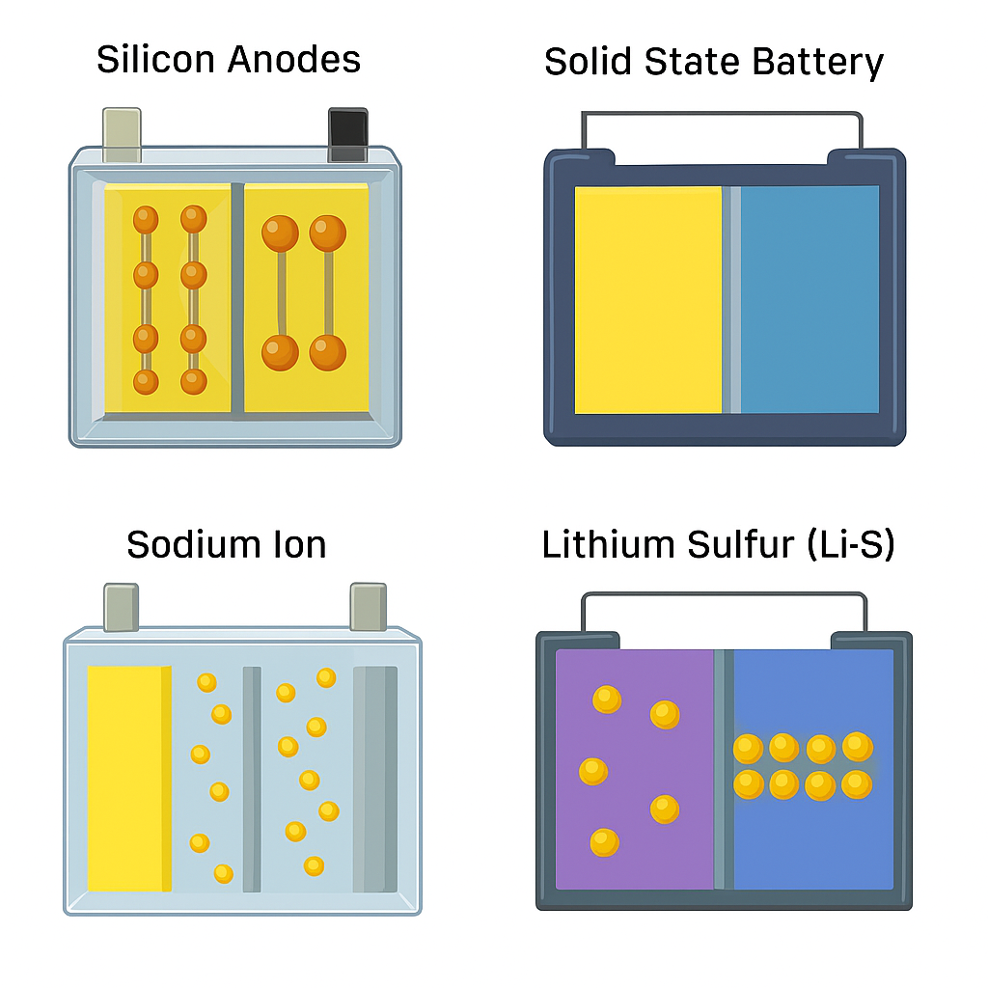
- Lithium-Sulphur Batteries: Promise up to four times the gravimetric energy density of conventional lithium-ion. Companies (e.g., Lyten, Stellantis-Zeta) are aiming for automotive commercialization by 2030, pending solutions to stability and volumetric density challenges. (Ather, 2025)

Sensors And Artificial Intelligence
- Sensors: Hardware Development for Avs
- LiDAR, Radar, and Camera Fusion
- LiDAR: Rapid advances in solid-state and frequency- modulated continuous- wave (FMCW) LiDAR have bought down costs, miniaturized form factors, and enabled greater reliability. These sensors allow for real-time, high-resolution 3D mapping-critical for level 3-5 Avs -and are increasingly integrated in both luxury and mass-market vehicles. (He, 2024)
- Camera System: Camera- only AV solutions have been championed by Tesla (Tesla Vision) and now by other OEMs seeking cost-effectiveness, but most global AV developments use sensor fusion with radar and/or LiDAR for redundancy.
- Radar And Ultrasonic: Used for adoptive cruise control (ACC), automatic emergency braking, parking aids, and as backup for perception in low-visibility conditions.
- Artificial Intelligence and Decision-Marketing Algorithms
A. AI Perception, Prediction, And Planning
- Perception: Modern perception systems rely on multimodal sensor input (LiDAR, radar, cameras) processed by advanced detection- segmentation neural networks (e.g., Multitask V3), providing real-time object detection, road scene understanding, semantic with minimal computer and power draw. (Baczmanski, et al., 2023)
- Prediction: AI models estimate intent and likely trajectories of surrounding actors, informed by vast data pools (hundreds of millions of simulated and real-world miles). Companies like Waymo, Baidu, and Tesla are leaders in self- supervised and reinforcement learning approaches.
- Planning: Hybrid systems combine data-driven learning (end-to-end, imitation learning, reinforcement learning) with rule-based (knowledge-driven) logic for trajectory generation, obstacle avoidance, and decision- making- ensuring adaptability and adherence to safety/regulatory constraints. (Tokuhiro, 2024)
- Simulation and Validation
- Simulation Platforms: Companies such as Waymo, Mobileye, and Aurora use cloud-based simulation to run billions of complex scenarios, training and validation perception and control stacks against edge cases, weather variations, and rare incidents. The accuracy and diversity of simulation data are becoming as important as real-world testing for regulatory validation.
- Explainable and Reliable AI: The imperative of explainable AI, uncertainty calibration, and robust post-hoc reliability assessment is critical in safety-critical applications like AVs. Regulatory and consumer trust increasingly hinge on interpretable, well-calibrated AI decisions- an area of active academic and commercial innovation. (Barros, et al., 2025)

Market Adoption
- Global EV Market Trends (2024-2025)

- Sales and Markets Share

- Sales Trends: Global EV sales exceeded 17 million in 2024, representing over 20% of total new car sales; projections suggest over million units for 2025 and 40 million (42% share) by 2030. (Agency, 2025)

- China: 11+ million units in 2024, 48% of new car market; set to reach 60% share in 2025 and over 80% by 2030.

- Europe: Over 2 million BEV sales in 2024 (15.4% share; 13.6% in EU), led by Norway, Denmark, the Netherlands, and the UK. Regional disparities persist, with some southern and eastern states below 10%.

- United States: 1.6 million units in 2024, 10% share, with growth continuing but slowing in 2024 (up only 0.5 percentage points from 2023). (Daly, 2025)

- Emerging Markets: India (7-9% share in 2024), Brazil more than doubled EV sales (6.5% share), and rapid growth in southeast Asia.

- Key Players and Industry Partnerships

- Top Automakers: As of 2025, BYD, Tesla, Volkswagen Group, GM, Hyundai-Kia, Geely, and BMW are the largest EV makers by global volume. (Dommeti, 2025)

- China: BYD leads globally, with affordable models and vertical battery integration. Local brands (Geely, GWM, SAIC) expand into Latin America, Southeast Asia, and Europe.

- US/EU: Tesla’s market share in the US fell to 38% in 2024 (from 60% in 2020) as Ford, GM, Stellantis, and international brands introduced competitive BEV lineups. Volkswagen, BMW, Stellantis leas the EU BEV transition.

- Consumer and Government Spending
- Global consumer spending on EVs reached $560 billion in 2024; government support is down to 7% per vehicle, signalling growing market maturity. (Agency, 2025)

Conclusions

The last two years (2024-2025) mark an inflection point in the global transition to electric and autonomous mobility. EVs are firmly on a path toward mainstream dominance, led by China’s scale and manufacturing advances, mature policy frameworks in Europe and the US, and early but rapid growth in emerging economies. Autonomous Vehicles, once regarded as science fiction, are moving from pilots to scalable commercial reality-in, in robotaxi fleets, logistics trucks, and industrial-specific environments. This confluence is underpinned by-and will catalyse further-breakthroughs in battery chemistries, sensor technologies, and artificial intelligence. (Agency, 2025)

Challenges endure – charging network equity, raw material sustainability, AI robustness, public trust, liability, cybersecurity, and regulatory harmonization. But the conversation of electric and autonomous technologies, delivered through global alliances and adaptive policy, is setting the stage for a far-reaching transformation- one that will define personal, public, and commercial mobility to come. (Agency, 2025)

The trajectory is clear: by 2030, EVs could capture 40%+ of global new car sales, with Avs operating at scale across continents. The next five years will reveal which players, technologies, and regions lead the charge into the charge into this bold new era. (McKerracher, 2025)

Bibliography
Agency, I. E., 2025. Global EV Outlook 2025. [Online]
Available at: https://iea.blob.core.windows.net/assets/c3f7fb7b-4205-4fd6-a20e-afe14a9aa252/GlobalEVOutlook2025.pdf
Agency, I. E., 2025. Global EV Outlook 2025. [Online]
Available at: https://iea.blob.core.windows.net/assets/c3f7fb7b-4205-4fd6-a20e-afe14a9aa252/GlobalEVOutlook2025.pdf
Ather, I., 2025. Synergy Files. [Online]
Available at: https://synergyfiles.com/2025/06/sodium-ion-batteries-in-2025-a-snapshot-of-the-fast-emerging-post-lithium-option/
Baczmanski, M., Wasala, M. & Kryjak, T., 2023. Simple Science. [Online]
Available at: https://scisimple.com/en/articles/2025-10-08-advancements-in-autonomous-vehicle-perception-systems--a9mep12
Barnard, L., 2025. Electric Specifier.com. [Online]
Available at: https://www.electronicspecifier.com/industries/automotive/queen-mary-scientists-unveil-silicon-battery-breakthrough-promising-30-cost-cuts-and-faster-ev-charging/
Barros, T., Conde, p. & Cardoso, W., 2025. Reliable AI applied to perception systems in autonomous vehicles. [Online]
Available at: https://www.insticc.org/Primoris/InvitedSpeakers/VEHITS_2025/Keynotes/VEHITS_2025_KS_4_Presentation.pdf
Daly, L., 2025. The Motley Fool. [Online]
Available at: https://www.fool.com/research/largest-ev-companies/
Dommeti, M., 2025. thecconnects. [Online]
Available at: https://thecconnects.com/top-20-electric-vehicle-manufacturers-in-2025/
He, D. X., 2024. IDTechEx. [Online]
Available at: https://www.idtechex.com/en/research-report/lidar-2024-2034/995
Katanich, D., sep=2025. Which country offers the most Subsideis to buy EVs?. [Online]
Available at: https://www.euronews.com/business/2025/09/17/which-european-country-offers-the-most-government-subsidies-to-buy-evs
Krampf, S., 2025. Sodium Battery Hub. [Online]
Available at: https://sodiumbatteryhub.com/2025/04/10/whats-currently-happening-in-sodium-ion-batteries-2025/
Matulka, R., 2014. The Histroy Of ElectrIc Vehicles. [Online]
Available at: https://www.energy.gov/articles/history-electric-car
Tokuhiro, 2024. Frontiers. [Online]
Available at: https://www.frontiersin.org/journals/neurorobotics/articles/10.3389/fnbot.2025.1451923/full
Willing, N., 2025. Charged-EV Engineering News. [Online]
Available at: https://chargedevs.com/features/how-the-transition-from-graphite-to-silicon-anode-batteries-will-revolutionize-the-ev-industry/
[Accessed May].
Zoting, S., Aug 2025. Euro News. [Online]
Available at: https://www.precedenceresearch.com/autonomous-vehicle-market

