26/04/2026
Assessment 2 data
Practical and Professional Development of the Proposed Project

Module NaMe: Changemakers, Creativity and Value creation
Module Code: ACCA 5033
Student NAME: joao paulo borges straioto
Student ID: 2430803
Lecturer: Koushik Modak
Trinity saint david University of Wales (London Campus)

Name: Joao Paulo Borges Straioto
Student ID:2430803
Table of Contents
Introduction 3
Task 1- Project Management 3
Q1. Project Management & Planning: 3
1. Project Aim 3
1.2 Problem Statement 3
1.3 Proposed Solution 3
1.4 Technologies and Resources 4
1.5 Project Timeline and Schedule 4
1.6 Project Constraints 4
➢ Gantt Chart: 5
Q2. Project Design: 7
➢ flowchart 7
➢ Wireframe 8
➢ Implementation Plan 10
➢ Prototype Development 10
➢ Key Features and Process 10
Task 2- Enterprise & Innovation 11
Q1. PEST & SWOT Analysis 11
PEST Analysis 11
SWOT Analysis 11
Legal & Ethical Considerations 12
Q2. Tech Start-up Proposal 12
Start-up Name & Logo 12
Business Type (Legal Classification) 12
Business Strategy 12
Funding Initiatives 13
Task 3 -Project reflection 14
Project Reflection 14
Skills Development 14
Positive Social Impact (PSI) 14
Risks and Challenges 15
Conclusion 16
Reference 17
Appendices 19
Project Idea: Smart Home Mobile Application 19
Project Progress Form 19
Project Aim: 19
Project Objectives: 19
Recommendations: 19

Introduction
This report focuses on the planning and development of a Smart Home System designed to improve home security and automation. The idea of this project is based on the growing use of smart technologies in everyday life, where devices can be connected and controlled remotely to make homes safer and more efficient.
The main aim of this project is to design a system that uses IoT devices and basic artificial intelligence to monitor activities inside a home, detect unusual behaviour, and send alerts to users when needed. This can help improve response time in emergency situations and reduce the need for constant manual monitoring.
This report will mainly focus on how the project can be planned and managed. It will include the project scope, the technologies required, a timeline using a Gantt chart, and design elements that show how the system would work. In addition, business considerations and a reflection on the project will also be discussed.
Overall, the report aims to show a clear and realistic approach to developing a smart home solution while applying project management and planning concepts.

Task 1- Project Management

Q1. Project Management & Planning:
Project Scope:

1. Project Aim
The aim of this project is to design a Smart Home mobile application that provides centralized control of devices, automation features, energy monitoring, and security management through a simple and user-friendly interface. The focus is on improving usability and integration within a single platform.[1] [2] [3] [4]

1.2 Problem Statement
Many smart home users rely on multiple disconnected applications to control different devices, resulting in poor user experience and inefficiency. Existing systems often lack integration, consistency, and real-time monitoring capabilities, making home management more complex.[5]

1.3 Proposed Solution
This project proposes a Smart Home mobile application that integrates key features such as device control, home automation, energy management, security monitoring, remote access, voice assistant, and device integration. The system is designed to provide a unified interface that simplifies interaction and improves overall user experience. [6]

1.4 Technologies and Resources
The project uses design and planning tools rather than full implementation technologies. These include:
- Canva (wireframes and UI design)
- Microsoft Word (documentation)
- Gantt chart tools (Excel or online software)
- Academic research sources
- Basic concepts of IoT and mobile application design
The system concept is based on IoT integration, mobile interfaces, and cloud-based communication principles. [7]

1.5 Project Timeline and Schedule
The project is divided into the following stages:
- Research and idea development
- Requirements planning
- Wireframe design
- Flowchart creation
- Review and improvements
- Final documentation and submission
This structure ensures a logical progression from planning to design and final delivery.

1.6 Project Constraints
The project is subject to several limitations:
- Limited time due to academic deadlines
- No full system implementation (design-focused project)
- Limited access to real smart home devices
- Limited user testing and feedback
- Dependence on secondary research sources
These constraints define the scope and ensure the project remains realistic and achievable.

Gantt Chart:
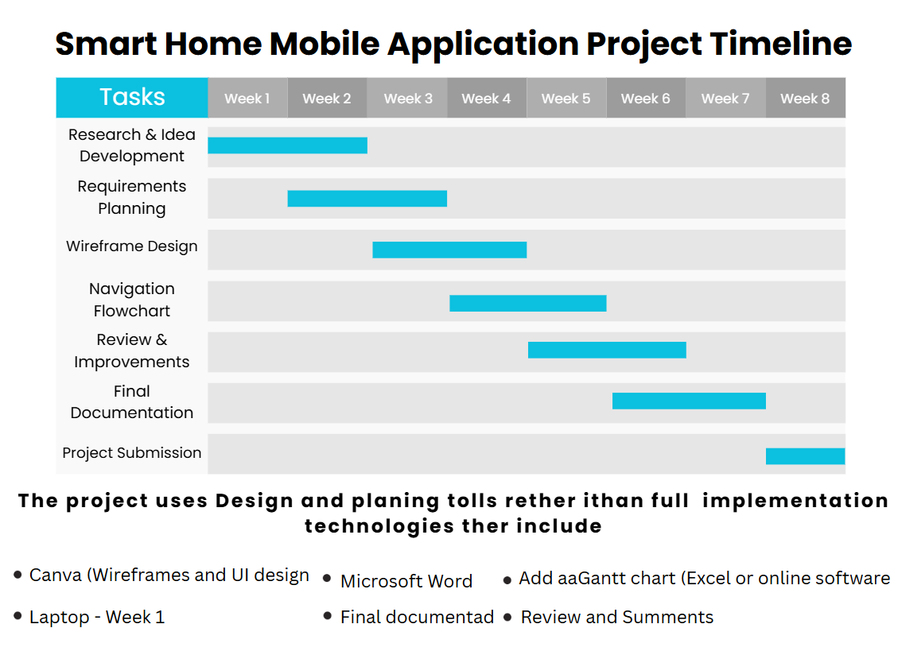
Figure 1 -Smart Home project timeline (Gantt chart).
The Gantt chart illustrates the planned timeline of the Smart Home mobile application project, showing how each stage is organised over time. It highlights the sequence of activities, including research, design, development planning, and final documentation. This structure helps ensure that tasks are completed in a logical order, improving time management and overall project organisation. Gantt charts are widely used in project planning as they provide a clear visual representation of task progression and dependencies. [8]
The link represents the Smart Home project timeline (Gantt chart), showing how tasks are organised over time.
Link
- Smart Home Mobile Application Project Timeline

Weekly Project Progress Sheet
Week | Task | Progress | Notes
Week-1 | Research | Completed | Project idea defined
Week-2 | Planning | Completed | Scope created
Week-3 | Wireframes | Completed | Screens designed
Week-4 | Flowchart | Completed
  Navigation structure defined
Week-5 | Gantt Chart | Completed | Timeline created
Week-6 | Review | In Progress | Improving design consistency
Week-7 | Final Report | Pending | Final adjustments
The table below shows the weekly progress of the project, used to monitor completed tasks, current progress, and remaining work.

Development Method
This project follows an Agile development approach, specifically Scrum, which allows the work to be completed in small stages with continuous improvements. Instead of developing everything at once, the project is built step by step, including planning, wireframe design, flowchart creation, and refinement.
This method is suitable for the Smart Home application because it includes multiple features such as device control, automation, energy management, and security monitoring. Agile helps to keep the work organised, review progress regularly, and make adjustments when needed.
Overall, this approach improves flexibility, supports better organisation, and ensures a more consistent and user-friendly final design. [9]

Q2. Project Design:

flowchart
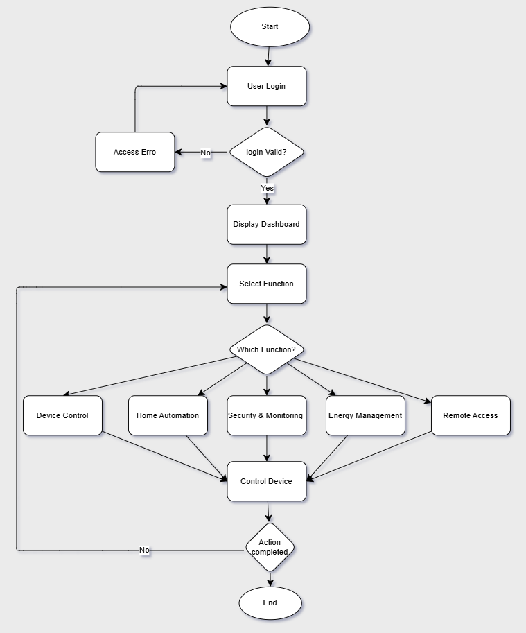
Figure 2 -Smart Home application flowchart showing user navigation and system process.
The Smart Home App flowchart visually illustrates how a user interacts with a smart home application in a simple and intuitive way. The journey begins with the user logging in, where the system checks whether the credentials are valid — if not, an error message appears and the user is given the chance to try again. Once successfully logged in, the dashboard is displayed, giving the user access to five core features: Device Control, Home Automation, Security & Monitoring, Energy Management, and Remote Access [1] Each feature carries out its own process, and at the end the system checks whether the action was completed successfully. If it was, the flow comes to an end; if not, the user is brought back to select a new function. Overall, this diagram shows in a clear and straightforward way how a smart home app can bring all home controls together into one single, easy-to-use platform, making everyday life simpler and more comfortable for its users [2]

Wireframe
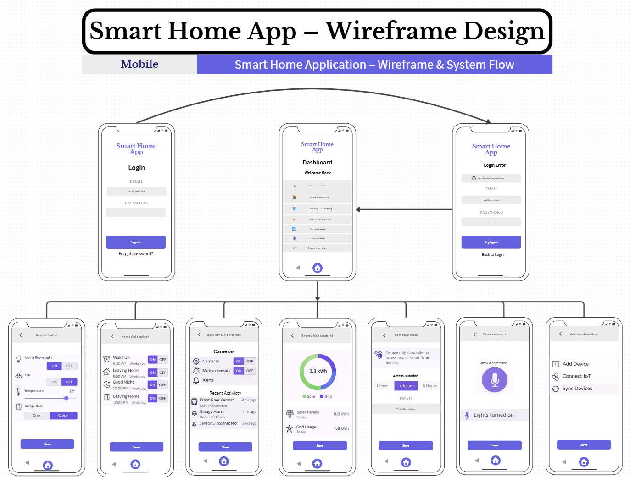
Figure 3 -Smart Home application wireframe showing the initial layout and user interface structure.
This wireframe presents the design of a Smart Home mobile application, focusing on a simple and user-friendly experience. The system begins with a sign-in process, followed by access to a central dashboard where users can easily navigate between key features such as device control, home automation, energy management, and remote access. Each screen is designed with a clear purpose, allowing users to control devices, manage routines, and monitor energy usage efficiently. Additional features such as security monitoring, voice assistant, and device integration are also included to extend the system’s functionality and improve overall interaction. Overall, the design follows basic user interface principles, ensuring clarity, consistency, and ease of use throughout the application [3][4]
The provided link corresponds to the wireframe of the project, representing the initial layout and structure of the Smart Home application.
- Link: chengmakers
Implementation and Prototype Development

Implementation Plan
The implementation of this project focused on the design and development of a Smart Home mobile application prototype. The work was completed in stages, including research, planning, wireframe design, and flowchart creation. This step-by-step approach helped organise the project and ensure that each part was clearly developed before moving forward [10]

Prototype Development
The practical development of the project is represented through a low-fidelity prototype created using wireframes. This prototype shows how users interact with the system, including login, dashboard access, and navigation between features such as device control, automation, and energy management. It allows the system to be visualised without requiring full technical implementation [11]

Key Features and Process
The key features of the application are demonstrated through the wireframes and flowchart. The flowchart shows the navigation process, while the wireframes represent the layout and user interaction. Together, these elements provide a clear understanding of how the system works and how users move through the application [12]

Task 2- Enterprise & Innovation

Q1. PEST & SWOT Analysis

PEST Analysis
A PEST analysis helps evaluate external factors that may impact a technology company operating in the smart home and IoT industry.
- Political: Government regulations related to data protection (such as GDPR in the UK/EU) can affect how user data is collected and managed. Compliance is essential for operating legally .[13]
- Economic: The growing demand for smart home devices and energy-efficient solutions creates strong market opportunities. However, economic instability may reduce consumer spending on non-essential technologies [14]
- Social: Increasing interest in home automation, security, and convenience is driving adoption. Users are becoming more comfortable with smart technologies in everyday life.
- Technological: Rapid advancements in IoT, artificial intelligence, and cloud computing enable continuous innovation, but also require regular updates and system maintenance.

SWOT Analysis
A SWOT analysis evaluates internal strengths and weaknesses, along with external opportunities and threats.
- Strengths:
  - Centralized system design
  - User-friendly interface
  - Integration of multiple features
- Weaknesses:
  - No full implementation (prototype only)
  - Limited real-world testing
- Opportunities:
  - Growing smart home market
  - Increasing demand for automation and energy monitoring
- Threats:
  - High competition (e.g., Google Home, Amazon Alexa)
  - Data security and privacy concerns

Legal & Ethical Considerations
The application must comply with data protection laws such as GDPR, ensuring that user data is stored securely and used responsibly. Ethical considerations include protecting user privacy, ensuring transparency in data usage, and avoiding misuse of personal information [15]

Q2. Tech Start-up Proposal

Start-up Name & Logo
Smart Nest
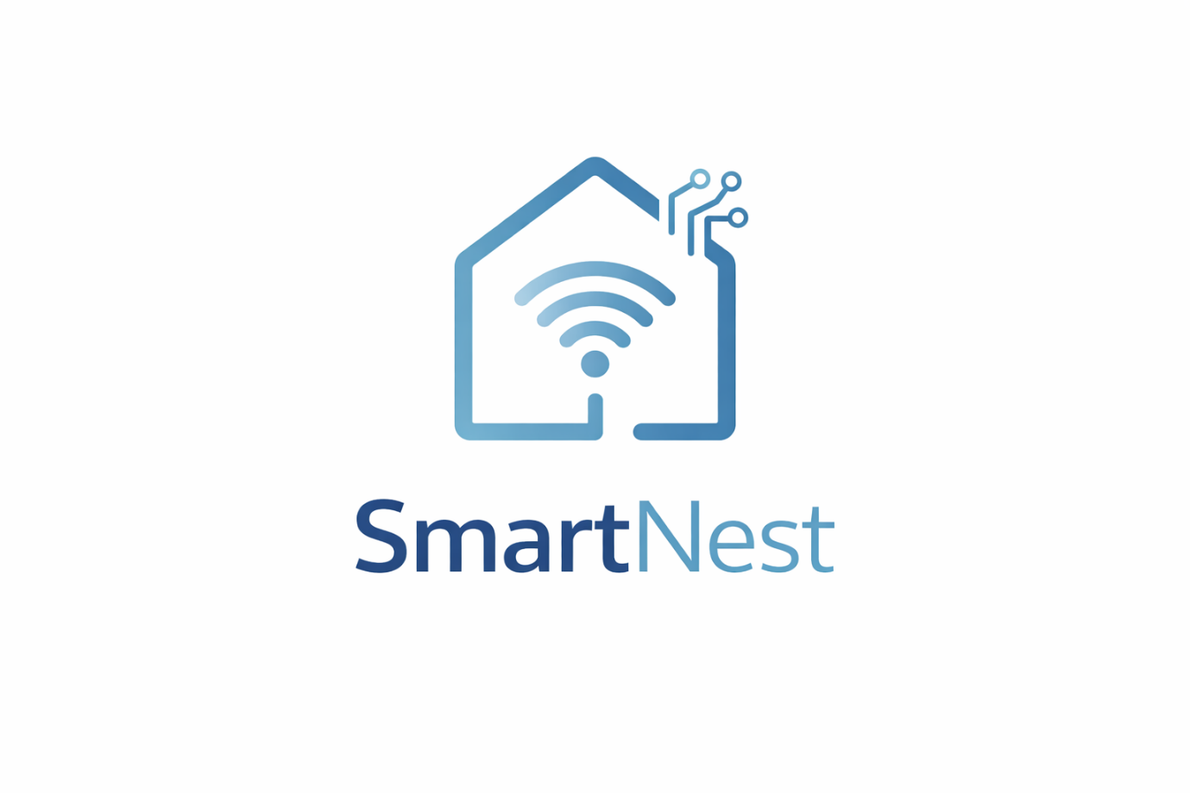
Figure 4-SmartNest logo design representing a smart home system, combining connectivity, automation, and modern IoT technology.

Business Type (Legal Classification)
The proposed business would operate as a Private Limited Company (Ltd) in the UK. This structure provides limited liability, protects personal assets, and is suitable for technology start-ups.

Business Strategy
The business strategy focuses on developing a user-friendly Smart Home application that integrates multiple features into a single platform. The goal is to simplify device control, improve home security, and optimize energy usage.
The company will target:
- homeowners
- families
- users interested in smart living technologies
A key strategy is to differentiate through:
- simplicity
- integration
- user experience

Funding Initiatives
The start-up could be funded through:
- Seed funding / investors (venture capital)
- Subscription model (premium features)
- Freemium model (basic free, advanced paid)
- Partnerships with smart device manufacturers
These funding strategies allow the company to grow while maintaining flexibility and supporting future scalability.

Task 3 -Project reflection

Project Reflection
This project provided a valuable opportunity to develop both technical and analytical skills through the design and planning of a Smart Home mobile application. Throughout the project, I improved my understanding of project management, user interface design, and system planning. The use of tools such as wireframes, flowcharts, and Gantt charts helped me organise tasks effectively and understand how a real project is structured.
If I were to undertake this project again, I would focus more on user feedback and testing. Although the design is clear and structured, the lack of real user interaction is a limitation. Gathering feedback from potential users would help improve usability and ensure that the application meets real-world needs. I would also spend more time refining the visual consistency of the interface to make it more professional.

Skills Development
This project allowed me to develop several important skills. I improved my ability to plan and manage a project using structured methods such as Agile. I also developed design skills by creating wireframes and understanding how users interact with a mobile application. Additionally, I gained knowledge in smart home technologies, IoT concepts, and the importance of integrating multiple features into a single platform.
In the future, I intend to continue developing these skills by learning programming languages and tools required for full application development. This includes mobile app development frameworks, database management, and cloud-based systems. These skills will allow me to move from design and planning to full implementation, making the project more realistic and functional [16]

Positive Social Impact (PSI)
The Smart Home application has the potential to create a positive impact on society by improving safety, convenience, and energy efficiency. Features such as security monitoring and real-time alerts can help protect users and reduce risks in emergency situations. Energy management tools can also help users monitor and reduce energy consumption, contributing to environmental sustainability.
In addition, the application can support vulnerable groups, such as elderly users, by providing automated systems and monitoring features that improve daily living. The integration of smart technologies into homes can enhance quality of life and promote smarter and more efficient living environments [17]

Risks and Challenges
Despite its benefits, the project may face several risks and challenges. One major challenge is data security and privacy, as smart home applications collect sensitive user information. To reduce this risk, strong security measures such as encryption and secure data storage must be implemented.
Another challenge is system compatibility, as different devices may use different standards. This can be addressed by supporting common IoT protocols and ensuring better integration between devices.
Additionally, user adoption may be a challenge, especially for individuals who are not familiar with smart technologies. To overcome this, the application must focus on simplicity, clear design, and ease of use.
Finally, the lack of full implementation is a limitation of this project. Future development would require technical skills, testing, and real-world deployment to ensure the system works effectively [18].

Conclusion
This project showed how a Smart Home mobile application can be planned and designed in a clear and structured way. By using tools such as wireframes, flowcharts, and a Gantt chart, it was possible to understand how the system would work, how users would interact with it, and how the different features connect within one platform.
The project also highlighted the importance of keeping the design simple and consistent, making it easier for users to navigate and control different smart home functions. Features such as device control, automation, energy management, and security monitoring were designed to work together in a single application, improving usability and overall user experience.
In addition, the Enterprise section helped to show how this idea could be developed into a real business. It included a start-up concept, business strategy, and funding options, as well as an analysis of external factors through PEST and SWOT. This made the project more realistic and connected it to real-world applications.
Overall, this project helped me improve my understanding of project planning, system design, and the role of smart technologies in everyday life. It also allowed me to develop useful skills that can be applied in future academic work and real-world projects.

Reference
[1] R. S. Pressman, Software engineering: a practitioner's approach, Palgrave macmillan, 2005.
[2] A. Al-Fuqaha, M. Guizani, M. Mohammadi, M. Aledhari and M. Ayyash, "Internet of things: A survey on enabling technologies, protocols, and applications," vol. 17, no. 4, pp.2347–2376, 2015,
[3] E. Foster and B. Towle Jr,Software engineering: a methodical approach, Auerbach Publications, 2021.
[4] P. Voigt and A. Von dem Bussche, "The eu general data protection regulation (gdpr)," vol. 10, no. 3152676, pp.10–5555, 2017,
[5] L. Da Xu, W. He and S. Li, "Internet of things in industries: A survey," vol. 10, no. 4, pp.2233–2243, 2014,
[6] A. Al-Fuqaha, M. Guizani, M. Mohammadi, M. Aledhari and M. Ayyash, "Internet of things: A survey on enabling technologies, protocols, and applications," vol. 17, no. 4, pp.2347–2376, 2015,
[7] R. S. Pressman, Software engineering: a practitioner's approach, Palgrave macmillan, 2005.
[8] J. Nielsen, Usability engineering, Morgan Kaufmann, 1994.
[9] E. Foster and B. Towle Jr,Software engineering: a methodical approach, Auerbach Publications, 2021.
[10] K. Schwaber and J. Sutherland, "The Scrum Guide, Scrum. org. 2020,"
[11] H. Kerzner, Project management: a systems approach to planning, scheduling, and controlling, John Wiley & Sons, 2025.
[12] A. Al-Fuqaha, M. Guizani, M. Mohammadi, M. Aledhari and M. Ayyash, "Internet of things: A survey on enabling technologies, protocols, and applications," vol. 17, no. 4, pp.2347–2376, 2015,
[13] L. Da Xu, W. He and S. Li, "Internet of things in industries: A survey," vol. 10, no. 4, pp.2233–2243, 2014,
[14] D. Bandyopadhyay and J. Sen, "Internet of things: Applications and challenges in technology and standardization," vol. 58, no. 1, pp.49–69, 2011,
[15] J. Nielsen, Usability engineering, Morgan Kaufmann, 1994.
[16] B. Shneiderman, Encounters with HCI pioneers: A personal history and photo journal, Springer Nature, 2022.
[17] B. Mustafa, et al., "IOT based low-cost smart home automation system", 2021 3rd international congress on human-computer interaction, optimization and robotic applications (HORA), pp. 1–6.
[18] I. Pătru, et al., "Smart home IoT system", 2016 15th RoEduNet Conference: Networking in Education and Research, pp. 1–6.

Appendices

Project Idea: Smart Home Mobile Application

Project Progress Form
Name: Joao Paulo Borges Straioto
ID: 2430803
Course Title: BSc Applied Computing

Project Aim:
The aim of this project is to design a Smart Home mobile application that allows users to control devices, manage energy, and monitor home security through a simple and user-friendly interface.

Project Objectives:
- To design a clear and user-friendly interface using wireframes.
- To create a system structure using a flowchart.
- To manage the project effectively using planning tools such as a Gantt chart.

Recommendations:
Future improvements could include developing a fully functional application, adding real user testing, and improving integration with smart home devices.
Log 1:
Day & date: Week 1
Progress:
Completed initial research and developed the Smart Home project idea.
Actions:
Define project scope
- Identify main features
- Plan project structure
Next review date: Week 2
Log 2:
Day & date: Week 2
Progress:
Completed project planning and defined scope, objectives, and requirements.
Actions:
- Finalise project scope
- Prepare design plan
- Start wireframes
Next review date: Week 3
Log 3:
Day & date: Week 3
Progress:
Designed main wireframes including login and dashboard screens.
Actions:
- Improve layout
- Add more screens
- Review design
Next review date: Week 4
Log 4:
Day & date: Week 4
Progress:
Created system flowchart to show navigation and logic.
Actions:
- Check flow consistency
- Align with wireframes
- Prepare timeline
Next review date: Week 5
Log 5:
Day & date: Week 5
Progress:
Developed Gantt chart to organise project timeline.
Actions:
- Review timeline
- Adjust tasks
- Begin review
Next review date: Week 6
Log 6:
Day & date: Week 6
Progress:
Reviewed and improved design for better usability.
Actions:
- Refine UI
- Improve descriptions
- Finalise content
Next review date: Week 7
Log 7:
Day & date: Week 7
Progress:
Completed final report and prepared for submission.
Actions:
- Final check
- Fix formatting
- Submit
Next review date: Completed
Log 8:
Day & date: Week 8
Progress:
Submitted the final project and completed all required sections, including planning, design, implementation, and reflection.
Actions:
- Review final document
- Ensure all sections are complete
- Submit assignment
Next review date: Project completed
References
[1] R. S. Pressman, Software engineering: a practitioner's approach, Palgrave macmillan, 2005.
[2] A. Al-Fuqaha, M. Guizani, M. Mohammadi, M. Aledhari and M. Ayyash, "Internet of things: A survey on enabling technologies, protocols, and applications," vol. 17, no. 4, pp.2347–2376, 2015,
[3] E. Foster and B. Towle Jr,Software engineering: a methodical approach, Auerbach Publications, 2021.
[4] P. Voigt and A. Von dem Bussche, "The eu general data protection regulation (gdpr)," vol. 10, no. 3152676, pp.10–5555, 2017,
[5] L. Da Xu, W. He and S. Li, "Internet of things in industries: A survey," vol. 10, no. 4, pp.2233–2243, 2014,
[6] A. Al-Fuqaha, M. Guizani, M. Mohammadi, M. Aledhari and M. Ayyash, "Internet of things: A survey on enabling technologies, protocols, and applications," vol. 17, no. 4, pp.2347–2376, 2015,
[7] R. S. Pressman, Software engineering: a practitioner's approach, Palgrave macmillan, 2005.
[8] J. Nielsen, Usability engineering, Morgan Kaufmann, 1994.
[9] E. Foster and B. Towle Jr,Software engineering: a methodical approach, Auerbach Publications, 2021.
[10] K. Schwaber and J. Sutherland, "The Scrum Guide, Scrum. org. 2020,"
[11] H. Kerzner, Project management: a systems approach to planning, scheduling, and controlling, John Wiley & Sons, 2025.
[12] A. Al-Fuqaha, M. Guizani, M. Mohammadi, M. Aledhari and M. Ayyash, "Internet of things: A survey on enabling technologies, protocols, and applications," vol. 17, no. 4, pp.2347–2376, 2015,
[13] L. Da Xu, W. He and S. Li, "Internet of things in industries: A survey," vol. 10, no. 4, pp.2233–2243, 2014,
[14] D. Bandyopadhyay and J. Sen, "Internet of things: Applications and challenges in technology and standardization," vol. 58, no. 1, pp.49–69, 2011,
[15] J. Nielsen, Usability engineering, Morgan Kaufmann, 1994.
[16] B. Shneiderman, Encounters with HCI pioneers: A personal history and photo journal, Springer Nature, 2022.
[17] B. Mustafa, et al., "IOT based low-cost smart home automation system", 2021 3rd international congress on human-computer interaction, optimization and robotic applications (HORA), pp. 1–6.
[18] I. Pătru, et al., "Smart home IoT system", 2016 15th RoEduNet Conference: Networking in Education and Research, pp. 1–6.

