

A critical evaluation of Government incentives implemented across the home nations, to establish best practice for encouraging energy saving retrofit measures in traditionally built houses in the United Kingdom.

By R. Thomas

Student Number: 1704814

Word Count: 14,570

Statement of originality

I, Rhodri Thomas attest that the work presented in this project, except where specific reference is made, is the result of research carried out by myself. Reference to the work of others, whether published or unpublished will be made in the body of the work and by the use of a reference section.

Student Signature: R Thomas
Date: 5th of March 2024

Acknowledgements

I thank my research supervisor Dr Deborah Hughes for her patience and assistance and Chris House for his tuition in research methodologies. I would also like to thank my family and The University of Wales Trinity Saint David for their support during my studies. I also owe thanks to the people who completed my surveys and provided me with primary data for my research and valuable insight into public opinion on the subject.

Abstract

- Research Objectives

- Establish methods of construction used across the UK and the makeup of housing stock by age.
- Find and present information about current and recent incentivisation schemes implemented across the UK.
- Critically compare the methods used in 2 UK countries to establish best practices.
- Carry out research into public opinion on implementation of energy saving measures.

- Research Aim

- To identify opportunities and barriers to implementing energy saving improvement measures in older private houses in the UK

- Methodology

- Primary research identifies public opinion on current Government policies and perceived barriers to adoption of energy saving measures in older houses.
- Secondary research outlines different schemes tried across the UK to varying degrees of success, positives and negative attributes are examined using third party reviews. The information is presented as a mixture of qualitative and quantitative data.

- Findings

- Public opinion doesn’t necessarily mirror Government policies. There is a large amount of mistrust about whether some measures are truly sustainable and potential negative side effects of technologies and materials on certain types of house construction. The need for more funding and cheaper energy saving measures is also evident.

- Conclusions
- Following on from scams, cold calling and controversies such as pumped cavity wall insulation, there is a great deal of mistrust. The Government needs definitive, clear direction of policy and needs to publicise accredited, clear research to convince the public of the long-term effects of newer energy saving measures. There also needs to be a structured, strictly scrutinised framework of approved installers who understand traditional house construction and the ramifications, both positive and negative of the retrofit measures carried out.

Glossary of Terms

AaB - Arbed am Byth
AWS – Affordable Warmth Scheme
BEC – Benefits Entitlement Check
BEIS - Department for Business, Energy and Industrial Strategy
BG – British Gas
CAB – Citizens Advice Bureau
CDM – (Nest) Contract Development Manager
CERT – Carbon Emissions Reduction Target
CERO – Carbon Emission Reduction Obligation
CESP – Carbon Energy Saving Programme
CSCO – Carbon Saving Communities
DEA - Domestic Energy Assessors
DFC – Department For Communities
ECO - Energy Companies Obligation
EEM - Energy Efficiency Measures
EPC - Energy Performance Certificate
ERDF - European Regional Development Fund
ESAS - Energy Saving Advice Service
EST – Energy Saving Trust
EWD - Excess Winter Deaths
EW - East Wales
FIT - Feed in Tariff
GHG - Greenhouse Gas
HEES - Home Energy Efficiency Scheme
HHCRO - Home Heating Cost Reduction Obligation
HUG – Home Upgrade Grant
ICO – Information Commissioner’s Office
ITT - Invitation-to-Tender
KPIs - Key Performance Indicators
LA - Local Authority
LAD – Local Authority Delivery
NISEP – Northern Ireland Sustainable Energy Programme
NIHE – Northern Ireland Housing Executive
NRLA - National Residential Landlords Association
PCM – (Nest) Personal Customer Manager
PDM – (Nest) Partnership Development Manager
RCT - Rhondda Cynon Taf
RFT - Right first time
SAP - Standard Assessment Procedure
SLA - Service-level Agreement
SME – Small to medium sized enterprise
SW – Sustainable Warmth (Scheme)
WEFO - Welsh European Funding Office
WG - Welsh Government
WHA - Whole House Assessment
WHD – Warm Homes Discount
WHS – Warm Homes Scheme
WHQS - Welsh Housing Quality Standard
WIMD - Welsh Index of Multiple Deprivation
WW&V - West Wales and the Valleys

Table Of Contents

Chapter 1: Introduction…………………………………………………………………………………………..………..12

1.1 Traditionally build houses………………………………………………………………………..……….……….12

1.2 Housing Stock Makeup…………………………………………………………………………………….………..12

1.3 Incentives……………………………………………………………………………….………………………..……….12

Chapter 2: Literature review………………………………………………………………………………...…..………13

2.1 Introduction………………………………………………………………………………………………………..…….13

2.2 Housing Stock in the UK……………………………………………………………………………………..……..13

2.3 Carbon Targets……………………………………………………………………………………………….….……..13

2.4 Debates, conflicts, and contradictions: where do sources disagree?............................14

2.5 Gaps: what is missing from the literature?.....................................................................14

Chapter 3: Methodology………………………………………………………………………………….…….….……..15

3.1 Timeline……………………………………………………………………………………………………..…….……….15

3.2 Data Gathering………………………………………………………………………………………..………………..15

3.3 Ethical Considerations…………………………………………………………………….………………....…….16

Chapter 4: Primary Data Collection…………………………………………………………………………………..16

4.1 Survey Questionnaire……………………………………………………………………………………...……….16

Chapter 5: Primary Data Results…………………………………………………………………….…..…..……….19

5.1 Results……………………………………………………………………………………………………………………..19

Chapter 6 : Secondary Data Collection………………………………………………………..….……………….30

6.1 Traditional Construction……………………………………………………………….……………….………..31

6.2 Introduction of Cavities……………………………………………………………….…….…………….………32

6.3 Research Problem………………………………………………………………………….………………….…….34

6.4 Context……………………………………………………………………………………………………….…….…….34

6.5 Wales………………………………………………………………………………………………….…………….…….35

6.5.1 Nest…………………………………………………………………………………………………………..35

6.5.2 Arbed………………………………………………………………………………………………………..36

6.6 Scotland………………………………………………………………………………………….……………………...37

6.7 England…………………………………………………………………………………………………………………..37

6.8 Northern Ireland…………………………………………………………………………….…………..………….38

6.9 UK Wide……………………………………………………………………………………………..………………….39

Chapter 7 : Secondary Data Results………….………………………………………..………………………….39

7.1 Wales……………………………………………………………………………………………………………………..41

7.1.1 Nest………………………………………………………………………………………………………….41

7.1.2 Arbed……………………………………………………………………………………………………….45

7.1.3 Key Findings for Wales……………………………………………………………………………..48

7.2 Northern Ireland………………………………………………………………………………………………….…50

7.2.1 Affordable Warmth Scheme…………………………………………………………………….50

7.2.2 Boiler Replacement Scheme…………………………………………………………………....58

7.2.3 NI Sustainable Energy Programme (NISEP)………………………………………….……58

7.2.4 Key findings for Northern Ireland……………………………………………………………...58

7.3 UK Wide…………………………………………………………………………………………………………….….…59

7.3.1 Energy Company Obligations or ECO………………………………………………………….59

7.3.2 Key findings for UK Wide………………………………………………………………………..….62

Chapter 8: Summary of Key Findings………………………………………………………………………………..64

Chapter 9: Conclusion………………………………………………………………………………………………………66

Reference List…………………………………………………………………………………………………………………..68

Appendices……………………………………………………………………………………………………………………….76

List of Figures

Figure 1: Results of initial survey Question 1

Figure 1.1: Results of second survey Question 1

Figure 2: Results of initial survey Question 2

Figure 2.1: Results of second survey Question 2

Figure 3: Results of initial survey Question 3

Figure 3.1: Results of second survey Question 3

Figure 4: Results of initial survey Question 4

Figure 4.1: Results of second survey Question 4

Figure 5: Results of initial survey Question 5

Figure 5.1: Results of second survey Question 5

Figure 6: Results of initial survey Question 6

Figure 6.1: Results of second survey Question 6

Figure 7: Results of initial survey Question 7

Figure 7.1: Results of second survey Question 7

Figure 8: Results of initial survey Question 8

Figure 8.1: Results of second survey Question 8

Figure 9: Results of initial survey Question 9

Figure 9.1: Results of second survey Question 9

Figure 10: Results of first and second survey Question 10

Figure 11: Age of dwellings in England in 2020 by tenure

Figure 12: Homes in England & Wales by construction period

Figure 13: Annual Installation Rates of different types

Figure 14: Annual energy efficiency measures installations to 2022

Figure 15: Housing stock estimates to the end of 2022

Figure 16: Distribution and description of housing in the UK

Figure 17: Types of measures & tenure status under Nest scheme

Figure 18: Before and after SAP ratings under Nest scheme

Figure 19: Estimates of households in fuel poverty

Figure 20: Spending measures by Local Authorities in Wales

Figure 21: Awareness of Arbed3

Figure 22: Satisfaction survey responses

Figure 23: Delivery profile by Local Authority

Figure 24: British demands for electricity for heating by year

Figure 25: Sources of information for Affordable Warmth Scheme

Figure 26: Aspects of Affordable Warmth Scheme Explained

Figure 27: Satisfaction with information & ease of use

Figure 28: Satisfaction with quality of work & time taken

Figure 29: Overall happiness with condition of house

Figure 30: Improved results after measures installed

Figure 31: Allocation of grants by county (NI)

Figure 32: Number of measures by different schemes

Figure 33: Frequency of different measures

Figure 34: Breakdown of different amounts of measures under different schemes

Figure 35: Carbon & lifetime savings by measure type

Figure 36: Amount of measures by are (GB)

Figure 37: ECO costs per year

Figure 38: Remaining potential properties

Figure 39: Measures carried out under different schemes (NI)

Figure 40: Percentage of measures installed 21/22 (Wales)

List of Tables

Table 1: Timeline showing a breakdown of activities by month

Table 2: Property ages in England & Wales against likelihood of energy performance

Table 3: Housing stock by nation

Table 4: Increase in EPC ratings after installations

Table 5: ARBED programme sources of funding

Table 6: Reduction in GHG emissions

Table 7: Sample groups & responses from each area

Table 8: Survey responses on measures installed

Table 9: Responses on clarity of information

Table 10: Responses on documentation usefulness

Table 11: Responses on time taken for approval

Table 12: Responses on ability to find contractor

Table 13: Knowledge of who was dealing with your application

Table 14: Issues with condensation

Table 15: Issues with damp

Table 16: Issues with mould

Table 17: Issues with draughts

Table 18: Issues with indoor temperature.

Table 19: Responses on improved conditions

Table 20: Responses on improved bills

Table 21: Cancellation figures

Table 22: Cost by frequency (of measures)

Table 23: Number of measures by average cost

Table 24: Total findings for Wales and Northern Ireland

List of Images

Image 1: Traditional wall construction

Image 2: Examples of early cavity walls

Image 3: Modern cavity wall

Image 4: Nest management structure

Chapter 1: Introduction

The purpose of this work is to research and present the current financial incentives and stimuli provided by Governments to encourage the improvement, through retrofit of the energy performance and thusly consumption, of private housing stock in the UK. Consideration will be given to the barriers restricting private individuals from implementing these improvements in order to establish the most effective response from a Government.

Traditionally Built Houses
A particular type of house construction has been chosen, most commonly referred to as “traditional” build, characterised by solid wall construction. This method is typically recognised as being built pre-1919, Cadw (2019). This is different from cavity wall construction which became a recognised method of construction in 1920 and is still the most common method of construction to the present day. Traditional or solid wall construction utilises walls made of brick or stone which provide the envelope of the building and the structural frame. They transfer the wight of the roof and internal floors to the ground. They are solid meaning there is no void or cavity, any thermal insulation provided is by the natural characteristics of the stone or brick used. The relevance of choosing this type of house construction will be demonstrated by presenting data on its prevalence in the makeup of housing stock in the UK as well as its performance with regards to energy efficiency.

Housing Stock Makeup
The focus of the research is on privately owned houses, not social or local authority housing, for which there are different financial revenues for implementing improvements. The relevance of this will also be demonstrated by use of data on housing stock by ownership. Consideration will be given to whether the house is owner occupied or let, as many incentives for improvements are means tested based on the occupier not the owner.

1.3 Incentives
Research will be carried out to establish incentives currently available in the UK home nations (Northern Ireland, Wales, Scotland and England). Secondary quantitative data will be used to establish which incentives have been most successful in stimulating retrofit work required to improve the energy performance of the houses. Socio-economic factors will be taken into account e.g. population of country and number of houses needing improvement. The secondary data will be used to critically compare schemes used in Wales and Northern Ireland.
This information will allow the formation of a blueprint of best practice and recommendations for improvements, demonstrating which incentives lead to the most public uptake of improvement measures. Primary qualitative data by method of a questionnaire will be used to measure public awareness and opinion of current incentives. This will help determine whether current policy reflects public interest.

Chapter 2: Literature review

2.1 Introduction

In this chapter the most current and relevant published literature will be reviewed to identify themes, trends and patterns over time. This will be done to establish the makeup of housing stock in the UK and the link between financial stimulation through grants and subsidies leading to the uptake of installing energy saving measures by the general public.

2.2 Housing Stock in the UK

Initial research was carried out into the types of construction and age of the housing stock in the UK, the English housing survey 2014 to 2015: housing stock report and the English housing survey 2020 to 2021: Headline Report. The former gave more detailed information on the profile of English housing stock while the latter gave detailed information on SAP values of houses. Both however provided detailed information only post 1996. The University of West England Bristol provided detailed information on methods of construction pre and post 1919 in the UK.
A report by the BRE Trust entitled The Housing Stock of The United Kingdom provided invaluable data on the combined findings of housing condition surveys from England, Scotland, Wales and Northern Ireland.
Surveys aren’t standardised through the four nations of the UK, with different criteria, survey equipment and timescales. But there is enough key information to provide comparable data for the four countries, and in 2017 for the first time in nearly a decade all surveys were conducted at the same time.

2.3 Carbon Targets

‘Home insulation and the net zero target’ published by the House of Lords Library in June 2020 discusses carbon budgets, the reason for reducing energy use in homes and gives detailed data on the breakdown of energy use in homes, types of insulation used in different types of wall construction as percentages of total houses and how this has progressed over time through government schemes between 2008-2017. Socioeconomic factors which hinder the uptake of energy efficient measures are discussed, as well as government approaches to negate.
The Committee for Climate Change publication ‘UK housing: Fit for the future?’ criticises the governments “chopping and changing” of policy around energy conservation which has led to a skills shortage in knowledgeable and skilled professional installers and designers which could have been addressed in the Construction Sector Deal. It also identifies the government and HM Treasury as the key in upgrading existing housing stock to low carbon, energy efficient and climate change resilient. The document takes a strategic approach to decarbonising the heating needs of existing houses in the UK.
In analysing the performance of schemes implemented in Wales, the following literature will be utilised:
- Next iteration of the Warm Homes Programme: review and recommendations report, June 2023 Welsh Government
- Nest Annual Report 2021-2022
- Evaluation of the Nest energy efficiency scheme March 2015, Welsh Government
- Evaluation of Arbed 3: Final Report, February 2022, Welsh Government
The following literature for Northern Ireland
- Affordable Warmth Customer Satisfaction Survey 2019, Housing Executive (2019)
- Response to the Utility Regulator, Review of the Northern Ireland Sustainable Energy Programme (NISEP) & Energy Efficiency Provision. NEA (2019)
- A Health Impact Analysis of the Affordable Warmth Programme: 2014-2018. McKenzie, et al (2018)
- Home Energy Conservation Authority Annual Progress Report 2022. HECA (2023)

2.4 Debates, conflicts, and contradictions: where do sources disagree?

While there is abundance of clear, concise information from three of the four nations, NI, Wales and Scotland, when looking at England and the UK as a whole, the information is less straightforward. At first glance, old schemes still appear to be running, further research is required to find that they have been discontinued. There is widespread criticism of the UK government by regulatory bodies and energy saving organisations. A common claim is that the information is available on how to improve thermal performance of older houses, but central government is struggling to deliver an effective clear approach across the whole of the UK. An argument for devolution of power to subnational governments and publicly owned energy saving companies following successful European examples is made by the UK Energy Research Centre, Stabler (2020).

2.5 Gaps: what is missing from the literature?

‘Home insulation and the net zero target’ discusses government schemes for improving energy efficiency such as The Green Deal, which began in 2013, however there is no mention of it ending, which it did due to lack of uptake and amongst much criticism in 2015. The literature was produced in 2020 so it seems quite an oversight. The government websites don’t clearly state this either and though in theory it is still possible to apply for Green Deal Finance, there are very few firms who will offer loans now that the government support has ended, Punjwani (2018). The government at the time confusingly declared that the scheme had ended due to overwhelming demand, UK Government (2014)

Chapter 3: Methodology

3.1 Timeline

Table timeline showing a breakdown of activities by month.
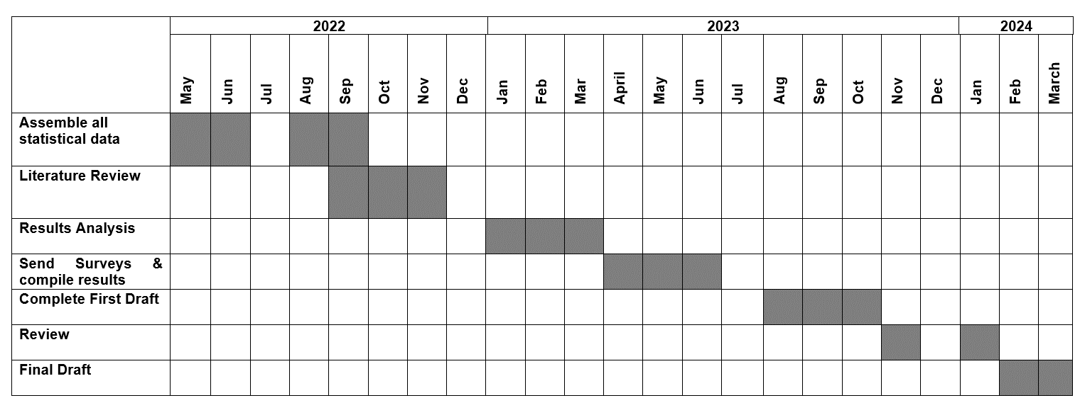
Table 1

3.2 Data Gathering

It is important to establish the similar methods of construction within the UK for evaluation. By selecting countries with different climates e.g. Scandinavian countries there is a much higher chance of different methods of construction. In a country with much harsher winters, there will have been much more emphasis during construction on thermal efficiency, even in older buildings. This would result in a housing stock which is much more thermally efficient than areas such as the UK. As a result of this there may be fewer or much less robust strategies in those countries for improving thermal performance of older houses.

The majority of the data will be secondary data and come from Government data and commissioned reports for the various strategies used in each country. Sustainability and carbon emissions reduction is a very popular subject and massively in the public and global eye. Predictions can be made which are biased and data can be misinterpreted. Careful, diligent research will need to be carried out to interpret the data unbiasedly without political agendas. For example, many newspapers and other media sources have political biases, so tracking information back to its origin will be critical.

Primary data will be gathered from surveys, to establish whether current policy and schemes reflect public opinion, interest and requirements.

For a well-rounded evaluation there needs to be investigation into current and recent historical strategies used and the socioeconomic impact. For any historical strategies that are no longer used, it will be important to determine why they were discontinued or changed.

3.3 Ethical considerations

For the purposes of confidentiality, surveys conducted will remain anonymous. No identifiable information will be collected on individuals. Secondary data gathered will be taken from information in the public domain.

Chapter 4: Primary Data Collection

4.1 Survey Questionnaire

The following questions were answered anonymously, however the country of residence was a required data point. The questionnaire was posted on the following social media groups to attempt to target the suitable owners of older houses in need of energy improvement measures. Social media sites across the UK were selected in an attempt to get a variety of responses from each of the countries within the UK. The survey was voluntary and ten questions were chosen to keep the survey brief and minimise the risk of participants giving up before finishing. A brief was included before the questions to make sure the participant was aware of the context. Due to limitations and restrictions with many free survey software, the chosen survey tool used was SurveyLegend, this site allowed the creation of a survey for free and produced graphs based on the results. Whilst the responses were kept anonymous, there was one site which generated the most engagement and responses to the post, which was Your Old House UK – Repair and Conservation. Based on ensuing discussions and confirmations by individuals, it is likely that many of the responses came from this site, although this would not affect the results of the data in any way. The link to the survey and contextualising statement was sent to the following social media sites:

House Extensions, loft conversions and Renovations UK:
- First round of surveys (April 2023) 146k Members.
- Second round of surveys (December 2023) 210k Members.
Everything Construction Ireland:
- First round of surveys (April 2023) 5.7k Members.
- Second round of surveys (December 2023) 7.4k Members.
Ireland Self Build & Renovation Deals:
- First round of surveys (April 2023) 5.1k Members.
- Second round of surveys (December 2023) 5.7k Members.

Home Improvements in Northern Ireland:
- First round of surveys (April 2023) 239 Members.
- Second round of surveys (December 2023) 270 Members.

DIY Home Improvements On a Budget UK:
- First round of surveys (April 2023) 35k Members.
- Second round of surveys (December 2023) 46k Members.

DIY On a Budget UK:
- First round of surveys (April 2023) 105k Members.
- Second round of surveys (December 2023) 146k Members.

UK DIY, Interior and Exterior, Help, Advice and Chat:
- First round of surveys (April 2023) 21k Members.
- Second round of surveys (December 2023) 25k Members.

Your Old House UK – Repair and Conservation:
- First round of surveys (April 2023) 13k Members.
- Second round of surveys (December 2023) 19k Members.

Home Extensions & Renovations UK:
- First round of surveys (April 2023) 2.5k Members.
- Second round of surveys (December 2023) 2.8k Members.

DIY Home Projects (Remodelling, Renovation & Construction):
- First round of surveys (April 2023) 471k Members.
- Second round of surveys (December 2023) 525k Members.

UK Renovations and Home Improvements Tips And Ideas, renamed Renovations And Home Improvements Tips And Ideas:
- First round of surveys (April 2023) 21k Members.
- Second round of surveys (December 2023) 29k Members.

Home Building + Renovations UK + Ireland:
- First round of surveys (April 2023) 1k Members.
- Second round of surveys (December 2023) 3.1k Members.

HOUSE RENOVATION UK:
- First round of surveys (April 2023) 18 Members.
- Second round of surveys (December 2023) 211 Members.

Home Renovation Tips & Advice UK – 9.5k Members
- First round of surveys (April 2023) 9.5k Members.
- Second round of surveys (December 2023) 10k Members.

Renovation Projects UK – 478 Members
- First round of surveys (April 2023) 478 Members.
- Second round of surveys (December 2023) 663 Members.

Building & Construction UK – 34k Members
- First round of surveys (April 2023) 34k Members.
- Second round of surveys (December 2023) 37k Members.

LinkedIn – 134 connections.

Chapter 5: Primary Data Results

5.1 Results

The primary research was carried out in two waves. The purpose of this was to gain as much data as possible from different individuals in the targeted groups. In addition to this, in the span between waves the groups had grown significantly meaning a much higher chance of responses.
For comparison, the results of the first round of surveys is on the left (April 2023), whilst the second round (December 2023) is on the right.
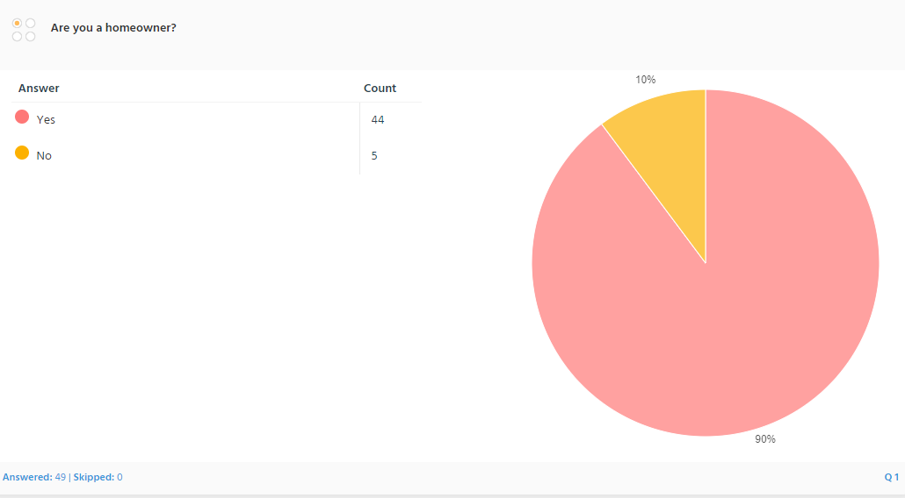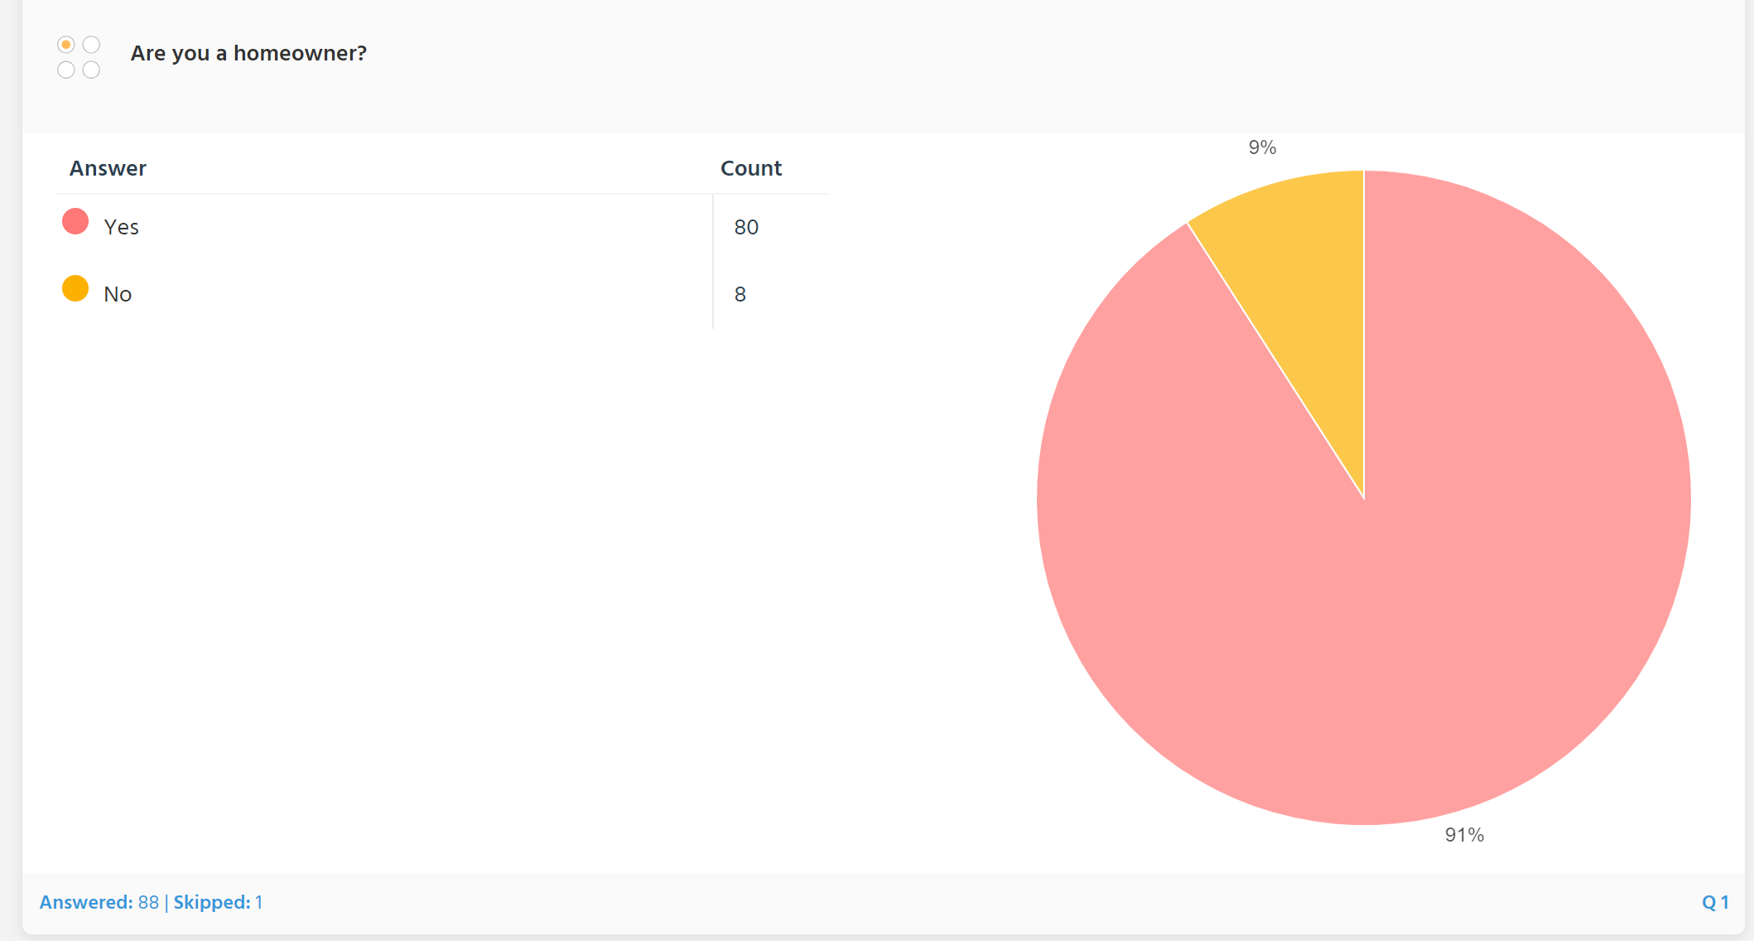
Figure 1 Figure 1.1
This first question establishes that 90% in the first wave and 91% total by the second wave were homeowners. This is important as the purpose of this research is to evaluate improvement schemes for privately owned owner/occupier or privately rented properties. Compared to statistics on proportions of owner occupier houses in the UK, we can see that England - 15.7m (62.4%) Statista (2023) Wales - 894k (66.4%) Gov.Wales (2023) Scotland - 1.5m (58%) Scottish Government (2022) and Northern Ireland – 500k (64.2%) Cook&Co (2023). Therefore the percentage of respondents to the questionnaire who are homeowners is far higher than the national average of 62.75% this was to be expected due to the nature of the targeted groups.

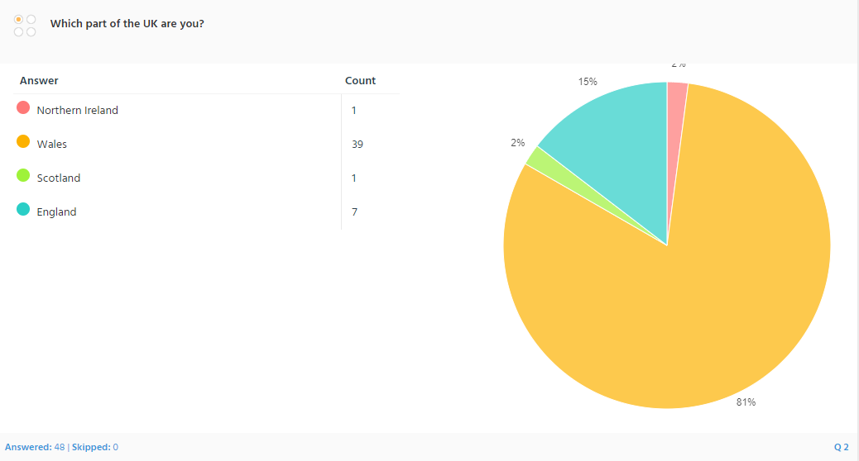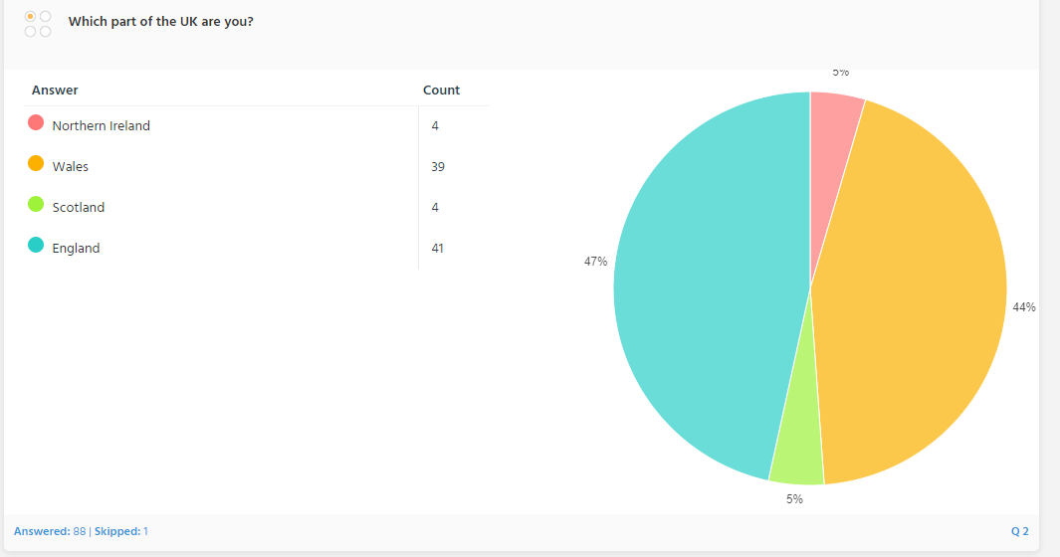
Figure 2 Figure 2.1
The second question establishes the locality of the participant, within in the UK. The initial survey provided predominantly Welsh responses, however by the second round of surveys, the number of English responses had increased. If we compare this to data from the English Housing Survey 2017, Welsh Housing Conditions Survey 2017-18, Northern Ireland House Condition Survey 2016 and Scottish House Condition Survey 2017 for the makeup of housing stock for the UK, we see that 84% of housing stock is in England, 9% in Scotland, 5% in Wales and 3% in Northern Ireland, BRE (2020).

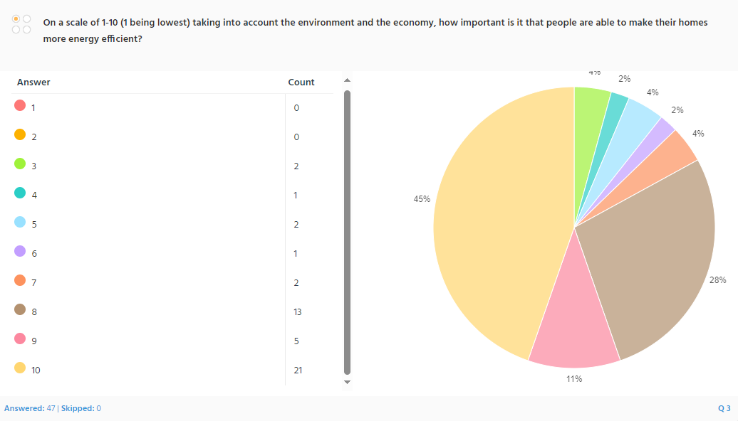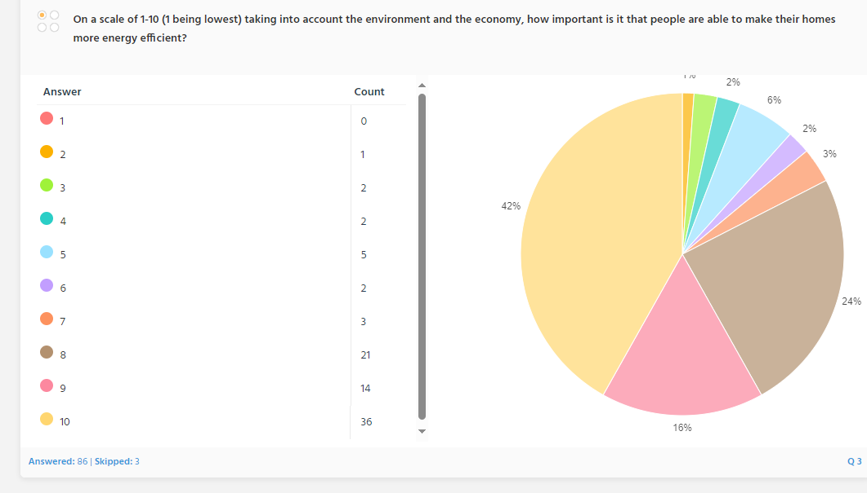

Figure 3 Figure 3.1

Question three asked the participants to rate the importance of improving home energy efficiency when considering factors like the economy and environment. Overwhelmingly, 45% initially and 42% overall placed a 10 (the highest score). Overall 82% gave a score of 8 or higher. Equally important is the fact that these figurer only slightly changed between the first and second round of surveys. This provides evidence that the public considers making their homes more energy efficient extremely important both for economic and environmental reasons. In 2020, following the Covid pandemic, research commissioned by the Royal Institute of British Architects (RIBA) found that 40% of respondents wanted to improve their house to have more environmental features including improving the energy efficiency of their home, RIBA (2020).

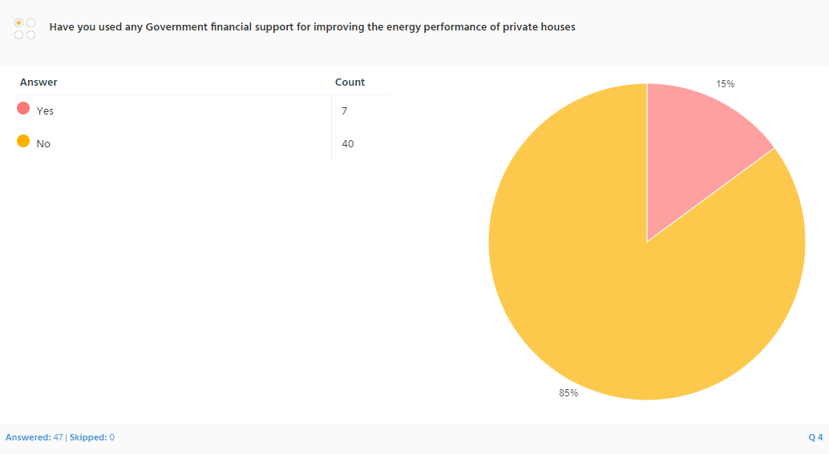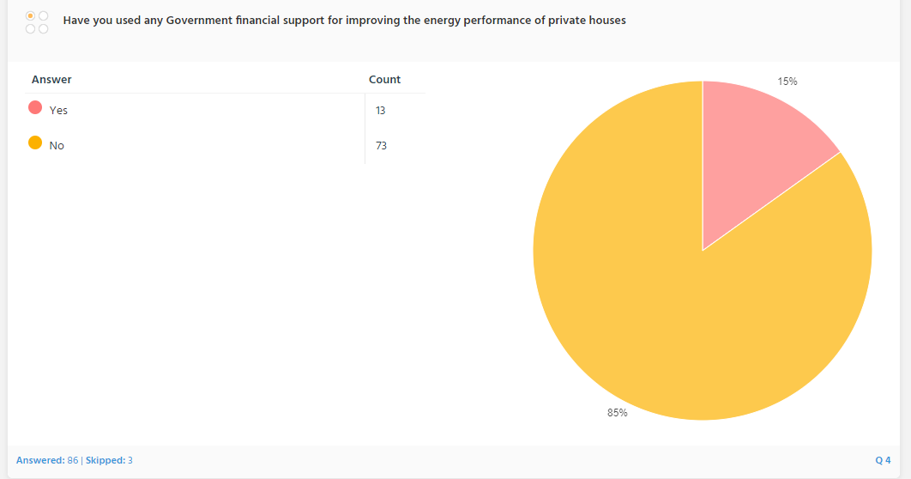

Figure 4 Figure 4.1

In question four, the figures didn’t change at all between the first and second rounds of surveys. 85% stated they hadn’t used any Government financial support to improve the performance of a private house. The figure is initially staggering showing the lack of engagement or qualification fo these improvement measures. There are some possible failings with this question. Firstly it is possible that a participant could be living in a new build house and wouldn’t require the use of energy improvement measures. It is also possible though less likely that someone had received improvement measures but wasn’t aware that it was Government subsidised. To overcome these issues, the careful selection of the social media groups was key. By targetting home improvement and renovation groups for older properties predominantly and including in the brief about the focus on older homes the aim was to target people most likely to require the use of home improvement schemes. A poll carried out in the most active Facebook group surveyed showed 85% (724) had houses pre 1919, 9% (82) were 1914-19-44, 2% (22) were 1945-1964, and 1% (11) post 1990. More insight will be gleaned from the answers to the final question where the participants are given the opportunity to elaborate on their answers.

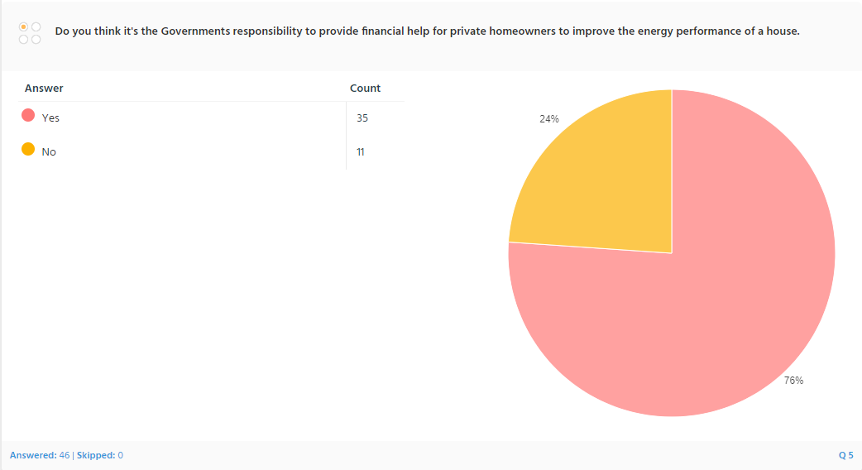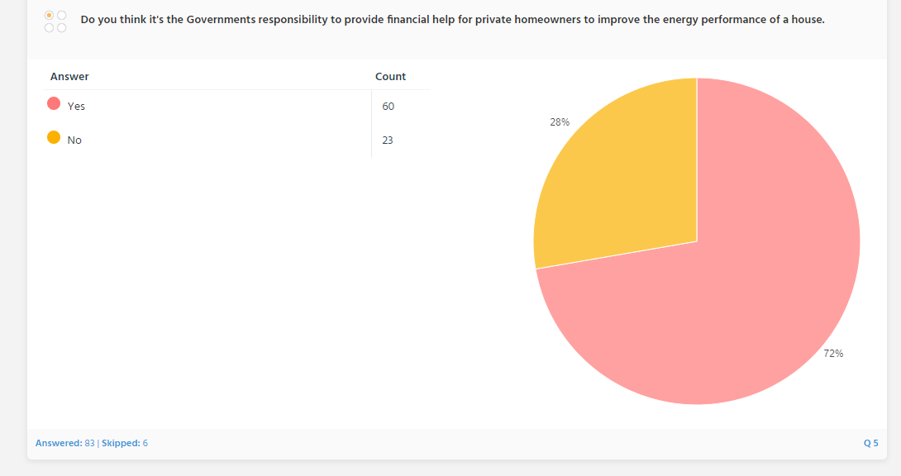

Figure 5 Figure 5.1

In question 5 the figure grew between the first and second surveys. It asked whether people thought it was the Government’s responsibility to provide financial help for energy improvement measures for privately owned homes. Firstly 24% then a total of 28% answered no. To help understand these responses the final question, question 10 asked the participants to list barriers to implementing energy saving measures in homes. Some of these answers can give insight into why more than a quarter believed it isn’t the Government’s responsibility. A large amount of people replied that cost is an issue, at first sight this could be taken to mean cost to the individual, but many elaborated that the cost to the Government and therefore the taxpayer was too much. Another suggestion was cheaper renewable energy sources woul be a better investment for Government money instead of spending it on improving energy efficiency. Government grants were also criticized for generalising improvement measures and too little scrutiny given the what was “best” for the individual properties. However Consumer Rights (2023) discuss the importance of the Governments role in promoting energy efficiency citing a 2021 report published by the Department for Business, Energy and Industrial Strategy which claimed a 17% reduction in UK energy consumption since 2000 despite increased economic output. It claims that energy improvement measures for homes and businesses contributed a “significant” amount of this reduction, DfBE&IS (2021).

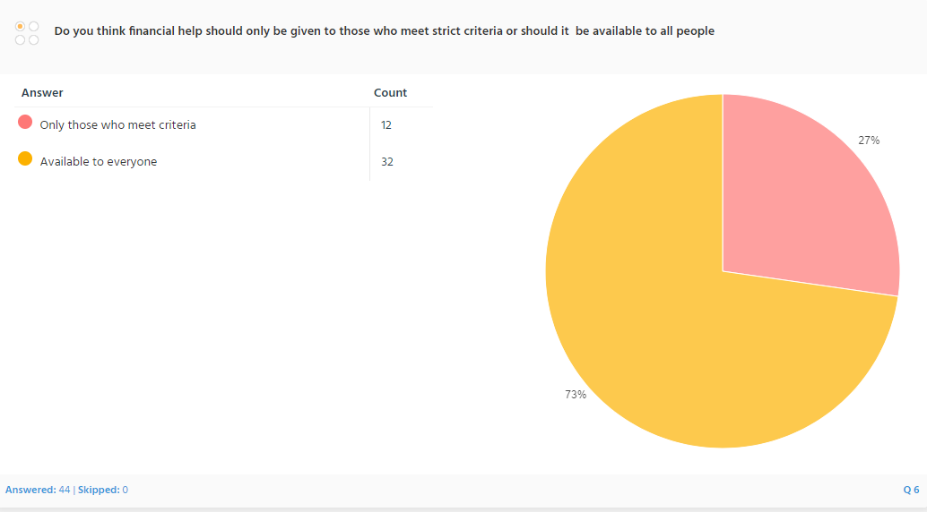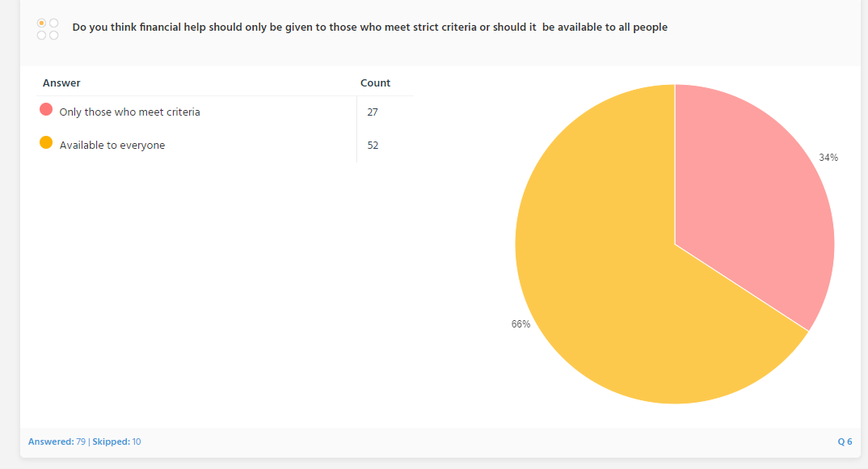

Figure 6 Figure 6.1

Quesiton 6 shows that the majority overall (66%) believe financial aid should be available to everyone regardless of eligibility criteria. These results are interesting as they aren’t very different to the percentages for the previous question. It points towards a similar number of people believing it’s not the Government’s role to provide funding as who believe funding should only be provided for households who meet eligibility criteria. Crompton (2021) points out the obvious truth that without more funding, it isn’t possible to carry out more work. With more expensive technologies being added to schemes like Nest, the end result is fewer houses receiving improvement measures. Many of the comments in question 10 show an awareness of this, pointing out that those on “middle income” are left to foot the costs of the improvement themselves.

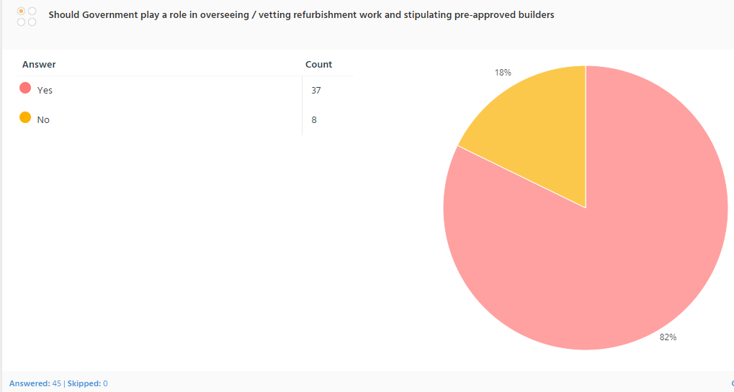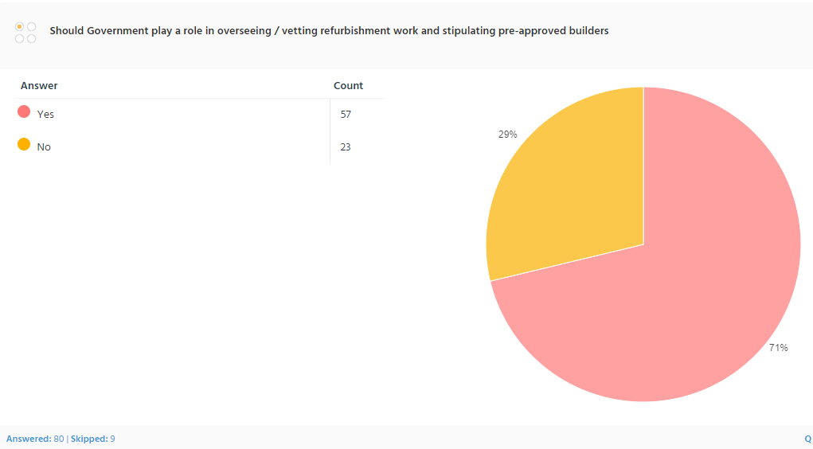

Figure 7 Figure 7.1

Question 7 asked whether participants believed the Government should play a role in vetting or overseeing the improvement works. Overall 29% said no and 71% said yes. This is again reflected in the comments in question 10. Many believe that subsidies and Government funding result in many new companies “springing up” to chase the quick money and enough isn’t done to vet them. These companies are attributed with poor quality work and only being interested in the money rather than correctly implementing the improvement measures. There were multiple comments about lack of reliable information about the efficiency of measures with conflicting information in the media. Cold calling was reported as an issue with many companies saying they were Governmnent backed, Citizens Advice (2021) refer to people being targeted by a green scam. In December 2021 it published information about emails, phone calls and texts being used to trick 5.2 million of a targeted 19 million. Research by Citizens Advice also found that more than two thirds of adults were considering implementing measures to make their homes more energy efficient int 2022 but 36% admitted to already being targeted by a green scam.

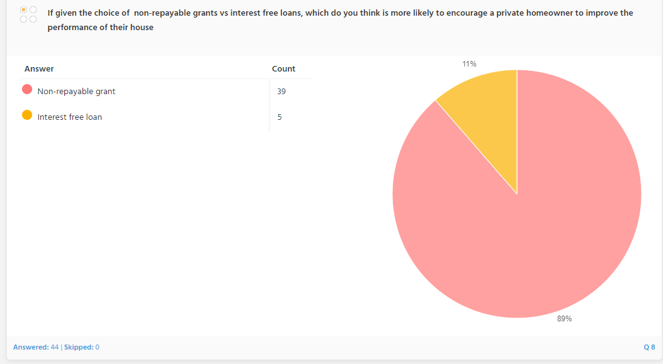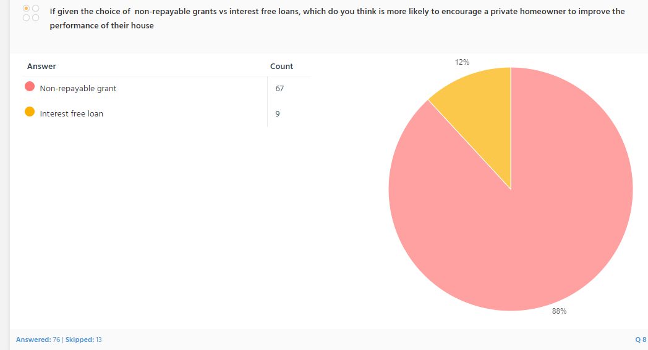

Figure 8 Figure 8.1

Question 8 asked if people thought an interest free loan or a non-repayable grant were potential solutions to funding the improvement works. Initially 89% then 88% overall chose the non-repayable grant as a preferred choice. A non-repayable grant is for energy saving home improvement works is what is provided by the Energy Company Obligation (ECO) the current scheme being ECO4 and Eco+. These schemes are discussed in detain in the secondary data. What the primary data clearly shows is that this is the preferred method by the public, over interest free loans or similar systems like the Green Deal which is also discussed in this research and was found to be largely innefective and discontiued due to lack of public uptake, Vaughan (2015).

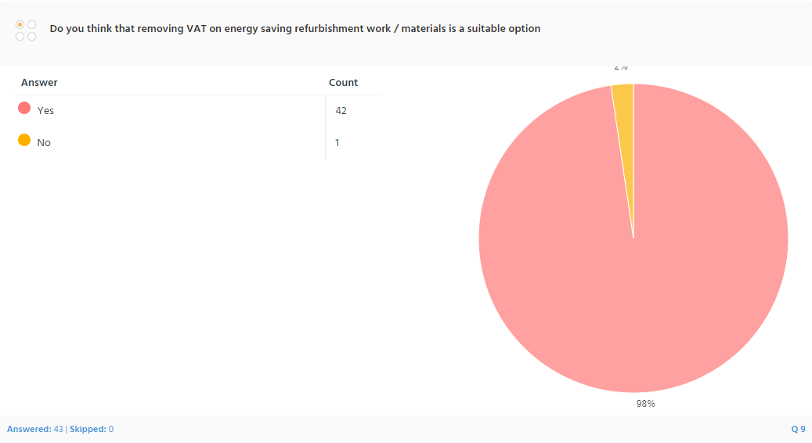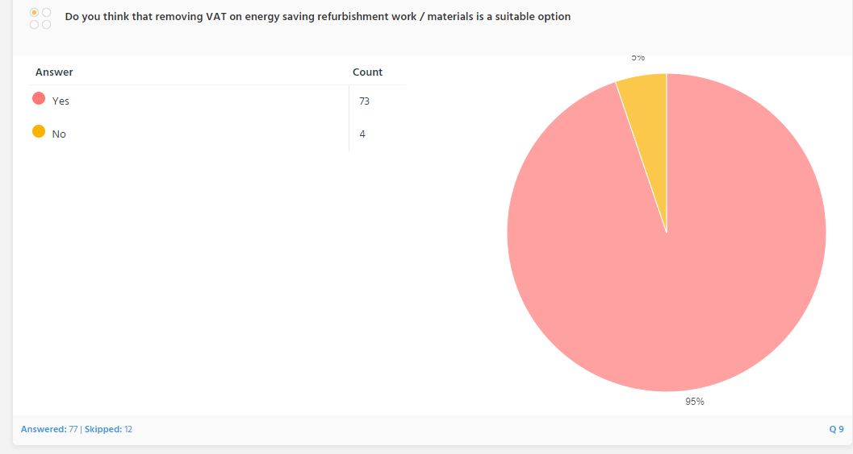

Figure 9 Figure 9.1

Question 9 asked the participants whether removing VAT on energy efficient home improvement work/materials was a good option. 95% said yes. In 2022 the then UK Chancellor Rishi Sunak announced the Value Added Tax (Installation of Energy-Saving Materials) Order. This saw a time limited (until 2027) widening of energy saving measures which were eligible for zero VAT for businesses and customers receiving energy saving measures in England, Wales and Scotland, Gov.UK (2022). The measures in Northern Ireland remained the same and the Barnett formula (funds allocated proportional to population) was used to calculate their funds from the UK. This is a result of the UK’s withdrawal from the EU and being no longer bound by infraction proceedings (European Comissions v United Kingdom C-161/14) in 2019. This new order means that the installation of solar panels, batteries, heat pumps and other renewable technologies are eligible for 0% VAT. Taking effect from the 1st of February 2024, this move is hoped to have a beneficial impact on adoption of renewable energy technologies in households across the UK, MCS (2023). It is claimed that the additional cost of VAT deters 4 million households a year from carrying out home improvement work FMB (2022). While installing many of these technologies still carries a high cost, it is hoped customers could make substantial savings.

Question 10:

In general, what barriers do you see to the public uptake of energy efficient home improvements.

The word for word answers are included in the appendix – section2. Some of the participants go into great depth about the barriers they faced. The following chart was created to group together similar answer for clarity. Where people have stated more than one issue, all issues have been counted.

Figure 10
The complete numerical breakdown of the figure is in the appendices section 3.
The most common answers are relating to cost and affordability. Furthermore, many claimed that the costs of implementing energy improvement measures is too high and therefore un-justifiable to implement. This reason is confirmed by research carried out by the UK Energy trade association, into barriers people face to implementing energy improving measures and lowering bills. Their polling results show that in 2023, two thirds of people didn’t implement any energy improvement measures whatsoever in their homes because of too expensive upfront costs, Energy UK (2024).
This is also linked in some answers to barriers in the application, meaning some weren’t eligible to receive financial aid for the measures. However it was overall believed that initial costs were too high, with some stating that when there is Government funding for measures, often the costs are increased by companies carrying out the work. Some raised concerns over maintenance and long term costs of new technologies and claimed lack of information available about these potential costs. Research by NatWest found that 66% of those questioned said they were planning on carrying out environmental and sustainability improvements to their homes within the next 10 years. Of the 44% who weren’t, 74% of homeowners weren’t doing so because of high costs, NatWest (2023).
Lack of information is the second barrier stated. This ranged from lack of information about measures available, which types of measures were most suitable for different scenarios. Information about payback times, future maintenance costs of new technologies and potential negative side effects of incorrectly installed or unsuitable measures. Conflicting information in the media about efficiency and effectiveness of new technologies such as air source heat pumps was also cited as a contributing factor for lack of information. Some claimed there was lack of expertise and information about measures suitable for older traditionally build buildings, claiming most of the measures available aren’t suited to old buildings. Lack of definitive information from the Government and too much information from multiple sources citing Government backing was another factor. Cold calling was noted as an issue, with the Information Commissioners Office (ICO) fining four companies responsible for a cold calling campaign of 820,00 calls using predatory tactics to sell home improvement works, ICO (2022). The investigation found that vulnerable people were being targeted for home improvement measures by companies “flouting electronic marketing laws to make a profit” and illegally using different trading names to hinder identification.
This links to the next two categories ‘trust in methods or installers’ and ‘building suitability’ In both of these categories there was substantial opinion that the majority of measures weren’t suitable for older buildings which ‘breathe’ using materials such as lime and single glazed windows. There was strong opinion that the companies carrying out the installations weren’t knowledgeable or interested in carrying out works in a sympathetic manner to how the house was built. It was also claimed that there was generally a lack of certified, skilled installers in some parts of the UK.

Chapter 6 : Secondary Data Collection

As a result of the industrial revolution, and associated production and population growth, the UK boasts some of the oldest housing stock in Europe, and globally. Within the UK, Wales has some of the oldest housing stock while Northern Ireland the youngest. It is not easy to compare housing stock from each of the four countries. While flats are dominant in heavily urban areas, in Northern Ireland there are much more bungalows, in Scotland houses were traditionally tenements rather than terraces.
In 2017 there were 28.5 million homes in the UK. The great majority of these were in England 84%, Scotland 9%, Wales 5% and Northern Ireland 3%. BRE Trust (2020)
If we further break down the number of homes by age, we can see that in England alone pre 1919 is the largest type of construction.

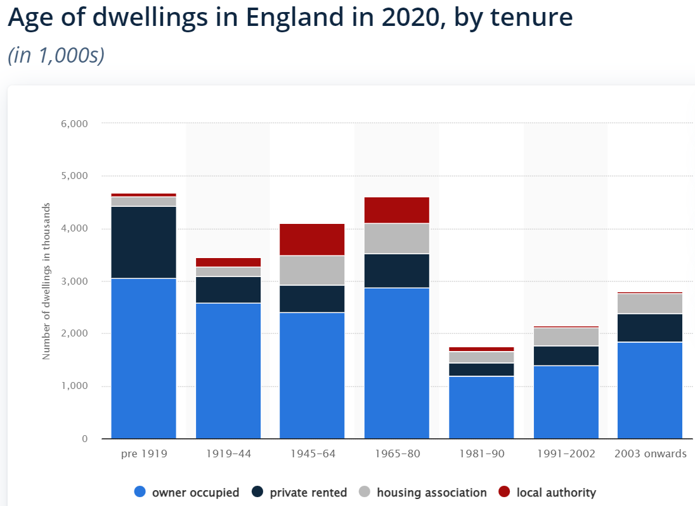

Figure 11 Statista (2022)

This is important as houses built pre 1919 are considered to be traditional build. While cavity walls began appearing in the late 19th century and though it is impossible to have one exact date where traditional build ended across all regions, 1919 is widely accepted in the UK as when solid wall construction started changing to cavity wall. In the 1920’s cavity wall became the standard form of construction. UWE (2009)

Using walls as an example is an easy way to demonstrate how thermal efficiency of houses has improved through legislative requirements over time and how construction methods have changed to meet these requirements.

6.1 Traditional Construction

Solid wall traditional construction allowed for no insulative materials other than the stones and rubble which have very poor insulative value. Pre 1919 construction typically used no insulation in roofs, lofts, ground floors or first floors, windows were single glazed, not very well sealed and allowed air movement. Damp proof coursing (DPC) was in its infancy and rarely used, buildings were constructed using breathable materials allowing damp walls to dry out.

Walls used lime mortar and stone, ashlar, brick, or a combination of either. In affluent cities and large towns solid brick walls were more common, while in rural areas stone was predominant. Sometimes the brick walls would have DPC to prevent rising damp.

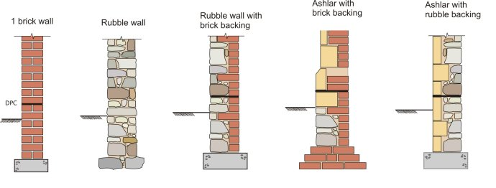
Image 1 UWE (2009)

This resulted in building with poor thermal performance and open fires were used to heat rooms.
Houses constructed from 1919 – 1980 make up a very large section and houses aged pre 1919 to 1980 make up the vast majority. National Statistics (2016)
Looking at more detailed data for England and Wales we can see that 38% of houses existing today were built prior to the second World War and 60% built before 1960 and just over 10% between 1991 and 2010. BPIE (2011)

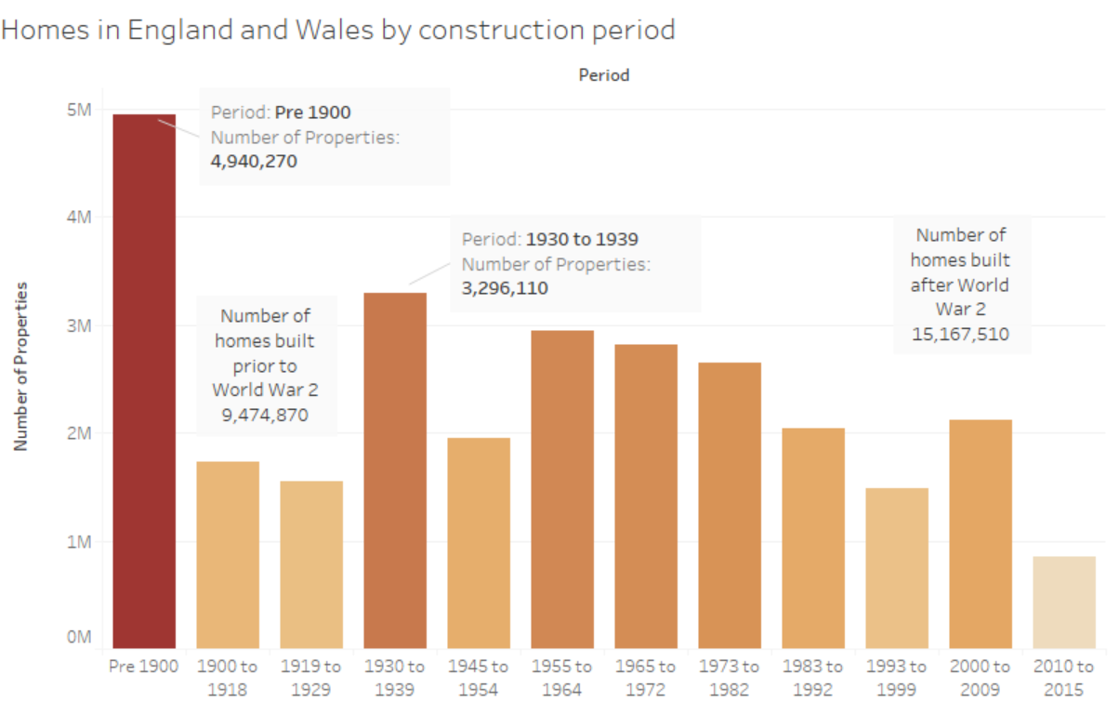
Figure 12 Historic Doors (2017)

One reason for many houses being built post 1919 in the UK is the end of the First World War, when the government realised the need for a healthy population. It was concluded that to have a healthy workforce the Government needed to help people to have clean living space. Housing stock in England and Wales in 1911 was 7.6million, in 1921 8million, in 1931 9.4million and in 1939 11.3million. Rubenstein (2003).

6.2 Introduction of Cavities

Once cavity walls became commonplace houses were slightly better insulated and weatherproofed. The cavity reduced penetrating damp and heat transference. However, a cavity with no insulation meant it was only a minor thermal improvement. There are some non-standard prefabricated methods of construction which were used particularly following the second World War where fast construction was required to increase housing stock rapidly. Many of these houses remain today and were often concrete built with little or no insulation in the walls. They aren’t as popular among buyers as traditional or modern built houses as there is a stigma attached that some mortgage companies are wary of lending against non-standard constructed houses.

The early cavity walls consisted of an inner and outer leaf of bricks with a 50mm cavity with no insulation and were tied together for strength by use of wall ties.
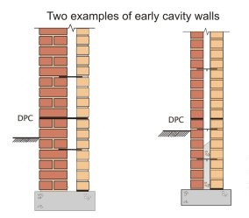
Image 2 UWE (2009)

Post 1920 there is little change to the method other than the replacement of lime mortar with cement. Towards the 50’s and 60’s breeze blocks were sometimes used for the inner leaf to increase speed of construction. UWE, (2009)

It wasn’t until the 70’s that thermal improvement appeared. In 1972 a maximum U-Value of 1.70 was introduced for walls, which was easily achieved with a brick outer leaf, 50mm cavity and dense block inner leaf. The U-Value was lowered to 1 in 1980 which required the inner block to be lightweight (more air in the block meaning better thermal performance).
This figure further dropped in the 90’s to a U-Value of 0.45. To achieve this insulative material would need to be incorporated into the wall to meet the U-Value. By 2006 the U-Value was 0.3 which is 5-6 times more than a 1920’s equivalent cavity wall. Kingspan (2016)

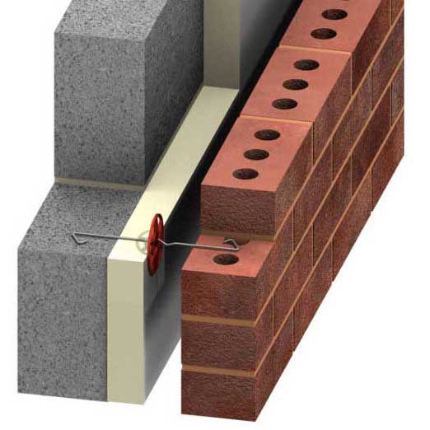
Image 3 Ancon (2019)

6.3 Research Problem

For many years there has been growing realisation that the improvement of the thermal performance of houses plays a significant role in lowering heating bills, reduce carbon footprint eliminating reliance on fossil fuels and meeting net zero carbon targets. Put simply, the more insulated a house is, the less heat it loses through roof, windows, walls and floors and the less energy required to heat it. UK Parliament (2020)

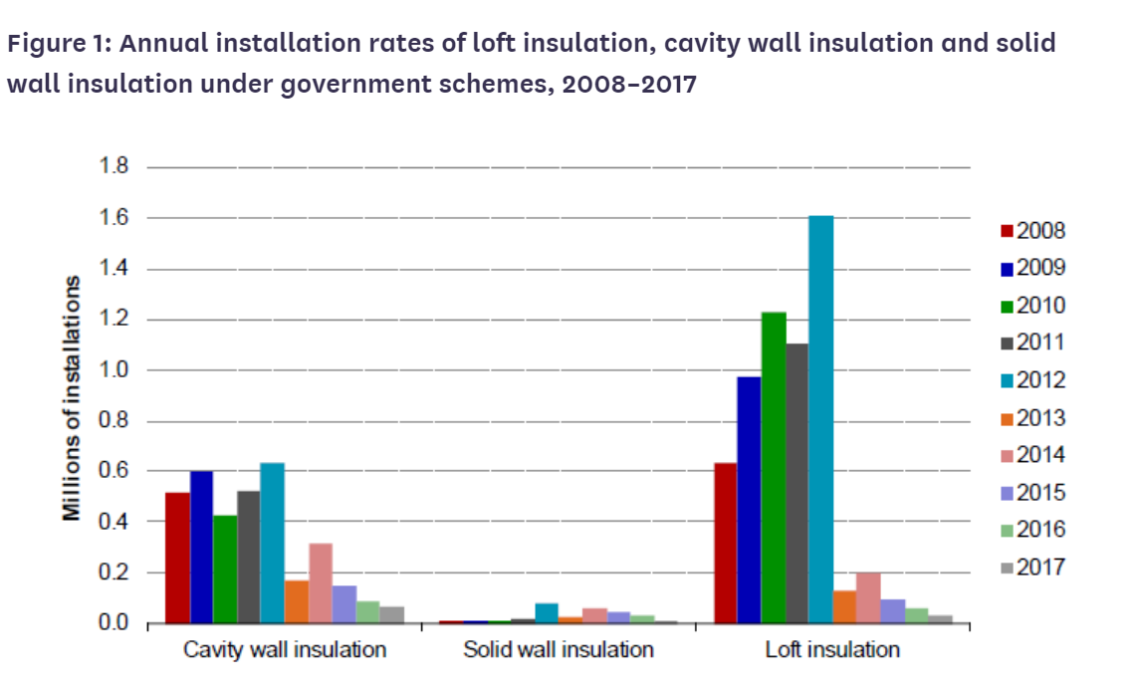
Figure 13 UK Parliament (2020)

6.4 Context

While the performance of new build homes has drastically improved over recent years, improving the performance of housing stock by replacement of the old with new build is slow and unrealistic. There are economic, social and sustainability benefits of improving existing housing stock without the perceived negative financial costs. BRE Trust (2020)

Many Governments across the globe have tried different incentives and schemes to stimulate the adoption of renewable energy sources and insulation in existing housing stock.

The UK has a net zero carbon target by 2050. To achieve this, it must cut carbon emissions by 80%. It is claimed a third of those emissions come from heating poorly insulated homes Harrabin (2017). In Wales it is claimed that residential emissions make up 10% of the countries carbon emissions, Welsh Government (2021a). To achieve this the Government would require a robust scheme for insulating existing poorly insulated homes. It is claimed that the UK will have to insulate 25 million homes and refurbish more than one home every minute. The claim is made by the Green Building Council UKGBC (2021) who, responding to a report published by the Committee on Climate Change, also state the Government has failed to stimulate insulative improvements and that a big issue with insulating owner-occupier homes is that The Treasury is reluctant to finance home improvements which will improve the sale value of private houses. Committee on Climate Change (2019).

The following are some strategies operating in different nations within the UK.

6.5 Wales

In the summer of 2021, the Welsh Government announced a ban of fossil fuels for heating new built social housing and has motioned for the private sector to be following the example by 2025. On the 2nd of November Lee Waters the deputy minister for Climate Change announced £150 million would be available to retrofit social homes with sustainable technologies and insulation as part of its Optimised Retrofit Programme. Welsh Government (2021b)
While this is an example of Government subsidising the cost of improving building thermal performance and sustainability. It is important to note that it is for social housing and not available to private housing.
On the 8th of November 2022 proposals were set out by the Minister for Climate Change (Julie James MS) for improving the energy efficiency of all Welsh Homes through the Warm Homes Programme. They stated £60m had been allocated in 2022 and were predicting £70m over the following two years. Solar PV and battery was added to the measures available for home improvements. James, J (2022)
The Warm Homes Programme Wales delivered improvements through two schemes, Nest and Arbed, which will be discussed in this section.

6.5.1 Nest Scheme

The current main Welsh Government approach is the Nest Scheme. It replaced the prior Home Energy Efficiency Scheme (HEES) as a result of the Welsh Government Fuel Poverty Strategy in 2010. The Nest Scheme was established in 2011 as an initiative to provide free sustainability advice and energy saving measures for homes in Wales. The resources are available for people living in energy inefficient homes with a SAP rating of F or G, and subject to meeting 3 means tested eligibility criteria Nest (2020). Where possible the aim is to improve the SAP rating to band C. The eligibility criteria are as follows:

- You must own or rent the property privately (not social housing)
- The property must be expensive to heat and thermally inefficient
- The owner or someone living at the property has an annual income below £16,105 or receive a means tested benefit or a mental health condition or a chronic respiratory or circulatory condition.

Designed to address fuel poverty in Wales by offering home energy improvements to those on lower incomes or living in highly inefficient homes GSR (2015). The free resources available are new central heating systems, boilers and insulation to enable households on low income to reduce heating costs and save money on energy bills. The Nest Scheme supports the Welsh Governments commitments to improve economic development, eliminate fuel poverty and minimise climate change. Energy Saving Trust (2022). Funding is capped at £8,000 for on-grid properties and £12,000 for off-grid.

The management organisational structure is illustrated below. Overall managed by British Gas (BG), the front end service is subcontracted to the Energy Saving Trust (EST), who are responsible for providing advice directly and refer applicant to third party members who provide advice and financial services. They also assess the eligibility of applicants. Successful applicants are passed on to BG who carry out assessments, organise, install and inspect the improvement works.
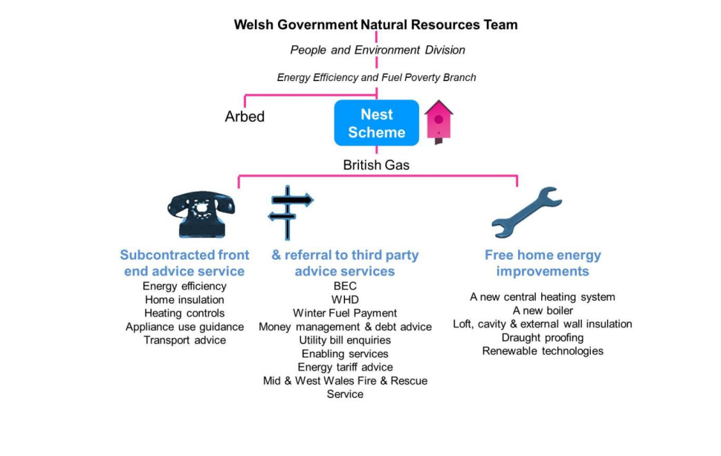
Image 4 Energy Saving Trust (2022).

6.5.2 Arbed

No longer in operation, the Arbed scheme was established in 2009 and aimed to improve energy performance of homes with low Energy Performance Certificates (EPC) in the most deprived areas of Wales. Phase one funded improvement energy improvement measures in 7500 homes. It’s latest iteration was Arbed 3, which ran to 2021. Welsh Government (2023). The scheme was governed by the Welsh Government and delivered by Arbed am Byth (AaB) who were responsible for marketing, communication and collaboration with stakeholders and Local Authorities (LA). The scheme aimed to lower the carbon footprint of Wales’ existing housing stock by providing advice and implementing energy improvement measures for houses with occupants suffering from fuel poverty and living in a house with an Energy Performance Certificate (EPC) of E, F or G with an estimated improvement of two bands. Date for identifying areas of low income households was mainly sourced from the Welsh Index of Multiple Deprivation (WIMD), GSR (2022).

6.6 Scotland

In 2015 Scotland launched the Warmer Homes Scotland Scheme, which has since seen 22,000 homes receive support and 8 out of 10 of those homes receiving free energy saving measures worth over £5,000 each. This led to an average saving of £300 per household per year. Like the Welsh Nest Scheme, it is provided for private homeowners and renters, not social housing users. The most common improvements are new central heating systems, boilers, loft and insulation.

Home improvements are carried out by an approved installer after an initial survey is carried out to identify the best energy saving solutions for a property. This is funded by the Scottish Government and there are usually no costs to the homeowner or resident. Scottish Government (2021)

For more expensive improvements such as solid wall insulation there may be a contribution to costs from the customer. The Energy Saving Trust provides an interest free loan to support these costs.

Similar to the Nest Scheme, it is aimed at more vulnerable and lower income households with eligibility criteria included stipulating conditions which must be met.

6.7 England

In England funding for improvements came in the form of the Green Homes Grant Scheme, part of the Governments “build back greener” initiative as a green economic recovery plan from the Covid-19 pandemic and part of a green industrial revolution Harvey (2021).
£439 million of funding was distributed via the Sustainable Warmth scheme (SW) launched in 2022. £287 million of which was distributed to the Local Authority Delivery (LAD) and £152 million through the Home Upgrade Grant (HUG). The scheme aims to implement energy efficient upgrades in low income households, those at risk of fuel poverty and those living in energy inefficient homes, Department for Energy Security & Net Zero (2023)b.
The GHGS allowed homeowners the opportunity to apply for vouchers for between £5,000-£10,000 (depending on household income) for home energy improvements. The vouchers would pay certified operatives to install energy saving measures including heat pumps, insulation, heating controls and insulative windows and doors.

However, this scheme no longer exists, after being unveiled in September 2020 it was widely criticised and cancelled after a short-lived period in March 2021. During its implementation 47,500 homes were upgraded opposed to the planned 600,000 which used £314 million of the £1.5 billion budget, with an expected additional 50 million in administration costs. It also created a much smaller amount of the new jobs than were predicted, House of Commons (2021).

The House of Commons Committee of Public Accounts Report criticises the Governments poor record of energy efficiency initiatives and warns that it jeopardises future attempts to achieve the net zero target. Blame is also attributed to the 12 week timescale of the scheme which it called “unrealistic and imposed constraints on its design and implementation” The scheme again heavily criticised for being implemented despite its Project and Investment Committee dismissing its practicability. House of Commons (2021).

6.8 Northern Ireland

The Affordable Warmth Scheme, introduced in 2014, aims to help low-income families improve the thermal efficiency of their homes and thus reducing energy inefficiency and fuel poverty. The scheme is aimed at owner-occupiers and private renters but not those living in social housing, whose annual income does not exceed £23,000. There are no other eligibility criteria other than the annual income. Some properties are excluded such as commercial properties, bed and breakfasts and holiday homes. NIHE (2020)

Once and enquiry has been made, the local authority will send an employee to visit the customer and offer free energy saving advice and provide information on available energy saving measures. They will also help the customer complete an application and check eligibility. Next a Technical Officer will visit to assess the most suitable energy saving measures for the house. The assessment will include cavity borescope investigation (if cavity walls) and inspection of lofts, boilers, ground floor and first floor rooms.
After the assessment an Approval Pack will be issued which will contain all information about the work which will be covered, grants of up to £7,500 are available or if more expensive solid wall insulation is required, £10,000 grants may be available. There is no requirement for the customer to pay towards work agreed upon in the scheme. If solid wall insulation is required, the installer carrying out the work must provide a minimum 25 year guarantee. Where there are private sector tenants, the landlord must agree to the measures, be registered with the Landlord Registration scheme and contribute 50% to the overall cost of the improvement measures installed, Housing Executive (2020).
It is then the responsibility of the customer to get quotes from builders to carry out the work (suggested a minimum of 3). This information must be provided to the Local Authority before any work begins and if the quotes are higher than estimated in the Approval Pack, additional grant may be issued to cover the work. NIHE (2020)

6.9 UK wide

The Green Deal went live in January 2013, but it was not a big success. By the end of June 2015, only 10,000 households had installed-energy saving measures using Green Deal finance, with a further 5,600 plans in progress.
The low take-up rate of the scheme, plus some concerns about standards, prompted the government to pull the plug on Green Deal funding in July 2015, Vaughan (2015).
Energy Company Obligations or ECO, is a UK scheme which can help certain households access funding to make energy-efficient home improvements. It began in 2013 as ECO, this was followed by ECO2, then ECO3 which ran until March 2022. By the time this version ended, the government estimated energy-efficiency measures had been installed in up to 900,000 eligible homes. Dodd (2013). ECO4 is the current iteration of the scheme.
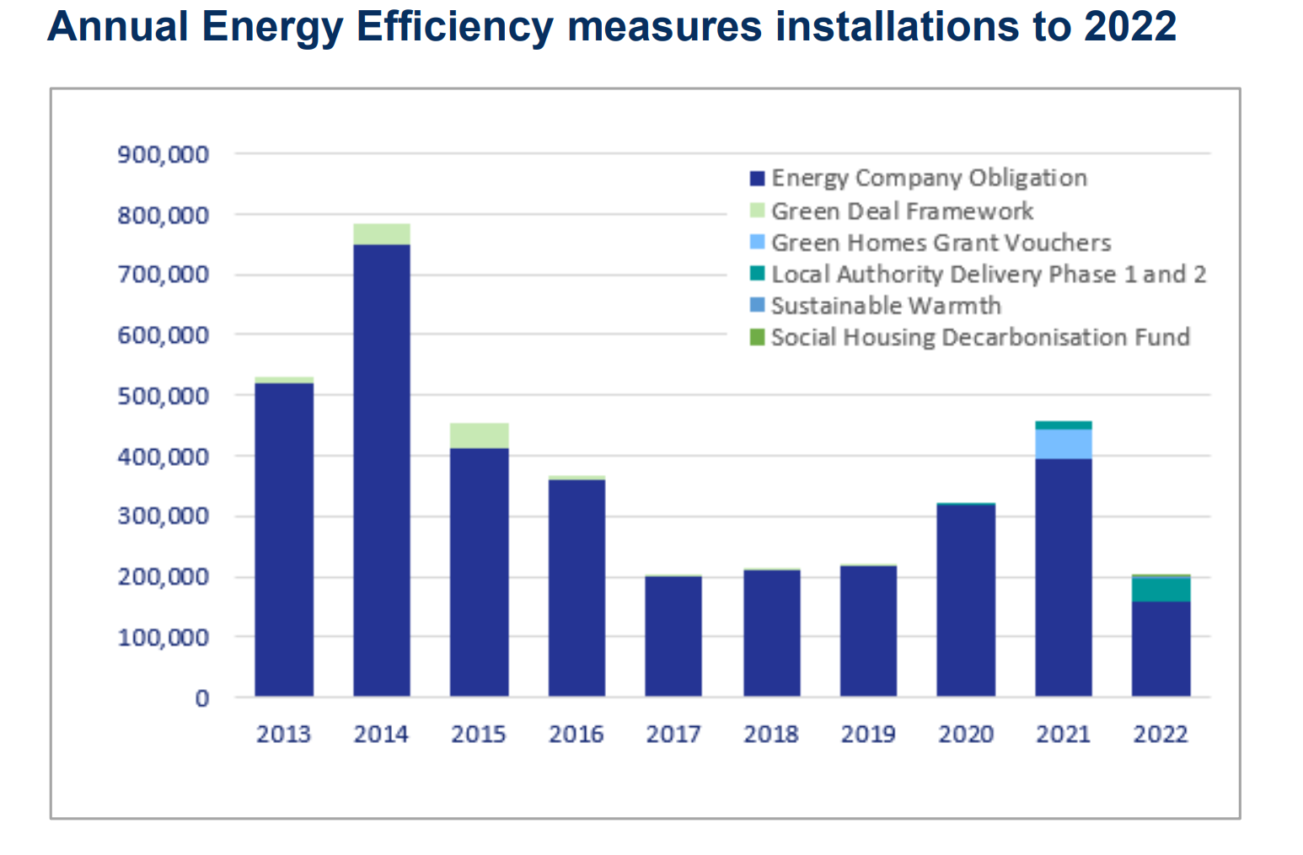
Figure 14 Department for Energy Security & Net Zero (2023)b

Chapter 7 : Secondary Data Results

For a detailed critical comparison two countries were chosen, Wales and Northern Ireland. The reasons for this being the closest similarity in population sizes, proportion of owner occupied properties and the GDP per capita.
Population of UK countries as of 2021, ONS (2022) England 56.5m, Scotland 5.48m, Wales 3.1m and NI 1.9m. The gross domestic product per capita for England was £32,763, Scotland was £29,035. Wales £24,339, and £25,399 in Northern Ireland, Clark (2023).
Owner occupier households as of 2021
England - 15.7m (62.4%) Statista (2023)
Wales - 894k (66.4%) Gov.Wales (2023)
Scotland - 1.5m (58%) Scottish Government (2022)
Northern Ireland – 500k (64.2%) Cook&Co (2023)

Infographic 1, showing figures for GB (excluding NI)

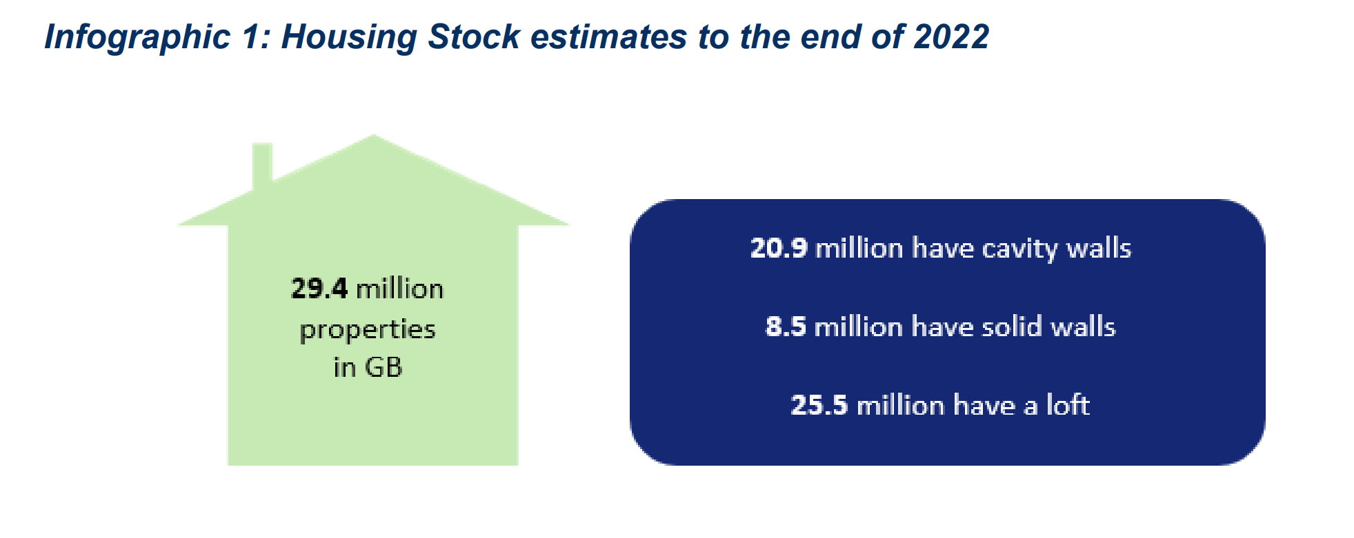
Figure 15 Department for Energy Security & Net Zero (2023)b

Wales typically has more older homes than England, with 39% being built between 1930 and 1982, and only 5% being built after 2012. Wales also has 23% of its houses being built before 1900, ONS (2022)b. This is important as practically all homes built after 2012 will have a high energy efficiency rating, compared to only 8% of homes built before 1900 in Wales. This same source states that only 37% of homes in Wales have an EPC rating of C or higher.
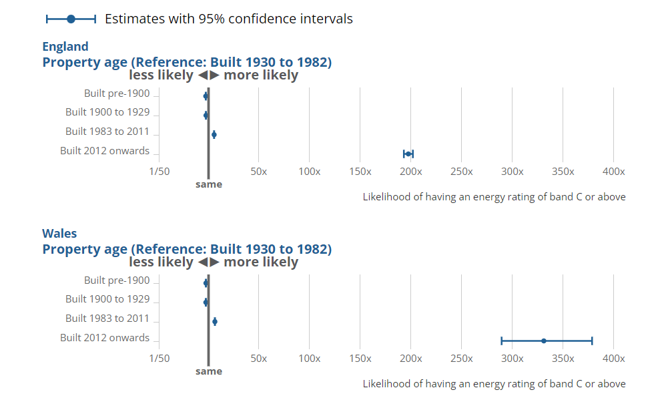
Table 2 showing property ages in England and Wales against likelihood of energy performance ONS (2022)b

We can see from the following statistics that for the housing stock of the whole UK, England makes up 84%, Scotland 9%, Wales 5% and Northern Ireland 3%. This data also strengthens the reasoning for the comparison of schemes implemented in Wales and NI. Data collected in 2017 shows a slightly higher figure of 26% being built pre 1900 for Wales as opposed to the 2020 data showing 23%. This makes sense as without improvement measures, older buildings may become dilapidated and get demolished as time moves on, BRE (2020) .
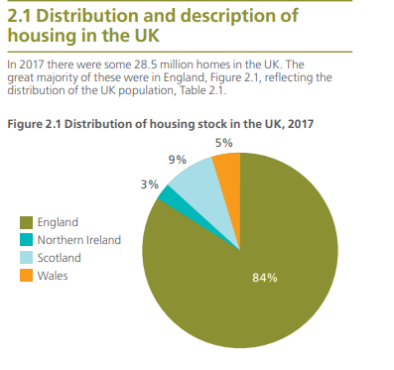
Figure 16 BRE (2020)
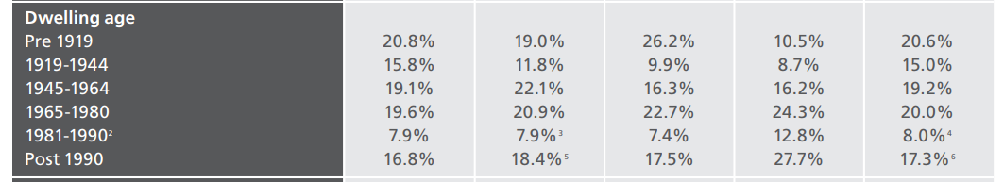
Table 3 BRE (2020)

There are noticeable differences in the figures between NI and Wales. It is noteworthy that NI ha fewer properties pre 1945 and more properties post 1965 meaning that proportionally, Wales has the most older properties in the UK.

7.1 Wales

7.1.1 Nest

In evaluating the Nest Scheme an important resource is the Government Social Research paper “Evaluation of the Nest energy efficiency scheme” commissioned by the Welsh Government in 2014 and carried out by Miller Research (UK) and Brook Lyndhurst Ltd. The aim of the evaluation was to determine:
- Whether the scheme had achieved its goal of helping households in need.
- Whether the scheme achieved good value for money
- Did the scheme create energy savings
- An evaluation of the process and customer satisfaction.
Qualitative and quantitative evidence was gathered evidence. The qualitative was carried out between June to October 2014 by means of interviews of various stakeholders in the scheme, people managing and delivering and those benefiting from the improvement measures. The quantitative data was gathered in September 2014 from two large scale surveys of people benefiting from the scheme. GSR (2015). The report was released 10th of March 2015.

The results are assessed in four elements:
Was the scheme managed effectively – High levels of customer satisfaction were attributed to effective management, this was praised by all parties in the interviews. There was however, indication from the interviews that the programme might present accessibility issues for participants with sight and hearing impairments.
Did the households most in need benefit – The results of the survey indicate the scheme was successful. Households which could not have had support elsewhere were able to access home improvements through Nest. These being elderly, or people with debilitating illnesses, however data also shows that those in rural areas had not benefitted as much as initially perceived. According to the quantitative data, many who were ineligible for the scheme, also faced the same difficulties and hardships as those who were eligible. This points towards the notion that many households in need are being missed due to the eligibility criteria. The criteria have been a point of note many times, with multiple adjustments being considered. The appealing solution would be to lower or widen the limitations to allow more eligibility, the reality being that this would require a larger budget. Without the increased budget, there would be an impact on the amount of measures available to each household and number of overall households which could be helped.
Did the householder benefit – 89% of those who received improvement works reported being better able to heat their homes. The results of those who solely received advice were lower at just over half. There were also reports of energy and cost savings and improved health as a result of the service and some being able to use heating and hot water when previously they had no systems.
Achieving value for money – Up to September 2014 an overall investment of £58m had been made with a calculated overall saving for households of £7.5m, creating a benefit to cost ration of 1.29. This is translated into a 7.75 year payback period. GSR (2015)

Nest also produces its own annual reports, the latest version available being Nest Annual Report 2021-22, Nest (2022). This is a valuable source of more current data on amount of users of the service, as well as a breakdown of the services delivered.
For the 21-22 period, £24.5m of funding was provided leading to beneficial home improvement measures in more than 5127 homes. Based on the data a modelled average saving of £300 a year per household. 20.5% of those having previously been in severe fuel poverty, and 34.1% in fuel poverty, Nest (2022). A household which spends 10% of income on energy bills are classed as being in fuel poverty, while 20% is considered to be in severe fuel poverty. Taking into account the free information and advice provided by the service, an additional 15,777 people have benefitted from the scheme. During this period 100% of installations were carried out by Welsh based installers, 15 new permanent jobs creates, 25 apprenticeships and 2 traineeships.
As of 2019, health considerations were also taken into account. If a household member is living with a health condition while living in a house with an indicative energy rating of D,E,F or G and earning below a defined income, they would be eligible for energy saving home improvement measures. Between July 2019 and March 2022 a total of 16,451 households, which had failed the original criteria were assessed against the health criteria. This resulted in 7,943 progressing to be vetted against the income criteria and 4,710 achieving all criteria for work to be carried out.

The following charts show a breakdown of types of measures installed and the tenure status of houses.
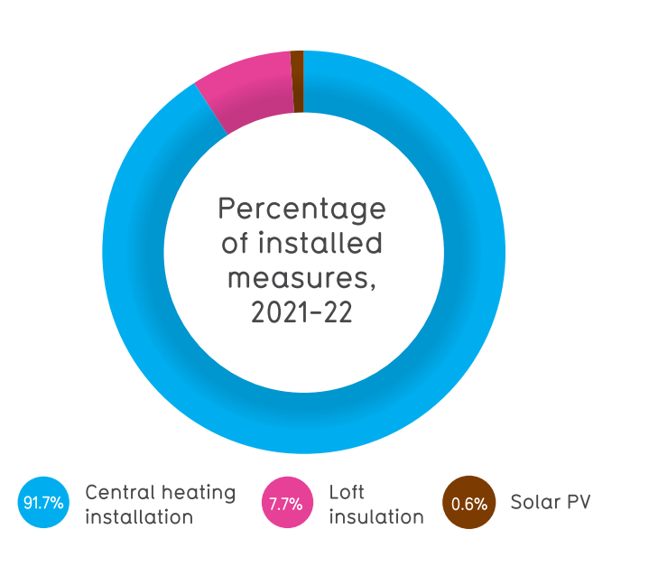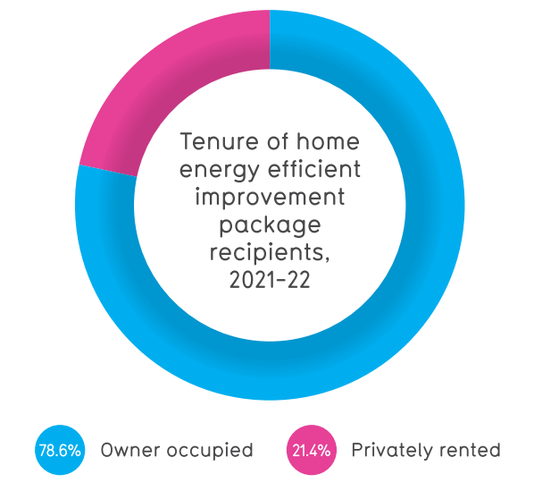
Figure 17

The following chart shows the before and after SAP band for houses receiving the improvement works. All houses were D or below prior to work, after work 83% were C-D and no houses were G rated. The aim is to reach a SAP rating of C where it is possible.
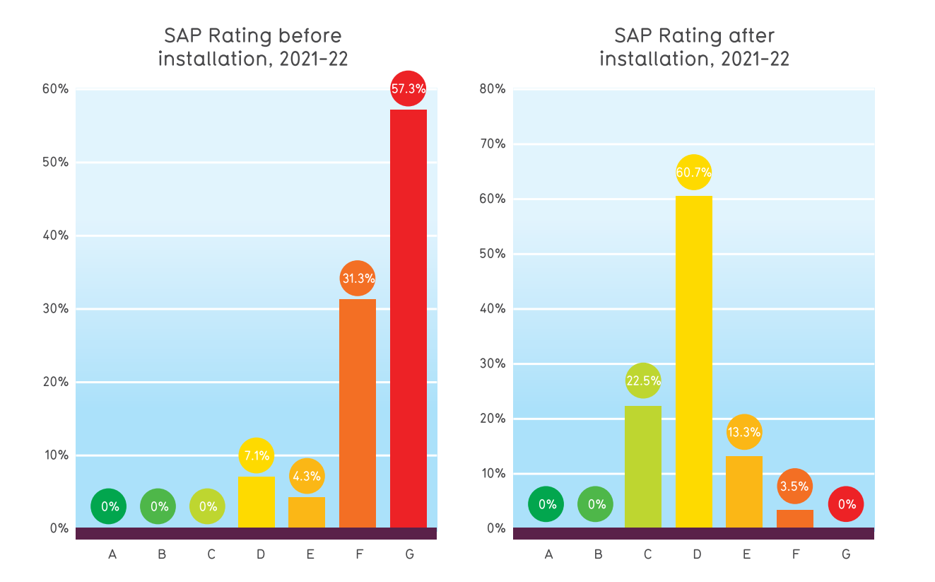
Figure 18
Using data from the Welsh housing conditions survey 2017-2018 this graph shows estimated percentage of households suffering from fuel poverty, against percentages of installations completed, by local authority.
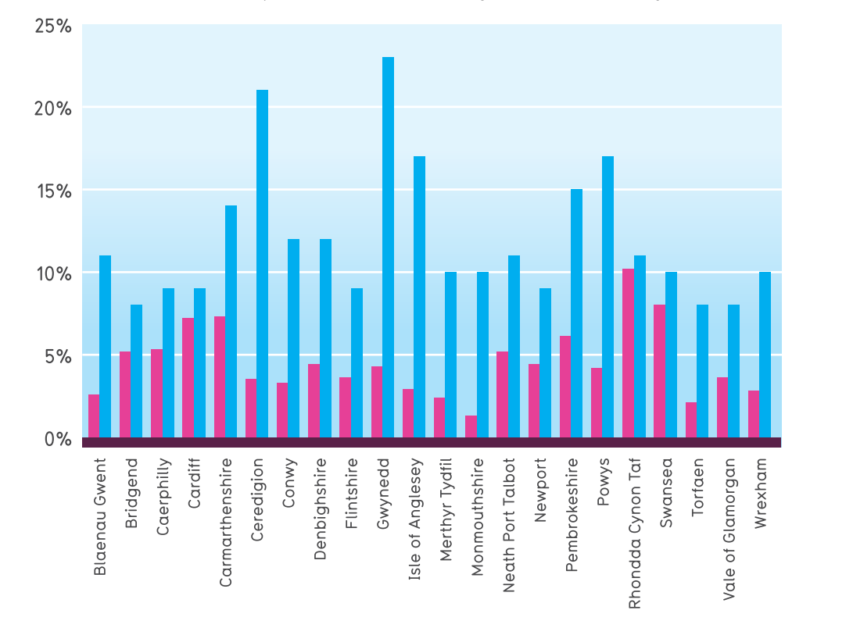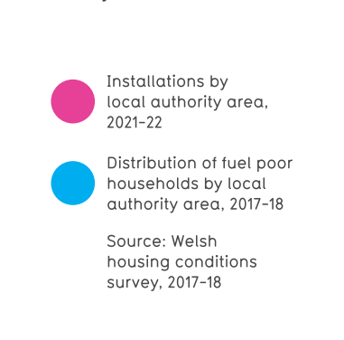
Figure 19
The following chart shows average spending on improvement measures by local authority. It is important to note the spending doesn’t necessarily reflect number of households but rather the ammount of work carried out. Some areas have more houses which aren’t connected to mains gas, meaning those properties would receive more improvement works.

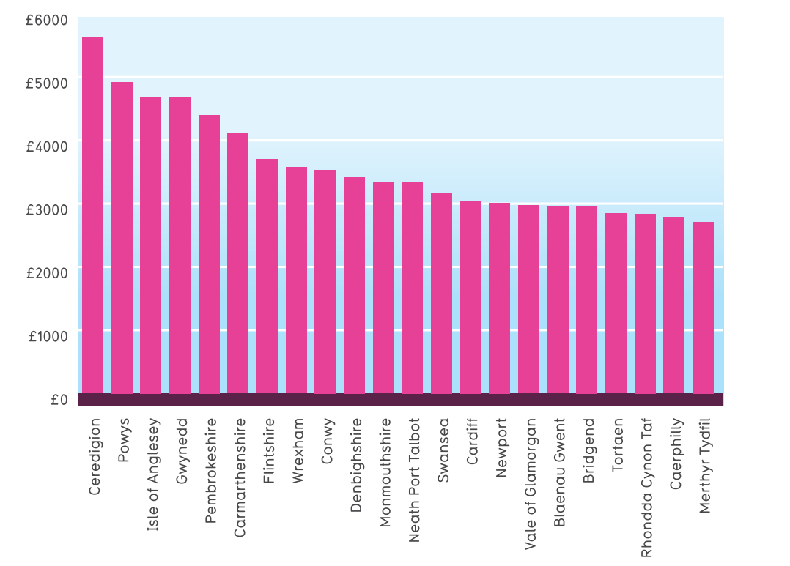
Figure 20

7.1.2 Arbed

The other half of the Welsh Government’s Warm Homes Programme, Arbed began in 2009. In evaluating the results and efficiency of this scheme, the Welsh Government Report entitled Next iteration of the Warm Homes Programme: review and recommendations report 2023 will be used as a key source of data, Welsh Government (2023). Also used will be the Government Social Research paper Evaluation of Arbed 3: Final Report commissioned by the Welsh Government in 2022 and carried out by Miller Research (UK) GSR (2022) and The Welsh Government’s Warm Homes Programme Report of the Auditor General for Wales, published in November 2021, Crompton (2021).

Arbed 3 was supported by the European Regional Development Fund (ERDF) and ran until 2021. The review carried out by GSR (2022) was carried out between January-July 2021 and build on research carried out between April 2020 to March2021 and was published in February 2022. The basis of the data collected for the review was:
- Quantitative survey of household beneficiaries – by means of telephone surveys to achieve better response rates than postal or email, carried out one year after improvement works to allow time for realisation of benefits. Carried out in three waves, a total of 506 responses were collected. A breakdown by location was established as: 417 from West Wales & the Valleys (WW&V) being 23.4% of households which received the works and 89 from East Wales (EW) a proportion of 11.6% for that area.
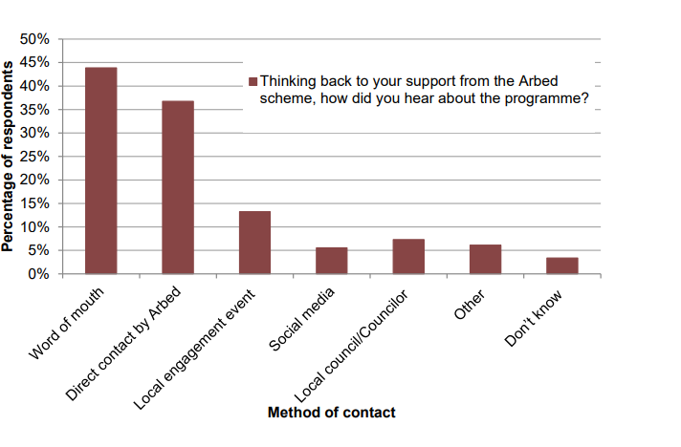
Figure 21 showing responses to awareness of Arbed 3, GSR (2022).

- Qualitative interviews with household beneficiaries, Local Authorities, contractors and suppliers, AaB staff, Welsh Government and with representative of the Private Rented Sector. For the 41 interview the topics covered were overall coordination, management and delivery and suggested improvements, GSR (2022).
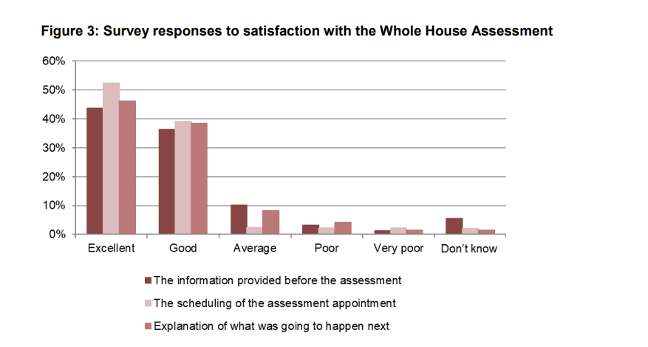
Figure 22

The original target number of homes for improved energy consumption was 3,825. This consisted of 3,060 in WW&V and 765 in EW. The progress data comes from claims made to the Welsh European Funding Office (WEFO) from the beginning to end of the Arbed scheme. The first claim was for the period April to December 2019, the second claim January to March 2020 and third claim April 2020 to March 2021. Alterations were made to the original target, following less work being carried out on houses as a result of the Covid-19 pandemic during claim period 2. For this period there was a defunding of £7.5m of European Regional Development Fund (ERDF) money. The resulting numbers of completed properties were 1,875 in WW&V and no change to EW, giving a combined total of 2,640 instead of the original 3,060.
The three largest areas where work was carried out were Rhondda Cynon Taf (RCT), Flintshire and Blaenau Gwent.
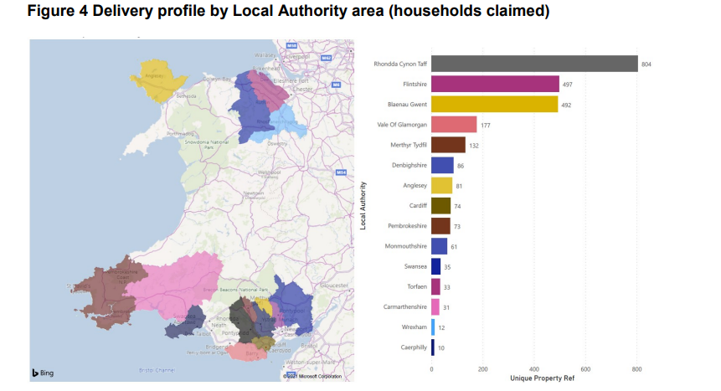
Figure 23
Noticeably (as of 2022) there are five Local Authorities, which didn’t benefit from the scheme. There are variety of reasons for this, including lack of engagement with AaB or insufficient number of eligible properties in that area which met the criteria for works.
The improvement work resulted in all properties seeing an increase of at least one EPC band, those just increased by one band made up 70%, 24% were raised by two bands and 5% were raised by three bands. Naturally, the larger increases were achieved in the properties which were most inefficient to begin with.
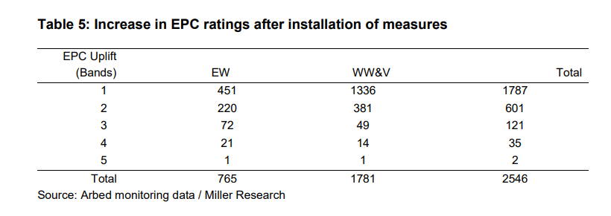
Table 4

Funding
The initial budget for Arbed 3 was £35.5m. With the ERDF funding £23.2m and the rest made up by the Welsh Government. After the de-funding as a result of Covid, the total was £24.7m, with £15.7m coming from European funding streams.
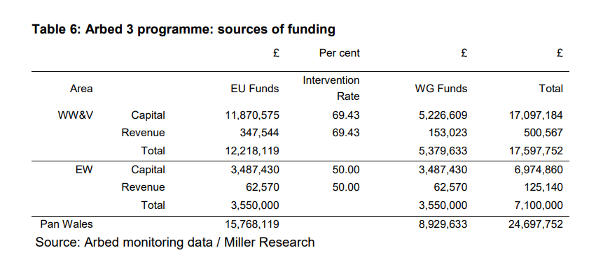
Table 5

Reduction in Greenhouse Gasses
An estimated target reduction of 1.8t of Greenhouse Gasses (GHG) per household was set. However measurement post work showed reductions of 2t per household.
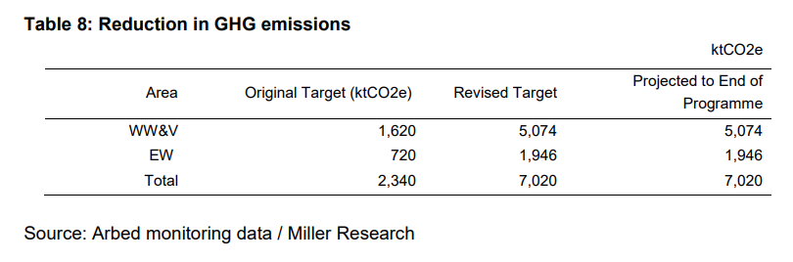
Table 6

7.1.3 Key Findings for Wales

All the sources cited refer to qualitative and quantitative data when measuring the success of the schemes. It is also necessary to compare the date to Key Performance indicators (KPI’s) while. evaluating. In this section the data will be further scrutinised to ascertain the positives and negatives from the Nest and Arbed schemes.
A review of the Welsh Government’s Warm Homes Programme by Audit Wales will be used to provide critical evaluation of the schemes, Crompton (2021).
Though the ambition of achieving net-zero carbon emissions is admirable, a key point of the WHP is that it still relies on fossil fuels. New gas boilers are still being installed as an energy saving measure. Admittedly newer boilers will be more efficient than older counterparts, however they are not the most sustainable choice. More recently the Nest scheme has seen solar PV and batteries added as choices, James (2022) but with more expensive technologies, the cost per home would increase, meaning a need for increased funding. Without increased funding, the result would be fewer homes receiving improvement works, Crompton (2021). Heat pumps are also available through the Nest Scheme, Nest (2023). However these technologies use electricity, which can be generated from sustainable sources making them far more sustainable and environmentally friendly than gas boilers. Currently more than 80% of British domestic heating is supplied by gas boilers, Watson (2018). This wouldn’t allow the UK to reach its net zero target. Shifting to electrical would, but there will inevitably be an increase in demand for electricity.
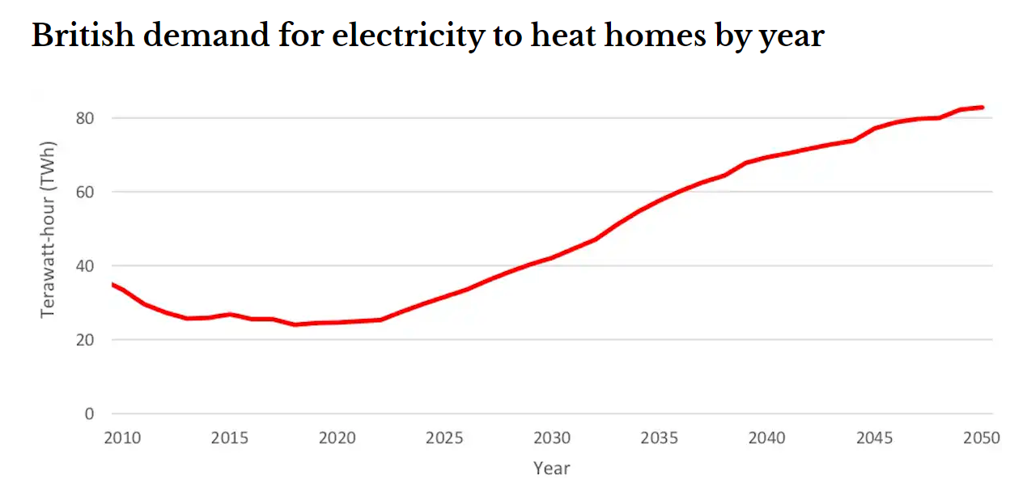
Figure 24 Preece 2021
The current electrical grid would have to handle much heavier demand. The current basis of the national grid is that not everyone uses the same amount at the same time. If this were to change or much more people had electrical heating systems, such as heat pumps, large parts of the grid couldn’t cope, Preece (2021). In a 2019 report, it is claimed that if by 2035, 5.7m heat pumps had been installed the National Grid would require a 42% reinforcement at a cost of £40.7b, Imperial College London (2019).
Crompton (2021) also states that the Nest scheme’s focus has shifted from tackling fuel poverty to becoming over focussed on replacing old boilers for new gas ones for people on means tested benefits, people who may not necessarily be in fuel poverty. The majority of people in fuel poverty won’t have a broken boiler, therefore may not reach out to the Nest scheme. The scheme targets for new boilers can be met by the demand from people with broken boilers, meaning little incentivisation for the scheme to target those in fuel poverty but with working boilers. The under delivery of the Arbed scheme is also questioned. In the review GSR (2022) the shortfall is attributed to the Covid pandemic, however Crompton (2021) states that the scheme was quite behind targets before the pandemic. It is claimed that the changes made to the management of the scheme resulted in Arbed 3 had little impact to the efficiency of its delivery. Furthermore, the £7.5m of European funding which was decommitted from Arbed, wasn’t redirected to Nest, as that scheme was at full capacity and couldn’t deliver any more. Contingency plans and flexibility should be incorporated into a scheme to utilise sudden increase in funds and maximise delivery.
Lack of consistency for costs is highlighted, calling for increased benchmarking. Significant differences were identified in how the two schemes charged the Welsh Government to supply and install the same measures. The contracts need to be improved, specifically when specifying what works a contractor has to carry out to be paid. One example cited is that a contractor could potentially claim full lighting or water measure payments, for changing a few lightbulbs or installing aerators on taps.
Previous versions of both schemes had issues with poorly installed systems causing damage or working inefficiently. This was remedied by using an independent organisation to test compliance and check quality. There is, however a backlog of properties still requiring inspection, which has been further impacted by the Covid pandemic.

7.2 Northern Ireland

7.2.1 Affordable Warmth Scheme

For evaluation of the Affordable Warmth Scheme (AWS), by the Department for Communities (DFC), data will be used from the Affordable Warmth Customer Satisfaction Survey 2019, Housing Executive (2020). The Response to the Utility Regulator, Review of the Northern Ireland Sustainable Energy Programme (NISEP) & Energy Efficiency Provision, NEA (2019). A Health Impact Analysis of the Affordable Warmth Programme: 2014-2018. McKenzie, et al (2018) and the Home Energy Conservation Authority Annual Progress Report 2022, HECA (2023).
Introduced in 2014 to replace the previous Warm Home Scheme (WHS), the Affordable Warmth Scheme is aimed at tackling fuel poverty in the nation by providing grants for energy saving improvement works for low income and vulnerable household owners and private rented tenants.
Funded by the Department for Communities and delivered by the Northern Ireland Housing Executive (NIHE), in 2021/22 the Scheme implemented 4,585 improvements in 2,841 homes, with a total cost of £11.5m. To break this figure down, the works involved: installation of loft insulation in 395 homes, heating system improvements in 2,175 houses. New double glazed windows in 1,114 homes, cavity wall insulation in 320 homes, draught-proofing measure in 39 homes and solid wall insulation in 2 homes, HECA (2023).
The Affordable Warmth Customer Satisfaction Survey 2019, published in 2020 is a valuable source of qualitative and quantitative data, some more relevant than others for the purposes of this research.
A sample of 500 customers were chosen, which had works carried out under the scheme in the 2018/19 period, and questionnaires were issued by post in Autumn 2019. 265 were returned, a 59% response rate. 93% of those surveyed were the owner occupier, 3% landlords and the remaining 4% were tenants. 37% of those surveyed were self-referred to the scheme, 18% had heard about the scheme from a local advisor and 6% had been identified and contacted by a local authority surveyor, Housing Executive (2020). Unless otherwise stated, the statistics referred to in the body of this section will be from the 2019 data.
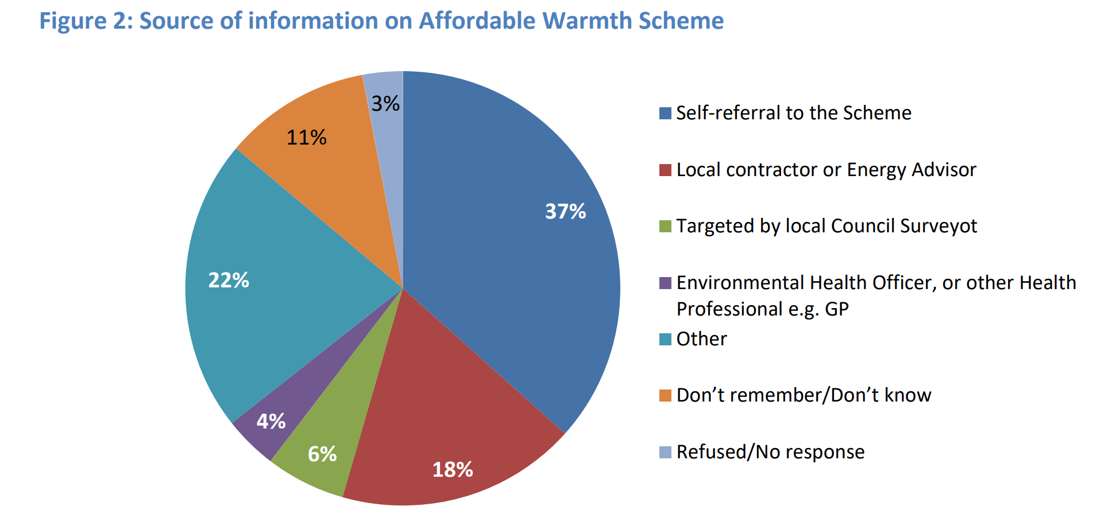
Figure 25

The following tables show the sample group and responses from each area.
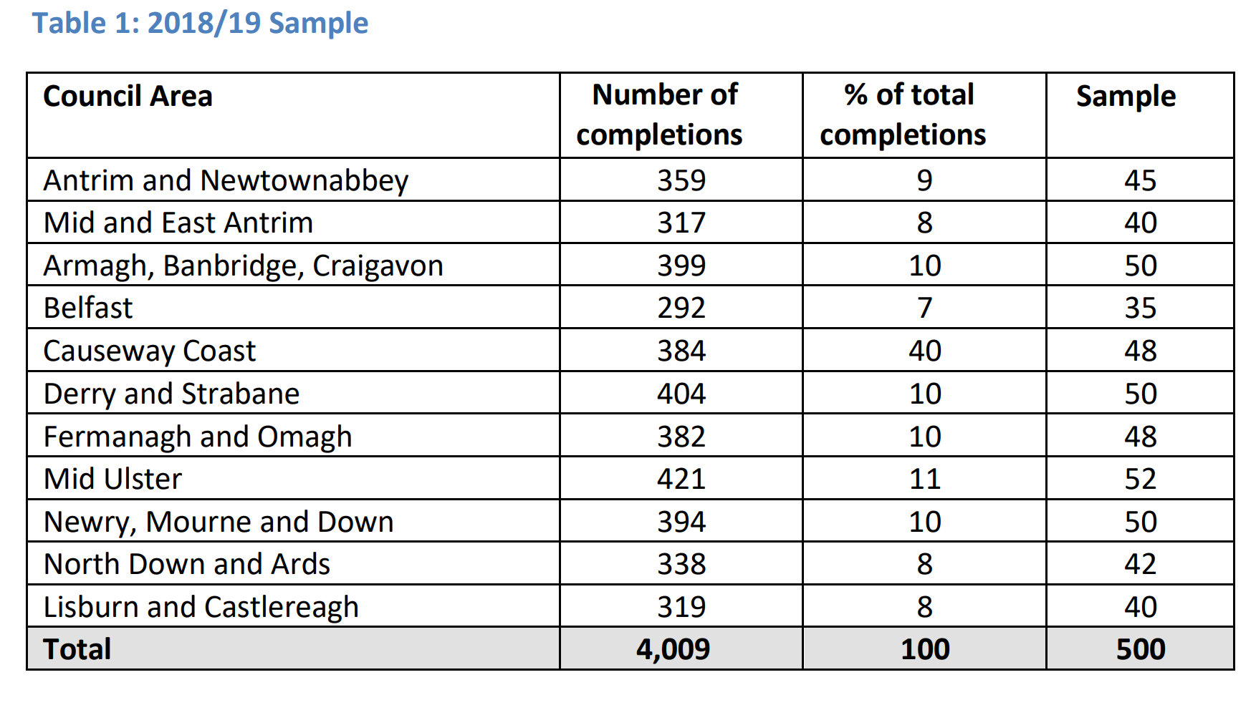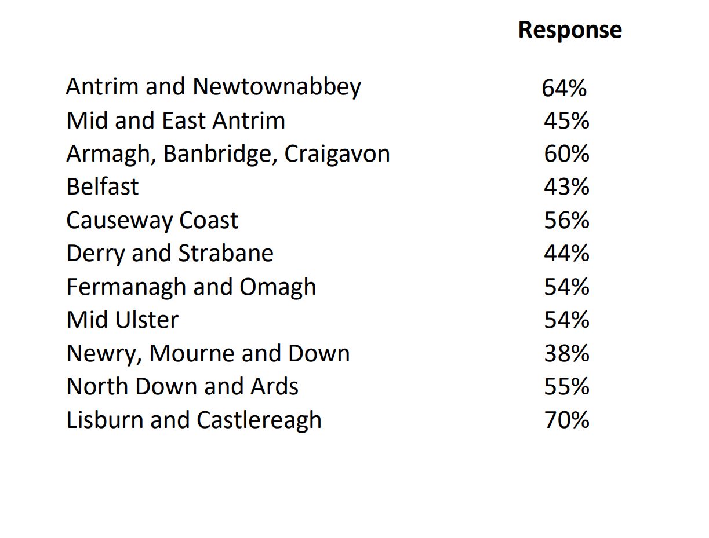
Table 7 Housing Executive (2020).

In terms of satisfaction with the overall scheme, 97% were satisfied or very satisfied and only 1% dissatisfied or very dissatisfied. 88% stated that the quality and standard of their home had improved.
92% stated they received clear information on what measures they could receive under the scheme. 90% were satisfied with the ease of access to a contractor, 88% reported receiving easy to understand documentation and 87% were satisfied with being aware of who was dealing with their application and the time taken for its approval.
When asked about their satisfaction with the explanations they received from the surveyor, more than two thirds stated that all areas of the scheme had been explained to them.
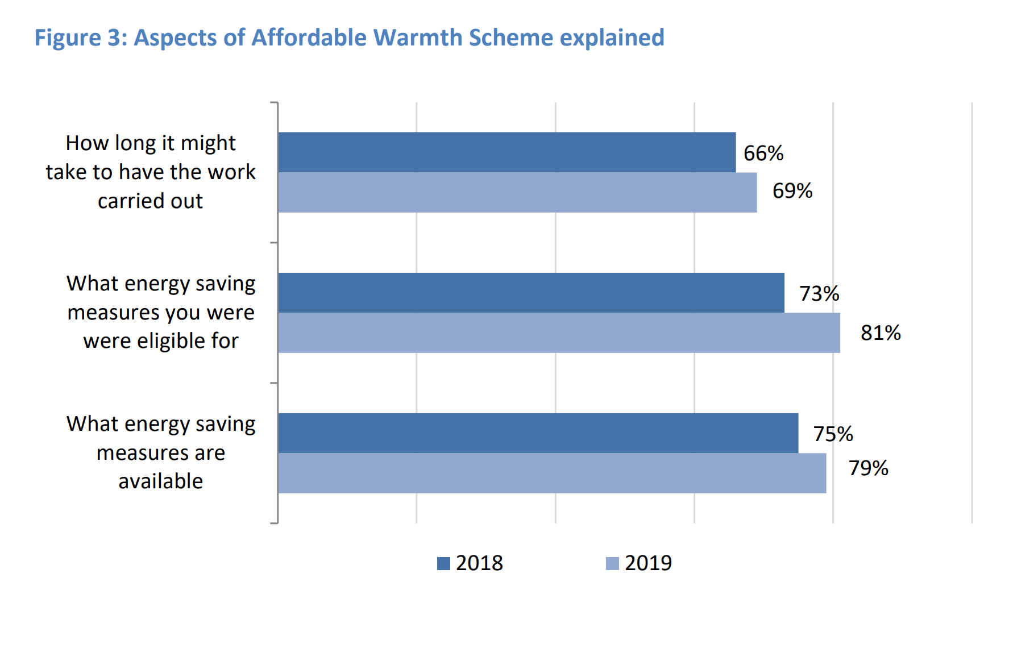
Figure 26
For a breakdown of measures received, the survey respondents reported, 83% receiving new central heating system/boiler, half received loft insulation and almost a third received new windows. Smaller numbers were reported for window repair – 25%, cavity wall insulation – 22%, 3% for draught proofing and 4% for solid wall insulation.
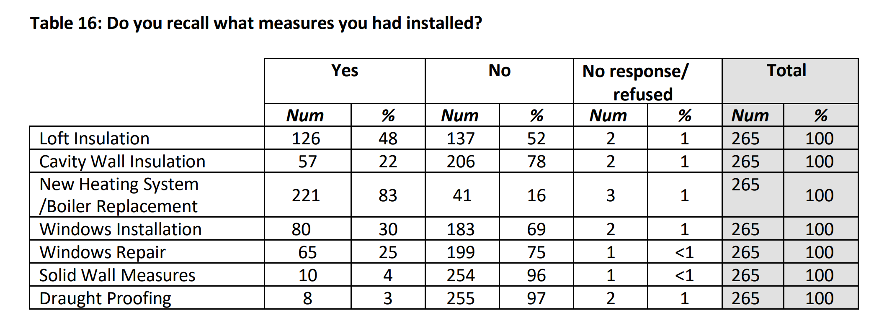
Table 8
Once the applicants were vetted and improvement works decided upon, the applicants were sent an approval pack. This document explained the works to be carried out, the amount of grant available for each measure and the schedule of works for the measures. It also included information on whether Building Control approval was required for each of the measures. The survey posed questions about the approval pack to ascertain its effectiveness. 89% were satisfied or very satisfied with how long they had to wait to receive the document and 91% claimed that the document was easy to understand. 84% stated that the document wasn’t difficult to complete.
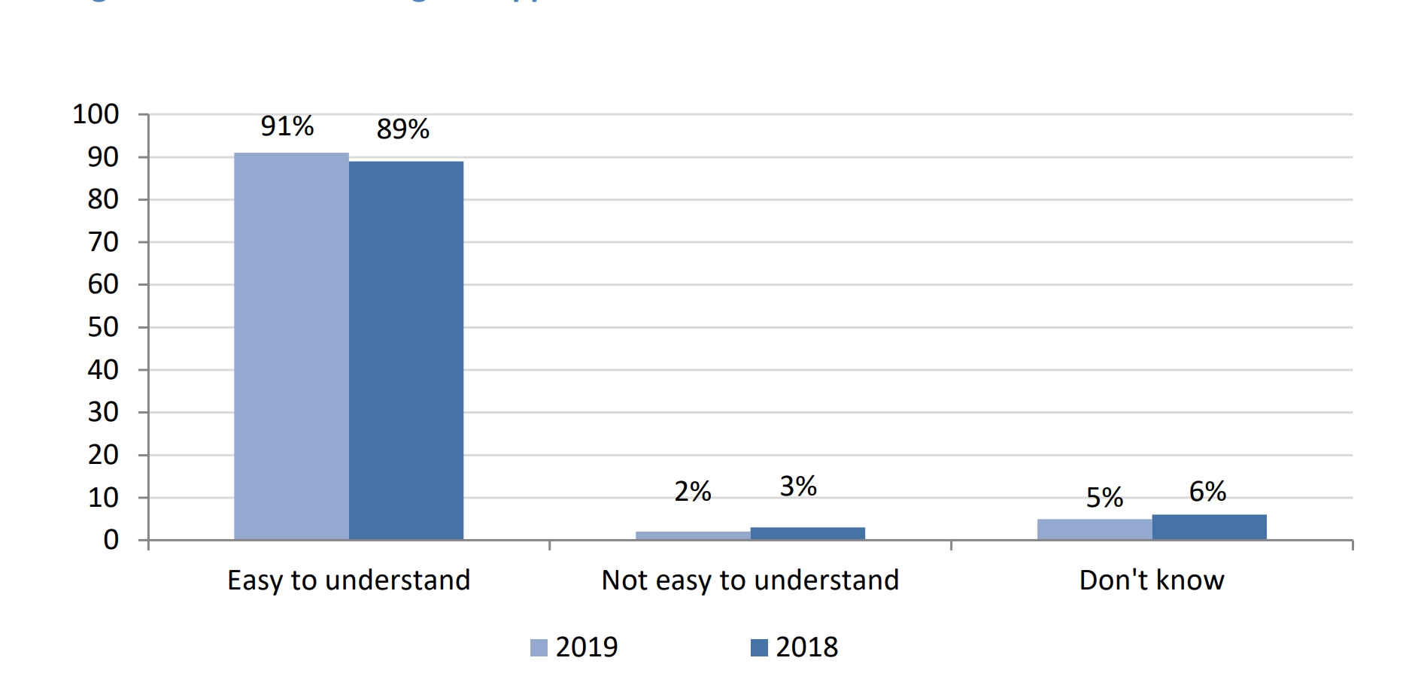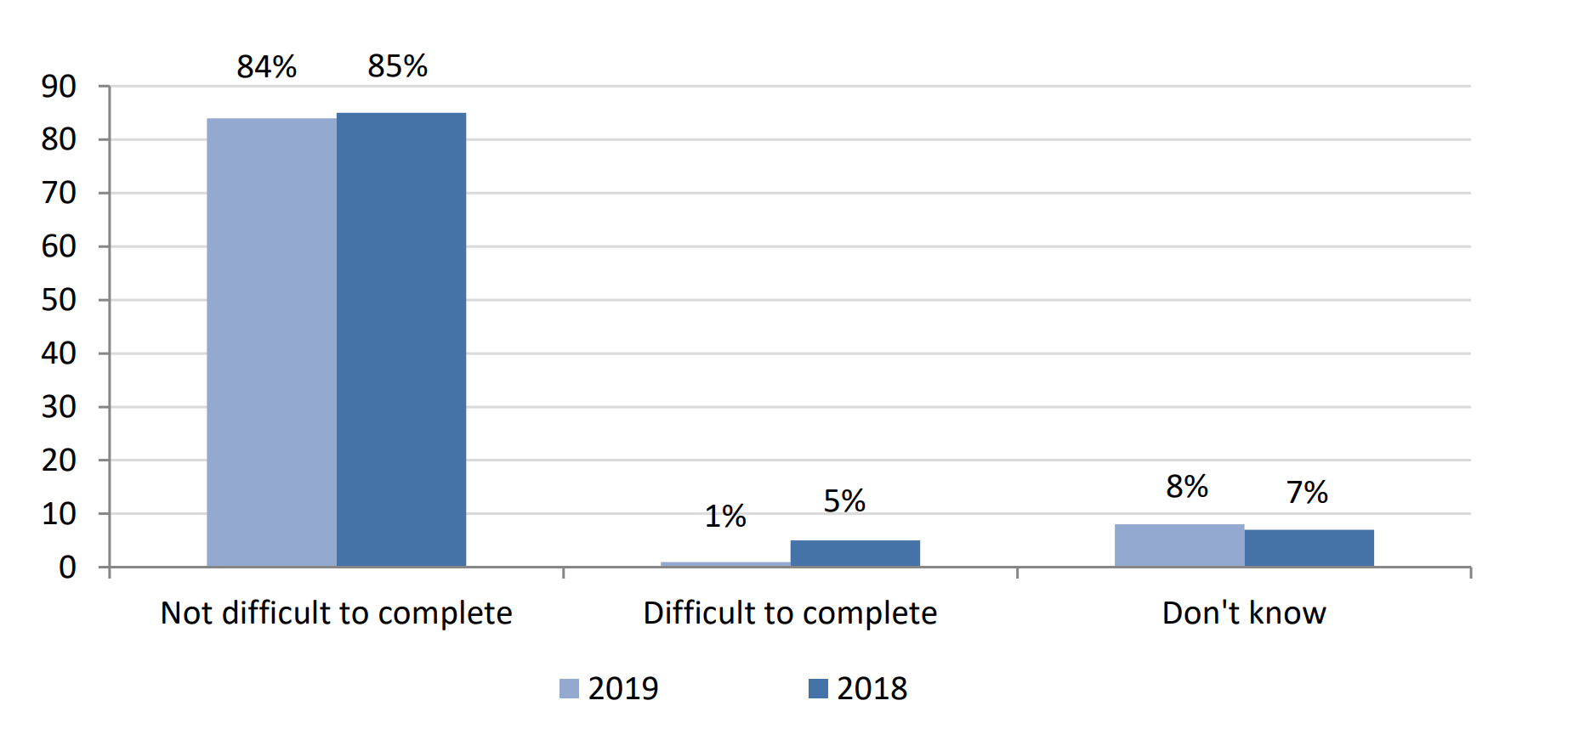
Figure 27
Another research area for the survey was ease of finding a contractor to carry out the improvement works. 84% responded that it was easy or very easy to find a contractor to carry out the work. 11% stated that they required the Housing Executive’s help to find a contractor. Of that figure, 77% claimed they would have preferred the Housing Executive to manage the process on their behalf.
94% of those surveyed were satisfied or very satisfied with the quality of the work, 94% were satisfied or very satisfied with the quality of the materials and the same percentage for the tidiness of the contactor, with 95% satisfied or very satisfied with their politeness. Those satisfied or very satisfied with the time taken to carry out the work were 94%.
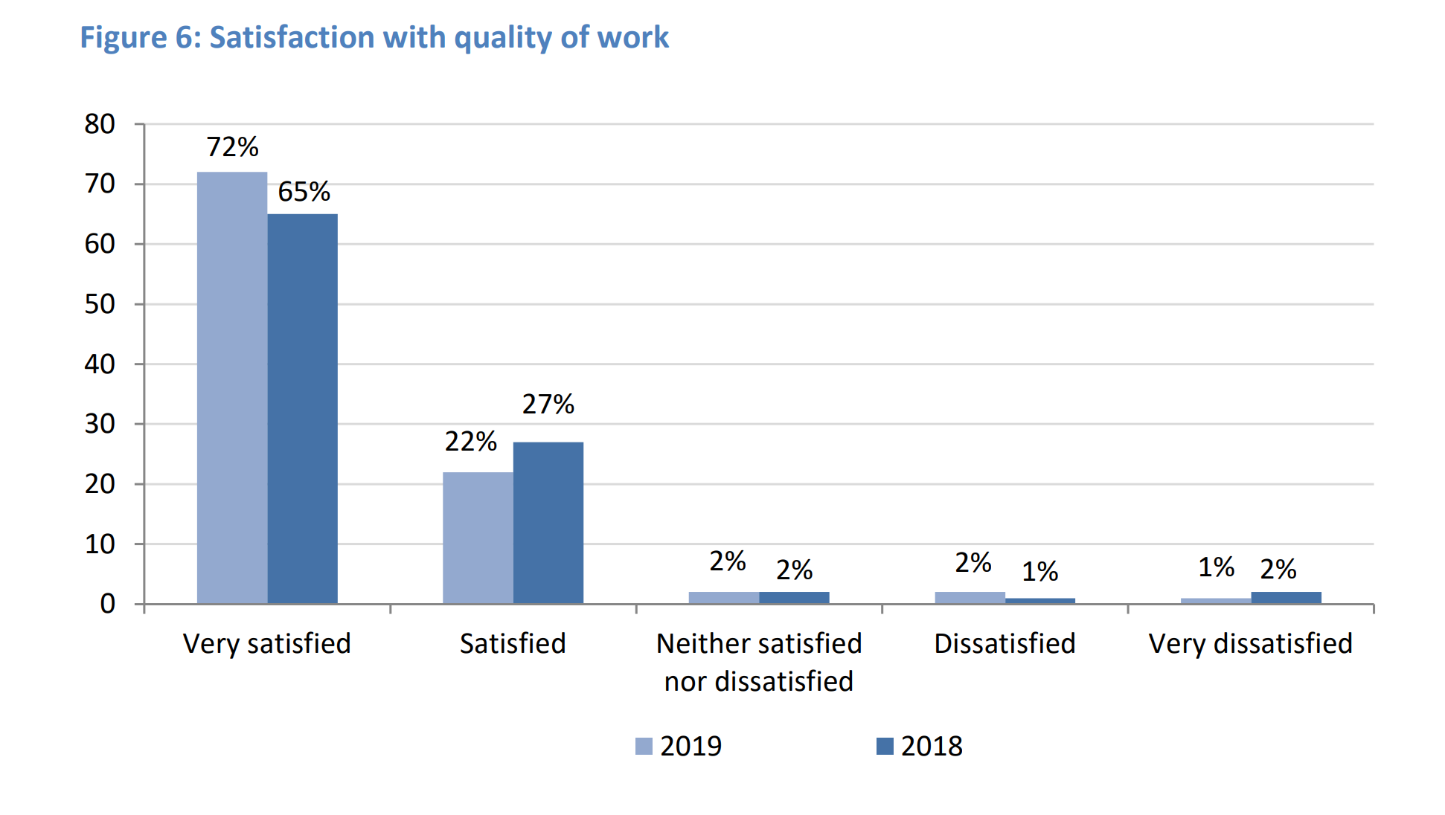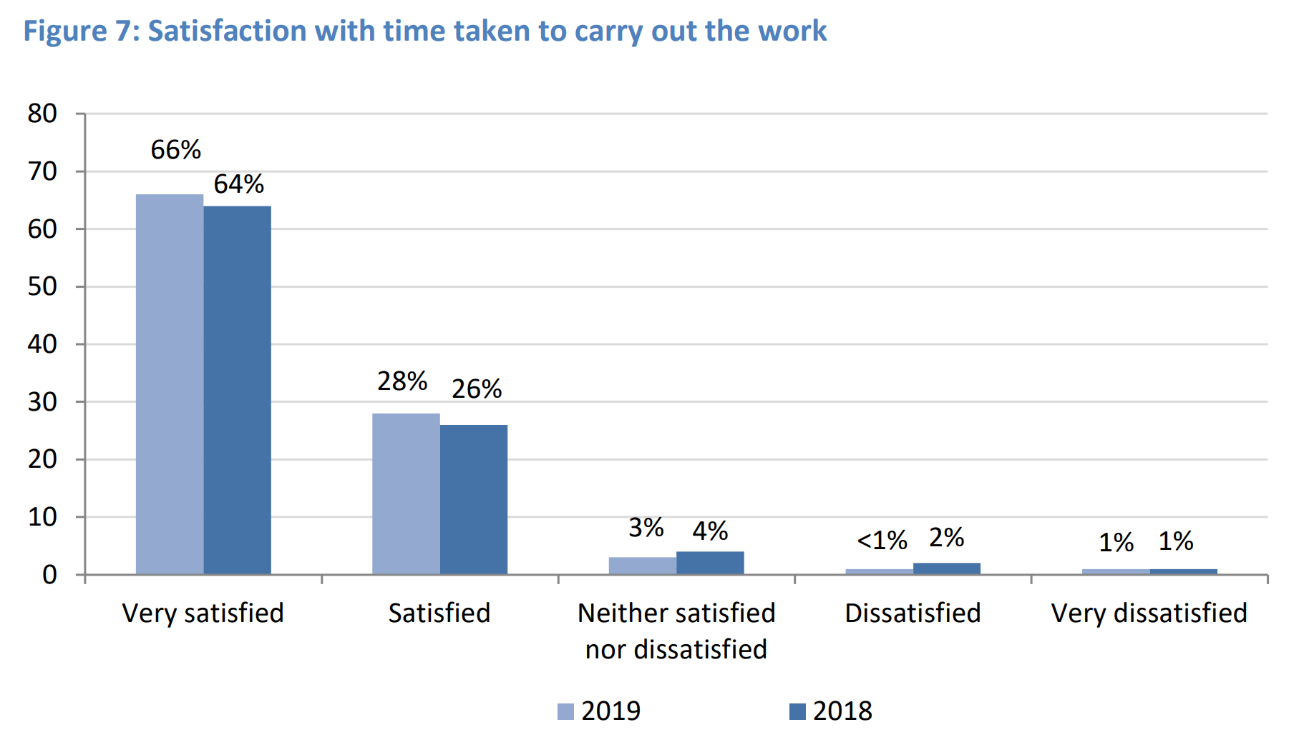
Figure 28
Overall satisfaction results can be split into five categories:
Clarity of information regarding entitlement to measures – 92% of those surveyed said they were satisfied or very satisfied with the clarity of communication about what measures they qualified for, with only 2% being dissatisfied or very dissatisfied.
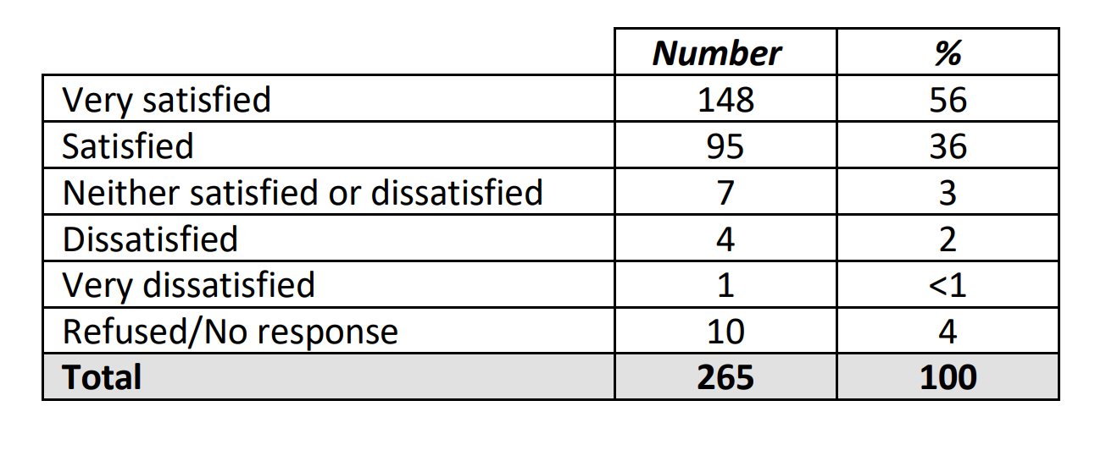
Table 9
Documentation being easy to understand – 88% of those surveyed said they were satisfied or very satisfied with documents and communications being simple to interpret, with ˂1% being dissatisfied or very dissatisfied.
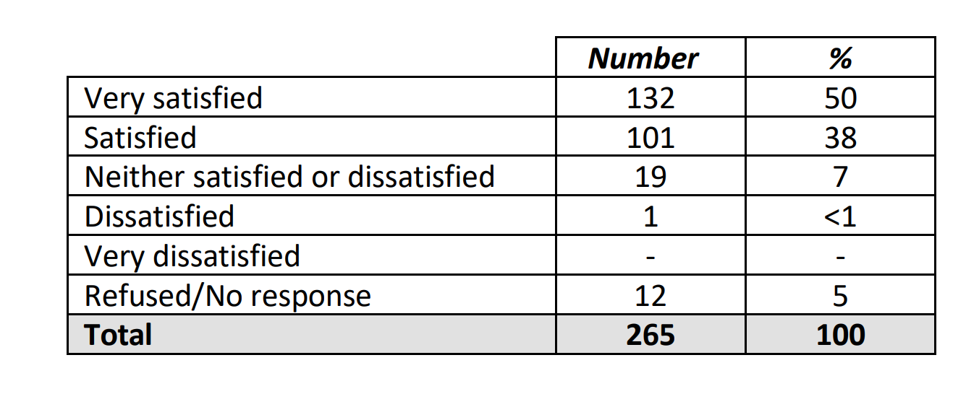
Table 10
Amount of time for approval to commence work – 87% were satisfied or very satisfied and 3% dissatisfied with the time taken to get approved for work to start.
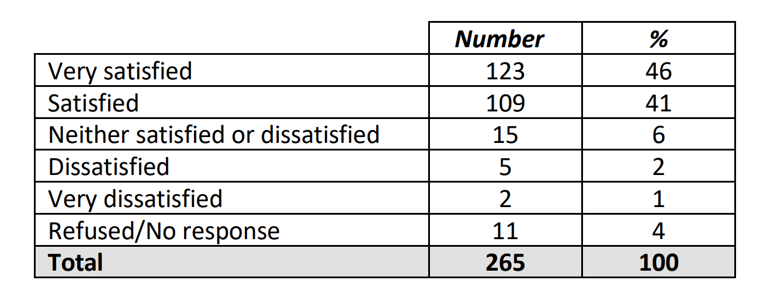
Table 11
Ability to find a contractor to carry out work – 90% were satisfied or very satisfied, with 2% being unsatisfied or very unsatisfied with access to a builder or contractor to carry out the work.
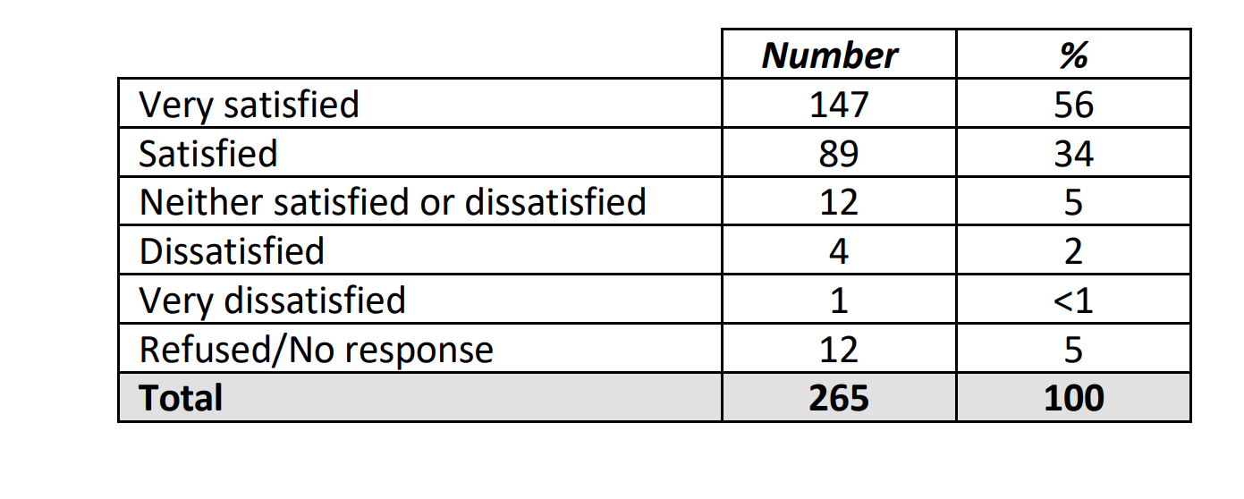
Table 12
Knowledge of who was dealing with the application – 87% of those surveyed said they were satisfied or very satisfied, with 2% unsatisfied or very unsatisfied.
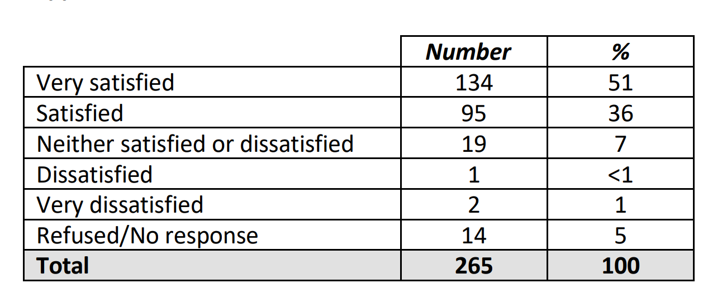
Table 13
The vast majority of responses (96%) were happy with the overall condition of their house after the works had been completed.
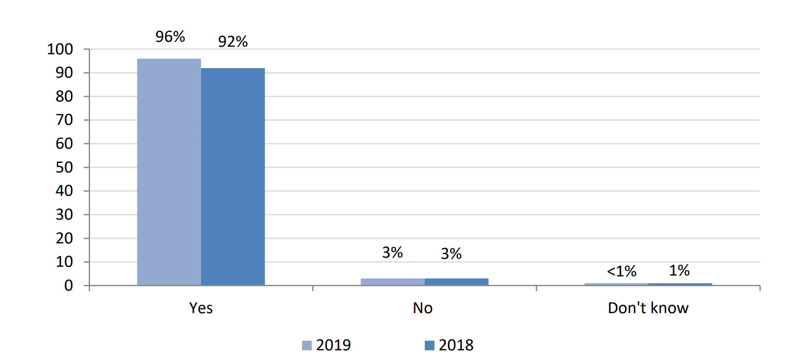
Figure 29

To establish the condition of houses prior to the improvement works, respondents were asked to highlight issues they may have.
Condensation
33% had no issues with condensation prior to works, 46% had slight to moderate issues with damp and 9% had large or extreme problems.
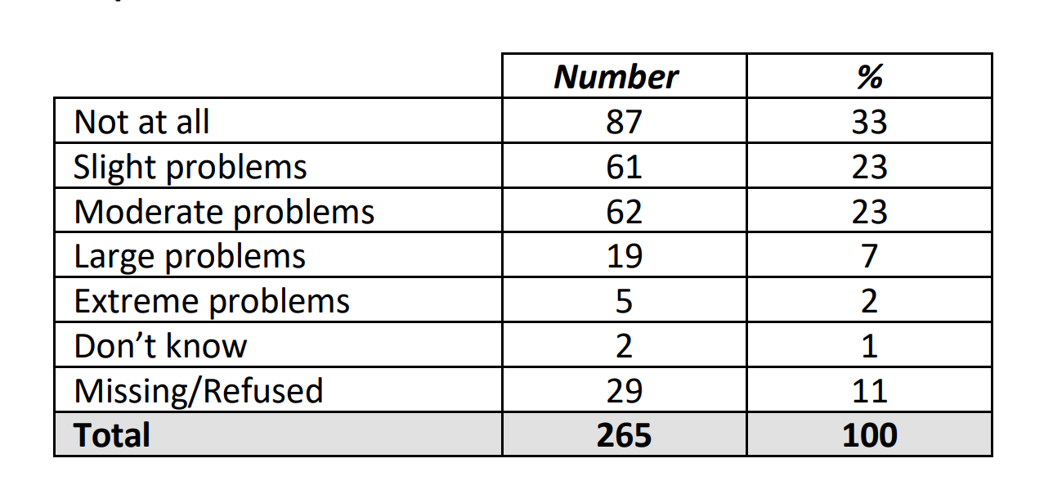
Table 14

Damp
For damp problems, 8% had large or extreme issues, 30% had slight or moderate and 46% had none.
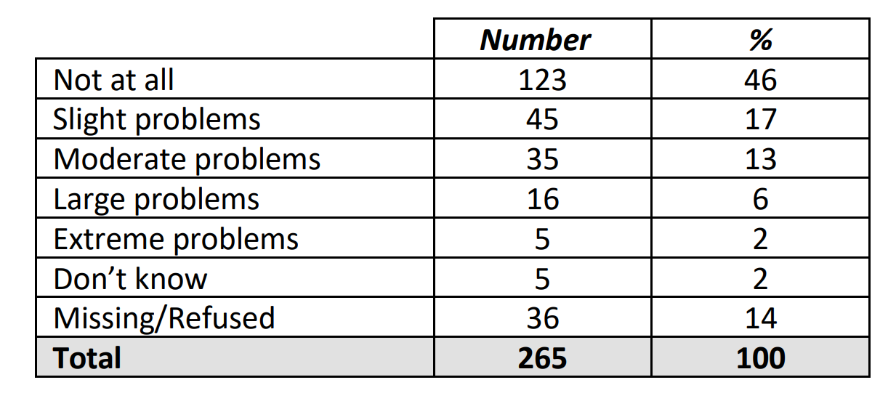
Table 15
Mould
For issues with Mould, 7% had large or extreme issues, 29% had slight to moderate issues and 47% had no issues at all.
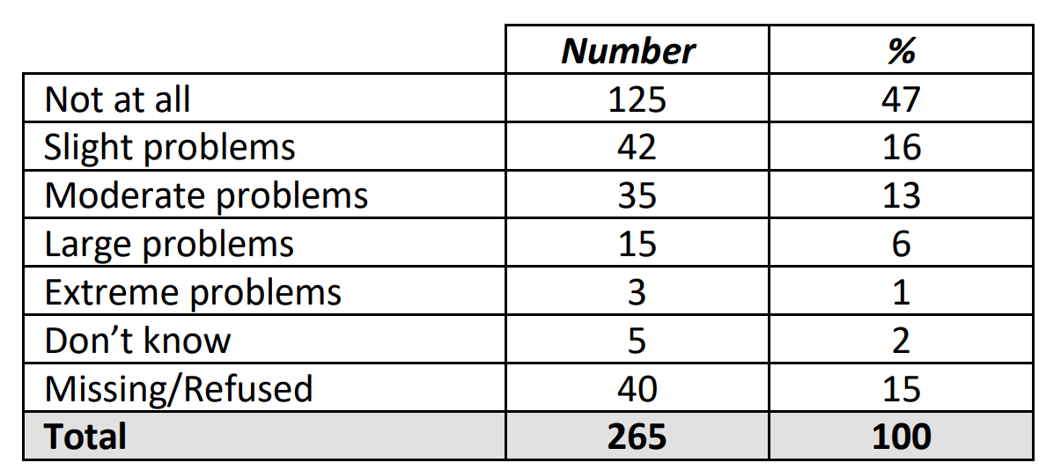
Table 16
Draughts
23% of respondents claimed to have no issues with draughts, 44% had slight to moderate and 20% reported large to extreme issues.
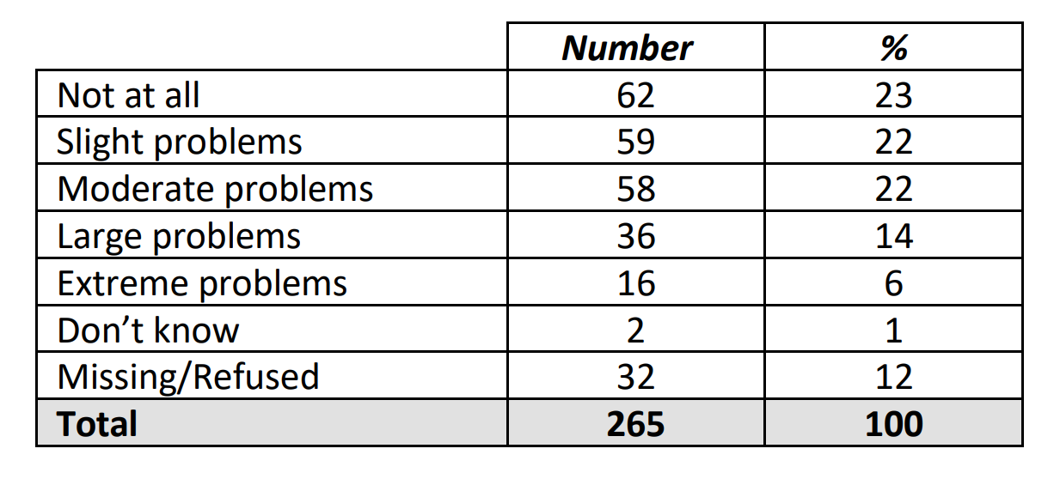
Table 17
Indoor Temperature
27% reported large or extreme issues, 42% had slight or moderate issues and 20% had no issues at all with indoor temperature prior to improvement works.

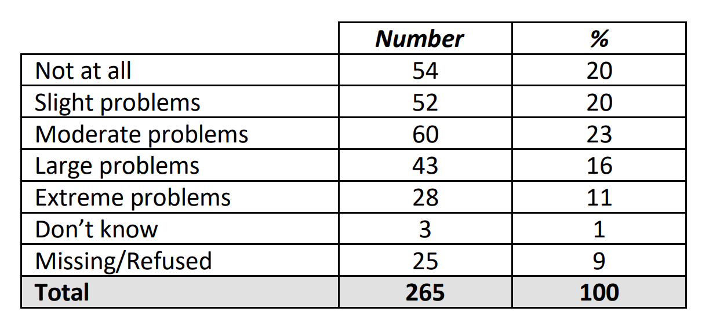
Table 18
Results after installation of home improvement measures
The survey asked what the standard of the house was like after the improvement measures had been installed, 88% stated that it had improved and 4% stated no change.
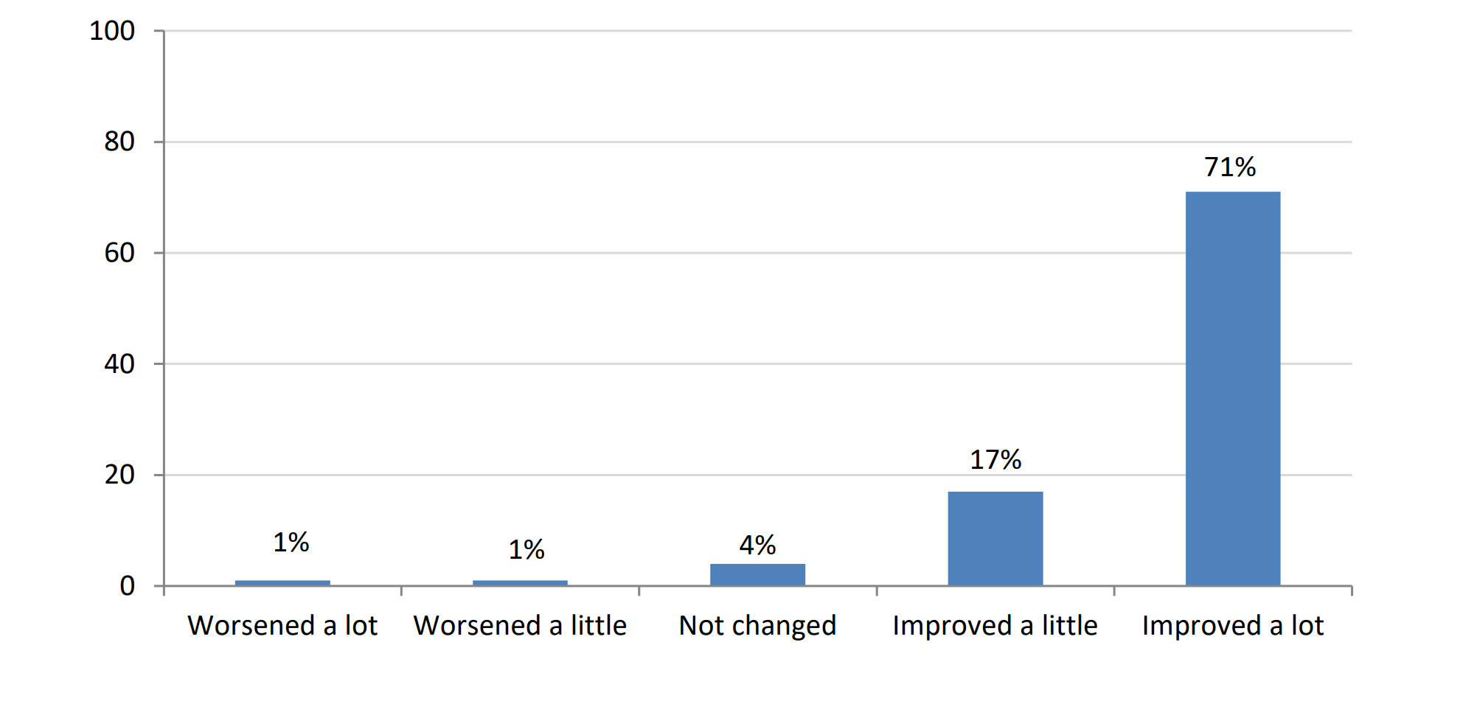
Figure 30
When asked about the conditions of damp, mould and condensation, 60% stated that conditions had improved, 29% said no change and 3% saw them worsen.
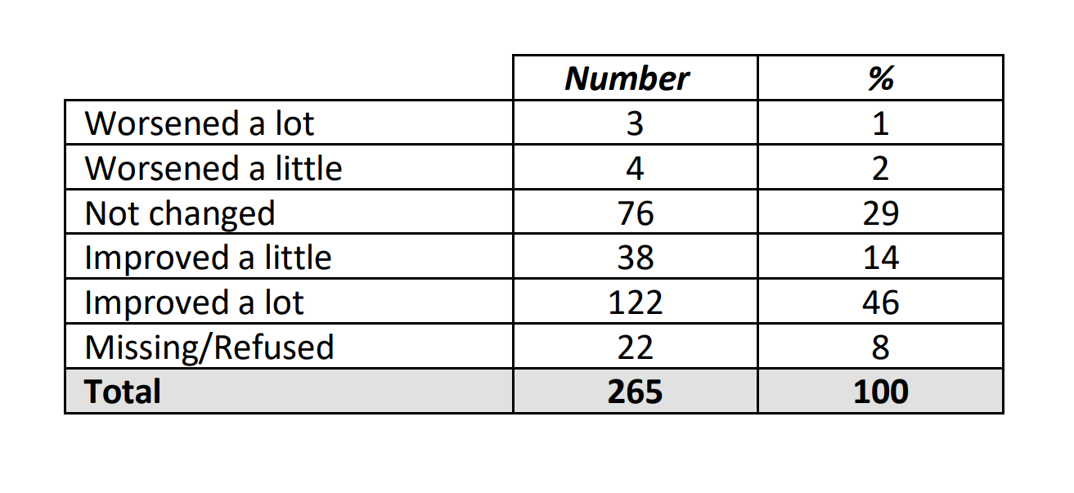
Table 19
With bill paying, 47% stated problems had improved since the home improvement works, and 48% seeing no change.
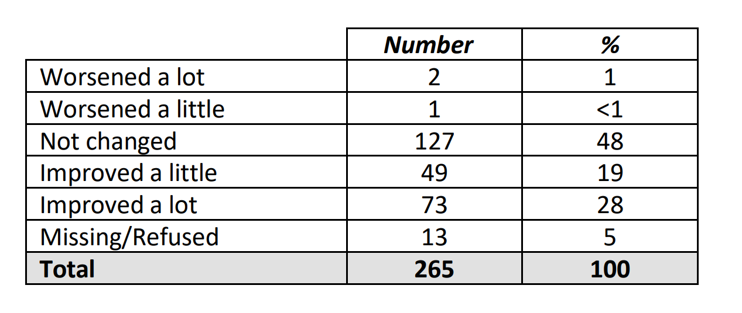
Table 20
When asked whether their health had improved as a result of the measures, 31% stated an improvement, 64% saw no change and 2% saw their health worsen.
Useful for evaluating the effectiveness of the scheme, the Health Impact Analysis of the Affordable Warmth Programme: 2014-2018. McKenzie, et al (2018) identifies the number of and reasons for cancellations of works under the AWS, a total of 3,195 against the total of 16,119 which had energy improvement measures installed for the period of November 2014 to October 2018, McKenzie (2018). Only records above 5% are shown.
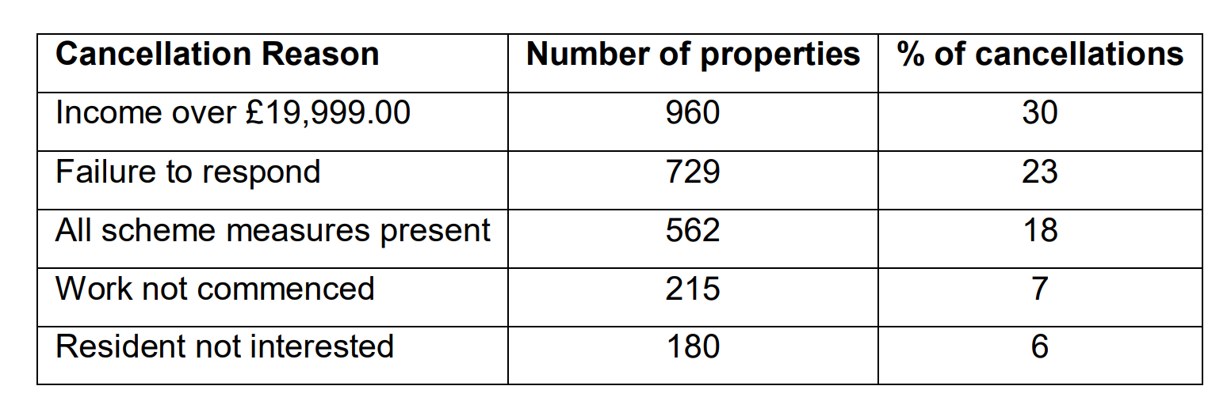
Table 21
This data is very useful in understanding the reasons why the majority of work isn’t carried out. Whilst an income over the designated threshold can be difficult to overcome without further investment, failure to respond is something which could be addressed with improved communication methods. This reason makes up nearly a quarter of homes making it an extremely important area to focus on improvement which could result in a much higher success rare for the scheme.
In looking at the allocation of funding, grants ranged from £50 for works such as draught proofing or loft insulation and up to £10,000 for solid or cavity wall insulation or central heating improvements. The total amount for the 2014-18 period was £66,206,343 an average grant value per household of £4,186.30. The following table on the left hand side shows a breakdown of grants per Council, whilst the table on the right uses a threshold of £1,800 to identify which numbers received minor and major works, Walker (2013).
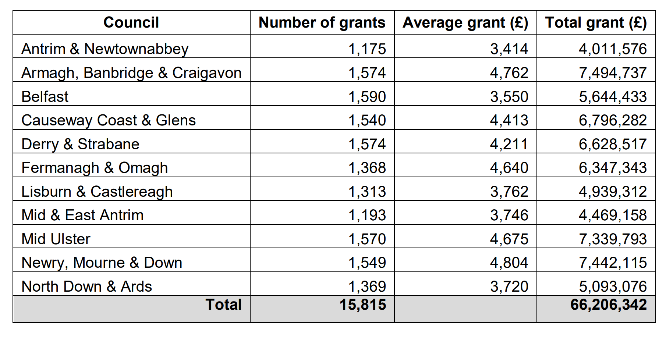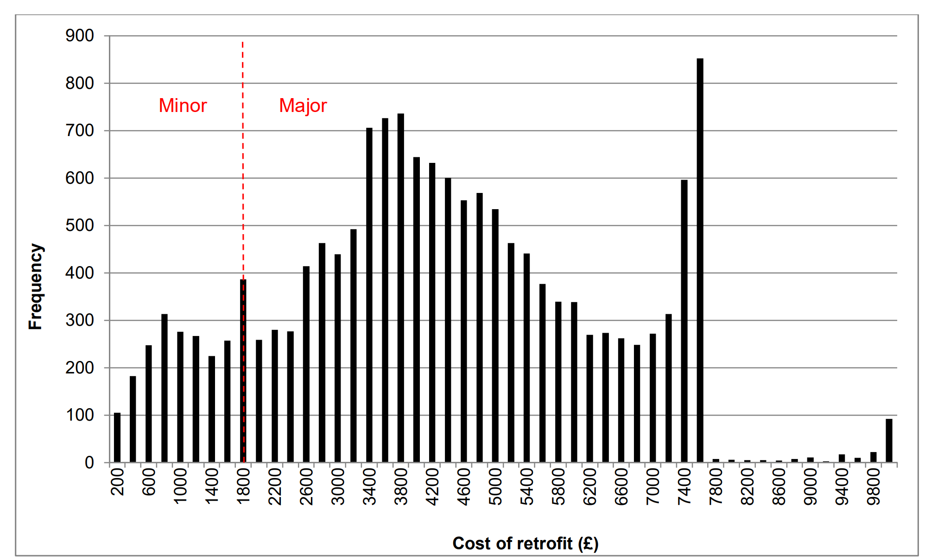
Figure 31 Table 22
The following table shows a further breakdown of measures per household and average cost.
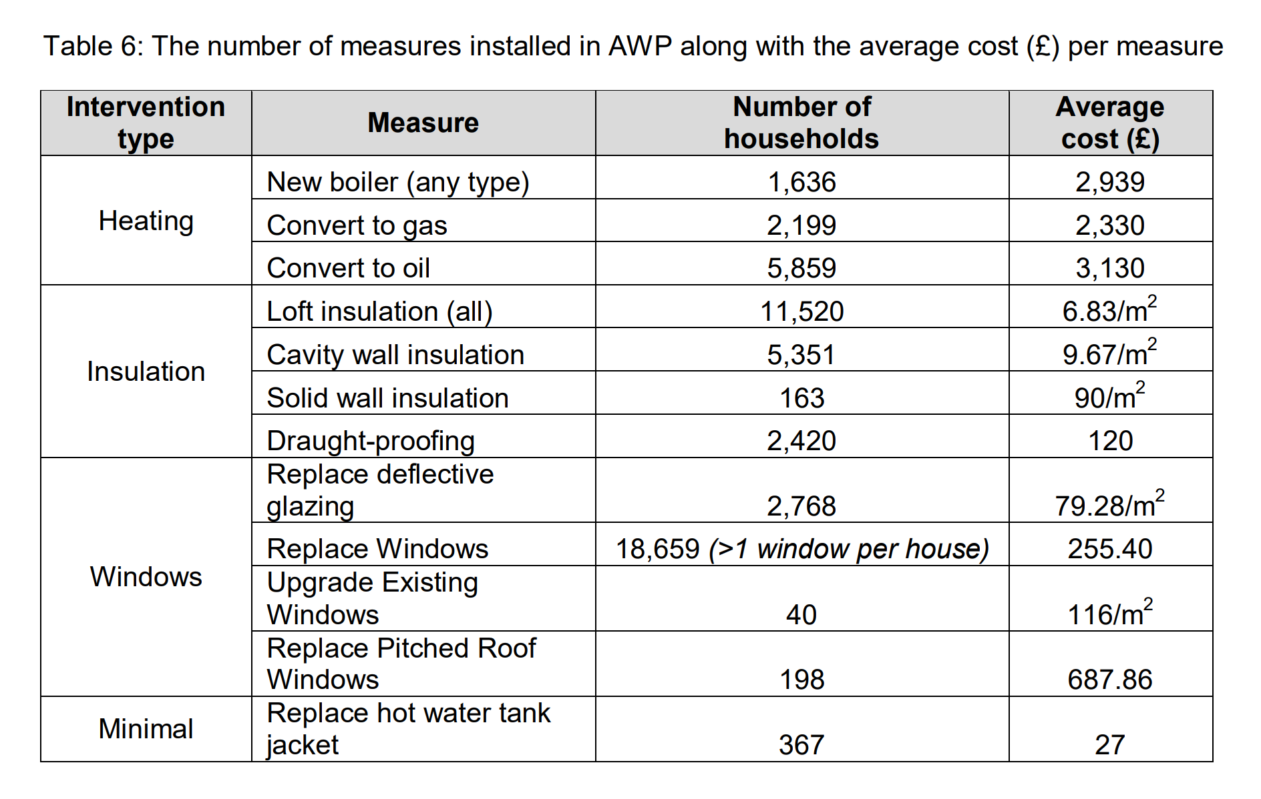
Table 23

7.2.2 Boiler Replacement Scheme

This scheme is aimed at households including owner occupier or private rented tenants, with an annual gross income of less than £40k. A grant of up to £1k was available towards the cost of installing new boilers to replace outdated oil and gas boilers over 15 year old. For the period 2021/22 the Boiler Replacement Scheme installed 2,092. The total cost for this was £1.3m, HECA (2023).

7.2.3 NI Sustainable Energy Programme (NISEP)

Administered by the Energy Saving Trust (EST) and delivered by a wide range of organisations throughout Northern Ireland, NISEP is a customer funded programme, which provides funding for energy saving implementations for houses which are owner occupier or private rented tenants, meeting income based eligibility criteria. Funds are raised by levies on domestic and commercial electricity customers, however for vulnerable customers, funding is ringfenced. In 2021/22, £7.6M of funding was used to implement energy efficient measures in houses including 1,747 loft insulation installations, 1,925 cavity wall insulation installations and 1,317 central heating systems (boiler replacements for gas and LPG), HECA (2023).

7.2.4 Key findings for Northern Ireland

The recent increases in fuel costs and cost of living have highlighted the need to improve energy efficiency in private and social housing in NI, the importance of energy efficiency and security is further demonstrated, coupled with recent data showing that Greenhouse Gasses emissions have only fallen by 24% in 30 years, DAERA (2023). 14% of these emissions come from the residential sector. In order to achieve Net Zero there will need to be a 3x reduction over the next 27 years.
In their Response to the Utility Regulator, “Review of the Northern Ireland Sustainable Energy Programme (NISEP) & Energy Efficiency Provision” National Energy Action NI make some useful suggestions for improvements.
To aid in improving cost effectiveness and efficiency of the programme, NEA (2019) makes recommendations to install technology and robust systems for creating a “triage” of properties most requiring improvements. Using electronic systems and databases would improve efficiency and should be used to increase transparency of allocation of resources.
The NEA also recommend flexibility in installation of simpler methods for energy improvements. For example under the current schemes improved heating controls are only available for properties receiving full heating upgrades. Improvements such as room, radiator and hot water thermostats are proven energy saving measures which require minimal costs and installation, NEA (2019). A previous scheme by Power NI distributed “Energy Saving Packs” which supplied houses with measures such as reflective radiator panels, hot water jackets, LED bulbs, energy monitor and water widget. This scheme is cited as being noteworthy as an example of supplying measures requiring minimal effort and cost. The NEA now provides these measures as a charity.
Provisions for repairing boilers are also recommended. Currently funding is available for new boilers but not for those unable to afford repairs to a newer boiler. Also consideration and provision of extra work required where households have floorboards in lofts prohibiting insulation being installed.
For future improvements and achieving net zero the NEA recognise the importance of communication with the public and education with regards to energy efficiency, this will coincide with rising public interest and awareness due to climate change and rising energy costs. Stakeholder engagement events are key to communicating this information and clearly discussing how decarbonisation will be paid for.

7.3 UK Wide

It is important to note that Northern Ireland is part of the United Kingdom but not Great Britain. Therefore, many schemes which are available in Great Britain aren’t available in NI. This section will focus on UK wide schemes available to both countries, British schemes available to Wales, and Northern Irelands equivalents if they exist.
Whilst some schemes, such as the Green Deal and Green Homes Grant Scheme have been discontinued, Ingrams (2023) confusingly many companies still use variations of these names to gain custom as some of the terms have become “buzzwords” as people panic amidst rising energy costs, during the confusion scamming has also began, Citizens Advice (2021)

7.3.1 Energy Company Obligations or ECO

Established in 2013 originally as ECO, the latest version is ECO4 which runs from July 2022 to March 2026. The scheme puts a Home Heating Cost Reduction Obligation (HHCRO) on medium to large energy companies, this places a responsibility on the provider to promote energy saving measures to customers, Ofgem (2022). Eligibility is means tested, meaning this scheme is targeted towards vulnerable or low earning households, Gov.UK (2023) Not to be confused with ECO+ also known as the Great British Insulation Scheme. This was brought in to supplement ECO4 and is aimed at middle income households, a key difference with ECO+ is that households could be eligible for improvement measures under even if they aren’t receiving means tested benefits. However ECO4 and ECO+ are only available in Great Britain, so households in Northern Ireland are ineligible as the UK energy policy is devolved to the Northern Ireland Executive and the Department for the Economy, Department for Energy Security & Net Zero (2023)a.
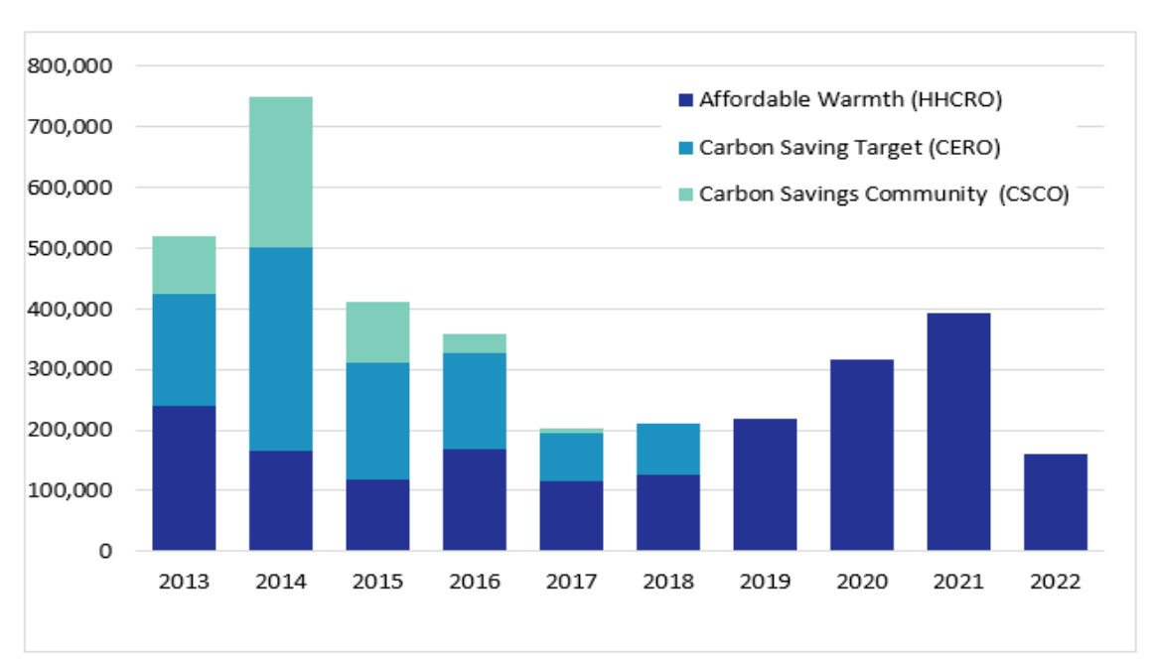
Figure 32 Department for Energy Security & Net Zero (2023)b
The above table shows the number of measures installed through different energy efficiency schemes. Note that the Carbon Emission Reduction Obligation (CERO) finished at the end of September 2018 and the Carbon Saving Communities (CSCO) finished at the end of March 2017. This shows that since 2019, the ECO scheme has been the primary method of subsidising energy efficient home improvement measures in Great Britain. It also shows that 2022 was the lowest year for total measures carried out.
By the end of 2021, a total of 1.86m measures had been installed, producing an estimated lifetime bill saving of £18.6 billion. Between January and March 2022, 90.5k measures were installed producing estimated savings of £659m.
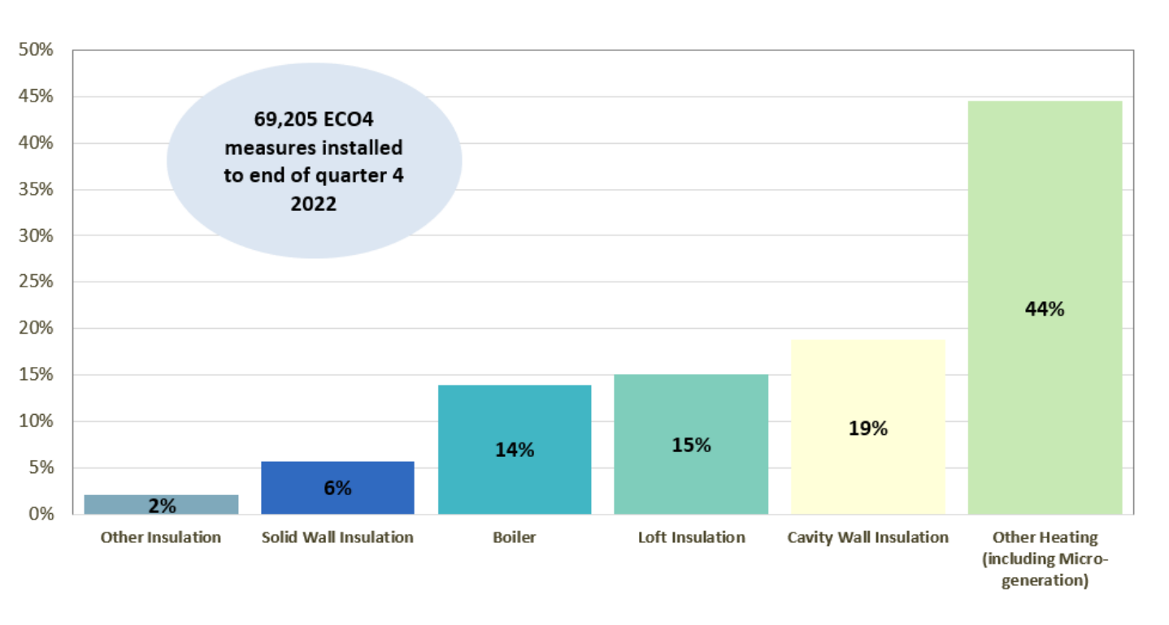
Figure 33 Department for Energy Security & Net Zero (2023)b
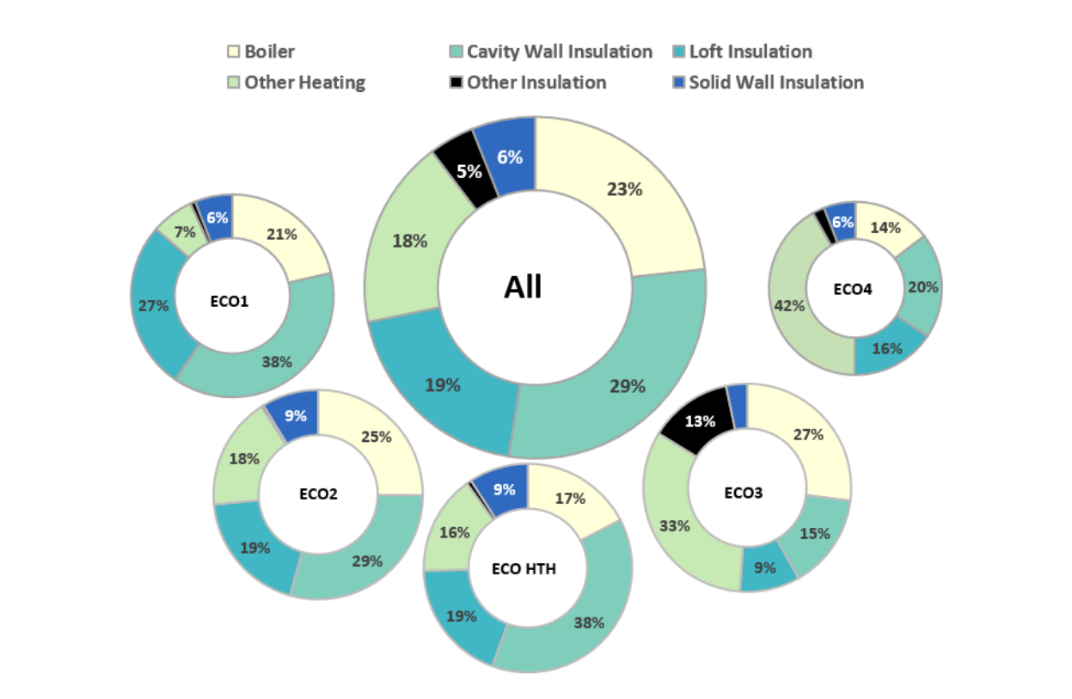
Figure 34
Both above images show installed measures by type and proportion. The first diagram shown a breakdown of all measures in ECO4, up to the end of the 4th quarter. The second diagram shows a breakdown from previous iterations of the ECO scheme since 2013. By the end of 2022, an estimated 14.8 million properties received cavity wall insulation (71% of the total properties which have cavities), 17 million have loft insulation (67% of houses with lofts) and 805,000 properties have external wall insulation (9% of properties with solid walls).

The following table shows estimated carbon and lifetime savings by measure type. Up to the end of 2022, of all ECO measure installed, 59% were insulation measures and 41% were heating. Under ECO4 the amount of heating measures has increased to 58%. This shows a trend in the data towards more boilers being installed, a trend which has been seen in other schemes throughout Wales and NI.
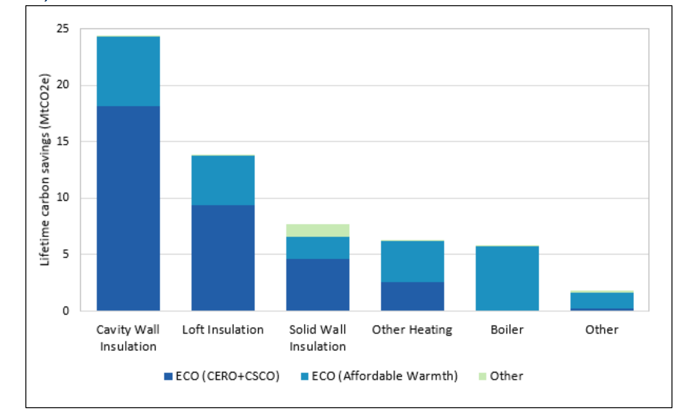
Figure 35 Department for Energy Security & Net Zero (2023)b

70% of properties which received measures were owner occupied (1.6m). In Wales there were 10,600 measures installed at properties for the overall ECO scheme equivalent to 5% of the whole scheme. This increased up to 7% for measures installed in 2022. This equates to 90 measures per 1000 households in Wales. The following image shows households in receipt of ECO measures per 1000 households by local authority. Map 3 in the appendices also shows the prevalence of boilers or other heating as the predominant measure in Wales.

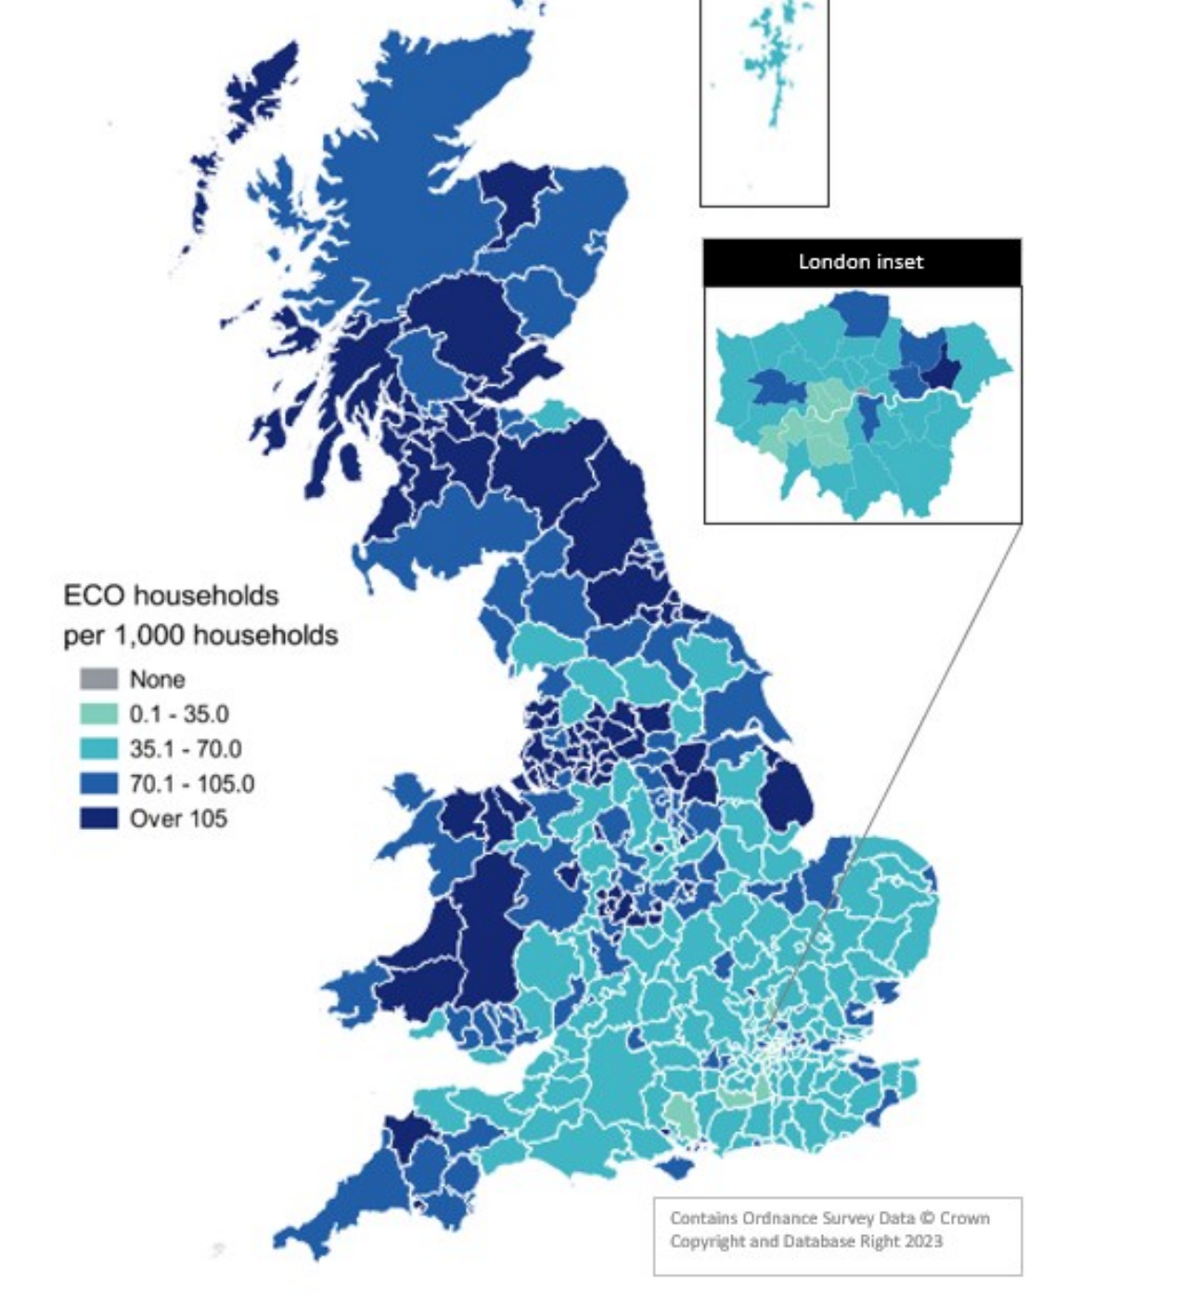
Figure 36 Department for Energy Security & Net Zero (2023)b

7.3.2 Key Findings for UK

During 2022 through retrofit and new builds the following data can be presented:
- 32,000 homes with cavity insulation through retrofit and 201,000 through new build making a total of 233,000.
- 24,000 homes retrofitted to include a minimum of 125mm loft insulation and 180,000 through new build, a total of 204,000 which is an increase of 1.2% between December 2021 and December 2022.
- 10,000 homes retrofitted with solid wall insulation, up 1.4% from December 2021 and December 2022.
By the end of 2022 Wales had a higher proportion of insulated cavity wall properties than England 76% compared to 69%. Bothe England and Wales had the same levels of loft insulation at 65% and Wales had lower levels of solid wall insulation at 7% to England’s 9%.
Since 2013, of all retrofit measures implemented, ECO is responsible for over 99% of cavity wall insulation, 96% of loft insulation and 76% of solid wall insulation in GB.
Delivery costs by the end of 2022 came to a total of £6,44 billion, made up of £5.9 billion plus £539 million in admin costs. There was a 35% reduction in delivery costs in 2022 compared to 2021. The following chart shows ECO costs by obligation, by year. At the end of the ECO3 phase (March 2022) the average cost of delivery was 24p per £1 of lifetime saving bills.

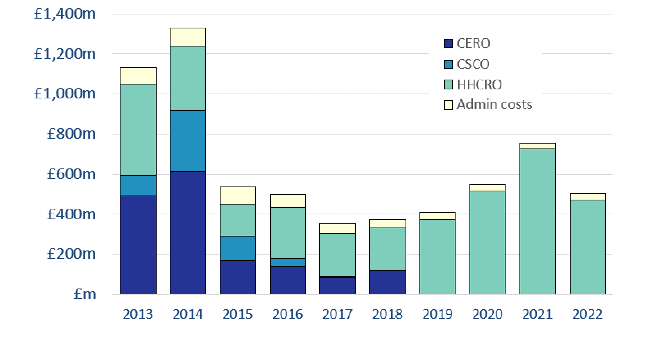
Figure 37 Department for Energy Security & Net Zero (2023)b

The following chart shows remaining potential properties for improvement works, specifically for different types of insulation. We can see that 71% of cavity walled properties have received insulation and 67% of lofts have insulation, the main area showing room for significant improvement is properties with solid walls.

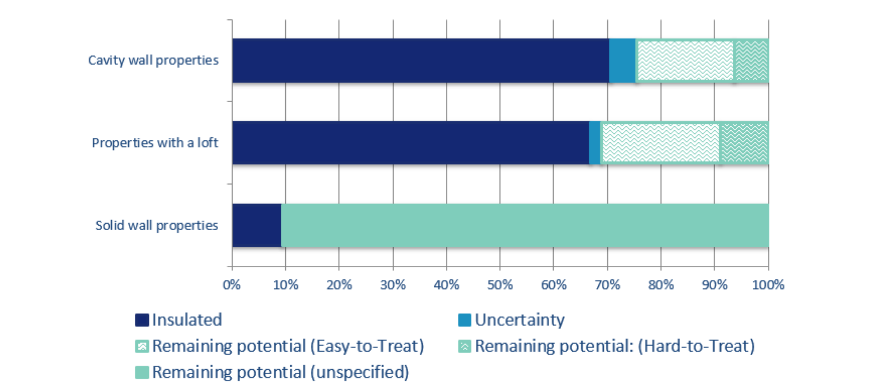
Figure 38 Department for Energy Security & Net Zero (2023)b

Solid walls can be insulated internally of externally, and estimated 7.7 million uninsulated solid walls remain (91% of solid wall houses). Reasons for less uptake of solid wall insulation can include listed properties or properties within conservation areas, making adaptation difficult or impossible and higher costs than other forms of insulation. Wales typically has more older homes than England, with 39% being built between 1930 and 1982, and only 5% being built after 2012. Wales also has 23% of its houses being built before 1900, Department for Energy Security & Net Zero (2023)b.

Chapter 8: Summary of Key Findings

For a critical evaluation and comparison of NI an Wales, the data used will be number of measures installed, number of properties and overall cost for the same periods. The sources of data will be from schemes carried out in each individual country and for Wales the data from the ECO scheme which covers GB will also be included. This will identify which scheme has been most successful from a fiscal perspective. After this, the socio economic factors will be considered an critiques of both schemes will be explored to identify positives and negatives from non-financial perspectives. This information will then be compared to the results of the primary research to determine whether the schemes reflect public interest and opinion and whether this could be a factor in public engagement with the schemes.
Northern Ireland – Figures taken for 2021/2022 from Home Energy Conservation Authority Annual Progress Report 2022 (HECA 2023).
- NIHE’s Affordable Warmth Scheme 2021/22:
The scheme implemented 4,585 improvements in 2,841 homes, with a total cost of £11.5m. To break this figure down, the works involved: installation of loft insulation in 395 homes, heating system improvements in 2,175 houses. New double glazed windows in 1,114 homes, cavity wall insulation in 320 homes, draught-proofing measure in 39 homes and solid wall insulation in 2 homes, HECA (2023).
- Boiler Replacement Scheme 2021/2022:
For the period 2021/22 the Boiler Replacement Scheme installed 2,092. The total cost for this was £1.3m, HECA (2023).
- Northern Ireland Sustainable Energy Programme (NISEP) 2021/2022:
In 2021/22, £7.6M of funding was used to implement energy efficient measures in houses including 1,747 loft insulation installations, 1,925 cavity wall insulation installations and 1,317 central heating systems (boiler replacements for gas and LPG), HECA (2023).

As illustrated below, in Northern Ireland the total figure for investment in 2021/2022 was £48.5 million. 12,400 measures were implemented as well as schemes like oil buying clubs and advice on energy saving measures.
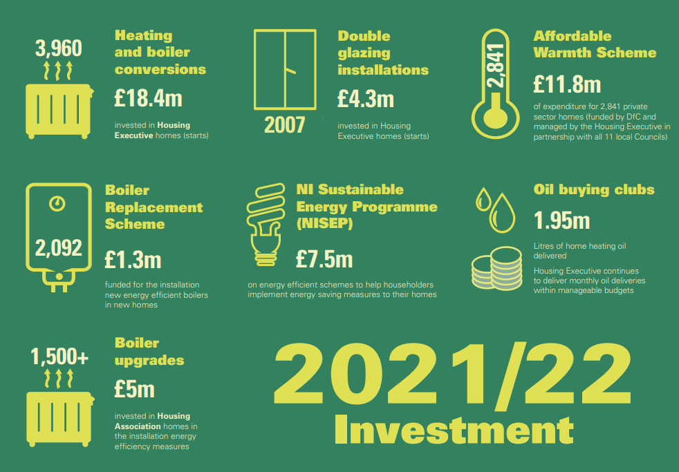
Figure 39 HECA (2023)
Wales – Figures taken for the 2021/2022 period from Nest Annual Report 2021-22, Nest (2022)
Under the NEST Scheme, for the 21-22 period, £24.5m of funding was provided leading to beneficial home improvement measures in more than 5127 homes. Based on the data a modelled average saving of £300 a year per household. 20.5% of those having previously been in severe fuel poverty, and 34.1% in fuel poverty, Nest (2022). Taking into account the free information and advice provided by the service, an additional 15,777 people have benefitted from the scheme. During this period 100% of installations were carried out by Welsh based installers, 15 new permanent jobs creates, 25 apprenticeships and 2 traineeships. The following illustration shows a breakdown of 91.7% receiving new central heating installation, 7.7% receiving loft insulation and 0.6% receiving solar PV.
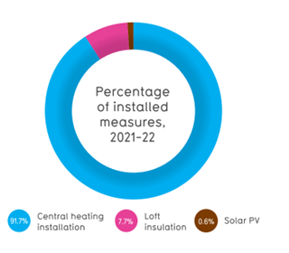
Figure 40
Arbed 3 was supported by the European Regional Development Fund (ERDF) and ran until 2021. It was an area based approach to tackling fuel poverty rather than Nests means tested approach, data for this scheme will not be included in the figures for comparison with NI as there is no 2021/2022 data due to the scheme not running.
ECO4 & ECO+ statistics for Wales for 2021/2022 show that up to the end of 2022 there were 10,600 measures installed at properties for the overall ECO scheme, equivalent to 5% of GB. This increased up to 7% for measures installed in 2022. This equates to 90 measures per 1000 households in Wales.
Delivery costs in 2022 as reported by suppliers was £471 million. There was a 35% reduction in delivery costs in 2022 compared to 2021. It is important to note that these are costs for England Wales and Scotland. By the end of March 2022, the average cost of delivery was 24 pence per pound of lifetime bill savings. If we use the 7% figure of measures used in Wales for 2022, we can estimate costs of £33 million as a proportion for Wales.
The total findings can be summarised in the following table.
2021/2022 | Northern Ireland | Wales - Nest + ECO
Measures | 12,400 | 15,727
Cost | £48.5 Million | £57.5 Million
Table 24
The figures are kept intentionally simple. Which can be misleading, as the type of measures, effectiveness and costs vary greatly. The precise breakdown of different measures and amounts is included in the Secondary Data sections of this document for each respective country.

Chapter 9: Conclusion

There have been various reviews of the schemes in Wales, Northern Ireland and across the UK. There have been internal reviews and external reviews carried out by third parties. These reviews aim to establish whether various criteria for success have been met and at what cost to the taxpayer.
A common idea, which was held by the author was that more funding would equal more measures. Of course efficient management and delivery is also key to minimise wastage. The dilemma with this approach is lack of budget. Without increased financial input, there couldn’t be increased implementation of energy efficient home improvement measures. The secondary data suggests this to an extent by showing that more measures have been caried out with more budget spent. In a review of the Nest scheme James (2022) acknowledges that more costly measures such as solar PV and heat pumps are the solution, but without increased budget, fewer properties could have them installed.
However this would be a very superficial observation to make, as the intricacies of the schemes and barriers to successful implementation are far more complex. In reviews of the schemes in Northern Ireland and Wales many authors point out there is too much reliance on fossil fuels. An easy solution is to replace an old inefficient gas boiler with a new, more efficient one. However, Crompton (2021) points out the majority of people in fuel poverty may not have a broken boiler so may not reach out to Nest meaning they don’t receive help. The data for both countries shows significant installations, but is this a truly sustainable solution when all new houses built after 2025 will have to use alternative heating systems, British Gas (2023). Will the millions of older houses still using gas boilers after 2025 the UK net zero 2050 target will be difficult to achieve.
From the data provided in the secondary research, there are very low numbers of solid wall insulation installations, there are huge amount of properties but easier, less costly measures have been implemented in the past, leaving large amounts of solid wall houses uninsulated. External wall insulation is less likely to create follow on issues like air source heat pumps might (and increasing trend of electric cars) which put more strain on the national grid and require further spending for improvements to cope with increasing electrical domestic usage. The key findings for Wales discussed the ramifications of an all (or mostly) electric domestic energy consumption and the barriers which would need to be overcome. A recent press release the Department for Energy Security & Net Zero (2023c) announced measures being put in place to increase grid capacity and encourage low carbon energy usage shows a glimpse of awareness by the Government of the work required to achieve net zero.
The secondary data for Wales and NI discuss the difficulty in raising awareness of the schemes, with results showing that it was mostly passed on by word of mouth, GSR (2022).
NEA (2019) recommend flexibility in installation of simpler methods for energy improvements. For example under the current schemes improved heating controls are only available for properties receiving full heating upgrades. Improvements such as room, radiator and hot water thermostats are proven energy saving measures which require minimal costs and installation.
Provisions for repairing boilers are also recommended. Currently funding is available for new boilers but not for those unable to afford repairs to a newer boiler. Also consideration and provision of extra work required where households have floorboards in lofts prohibiting insulation being installed.
For future improvements and achieving net zero the NEA recognise the importance of communication with the public and education with regards to energy efficiency, this will coincide with rising public interest and awareness due to climate change and rising energy costs. Stakeholder engagement events are key to communicating this information and clearly discussing how decarbonisation will be paid for.
The department for Energy Security & Net Zero (2023)b estimate that 7.7 million solid wall houses (91%) remain uninsulated and identify this demographic as a key target area for insulation under ECO. However they also recognise the reasons for less uptake of solid wall insulation including listed properties and properties within conservation areas.
A key finding of this work comes from the primary data. Based on the opinions of people who own or live in older houses in the UK, it shows it’s not just a case of increasing funding to carry out more measures. Cost is an issue but there is considerable public hesitation caused by lack of confidence in technologies. The long term running & maintenance costs of new technologies is a sticking point for many. Lack of confidence in quality, knowledge and expertise of installers especially regarding older and traditionally built homes and knowledge of what negative side effects these improvement measures may have. There is the opinion that a lot of installers chase Government grants with little consideration for long term impacts, coupled with cold calling and scams, much of the public has lost confidence in green schemes. Crompton (2021) points out that stricter contracts need to be in place to control funding released to contractors and stop them going for easier measures which pay well such as changing lightbulbs or tap aerators. In Wales, it is also worth mentioning that previous versions of Nest and Arbed schemes had issues with poorly installed systems causing damage or working inefficiently. This was remedied by using an independent organisation to test compliance and check quality. There is, however a backlog of properties still requiring inspection, which has been further impacted by the Covid pandemic.
There are plenty of lessons which can be learnt from mass uptake of inadequate cavity wall insulation which is now being removed after causing negative side effects to properties across the UK, BBC (2023). These kinds of stories emphasise the apprehension of a largo proportion of the general public in older houses. And yet retrofit cavity wall insulation is still being funded, 32,000 in 2022 through ECO4, Department for Energy Security & Net Zero (2023)b.
The primary data also helped highlight the scale of cold calling and green energy home improvement scams in the UK, creating more prejudice against new schemes. Lack of Government co-ordination and lack of definitive literature amongst conflicting media review of technologies and materials was shown in the primary data.
Whilst in NI 84% responded that it was easy or very easy to find a contractor to carry out the work. 11% stated that they required the Housing Executive’s help to find a contractor. Of that figure, 77% claimed they would have preferred the Housing Executive to manage the process on their behalf.
Finally the primary data reflected findings from the secondary data showing the eagerness of the public to have Government vetting and scrutinization of the schemes and scrutinization of contractors carrying out the work. There is a massive trust issue for people with older houses in the UK. This is what needs to be overcome before more money is made available in order to achieve significant results.

Reference list

Ancon, 2019 - Ancon Building Products. Published by The Construction Centre 2019. Accessed on: 1/2/22. Available from: https://www.theconstructioncentre.co.uk/companies/ancon-building-products/1043/
BPIE, 2011 - Europe's Buildings under the microscope. A country by country review of the energy performance of buildings. Buildings Performance Institute Europe (BPIE). 1 October 2011. ISBN 9789491143014
BRE 2020 - The Housing Stock of the United Kingdom. BRE Trust. Published February 2020. Accessed on 1/3/23. Available from: https://files.bregroup.com/bretrust/The-Housing-Stock-of-the-United-Kingdom_Report_BRE-Trust.pdf
British Gas, 2023 - What does the gas boiler ban mean for me and my home? British Gas. Published November 2023. Accessed on 1/2/24. Available from: https://www.britishgas.co.uk/the-source/greener-living/gas-boilers-ban-2025.html
BBC, 2023 - 'Government insulation scheme ruined my home'. BBC. Published 11th May 2023. Accessed on 10/2/24. Available from: https://www.bbc.co.uk/news/uk-scotland-glasgow-west-65543897
Cadw, 2019 - Understanding Traditional (pre-1919) and Historic Buildings for Construction and Built Environment Courses. Cadw and Historic England. Published July 1st 2019. Accessed on 1/11/23. Available from: https://cadw.gov.wales/sites/default/files/2021-02/Teaching%20resources%20-%20Understanding%20traditional%20%28pre-1919%29%20and%20Historic%20buildings.pdf
Citizens Advice, 2021 - 19 million targeted by a green scam - here are five top tips on staying safe when making your home more energy efficient. Citizens Advice. Accessed on 2/11/23. Available From: https://www.citizensadvice.org.uk/about-us/about-us1/media/press-releases/19-million-targeted-by-a-green-scam-here-are-five-top-tips-on-staying-safe-when-making-your-home-more-energy-efficient/
Clark, C. 2023 - Gross domestic product per capita of the United Kingdom from 1999 to 2021, by country (in GBP). Statista. Accessed on 1/12/23. Available From: https://www.statista.com/statistics/478754/gdp-per-capita-uk-by-country/#:~:text=In%202021%2C%20the%20gross%20domestic,and%2025%2C399%20in%20Northern%20Ireland.
Committee on Climate Change 2019 - UK housing: Fit for the future? Committee on Climate Change. Published February 2019. Accessed on 12/2/22. Available from: https://www.theccc.org.uk/wp-content/uploads/2019/02/UK-housing-Fit-for-the-future-CCC-2019.pdf
Consumer Rights 2023 - Government’s Role in Promoting Energy Efficiency in the UK. Consumer rights. Published 17th August 2023. Accessed on 1/12/23. Available from: https://consumer-rights.org/news/the-role-of-government-in-promoting-energy-efficiency-in-the-uk/
Cook & Co 2023 - REGIONAL PROPERTY MARKET UPDATE SPRING 2023: NORTHERN IRELAND. Cook & Co. Accessed on 2/2/23. Available From: https://www.cooke-and.co.uk/blog-box-view/1454924560/1678993068/regional-property-market-update-spring-2023-northern-ireland?from_page=%2Fblog&post_width=full_width#:~:text=Nearly%20500%2C000%20of%20the%20of,England%20and%20Wales%20(61.6%25).
Crompton, A. 2021 - The Welsh Government’s Warm Homes Programme. Report of the Auditor General for Wales. Audit Wales. Accessed on: 5/10/23. Available from: https://business.senedd.wales/documents/s122214/The%20Welsh%20Governments%20Warm%20Homes%20Programme%20-%20A%20report%20by%20the%20Auditor%20General%20for%20Wales.pdf
DAERA, 2023 - Northern Ireland Greenhouse Gas inventory 1990-2021 statistical bulletin. Department of Agriculture, Environment and Rural Affairs. Accessed on 12/8/23. Available from: https://www.daera-ni.gov.uk/publications/northern-ireland-greenhouse-gas-inventory-1990-2021-statistical-bulletin
DfBE&IS 2021 - Energy Consumption in the UK (ECUK) 1970 to 2020. Department for Business, Energy & Industrial Strategy. Published 30th September 2021. Accessed on 1/12/23. Available from: https://assets.publishing.service.gov.uk/media/62334e14d3bf7f047bfa92b0/Energy_Consumption_in_the_UK_2021.pdf
Department for Energy Security & Net Zero, 2023a - Energy Company Obligation Great British Insulation Scheme (2023-2026) & Amendments to ECO4 regulations. Government Response. Accessed on 3/12/23. Available From: https://assets.publishing.service.gov.uk/media/6442796d22ef3b000f66f695/gb-insulation-scheme-government-response.pdf
Department for Energy Security & Net Zero 2023b – Household Energy Efficiency. Statistical Release 30 March 2023. Accessed on 12/12/23. Available from: https://assets.publishing.service.gov.uk/media/64230bbd3d885d000cdadd20/HEE_Stats_Detailed_Release_-_Mar_23.pdf
Department for Energy Security & Net Zero, 2023c - Huge boost for UK green industries with £960 million government investment and major reform of power network. Press Release 23rd November 2023. Accessed on 12/2/24. Available from: https://www.gov.uk/government/news/huge-boost-for-uk-green-industries-with-960-million-government-investment-and-major-reform-of-power-network
Dodd, T. 2013 - Nearly everyone hates ECO – but how else can we make houses more energy efficient? Carbon Brief. Published October 10 2013. Accessed on: 24/2/22. Available from: https://www.carbonbrief.org/nearly-everyone-hates-eco-but-how-else-can-we-make-houses-more-energy-efficient
Elsharkawy, H. and Rutherford, P., 2018. Energy-efficient retrofit of social housing in the UK: Lessons learned from a Community Energy Saving Programme (CESP) in Nottingham. Accessed on: 12/8/23. Available From: https://repository.uel.ac.uk/download/0de953cbe4b37ac354bc8526e002afa75926b78ec9ffa095a5769a0e6918e274/835958/ENB_2018_575%20Full%20manuscript.pdf
Energy UK 2024 - New polling reveals the barriers people face to improve energy efficiency and bring down bills. Energy UK. Published 2nd February 2024. Accessed on 5/2/24. Available from: https://www.energy-uk.org.uk/news/new-polling-reveals-the-barriers-people-face-to-improve-energy-efficiency-and-bring-down-bills/#:~:text=Financing%20energy%20efficiency%20improvements%20was,not%20worth%20the%20upfront%20investment.
Energy Saving Trust 2022 Welsh Government Warm Homes Nest scheme. The Energy Saving Trust. Published 28 February 2022. Accessed on 14/3/22. Available from: https://energysavingtrust.org.uk/programme/welsh-government-nest-scheme/
FMB, 2022 - 0% VAT measures on energy efficiency installation – what this all means. Federation of Master Builders. Published 14th April 2022. Accessed on: 12/1/24. Available from: https://www.fmb.org.uk/resource/0-vat-measures-on-energy-efficiency-installation-what-this-all-means.html

Gillich, A., Sunikka-Blank, M., Ford, A., 2018. Designing an ‘optimal’ domestic retrofit programme, Building Research and Information. Accessed on 12/8/23. Available From: https://openresearch.lsbu.ac.uk/item/86x92
Gov.UK, 2022 - The Value Added Tax (Installation of Energy-Saving Materials) Order 2022. HM Revenues & Customs. Published 23rd March 2022. Accessed on: 12/12/23. Available from: https://www.gov.uk/government/publications/changes-to-the-vat-treatment-of-the-installation-of-energy-saving-materials-in-in-great-britain/the-value-added-tax-installation-of-energy-saving-materials-order-2022
Gov.UK, 2023 - Help from your energy supplier: the Energy Company Obligation. Gov.UK. Accessed on: 12/4/23. Available From: https://www.gov.uk/energy-company-obligation/eligibility
Gov.Wales, 2023 - Housing in Wales (Census 2021) Welsh Government. Accessed on: 12/3/23. Available From: https://www.gov.wales/housing-wales-census-2021-html
GSR 2015 – Government Social Research. Evaluation of the Nest energy efficiency scheme. Miller Research (UK) Ltd. Brook Lyndhurst Ltd. Accessed on: 5/9/23. Available from: https://www.gov.wales/sites/default/files/statistics-and-research/2019-07/150310-evaluation-nest-energy-efficiency-scheme-en.pdf
GSR 2022 - Government Social Research. Evaluation of Arbed 3: Final Report. Miller Research (UK) Ltd. Accessed on: 2/8/23. Available from: https://www.gov.wales/sites/default/files/statistics-and-research/2022-02/evaluation-of-arbed-3.pdf
Harrabin, R. 2017 UK 'must insulate 25 million homes. BBC. Published 28 February 2017. Accessed on: 2/3/22. Available from: https://www.bbc.co.uk/news/business-39107973
Harvey, F. 2021 UK government scraps green homes grant after six months. The Guardian. Published 27 March 2021. Accessed on: 15/2/22. Available from: https://www.theguardian.com/environment/2021/mar/27/uk-government-scraps-green-homes-grant-after-six-months
HECA 2023 - Home Energy Conservation Authority Progress Report. HECA. Published: 30/3/23. Accessed on: 2/10/23. Available From: https://www.nihe.gov.uk/home/news/heca-progress-report-2022
Historic Doors, 2017 Homes in England and Wales by Construction Period. Published by Historic Doors April 3, 2017. Accessed on: 2/2/22. Available from: http://www.historicdoors.co.uk/blog/englands-building-age-infographic/
House of Commons 2021 - Green Homes Grant Voucher Scheme. Published on 1 December 2021 by authority of the House of Commons. Accessed on: 10/2/22. Available from: https://committees.parliament.uk/publications/8007/documents/82623/default/
Housing Executive 2020 - Affordable warmth Customer Satisfaction Survey 2019. Housing Executive of Northern Ireland. Accessed on 2/9/23. Available From: https://www.nihe.gov.uk/getattachment/5e78f576-bb3c-4a79-919d-771f4930da03/Affordable-Warmth-Customer-Satisfaction-Survey-report-2019.pdf
ICO 2022 - ICO fines four firms targeting people with home improvement predatory marketing calls. Information Commissioners Office. Published 3rd October 2022. Accessed on: 1/11/23. Available from: https://ico.org.uk/about-the-ico/media-centre/news-and-blogs/2022/10/ico-fines-four-firms-targeting-people-with-home-improvement-predatory-marketing-calls/
Ingrams, S. 2023 - Energy grants for your home. Which? Accessed on: 2/3/23. Available From: https://www.which.co.uk/reviews/home-grants/article/government-energy-grants-for-your-home-avOaP8E1ZGdx
Imperial College London 2019 - Accelerated Electrification and the GB electricity system. Imperial College London. Accessed on 3/7/23. Available from: https://www.theccc.org.uk/wp-content/uploads/2019/05/CCC-Accelerated-Electrification-Vivid-Economics-Imperial-1.pdf
James, J. 2022 - Welsh Parliament Plenary, 8th of August 2022. Accessed on: 10/7/23. Available from: https://record.assembly.wales/Plenary/13043#A75660
Kingspan, 2016 Cavity walls: The past. Kingspan Insulation UK. Published 13 June 2016. Accessed on: 18/2/22. Available from: https://www.kingspan.com/gb/en-gb/products/insulation-boards/insulation-technical-hub/articles-and-advice/cavity-walls-the-past
McKenzie, et al 2018 - A Health Impact Analysis of the Affordable Warmth Programme: 2014-2018. Ulster University. Accessed on: 12/10/23. Available From: https://www.google.com/url?sa=t&rct=j&q=&esrc=s&source=web&cd=&ved=2ahUKEwi2ubO9-LaCAxVnXUEAHY3CD40QFnoECCEQAQ&url=https%3A%2F%2Fwww.shu.ac.uk%2F-%2Fmedia%2Fhome%2Fresearch%2Fcresr%2Freports%2Fh%2Fhealth-impact-assessment-affordable-warmth-programme.pdf&usg=AOvVaw0wWQJ0b6icblSxGnhPMZEM&opi=89978449
MCS, 2023 - Government removes VAT for Heat Pumps and Battery Storage. Microgeneration Certification Scheme. Published 13th December 2023. Accessed on: 10/1/24. Available from: https://mcscertified.com/government-removes-vat-for-heat-pumps-and-battery-storage/#:~:text=In%20response%20to%20the%20findings,Water%2DSource%20Heat%20Pumps
NatWest 2023 - Greener Homes Attitude Tracker 2023. NatWest. Published July 2023. Accessed on 1/2/24. Available from: https://www.natwestgroup.com/news-and-insights/latest-stories/climate/2023/aug/homeowners-plan-greener-home-improvements-but-high-costs-remain-.html
National Statistics, 2016 English housing survey 2014 to 2015: housing stock report. Ministry of Housing, Communities & Local Government. Published 21 July, 2016. Accessed on 25/1/22. Available from:https://www.gov.uk/government/statistics/english-housing-survey-2014-to-2015-housing-stock-report
NEA 2019 - Response to the Utility Regulator, Review of the Northern Ireland Sustainable Energy Programme (NISEP) & Energy Efficiency Provision. National Energy Action NI. Accessed on: 10/9/23. Available From: https://www.nea.org.uk/wp-content/uploads/2020/11/NEA-NI-Response-to-Review-of-NISEP-EEP.pdf
Nest 2022 - Nest Annual Report. Nest. Accessed on: 1/8/23. Available from: https://nest.gov.wales/wp-content/uploads/2023/01/Nest-annual-report-2022-ENGLISH-Interactive-1.pdf
Nest 2023 - Helping you make your home warmer and more energy efficient. Nest Website. Accessed on 2/1/23. Available from: https://nest.gov.wales/
Ofgem 2022 - Energy Company Obligation (ECO). Ofgem. Accessed on 1/3/23. Available From: https://www.ofgem.gov.uk/environmental-and-social-schemes/energy-company-obligation-eco
ONS 2022 - Population estimates for the UK, England, Wales, Scotland and Northern Ireland: mid-2021. The Office for National Statistics. Accessed on 1/4/23. Available from: https://www.ons.gov.uk/peoplepopulationandcommunity/populationandmigration/populationestimates/bulletins/annualmidyearpopulationestimates/mid2021
ONS 2022b - Age of the property is the biggest single factor in energy efficiency of homes. The Office for National Statistics. Published January 6th 2022. Accessed on 5/12/23. Available from: https://www.ons.gov.uk/peoplepopulationandcommunity/housing/articles/ageofthepropertyisthebiggestsinglefactorinenergyefficiencyofhomes/2021-11-01#:~:text=In%20Wales%2C%2039%25%20of%20homes,before%201900%2C%20at%2023%25.
Preece, R 2021 - Heat pumps: UK to install 600,000 a year by 2028 but electrical grid will need massive investment to cope. The Conversation. Accessed on 2/11/22. Available from: https://theconversation.com/heat-pumps-uk-to-install-600-000-a-year-by-2028-but-electrical-grid-will-need-massive-investment-to-cope-168221#:~:text=If%20everyone%20were%20to%20use,to%20handle%20the%20power%20demand.&text=The%20grid%20is%20built%20on,electric%20showers%20at%20different%20times.
Punjwani, M. 2018 The Green Deal explained. Money Supermarket. Published 15 February 2018. Accessed on 18/2/22. Available from: https://www.moneysupermarket.com/gas-and-electricity/the-green-deal-explained/
RIBA 2020 - Pandemic reveals demand for UK home transformations. Royal Institute of British Architects. Published 8th October 2020. Accessed on: 1/12/23. Available from: https://www.architecture.com/knowledge-and-resources/knowledge-landing-page/pandemic-reveals-demand-for-uk-home-transformations
Rubenstein, W.D. 2003 - Twentieth-Century Britain: A Political History. William D. Rubinstein. Published by Palgrave 2003. ISBN 9780230629134.
Scottish Government 2022 - Housing Statistics 2020 & 2021: Key Trends Summary. Scottish Government. Accessed on: 1/2/23. Available From: https://www.gov.scot/publications/housing-statistics-2020-2021-key-trends-summary/pages/6/
Stabler, L. 2020 Devolution and heat decarbonisation: Lessons from Europe. UK Energy Research Centre. Published July 01 2020. Accessed on: 13/2/22. Available From: https://ukerc.ac.uk/news/devolution-and-heat-decarbonisation-lessons-from-europe/
Statista, 2022 Age of houses in England in 2020, by tenure. Published by Statista Research Department. Published Feb 4, 2022. Accessed on: 10/2//22. Available from: https://www.statista.com/statistics/292252/age-of-housing-dwellings-in-england-uk-by-tenuree/
Statista, 2023 - Share of owner occupied households in England from 2000 to 2022. Statista. Accessed on 11/12/23. Available From: https://www.statista.com/statistics/286503/england-propportion-of-owner-occupied-households/#:~:text=The%20proportion%20of%20households%20occupied,million%20households%20in%20that%20year.
UWE, 2009 - Evolution of Building Elements. University of the West of England. Published 2009. Accessed on: 25/1/22 Available from: https://fet.uwe.ac.uk/conweb/house_ages/elements/section2.htm
UK Government 2014 Applications to the Green Deal Home Improvement Fund close. Department of Energy & Climate Change. Published 24 July 2014. Accessed on: 22/2/22. Available from: https://www.gov.uk/government/news/applications-to-the-green-deal-home-improvement-fund-close
UK Parliament 2020 - Home insulation and the net zero target. House of Lords Library. Emily Haves. Published 17 June, 2020. Accessed on: 1/3/22. Available from: https://lordslibrary.parliament.uk/home-insulation-and-the-net-zero-target/
UKGBC 2021 - UKGBC responds to CCC Report to Parliament. The UK Green Building Council. Published June 24, 2021. Accessed on: 5/3/22. Available from: https://www.ukgbc.org/news/ukgbc-responds-to-ccc-report-to-parliament-2/
Vaughan, A. 2015 - Government kills off flagship green deal for home insulation. The Guardian. Published 23rd July 2015. Accessed on: 2/12/23. Available from: https://www.theguardian.com/environment/2015/jul/23/uk-ceases-financing-of-green-deal

Walker, R., Liddell, C., McKenzie, P. and Morris, C. 2013. Evaluating fuel poverty policy in Northern Ireland using a geographic approach. Accessed on: 22/8/23. Available from: https://www.sciencedirect.com/science/article/pii/S0301421513008513
Welsh Government 2021a - No more fossil fuels to heat new homes. Welsh Government. Published 17 August 2021. Accessed on: 12/3/22. Available from: https://gov.wales/welsh-government-no-more-fossil-fuels-heat-new-homes
Welsh Government 2021b - £150 million for insulation, clean energy and carbon reduction in social homes. Welsh Government. Published 2 November 2021. Accessed on: 2/3/22. Available from: https://gov.wales/150-million-insulation-clean-energy-and-carbon-reduction-social-homes
Welsh Government 2023 - Next iteration of the Warm Homes Programme: review and recommendations report. Welsh Government. Accessed on 20/7/23. Available from: https://www.gov.wales/next-iteration-warm-homes-programme-

Appendices
Section1

Questionnaire

This questionnaire is about funding that Governments could offer to help homeowners improve the performance of their older homes, to lower energy usage, save money and lower carbon consumption.

- Are you a homeowner?

- Which part of the UK are you. Northern Ireland, Wales, Scotland or England?

- On a scale of 1-10 (1 being lowest) taking into account the environment and the economy, how important is it that people are able to make their homes more energy efficient?

- Have you used any Government financial support for improving the energy performance of private houses?

- Do you think it’s the Governments responsibility to provide financial help for private homeowners to improve the energy performance of a house?

- Do you think financial help should only be given to those who meet strict criteria or should it be available to all people?

- Should Government play a role in vetting/overseeing refurbishment work and stipulating pre-approved builders?

- If given the choice of non-repayable grants vs interest free loans, which do you think is more likely to encourage a private homeowner to improve the energy efficiency of their house?

- Do you think that removing VAT on energy saving refurbishment work/materials is a suitable option?

- In general, what barriers do you see to the public uptake of energy efficient refurbishments?

Section 2

Question 10: I general, what barriers do you see to the public uptake of energy efficient home improvements.

Answers:

Awareness. Knowledge of technology and materials available to suit an older house
Cost and convenience
Cost and what is available
Apathy
Financial cost
Initial cost of getting it sorted and fear of not knowing what it is, how it works and who to trust with the job
Mainly cost.
Money affordability
Getting someone to do it. Affordability Reliability of alternatives Suitability and integration
Apathy
Finding a qualified and reliable person to undertake the work in some parts of the UK could be a challenge if everyone wanted to have their homes refurbished. Lack of clear messaging about what would be of benefit to homeowners is an issue - there are different stories in the press about the efficiency of heat pumps for example.
Cost, especially at the moment with the cost of living
Cost
Laziness
Cost
Cost
Cost, time taken to recoup expenditure
To high a cost at first outlay.
Financial costs
Affordability
Complacency and lack of reliable information. I followed a link on the government website only to be warned that the site was not trustworthy and might ‘steal’ my data.
Cost of installation always the biggest barrier. Current limitations of grant eligibility make improvements impossible for middle income (no benefits) earning households. Cost of living rises mean there is no 'spare' funds to save for renovations. Even if these are essential, it is impossible.
Not sustainable and too costly to tax payers
The high costs.
Some older properties are unsuitable for refurbishment, eg cavity wall insulation, listed building
Trusting the companies
Lack of money
Knowledge of availability of schemes and general apathy, i.e having climate change rammed down their throat. Focus on the benefit to the homeowner
Will "energy efficiency" reqlly save money in the long term?
Cost Difficulty using heat pumps in old stone buildings or flats
cold calling phone calls saying it is govt backed - can’t verify who people are offering services
No available funds
Lack of Funding
Apathy amongst the public.
Cost, value for money
Overall cost of living being too high and wages not matching it.
Reliability, cost, cost of maintenance, future proof, and no sneaky taxes.
Inability to organise the work needed .
A lack of scientific based advice relevant to different forms of construction
The Goverment
Q 6 - for me I think it is not up to the taxpayer (government doesn’t have money it just distributes your tax money) to fund private homes whether listed or not. Perhaps a third option on the question as it doesn’t allow a blank. Grants, loans etc may assist but usually have caveats on what method/materials are used which is often inappropriate (spray foam insulation is just one that springs to mind) for older properties. Removal of VAT would be most attractive.
It’s difficult to apply for and you don’t get a choice of what materials are used, which for old houses can be very problematic.
None
Planning consent and guidance for old properties
Many listed buildings cannot be made more energy efficient. We should not be penalised for living in a historic building because it’s not energy efficient (eg. Mortgages etc)
Poor choice of eco energy options, coupled with ridiculous costs of insulation and boilers/pumps. Even with grants its still costly and there is zero quality in the workmanship of insulation fitting and heat pump installations even if they are feasible. Cheaper electric would be a huge benefit rather than government investment requiring immediate payback in the form of higher eco generated electric prices. Interest free loans are only going to serve a forced installation of eco energy regardless of its suitability and running costs.
X
Dealing with all thr information and companies. Should be just one or two big enough to deal either it all. Too many forms, then fielding the phonecalls.
Cost
Lack of knowledge, lack of information, lack of understanding that retrofit/energy works need to look at the whole house rather than piecemeal, lack of knowledge to stand up against overselling of inappropriate products/techniques/materials (particularly UPVC), misguided assumption that it has to be expensive rather than simple energy saving fixes like draught proofing, thick curtains, secondary glazing
The fact that most aren’t really designed for old houses. Work well for new builds but not the complexities of differing old homes.
The crap that the agencies spill out over the phone and the dodgy companies that are ‘selling’ it
Inappropriate materials/options for traditional properties
Cost (high capital outlay; long payback periods etc) Low public awareness of suitable options, particularly for period homes Lack of knowledgeable advisors / trades who can advise on suitable energy efficiency measures for period homes Government grants seemingly randomly assigned, encouraging use of inappropriate interventions for period homes (ie choice based on the grant / financial incentive rather than what is appropriate for a period home)
Not knowing what is available
Poor understanding of retrofit measures, their suitability and effectiveness among providers of information, resulting in conflicting information and confusion
People don’t generally understand what they need to do. I have insulated lofts for numerous family members but if I had not considered it then they wouldn’t have considered it. Government supported schemes always results in the cost being artificially inflated and poor quality work. Our loft had been insulated by the previous owner under a government scheme. The insulation had been installed across as opposed to between the joists and as a result was entirely pointless.
Availability of certified companies, pay back times.
The barriers I had left me feeling that the whole scheme is simply a con for quickly formed companies to make money on 'surveys'. Twice I've been promised help with insulation and twice it hasn't happened. First time through my local councils scheme. Second time through ECO 4
Appointed companies do not understand old buildings. Most offers are one size fits all and are not suitable for old and especially listed buildings. The solutions offered often cause dampness and mould as materials do not breathe.
The grants are unsuitable for heritage / traditional / listed buildings as they don't cover things like secondary glazing, insulating lime plaster, wood fibre boards and sheep's wool etc. VAT should be removed on all energy saving products for this category of building. EPC assessors should learn the difference and be able to assess these materials as part of an EPC assessment.
Cost/cash flow
Cost is the usual reason why people won't make the necessary changes. If we need fast action (which we do) there will need to be grants available, otherwise people will put any changes off until they are desperate and have no choice. We don't have the luxury of that amount of time.
Public understanding of effectiveness and running costs eg heat pumps in old houses not more efficient generally
Most ideas aren’t suitable for old or listed buildings…and permission wouldn’t be given anyway. Income limits are currently too low to encourage take up of the grants. Many so-called specialist providers are cowboys. Long-term benefits are unknown.
Insufficient government budgets to fund environmentally friendly improvements.
Too much new technology and not enough guidance for the average person on which is best and most cost effective.

Section 3
Survey Responses by grouping

Reason | Number of Responses
Cost / Affordability | 40
Apathy / Laziness | 5
Lack of information | 15
Trust in methods or installers | 13
Building unsuitability | 11
Value for money | 5
Reliability & maintenance issues | 3
Barriers in application process | 4
None | 1

Section 4
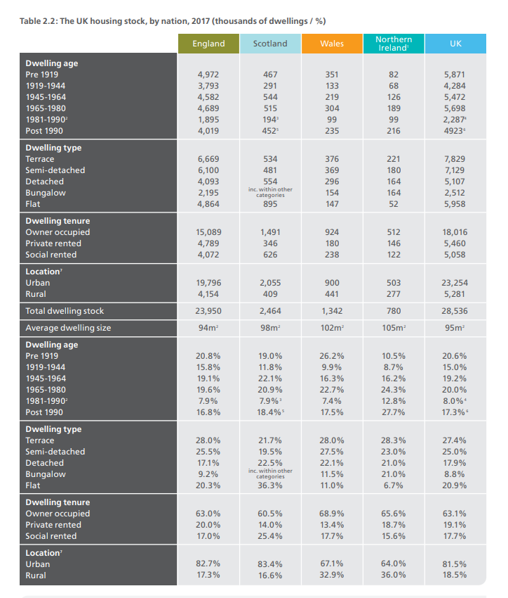

Section 5
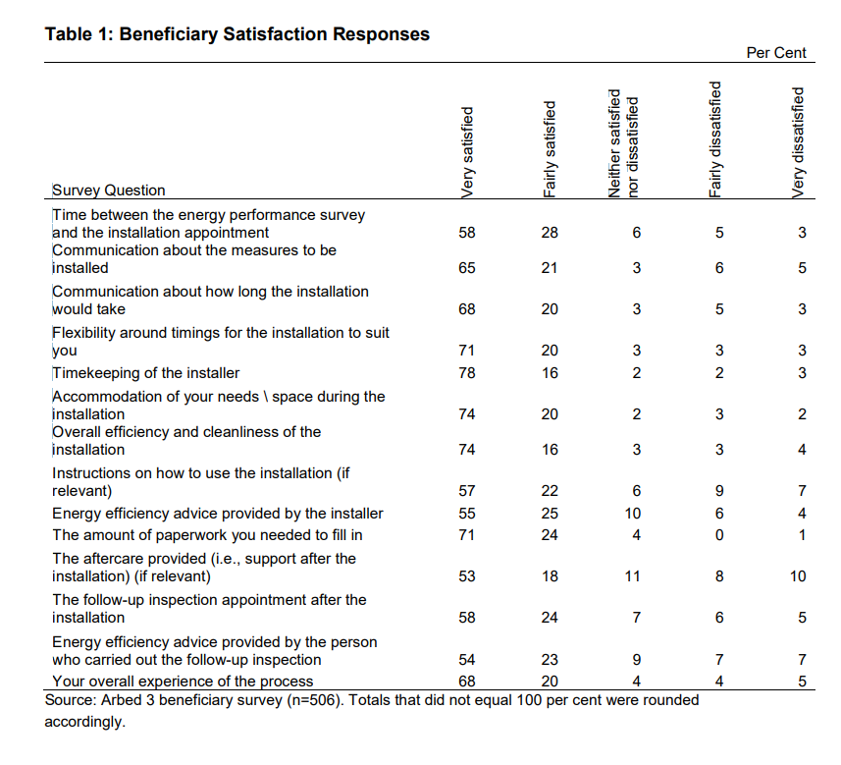

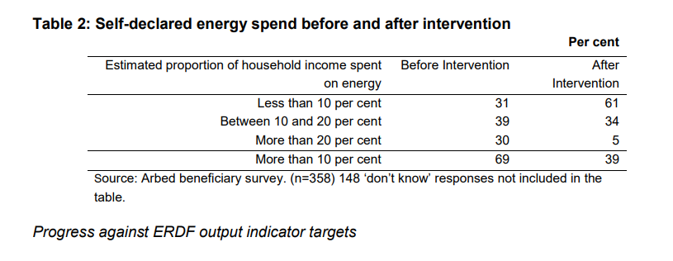

Section 6
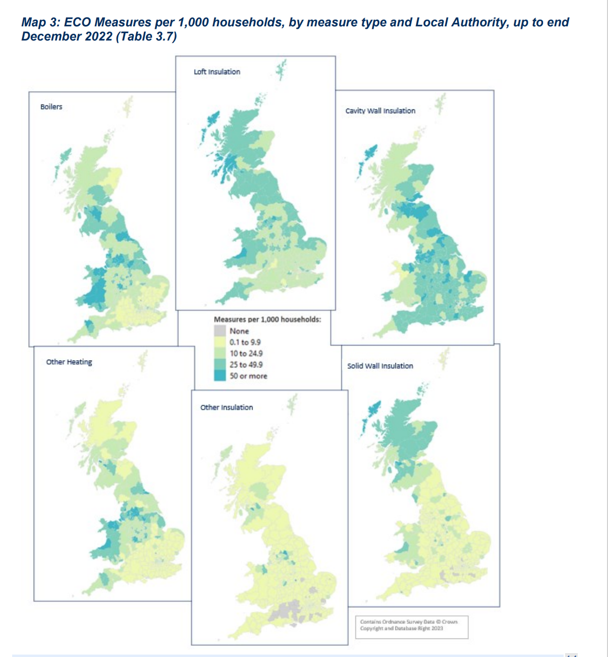

Section 7

Social Media Groups used for survey: Red denotes the post was declined by admins. Green was allowed.

House Extensions, loft conversions and Renovations UK – 146k Members
Everything Construction Ireland – 5.7k Members
Ireland Self Build & Renovation Deals – 5.1k Members
Home Improvements in Northern Ireland – 239 Members
DIY Home Improvements On a Budget UK – 35k Members
DIY On a Budget UK – 105k Members
UK DIY, Interior and Exterior, Help, Advice and Chat – 21k Members
Your Old House UK – Repair and Conservation – 13k members
Home Extensions & Renovations UK – 2.5k Members
DIY Home Projects (Remodelling, Renovation & Construction) – 471k Members
Renovations and Home Improvements Tips And Ideas – 21k Members
Home Building + Renovations UK + Ireland – 1k Members
HOUSE RENOVATION UK – 18 Members
Home Renovation Tips & Advice UK – 9.5k Members
Renovation Projects UK – 478 Members
Building & Construction UK – 34k Members
LinkedIn

