Ensure you have a suitable environment open, and that you have a working instance of Jupyter Notebook.

- Open Anaconda Navigator and ensure you are in the environment that you set up. Click ‘Launch’ on the Jupyter Notebook tab.


- Once the Jupyter Notebook tab opens in a browser window, choose ‘New’ and in the dropdown menu choose ‘Python 3 (ipykernel)’.
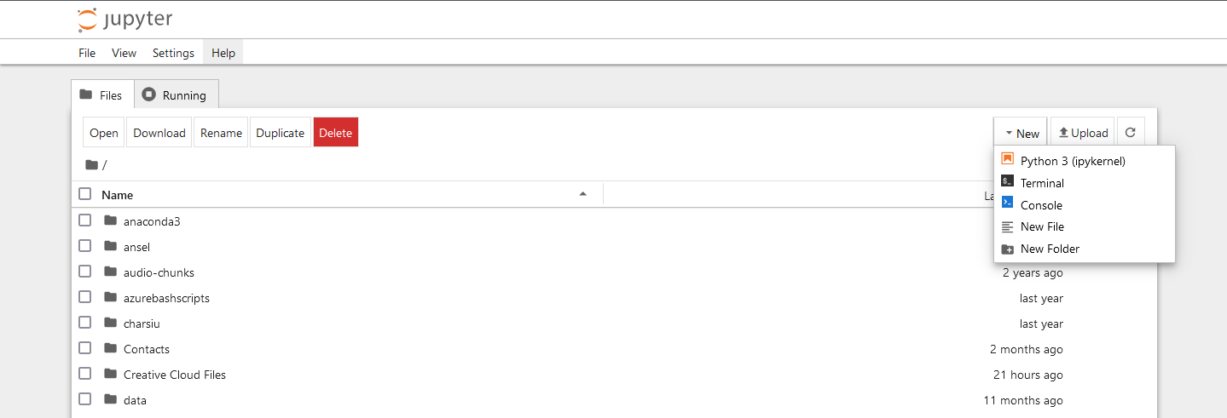

- Once a notebook window is opened, you can start coding. Ensure ALL CODE is typed from the GREYED CELL in the images.
Firstly import the packages you will need. For this tutorial you will need:
  - Numpy
  - Pandas
  - seaborn
  - train_test_split (from skleanr.model_selection)
  - DecisionTreeClassifier (from sklearn.tree) one of the many tree algorithms.
  - Metrics (from sklearn)
  - tree (from sklearn), although we are importing DecisionTreeClassifier so may not be necessary. We will use this to plot the tree.
Numpy, Pandas, Seaborn and matplotlib.pyplot (see next step) will be imported using an alias (a variable to use in stead of the full name). This will be quite common with several packages. Importing packages will always be the first step. Once you have coded a cell in Notebook, you will need to click the ‘run’ button to run that cell (looks like a play button, see below).

# Import dependencies and packages needed from sklearn import datasets
import numpy as np
import pandas as pd
import seaborn as sn
from sklearn.model_selection import train_test_split
from sklearn.tree import DecisionTreeClassifier
from sklearn import metrics
from sklearn import tree

- For this notebook, we will use ‘%matplotlib inline’. This sets the notebook backend to inline and allows plots to be rendered in the notebook following the code (see top of code cell). We will also import matplotlib and matplotlib.pyplot. Further to this we will set a numpy random seed which will stabalise the notebook’s performance across the runs.
# to make this notebook's output stable across runs
np.random.seed(42)

# To plot pretty figures
%matplotlib inline
import matplotlib
import matplotlib.pyplot as plt

- We will also set some parameters for plotting with pyplot to visualise the trees. Run the cell with steps 3 to 5.
plt.rcParams['axes.labelsize'] = 14
plt.rcParams['xtick.labelsize'] = 12
plt.rcParams['ytick.labelsize'] = 12

- As a note, remember you can name your notebook to be saved for later reference.

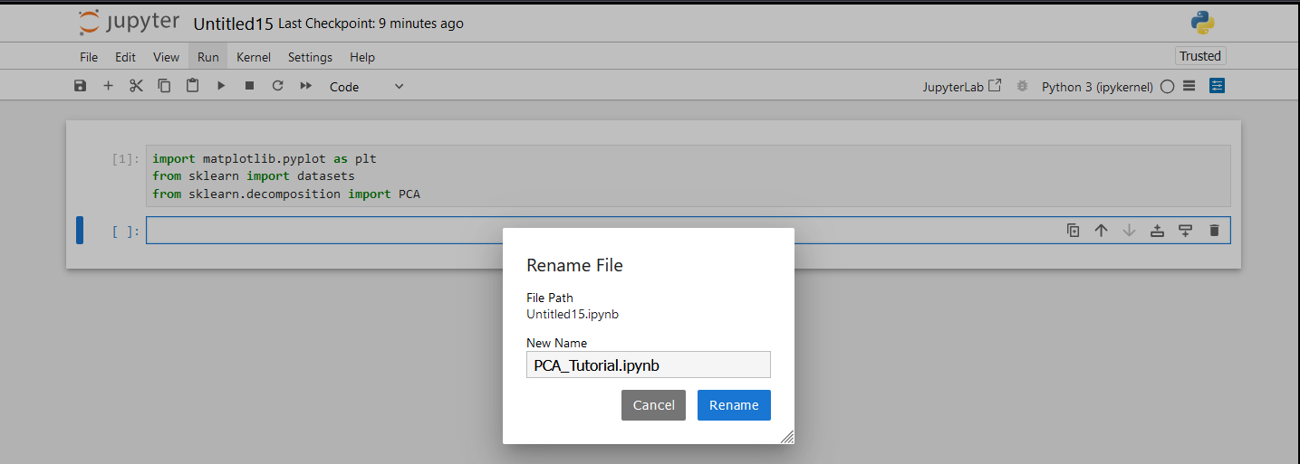

- Load the diabetes dataset that should already be downloaded from a previous tutorial. This can be downloaded from Moodle if you do not have it. Set it to a suitable folder and use that folder for the path (ideally the folder you are in as shown in the example). Check the size and shape of the dataset as we explore it. Run the cell.
# load the dataset (stored in a variable)
diabetes = pd.read_csv('./diabetes.csv', sep=',',header = 0)

print ("The length of the dataset is ", len(diabetes))
print("The shape of the dataset (Number of columns / features) is ", diabetes.shape)

- Run the following cell to show the parameters that can be fine tuned. Run the cell.
# this step is just to demonstrate the adjustable parameters within the algorithm and not a necessary step
# Specifically note 'criterion', max_depth', 'max_leaf_nodes'
# Also notice 'min_samples_leaf' and 'min_samples_split'
DecisionTreeClassifier().get_params()

Specifically note 'criterion', max_depth', 'max_leaf_nodes'
Also notice 'min_samples_leaf' and 'min_samples_split'

- While we explore the dataset we can look at the data as we did previously with the head() method. Run the cell.
diabetes.head()

Enter 10 or 20 as a parameter within the brackets. What happens?

- Also we will explore the information of the data. Run the cell.
diabetes.info()
What does this show you?
What does it all mean?
- Now split the dataset into train and test sets using train_test_split() method and set it to a 25 / 75% split, random_state will allow it to randomly split the set as opposed to splitting it in a linear form. We will also print the info of the train set here too. Run the cell.
# split the data into train and test using the SciKitLearn package
train,test=train_test_split(diabetes,test_size=0.25,random_state=42)
# view the information
train.info()

What do you notice different to the last info that you printed?

- Now we need to take the labels / classifications and set them to their own variable (y). Then we need to remove them from the main dataset by dropping the column. We will also drop irrelevant columns and set the rest of the dataset to its variable X. We will do this for the train and test set. Lastly we will test the info again, this time on the test set. Run the cell.
# Ensure only labels are saved in y variables
y_train=train['Outcome']
y_test=test['Outcome']
#drop the unwanted / irrelevant columns, features are stored in X variables
X_train=train.drop(['PatientId','Outcome'],axis=1)
X_test=test.drop(['PatientId','Outcome'],axis=1)
# view the information
X_test.info()

What do you notice this time with entries?
What is different?

- At this point, to make it easy for us to read the headings and labels, we need to extract the labels away into a numpy array. Wre will also do this for the numerical attribute values and show the headings by slicing the columns so we can caption the tree splits. Run the cell.
#extract labelled results
mtarget = diabetes["Outcome"].values
mtarget = np.array(mtarget, dtype='int') #array of class targets results Has diabetes=1, Does not have diabetes=0
values = np.array(diabetes.values,dtype='int') #array of attribute values for training data
values = values[:,1:9] #slice-> cols 1,2,3 and 4 kept. cols 0 and 9 excluded.
targetNames=['Diabetes','No Diabetes']
feature_names=list(diabetes)

feature_names=feature_names[1:9] #slice-> cols 1,2,3 and 4 kept. cols 0 and 5 excluded.
feature_names

- Now we are ready to create a model. We will create a decision tree classifier algorithm using the Gini criterion to a maximum depth of 5 layers and store it in a variable. We can then fit the training data to the model to train it using our created variables, ‘values’ (attributes) and ‘mtarget’ (labels). Run the cell.
# Create the algorithm and fit the data to the model to train it
gini_tree_clf = DecisionTreeClassifier(criterion='gini', max_depth=5, random_state=42)
gini_tree_clf.fit(values, mtarget)

- Predict with the model using the test dataset (only the data) and print the predictions. We can then print the predictions. Run the cell.
y_pred_gini = gini_tree_clf.predict(X_test)
print(y_pred_gini)
len(y_pred_gini)

Want does the prediction look like?
How many predictions were made?

- We can print the test labels (the ground truth) to see what the predictions should look like. Run the cell.
print(y_test)

- We now evaluate the model’s predictions against the ground truth test data using metrics from sklearn. The metrics show how accurate and precise the model is through the confusion matrix and classification report, as well as showing the recall and f1-score as we learned in the data lectures. Run this cell.
# display the metrics of the model's classification through confusion matrix and classification report
# (accuracy / precision / recall / f1)
print(metrics.confusion_matrix(y_test, y_pred_gini))

print(metrics.classification_report(y_test, y_pred_gini, digits=3))

How accurate is the model overall?
What can you learn from this?

- We will now use Pandas to create a dataframe. This will allow us to view the predictions and ground truths side by side. It will also allow us to generate a heatmap confusion matrix. Run the cell.
# use Pandas to create a dataframe to view the ground truth and classifications side by side
data = {'Actual': y_test,
'Predicted':y_pred_gini}
df = pd.DataFrame(data)
print(df)

What do you notice from the output?

- Now using Seaborn, we can generate a heatmap confusion matrix from the dataframe and plot it using matplotlib.pyplot. For the fun of it we will reprint the classification report too. Run the cell.
# Use Seaborn to create a confusion matrix heatmap and MatPlotLib to display
confusion_matrix = pd.crosstab(df['Actual'], df['Predicted'], rownames=['Actual'], colnames=['Predicted'])
sn.heatmap(confusion_matrix, annot=True)
plt.show()
print(metrics.classification_report(y_test, y_pred_gini, digits=3))

- Now let’s create a different model. We will create a decision tree classifier algorithm using the entropy criterion to a maximum depth of 3 layers and a minimum samples leaf of 5, and store it in a variable. We can then fit the training data to the model to train it using our created variables, ‘values’ (attributes) and ‘mtarget’ (labels). Run the cell.

entropy_tree_clf = DecisionTreeClassifier(criterion='entropy', max_depth=3, random_state=42, min_samples_leaf=5)
entropy_tree_clf.fit(values, mtarget)

- Now predict using the new model on the test dataset as we did with he previous model. Run the cell.
y_pred_entropy = entropy_tree_clf.predict(X_test)
print(y_pred_entropy)
len(y_pred_entropy)

- Next we can evaluate the performance with the confusion matrix and classification report. Run the cell.
# display the metrics of the model's classification through confusion matrix and classification report
# (accuracy / precision / recall / f1)
print(metrics.confusion_matrix(y_test, y_pred_entropy))

print(metrics.classification_report(y_test, y_pred_entropy, digits=3))

Which tree produced the better results?
Why is this?

- Now let’s have a look at the trees and how the decisions were formed. We can use ‘tree’ from scikit learn with the method plot_tree() to do this. The max_depth can be set to any number to show more depth although this becomes harder to read. We can also print out the statistics of each decision made.
gini_plot = tree.plot_tree(gini_tree_clf,
max_depth = 1,
feature_names = feature_names,
class_names=targetNames,
filled = True)

plt.show(gini_plot)

gini_plot

What was the attribute used at the root?
How does it show the splits down the branches?
In which nodes are the classifications shown?
Now leave out plt.show() to print the array of decisions.

- Leave out the parameter max_depth on this cell and see the difference. Then maybe try different values for max_depth. Give the variables for each plot different names. Run the cell.
gini_plot = tree.plot_tree(gini_tree_clf,
feature_names = feature_names,
class_names=targetNames,
filled = True)

plt.show(gini_plot)

gini_plot

- Now repeat the process for the entropy tree. Run the cell.
entropy_plot = tree.plot_tree(gini_tree_clf,
feature_names = feature_names,
class_names=targetNames,
filled = True)

plt.show(entropy_plot)

entropy_plot

What was the attribute used at the root?
How does it show the splits down the branches?
In which nodes are the classifications shown?
What differences do you notice between the two trees?

