Welsh Film and Television in Protest of English Oppression

  - How has Welsh folk horror been used to protest English and, specifically, Westminster's intervention and oppression of Wales?

For over 740 years, Wales has endured governance under English rule. This lengthy saga, marked by oppression and strife, is a testament to the unwavering strength of the Welsh people. Since 1283, when English power took hold of the region, Wales has been subjected to control over finances, resources, language, and homes. In the 1990s, the Westminster Labour government called for a referendum for Wales to be granted a devolved government, and in 1999, the National Assembly for Wales was formed. However, they were only given limited powers previously held by The Secretary Of State For Wales in Westminster, such as agriculture, fisheries, education, housing, and highways (Senedd Cymru, 2020). Yet, the Welsh spirit stands unbroken, a beacon of resilience in the face of adversity.

Welsh is one of the oldest languages in Britain and the only de jure official language in any part of the United Kingdom (Gray, 2022). The resurgence of the Welsh language is not just a movement. It is a vital response to the historical loss of spoken Welsh in many parts of Wales. Despite being granted the same privileges as England through the Act of Union in 1536, access to these rights often came at the cost of not being allowed to speak Welsh. This systematic suppression led to the anglicisation of traditional Welsh names, as seen in cities like 'Abertawe' becoming 'Swansea' and 'Glynebwy' becoming 'Ebbw Vale.' The urgency and significance of this revival cannot be overstated, as it serves as a poignant reminder of the ongoing struggle for cultural identity and autonomy.

This essay will use a Marxist perspective to discuss these aspects of Welsh history through relevant films in the Welsh folk horror genre. Rooted in the theories initiated by Karl Marx, who argues that there is a struggle between the classes (the proletariat working classes and the bourgeoisie capitalists), the Welsh have often been disproportionately underfunded when compared to England, especially compared to London (Agrawal & Phillips, 2020). A Marxist lens will offer a critical framework for analysing the chosen films through the perspective of socio-economic structures. This approach examines how folk horror film reflects and challenges power dynamics, economic conditions, and the distribution of wealth, as well as how the characters and their interactions are influenced by their social and economic environments.

As part of this independent project, I plan to write and produce a film based on my research. The goal is to create a film that captures Welsh identities while drawing inspiration from the flooding of the Tryweryn Valley and the town of Capel Celyn, which was done to supply water for England. The film will incorporate the story of the Lady of Llyn y Fan Fach, a Welsh myth about a woman who emerges from a lake and marries a mortal man, and other 'Lady of the Lake' stories from across Wales. These stories, with their themes of loss and resilience, will serve as a powerful metaphor for the Welsh struggle against English oppression.

Film Theory in the Welsh Context
Film and TV play a pivotal role in reflecting and shaping the cultural discourse of their time, often tackling social change and political issues. During the COVID-19 lockdown, there was a noticeable surge in films exploring themes of loneliness and isolation. Notable examples include Ben Wheatley's ‘In The Earth' (2021) and Kevin Lewis' 'Willy's Wonderland' (2021). Both films underscore isolation and separation as key themes and driving forces in their narratives. Similarly, Welsh films have often addressed the issues of their time, too. In her thesis titled 'Changing Narratives of Minority Peoples' Identities in Welsh and Basque Film,' Dilys Jones (2013) discusses how early Welsh films commented on traditional and essentialist views of identity centred around 'heteropatriarchy.' Over time, these films shifted to focus more on individual and ambiguous issues that reflect contemporary crises such as masculinity and globalisation. This evolution in the themes of Welsh films reflects the changing times. It engages the audience in the ongoing cultural discourse, fostering a sense of connection and understanding of Welsh issues.

These films, while not explicitly about Welsh history, can be seen as reflections of the Welsh experience. They depict struggles against oppressive forces, which resonate with the Welsh narrative of resistance against English rule. A prominent theme in Welsh cinema is the oppression by the English, with numerous film and television projects from Wales exploring the struggle for identity. In recent years, both overt and subtle references to the oppression from Westminster have surfaced. Some media portrayals take these themes to extremes, such as Michael Sheen's The Way (2024), which depicts a scenario where civil unrest leads to a surge in anti-Welsh sentiments, forcing many Welsh people to flee the country. This television series intertwines its narrative with Welsh folklore while maintaining a sense of realism. Set in contemporary times, it reflects on historical issues the people of Wales faced, such as the punishment for speaking Welsh.

Other Welsh films tackle true stories of the quest for independence, like Lee Haven Jones's Y Swn (2023). This film recounts the protests for establishing a Welsh language channel, focusing on the perspectives of those involved on both sides. It highlights the sacrifices made by advocates for the channel and those who resisted it. The cinematography expertly captures the landscape and the people's beliefs, employing Black and White imagery for those opposing the establishment of the Welsh language channel, emphasising the outdated nature of their views. This choice illustrates that clinging to tradition simply because ‘that is how it's always done’ may not always be beneficial.

The Dictionary of Film Studies defines horror as "a large and heterogeneous group of films that, via the representation of disturbing and dark subject matter, seek to elicit responses of fear, terror, disgust, shock, suspense, and, of course, horror from their viewers" (Kuhn & Westwell, 2020). This definition implies that any film that intentionally provokes a sense of fear in viewers belongs to the horror genre. However, this may not be entirely accurate, as dramas and thrillers often aim to elicit similar responses but are not typically classified as horror films. This suggests that the boundaries distinguishing horror from drama might be more ambiguous than can be easily articulated.
Consequently, the 'folk horror' subgenre may be even more challenging to define. While we can usually identify different genres, articulating how the production styles of these genres differ is more complicated. One possible explanation is that dramas often focus on investigators or outsiders rather than directly following the victims, which creates a distance between the audience and the horror. Alternatively, a film might be classified as horror when fear is more persistent or intense. A persistent sense of intense fear or unease is what will be considered a horror throughout this essay, and by using this definition, folk horror is a horror film that draws from elements of folklore for story or theming.

Some of Wales's most celebrated folklore revolves around battles against outside forces, notably the story of the Welsh dragon. In the ancient narrative from the Mabinogi, a red dragon confronts a white dragon. The red dragon has symbolised Wales since at least the 4th century (Johnson, 2017), and its origins may stretch even further back. Historically the Dragon represented the Welsh in their struggles against the Romans during that period. Later, in 1400, Owain Glyndŵr adopted the red dragon as an emblem of rebellion against the English crown. The white dragon in this tale is believed to symbolise the invading Anglo-Saxon forces of the time (Bryn y Castell, 2012). This illustrates that Wales’s most prominent folk stories are rooted in themes of rebellion, reflecting the enduring Welsh spirit of resistance against invaders and oppressors. Therefore, there is no clear reason why our modern interpretations of these tales and others cannot resonate with the ongoing pursuit of independence and recognition that the Welsh people rightfully deserve.

Analysis of Welsh Folk Horror Films
The following section will explore important aspects of Welsh history and the oppression experienced under English rule, focusing on several Welsh folk horrors. Key scenes from these films will be analysed through a Marxist lens to comment on their relation to Welsh history and the governance of Wales.

Film 1 - Apostle
The film "Apostle" (2018), directed by Gareth Evans, intricately weaves a narrative set on a hauntingly isolated island, steeped in foreboding ambience and dominated by a cult whose shadowy rituals conceal profound and often terrifying truths. The storyline centres on Thomas Richardson, a man with unwavering determination and resilience. He embarks on a perilous journey to this remote island after he receives harrowing news regarding the disappearance of his sister, who is believed to have fallen into the clutches of the cult. This personal crisis catalyses Thomas's descent into a world shrouded in mystery, danger, and esoteric practices.

As Thomas bravely navigates the treacherous and unforgiving landscape of the island, he finds himself enmeshed in its sinister undercurrents and dark secrets. The atmosphere is palpably tense, enhancing the dread as he delves deeper into a society entrenched in ancient beliefs and blood rites linked to a malevolent deity. In a strategic move to infiltrate the cult and gather information about his sister's fate, Thomas assumes the guise of a devoted follower. This act of subterfuge forces him to navigate an environment fraught with peril and suspicion, compelling him to cultivate precarious alliances with both cult members and other marginalised figures on the island, each rife with their motivations and agendas.

The narrative is rich with themes of faith and sacrifice, compelling the audience to ponder the extremes one might go to for love and the lengths individuals will traverse to rescue those they cherish in dire circumstances. The psychological landscape of the film evolves as Thomas confronts not only external threats but also internal dilemmas that challenge his understanding of faith, morality, and loyalty. The film's atmospheric horror and suspense are masterfully crafted, ensuring viewers remain captivated and alarmed by the unfolding drama.

Moreover, the island is a potent metaphor for Wales' historical longing for autonomy and independence from external control. The inhabitants regard their isolated home as self-governing, striving for recognition and respect from the outside world. This sentiment echoes the contemporary discourse surrounding Welsh independence, presenting a complex picture wherein some perceive Wales as a distinct and sovereign nation. In contrast, others view it merely as a part of England regarding legal, political, and religious frameworks.

In contrast to Wales being viewed globally as a subsection of England, Scotland boasts a distinct legal framework and branches of Protestantism separate from the rest of the United Kingdom. This significant distinction highlights the often simplistic tendency to conflate England and Wales as a singular entity. In light of this, it is crucial to recognise the Welsh people's unique identity and religious practices.

In addition to their legal complexities, the islanders exhibit a profoundly ingrained and unique religious belief system. This narrative element may symbolise the growing discontent among specific segments of Welsh Christians who feel alienated due to the lack of representation of the recognised Church of Wales. Following the establishment of the "Church in Wales" in 1920 under the 'Welsh Church Act' of 1914 (Watkin, 2021), many have perceived a disconnect from the historical governance of the Church of England, effectively underscoring the enduring struggle for Wales to assert itself as a legitimate and distinct nation within the broader United Kingdom.

The faith practised by the islanders draws striking parallels to the ancient pagan beliefs of the Welsh Druids (The Editors of Encyclopaedia Britannica, 2019) which further underscores the thematic richness. This complex tapestry of characteristics, reflecting deep devotion, intense faith, and the ritualistic practice of sacrificial rites, poignantly encapsulates the film's central themes. The unwavering belief of the islanders in their deity, along with their disturbing readiness to partake in bloodshed for the promise of a bountiful harvest, serves as a profound reflection of the film's exploration of faith, sacrifice, and the extreme lengths individuals are willing to traverse in their pursuit of love and familial bonds amidst the darkness that envelops them.

Film 2 – Darklands
Julian Richards' Darklands (1996) is a film that serves as a spiritual counterpart to Robin Hardy's The Wicker Man (1973). Set in an industrial Welsh town, the narrative revolves around Fraizer Truick, an outsider who embodies the dislocation and alienation experienced by individuals who return to their place of origin after an extended absence. Although Port Talbot is Truick's birthplace, his unfamiliarity with the town accentuates the theme of otherness prevalent throughout the film.

The narrative constructs a dichotomy between the indigenous Welsh townsfolk and the protagonist, positioning the former as the embodiment of 'evil' in a manner reminiscent of the community in Apostle. This portrayal invites a critical examination of the socio-economic landscape of Port Talbot, particularly in the context of a post-recession environment. The film subtly critiques contemporary societal issues by framing the town's descent into human sacrifice as an extreme manifestation of desperation.

Central to the storyline is the inquiry into Truick's relocation to Port Talbot, specifically, the reasons behind his departure from London. As the plot unfolds, it is revealed that his migration was not a matter of choice but rather a consequence of job loss resulting from corruption within the structures of London's economic and political landscape. This significant narrative detail underscores a broader commentary on the perceptions surrounding the two locales; London, often idealised as a beacon of opportunity and success, starkly contrasts the perceived failings of the Welsh town.

The film reflects prevailing attitudes toward geography and success, illustrating that movement to London represents achievement, while departure from the capital is interpreted as failure. This nuanced portrayal of place, identity, and economic hardship resonates with contemporary discourse surrounding regional disparities in the United Kingdom, as it interrogates the socio-political dynamics that inform individual and collective identities in the face of systemic corruption and economic decline.

Through exploring these themes, Darklands invites viewers to reconsider the implications of belonging and displacement, ultimately revealing how personal histories are interwoven with larger societal narratives. This duality continues to resonate in current discussions of identity and place.

The film profoundly explores the townspeople's harsh realities, delving into their struggles and moral dilemmas. Truick, in several instances, resorts to using money to manipulate individuals into engaging in morally questionable or outright illegal actions. For instance, while desperately fleeing for his life, he encounters two individuals who immediately offer him drugs as part of their everyday survival. Truick desperately offers them money to steal a car for him, highlighting individuals' stark choices when faced with dire circumstances. This contrast creates a somewhat darkly comedic portrayal of how people can resort to low behaviour in times of crisis.

In stark contrast to the town's plight, other characters in the film seem to lead comfortable lives, oblivious to the struggles surrounding them. The main characters inhabit their own spacious homes and exhibit a sense of financial security. Their relatively stable existence accentuates the disparity within the community, where some individuals are forced to make difficult decisions to survive while others remain insulated from such hardships.

Furthermore, the theme of money emerges as a clandestine source of corruption and moral decay within the narrative; as Marx posited, the function of money is to measure the value of the task, but the value of a task is not direct to the task itself but the person doing it. (Ivanova, 2019) This would suggest that a task completed by one individual would not have the same monetary value as a task completed by another. This film explores this by showing how little money it would take for an individual with a lower perceived ‘value’ to complete a morally corrupt task. Truick's love interest, initially portrayed as a supportive figure, is eventually revealed to be deceiving him for her financial gain, illustrating the lengths individuals will go when entangled in monetary motives. Meanwhile, the cult leader is unveiled as the town's Member of Parliament, a position that carries significant influence and power. This politician resides in an opulent and spacious home adorned with priceless works of art, showcasing a life of privilege that starkly contrasts with the realities faced by the townspeople.

The connection between the cult leader's political role and his manipulation of the town intertwines the local struggles with broader systemic issues. As a Member of Parliament, he possesses the authority to enact meaningful change and secure funding for the impoverished community. This community plays a crucial role in generating income for the UK. However, instead of leveraging this power for the benefit of the town, he chooses to exploit its vulnerabilities, transforming it into a paganistic cult and perpetuating a cycle of despair and disillusionment among its residents. This intricate web of personal and systemic corruption is a striking commentary on the complexities of power, greed, and morality in the face of adversity.

Film 3 - The Feast
Lee Haven Jones's Gwledd (2021), also known as The Feast, is a Welsh-language folk horror film that delves into the lives of affluent friends and family members of a local Member of Parliament (MP). Each character embodies one of the seven deadly sins from the Christian tradition. While there may be some nuances, the characters could be interpreted as follows: The first character we encounter is Gweirydd, who, throughout the film, demonstrates narcissistic and sexually predatory behaviour. He fixates on Cadi, asking his brother if she "let you touch her," which reveals his motivations driven by sexual desire and highlights his objectification of women. Ultimately, it is revealed that he was dismissed from the hospital where he worked for raping patients. This revelation serves as his downfall; his obsession with sex ultimately leads to his demise through Cadi's act of justice, firmly establishing him as the embodiment of lust.

The next character we meet is Guto, who is deeply reliant on drugs and has no intention of advancing his career or improving his life. Comfortable living off his parents' earnings, he enjoys a lifestyle of ease without the need to work for it. Guto's addiction and his anger toward his family provide Cadi with the means to enact her form of justice. She gives him mushrooms from the forest, which he indulges in excessively, resulting in the decay of his body, and his leg begins to rot. When Cadi brings his brother to rescue him, Guto starts shouting about the terrible things his brother has done, prompting the brother to amputate Guto's leg with a wood axe. This behaviour illustrates Guto's embodiment of sloth.

Our next character is Glenda, the mother of the previous two characters and the wife of the MP. Throughout the film, she takes every opportunity to boast about her wealth, proudly displaying her newly constructed home and her collection of expensive art to Cadi and her childhood friend Mair, who appears unimpressed. Eventually, Glenda crosses a line when she inquires to Mair, who owns the adjacent land for farming, whether they could obtain rights to mine for minerals in "The Rise." This moment signifies a pivotal connection to Cadi's origins. Mair alludes to a children's story about something buried beneath "The Rise," cautioning that it should never be disturbed. Glenda's excessive sin of pride ultimately leads to her downfall; as she witnesses her family's disintegration, she loses everything that once brought her joy and status.

Our next character is Gwyn, the MP and father of the family. He spends the film finding ways of making more money; his friend Euros is mining for minerals on his land and giving him large amounts of money in return; it is interesting to note that the money we see is in cash, which may mean that Gwyn is not disclosing this money, and is allowing the digging to happen off the record in order to make more money, he often lends his ear to Euros, listening to his advice on how to make more money. This ultimately is his downfall, as throughout the film we see as Cadi sings. Gwyn's ears ring painfully. At the end of the film, this means that as Cadi sings to him, he drives a skewer through his ear, killing him, but also symbolically stopping him from listening to Euros who has been providing his ways of making money.

The next sinner is Euros. Euros, as discussed, is digging for wealth on the land, with no caution for the dangers; we see at the beginning of the film that one of the workers dies at a dig site when this is referenced later in the film by Euros he glosses over it without any condolences for the worker. He is also the character we see eat the most when handed his first piece of food he takes a chewing gum out of his mouth to eat it and puts it on the plate that Cadi is handing around, we later see him filling his mouth with as much food as possible, this is ultimately his demise after Glenda has seen her whole family fall apart. Her pride is ruined, and she kills Euros by putting a shotgun in his mouth and pulling the trigger while reciting the line "After you have taken everything, what will be left?" illuding to Euros' gluttony.

Additionally, The names used in the story carry significant symbolism. Cadi, revealed to be a spirit inhabiting a girl's body from the town, has a Welsh name that translates to "Pure, Clean, or Clear" (Qureshi, 2025). This reflects her identity as pure of sin when we first encounter her; she embodies a force of nature returned to seek justice against those who have committed atrocities. On the other hand, Euros means "Gold" in Welsh (Ancestry.com, 2017), underscoring his being nothing more than monetary value to the family. Furthermore, the fact that all the family names start with the letter G may symbolise their shared guilt, hinting at their greed; each one has taken from the world without giving back, thus provoking Cadi's quest for vengeance.

This film is an adaptation of the Mabinogion tale of Blodeuwedd, illustrating how 'Cadi' exacts revenge on an affluent family for betraying their homeland and the surrounding nature. It stands out as the most explicitly anti-Westminster film among the three films examined. As we witness the downfall of an MP's family, driven by their faults and greed, we see as an embodiment of the Welsh landscape works through them systematically taking out her revenge on them. It shows an attitude towards Westminster that is underlying in many Welsh people, especially seemingly in director Lee Haven Jones who also made the film Y Swn discussed earlier. The fact that this family is that of a member of parliament is no coincidence to the story, but instead a message of rebellion from the filmmaker.

Other films.

A folk horror film from Cornwall, rooted in a similar Celtic heritage to Wales, delves into themes of isolation and loss. "Enys Men" (2022) follows a woman on a remote island engaged in plant research. Often described as a "poem film," it eschews a conventional narrative, concentrating instead on eliciting emotional responses and inviting the audience to fill in the narrative gaps. An interpretation of the film is that it portrays a woman mourning the loss of someone meaningful to her while isolated, highlighting the profound impact this grief has on her psyche. The film uses non-linear storytelling in a way that makes the narrative subjective; it is never clear what is happening in what order. One interpretation is that a daughter that the main character had lost could be a past version of herself. This echoing of the past is also true for future events, as we hear radio transmissions of events that have not yet happened in the film. The vagueness of the narrative causing the audience to draw their conclusions is a fascinating technique, meaning the film is whatever the audience makes of it rather than the story being based on what is written. It is based on what you, as an audience, feel, which is what Roland Barthes calls ‘Death of the Author’ as the author’s intentions are irrelevant (Barthes, 1977).
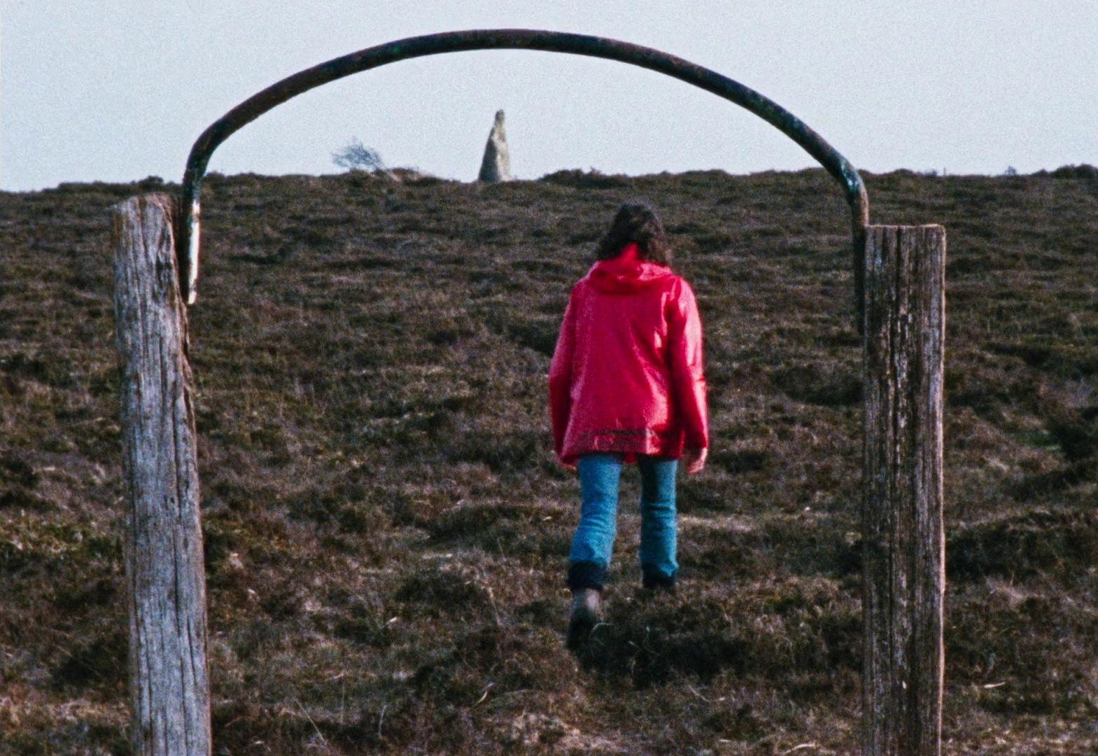
(Fig 1. Still from Enys Men)
To enhance the overall aesthetic, the director utilises vintage camera equipment, imparting a nostalgic quality to the film. Another work by the same filmmaker, Mark Jenkin, is Bait (2019), which addresses the plight of locals facing the influx of non-residents purchasing second homes in the area. This phenomenon drives up housing costs, making it increasingly difficult for locals to find affordable living options. Although set in Cornwall, this is reliable to Wales as it is a pressing issue in many Welsh seaside towns. The result is a landscape of 'ghost towns', nearly deserted for most of the year until the holiday season brings the owners back. Marx was a strong supporter of the philosopher Proudhon, claiming "Proudhon is the only thinker who personifies proletarian thought," going on to state, "Proudhon has inspired a total upheaval in social economy" (Gurvitch, 1965). Proudhon stated, "All property is theft" (Proudhon, 1994). This is demonstrated in this specific instance, where owning holiday homes could directly result in the lack of housing for the less fortunate. This situation, combined with Wales's ongoing struggle with homelessness, fosters considerable unrest, as it raises concerns about the prioritisation of outside leisure over the fundamental right of Welsh residents to secure shelter and comfort.

Cofiwch Ty

By applying research into Welsh folk horror, I have created a short film that uses the genre to highlight the loss of the Tryweryn Valley and the village of Capel Celyn. The decision to flood the village to create a reservoir for England sparked significant controversy in Wales, as most Welsh people protested against it (Powys, 2023). Ultimately, the villagers were forced to relocate, illustrating that the needs of England took precedence over the Welsh people's right to remain in their homes. This unfair hierarchy exposes the power dynamics between England and Wales, which are reinforced by Marxist theories of power and control.

In making the film, it was crucial to feature the rock painted with the words' Cofiwch Dryweryn' ('Remember Tryweryn'), as it signifies that the loss of the village is still felt today and adds context to the film's location and backstory. Notably, another painted rock just behind this wall bears the phrase 'fe godwn ni eto,' which translates to 'we will rise again,' serving as the motto of the Free Wales Army. Although this rock is not depicted in the film, it reflects the prevailing sentiment within the community.
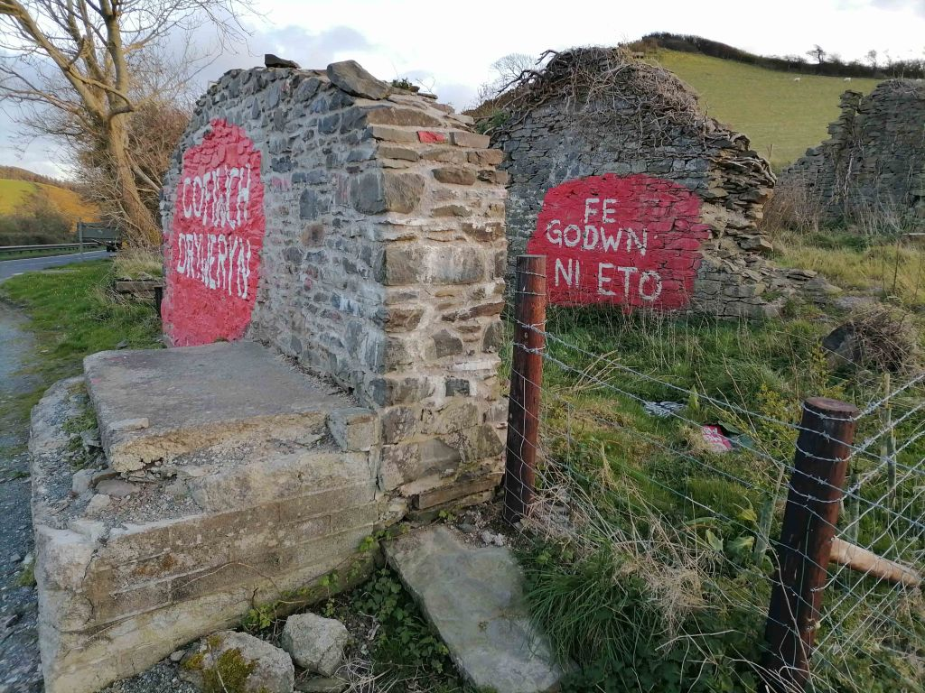
(fig 2. Both walls together)
Furthermore, I have noticed a tendency among Welsh people to desire a connection to their roots. For example, my parents moved back to the town where my grandparents lived to feel closer to their heritage. Many other Welsh individuals I have spoken with have expressed similar feelings about their families. This idea—that a true sense of "home" for the Welsh often means returning to the same town as their relatives—drives the plot of my film, which centres around a character drawn back to his grandmother's home. However, this home is located in Capel Celyn, now submerged under a reservoir, making the journey back far more perilous.

The film, based on one of the most famous instances of the English prioritising its needs over those of the Welsh people, sheds light on the oppression faced by the Welsh. It also explores aspects of Welsh identity often overlooked in media, highlighting the importance of these elements of Welshness.

Conclusion

In conclusion, film as an art form has often served as a commentary on the issues confronting filmmakers, and folk horror proves to be a particularly effective medium for this purpose. It engages audiences with its themes in a manner that feels organic rather than forced or overt. For the Welsh people, interference from Westminster has been a significant issue for centuries. The earliest Welsh folk stories frequently featured allegories of Wales resisting invaders, making it only natural that contemporary narratives would focus on the suppression of our culture, people, and land by Westminster.

Moreover, the films I selected, all Welsh folk films suggested to me without prior knowledge of my writing's context, consistently revealed anti-governmental sentiments. This suggests that folk horror and Welsh media have successfully intertwined over the decades to articulate the feelings many Welsh people harbour regarding Westminster's failures. I chose to include a Cornish director in this analysis due to the similarities in culture and history of oppression. I also sought to create my own folk story that encapsulates my dissatisfaction with the Westminster government and my pride in the Welsh people. I believe I have crafted a narrative that is truly reflective of that sentiment.

Bibliography
Agrawal, S. and Phillips, D. (2020). Catching up or falling behind? Geographical inequalities in the UK and how they have changed in recent years. [online] ifs.org.uk. Available at: https://ifs.org.uk/inequality/geographical-inequalities-in-the-uk/. [Accessed 20 Dec. 2024]
Ancestry.com. (2017). Origin and Meaning of First Name Euros | Search Family History on Ancestry®. [online] Available at: https://www.ancestry.com/first-name-meaning/euros [Accessed 17 Jan. 2025].
Badder, D. and Norman, M. (2023). The Folklore of Wales: Ghosts. Cardiff: Calon.
Barthes, R. (1977). The Death of the Author. In Image-Music-Text (Translated by Stephen Heath, pp. 142-148). London: Fontana.
BBC (2012). Bryn y Castell. [online] Available at: https://downloads.bbc.co.uk/wales/archive/bbc-north-west-wales-celts.pdf [Accessed 16 Jan. 2025].
Cannon, N. (2013). Wales: the language and the people. [online] Available at: https://www.gov.uk/government/speeches/wales-the-language-and-the-people [Accessed 22 Dec. 2024].
Fayers, C. (2024). Welsh Giants, Ghosts and Goblins. Cardiff: Firefly Press.
FelinFach (2024). Welsh Not - A Form of Punishment. [online] FelinFach. Available at: https://www.felinfach.com/pages/welsh-not-welsh-knot?srsltid=AfmBOopV8yMj7s0ORnB7hIwc1wcFroj5S7gZ9p23bI9vjgj4TEoxStI1 [Accessed 20 Dec. 2024].
Gray, D. (2022). Which languages are native to the United Kingdom? [online]Available at: https://apostrophgroup.de/en/magazine/which-languages-are-native-to-the-united-kingdom [Accessed 20 Dec. 2024].
Gruffudd, P., Smith, J.B. and Carter, H. (2019). Wales | History, Geography, Facts, & Points of Interest. In: Encyclopædia Britannica. [online] Available at: https://www.britannica.com/place/Wales [Accessed 26 Nov. 2024].
Gurvitch, G. (1965). Proudhon and Marx. [online] The Anarchist Library. Available at: https://theanarchistlibrary.org/library/georges-gurvitch-proudhon-and-marx.
In The Earth. (2021). Neon, Universal Pictures, Focus Features.
Ivanova, M.N. (2019). Marx’s Theory of Money: A Reappraisal in the Light of Unconventional Monetary Policy. Review of Radical Political Economics, 52(1), pp.137–151. doi:https://doi.org/10.1177/0486613419856727.
Johnson, B. (2017). The History of the Welsh Dragon - Symbol of Wales. [online] Historic UK. Available at: https://www.historic-uk.com/HistoryUK/HistoryofWales/The-Red-Dragon-of-Wales/ [Accessed 16 Jan. 2025].
Keetly, D. (2016). Identity and Folk Horror in Julian Richards’ Darklands : Revenant. [online] Revenantjournal.com. Available at: https://www.revenantjournal.com/contents/identity-and-folk-horror-in-julian-richards-darklands/ [Accessed 3 Nov. 2024].
Kuhn, A. and Westwell, G. (2020). Dictionary Of Film Studies. 2nd ed. Oxford: Oxford University Press.
Powys, B. (2023). Tryweryn: The stories behind drowned village Capel Celyn. [online] Available at: https://www.bbc.co.uk/news/uk-wales-64799911. [Accessed 17 Jan. 2025]
Proudhon, P.-J. (1994) Proudhon: What is Property? Edited by D.R. Kelley and B.G. Smith. Cambridge: Cambridge University Press (Cambridge Texts in the History of Political Thought).

Qureshi, S. (2025). Cadi - Baby Name Meaning, Origin and Popularity. [online] Thebump.com. Available at: https://www.thebump.com/b/cadi-baby-name [Accessed 17 Jan. 2025].
Senedd Cymru (2020). History of devolution. [online] Available at: https://senedd.wales/how-we-work/history-of-devolution/ [Accessed 26 Nov. 2024].
The Editors of Encyclopaedia Britannica (2019). Druid | Celtic culture. In: Encyclopædia Britannica. [online] Available at: https://www.britannica.com/topic/Druid.
VisitWales. (2024). The History of the Welsh Language. [online] Available at: https://www.visitwales.com/info/language/poetry-motion-discover-language-wales [Accessed 20 Dec. 2024].
Wales. (2023). Why is there a dragon on the Welsh flag? [online] Available at: https://www.wales.com/about/why-there-dragon-welsh-flag.
Wang, G. (2019), Marx’s monetary theory and its practical value, China Political Economy, Vol. 2 No. 2, pp. 182-200. https://doi.org/10.1108/CPE-10-2019-0026 [Accessed 21 Jan 2025]
Watkin, T. (2021). Ecclesiastical law and the Church in Wales | Law Wales. [online] law.gov.wales. Available at: https://law.gov.wales/ecclesiastical-law-and-church-wales.
Willy’s Wonderland. (2021). Screen Media.
Y Swn. (2023). S4C.
  - List of Figures
Figure 1: Still from Enys Men (2022) Available at [FILMGRAB]. (2024). Enys Men. [online] Available at: https://film-grab.com/2024/01/15/enys-men/#bwg3390/203754 [Accessed 21 Jan. 2025].
Figure 2: Both walls together (2023) Available at Williams, H. (2023). Cofiwch Dryweryn Revisited. [online] Archaeo𝔡𝔢𝔞𝔱𝔥. Available at: https://howardwilliamsblog.wordpress.com/2023/03/25/cofiwch-dryweryn-revisited/ [Accessed 21 Jan. 2025].

