Application Development
C# Database application
Kieran Perrin – per09098703
Table of Contents
Introduction 2
Application Development Concepts 2
Progressive Web Apps 2
What is a Progressive Web App? 2
Do Progressive Web Apps Improve User Experience? 2
Requirements 3
Design and Implementation 3
Entity Relationship Diagram 3
Pseudocode 4
Screenshots 9
Evaluation 11
References 13

Introduction
In this report I will discuss current application development trends and discuss one in further detail. I will then document the development stages of my own application, including the design, implementation and testing stages ending with a final evaluation.

Application Development Concepts
According to an article written by Roger James on Hackernoon the top ten development trends in 2019 are as follows [1]:
- Mixed Reality – A combination of virtual reality and augmented reality to overlay virtual objects in real world situations.
- Artificial Intelligence – Creating software that can-do things humans can do by using intelligent thinking patterns.
- Internet of Things – More devices are connecting to the internet all the time such as the smart assistants in homes that can control lighting and such.
- Progressive Web Apps – mobile and web app hybrid that has all the benefits of each.
- Blockchain – Popular with digital currencies but blockchain is also starting to be used in other sectors.
- Language trends – A stack overflow survey found that JavaScript is the most popular language in 2019.
- Low code development – An approach to development where each part of the product is created in small individual parts.
- Code Quality – A focus on quality coding practices like low code development is the normal now.
- Cybersecurity – With new threats come the need for better security, cybersecurity is always a needed sector.
- Outsourcing software development – Outsourcing coding to a global market has become a trend.

Progressive Web Apps
As part of the brief I must discuss a trend in more detail, and I chose progressive web apps, as the idea intrigues me, and I see this trend becoming the norm for all application in the future.

What is a Progressive Web App?
When thinking of applications, you can have native apps that are installed on the device and have a higher capability of things it can achieve but uses more of the device resources and has a lower reach than a web app. On the other side, a web app is seen as being reachable anywhere (if you have an internet connection), uses less resources on the device but generally has lower capabilities. A progressive web app is a combination of the two, where it is available from anywhere, uses less device resources but has the capabilities of a native app thanks to modern APIs. Most progressive web apps also have the capability to have some functionality to be used offline, such as Spotify, which allows users to download songs to their device and use its web app to listen without an internet connection [2].

Do Progressive Web Apps Improve User Experience?
In 2019 an assessment on progressive web application using AHP was published on science direct. This assessment first discusses anecdotes of companies that have made PWAs(progressive web apps) such as twitter claiming their PWA consumes 3% less battery than their native app or Fandango claiming a 30% speed gain over loading desktop website and 50% speed gain from loading native mobile app. They then move on to doing their AHP assessment, weighing it against native apps and normal websites. They concluded that PWAs weigh heavier than the other two suggesting a superiority. The assessment is finished with a conclusion discussing the superiority of PWAs and mobile application based on PWA architecture are preferred because of their features such as use offline, small size and being available on multiple platforms. It is also discussed that PWA development would take considerably less time to produce as one app can be made for all platforms [3].

Requirements
A local game shop wanted a system to help them keep track of tables they have booked out to customers, so I helped them by designing and implementing a C# desktop application using a sql database to do this.
The features of this application include:
- A secure login for staff to have access to the program.
- A dashboard layout so staff can easily navigate the sections of the program.
- A responsive UI that feels good to use.
- A customer page to find, add, edit and delete customers from the system which also shows the bookings the customer has made.
- A Game page to find, add, edit and delete games from the system.
- A table page to find, add, edit and delete tables from the system.
- A booking page to find, add, edit and delete bookings from the system pulling information from customers, staff, games and tables.

Design and Implementation

Entity Relationship Diagram
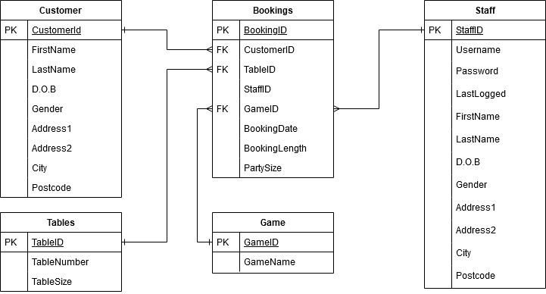
Figure 1 Database ERD

Pseudocode
PROGRAM gameShopBookingSystem
START
SET usernameInput = INPUT
SET passwordInput = INPUT
GET username
GET password
IF usernameInput = username AND passwordInput = password
DISPLAY Dashboard
SET page = INPUT
IF page = “customer”
CALL: customer
ENDIF
IF page = “bookings”
CALL: bookings
ENDIF
IF page = “tables”
CALL: tables
ENDIF
IF page = “games”
CALL: bookings
ENDIF
ENDIF

FUNCTION customer
SET custID = 0
SET utton = INPUT
CALL: getCustomer
FUNCTION getCustomer
IF customerID = 0
SET SQL = “SELECT TOP 1 * FROM customers”
ENDIF

ELSE
SET SQL = “SELECT * FROM customers WHERE customerID = custID”
ENDELSE

DISPLAY firtstName
DISPLAY lastName
DISPLAY dateOfBirth
DISPLAY gender
DISPLAY Address1
DISPLAY Address2
DISPLAY city
DISPLAY postcode

ENDFUNCTION

IF button = “create”
SET firtstName = INPUT
SET lastName = INPUT
SET dateOfBirth = INPUT
SET gender = INPUT
SET Address1 = INPUT
SET Address2 = INPUT
SET city = INPUT
SET postcode = INPUT
SET SQL = “INSERT INTO customers firstName, lastName, dateOfBirth, Gender, Address1, Address2, City, postcode”
CALL: getCustomer
ENDIF

IF button = “find”
SET custID = INPUT
CALL: getCustomer
ENDIF

IF button = “delete”
SET SQL = “DELETE FROM customers WHERE customerID = custID”
CALL: getCustomer
ENDIF

IF button = “update”
SET firtstName = INPUT
SET lastName = INPUT
SET dateOfBirth = INPUT
SET gender = INPUT
SET Address1 = INPUT
SET Address2 = INPUT
SET city = INPUT
SET postcode = INPUT
SET SQL = “UPDATE customers firstName, lastName, dateOfBirth, Gender, Address1, Address2, City, postcode WHERE customerID = custID”
CALL: getCustomer
ENDIF
ENDFUNCTION

FUNCTION bookings
SET bookingID = 0
SET utton = INPUT
CALL: getBooking
FUNCTION getBooking
IF bookingID = 0
SET SQL = “SELECT TOP 1 * FROM Bookings”
ENDIF

ELSE
SET SQL = “SELECT * FROM Bookings WHERE bookingID = bookingID”
ENDELSE

DISPLAY customerID
DISPLAY TableID
DISPLAY GameID
DISPLAY BookingDate
DISPLAY BookingTime
DISPLAY BookingLength
DISPLAY PartySize

ENDFUNCTION

IF button = “create”
SET customerID = INPUT
SET TableID = INPUT
SET GameID = INPUT
SET BookingDate = INPUT
SET BookingTime = INPUT
SET BookingLength = INPUT
SET PartySize = INPUT
SET SQL = “INSERT INTO Bookings customerID, TableID, GameID, BookingDate, BookingTime, BookingLength, PartySize”
CALL: getBooking
ENDIF

IF button = “find”
SET bookingID = INPUT
CALL: getBooking
ENDIF

IF button = “delete”
SET SQL = “DELETE FROM Bookings WHERE bookingID = bookingID”
CALL: getCustomer
ENDIF

IF button = “update”
SET customerID = INPUT
SET TableID = INPUT
SET GameID = INPUT
SET BookingDate = INPUT
SET BookingTime = INPUT
SET BookingLength = INPUT
SET PartySize = INPUT
SET SQL = “UPDATE Bookings customerID, TableID, GameID, BookingDate, BookingTime, BookingLength, PartySize WHERE BookingID = bookingID”
CALL: getCustomer
ENDIF
ENDFUNCTION

FUNCTION tables
SET tableID = 0
SET utton = INPUT
CALL: getTables
FUNCTION getTables
IF tableID = 0
SET SQL = “SELECT TOP 1 * FROM Tables”
ENDIF

ELSE
SET SQL = “SELECT * FROM Tables WHERE TableID = tableID”
ENDELSE

DISPLAY TableNumber
DISPLAY TableSize

ENDFUNCTION

IF button = “create”
SET TableNumber = INPUT
SET TableSize = INPUT
SET SQL = “INSERT INTO Tables TableNumber, TableSize”
CALL: getTables
ENDIF

IF button = “find”
SET tableID = INPUT
CALL: getTables
ENDIF

IF button = “delete”
SET SQL = “DELETE FROM Tables WHERE TableID = tableID”
CALL: getTables
ENDIF

IF button = “update”
SET TableNumber = INPUT
SET TableSize = INPUT
SET SQL = “UPDATE Tables TableNumber, TableSize where TableID = tableID”
CALL: getCustomer
ENDIF
ENDFUNCTION

FUNCTION games
SET gameID = 0
SET utton = INPUT
CALL: getGames
FUNCTION getGames
IF tableID = 0
SET SQL = “SELECT TOP 1 * FROM Games”
ENDIF

ELSE
SET SQL = “SELECT * FROM Games WHERE GameID = gameID”
ENDELSE

DISPLAY GameName
ENDFUNCTION

IF button = “create”
SET GameName = INPUT
SET SQL = “INSERT INTO Games GameName”
CALL: getTables
ENDIF

IF button = “find”
SET gameID = INPUT
CALL: getGames
ENDIF

IF button = “delete”
SET SQL = “DELETE FROM Games WHERE GameID = gameID”
CALL: getGames
ENDIF

IF button = “update”
SET GameName = INPUT
SET SQL = “UPDATE Games GameName where GameID = gameID”
CALL: getGames
ENDIF
ENDFUNCTION

END

Screenshots
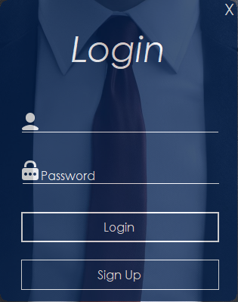
Figure 2 Login Page

Figure 3 Dashboard
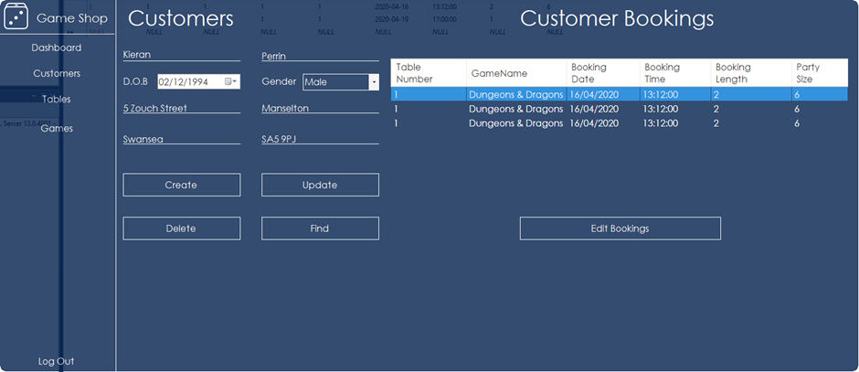
Figure 4 Customer Page
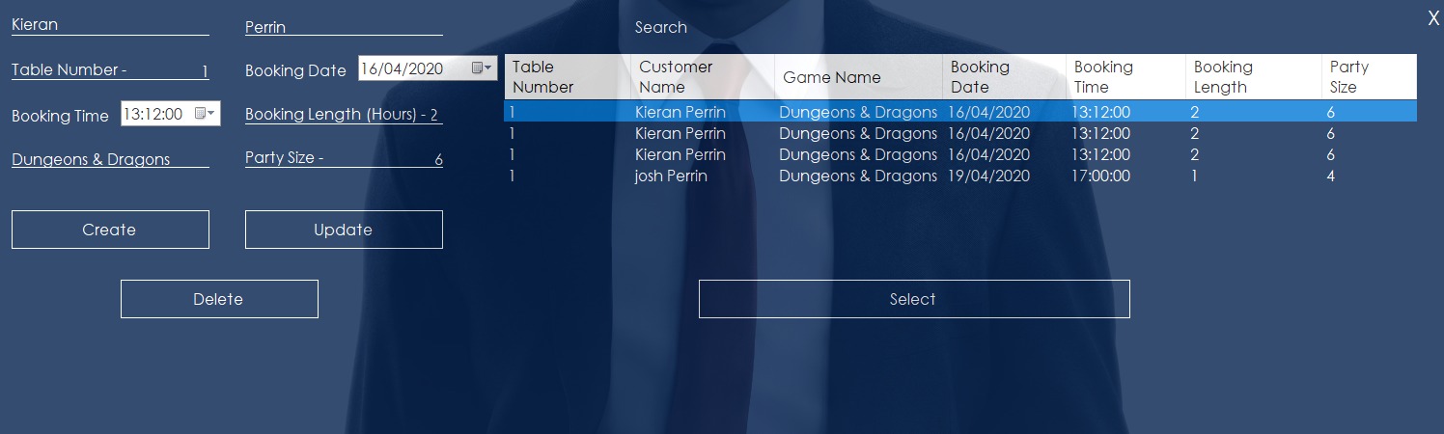
Figure 5 Edit Customer Bookings
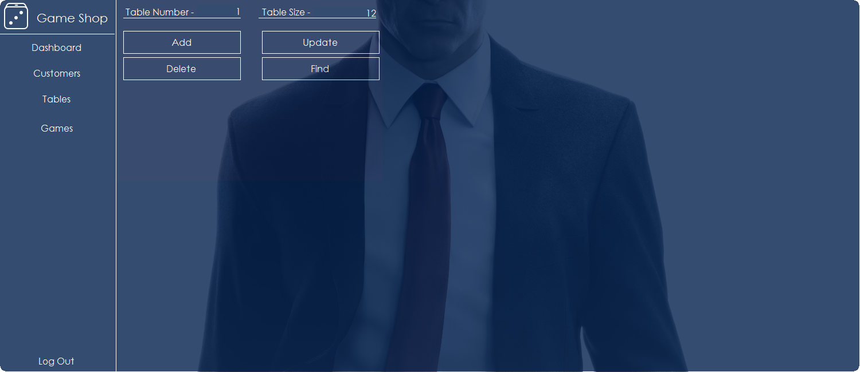
Figure 6 Table Page
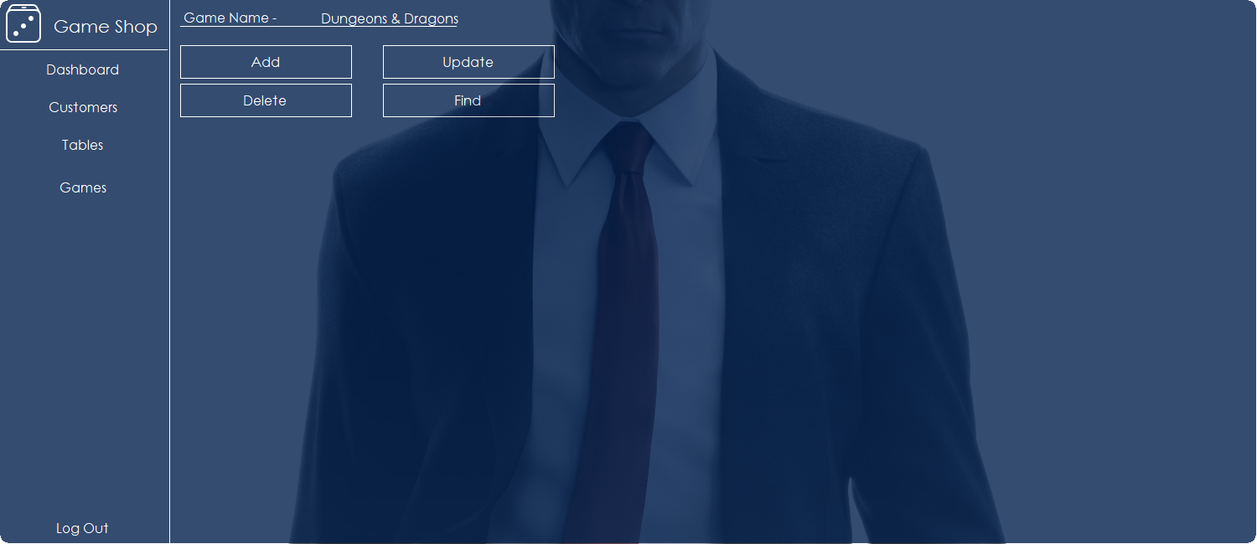
Figure 7 Game Page

Evaluation
Description | Customers can be added, edited or deleted from the system
Preconditions | Program is logged in.  Game shop database connected.  At least one customer record in the database.

Step | Procedure | Expected result | Actual result
1 | Open customer page | Top entry in database displays. | Works as expected.
2 | Bookings retrieved | After customer information is retrieved, related bookings to the customer is also retrieved. | Works as expected.
3 | Data entry | Data is entered into relevant areas. | Works as expected.
4 | Create button clicked | Data entered is added to the customers table in the database. New entry is displayed on the page. | Works as expected.
5 | Delete button clicked | Data loaded is deleted from the database and the next entry is loaded. | Works as expected.
6 | Update button clicked | Data in the database is updated to what is in the inputs on the page. | Works as expected.
7 | Find button clicked | Search box, data table and select button become visible. Data table populates with all customer names in database. | Works as expected.
8 | Input in search box | Data in the data table is filtered by what the user has input into the search box. | Works as expected.
9 | Name is selected | Variable is populated with the data for the customer selected. | Works as expected.
10 | Name double clicked/select button clicked | Search box, data table and select button goes back to invisible and the selected customer information is displayed on the page for the user to edit. | Works as expected.

Description | Customers bookings can be created, edited, deleted and selected.
Preconditions | Program is logged in.  Game shop database connected.  At least one customer record in the database.

Step | Procedure | Expected result | Actual result
1 | Add booking button clicked | Booking form opens and all other forms hide. Customer information transfers into booking form and displays top booking for the customer. All bookings in the database are loaded into the data grid on the page. | Works as expected.
2 | Create button clicked | All the information in the inputs on the page are added to the database. | Works as expected.
3 | Update button clicked | The database gets updated with the data input by the user from the page. | Works as expected.
4 | Delete button clicked | Current data displayed gets removed from the database and the top booking gets displayed. | Works as expected.
5 | Booking in the data grid is selected | Variable is populated with data for the booking selected | Works as expected.
6 | Booking double clicked/ select button clicked | Selected booking information gets displayed on the page for user to edit. | Works as expected.
7 | Input in search box | Data in the data table is filtered by what the user has input into the search box. | Does not work.
8 | X pressed in top right | Booking form closes and dashboard with customer is unhidden with the data from the customer last loaded in bookings displayed. | Works as expected.

References

[1] | R. James, “Hackernoon,” 25 April 2019. [Online]. Available: https://hackernoon.com/10-top-software-development-trends-a12d25f5fd2d. [Accessed 10 April 2020].
[2] | P. L. Sam Richard, “web.dev,” 6 Jan 2020. [Online]. Available: https://web.dev/what-are-pwas/. [Accessed 10 April 2020].
[3] | A. A.-B. M. A.-K. Asharul Islam Khan, “Progressive Web Application Assessment Using AHP,” Procedia Computer Science, Halifax, Canada, 2019.

