

Programme: BA(Hons) International Hotel Management
Module: Organisational Consultancy (BMIH 6005)
Consultancy Report: Consultation for Britannia’s Adelphi Hotel
Lecturer: Natalie Brailsford
Student Name: Oana-Andreea Puscuta
Student ID: 2232738
Word:6274

Declaration:

I confirm that I have not used any AI tools in the research and creation of this presentation, and I confirm I have not presented any AI generated materials as my own work.

Executive Summary

This consulting report was completed for the Adelphi Hotel, a Britannia Hotels affiliate and a historically significant but now dilapidated establishment in the heart of Liverpool. This report, which was created by VisionRevive Consulting Ltd., offers a comprehensive analysis of the reasons for the hotel's ongoing deterioration as well as tactical suggestions to aid in its recovery. In recent years, the once-iconic Adelphi Hotel in the UK’s hospitality industry has been linked to operational neglect, a drop in client satisfaction, and a negative brand image. Britannia Hotels has been named the worst hotel chain in the UK for ten years running, according to a 2022 Guardian study (Parveen, 2022). The Adelphi Hotel’s performance has been directly impacted by the reputational issue. The study begins by providing background information about the hotel’s size, historical significance, and strategic location in order to set the stage for this performance problem. The hotel’s deteriorating internal standards have made it a watchword in the business, despite its strategic location close to transportation hubs and cultural sites. The diagnostic study of the hotel’s main issues is one of the report’s first crucial chapters. Poor customer service, underinvested facilities, and hygiene problems were the most frequently reported issues, according to the analysis. The 2025 ratings report from Britannia Hotels revealed a 56% decline in ratings, with complaints citing poor sanitary standards, unhelpful staff, and poor value (Coffey, 2023). Over 54% of visitors complained about issues like mould, dust, damaged furniture, and inadequate upkeep; these issues led to recurring bad internet reviews, low occupancy, and decreased profitability (Macmahon, 2022). In addition to operational problems, the paper identifies systemic shortcomings in feedback handling. The Adelphi Hotel has not closed the feedback loop despite receiving complaints and guest insights to improve. Customer trust has been further damaged by this inaction, which has also created the appearance of indifference. In terms of finances, the hotel has struggled to balance cost and value. Customers have frequently complained that the rate of improvement in the quality of service does not keep up with rival brands like Premier Inn, which raised prices in tandem with service improvements and recorded a 78% satisfaction rate. This is true even though room rates have increased over the past ten years in line with the level of inflation in the UK.
A STEEPLED analysis was conducted to identify the external macro-environmental elements influencing the Adelphi Hotel in order to systematically contextualise these difficulties. The hotel has failed to meet the growing need for individualised and sanitary guest experiences, as indicated by the social component. When technological factors were examined, it was found that the hotel was lagging below industry standards in the use of automation tools, digital check-in solutions, and CRM software (McCallister, 2022). Financial strain has increased due to economic issues, particularly inflation and hiking operational costs, while environmental and ethical aspects have revealed a lack of corporate social responsibility and sustainable efforts. The interlink between legal and political aspects have also been estab;lshed including failure of compliance and labour shortages with worsened adherence to safety regulations, as well as demographic changes leading to multigenerational demands. After that, a SWOT analysis was conducted, weighing the company’s internal strengths, such as its central location and heritage appeal, against its weaknesses, which included old infrastructure, inconsistent services, and a lack of unique selling points. Threats include more competition, ongoing bad press, and online reviews that are being magnified by the digital booking culture. Opportunities include the city's growing tourism and potential renovation grants. To match these findings with strategic directions, a TOWS matrix was utilised.
It was followed by providing attribute recommendations for Adelphi to improve their overall service quality in customer-focused areas. The discussion in this section started with providing a multifaceted approach for improving service quality. Emphasis was put on Service quality, business operation management, and then positioning. In the case of service quality improvement, the discussion highlighted how providing quality training to employees is necessary for upskilling staff. Reviews from customers regarding Adelphi Talked about inconsistency in staff behaviour, service delivery, personalisation, and more. Keeping this in mind, recommendations highlighted providing employees training regarding cultural norms, communication skills, interactivity, and so on. These elements are necessary in the case of improving customer service. Along with that, this section also highlighted benefits of standardisation in service delivery (Williams, 2022). Besides how custom relationship management systems can be helpful for managing customer focused areas effectively were also discussed. The discussion then moved towards recommendations regarding operational improvement. Adelphi is a business that has been utilising outdated systems in their overall business processes. In this context, recommendations in this section emphasise utilising digital payment systems, artificial intelligence technologies and so on for automating manual tasks. Strategic HRM processes like shifting human labour to more customer focused areas for improving service quality was also mentioned. After that, as for recommendations for brand positioning, the discussion emphasised Giving a fresh start to the branding of the hotel. The discussion showed how it is important to maintain consistency in brand messaging on different platforms. It talked about influencer marketing and justified its use case for Adelphi. At the same time, the recommendations also included utilising popular social media platforms for reaching customers. This discussion also included a change management process. It applied the “Kotter's 8 step change management” framework for this. A detailed step by step approach as per this framework was discussed for Adelphi to improve their service quality. Then, a brief action plan was devised for the company to overcome identified challenges, concluding the overall discussions and findings at the end.

Table of Contents
Introduction 7
Analysis 9
Issue and its impact on the hotel 9
STEEPLED Analysis 10
SWOT Analysis 12
TOWS Analysis 13
Recommendations and Change Management 14
Action Plan 20
Conclusion 21
References 23

Introduction
The UK hospitality businesses have always faced unstable market situations, and guests have been requesting more individualised and high-quality experiences from lodging establishments. However, not every hospitality service provider succeeds in adjusting to customer expectations taking uncertain turns, technological adaptation acceleration, or improving service standards. Located in the heart of Liverpool and run by Britannia Hotels, the Adelphi Hotel is a prime example. The Adelphi, which was once praised for its beauty and historical significance, is now a case of the structural issues that have affected its parent company. The hotel, which is now frequently referred to by its guests as “tired and tatty”, has ongoing issues with customer satisfaction, reputation, upkeep, and service quality. According to an article in The Guardian Britannia Hotels has been named the UK’s worst hotel chain for the ninth consecutive year (Parveen, 2022). These issues with the Adelphi Hotel’s reputation have directly affected prospective guests, reduced customer retention, and jeopardised the hotel's ability to compete in the market.
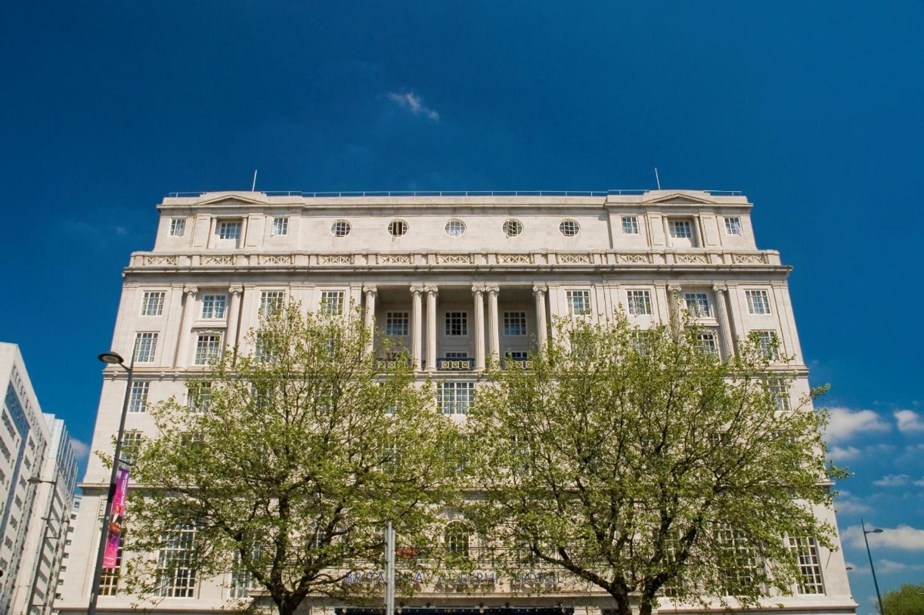
Figure 1: The Adelphi Hotel
(Source: (The Elite Venue Selection, 2025)

The Adelphi Hotel is perfectly situated in the heart of Liverpool's commercial, nightlife, and cultural attractions, close to Lime Street Station. With more than 400 rooms, the hotel can host both business and pleasure guests (Lloyd, 2022). The hotel has a rich architectural and legacy heritage, but it has also suffered from years of underinvestment and deteriorating service (The Elite Venue Selection, 2025). Negative media coverage and internet reviews highlight issues such inadequate modernisation, poor hygiene, a lack of technology adoption, and unresponsive customer service. These elements have weakened patron loyalty and worsened Adelphi’s deteriorating brand equity. The damage to its internet reputation has long-term consequences at a time when digital booking platforms and review-based decision-making are prevalent.
The consultancy report is commissioned as an outcome of the request made by the senior management of Adelphi Hotel as they look for strategic guidance in order to reverse its worsening performance. As an organisational consulting company, VisionRevive Consulting Ltd.’s main objective is to offer data-driven, implementable solutions that are based on change management theory and best practices in the hospitality industry. Experts in transforming failed heritage hotels, VisionRevive Consulting focuses on revitalising legacy establishments through operational efficiency, brand relaunch, and service enhancement. With organised recommendations and a workable change implementation strategy, this report serves as a comprehensive diagnostic of the internal and external variables compromising the Adelphi Hotel’s performance. Reputational damage, customer discontent, operational inefficiencies, technological stagnation, and a lack of strategic distinctiveness will be the main concerns of this consulting The underlying causes of these issues and their effects on business will be thoroughly examined in this paper. The report’s diagnostic approach makes use of a well-established framework for strategic analysis, including:
The macroenvironmental elements that characterise hotel operations, such as economic pressures, shifting societal values, and technology disruption, are measured using STEEPLED analysis in detail. SWOT analysis is used to identify external opportunities and threats as well as internal strengths and weaknesses. The TOWS Matrix is used to utilise strengths against threats, convert weaknesses into strategic opportunities, and close the gap between internal and external assessments. Considering the analysis context, the report emphasises drawing evidence supporting the suggestions given to the company utilising Kotter’s Change model in eight easy stages, structuring the entire transformation procedure. This model is especially effective for a stepwise approach so that an appropriate level of comprehension about the urgency is created to mobilise existing leadership and render the organisational change for a long term. Also, detailed strategies will also be drawn in order to aid Aldehi in achieving greater modernisation of technology, improved service delivery, improved mechanisms for consumer feedback, brand repositioning, and engaged staff members.

Analysis

Issue and its impact on the hotel
The Adelphi Hotel located in Liverpool is regarded as a crucial part of Britannia Hotels Chain that engages in dealing with the crisis of operations and reputations (McCallister, 2022). This focuses on Britannia being regarded as the worst hotel chain in the UK for the last 10 years. The underperformance of the hotel influences the perception of customers at Adelphi Hotel, competitiveness and financial performance within the hospitality industry. The hotel faces the issue of brand image and reputation that creates a decline. Britannia Hotel Chain possesses historic importance; the Adelphi Hotel is linked with tiredness that highlights their decline within their standards. As per 2025 customer survey, Britannia Hotels attained a decline of 56% within the rating of customer satisfaction with limitation in categories and two stars which includes value for money, cleanliness and food (Coffey, 2023). This included a decline and damages within the capability of Adelphi Hotel to engage guests and deal with the returning customers. The other issue that is faced by Adelphi Hotel under Britannia Hotel Chain faces the complexity of maintenance and cleanliness failures. The concern within the hotel is caused due to limitations in cleanliness. More than 54% of the unhappy hotel guests faced the issues including mould, poor maintenance of rooms and dirt. This indicates a hygiene risk and violates the expectations of guests (Macmahon, 2022). This also creates the impact on the online review scores and occupancy rates. In the contemporary world, the digital booking culture creates an influence through negative online reviews which leads to reducing the trust of customers.
The other issue that is faced by Adelphi Hotel is poor management of customer feedback as the negative feedback over the last ten years includes the limitation of feedback mechanisms and management responses. The failure to manage guest complaints has led to creating a feedback loop based on declining reputation and poor service (Noordzife, 2014). The organisation has not initiated certain steps to solve the recurring types of complaints within the hotel that creates the impact of reducing reputation. Another issue is financial implications as the hospitality sector in the UK has been involved in increasing the hotel prices by 21% in the last ten years (McCallister, 2022). The high prices within the hotel have not involved in translating through effective value for the Britannia Hotels Chain. Premier Inn involved in securing a 78% within their satisfaction score that led to increasing prices by 35% and engaged in retaining the trust of customers due to the quality of service (Coffey, 2023). The Adelphi Hotel has been involved in declining their potential revenue that is caused due to the dissatisfaction of guests and minimisation of capability to deal with competitive rates. The other issue is low scope based on positive differentiation. As compared with the competitors including Warner Hotels, the Adelphi Hotel provides limited aspects beyond their hotel locations.

STEEPLED Analysis
Social Factors: The changes within the social expectations creates an influence on the experiences of guests within the hospitality sector. The modern customers demand comfort, personalised experiences, cleanliness and sustainability (Khan et al., 2025). The online platforms for travel booking have involved in empowering the customers to include dissatisfaction that leads to bad experiences which creates a bad reputation. Based on Adelphi Hotel, the social expectations for standards and hygiene are unmet (McCallister, 2022). The guests faced a decline in their experiences that includes the outdated interiors and limited cleanliness attention. The issue with the changes of the guest standards creates a negative influence in the social approach and decline within their loyalty.
Technological Factors: The hospitality sector depends on fostering the satisfaction of guests and technology integration for streamlining the services which includes automated systems of customer feedback, digital check-ins, mobile bookings and smart rooms. Different mid-tier and budget hotels including Premier Inn have implemented technologies to foster the engagement of customers. Britannia Hotel Chains including Adelphi Hotel faces the issue of technological evolution (Coffey, 2023). The organisation has not included innovations such as modern technological rooms and online complaint resolution. The limitation of technological focus minimises the competitiveness within the hospitality sector.
Economic Factors: The increasing inflation rate and cost-of-living crisis in the UK have involved creating economic pressure for the customers and hotel operators. The inflation rate in the UK was 2.6% in 2025 that saw a potential decline from the previous month (Statista, 2025). The report included that the UK hotels have been involved in increasing the price by 21% in the last few years. The increase leads the customers to be sensitive towards value. In the hospitality sector, Premier Inn has been involved in increasing the price by 35% and retained the satisfaction of customers due to the consistency of service delivery (The Institute of Customer Service, 2023). The price sensitivity within the hotel reduces the capability of Adelphi Hotel to enhance margins or renovation investment.
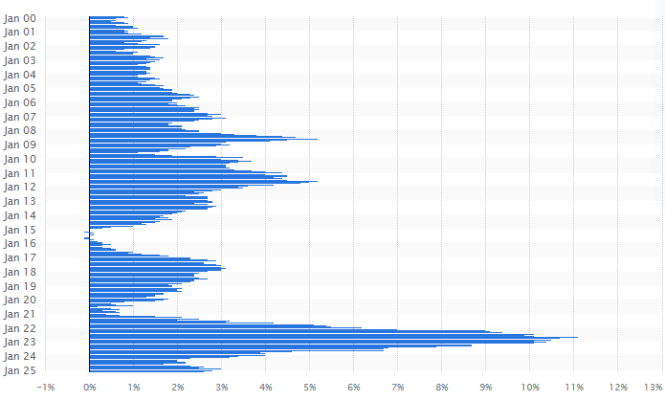
Figure 2: Inflation rate in the UK
(Source: Statista, 2025)
Environmental Factors: The UK government has initiated the “Environmental Protection Act 1990” that focuses on securing the environment through eco-friendly practices and net-zero carbon emission (Legislation.gov.uk, 2025). Environmental consciousness is a crucial aspect in the hospitality sector with the guests demanding sustainable practices including water conservation, eco-friendly rooms and energy-effective lighting. Adelphi Hotel under Britannia Hotel Chain limits the public commitments to the different green practices. The hotel has not engaged in advertising the recycling initiatives, energy saving and green certification innovation. This leads to limited engagement of environmentally conscious customers in the hospitality sector.
Political Factors: The UK government has been involved in reducing VAT by 6% in the hospitality sector (GOV.UK, 2022). The labour shortages have involved dealing with the retention and recruitment challenges in the hospitality sector. Hotels encounter an increasing cost in training and recruiting staff and report shortages of skilled hospitality employees (Giousmpasoglou and Marinakou, 2024). Hotels like Adelphi Hotel, this leads in a decline of service quality and issues of cleanliness as creates a minimisation of the slow services and room maintenance. The ongoing war between Russia and Ukraine faces a negative impact on the hospitality sector due to their disruption of trade facilities.
Legal Factors: The government of the UK has initiated the “Health and Safety at Work Act 1974” that ensures the safety and maintenance of hotel staff in the hospitality industry (Hse.gov.uk, 2024). Hospitality organisations deal with safety, accommodations and health including fire regulations, safety building and cleanliness. The negligence to comply with the legislation leads to reputational damage and fines. The negative reviews create a breach of hygiene standards that creates an exposure of legal risks within Adelphi Hotel. The UK government has also initiated the “Consumer Protection Act 2015” that needs businesses to deal with services and products (Legislation.gov.uk, 2023). The high imposition cost of the legislation creates a negative impact.
Ethical Factors: In the hospitality sector ethical business practices include staff responses of customer service, transparency and staff’s fair treatment and CSR (Saxena et al., 2025). The repeated low scores of Britannia and negligence of responses include limitation of ethical accountability and the care aspect of guest-focused. Through negligence of the guest complaints and reducing the improvement in investments, Adelphi Hotel faces the breach of ethical service expectations (Macmahon, 2022).
Demographic Factors: The increasing generational travel is shifting the preferences of accommodation. The families and older customers demand accessible, clean and comfortable environments with the different amenities that deal with the different needs (Noordzife, 2014). The negligence of comfort and room quality of Adelphi faced within the feedback of guests creates an influence within the demographic trends. As compared, hotels that sustain the family and older travellers with the adopted room and service face repeat and engagement bookings.

SWOT Analysis
SWOT Analysis
Strengths | Adelphi Hotel, Liverpool includes historical significance as it is close to cultural sites, nightlife and transport links. The historical significance is the potential strength as famous personalities chose their hotel which adds heritage appeal that leads in attracting tourists. The other strength is large capability with more than 65 rooms and wider public areas (Adelphi Hotel, 2022). The hotel is effective in hosting events, group bookings and conferences that helps in maintaining a competitive advantage in situations if it is properly managed.
Weaknesses | The major weakness that is faced by Adelphi Hotel is poor maintenance and cleanliness as criticism from the customers is regarded as outdated furnishings, poor hygiene and mould presence (Macmahon, 2022). The weakness creates an influence on the experiences of customers and satisfaction score. The other weakness is reputational damage as the organisation has been ranked as the worst hotel chain for the last 10 years that reduces the booking intent and trust of customers (Akhtar and Siddiqi, 2024). Adelphi Hotel faces the weakness of limited service and technological innovation. As compared with the competitors, the hotel limits online tools of feedback, modern amenities and digital check-ins that creates limitations in attractiveness to the travellers (Dixit, 2025).
Opportunities | Adelphi Hotel faces the opportunity of increasing growth of tourism in Liverpool. With the increasing popularity of Liverpool as a crucial tourist destination, the hotel can increase their capitalisation based on football standards. The other opportunity is branding and refurbishment revival as modernisation investment, service quality and sustainability can help in rebranding the business as an experience of heritage luxury (Melhuish, 2022).
Threats | The organisation possesses the threat of competitor growth as different brands including Premier Inn are demand string reputations providing service, value and comfort. Adelphi Hotel also faces the threat of online reviews and negative publicity as poor online reviews creates an influence that declines the engagement of guests influencing profitability (Britanniahotels.com, 2025).
Table 1: SWOT Analysis
(Source: Adelphi Hotel, 2022)

TOWS Analysis
TOWS Analysis
Strengths - Opportunities | The strength of Adelphi Hotel can create the opportunities through enriching the central location and historical value for repositioning the business as a heritage-based experience (Britanniahotels.com, 2025). This can involve attracting history and cultural enthusiasts. The use of the large capacity to conduct conferences, heritage tours and host events deals with the growth of Liverpool’s tourism sector.
Weaknesses - Opportunities | The weakness can be solved through dealing with outdated and cleanliness facilities through targeted refurbishment that will be supported by tourism grants of government and partnering with local business (Seow et al., 2024). The weakness will create the opportunities through including tech upgrades and eco-friendly innovation to Austin the guest expectations and engaging environmentally-friendly conscious travellers.
Strengths - Threats | The threats and strengths can be managed through encouraging the scale and location of the hotel with the help of marketing campaigns to deal with the nearby hotels. The improvement can also be done through providing discounted packages on heritage to create a differentiation from the different budget hotel chains including Premier Inn through retaining the competitiveness in pricing structure (Nag and Mishra, 2025).
Weaknesses - Threats | The strategy can be initiated by Adelphi Hotel through launching a campaign on reputation recovery which will include transparency regarding improvements and responding towards online reviews. Through implementing staff training initiative can help in enhancing the service standards and minimising negative feedback while managing the poor operations and customer service (Fayyaz et al., 2025).
Table 2: TOWS Analysis
(Source: Britanniahotels.com, 2025)

Recommendations and Change Management
For transforming Adelphi from its reputation for being the worst in the UK hotel chains to one of the notable hospitality establishments, significant transformations are necessary. In this strategy emphasis needs to be given on several aspects like improving service quality, technological upgrades on business operations, repositioning the brand, and so on (‌Ezechi et al., 2025). Each of these elements look into addressing major causes that have resulted in this hotel for being known as highly underperforming.
In the case of service quality improvements, above discussions have shown how Adelphi is performing poorly in the case of service delivery. There were several instances where guests reported unresponsive behaviour from staff, services getting delayed, not having a sense of personalised attention towards customers, and so on. These are elements that need to be focused on in a hotel setting since they are directly connected to customer satisfaction and business reputation (Alharbi et al., 2025). Therefore, in order to make improvements in these elements the management at Adelphi can focus on providing workers with appropriate training programmes. In these training sessions, emphasis should be put on understanding cultural norms, communication skills, interactivity, and more. These are necessary for maintaining proactiveness in customer service. This will help staff in such hotels become confident and efficient in customer service. Similarly, it is also important to maintain standardisation in business operations (Abuelhassan and AlGassim, 2022). Having standard operating procedures for each task in the hotel setting is necessary. SOP provides structured guidelines regarding service benchmarks, response times, hospitality protocols, and so on. There were instances regarding cleanliness issues in the hotel. Many customers called it “tired and tatty” (Parveen, 2022). Therefore, making employees follow a structured guideline can help management ensure that these issues do not occur in future when it comes to customer services. In this context, implementing a Customer Relationship Management system is another approach organisations like Adelphi can look into. These are tools that can help with collecting customer information and analysing them so that better services can be provided (Adnan et al., 2021). In this way the business can resolve their service-related issues. Aside from this, regular audits are also necessary. In this context operational managers can focus on identifying any bottlenecks in existing processes. This will be helpful for coming up with targeted intervention measures.
In the case of operational improvement, as mentioned before, Adelphi has become a business that has been utilising outdated frameworks for their business operations. In the modern digital world, utilising legacy systems manual processes for tasks like booking, check-in and check-out process payment systems and so on makes overall operations extremely slow. This results in delaying responses to customers (Oliinyk et al., 2022). This is another issue that results in damaging brand image. In order to address these issues, organisations like Adelphi in Liverpool can invest more in upgrading their existing technologies. For example, utilising technologies like artificial intelligence can help with automating many manual tasks like check-in and check-out process, payment system, and so on (Kim et al., 2021). This significantly improves service speed. Another approach can be utilising cloud-based platforms. With these, such businesses can provide a more user-friendly experience to their guests. Automating manual labour tasks can help with shifting their human resources to other customer-focused areas (Kambur and Yildirim, 2023). This will be helpful for organisations like Adelphi to showcase their dedication towards improving customer relationships.

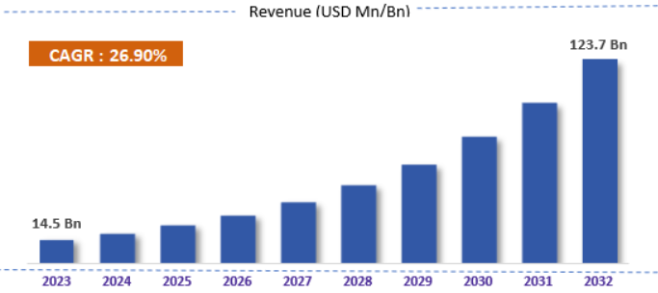
Figure 3: Global influencer marketing revenue projection
(Source: Zionmarketresearch.com, 2025)
Similarly, for brand positioning, it is important for such businesses to conduct rebranding campaigns. In this context, major backlash for Adelphi was constant negative coverage in media publications. Along with that, several customer reviews also mentioned their dissatisfaction regarding the quality of the services they receive from the hotel (Williams, 2022). Therefore, it is essential for such businesses to have a fresh start. In this context, having a rebranding strategy can help with refreshing the overall brand message to customers. For instance, messages need to provide information regarding how the business will be committing towards quality improvement, innovation, customer services, and so on. In all the marketing platforms these messages need to be consistent (Ernawati et al., 2022). In the context of the positioning, utilising digital technologies and social media platforms are vital. One notable approach here is that organisations like Adelphi can look into influencer marketing. Influencer marketing size is increasing rapidly. It is expected that by the end of 2032, it will reach $123.7 billion revenue figures globally (Zionmarketresearch.com, 2025). Keeping this in mind, this is a major recommendation for organisations like Adelphi to consider. Along with that, such businesses can also utilise popular social media platforms. As Sooksabai (2024), states, posting consistent brand messaging contents in major platforms like Instagram, TikTok, Facebook, and so on can be helpful for such businesses to increase their consumer reach.
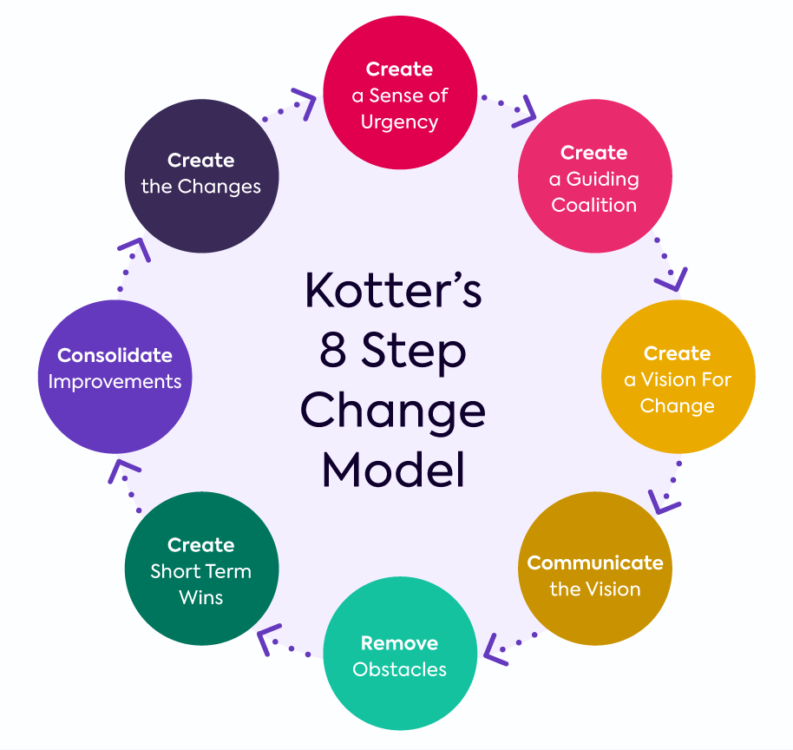
Figure 4: Kotter’s 8 step model
(Source: Radwan, 2022)
In the context of transformational change, one notable model is “Kotter’s 8-step change model”. When it comes to understanding issues, an organisation facing this model is highly effective (Burnes, 2014). In the case of Adelphi Hotel in Britannia Hotel Chain this systematic approach can be helpful for improving overall service quality and brand reputation. Primary emphasis in this model has been put on elements like urgency, leadership, clear vision, impounding employees, and more. It looks into 8 distinct steps in the change process (Radwan, 2022). It is relevant as making quality improvements in service delivery is essential for hotel organisations like Adelphi.
Creating a sense of urgency: In the case of organisations like Adelphi, the hotel management needs to have evidence regarding lower customer satisfaction, media backlash, cleanliness issues, and so on. This will help management showcase that taking urgent action regarding this is necessary (Whittington et al., 2020). In this context, it is important for management to organise regular meetings and discuss performance data. Customer testimonials are also vital for understanding performance gaps (Singgalen, 2025). With these initial steps, staff and management will be motivated for this transformation process
Building a guiding coalition: After developing the urgency, management in hotels like Adelphi needs to have a cross functional team for this change. In this guided coalition, team members should have people from diverse backgrounds like senior executives, commercial management, department heads, and so on. Having people from different departments will help develop robust strategies that will be applied for every aspect of the business (Della Corte et al., 2021). Their commitment in this change management will have a positive impact among consumers.
Developing vision and strategy: Organisational vision provides guidance to employees and management so that a business can sustain for long and reach its goals effectively (Buttrick, 2009). In this context, organisations like Adelphi need to ensure that their vision is focused on having a customer-focused approach. This will provide guidance to employees and workers regarding improving their customer-facing work. Management here also needs to develop measurable goals and targets for workers. This will create a structured guidance for employees to follow (Rajapakshe, 2024).
Communicating the vision: Maintaining seamless communication in the entire change management process is necessary. During a major operational change in a business, it is common for employees and workers to have doubts and concerns regarding their position in the workplace (Phillips and Klein, 2023). Keeping this in mind, management in organisations like Adelphi needs to communicate to their workers why this change is necessary. Along with that, how improving service quality will help the business maintain their reputation in the competitive hospitality industry needs to be communicated appropriately to workers. This will create a sense of motivation among people.
Removing obstacles: In the change management process, having potential obstacles is common. In the case of organisations like Adelphi, there can be potential resistance from workers. This usually happens when people get accustomed to a certain workflow (Rehman et al., 2021). However, to improve overall service quality, it is important for managers to ensure that this entire change process is supported by employees at every level. In this context, communication is vital. This can be helpful for understanding problems employees may face and solve them accordingly. As discussed before, in such hotel businesses, there are also issues like outdated technological infrastructure, manual processes, and so on (Baker and Stewart, 2025). These are the ideas for distance management processing to emphasise most. Employees need to be given appropriate training regarding how to maintain cleanliness when serving customers. This will help Adelphi reduce their quality management issues.
Generating short-term wins: Short-term wins are necessary for a large change management process to be successful. In this context, managers in hotel businesses like Adelphi can use a phased approach for this. Rather than focusing on improving overall service quality at the same time, the business can target one issue at a time and fix it appropriately. This will create a systematic approach for this change management process (Errida and Lotfi, 2021). For instance, in the case of improving cleanliness when serving customers, Employee training programmes can include lessons regarding hygiene factors in a hospitality setting. This will help hotel staff develop basic hygiene skills. Fixing issues one at a time like this will also develop a sense of short-term wins among people. This will build confidence when it comes to welcoming change management processes.
Consolidating improvements
Consolidating improvements and avoiding a return to previous practices are essential to extending the life of the Adelphi Hotel’s modifications. After these short-term accomplishments (clean governance, responsive personnel, updated booking systems) are done, management needs to integrate these early victories into the hotel’s operations and culture (Portocarrero and Burbano, 2024). Consolidation entails maintaining momentum, building on prior accomplishments, and continuously enhancing the actions and procedures that served as the foundation for the early triumphs. A systematic approach to consolidation includes performance evaluation metrics using Key Performance Indicators (KPIs), such as online review ratings, staff retention rates, customer happiness scores, and service delivery times (Kurki, 2023). The hotel will be able to track the impact of change initiatives and areas that require improvement with the help of these indicators. In order to foster the value of transformation and keep departments cooperating, managers must also acknowledge and reward those who support new practices. Internal communication should also be consistent and unambiguous. Success stories should be shared and driven via regular meetings and feedback forums. Newsletters and feedback forums should be used to acknowledge progress (‌Zamiri nd Esmaeili, 2024). This could be exemplified by how celebrating a 20% increase in TripAdvisor reviews or a 20% decrease in the number of complaints can inspire teams and strengthen their resolve to make changes (Sharkey et al., 2023). To prevent complacency and a return to outdated methods, the leadership team must continue to be present, accessible, and actively supportive at this time.
Anchoring new approaches
Integrating new organisational strategies into the Adelphi Hotel's culture is the final phase in an effective change management process. Making one-off projects standard operating practices is the simplest way to anchor change. This will be accomplished by coordinating performance reviews, training initiatives, and employee onboarding with the new standards and values established during the transformation process (Evans, 2024). For instance, if proactive service and guest-centricity are now top goals, the ideals must be represented in hiring practices and staff development programs. In order to anchor change, leadership is essential. Managers and team leaders must set an example by constantly striving to exhibit the desired behaviours and to set higher standards (Mouazen et al., 2024). One-on-one coaching sessions and regular staff briefings would support the maintenance of these cultural shifts. Institutional policies must be modified concurrently to take into account the new methods of operation (Nair et al., 2024). For example, tech-enabled customer service procedures, complaint escalation procedures, and hygiene checklists should be added to SOPs. These system modifications ensure that important practices continue even when employees leave.

Action Plan
The following action plan has been created for the Adelphi Hotel in order to successfully execute the suggestions made in this report. A blueprint for the efficient resolution of the aforementioned issues in terms of time and cost will be established by this methodical strategy, which will focus on important areas like service quality, cleanliness, technology advancements, and brand reputation (Nilashi et al., 2023). Every activity is practical and accountable since it has clear goals, anticipated results, deadlines, and cost estimates (Datta et al., 2024). The plan aims to break down the change process into manageable chunks while keeping momentum, which aligns with the transformation model that this consultant has adopted, notably Kotter’s 8-Step Model. Parts of the plan will be delivered by the responsible department heads and important team members, using performance indicators such as audit reports and scores on customer feedback to monitor its development.
Problem Area | Proposed Solution | Desired outcome | Timeline | Estimated Cost
Poor service quality | Staff training on hospitality standards, communication | Improved guest satisfaction, ensured repeat visits (Ali et al., 2021). | 0-3 months | £8,000
Hygiene and cleanliness | Implementation of daily checklists, audit routines, SOPs | Improved reviews and cleaner rooms | 0-2 months | £3,000
Outdated technology | Installation of digital check-in kiosks and CRM system | Improved feedback obtained, faster services | 3-6 months | £15,000
Damaged reputation of the brand | Rebranding campaign rollout using influencer partners | Higher visibility online and positive public image | 2-5 months | £12,000
Negative online reviews | Appointment of guest relations teams for feedback management | Proactive review management, complaints reduction (Hudson and Hudson, 2025). | 1-3 months | £4,000
Low staff engagement | Schemes for performance recognition and internal communication | Lower turnover with higher staff morale | 1-6 months | £2,500
Table 3: Action Plan for the Adelphi Hotel
(Source: Developed by the learner)
With the help of the action plan, some concrete tasks have been determined, while effectively reflecting practical acknowledgement of the financial capacity of Adelphi Hotel as well as its market position and operational threats. These solutions are proposed by designing with the focus of creating long-term meaningfulness with reinforced service-oriented organisation culture (Nocca et al., 2023). All aiming to enhance and restore the credibility of the hotel with aligned industry best practices-related operations.

Conclusion
The report has highlighted a discussion on the issue that is faced by Britannia Hotel chains including Adelphi Hotel in Liverpool. The issue within the organisation is caused due to customer satisfaction and decline of brand reputation. The report has highlighted discussion on the analysis of the organisation and their current situation. The issue that has been included in the analysis section focused on Adelphi Hotel’s brand reputation and image that influences the customer satisfaction, food and customer satisfaction. The report has also included the issue of cleanliness and maintenance failures as unhappy guests lead to a decline within the reputation of the business. The report has also included poor management of the feedback of customers as the negative form of feedback leads to decline in the responses of management. Another issue is financial implications within the business that declines their value. The report has also included the issue of limited scope depending on positive differentiation. The discussion has also included STEEPLED Analysis that included social factors which are influenced due to the shift within the demand of the customers causing bad reputation. Technological factors within the framework have included the influence of the automated system and the issue of Adelphi Hotel is faced due to the evolution of technology. Economic factors create an influence due to cost-of-living and inflation crisis and environmental factors create an influence due to the demand of sustainability by the guests as the hotel does not engage in environmentally-consciousness. It has also included political factors as changes in labour shortages and trade patterns creates an influence. Legal factors, ethical factors and demographic factors have also been included.
In order to ascertain the Adelphi Hotel’s internal strengths and weaknesses as well as external opportunities and threats, the report also contained a comprehensive SWOT analysis. Significant drawbacks like inadequate cleaning, antiquated amenities, and a damaged reputation were contrasted with the hotel’s unique advantages, which included its historical legacy and prime central location in Liverpool. Possibilities for rebranding or greater tourism from places like Liverpool point to the potential for recovery if adjustments are made in a timely manner. However, threats from other ‘aggressors’, such as Premier Inn, and the impact of unfavourable internet reviews continue to jeopardise the hotel’s sustainability. The emphasis on bridging the identified gaps within strategic actions and insights, the TOWS model played an intricate role in transforming determined weaknesses into implementable opportunities like modernising infrastructure through refurbishment grants and introduction of sustainability initiative for greater appeal. In light of this, the report included a comprehensive set of suggestions that were based on Kotter's 8-Step Change Model. These included established SOPs, employee training programs, digital infrastructure upgrades, and rebranding using CRM and influencer marketing. Creating urgency, forming a coalition, having a clear goal, and integrating new practices into the organisational culture were some of the change management strategies. The successful establishment of these tactics, the Adelphi Hotel can begin to improve its image, increase operational effectiveness, and re-establish itself as a top-tier, competitive sector of the Liverpool hospitality market.

References
Abuelhassan, A.E. and AlGassim, A., (2022). How organizational justice in the hospitality industry influences proactive customer service performance through general self-efficacy. International Journal of Contemporary Hospitality Management, 34(7), pp.2579-2596.
‌Adelphi Hotel., (2022). ROOMS - The Adelphi Hotel. [online] The Adelphi Hotel - Luxury Hotel, Place to Stay in Saratoga Springs, NY. Available at: https://theadelphihotel.com/rooms/ [Accessed 8 May 2025].
Adnan, A.Z., Rahayu, A., Hendrayati, H. and Yusuf, R., (2021), February. The role of electronic customer relationship management (E-CRM) in improving service quality. In Journal of Physics: Conference Series (Vol. 1764, No. 1, p. 012051). IOP Publishing.
‌Akhtar, N. and Siddiqi, U.I., (2024). Effects of service providers’ self-disclosure on booking platforms on consumers’ trust, hesitation, and booking intentions: moderating role of social media influencers. Journal of Hospitality Marketing & Management, 33(4), pp.470-498.
Alharbi, R., Alshreef, R., Alhashmi, R., Alkhalaf, M. and Elhaj, S., (2025), February. Improving the Quality of Services and Increasing Customer Satisfaction in the Hotel. In 2025 2nd International Conference on Advanced Innovations in Smart Cities (ICAISC) (pp. 1-6). IEEE.
Ali, B.J., Gardi, B., Othman, B.J., Ahmed, S.A., Ismael, N.B., Hamza, P.A., Aziz, H.M., Sabir, B.Y., Sorguli, S. and Anwar, G., (2021). Hotel service quality: The impact of service quality on customer satisfaction in hospitality. International Journal of Engineering, Business and Management, 5(3), pp.14-28.
Baker, H. and Stewart, G. (2025). Hotel chain named worst in the UK for 11 years running sees profits fall after ‘difficult’ trading. [online] Liverpool Echo. Available at: https://www.liverpoolecho.co.uk/news/uk-world-news/hotel-chain-named-worst-uk-31401359 [Accessed 8 May 2025].
Baker, H. and Stewart, G., (2025). Hotel chain named worst in the UK for 11 years running sees profits fall after ‘difficult’ trading. [online] Liverpool Echo. Available at: https://www.liverpoolecho.co.uk/news/uk-world-news/hotel-chain-named-worst-uk-31401359 [Accessed 8 May 2025].
Britanniahotels.com., (2025). Adelphi Hotel Liverpool | Official Britannia Site. [online] Available at: https://www.britanniahotels.com/hotels/the-adelphi-hotel-liverpool [Accessed 8 May 2025].
Britanniahotels.com., (2025). The Adelphi Hotel History | Britannia Hotels Official Site. [online] Available at: https://www.britanniahotels.com/hotels/the-adelphi-hotel-liverpool/history [Accessed 8 May 2025].
Burnes, B., (2014). 4th Edition, Managing Change, Great Britain, Prentice Hall.
Buttrick, R., (2009). The Project Workout, London: Prentice Hall.
‌Coffey, H., (2023). Hotel chain named the UK’s worst for 11th year running. [online] The Independent. Available at: https://www.independent.co.uk/travel/news-and-advice/worst-hotel-chain-uk-britannia-b2438312.html [Accessed 8 May 2025].
Datta, S.D., Islam, M., Sobuz, M.H.R., Ahmed, S. and Kar, M., (2024). Artificial intelligence and machine learning applications in the project lifecycle of the construction industry: A comprehensive review. Heliyon.
Della Corte, V., Aria, M., Del Gaudio, G., Barney, J.B., Cobanoglu, C. and Sepe, F., (2021). The relevance of relational capabilities in collaborative decisions. International Journal of Contemporary Hospitality Management, 33(12), pp.4391-4417.
‌Dixit, P., (2025). Tourism and Technology: The Future. Educohack Press.
Ernawati, N.M., Vodă, M., Jendra, I.W., Tantri, G.A.D. and Avram, E.L., (2022). Hotel Recovery Post Pandemic: Is Rebranding Required?. Journal of Environmental Management & Tourism, 13(8), pp.2263-2270.
‌Errida, A. and Lotfi, B., (2021). The determinants of organizational change management success: Literature review and case study. International Journal of Engineering Business Management, 13, p.18479790211016273.
Evans, N.G., (2024). Strategic management for tourism, hospitality and events. Routledge.
‌Ezechi, O.N., Famoti, O., Ewim, C.P.M., Eloho, O., Muyiwa-Ajayi, T.P., Igwe, A.N. and Ibeh, A.I., (2025). Service quality improvement in the banking sector: A data analytics perspective. International Journal of Advanced Multidisciplinary Research and Studies, 5(1), pp.958-971.
Fayyaz, A., Liu, C., Xu, Y. and Ramzan, S., (2025). Effects of green human resource management, internal environmental management and developmental culture between lean six sigma and operational performance. International Journal of Lean Six Sigma, 16(1), pp.109-140.
Giousmpasoglou, C. and Marinakou, E., (2024). Human resources management in hotels. In The contemporary hotel industry: A people management perspective (pp. 129-158). Cham: Springer International Publishing.
‌GOV.UK., (2022). VAT: reduced rate for hospitality, holiday accommodation and attractions. [online] GOV.UK. Available at: https://www.gov.uk/guidance/vat-reduced-rate-for-hospitality-holiday-accommodation-and-attractions [Accessed 8 May 2025].
‌Hse.gov.uk., (2024). Health and Safety at Work etc Act 1974 - HSE. [online] Available at: https://www.hse.gov.uk/legislation/hswa.htm [Accessed 8 May 2025].
Hudson, S. and Hudson, L., (2025). Customer service for hospitality and tourism. Goodfellow Publishers Ltd.
Kambur, E. and Yildirim, T., (2023). From traditional to smart human resources management. International Journal of Manpower, 44(3), pp.422-452.
Khan, F., Yusoff, R.M. and Kakar, P., (2025). Impact of service quality and customer satisfaction on tourism industry. Journal of Advanced Research in Social and Behavioural Sciences, 39(1), pp.1-11.
Kim, H., Hong, H., Ryu, G. and Kim, D., (2021). A study on the automated payment system for artificial intelligence-based product recognition in the age of contactless services. International Journal of Advanced Culture Technology, 9(2), pp.100-105.
Kurki, M., (2023). Determining KPI’s for learning as a service business.
‌Legislation.gov.uk., (2023). Consumer Rights Act 2015. [online] Available at: https://www.legislation.gov.uk/ukpga/2015/15/contents [Accessed 8 May 2025].
‌Legislation.gov.uk., (2025). Environmental Protection Act 1990. [online] Available at: https://www.legislation.gov.uk/ukpga/1990/43/contents [Accessed 8 May 2025].
Lloyd, D., (2022). Why has the Adelphi become Liverpool’s dirty secret? [online] The Post. Available at: https://www.livpost.co.uk/why-has-the-adelphi-become-liverpools/ [Accessed 9 May 2025].
‌Macmahon, A., (2022). Britannia is named the UK’s worst hotel chain for TENTH year running. [online] Mail Online. Available at: https://www.dailymail.co.uk/travel/travel_news/article-11404151/Britannia-named-UKs-worst-hotel-chain-TENTH-year-running-Premier-Inn-No1.html.
‌McCallister, R., (2022). Britannia named worst UK hotel chain for 10th year in a row - with faulty toilets and mouldy rooms. [online] Birmingham Live. Available at: https://www.birminghammail.co.uk/whats-on/whats-on-news/britannia-named-worst-uk-hotel-25466938 [Accessed 8 May 2025].
‌Melhuish, C., (2022). HERITAGE IN URBAN DEVELOPMENT. Critical Approaches to Heritage for Development.
Mouazen, A.M., Hernández-Lara, A.B., Abdallah, F., Ramadan, M., Chahine, J., Baydoun, H. and Bou Zakhem, N., 2024. Transformational and transactional leaders and their role in implementing the Kotter change management model ensuring sustainable change: An empirical study. Sustainability, 16(1), p.16.
Nag, A. and Mishra, S., (2025). Heritage-Led Destination Management: Strategies for Competitive Advantage. In Cases on Effective Destination Management (pp. 285-324). IGI Global Scientific Publishing.
Nair, M., Svedberg, P., Larsson, I. and Nygren, J.M., (2024). A comprehensive overview of barriers and strategies for AI implementation in healthcare: mixed-method design. Plos one, 19(8), p.e0305949.
Nilashi, M., Keng Boon, O., Tan, G., Lin, B. and Abumalloh, R., (2023). Critical data challenges in measuring the performance of sustainable development goals: Solutions and the role of big-data analytics. Harvard Data Science Review, 5(3), pp.1-36.
Nocca, F., Bosone, M., De Toro, P. and Fusco Girard, L., (2023). Towards the human circular tourism: recommendations, actions, and multidimensional indicators for the tourist category. Sustainability, 15(3), p.1845.
Noordzife, G., (2014). Project Management of Hotel Opening Processes: Exploring Better Ways to Manage New Hotel Openings, CreateSpace.
Oliinyk, O., Krasovskyi, S., Vasylenko, O., Prykhod'ko, K., Pliuta, O. and Tonkykh, O., (2022). Digitalization of business processes in the hospitality industry. Economic Affairs, 67(4s), pp.725-733.
Parveen, N., (2022). Britannia named worst UK hotel chain for tenth year in a row. [online] the Guardian. Available at: https://www.theguardian.com/travel/2022/nov/09/britannia-named-worst-uk-hotel-chain-for-tenth-year-in-a-row [Accessed 8 May 2025].
Phillips, J. and Klein, J.D., (2023). Change management: From theory to practice. TechTrends, 67(1), pp.189-197.
Portocarrero, F.F. and Burbano, V.C., (2024). The effects of a short-term corporate social impact activity on employee turnover: Field experimental evidence. Management Science, 70(9), pp.5871-5895.
Radwan, H.R.I., (2022). Factors influencing the implementation of organizational change management in large Egyptian hotels: Mediating effects of employee engagement. The International Journal of Tourism and Hospitality Studies, 3(2), pp.77-103.
Rajapakshe, W., (2024). Performance Management Process: Performance Planning and Monitoring. In Employee Performance Management for Improved Workplace Motivation (pp. 31-56). IGI Global.
Rehman, N., Mahmood, A., Ibtasam, M., Murtaza, S.A., Iqbal, N. and Molnár, E., (2021). The psychology of resistance to change: The antidotal effect of organizational justice, support and leader-member exchange. Frontiers in psychology, 12, p.678952.
Saxena, D., Sinha, C.N., Bajpai, S., Singh, U.P. and Prakash, A., (2025). Corporate Social Responsibility Approaches to Ethical AI in Hotel Industry Business. In Corporate Social Responsibility Approaches to Ethical AI in Business (pp. 263-276). IGI Global Scientific Publishing.
Seow, A.N., Choong, Y.O., Low, M.P., Ismail, N.H. and Choong, C.K., (2024). Building tourism SMEs' business resilience through adaptive capability, supply chain collaboration and strategic human resource. Journal of Contingencies and Crisis Management, 32(2), p.e12564.
Sharkey, A., Kovács, B. and Hsu, G., (2023). Expert critics, rankings, and review aggregators: The changing nature of intermediation and the rise of markets with multiple intermediaries. Academy of Management Annals, 17(1), pp.1-36.
Singgalen, Y.A., (2025). Uncovering Service Gaps in Hospitality: A Thematic Analysis of Guest Reviews for Service Quality Improvement. Journal of Business and Economics Research (JBE), 6(1), pp.105-117.
Sooksabai, P., (2024). A comparative content formats effectiveness on Instagram and TikTok platform which affect to target audience, reach, and followers on Magical Stories.
Statista., (2025). UK inflation rate 2025| Statista. [online] Available at: https://www.statista.com/statistics/306648/inflation-rate-consumer-price-index-cpi-united-kingdom-uk/ [Accessed 8 May 2025].
The Elite Venue Selection. (2025). Adelphi Hotel - The Elite Venue Selection. [online] Available at: https://theelitevenueselection.co.uk/adelphi-hotel/ [Accessed 8 May 2025].
The Institute of Customer Service. (2023). UK Customer Satisfaction Index The state of customer satisfaction in the UK. [online] Available at: https://lp.instituteofcustomerservice.com/hubfs/ICS%20UKCSI%20Main_Report_July_2023_ONLINE.pdf.
Whittington, R., Regnér, P., Angwin, D., Johnson, G. and Scholes, K., 2020. Exploring strategy. Harlow: Pearson Education Limited.
Williams, O., (2022). Staying at Adelphi ‘like a throwback to The Shining’ as Britannia named worst hotel chain. [online] Liverpool Echo. Available at: https://www.liverpoolecho.co.uk/news/liverpool-news/staying-adelphi-like-throwback-shining-25472137 [Accessed 8 May 2025].
‌Zamiri, M. and Esmaeili, A., (2024). Methods and technologies for supporting knowledge sharing within learning communities: A systematic literature review. Administrative Sciences, 14(1), p.17.
Zionmarketresearch.com., (2025). Available at: https://www.zionmarketresearch.com/content/uploadedimages/global-influencer-marketing-platform-market-size.png [Accessed 8 May 2025].

