
Name: Md Easin Hossen
Student Id: 2419904

Module Name: Marketing Management
Module Code: LCMB7024

Lecturer’s Name: Dr. Jaya Gopalkrishnan
Assignment Title: Marketing Portfolio
Submission date: 17th of December 2025 by 2pm

Table of Contents
1. INTRODUCTION 1
2. ELEMENT 1: STDP ANALYSIS 1
2.1 Company Background and New Brand Concept 1
2.2 Market Trends and Consumer Behaviour 2
2.3 Market Segmentation 2
2.4 Target Audience 2
2.5 Differentiation Strategy 2
2.6 Positioning Strategy 3
3. ELEMENT 2: MARKETING MIX (4Ps) 3
3.1 Product Strategy 3
3.2 Price Strategy 4
3.3 Place (Distribution) Strategy 5
3.4 Promotion Strategy 6
4. ELEMENT 3: MARKETING STRATEGY PITCH 7
5. ELEMENT 4: REFLECTION 7
5.1 Brand Development Experience 7
5.2 Marketing Strategy Creation Process 8
5.3 Presentation Delivery Reflection 8
5.4 Skills Gained and Future Improvements 8
6. CONCLUSION 9
7. REFERENCES 9
8. APPENDICES 12
Appendix A: Marketing Strategy Poster 12

List of Tables
Table 1: Pricing Comparison of Electric Delivery Vehicles 4
Table 2: Distribution Channel Strategy for Samsung AutoOne 5
Table 3: Promotional Budget Allocation for Year 1 6

1. INTRODUCTION
Samsung is a global technology leader with strong expertise in electronics, smartphones, and battery technology. This portfolio presents Samsung AutoOne, a revolutionary electric delivery vehicle designed for urban professionals and delivery businesses. The global electric vehicle market is growing rapidly, driven by environmental concerns, government regulations, and technological advances (Hooley et al., 2020). AutoOne combines Samsung's artificial intelligence capabilities, connectivity solutions, and energy efficiency to create a competitive smart delivery vehicle. This portfolio critically evaluates the complete marketing strategy for AutoOne, including segmentation analysis, target market identification, differentiation approaches, comprehensive marketing mix, and reflective insights, demonstrating how Samsung can successfully enter the competitive electric vehicle industry.

2. ELEMENT 1: STDP ANALYSIS
Segmentation, Targeting, Differentiation, and Positioning (STDP) framework helps companies identify market opportunities and create competitive advantages in specific market segments (Hooley et al., 2020). This section examines Samsung's company background, market trends, segmentation approach, target audience selection, differentiation strategy, and positioning for AutoOne.

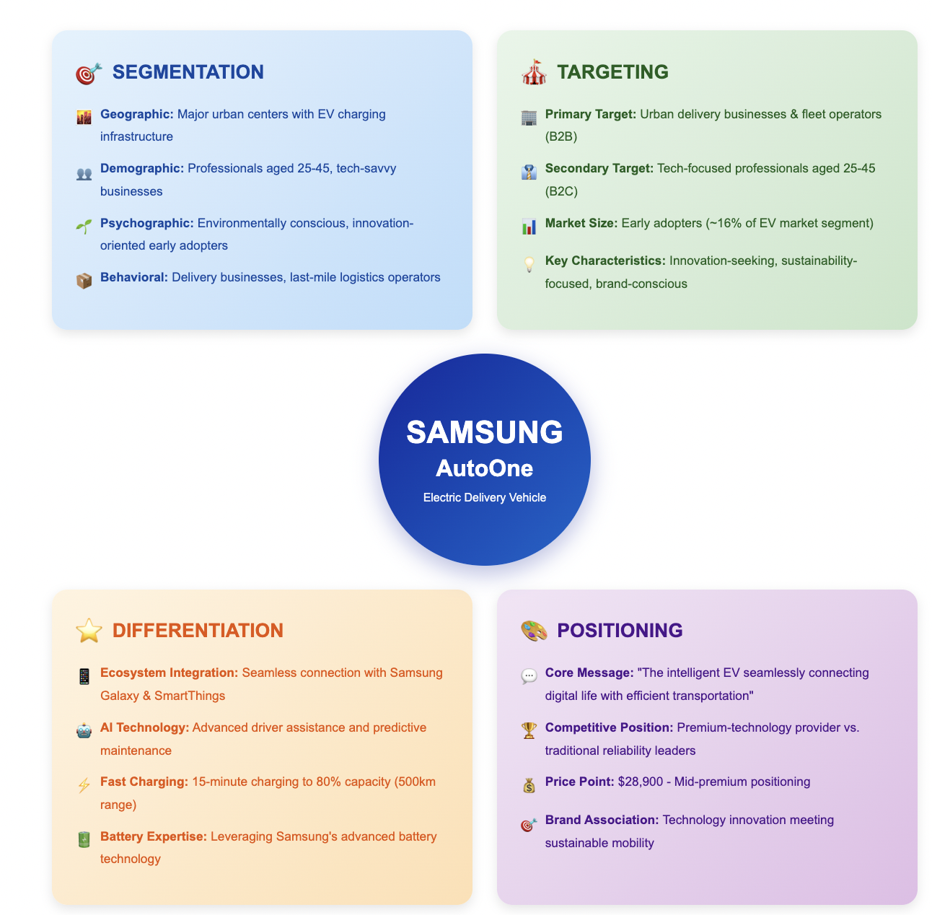

Fig1: STDP Framework for Samsung AutoOne

2.1 Company Background and New Brand Concept
Samsung Electronics was founded in 1969 and is a South Korean multinational company known for consumer electronics, semiconductors, and telecommunications (Noui and Boucetta, 2025). Although Samsung is strong in technology, it has no experience in making cars. This creates both opportunities and risks. AutoOne is Samsung’s attempt to enter the electric vehicle (EV) market, offering a 500 km driving range and 15-minute fast charging (Haizar et al., 2020). However, brand extension is risky. Kapferer (2012) explains that brand extensions only succeed when a company’s core skills fit the new product category. Samsung is strong in batteries and software, but lacks experience in vehicle safety, regulations, and large-scale car production. To reduce these risks, Samsung would need strong partnerships with experienced automotive manufacturers.

2.2 Market Trends and Consumer Behaviour
The global EV market is growing fast, with an expected annual growth rate of 18.2% until 2030 (International Energy Agency, 2024). This growth is driven by environmental laws and better technology. However, many consumers still hesitate to buy EVs. They worry about driving range, charging stations, and total cost (Rezvani et al., 2015). This does not fully match AutoOne’s focus on advanced technology. Commercial buyers are even more cautious and prefer reliable vehicles over new innovations (Rogers, 2003). Fleet managers focus more on durability, maintenance cost, and resale value than digital features (Haizar et al., 2020).

2.3 Market Segmentation
AutoOne’s market segmentation shows several challenges. Geographic segmentation targets cities with charging stations, but charging access differs widely between locations (Hardman et al., 2018). Demographic segmentation focuses on professionals aged 25–45, but many in this group do not make vehicle purchase decisions. Psychographic segmentation targets environmentally aware early adopters, who make up about 16% of the market (Moore, 2014). Behavioural segmentation focuses on delivery businesses, but this market is already controlled by established competitors. Targeting early adopters means less competition but low sales volume, while mainstream markets offer scale but require strong trust and marketing investment.

2.4 Target Audience
Samsung AutoOne targets urban delivery businesses and technology-focused professionals aged 25–45. However, these two groups have different needs. Individual buyers want innovation and image, while businesses focus on cost, reliability, and efficiency (Kotler et al., 2024). These groups also require different marketing strategies (Weinstein, 2004). Small business fleets usually operate only 5–15 vehicles, which is not enough to meet Samsung’s target of selling 150,000 units per year. This shows a possible mismatch between the target audience and sales goals. Larger fleet partnerships or focused regional strategies may be better options.

2.5 Differentiation Strategy
AutoOne’s main differentiation is integration with the Samsung ecosystem, such as Galaxy phones and SmartThings (Yun et al., 2018). However, this advantage may not last long. Competitors like Tesla and BYD are offering similar features (Porter, 2008). Also, focusing on Samsung users could exclude many customers, reducing the market size by up to 65% (Statista, 2024). The 15-minute charging feature also depends on limited charging infrastructure. Most car buyers value reliability, safety, and service networks more than digital connectivity (Ries and Trout, 2001). This suggests Samsung may need to rethink its differentiation strategy.

2.6 Positioning Strategy
Samsung positions AutoOne as "the intelligent electric vehicle seamlessly connecting digital life with efficient transportation." While this leverages Samsung's brand equity, several positioning challenges exist. First, Samsung lacks automotive credibility, creating cognitive dissonance where consumers question vehicle quality despite trusting Samsung electronics (Keller, 2013). Second, the premium positioning at $28,900 competes against established brands with proven track records. Third, emphasizing connectivity may inadvertently position AutoOne as "technology experiment" rather than "reliable commercial vehicle." Alternative positioning emphasizing "trusted technology company applying proven battery expertise to sustainable transportation" might better leverage Samsung strengths while addressing credibility concerns. This positioning choice significantly impacts marketing communication effectiveness and requires validation through customer research before full market launch.

3. ELEMENT 2: MARKETING MIX (4Ps)
The marketing mix represents tactical tools companies use to implement marketing strategy in target markets through Product, Price, Place, and Promotion decisions (Baines et al., 2021). This section analyzes AutoOne's product features, pricing strategy, distribution channels, and promotional activities.

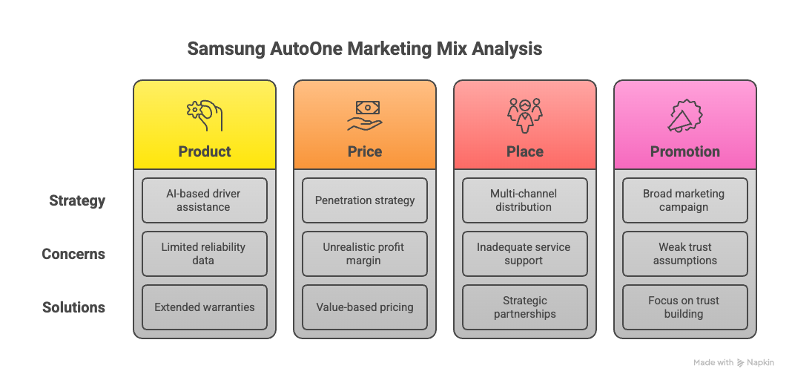
Fig 2: Marketing Mix (4Ps) Framework for Samsung AutoOne

3.1 Product Strategy
Samsung AutoOne offers a 500 km range, 3.5 cubic meter cargo space, and AI-based driver assistance linked with Samsung devices. While these features look strong, there are several product strategy concerns. First, a 500 km range is more than what most urban delivery vehicles need, as daily use is usually 150–200 km (Kotler et al., 2024). This may increase costs without real benefits. Second, the cargo capacity suits small deliveries but cannot handle large parcels, which limits the target market. Third, AI driver assistance raises safety and legal concerns during accidents, especially since Samsung has limited experience in vehicle safety (Chernev, 2020).
A major issue is the lack of proven reliability data. Business buyers usually want 2–3 years of real-world performance before investing (Armstrong et al., 2023). This creates a challenge for Samsung. Possible solutions include extended warranties, pilot fleet programs, or leasing options. Finally, the strategy ignores key service elements like trained staff, service processes, and service centers, which are very important in the automotive industry (Zeithaml et al., 2018).

3.2 Price Strategy
AutoOne's $28,900 pricing uses penetration strategy targeting rapid market share capture. However, this pricing approach involves significant risks and questionable assumptions.
Table 1: Pricing Comparison of Electric Delivery Vehicles
Vehicle Model | Price (USD) | Range (km) | Charge Time | Smart Features
Samsung AutoOne | $28,900 | 500 km | 15 min (80%) | Advanced AI, Full integration
Competitor A | $32,000 | 450 km | 30 min (80%) | Basic connectivity
Competitor B | $26,500 | 400 km | 45 min (80%) | Limited features

The pricing analysis shows AutoOne placed between premium and budget brands, but there are problems. First, a $6,900 profit margin (24%) is too hopeful for a new company without large-scale production. Tesla also lost money for years before making profit. Second, selling 150,000 cars in Year 1 and earning $4.335 billion seems unrealistic. For example, Toyota sold only 1,800 Prius cars in its first year. Third, the pricing ignores risks like trade tariffs, currency changes, and different regional laws. Lastly, low pricing may make people think the brand is low quality. Value-based pricing may work better long term.

3.3 Place (Distribution) Strategy
Samsung proposes multi-channel distribution combining company stores, online sales, B2B partnerships, and authorized dealers.
Table 2: Distribution Channel Strategy for Samsung AutoOne
Channel Type | Target Segment | Coverage | Year 1 Sales Target
Samsung Experience Stores | Individual professionals | 50 major cities | 30,000 units (20%)
Online Direct Sales | Tech-savvy customers | Global website | 45,000 units (30%)
B2B Fleet Partners | Delivery companies | Corporate contracts | 60,000 units (40%)
Authorized Dealers | General businesses | 200 locations | 15,000 units (10%)

This multi-channel plan covers the market, but it has major problems. Samsung Experience Stores do not have car sales skills, so staff need costly training (Armstrong et al., 2023). Online car sales are only about 4% worldwide, so a 30% online target is unrealistic (McKinsey, 2023). B2B fleet deals usually take 18–24 months, so getting 40% sales in Year 1 is unlikely. The biggest gap is service support. Cars need repair and maintenance. Building 100 service centers in Year 1 may cost around $150 million (Chernev, 2020). Dealers also need financing, commissions, and marketing. Tesla avoided some costs but faced legal limits. Samsung must choose between lower cost or faster market access.

3.4 Promotion Strategy
Samsung allocates $210 million for Year 1 marketing across digital, traditional, experiential, and sales promotion activities.
Table 3: Promotional Budget Allocation for Year 1
Promotion Tool | Budget Allocation | Activities | Expected Reach
Digital Marketing | $84 million (40%) | Social media ads, SEO, influencer partnerships | 18 million impressions
Traditional Advertising | $52.5 million (25%) | TV commercials, print ads in business magazines | 10 million viewers
Experiential Marketing | $42 million (20%) | Test drives, showroom events, trade exhibitions | 500,000 direct contacts
Sales Promotion | $31.5 million (15%) | Corporate discounts, early-bird offers, fleet incentives | 25,000 qualified leads

This promotional strategy is based on some weak assumptions. The 8–12% test drive conversion rate comes from traditional car brands with strong trust, which Samsung does not yet have in the automotive market (Kotler et al., 2024). Because of this, actual conversion is likely lower. Digital marketing also depends on accurate targeting, but commercial vehicle buyers do not use media the same way as consumer electronics buyers (Batra & Keller, 2016). Traditional ads reach many people but waste money on the wrong audience. Most importantly, the strategy does not focus enough on building trust. Improvements could include partnerships with trusted logistics companies, longer test periods, co-branding with known auto suppliers, and highlighting Samsung’s $50 billion R&D and battery expertise over connectivity features (Aaker, 2014).

4. ELEMENT 3: MARKETING STRATEGY PITCH
Marketing strategy pitches help explain a brand clearly and persuasively through good design and strong messages (Duarte, 2019). This section reflects on how the Samsung AutoOne pitch was developed and its main strategic ideas.
The Samsung AutoOne marketing pitch aimed to present the brand’s value to investors and customers using a visually structured poster. It highlighted six key areas: product strategy, customer-focused design, marketing effectiveness, technology investment, financial planning, and innovation. The poster was clean and attractive, making the information easy to understand at a glance.
However, the pitch also had some weaknesses. First, the poster format simplified complex strategies, risks, and trade-offs. This could lead stakeholders to expect results that may not be realistic (Osterwalder & Pigneur, 2010). Second, the pitch focused more on technology features than on solving customer problems, which is often more important for buyers. Third, the financial forecasts did not include different market scenarios, which reduced trust among experienced investors.
Stronger pitches balance excitement with honesty about challenges (Kawasaki, 2015). Including a section on risks and solutions would improve credibility. Real customer feedback from pilot users would also be more convincing than technical details. Finally, clearer calls-to-action should separate what investors are asked for from what customers are asked to do, since both groups need different information.

5. ELEMENT 4: REFLECTION
Reflection is a critical process where individuals review their experiences, understand what they learned, and identify areas to improve professional practice (Bolton, 2010). This section reflects on the brand development experience, marketing strategy creation, presentation delivery, and skills gained during the AutoOne portfolio project.

5.1 Brand Development Experience
Developing Samsung AutoOne helped me understand the challenges of brand extension and strategic thinking. At first, I assumed Samsung’s strong reputation in technology would easily work in the automotive market. However, research showed that customers do not automatically trust an electronics brand for vehicles (Kapferer, 2012). Kolb (2015) explains that real learning happens when assumptions are challenged, which occurred when I learned that commercial buyers value reliability more than innovation. This changed my thinking and helped improve my critical analysis. I also questioned whether Samsung should enter the automotive market alone or partner with existing car manufacturers. Acknowledging these weaknesses strengthened my overall strategy (Moon, 2004).

5.2 Marketing Strategy Creation Process
Creating the marketing strategy was challenging, especially balancing theory with real-world application. Gibbs’ (1988) reflective cycle helped me review each stage of learning. Initially, I applied STDP and the 4Ps framework without questioning their suitability. Later, I realized that vehicle marketing involves services, making the 7Ps framework more appropriate (Zeithaml et al., 2018). This showed improvement in my analytical thinking. I also faced difficulties with financial projections due to limited quantitative skills. Through peer feedback and further research, I refined my calculations. Schön’s (1983) reflection-in-action helped me understand that strong strategies need realistic, evidence-based assumptions rather than guesses.

5.3 Presentation Delivery Reflection
Preparing the presentation improved my communication skills but also revealed design weaknesses. Reynolds (2008) highlights the importance of clear visuals and simple messages. My first poster had too much information, which confused the audience. Peer feedback helped me realize that focusing on key points is more effective. Revising the poster taught me that removing unnecessary content is important. However, the final version still focused mainly on strengths and did not clearly show risks. In the future, I will include challenges and solutions to build trust and credibility. Cialdini (2006) explains that honesty and balance make presentations more persuasive.

5.4 Skills Gained and Future Improvements
This project helped me develop critical thinking, basic financial analysis, and strategic evaluation skills useful for marketing careers. I learned to question assumptions instead of accepting them quickly. Moon (2004) states that self-reflection helps people grow professionally. I also became aware of my confirmation bias, where I focused only on supporting information. However, I need to improve my financial modeling skills through further study. I also need more knowledge of the automotive industry and regulations. Following Gibbs (1988), I plan to study three industry case studies each month, attend automotive marketing webinars, and seek guidance from experienced professionals to improve these skills.

6. CONCLUSION
In conclusion, this portfolio reviews Samsung AutoOne’s marketing strategy and finds both chances and problems in entering the electric vehicle market. The STDP analysis shows the target group is eco-friendly urban professionals aged 25–45, but this group may be too small for Samsung’s high sales goals. The ecosystem-based differentiation is useful, but competitors can copy it quickly. The marketing mix shows weaknesses: too much focus on technology, weak service planning, high pricing expectations, limited service networks, and promotion that lacks trust-building. Overall, success needs honest thinking, realistic planning, and partnerships with experienced car makers.

7. REFERENCES
Aaker, D.A., 2014. Aaker on branding: 20 principles that drive success. New York: Morgan James Publishing.
Armstrong, G., Kotler, P., Harker, M. and Brennan, R., 2023. Marketing: an introduction. 15th edn. Harlow: Pearson Education Limited.
Baines, P., Fill, C. and Rosengren, S., 2021. Marketing. 6th edn. Oxford: Oxford University Press.
Batra, R. and Keller, K.L., 2016. Integrating marketing communications: new findings, new lessons, and new ideas. Journal of Marketing, 80(6), pp.122-145.
Bolton, G., 2010. Reflective practice: writing and professional development. 3rd edn. London: SAGE Publications.
Chernev, A., 2020. The marketing plan handbook. 6th edn. Chicago: Cerebellum Press.
Christensen, C.M., 2013. The innovator's dilemma: when new technologies cause great firms to fail. Boston: Harvard Business Review Press.
Cialdini, R.B., 2006. Influence: the psychology of persuasion. Rev. edn. New York: Harper Business.
Duarte, N., 2019. DataStory: explain data and inspire action through story. Hoboken: Wiley.
Gibbs, G., 1988. Learning by doing: a guide to teaching and learning methods. Oxford: Further Education Unit, Oxford Polytechnic.
Haizar, N.F.B.M., Kee, D.M.H., Chong, L.M. and Chong, J.H., 2020. The impact of innovation strategy on organizational success: a study of Samsung company. Asia Pacific Journal of Management and Education, 3(2), pp.93-104.
Hardman, S., Jenn, A., Tal, G., Axsen, J., Beard, G., Daina, N., Figenbaum, E., Jakobsson, N., Jochem, P., Kinnear, N., Plötz, P., Pontes, J., Refa, N., Sprei, F., Turrentine, T. and Witkamp, B., 2018. A review of consumer preferences of and interactions with electric vehicle charging infrastructure. Transportation Research Part D: Transport and Environment, 62, pp.508-523.
Hooley, G., Piercy, N.F., Nicoulaud, B. and Rudd, J.M., 2020. Marketing strategy and competitive positioning. 7th edn. Harlow: Pearson Education Limited.
International Energy Agency, 2024. Global EV outlook 2024. Paris: IEA Publications.
Kapferer, J.N., 2012. The new strategic brand management: advanced insights and strategic thinking. 5th edn. London: Kogan Page.
Kawasaki, G., 2015. The art of the start 2.0: the time-tested, battle-hardened guide for anyone starting anything. New York: Portfolio Penguin.
Keller, K.L., 2013. Strategic brand management: building, measuring, and managing brand equity. 4th edn. Harlow: Pearson Education Limited.
Kolb, D.A., 2015. Experiential learning: experience as the source of learning and development. 2nd edn. Upper Saddle River: Pearson Education.
Kotler, P., Keller, K.L., Brady, M., Goodman, M. and Hansen, T., 2024. Marketing management. 17th edn. Harlow: Pearson Education Limited.
McKinsey & Company, 2023. The future of automotive retail: the consumer perspective. [online] Available at: https://www.mckinsey.com [Accessed 10 December 2025].
Moon, J.A., 2004. A handbook of reflective and experiential learning: theory and practice. London: RoutledgeFalmer.
Moore, G.A., 2014. Crossing the chasm: marketing and selling disruptive products to mainstream customers. 3rd edn. New York: HarperBusiness.
Nagle, T.T. and Müller, G., 2018. The strategy and tactics of pricing: a guide to growing more profitably. 6th edn. Abingdon: Routledge.
Noui, F.Z. and Boucetta, Z., 2025. Marketing innovation and its contribution to achieving organizational excellence: a case study of Samsung. Revue des Economies financières bancaires et de management, 14(1), pp.379-399.
Osterwalder, A. and Pigneur, Y., 2010. Business model generation: a handbook for visionaries, game changers, and challengers. Hoboken: John Wiley & Sons.
Porter, M.E., 2008. Competitive advantage: creating and sustaining superior performance. New York: Free Press.
Reynolds, G., 2008. Presentation Zen: simple ideas on presentation design and delivery. Berkeley: New Riders.
Rezvani, Z., Jansson, J. and Bodin, J., 2015. Advances in consumer electric vehicle adoption research: a review and research agenda. Transportation Research Part D: Transport and Environment, 34, pp.122-136.
Ries, A. and Trout, J., 2001. Positioning: the battle for your mind. New York: McGraw-Hill.
Rogers, E.M., 2003. Diffusion of innovations. 5th edn. New York: Free Press.
Schön, D.A., 1983. The reflective practitioner: how professionals think in action. New York: Basic Books.
Statista, 2024. Global smartphone market share. [online] Available at: https://www.statista.com [Accessed 11 December 2025].
Weinstein, A., 2004. Handbook of market segmentation: strategic targeting for business and technology firms. 3rd edn. New York: Haworth Press.
Yun, J.J., Jeon, J., Park, K. and Zhao, X., 2018. Benefits and costs of closed innovation strategy: analysis of Samsung's Galaxy Note 7 explosion and withdrawal scandal. Journal of Open Innovation: Technology, Market, and Complexity, 4(3), p.20.
Zeithaml, V.A., Bitner, M.J. and Gremler, D.D., 2018. Services marketing: integrating customer focus across the firm. 7th edn. New York: McGraw-Hill Education.

8. APPENDICES

Appendix A: Marketing Strategy Poster


