LCMB 7001 MARKETING MANAGEMENT ASSIGNMENT TERM 1

ASSIGNMENT TITLE: ANALYSING and EVALUATING the CUSTOMER JOURNEY and SATISFACTION, CREATING BRAND AWARENESS and EQUITY for “TESCO OUTDOOR 6 PERSON TENT” FOR THE SOLE PURPOSE OF MEETING STAKEHOLDER’S EXPECTATIONS, FULFILLMENT, and IMPROVING THE SALES and PROFITABILITY OF TESCO PUBLIC LIMITED COMPANY.

STUDENT NAME: VICTOR IYAMABO

STUDENT ID NO: 1808348

LECTURER’S NAME: TUSHARA BALENDRAN

CONTENT PAGE
1, INTRODUCTION.
2, BACKGROUND AND MISSION STATEMENT OF TESCO PLC LIMITED.
3, DEFINITION OF COMMUNICATION.
3 (a), COMMUNICATION MODELS TO BE USED FOR THIS REPORT, INCLUDING DIAGRAMS TO ILLUSTRATE THE COMMUNICATION CHANNELS.
4, DEFINITION OF INTEGRATED MARKETING COMMUNICATION.
5, NEW PROMOTIONAL STRATEGIES USED BY TESCO PLC FOR THE “TESCO OUTDOOR 6 PERSON TENT”.
6, DEFINITION OF BRANDING AND BRAND EQUITY.
7, KELLERS BRAND EQUITY
7 (a), ADVANTAGES AND DISADVANTAGES OF KELLER’S BRAND EQUITY.
8, CUSTOMER’S JOURNEY AND CUSTOMER’S TOUCH POINTS.
9, CUSTOMER JOURNEY MAP FOR TESCO OUTDOOR 6 PERSON TENT.
10, STRENGHTS AND WEAKNESSES OF THE CUSTOMER JOURNEY MAP.
11, THE TOTAL ENGAGEMENT MODEL
12, CONCLUSION AND RECCOMMENDATION.
13, REFERENCES.

1, INTRODUCTION:
The purpose of this report is to critically analyse, evaluate and assess the Customer Journey and Satisfaction of “TESCO OUTDOOR 6 PERSON TENT”, produced and sold by Tesco PLC LIMITED. This report also aims to evaluate and critically assess the various creative, innovative and promotional marketing strategies used to raise awareness of the product brand. By so doing, the positive effects and unique qualities of the brand will be demonstrated to customers thereby building brand equity for the product. This will be done across a variety of communication channels.
The report will give a clear understanding of what Integrated Marketing is all about and define clearly the meaning of Branding and Brand Equity, before highlighting the new promotional strategies Tesco PLC can use in creating awareness of the brand. The use of Models is vital for illustration in this report and one of the Models to be used for branding is the “Keller’s Brand Equity” which will be done with a diagram and explanation. The Advantages and Disadvantages of the brand will also be made known. The next step will be to “analyse and evaluate” the Customer Journey and the 5 stages of the customer journey will be clearly explained with the Customer Journey Map included for a clearer understanding. The meaning and use of “Customer Touch Points” and the Strengths and Weaknesses of the Customer Journey Map will be included in this assignment.
The” Total Engagement Model” will be used in this report assessing and analysing Customer Satisfaction. Although Tesco is traditionally identified with the food industry, over the last few years they have been involved in producing brand products which has brought them into direct competition with other producers. With the customers having to make rational decisions before making a purchase, this report will highlight what Tesco needs to do to make the product successful. The report will end with a conclusion and recommendations will be given to the management of Tesco PLC
2, BACKGROUND AND MISSION STATEMENT OF TESCO PLC LIMITED:
TESCO’S BACKGROUND
Tesco Public Limited Company as it is presently known was started in 1919 by a market stall holder named Jack Cohen who sold groceries in London. He later merged with another Trader named T. E Stockwell, who he purchased Tea from, and they joined together and opened their first store in 1929 known as TESCO (The Times 100, 2020).
Since the merger, Tesco has grown and expanded over the years across many nations with its main base in the United Kingdom. It presently has 5000 stores around the world out of which 4074 are in the United Kingdom, with expansion still on going. The company also employs about 354,000 people worldwide. (Bedford E,2022).
TESCO’S MISSION STATEMENT: Tesco’s Mission Statement is geared towards bringing all the potentials of everyone connected with the organisation together in order to contribute towards the continued growth of the corporation. The important points in the company’s mission statement are 1, Improving the health of the company’s customers, 2, Improving lives, 3, Providing unique and quality Products and Services to its numerous customers. (Tesco annual reports, 2021, 2022).
1, The company does not compromise when it comes to the health of its customers. This is the main reason why the company takes its stocks directly from the farm groceries to ensure its freshness. Tesco also goes the extra mile in keeping all its sales outlets neat and tidy to protect the health and well-being of customers, employees, supplier’s management and visitors alike.
2, Improving Lives: Tesco has always been committed to creating a better environment through reaching out to the communities and colleagues anywhere it operates. Through the organisation’s “Little Helps Plan”, they have focussed on 3 main pillars which are People, Products and Places. This shows Tesco’s commitment in making the world a better place.
3, Unique Quality of Product and Services to its customers has been one of Tesco’s main selling points. Tesco has continually emphasized and demonstrated its passion and commitment towards delivering quality goods to its numerous customers and serving them better through its discount policies in its pricing without compromising quality. (Tescoplc.com, 2021).

3, DEFINITION OF COMMUNICATION:
Communication can be defined as the transformation of an information or message through speaking, writing, the telephone, mobile phone, social media or any other means that can be used to transmit a message from one person, a group or organisation to another. Communication can also be defined as exchanging information, messages or signals through talking, writing or gestures.
According to G. G Brown, communication is the transfer of information from one person to another that should be understandable to the person receiving the information. For the purpose of this research, emphasis will be placed on the business organisation communicating to its numerous customers or prospective customers to achieve customer patronage and brand awareness leading to improved sales and profitability of the business.

3 (a), COMMUNICATION MODELS TO BE USED FOR THIS REPORT, INCLUDING DIAGRAMS TO ILLUSTRATE THE COMMUNICATION CHANNELS:
Communication Models can be very useful in helping businesses and management of organisations communicate effectively. For the purpose of this report, the Shannon and Weaver Model of Communication will be used.
The Shannon-Weaver Model of Communication:
The Shannon and Weaver Model of Communication can be described as one of the most important models of communication presently used today for analysing the communication process in many well-established organisations. The Model was developed by Claude Shannon and Warren Weaver in 1948. The Model was initially designed as a linear model showing, with illustrations in a diagram explaining how communication takes place between a Sender and a Receiver.
The Model also known as the information Theory, was also used in engineering sector for calculating transmissions in Machines. It shows that the Sender initiates the communication and is the source of the information, which then relates through the brain and the lips in the form of a signal and is mixed with sounds and other distractions before it is finally received by the receiver. (Dickson G, Hendricks, B 2022). The diagram below illustrates the full explanation of the Shannon and Weaver Model.

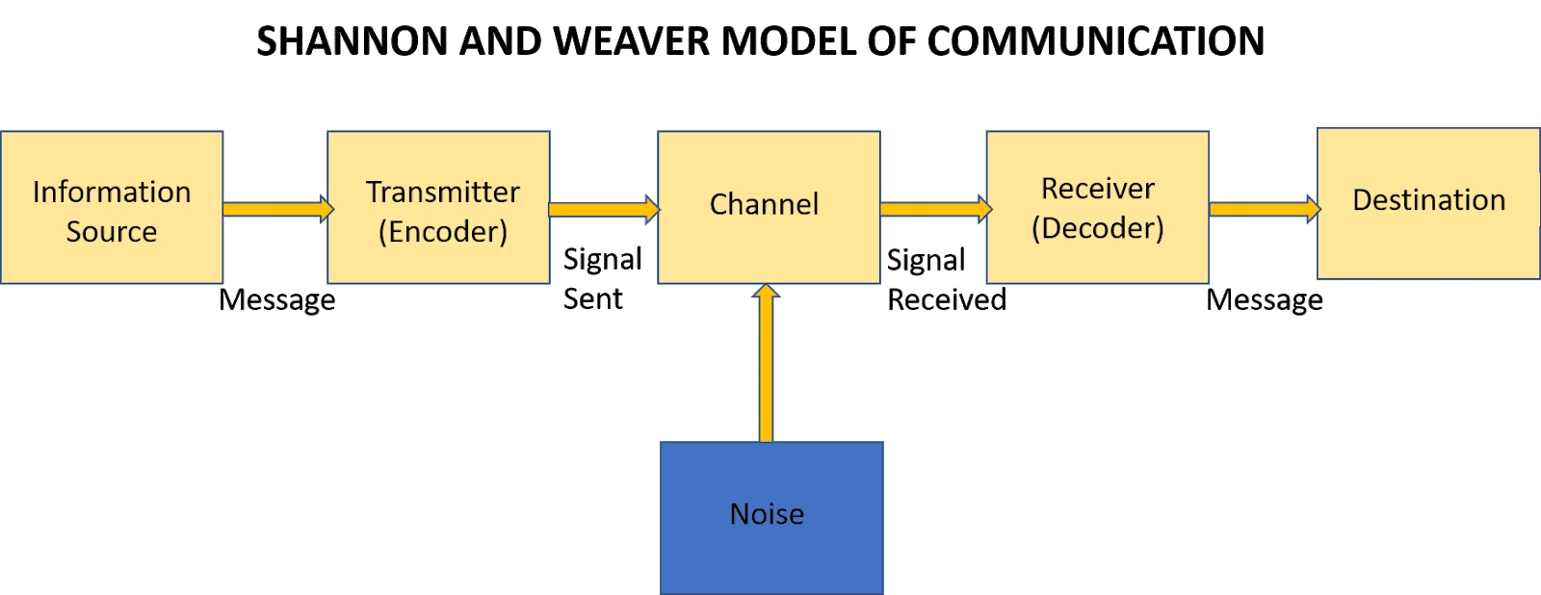
Reference: Communication Studies blog by Sis Michelle: Shannon and Weaver Model. 30th November 2018.

4, DEFINITION OF INTEGRATED MARKETING COMMUNICATION
Integrated Marketing Communication can be defined as a system where brand messages are put across through promotional methods, which are traditional and non-traditional. These promotional methods include online and offline strategies such as Facebook, Instagram, and other forms of social media advertising. Traditional methods include billboards, advertisements, sponsorships, public relations, sales promotions and all other forms of promoting the brand.
According to the American Marketing Association, Integrated Marketing Communication is a planning process that is made to ensure all customer brand contacts received by a company or prospective customer for a product or service is relevant to that company or person, and consistent over a period. (Davenport Debra, 2022).

5, NEW PROMOTIONAL STRATEGIES USED BY TESCO PLC FOR THE “TESCO OUTDOOR 6 PERSON TENT”
Tesco Public Limited Company has made use of both new Online and Offline promotional strategies to raise awareness of the “Tesco Outdoor 6 Person Tent”. While they may look like what others use, they had to analyse the market properly before coming up with these strategies. The online promotional strategies are mainly through digital marketing to ensure that the brand and its qualities are well known to prospective customers. Tesco has used its own website to showcase the product to Holiday makers, Families interested in Outdoor Camping and individual requests. The company also uses other websites such as hotukdeals.com, ukcampsites.co.uk, eBay, reevoo.com and a host of other sites. Most of the adverts highlights the unique qualities of their brand as compared to those of their competitors, thereby giving their valued customers the opportunity to compare and choose.
The Offline promotional strategies used are Direct Marketing, advertising which include radio and billboards, public relations such as selecting a family presently using the brand for their “Holiday Camping”, which is then shown on TV to showcase their brand. They have also used the radio which has been neglected for some time as a means of advertisement to create mass awareness in rural areas. Other forms of offline promotional strategies include sponsorship. Tesco sponsors some school kids holiday camp events where the “TESCO OUTDOOR 6 PERSON TENT “is used for the camping event. The main target market for this sponsorship are schools within the region.

6, DEFINITION OF BRANDING:
Branding can be defined as the method of creatively identifying the uniqueness of your Product or Service in the eyes of both customers and prospective customers to create greater awareness of the Product or Service. It can also be described as a process whereby you distinguish your business or service in the mind of your target audience or customers. This can be achieved through visual design of the company’s product, logo and its mission.
Other Methods of branding includes quality of your product or customer service, the pricing of your product or service and the company or organisations mission statement. Branding really helps to shape how and what people perceive about the product or service you offer. (www.shopify.com), 2022).

DEFINITION OF BRAND EQUITY:
Brand Equity can be defined as the value you create around a product or service that can bring out a positive effect or a negative effect in the mind of the target audience or customers. Brand equity is a basic factor that could help you increase the sales margin of your product by increasing how customers perceive the value of the product.
According to Samuel Timothy, Vice President of an inbound Marketing Agency One IMS, and co-founder of digital marketing intelligence platform named clickx, Brand Equity is the awareness created after companies and organisations have invested heavily in building their brand leading to an increase in the value of their products or services. An example of Branding is Apple Smartphone of the same Model and the same Functionality with Xiaomi smartphone, but the Apple Smartphone is 3 times more expensive than the Xiaomi Smartphone because of its brand name. (Timothy, S. 2021)
KELLERS BRAND EQUITY:
The Keller’s Brand Equity Model which is also known as the Customer-Based Brand Equity was developed was developed by Professor Kevin Lane Keller. In his book Strategic Brand Management, which was published in 1997, the model explains that in order to build a strong brand, you must change the way customers really feel, think and how they generally perceive the product. (Popovic, D. 2021).
KELLERS MODEL is explained clearly by the diagram below.

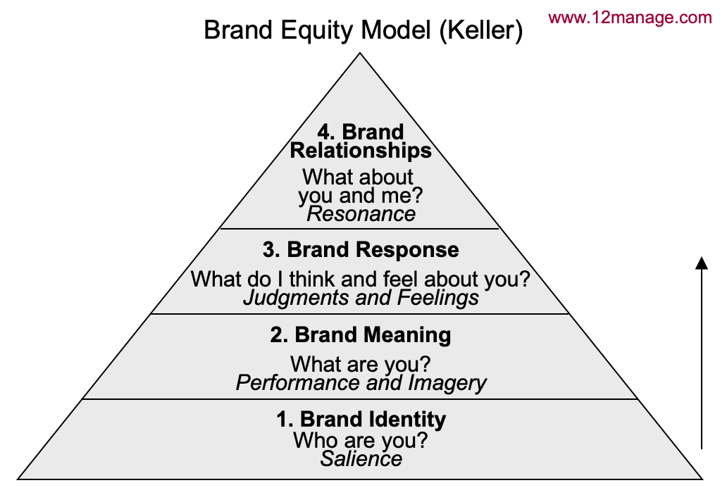

Explaining this model from the bottom to the top, the first step 1, is about the Positioning Strategy. This is about the image of the brand in the mind of customers and communicating about the brand with the right message. The brand name or logo should be explained clearly, including slogans associated with the brand.

2, The second step is the brand meaning. This is basically adding more meaning to your product or the service you provide. This is a step towards building loyalty with your customers or target audience. Examples of this is How much is your Company giving to society such as charities, environmental support etc. It is not just about the quality of your products or prices.
3, The third step is the brand response. It emphasizes on Customer feedback and their response when they buy or make purchases from your brand. The company must monitor their websites and their social media sites to see what customers are saying. They must build on their reputation based on the first 2 steps.

4, The fourth and final step is at the top of the brand pyramid which is relationship. This is highly based on the concept of resonance. The level of customer loyalty and communication must be continuous to build on the relationship.
Finally, the KELLERS Model sees building brand equity by any company or organisation as a very big opportunity creating a very high value for their product or service.

7 a, ADVANTAGES AND DISADVANTAGES OF KELLERS BRAND EQUITY:
ADVANTAGES:
The brand logo or Trademark is a huge basis for the company or organisation to continually make increased sales and profits for their brands.
The company or organisation can create long lasting relationships with the customer that can last for several years, and not just based on a single or short time purchase.
The value of the company’s products or service will increase tremendously compared to their competitors in the same industry.
Customers are now attached to your products and now have an emotional experience using your products as a result of the brand.

DISADVANTAGES:
PSYCOLOGICAL and SOCIAL IMPLICATIONS: There are psychological and social implications if any aspect of what the customer or target audience perceives about your product or service goes wrong. This has a widespread negative implication even though even though you may have taken a long period of time to build the brand.

8, CUSTOMER’S JOURNEY AND CUSTOMER’S TOUCH POINTS:
DEFINITION OF CUSTOMER JOURNEY:
A customer’s journey can be defined as the customer’s pathway which they make in their decision-making process towards purchasing a product or service. The customer journey is about all the stages the customer goes through before buying the product starting from being aware of the company or organisation selling the product, thoroughly finding out about the product before buying it, then actually using the product to know how good it is, before telling others of your experience about the product. (Insights for Professionals, 2022).
5 STAGES OF CUSTOMER JOURNEY:
The five stages of Customer Journey are Awareness, Consideration, Decision, Retention and Advocacy. They will be explained as follows; first with a diagram and a clearer explanation of all the stages below the diagram.
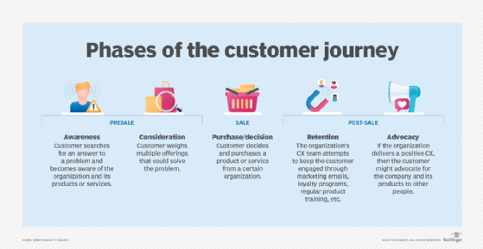

(techtarget.com)

AWARENESS:
This is the stage when the customer activates a potential need or want, and information is sought about how to solve the problem based on the awareness of the needs and wants. Marketers can leverage upon the use of paid adverts, the social media, emails, press releases, publicity and news articles to respond to the customers awareness.

CONSIDERATION and EVALUATION:
This is the process where the customer has done the internal and external information search, and now narrowing down their options by evaluating different brands. At this stage, customers may involve their families by asking for their opinion, may use social media, asking expert advice or other public sources to compare your product or service with those of your competitors.

DECISION:
This is the stage where a customer selects from their options and makes the purchase of the product or service from the company or organisation. The customer has now made the decision that the product can satisfy their needs and wants, For the marketer, product reviews are important at this stage.

RETENTION:
This stage is the ability of the organisation or company to retain their customers. The company tries to keep its customers through loyalty cards or programs, social media promotions, emails and regular promos on how best to use their products.

ADVOCACY:
This is the stage where the customer now becomes an advocate for the company’s brand. The customer now tells other people the positive qualities of the product.

DEFINITION OF CUSTOMER TOUCH POINT:
A Customer Touchpoint can be defined as any interaction the company’s brand or service has with the customer. Customer Touch points can be classified into 3 phases, Pre purchase, Purchase and Post purchase. These are explained below as follows.

Pre purchase:
These are Touchpoints before a purchase. These include 1, the use of social media, examples are Facebook and Instagram. 2, Direct online advertisements. 3, Company events to showcase your products. 4, Digital Marketing and Promotional content. 5, Referrals from colleagues and friends. 6, Promotional ideas to reach the customer.

Purchase:
These are Touchpoints during the purchase. They are1, Talking to salespeople. 2, Conversations had with representatives of the company. 3, Product Catalogues. 4, Product Reviews. 5, The company’s website. 6, Other websites. 7, Points of sale.

Post purchase:
These are Touchpoints after the purchase. They include 1, Letters to say Thank you for the patronage. 2, Subscription Renewals. 3, Product feedback surveys. 4, Upselling/cross-selling emails to constantly update the customers.

The Customer Touchpoints for “Tesco OUTDOOR 6 PERSON TENT” will be highlighted and explained in the Customer Journey map below.

9, CUSTOMER JOURNEY MAP FOR TESCO OUTDOOR 6 PERSON TENT:
DEFINITION OF CUSTOMER JOURNEY MAP:
A Customer Journey map can be defined as a visual diagram explaining every experience the company has with the customer making use of customer touchpoints. It is about the customers experience with your brand, with a view of engaging the customer in a long-term relationship.
BENEFITS OF THE CUSTOMER JOURNEY MAP:
The Customer journey map really helps the company to take notice of where the Customer interacts with their business so they can make improvements.
Helps focus the business on customer needs at various stages of the buying process.
Shows clearly the gaps between Customer experience and what is genuinely received.
Emphasizes development priorities.
5 BASIC STEPS IN CREATING A CUSTOMER JOURNEY MAP:
It is important to understand the basic steps of creating a customer journey map. They are:

First define who the customer is and how you expect them to use your system.
Define your customer phase.
Identify all the Touch Points.
Conduct research on the customer journey experience.
Determine the points of function.

CUSTOMERS JOURNEY MAP FOR TESCO OUTDOOR 6 PERSON TENT
This self-created Customer Journey map starts with a Tabular diagram explaining the customer journey experience for TESCO OUTDOOR 6 PERSON TENT with the Touchpoints in the customer journey.

CUSTOMER JOURNEY MAP | AWARENESS | CONSIDERATION | PURCHASE | RETENTION | ADVOCACY
WEBSITE | Tesco advertises Outdoor 6 Person Tent on website | Benefits and information of Outdoor 6 Person Tent highlighted on other websites
STORE | Billboards and flyers in all Tesco mega store about Outdoor 6 Person Tent |  | Purchase of Tesco Outdoor 6 Person Tent in store
EMAILS | Tesco sends emails about Outdoor 6 Person Tent |  |  | Emails sent about how to make best use of Tesco Outdoor 6 Person Tent
SOCIAL MEDIA |  | Facebook adverts about Outdoor 6 Person Tent |  |  | Forums on Facebook and Instagram post positive reports
POSTS and NEWSLETTERS |  |  |  | Letters sent by post thanking customers for their patronage
COMPANY EVENTS |  |  |  | Company events highlight Tesco Outdoor 6 Person Tent | Customer speaks on Outdoor 6 Person Tent in Tesco sponsored event.
WORD of MOUTH | Tesco’s sale reps talk about the benefits of the Outdoor 6 Person Tent |  |  |  | Existing customer of Outdoor 6 Person Tent.

10, STRENGHTS AND WEAKNESSES OF THE CUSTOMER JOURNEY MAP:
Looking at the Touchpoints from the diagram above, we must access it from the customer’s point of view to know the touchpoints that are working well (Advantages) and the touchpoints that are not working well (Disadvantages).

STRENGHTS (ADVANTAGES):
Touchpoints that worked well include the adverts placed on the Tesco billboards in their Megastores which attracted a lot of holidaymakers and school authorities who made the biggest patronage of the product from Tesco

The involvement of the Sales Representatives of Tesco also had a direct positive effect on the patronage and sales of the product. This is mainly because of their direct contact with prospective customers when they openly demonstrated the quality of the product during the sponsored events organised by Tesco PLC.

The use of existing customers who speak of the positive effects of the Outdoor 6 Person Tent during promotions events and on social media are Touchpoints that worked well.

WEAKNESSES (DISADVANTAGE):
The use of emails to advertise the Tesco Outdoor 6 Person Tent was not a Touchpoint that worked well. It did not yield positive results for the organisation because customers wanted more demonstration about the quality of the product before parting with their money to buy the product. Many customers had slight doubts, and some did not actually believe on what was written on the emails.

Companies must analyse both physical needs, emotional and rational needs customers will benefit from your products before mapping out a customer pathway in the customer journey. This will make the brand successful.

11, THE TOTAL ENGAGEMENT MODEL:
The Total Engagement Model is an integral strategic marketing model used for engaging and retaining the customer after the sales of a product or service. It is a key strategic design by companies and organisations to engage customers.
Companies and organisations face a lot of difficult challenges today that makes it very important to engage the customer after selling a product or service to them. We live in a competitive business world with increased media dilution, so companies must create engaged customers for them to remain loyal to your brand and for a long-term relationship in the use of your products. (Roberts, C. Alpert, F. 2010).
This diagram below will be used to explain all the concepts of the Total Engagement Model used by Tesco PLC for the Tesco OUTDOOR 6 PERSON TENT.

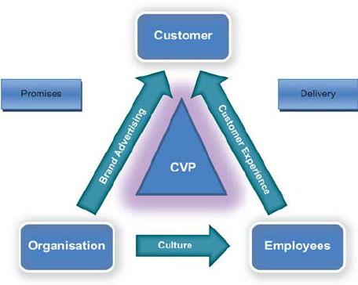
(ResearchGate, 2018).

The four key strategic concepts used by Tesco Plc was based on the collaboration between engaged employees of the organisation and engaged customers will be discussed below. From the arrows above, they are
1, Brand Advertising
2, Customer Experience
3, Culture
4, Customer-Value Proposition. (Based on the customer satisfaction)

1, BRAND ADVERTISING:
Tesco made use of positioning the Brand as a promotional strategy for the Tesco OUTDOOR 6 PERSONS TENT. This created a Brand image in the mind of their customers. They also used the social media, sales reps and corporate events to promote the Brand.

2, CUSTOMER EXPERIENCE:
The physical and emotional experience the employees of Tesco had with the customers in the advert and sales process of the OUTDOOR 6 PERSON TENT was a positive one. That experience helped them deliver good customer service.
3, CULTURE:

Tesco used a Decentralized Management Culture where the middle management that did most of the marketing job were decentralized and more freedom and rights were given to them to carry out their assignment. The corporate culture Tesco adopted was a significant factor to the results they achieved.

4, CUSTOMER-VALUE PROPOSITION:
The Tesco OUTDOOR 6 PERSON TENT has really given Customers value for their money. The price, quality and after sales services has been critical to customer gains. The Value Tesco has offered should make customers continue buying the product over what the competitors offer in the market.

CONCLUSION AND RECCOMENDATION:
To conclude this report, it is of my opinion that new Touchpoints can be created by Tesco PLC for Tesco OUTDOOR 6 PERSON TENT for increased patronage, sales and profitability.
New Touchpoints to be considered include direct marketing to social and cultural groups involved in Holiday camping both withing and outside schools and higher institutions of learning. These include Boy Scouts, Girls Guide, Brownies and other social and cultural groups that have regular holiday camping.

REFERENCES:
1, Hooley, Graham J. (2020) Marketing Strategy and Competitive Positioning. Seventh Edition. Published by Pearson Education Limited. Harlow, England.
2, THE TIMES 100. (2022) Background of Tesco PLC. (www.thetimes100.co.uk) Assessed 8-11-2022.
3, Bedford, E. (2022). How many Tesco Stores are in the UK? Published 27-12-2022.
4, Davenport, D. (2022) What is Integrated Marketing Communication (IMC). PURDUE UNIVERSITY ONLINE. (www.purdue.edu>blog) Assessed 27-11-2022.
5, Dickson, G. Hendricks, B. (2022) Shannon-Weaver Model of Communication. Updated 06-05-2022. (www.study.com/learn) Assessed 26-11-2022.
6, SHOPIFY. (2022). WHAT IS BRANDING? Branding Definition and Benefits. Published online 15-8-2022. (www.shopify.com) Assessed 16-12-2022.
7, Timothy, S. (2021) Branding Equity: WHY IT MATTERS AND HOW TO BUILD IT. Published 5-7-2021 by YEC COUNCIL POST.
8, Popovic, D, (2021) KELLERS BRAND EQUITY MODEL. Published online 1-9-2022 by Many Pixels/Blog (www.manypixels.co/blog/post/brand-awareness-model)
9, Roberts, C. Alpert, F (2010) TOTAL CUSTOMER ENGAGEMENT: Designing and Aligning Key Strategic Elements to Achieve Growth. Published June 2010 by ResearchGate. (www.researchgate.net) Assessed 1-1-2023.

