Programs in C and documentation
Software Development
ACCA4017

Author: Geraint Hill
Student Number: 9900497



Table of Contents
Introduction 3
Part C 3
Exercise 1 3
1 Pairs Game 3
1.1 Identify the problem 4
1.2Annotated Code 5
1.3 Testing 7
1.3.1 Normal Values – No Match 7
1.3.2 Normal Values – Match! 8
1.3.3 Non integer value 8
1.3.4 Values outside the grid 9
1.3.5 Same location selected 9
Conclusion 10

Introduction

As part of the Software Development module, this assignment has been handed to the author to assess his C Programming ability. In order to demonstrate that his program is working to the specification of the key exercises, the author used Microsoft Visual Studio to compile his code and provide the console output displayed in this report. This assignment is the author’s own work.

Part C

Exercise 1

Pairs Game

In this task, the author was required to create a program that resembled the “Pairs Game”. 4 rows and 3 columns of cards were required to be created and the player would then select the card they wanted to play each time. If the cards matched, then the board would print ‘M’ for match and take the cards out of the game. If the cards didn’t match, the user would be presented with a ‘-‘, and the game would resume.
This was the more complex of all the exercises.
The author organised his card as a struct called ‘card; which grouped the variables so that the state of the card could be used in the program (value of the card), If the card has been turned, and if the card has been found.
Two functions were created to organise the code.
Shuffledeck() is called at the start of the game, this would place the randomised cards into deck. The states of the card are set to false, and the card found variable is set to 0. The game begins.
Printboard() prints the board at the start of the game, and then throughout the game before the players next turn. The state of the board represented the state of play (whether the pairs had previously been identified or not). As there were 12 cards in the deck.
Main() Controls the flow of the game. The player is prompted for their choice via scanf and the printboard() is called after each completed selection. If the cards match, a score of 2 is allocated to the player, the while function in main() will proceed with the loop until all cards are found and the value of the cardsFound variable hits 12.

Identify the problem
- Define card structure int value, bool isVisible, bool isFound
- Prototype printBoard(), shuffleDeck
- Declare array deck
- Declare cardsFound and initialize to 0
- Declare int cardOneRow
- Declare int cardOneCol
- Declare int cardTwoRow
- Declare int cardTwoCol
//////////////////////////////////////////////////
- Shuffledeck()
- Declare int i
- Declare int j
- Declare int valueForCard (between 1 and 6)
- Loop until deck has been filled with random numbers
- Set cardsFound to 0
//////////////////////////////////////////////////
- Printboard()
- Declare int i
- Declare int j
- If deck isFound and isVisible is false
- Print ‘-‘
- If deck is found is false and deck is visible is true
- Print %d card value in deck
- If deck isFound is true
- Print match
- //////////////////////////////////////////////////
- Main()
- While cardFound is not equal to 12
- Get cardOneRow
- Get cardOneCol
- Printboard()
- Get cardTwoRow
- Get cardTwoCol
- Printboard()

1.2Annotated Code

#include <stdio.h>
#include<stdlib.h>
#include <time.h>

//structure for my card that provides number
// if the card has been seen
// if the card is found in the deck
struct card {
int value;
bool isVisible;
bool isFound;
};

void printBoard();
void shuffleDeck();

card deck[4][3];
int cardsFound = 0;

int cardOneRow;
int cardOneCol;

int cardTwoRow;
int cardTwoCol;

void main()
{
// Start the game

shuffleDeck();

// Start playing - until done
while (cardsFound != 12)
{
printBoard();

// Ask user for ROW/COL of card 1
printf("Choose a row for card 1 : between 0 and 3\n");
scanf("%d", &cardOneRow);
printf("Choose a column for card 1 : between 0 and 2\n");
scanf("%d", &cardOneCol);
deck[cardOneRow][cardOneCol].isVisible = true;
printBoard();

// Ask user for ROW/COL of card 2
printf("Choose a row for card 2 : between 0 and 3\n");
scanf("%d", &cardTwoRow);
printf("Choose a column for card 2 : between 0 and 2\n");
scanf("%d", &cardTwoCol);
deck[cardTwoRow][cardTwoCol].isVisible = true;
printBoard();

// Check Card1's value against Card2's value
// If they match, add score and set the matched cards to isFound
if (deck[cardOneRow][cardOneCol].value == deck[cardTwoRow][cardTwoCol].value)
{
// Increment cards found and set both cars to found
cardsFound += 2;
deck[cardOneRow][cardOneCol].isFound = true;
deck[cardTwoRow][cardTwoCol].isFound = true;
printf("MATCH!\n\n");
}
else
{
// Cards didn't match - set both cards back to face down
deck[cardOneRow][cardOneCol].isVisible = false;
deck[cardTwoRow][cardTwoCol].isVisible = false;
printf("No Match, Try again\n");
}

}

printf("WINNER!!WINNER!!");
}

void shuffleDeck()
{
int i;
int j;
srand(time(NULL));
int valueForCard;

for (i = 0; i < 4; i++)
{
for (j = 0; j < 3; j++) //loop that fills the columns and rows
{
deck[i][j].isFound = false; //card in play
deck[i][j].isVisible = false; //card in play
deck[i][j].value = valueForCard = 1 + rand() % 6;;

}
}

cardsFound = 0; //sets starting state of play
}

void printBoard()
{
int i;
int j;

for (i = 0; i < 4; i++)
{
for (j = 0; j < 3; j++)
{
// if the card is still in play but not visible to user
if (deck[i][j].isFound == false && deck[i][j].isVisible == false)
printf(" - ");

// if card is still in play but visible to user
if (deck[i][j].isFound == false && deck[i][j].isVisible == true)
printf(" %d ", deck[i][j]); //prints card visible

if (deck[i][j].isFound == true)
printf(" M "); //if found print an M

}

printf("\n");
}
}

1.3 Testing

1.3.1 Normal Values – No Match
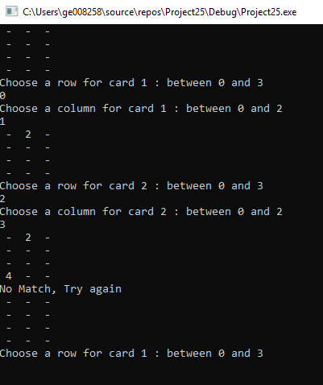
Result: Works correctly and as expected,

1.3.2 Normal Values – Match!
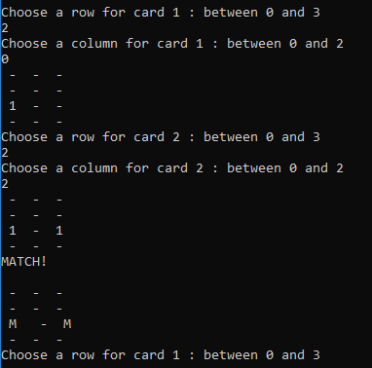
Result: Works Correctly and as expected

1.3.3 Non integer value
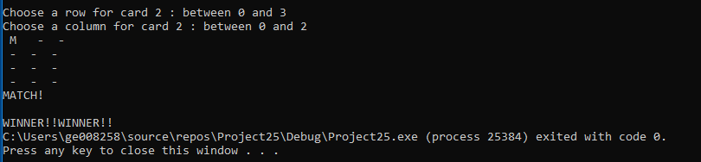
Result: User wins, prints”m” and game ends.

1.3.4 Values outside the grid
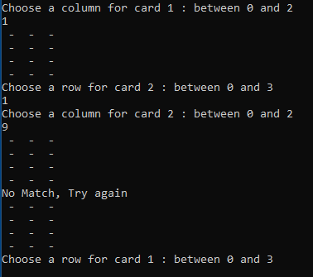
Result: Doesn’t select card in grid array, prompts user for next selection

1.3.5 Same location selected
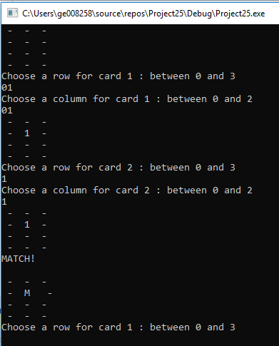
Result: The program sees the selection as a match in this game and populates it with an M.

Conclusion
The author realises that there is a chance that the game wont complete with the above code. The authors approach was that the numbers should randomly generate. The numbers do randomly generate, however an index could not be written to ensure only two of the same numbers would only be allowed. Numerous attempts were made.

Bibliography
[1] Udemy Online C Programming for Beginers "https://www.udemy.com/c-programming-for-beginners-/learn/lecture/8795306#" 2017.
[2] Bradley L. Jones, Peter Aitken, Dean Miller, "Sams Teach Yourself C Programming in One Hour a Day Seventh Edition", 2014, Pearson Publishing.

