DS 1 Template

My Screenshots/Photos
- Please add 4–6 screenshots or photos of your digital life.
- You can use your phone or laptop.
- For each screenshot, write one or two sentences explaining what it shows.

Screenshot/Photo 1
[Insert Photo/Screenshot below]
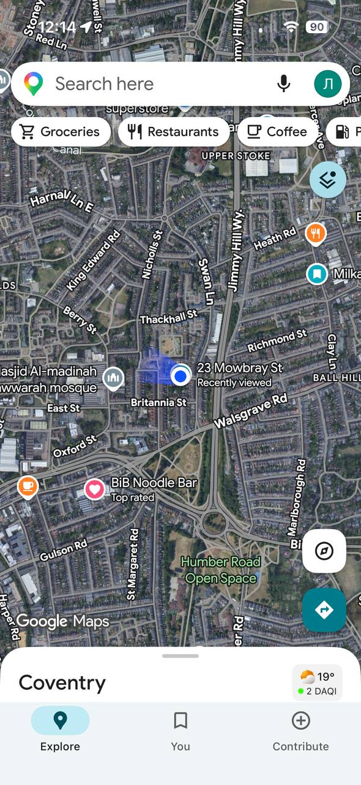
I use Google maps every day to find good places to visit and read rewiews. I also use Google maps to find the best routes for getting to university and work

Screenshot/Photo 2
[Insert Photo/Screenshot below]
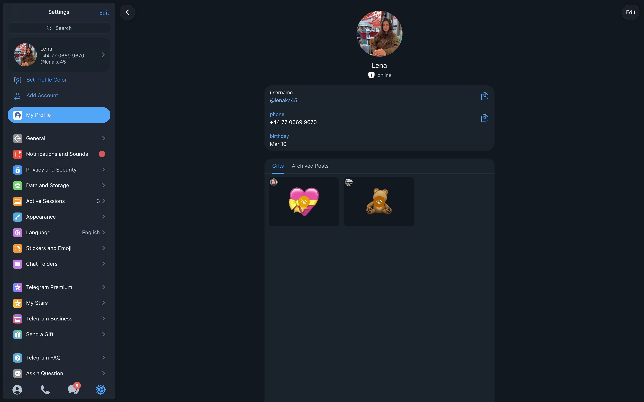
I use Telegram to communicate with my family and friends, read the news and subscribe to channels.

Screenshot/Photo 3
[Insert Photo/Screenshot below]
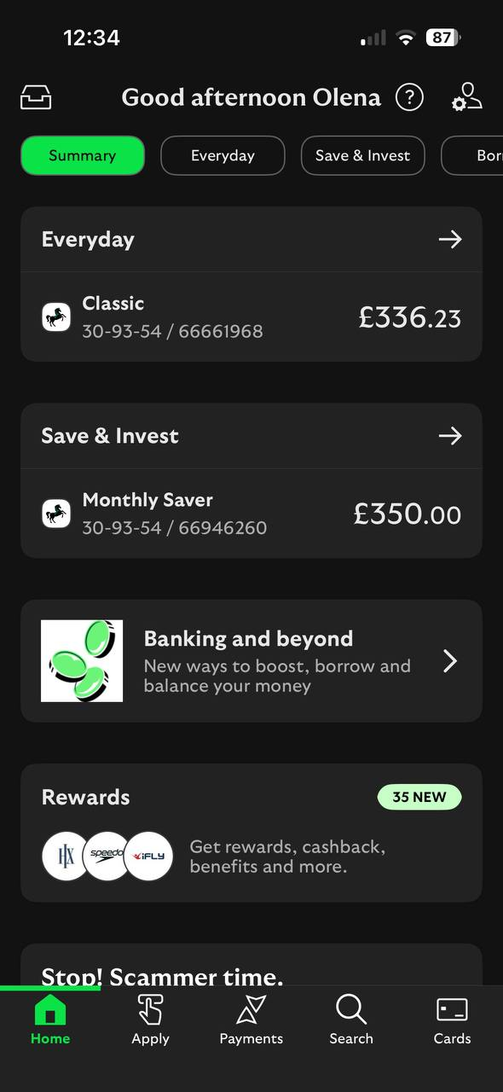
I use Lloyds bank for receiving my salary, my savings and for personal purchases.

Screenshot/Photo 4
[Insert Photo/Screenshot below]
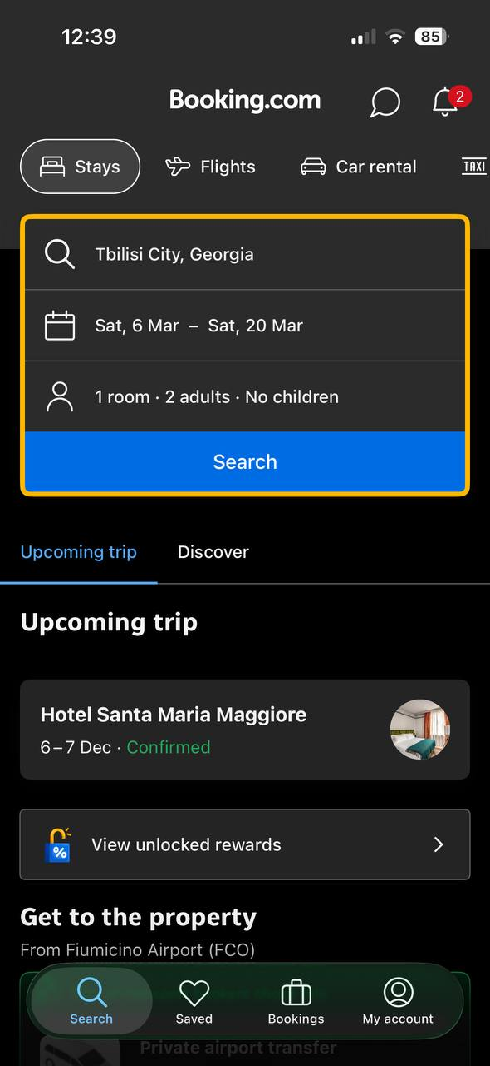
I use Booking to find good hotels, read reviews, and book my future trips.

Screenshot/Photo 5
[Insert Photo/Screenshot below]
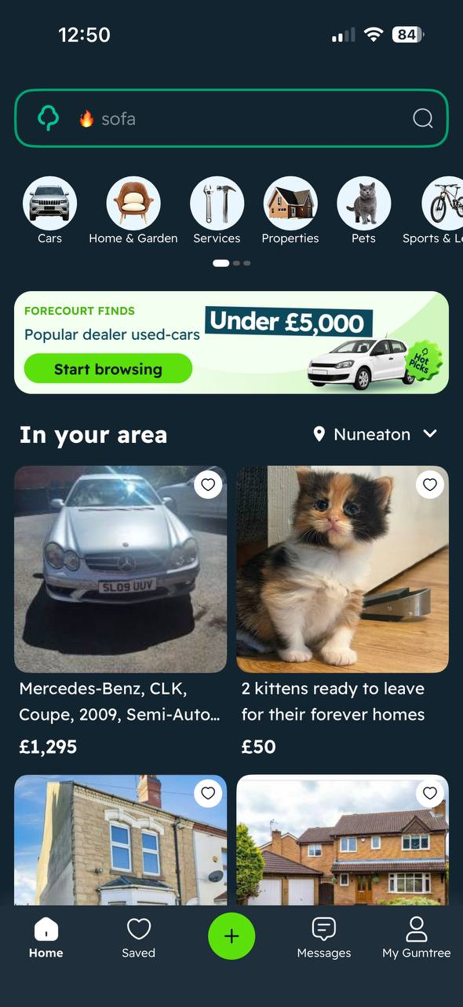
I use Gumtree to look for housing and to buy furniture and appliances.

Screenshot/Photo 6
[Insert Photo/Screenshot below]
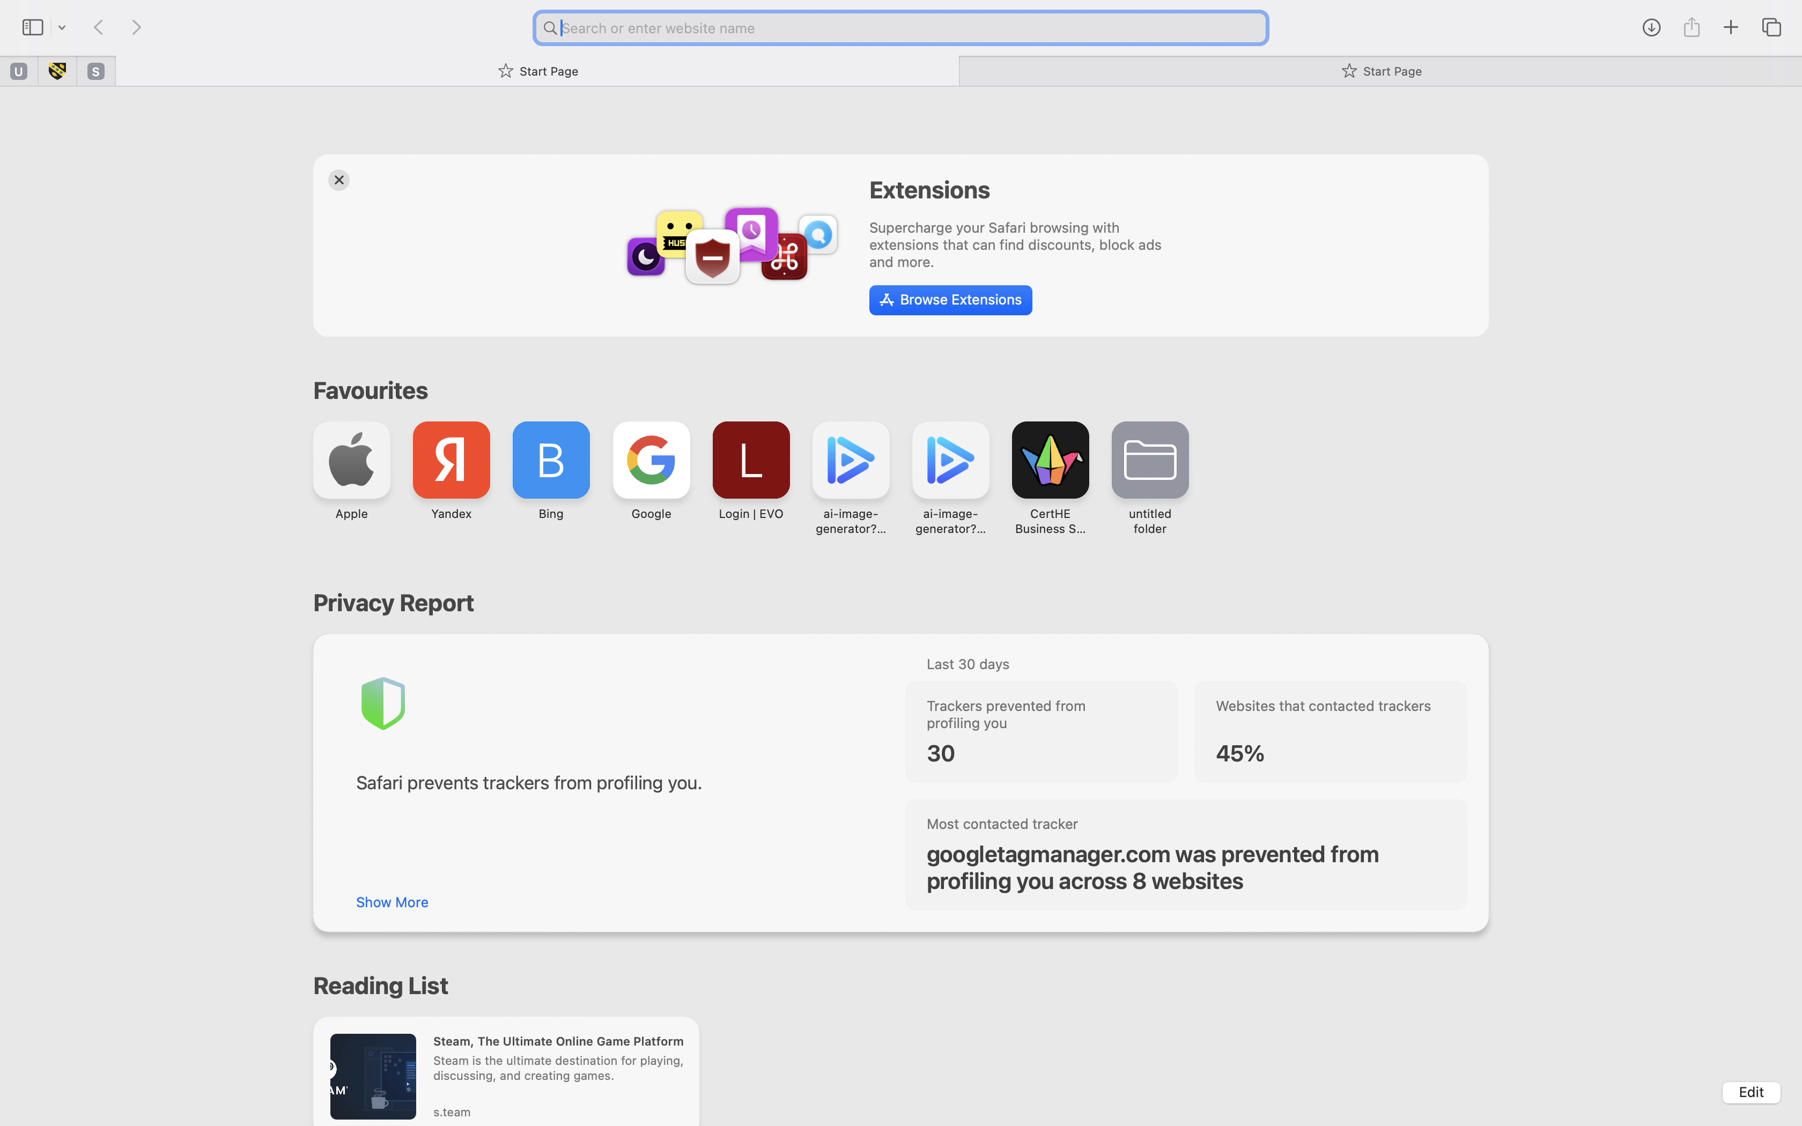
I use Safari every day – for studying, searching information, reading, and to order clothes and household goods.

My Short Reflection
- Write 5–8 simple sentences about your digital life.
- You can use the sentence starters below if helpful.
I use digital tools to find the information I need, as well as for communication, shopping and travel. Sometimes I feel nervous about the vast amount of fake information on the internet and the need to verify whether sources can be trusted, but I know how to do that and I feel more confident now. I want to improve my skills in Word and PowerPoint, because I sometimes realize that my current knowledge is not enough. I hope this module helps me better understand digital life and makes it easier to search and verify information online in the future. I feel confident communicating and use various platforms for this – such as Telegram, Instagram, WhatsApp, Messenger and Tik Tok. I am knowledgeable about banking, managing my finances and making online purchases.

Sentence starters
- I use digital tools to …
- I feel confident when I …
- I want to improve …
- I often use these tools: …
- I sometimes feel nervous about …
- I hope this module will help me …
- Digital skills are important for me because …
You can write more if you want.

Submission Checklist
Before you submit, please check:
​​​ ☐ I added 4–6 screenshots
☐ I wrote short sentences for each screenshot
☐ I wrote my short reflection
☐ My work is my own
☐ My file opens correctly
​​☐ My file opens correctly

