
Secure and Accessible Digital Platform for Family-Run Automotive SMEs
Independent Proposal-ACCA6020

26 November 2025
Sobia Tabassam – 2222632
Abrar Jahin Almazi Bipon
Contents
1.Introduction 2
1.1 Problem Statement 2
1.2 Project Aim 2
1.3 Project Objectives 3
1.4 Literature Review 3
1.4.1 SME Digital Transformation 3
1.4.2 Accessibility and WCAG 2.1 3
1.4.3 Cybersecurity for SMEs 4
1.4.4 Inclusive Design and Booking Systems 4
1.4.5 Research Gaps 4
2. Methodology and Project Design 4
2.1 Identification of the Problem 5
2.2 System Design and Tools 5
2.3 Data Collection and Implementation 6
2.4 Evaluation and Data Analysis 6
2.5 Project Deliverables 6
2.6 Challenges and Risks 7
2.7 Ethical and Legal Considerations: 7
2.8 Generalisability, Reliability, and Validity 7
2.9 Deployment and Documentation 7
2.10 Rationale for Life Cycle Model 8
2.11 Rationale for Methodology 8
3. Resources and Planning 8
3.1 Resources Required 8
3.2 Project Timeline 9
3.3 Milestones 9
References 10

1.Introduction
Small and medium-sized enterprises (SMEs), especially family-run and micro businesses, rely increasingly on digital tools but often lack resources, skills, and cybersecurity, making it difficult to build secure, accessible, GDPR/WCAG-compliant platforms and reducing trust, visibility, and service access. Although SME digital transformation is widely studied, accessibility, usability, and cybersecurity are rarely examined together, particularly in automotive services. This project addresses this gap by developing a secure, WCAG-compliant booking platform using literature insights, user-centred design, and evaluation, integrating cybersecurity, assessing usability and security, and supporting SMEs with limited technical capacity while promoting digital inclusion.

1.1 Problem Statement
SMEs often lack the financial, technical, and organisational capacity to implement secure, accessible digital platforms despite increasing pressure to adopt new technologies [1]–[5]. Limited IT skills, fragmented digital uptake, and low cybersecurity awareness hinder progress, while the absence of WCAG 2.1-compliant and GDPR-aligned systems increases legal, ethical, and reputational risks [7], [12], [14]. Although SME digital transformation has been studied [2], [5], integrated research on accessibility, cybersecurity, and usability remains scarce. This project addresses this gap by developing a secure, WCAG-compliant, user-centred booking platform to enhance digital inclusion, customer trust, and operational efficiency.

1.2 Project Aim
This project will design, develop, and evaluate a secure, accessible, user-centred website with an integrated online booking system for SMEs, incorporating WCAG 2.1 standards, GDPR-compliant data handling, and cybersecurity best practices to boost customer trust, compliance, and digital competitiveness.

1.3 Project Objectives
• Critically review literature on SME digital transformation, accessibility, cybersecurity, and inclusive design to identify gaps and define system requirements [1]–[20].
• Analyse business processes and produce an SRS supported by competitor benchmarking [21], [22].
• Design a WCAG 2.1-compliant interface with keyboard navigation, screen-reader support, and high-contrast visuals [7], [12].
• Develop an online booking system with secure data handling and GDPR-compliant practices [10], [14].
• Implement SME-appropriate cybersecurity safeguards, including HTTPS, TLS, secure authentication, and input validation [11], [17], [18].
• Evaluate accessibility, usability, and security using automated audits, expert heuristic reviews, and security assessment tools.

1.4 Literature Review

1.4.1 SME Digital Transformation
SME digital transformation depends on managerial capability, organisational readiness, technological maturity, and supportive culture [1], [2], with human factors, digital literacy, leadership, and employee skills playing a key role [2], [5]. Barriers like high costs, limited expertise, and perceived risks lead to fragmented adoption [3], [5]. Family-owned and informal SMEs are especially vulnerable due to weak technology evaluation and cybersecurity processes [4], [6], highlighting the need for simple, low-cost, secure solutions. COVID-19 accelerated adoption but often yielded inefficient systems [5], and micro-SMEs in sectors such as automotive services remain underrepresented [5]. This study explores sustainable, accessible, secure digital solutions for resource-limited SMEs [1]–[20].

1.4.2 Accessibility and WCAG 2.1
Although WCAG 2.1 offers detailed guidance on perceivability, operability, understandability, and robustness, research varies on the best approach for SMEs. Singh et al. [9] recommend lightweight, automated audits to minimise costs, while Paul [7] emphasises that manual testing can reveal subtle accessibility issues overlooked by automated tools. This project combines both methods, aiming to balance cost-effectiveness and thorough coverage for micro-SMEs with limited technical expertise.

1.4.3 Cybersecurity for SMEs
SMEs face cybersecurity challenges, “unaware, unfunded, and uneducated” [11], with weak passwords, outdated systems, and poor incident response [17]. UK NCSC guidance exists [14], but adoption is uneven, especially among micro-SMEs [13], [18]. The platform applies practical safeguards, including HTTPS, TLS encryption, secure authentication, and input validation, ensuring data protection while remaining operationally feasible.

1.4.4 Inclusive Design and Booking Systems
Inclusive design models emphasise designing systems that accommodate diverse user needs. While direct involvement of disabled participants is not included due to project time constraints, inclusive design principles and WCAG 2.1 standards form the framework for ensuring accessibility. Accessibility will be assessed through automated auditing tools and expert heuristic reviews to support broad usability.

1.4.5 Research Gaps
Literature reveals limited integration of accessibility, cybersecurity, and SME digital transformation, particularly for small, family-run automotive businesses. This informs the development of a secure, WCAG-compliant, user-centred booking system that SMEs can adopt and maintain, creating a practical, transferable model to enhance visibility, trust, compliance, and digital inclusion.

2. Methodology and Project Design
The project applies a structured methodology combining qualitative research, technical development, and iterative evaluation through the Iterative Waterfall Model [16], progressing from requirements to design, development, testing, and deployment with feedback loops. This provides strong structure, documentation, and evidence-based decision-making informed by literature on SME digital transformation, accessibility, cybersecurity, and inclusive design. Although Agile and rapid prototyping provide flexibility, they demand frequent client engagement and advanced technical skills, which may be challenging for SMEs [23], [24]. In contrast, the Iterative Waterfall Model delivers structured phases with clear documentation, feedback loops, and defined milestones, supporting rigorous development while remaining practical for SMEs with limited IT resources [16].
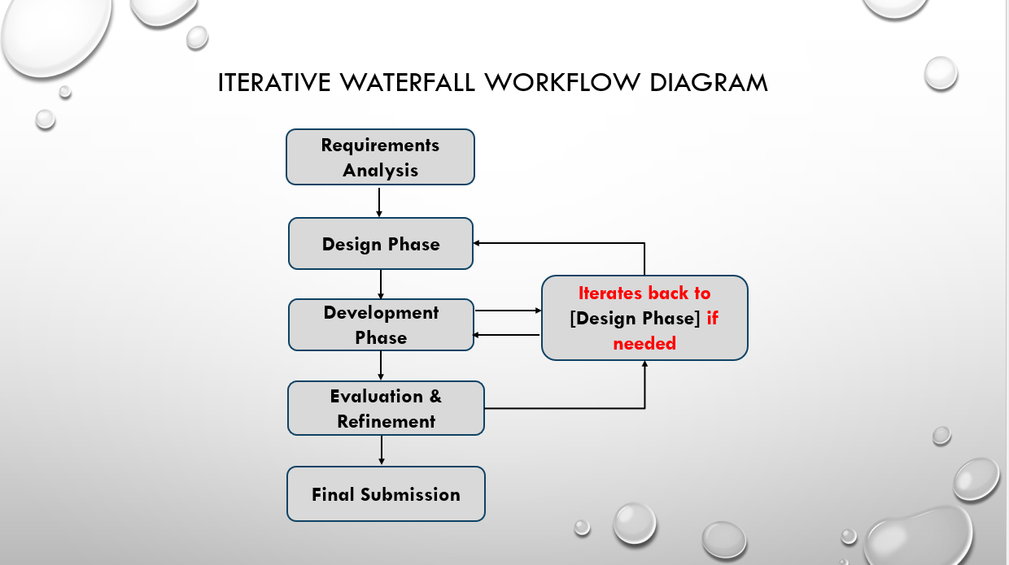
Figure 1: Iterative Waterfall Model Workflow

2.1 Identification of the Problem
Key SME digital transformation challenges:
• Limited IT skills and financial resources
• Fragmented digital adoption
• Accessibility barriers and lack of WCAG compliance
• Cybersecurity vulnerabilities and uneven GDPR adherence
These define the project scope: developing a secure, accessible, user-centred online booking system.

2.2 System Design and Tools
- Accessibility Features: Keyboard navigation, Screen-reader compatibility, High-contrast visuals
- Design & Development Tools: Wireframes/prototypes (Figma, Adobe XD), Front-end (HTML5, CSS3, JavaScript, Bootstrap). Back-end (Django, Laravel, Node.js), Version control (GitHub, VS Code).
Evaluation Tools: Accessibility (WAVE, Axe, Lighthouse), Security (OWASP ZAP, Burp Suite, TLS/HTTPS, secure authentication).
This toolset ensures feasibility while meeting accessibility and security requirements.

2.3 Data Collection and Implementation
Qualitative: SRS, competitor benchmarking, and user feedback inform operational, accessibility, and security requirements.
Quantitative: Accessibility metrics (WCAG compliance scores), task efficiency measures from internal evaluations, and security audit results.
The platform will be refined iteratively using automated accessibility tools and expert heuristic evaluations rather than user-based testing.

2.4 Evaluation and Data Analysis
Evaluation includes:
• Accessibility: Automated WCAG audits (WAVE, Axe, Lighthouse).
• Usability: Internal task-based usability testing and expert heuristic review.
• Security: Penetration testing via OWASP ZAP and Burp Suite.
Success criteria: WCAG Level AA ≥ 90%, task completion ≥ 85%, zero critical vulnerabilities. Quantitative data will be analysed using descriptive statistics; qualitative insights from expert reviews drive refinement.

2.5 Project Deliverables
The following tangible outputs will be produced, aligned with the project aims and objectives:
1. Functional WCAG 2.1-compliant website: User-centred, accessible interface with high-contrast visuals, keyboard navigation, and screen-reader support.
2. Integrated Online Booking System: Secure, GDPR-compliant management of appointments and customer data with HTTPS/TLS and secure authentication.
3. Software Requirements Specification (SRS): Documentation of functional and non-functional requirements informed by literature and benchmarking.
4. System Architecture and Design Documentation: Wireframes, high-fidelity prototypes, database and back-end design, and front-end integration.
5. Evaluation Reports: Automated accessibility audit results, usability testing results, and security assessment outcomes.
6. Deployment Package: HTTPS-enabled hosting and installation instructions.
7. Final Academic Report: Comprehensive methodology, results, and recommendations.

2.6 Challenges and Risks
Medium-level risks, like possible delays in expert evaluations, will be addressed through early scheduling and backup reviewers. High-level risks, including non-compliance with WCAG, GDPR, and cybersecurity standards, will be controlled using automated and manual audits, secure coding, TLS/HTTPS encryption, and penetration testing. These strategies aim to minimise both the likelihood and impact of issues, supporting successful project outcomes.

2.7 Ethical and Legal Considerations:
Although the project does not involve direct human participants, it follows ethical standards by responsibly and securely managing system-generated data. Accessibility is assessed through expert reviews and automated audits, reducing user involvement while ensuring WCAG 2.1 compliance. Additionally, GDPR-compliant data handling guarantees the ethical processing of any customer information within the booking system.

2.8 Generalisability, Reliability, and Validity
- Generalisability: Follows SME best-practice principles
- Reliability: Repeatable testing and standard audits
- Validity: WCAG 2.1 Level AA, GDPR, and cybersecurity compliance ensure realistic evaluation.

2.9 Deployment and Documentation
- Deployment on HTTPS-enabled hosting
- Documentation includes architecture, design, compliance measures, testing and evaluation
- Provides a replicable model for SMEs with limited IT skills

2.10 Rationale for Life Cycle Model
The Iterative Waterfall Model balances structure and iterative improvements, providing clear milestones while accommodating SMEs’ limited IT resources and managerial capacity [16]. Evidence from recent studies shows that small teams and SMEs benefit from structured SDLC models due to resource constraints, limited technical expertise, and the need for clear documentation [23], [24].

2.11 Rationale for Methodology
The methodology integrates accessibility, cybersecurity, and usability while recognising project constraints. Automated tools and expert heuristic evaluations provide a valid, reliable alternative to user testing.

3. Resources and Planning
This section outlines the technical, informational, and human resources required to successfully deliver the project, as well as the structured timeline to ensure all objectives are achieved efficiently.

3.1 Resources Required
Hardware: PCs and mobile devices for development, testing, and accessibility checks.
Software/Tools: Development/design (VS Code, GitHub, Figma, Adobe XD, HTML5, CSS3, JS, Bootstrap, Django/Laravel/Node.js) [16]; accessibility testing (WAVE, Axe, Lighthouse) [7], [8], [12]; security testing (OWASP ZAP, Burp Suite, TLS/HTTPS, secure authentication) [10], [11], [14], [17], [18].
Academic: Databases (IEEE Xplore, SpringerLink, MDPI) [1]–[5], [19], [20]; WCAG 2.1 and GDPR standards [7], [8], [14].
Human: Business owners for feedback [21], [22]; accessibility/UX experts for evaluation; supervisor guidance for technical, methodological, and ethical support.
All resources ensure that design, development, evaluation, and deployment are fully supported.

3.2 Project Timeline
Using the Iterative Waterfall Model from September 2025 to March 2026, the Gantt chart (Figure 2) outlines phase durations, dependencies, and resource allocation, aligned with deliverables to ensure measurable milestones.

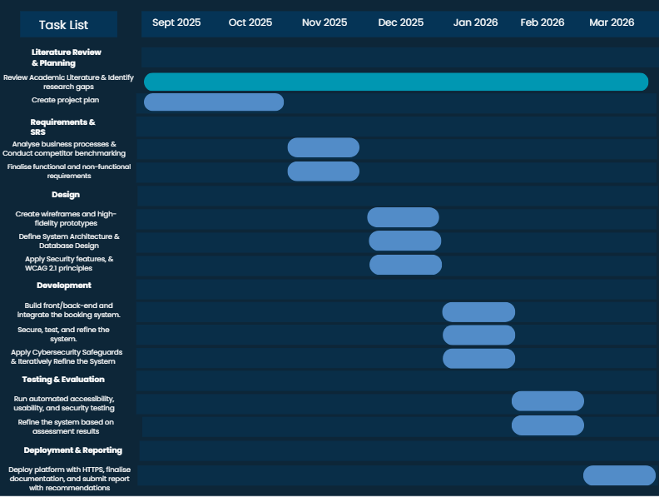
Figure 2: Project Timeline Gantt Chart

3.3 Milestones
- Sept–Oct 2025: Literature review and planning
- Nov: Business analysis, benchmarking, SRS finalisation
- Dec: Design, including wireframes, prototypes, system architecture, database, security, WCAG compliance
- Jan 2026: Front-end, back-end, booking system, cybersecurity implementation with design refinements
- Feb: Accessibility, usability, security testing and development fixes
- Mar: HTTPS deployment, full documentation, final academic report

References
[1] Romero, Isidoro, and Huseyn Mammadov. "Digital transformation of small and medium-sized enterprises as an innovation process: a holistic study of its determinants." Journal of the Knowledge Economy 16.2 (2025): 8496-8523.
[2] Sagala, Gaffar Hafiz, and Dóra Őri. "Toward SMEs digital transformation success: a systematic literature review." Information Systems and e-Business Management 22.4 (2024): 667-719.
[3] Restrepo-Morales, Jorge Aníbal, et al. "Breaking the digitalization barrier for SMEs: a fuzzy logic approach to overcoming challenges in business transformation." Journal of Innovation and Entrepreneurship 13.1 (2024): 84.
[4] Raes, Stephan. "Understanding SME heterogeneity: towards policy relevant typologies for SMEs and entrepreneurship: an OECD Strategy for SMEs and Entrepreneurship." (2021).
[5] Petropoulou, Katerina, et al. "Digital Transformation in SMEs: Pre and Post-Covid-19 Era: A Comparative Bibliometric Analysis." (2024).
[6] Pfister, Paul, and Claudia Lehmann. "Measuring the success of digital transformation in German SMEs." Journal of Small Business Strategy 33.1 (2023): 1-19.
[7] Paul, Surjit. "Accessibility analysis using WCAG 2.1: evidence from Indian e-government websites." Universal access in the information society 22.2 (2023): 663-669.
[8] W3C WAI, “Overview of WCAG,” 2023. [Online]. Available: https://www.w3.org/WAI/standards-guidelines/wcag/ [Accessed: Oct. 22, 2025].
[9] Singh, Utkarsha, et al. "Accessibility analysis of educational websites using WCAG 2.0." Digital Government: Research and Practice 5.3 (2024): 1-28.
[10] Olabode, Olufunmilayo. "The Relevance Of Cybersecurity Awareness Training For Employees In Small and Medium Enterprises (SMEs)." (2023).
[11] Junior, Carlos Rombaldo, Ingolf Becker, and Shane Johnson. "Unaware, unfunded and uneducated: a systematic review of SME cybersecurity." arXiv preprint arXiv:2309.17186 (2023).
[12] Inclusive Innovation, Transform your SME with Digital Accessibility,” Acelera PYME, Mar. 13, 2024. [Online]. Available:
https://www.acelerapyme.gob.es/sites/acelerapyme/files/2024-03/Inclusive%20Innovation%2C%20transform%20your%20SME%20with%20Digital%20Accessibility.pdf
[13] Sill, Yvonne. Cybersecurity Resources for Small and Medium-Sized Businesses. MS thesis. Utica University, 2023.
[14] National Cyber Security Centre, “Small Business Guide,” NCSC, UK, [Online]. Available: https://www.ncsc.gov.uk/collection/small-business-guide. [Accessed: 22-Oct-2025].
[15] Bedewy, Sara Farag. "The impact of data security and privacy concerns on the implementation of integrated." Smart Cities: Foundations and Perspectives 59 (2024).
[16] Mishra, A., Alzoubi, Y.I. Structured software development versus agile software development: a comparative analysis. Int J Syst Assur Eng Manag 14, 1504–1522 (2023). https://doi.org/10.1007/s13198-023-01958-5
[17] Erdogan, Gencer, et al. "Cybersecurity Awareness and Capacities of SMEs." ICISSP. 2023.
[18] Gibb, Alexander, and Peter Bednar. "g. Cybersecurity Best Practices in SMEs: A Socio-Technical Perspective." (2024).
[19] Moreno Martínez, Carlos, et al. "Responsive inclusive design (RiD): a new model for inclusive software development." Universal Access in the Information Society 22.3 (2023): 893-902.
[20] Z. Hosseini and M. Mehdizadeh, “Inclusive Design Considerations and Strategies for Digital Services: An Educational Perspective,” in Information Systems for Intelligent Systems (ISBM 2024), A. Iglesias, J. Shin, B. Patel, and A. Joshi, Eds., Lecture Notes in Networks and Systems, vol. 1254. Singapore: Springer, 2025, pp. xx–xx, doi: 10.1007/978-981-96-1744-9_4.
[21] Gobov, D. E. N. Y. S. "Practical study on software requirements specification and modelling techniques." International Journal of Computing 22.1 (2023): 78-86.
[22] Rączkowska-Gzowska, K. & Walkowiak-Gall, A. (2023). What Should a Good Software Requirements Specification Include? Results of a Survey. Foundations of Computing & Decision Sciences, 48(1)
[23] Fawareh, Hamed, et al. "A Comparative Study between Agile and Waterfall Methodologies during Software Development Process." 2024 25th International Arab Conference on Information Technology (ACIT). IEEE, 2024.
[24] A. V. Chawla, A. P. Agarwal, and P. K. Reddy, “A Comparative Study between Agile and Waterfall Methodologies during Software Development Process,” in Proc. IEEE, 2024.

