Student name: Rehina Zinovieva
Student ID: 2425418
Programme: BSc Applied Computing
Module: Scripting and Programming Concepts
Module code: ACCA5036
Lecturer: Dr Mobolanle Bello
Date: 23.07.2026

Table of Contents
Analysis 2
1.1 Introduction 2
1.2 Requirements Analysis 2
1.3 Problem Decomposition and Abstraction 3
Design 3
2.2 Pseudocode 4
2.3 Implementation Decisions 5
2.4 Variables 6
2.5 Programming Constructs 6
Selection Statements 7
Loops 7
Input Validation and Error Handling 7
Python Modules and Libraries 7
Source Code 8
3.1 GitHub Repository 8
https://github.com/rehina2026/Bright-Minds-Smart-Device-Manager.git 8
3.2 Code Listing 8
3.3 Code Explanation 12
3.4 Example Output During Testing 13
Testing and Debugging Report 13
4.1 Importance of Programme Testing 13
Types of Programming Errors 13
Logical Errors 14
Runtime Errors 14
Testing Commentary 15
Evaluation 17
References 19

Analysis

1.1 Introduction
After analysing the requirements of Bright Minds Academy, several key functionalities were identified for the software solution.
The first requirement is the ability to add new devices. Staff members should be able to enter the name of a device and the room where it is located. Each new device will automatically receive a default status of "offline" until the user updates it.
The second requirement is updating device status. The system should allow users to change the status of a selected device. The available statuses are "online", "offline" and "under maintenance". Input validation is required to prevent users from entering invalid status values.
The third requirement is viewing all devices. Users should be able to display a complete list of stored devices, including their names, locations and current statuses. This allows staff members to quickly check the condition of classroom equipment.
The final requirement is a search function. Users should be able to enter a device name and receive information about its location and current status. This reduces the time needed to manually search through device records.

1.2 Requirements Analysis
After analysing the requirements of Bright Minds Academy, several key functionalities were identified for the software solution.
The first requirement is the ability to add new devices. Staff members should be able to enter the name of a device and the room where it is located. Each new device will automatically receive a default status of "offline" until the user updates it.
The second requirement is updating device status. The system should allow users to change the status of a selected device. The available statuses are "online", "offline" and "under maintenance". Input validation is required to prevent users from entering invalid status values.
The third requirement is viewing all devices. Users should be able to display a complete list of stored devices, including their names, locations and current statuses. This allows staff members to quickly check the condition of classroom equipment.
The final requirement is a search function. Users should be able to enter a device name and receive information about its location and current status. This reduces the time needed to manually search through device records.

1.3 Problem Decomposition and Abstraction
The overall problem was divided into smaller tasks to simplify development. The first task was creating a method of storing device information. A list containing dictionaries was selected because it allows multiple devices to be stored while keeping each device's information organised.

The second task was designing functions responsible for different operations, including adding devices, updating statuses, displaying information and searching. Separating these tasks into individual functions improves code readability and makes the program easier to maintain.

Abstraction was applied by focusing only on the information required for device management. Details such as device manufacturers, prices and technical specifications were excluded because they are not necessary for the current system requirements.

The final system focuses on three main attributes:

- Device name
- Room location
- Current status

Design
The flowchart represents the overall logic of the Smart Home Device Manager. When the program starts, an empty device list is created. The user is presented with a menu where they can select different operations. Depending on the selected option, the program performs adding, updating, viewing or searching operations. After completing an action, the user is returned to the main menu until the exit option is selected.
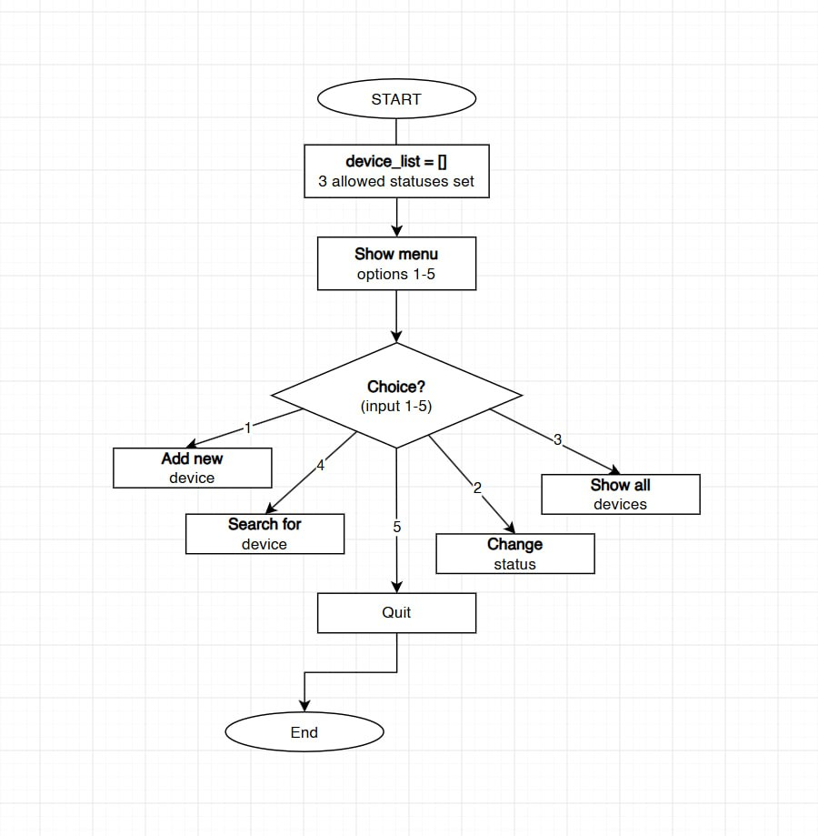
Figure 1 Flowchart of the Smart Home Device Manager.

2.2 Pseudocode
START PROGRAM
Create empty list called device_list
WHILE program is running:
Display main menu
Ask user to choose an option
IF option = 1 THEN
Ask user for device name
Ask user for room location
Validate input
Create new device dictionary
Add device to device_list
ELSE IF option = 2 THEN
Ask user for device name
Search for device
IF device exists THEN
Display available statuses
Ask user for new status
Validate status
Update device status
ELSE
Display error message
ELSE IF option = 3 THEN
Display all stored devices
ELSE IF option = 4 THEN
Ask user for device name
Search device list
Display device information
ELSE IF option = 5 THEN
Close program
ELSE
Display invalid option message
END PROGRAM

2.3 Implementation Decisions
Data Structures
The main data structure used in this project is a list containing dictionaries.
The program uses a list called device_list to store information about all smart classroom devices. A list was chosen because the number of devices can change while the program is running. It allows new devices to be added dynamically without creating separate variables for each device.
Each device is stored as a dictionary containing three main attributes:
{
"name": "Zinovieva 30",
"room": "30",
"status": "offline"
}
For example, during testing, devices such as Zinovieva 30 and Rehina were successfully stored in the list with their room information and default status.
Dictionaries were selected because they provide a clear structure where each piece of information can be accessed using a meaningful key. For example, "name" stores the device name, "room" stores the location and "status" stores the current connection status.
This structure makes it easier to search for devices, display information and update individual device statuses.

2.4 Variables
The program uses several variables to store and manage information:
Variable | Purpose
device_list | Stores all registered smart devices
ALLOWED_STATUSES | Stores the available status options: online, offline and under maintenance
name | Stores the device name entered by the user
room | Stores the device location entered by the user
device | Stores the dictionary of a selected device
new_status | Stores the updated status entered by the user

2.5 Programming Constructs

Functions
The program uses user-defined functions to separate different system operations.
Examples include:
def add_new_device():
This function collects device information from the user and adds a new dictionary to device_list.
def change_device_status():
This function searches for a selected device and updates its status.
def search_for_device():
This function allows users to search for a device by name and display its information.

Selection Statements
The program uses if, elif and else statements to make decisions.
For example:
if choice == "1":
add_new_device()
This allows the system to perform different actions depending on the option selected from the menu.

Loops
The program uses loops to control repeated actions.
The main menu uses a while loop:
while True:
This keeps the program running until the user chooses the exit option.
A for loop is used when searching through stored devices:
for device in device_list:
This allows the program to compare the user's search input with saved device names.

Input Validation and Error Handling
Input validation was implemented to prevent incorrect information from being stored.
The program checks that device names and room locations are not empty:
if name == "" or room == "":
It also checks that users only enter valid statuses:
if new_status not in ALLOWED_STATUSES:
The system also prevents duplicate devices from being added.
During testing, searching for a device that did not exist, such as "coffee", correctly displayed an error message instead of causing the program to crash.

Python Modules and Libraries
No external Python modules or libraries were required for this project.
The program only uses built-in Python features, including:
- input() for receiving user information
- print() for displaying results
- Lists and dictionaries for data storage
- String methods such as .lower() and .strip() for improving input handling
The decision not to use additional libraries keeps the application simple and suitable for the requirements of Bright Minds Academy. [1]

Source Code

3.1 GitHub Repository
The complete source code for the Smart Home Device Manager project is available in the following GitHub repository:

https://github.com/rehina2026/Bright-Minds-Smart-Device-Manager.git

3.2 Code Listing

device_list = []
ALLOWED_STATUSES = ["online", "offline", "under maintenance"]

def find_device(device_name):
"""Loops through device_list and returns the matching device dict,
or None if nothing matches. Used by a few other functions below so
I don't repeat the same loop everywhere."""
for device in device_list:
if device["name"].lower() == device_name.lower():
return device
return None

def add_new_device():
"""Asks the user for a device name and a room, then adds it to the list.
New devices always start as 'offline' until someone updates them."""
name = input("Enter device name: ").strip()
room = input("Enter room / location: ").strip()

if name == "" or room == "":
print("Device name and room can't be empty. Nothing was added.")
return

if find_device(name) is not None:
print(f"A device called '{name}' already exists. Try a different name.")
return

new_device = {"name": name, "room": room, "status": "offline"}
device_list.append(new_device)
print(f"Added '{name}' in {room}, status set to offline by default.")

def change_device_status():
"""Lets the user pick a device by name and update its status."""
name = input("Which device do you want to update? ").strip()
device = find_device(name)

if device is None:
print(f"Couldn't find a device named '{name}'.")
return

print("Available statuses:", ", ".join(ALLOWED_STATUSES))
new_status = input("Enter new status: ").strip().lower()

if new_status not in ALLOWED_STATUSES:
print("That's not a valid status, so nothing was changed.")
return

old_status = device["status"]
device["status"] = new_status
print(f"'{device['name']}' status changed from {old_status} to {new_status}.")

def show_all_devices():
"""Prints every device currently stored, in a simple table format."""
if len(device_list) == 0:
print("No devices have been added yet.")
return

print("\nDEVICE NAME ROOM STATUS")
print("-" * 50)
for device in device_list:
print(device["name"].ljust(20), device["room"].ljust(16), device["status"])
print()

def search_for_device():
"""Asks for a device name and shows its details if found."""
name = input("Type the device name to search for: ").strip()
device = find_device(name)

if device is None:
print(f"No device found matching '{name}'.")
return

print(f"\nName: {device['name']}")
print(f"Room: {device['room']}")
print(f"Status: {device['status']}\n")

def show_menu():
print("\n===== Bright Minds Academy - Device Manager =====")
print("1) Add a new device")
print("2) Update a device's status")
print("3) View all devices")
print("4) Search for a device")
print("5) Quit")

def main():
while True:
show_menu()
choice = input("Choose an option (1-5): ").strip()

if choice == "1":
add_new_device()
elif choice == "2":
change_device_status()
elif choice == "3":
show_all_devices()
elif choice == "4":
search_for_device()
elif choice == "5":
print("Closing the program, bye!")
break
else:
print("Please enter a number between 1 and 5.")

if __name__ == "__main__":
main()

3.3 Code Explanation
The Python program was developed using a modular approach where different functions are responsible for specific tasks. This improves readability and makes the program easier to maintain. [2]
The variable:
device_list = []
creates an empty list that stores all smart classroom devices during program execution.
The list:
ALLOWED_STATUSES = ["online", "offline", "under maintenance"]
stores valid device status options and is used for input validation.
The function:
find_device()
is used as a reusable search function. It checks the device list and returns the matching device if it exists. This avoids repeating the same search code in different parts of the program.
The function:
add_new_device()
allows staff members to enter a device name and location. The program validates the input, checks for duplicate devices and stores the new device as a dictionary.
The function:
change_device_status()
allows users to update an existing device status. The program checks whether the device exists and only accepts valid status options.
The function:
show_all_devices()
displays all stored devices in a simple table format, showing the device name, room and current status.
The function:
search_for_device()
allows users to search for a specific device by name and view its information.
Finally, the main() function controls the menu system and keeps the program running until the user selects the exit option.

3.4 Example Output During Testing
During testing, devices were successfully added to the system. [3]
Example:
Added 'Zinovieva 30' in 30, status set to offline by default.

Added 'Rehina' in 30, status set to offline by default.
The search function was also tested with an invalid device name:
Type the device name to search for: coffee

No device found matching 'coffee'.
This confirmed that the program correctly handles both successful operations and incorrect user input.

Testing and Debugging Report

4.1 Importance of Programme Testing
Testing is an important part of software development because it helps to identify problems and confirm that a program works according to its requirements. Without testing, software may contain errors that can affect usability and reliability.
For the Smart Home Device Manager, testing was used to verify that users can successfully add devices, update device statuses, view device information and search for existing devices.
Testing also ensures that incorrect user inputs are handled correctly. For example, the system should not allow empty device names, invalid statuses or searches for missing devices to cause the program to fail.
By performing different test cases, it was possible to confirm that the program functions correctly under both normal and unexpected situations.
Types of Programming Errors
During software development, different types of errors can occur.
Syntax Errors
Syntax errors happen when the code does not follow Python's programming rules. These errors prevent the program from running.
Example:
if choice == "1"
add_new_device()
The missing colon (:) would cause a syntax error.
These errors can usually be fixed by checking the error message provided by Python and correcting the code structure.

Logical Errors

Logical errors occur when the program runs successfully but produces incorrect results.

For example, if the search function returned the wrong device information, the program would contain a logical error.

Logical errors are usually found through testing and debugging. The developer must check the program logic and compare the actual output with the expected result.

Runtime Errors

Runtime errors occur while the program is running.

For example, trying to access information from a device that does not exist could cause a program crash.

In this project, runtime errors were reduced by using validation checks before performing operations.
Test ID | Function Tested | Test Input | Expected Result | Actual Result | Status
T1 | Add device |  | Device should be added successfully with offline status | Device added successfully | Pass
  Device name: Zinovieva 30, Room: 30
T2 | Add device | Device name: Rehina, Room: 30 | Device should be added successfully | Device added successfully | Pass
T3 | View devices | Select option 3 | System should display all saved devices | Devices displayed correctly | Pass
T4 |  |  | Device information should be displayed | Correct device information displayed | Pass
  Search device
  Search: Zinovieva 30
T5 | Search missing device | Search: coffee | Error message should appear | "No device found matching coffee" displayed | Pass
T6 | Update status | Zinovieva 30 online | Device status should update | Status changed successfully | Pass
T7 |  | Enter: hello | Program should reject invalid status | Error message displayed | Pass
  Invalid status
T8 | Empty input |  | Device should not be added | Validation message displayed | Pass
  Empty device name

Testing Commentary
The testing process confirmed that the main features of the Smart Home Device Manager operate correctly.
The first tests verified that new devices could be added successfully. Devices such as Zinovieva 30 and Rehina were stored with their room information and default offline status.
The search function was tested using both valid and invalid inputs. Searching for an existing device successfully displayed its details, while searching for "coffee" correctly returned a message indicating that no matching device was found.
Validation testing showed that the program prevents incorrect information from being stored. Invalid statuses were rejected, and empty fields were not accepted.
The results demonstrate that the program meets the functional requirements and provides a reliable solution for managing smart classroom devices.
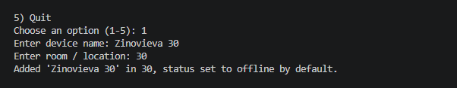
Figure 2 Adding a new device
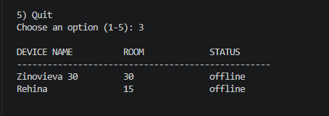
Figure 3 Displaying all devices
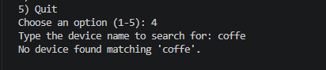
Figure 4 Searching for unavailable device

Evaluation
During the development of the Smart Home Device Manager, I faced several challenges, especially because I am still developing my programming skills in Python.
One of the first challenges was understanding how to organise and store information correctly. At the beginning, it was difficult to decide how devices should be represented in the program. I learned that using a list containing dictionaries was a suitable solution because each device could store multiple pieces of information, such as its name, location and status.
Another challenge was creating separate functions for each part of the program. Initially, writing all the code together seemed easier, but it made the program harder to understand. By separating the system into functions such as add_new_device(), change_device_status() and search_for_device(), the code became more organised and easier to debug.
Input validation was also an important challenge. Users may enter incorrect information, such as an empty device name or an invalid status. I added validation checks to prevent these problems and make the system more reliable.
During testing, I also found that searching for devices that do not exist needed to be handled correctly. For example, when searching for a device called "coffee", the program displayed an appropriate message instead of causing an error.
Future Improvements
Although the current version of the Smart Home Device Manager meets the project requirements, there are several improvements that could be added in the future.
One possible improvement would be adding a database instead of storing information only in a Python list. Currently, all device information is lost when the program closes. A database would allow information to be saved permanently and accessed again later.
Another improvement would be adding information about the last time a device was used. This would help staff members monitor device activity and identify equipment that may require maintenance.
The system could also be improved by creating a graphical user interface (GUI) instead of a text-based menu. A graphical interface with buttons and forms would make the system easier for staff members to use.
Additional features could include user accounts, automatic device monitoring and reports showing the number of online, offline and maintenance devices.
This project helped me improve my understanding of Python programming and the software development process. Before starting the project, I had limited experience with creating complete programs, but developing this system helped me understand how different programming concepts work together.
I learned how to use lists and dictionaries to store information, how to create reusable functions and how important validation is when creating software for real users.
I also learned that testing is an essential part of development. Before testing, it is easy to assume that a program works correctly, but testing helped me identify possible problems and confirm that the system behaves correctly with different inputs.
Overall, this project improved my confidence in programming and helped me understand how software solutions are designed, developed and evaluated. I believe that with more practice I can create more advanced applications in the future.

References

[1] | P. S. Foundation, Python 3 Documentation.
[2] | I. Sommerville, Software Engineering, vol. 10, Boston, 2015.
[3] | R. S. P. a. B. R. Maxim, Software Engineering: A Practitioner’s Approach, 2019.

