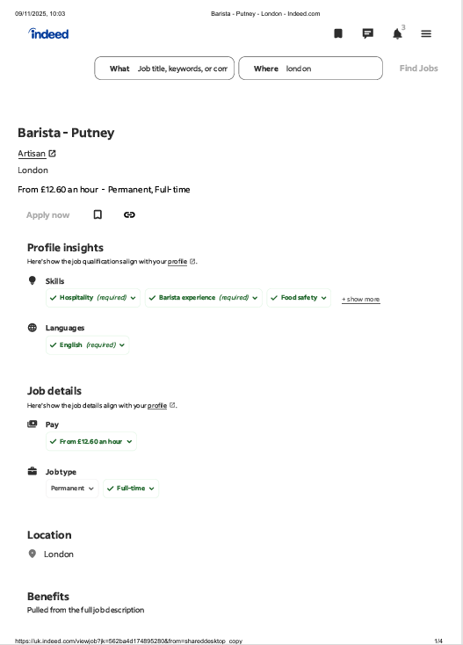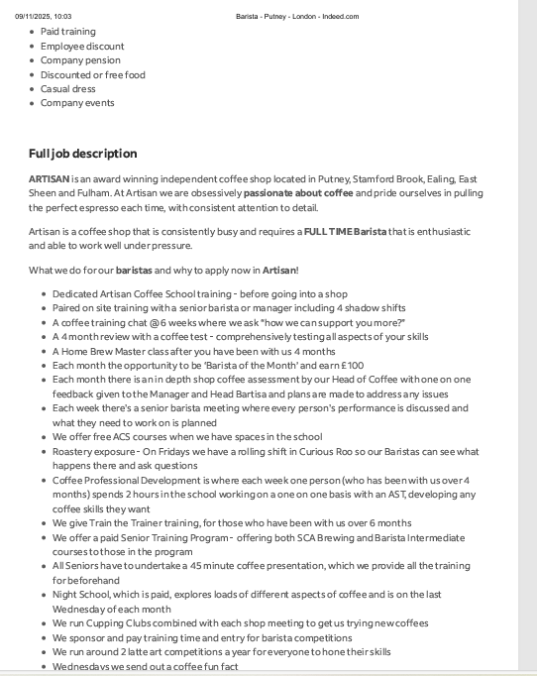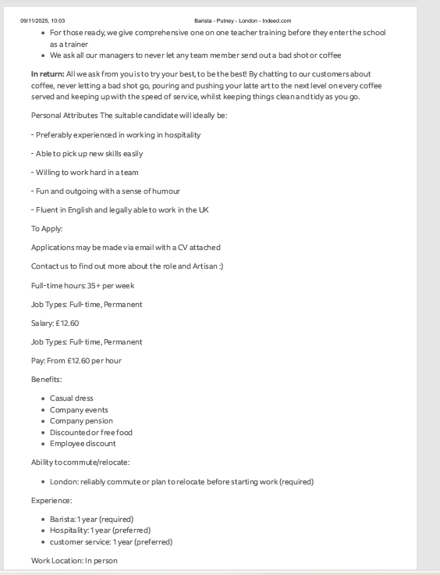

COVER LETTER
MYM
56,CDXE Street, London
Hiring manager
Coffee Warehouse Ltd, London
09/11/2025
Dear Mr/Mrs Hiring Manager
I wish to apply for the role of Barista, currently being advertised on indeed. Please find enclosed my CV for your consideration.
As you can see from my attached CV, I have over 2 year’s experience in the
Cafe industry, and I believe I will be the perfect candidate for this role
during this time make me the right/perfect candidate for the role.
In my current role as a Barista at Kiss the Hippo, I have been responsible for
Preparing high quality coffee and espresso beverages with attention to detail and consistency. Developing advanced latte art skills and enhancing product presentation. Providing friendly, professional customer service in a fast-paced specialty coffee shop environment. Maintaining cleanliness and compliance with food hygiene and safety
standards. All of this, coupled with my enthusiasm and dedication. Physically fit and confident handling deliveries or food service. Comfortable working independently or as part of a busy team. Passionate about coffee and continuous skill Growth
I am confident that I can bring this level of success with me to your organisation and help grow and build upon their reputation. With my previous experience and expertise, I believe my contribution will have a good impact on the company.
Thank you for your time . I look forward hear back from you

Yours sincerely/Yours faithfully,
MYM

CV


