Problem Solving and Decision Making

Student name | Alexandra Plumb
Student ID | 2007923
Lecturer name | Balendran Kandasemy
Module name and code | Problem Solving and Decision Making  BMSW4004
University Name | University of Wales Trinity Saint David

Table of Contents

Introduction 3
Organisation problem 3
PESTEL Analysis 3
Fishbone diagram 4
Solutions 5
Implementation plan 7
Stakeholder analysis 8
Conclusion 9
Reference list 10
Appendix 1 11

Introduction
The hospitality industry includes businesses such as food and beverage, tourism, airlines and accommodation.
The report is based on the Food and Beverage part of this industry, and its scope is to identify and bring solutions to the main problem faced by a restaurant located in the heart of London.
The reports will include a PESTEL analysis, a fishbone diagram which will lead us to the causes of the problem. We will use a PMI (Plus-Minus-Interesting) tool to identify the best solution in our case and stakeholder analysis to every individual related to the company and their effect on the decision.The last part of the report will present the implementation plan of the solution.

Organisation problem
The main scope of the report is to identify causes that lead to the problem by listening to the employee and the management team. The impact of the problem reflected on the company productivity and the most important, how this leads to the employee's dissatisfaction.
During the pandemic, the Hospitality industry and Jean-Jorge Restaurant faced hard times due to the extended closure. The problem continued even after the reopening, and the employees are unhappy with the working hours and the fact that they need to cover the shifts for new staff that leaves after two weeks of training (Appendix 1). The long hours and the unsatisfied payment make more people want to leave the place, and the management faces a hard time managing the shortage of staff and organising the rota not to exhaust the remaining team.

PESTEL Analysis
A PESTEL Analysis helps businesses to evaluate the external factors that they cannot control, such as Political, Social, Technological or Economic factors. This tool helps the company to grow its desirability, market capability and performance (Perera, 2017). The analysis will include the factors that affect the restaurant part of the industry and the whole Hospitality industry.
The political factors are connected with governments regulation and taxes, which influences the business (Rahman, 2021). In our situation, the financial crises produced by the Brexit and boosted by the pandemic greatly impacted the Restaurant situation. According to Rahman, M. (2021), instability in the political sector discourages people from eating out and spending money to boost the Hospitality sector, but it is also proved that it can easily come back.
Economic factors are connected with the political one. The pandemic affected the industry, and the restaurant suffered from being closed for a long time due to lockdown.
Developing technologically improves the customer's services and the restaurant standards. The restaurant needs to keep up with the technological part to survive in the market (Rahman, 2021). During the pandemic, they implemented a takeaway system that helps the business during hard times.
Helping the environment will attract more customers who appreciate and protect nature. The primary cause that influences the industry is hygiene. Also, another factor that influences the industry is pollution. This aspect could affect the business running.

Fishbone diagram
Finding a solution to the problem faced by the restaurant requires first finding the problem and its causes. We used the fishbone diagram for a more complex approach, which will help analyse all the factors that lead to our problem.
After a close analysis of what the employees and the managers told us in the interviews conducted, we concluded that the biggest problem is employee dissatisfaction, which leads to a decreased performance among the staff and customers complaints.
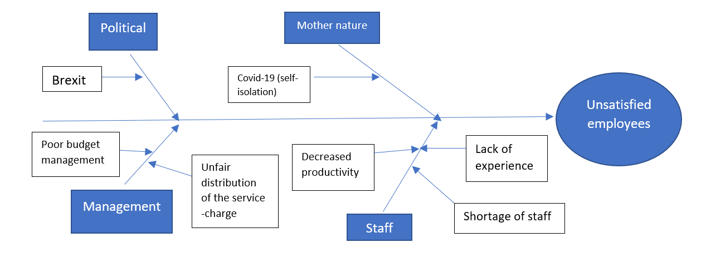
Figure1: Fishbone diagram (Original)
As we can see in Figure 1, we identify four leading causes of the problem. Every reason has subclauses, and all of them contributed to the effect represented by the Unsatisfied employees.
One of the causes, political, is an external factor, also included in the PESTEL Analysis. Brexit and the new government regulation influenced it. Studies (Vishnubhotla, 2021) showed that the unemployment rate would grow by 6.5% in the following years after Brexit, leading to a crisis because the EU citizens will no longer come to the UK to look for work. We can see already the consequences of our problem, unsatisfied employees due to the low number of people looking for a job.
The second cause of our problem is Mother nature (Fig. 1), specifically the Covid-19 pandemic. The Office for National Statistics (2021) showed the difference between unemployment and vacancies before the pandemic; the demand was high and the unemployment low. In 2021 the vacancies reach the highest level between May and July, increasing 953,000 vacancies. All this increase did the businesses in crisis to find employees, and our restaurant is trying to work with fewer people due to the incapacity to find staff.
Another two causes are related to the management and staff. The poor budget management, the shortage of staff and the unqualified people contributed to the unsatisfaction of the remaining team.

Solutions
Analysing all the causes discovered in the Fishbone diagram, we identify two possible solutions to our problem, which will help our unsatisfied staff and increase the number of new potential employees. The PMI Tool will help determine the pros and cons of the solution.
The first solution is the increase in wages among all the restaurant staff (Figure 2). Better pay will motivate the employees and their desire to stay longer in the company. Also, it will attract more potential employees with more experience in the field. The biggest minus in this solution is that the company's profit margin will drop in the short term. The staff can feel more pressure on them because of this increase and their motivation to work can drop again in long-term. There is an interesting fact in this first solution that is not necessarily a positive one. People get used to a particular thing and after a short period can feel like they deserve more and another pay rise will be necessary to keep the employees.

Plus | Minus | Interesting
Motivate the employee | Short-term decrease in the company's profit margin | The employee will take it for granted
Attract more potential employees | Higher expectations from the staff members
The new employee will feel motivated to stay
Figure 2: PMI in PayRise soulution (Original)
The second solution includes employee benefits packages (Figure 3), which encourage the staff to feel valued (Rolfe, 2021). The PMI Tool showed that this solution could motivate the team, attract new ones, retain the old staff, and have a competitive advantage during the selection. In this case, the interesting fact brings a plus by improving the working condition and making the staff feel relaxed and more motivated to work. Also, in this solution, the company will have more expenses, leading to a loss of company margin profit. The company need to keep their promises on long therm which could be a minus for the company.
Plus | Minus | Interesting
Motivate the employee | Extra costs for the company | Good working conditions
Attracting new employees | Long-term engagement
Retain current employees
Competitive advantage
Figure 3: PMI Tool in Employee Benefit Package (Original)
After analysing the solutions and with the help of the PMI Tool, we decided that the Employee Benefits Package will suit better in our case. The company will spend more money first, but the employees will improve their productivity, increasing the profit.
As studies showed (Iqbal, Guohao and Akhtar, 2017), the employees will attach to the job on long-term, and the satisfaction level will increase. The employee will feel appreciated, and the benefits will come as a reward for their commitment.

Implementation plan
Having benefits packages improves the retention tool; the employees became more than that and with the reward of the package (CIPD, 2021). Also, the pandemic has boosted the pressure on the management, forcing them to provide more healthcare insurance and sick pay to cover the absence of their employees during self-isolation (CIPD, 2021).
An implementation plan requires certain steps that need to be followed closely to find the benefits that suit more employees' needs and employers' interests (SHRM, 2021).
In our case, we advise the restaurant management to start by analysing the programme's budget and objectives. After that, a survey needs to be conducted in order to find what suits best the company's people, followed by the structure of the benefit plan and in the end, the management will transmit the plan to the staff.
The first step will provide a picture of the company and employees interests. The objectives of the benefits and the main purpose of the strategy. In our restaurant situation, we advise the HR and the manager to discuss and find the objectives followed by an analysis of the budget, which will help them choose the benefits that they can afford. This analysis has great importance for achieving the goals (SHRM, 2021).
The second step consists of conducting a survey among employees to understand their needs and make them happy and help them provide a better service. Another aspect that needs to be closely managed during this step is what other competitors provide as benefits. Having better benefits will force the staff to remain longer, knowing that the company offers more than others (SHRM, 2021).
The third step requires analysing what employees want and choosing the best benefits such as healthcare insurance (death in service, gym membership, sick pay or dental care), staff canteens, a relaxed room, and shorter breaks for coffee.
In the end, HR will need to deliver the information among staff, explaining in detail what are the benefits and how they can benefit from it.

Stakeholder analysis
the company needs to analyse which are the stakeholders of the company. The stakeholders are all the people involved in the business, the one that will support the project, block it or the people that they have power in the project but no interest (Product Plan, 2021). As we can see in the picture below (Figure 3) when you find the stakeholders you need to understand and evaluate their power and interest, to know which one you need to keep informed or consult during the process.
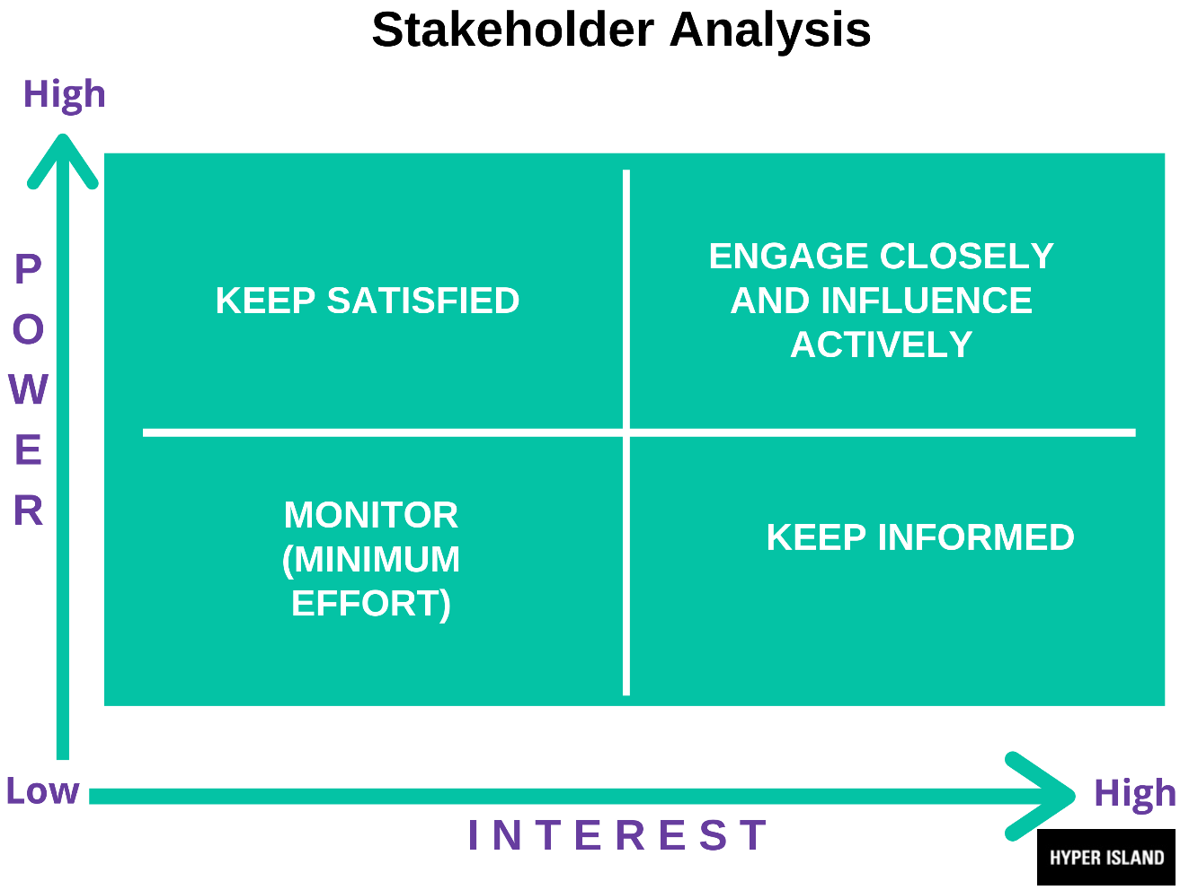
Figure 4: Power-Interest Map (Hyper Island, n/d)
The stakeholders of our project that most likely influence or are interested in the project are the customers, the owner of the firm, general manager, employees and competitors.
The customers need to be kept satisfied for the business to keep running, but their power is low in our project. If we analyse the employee's position on the map, we can position them on the map somewhere in between. They have higher interest and high power in the process, being directly involved. They need to be kept satisfied for the smooth running of the business, and they influence the structure of the benefits.
The competitors are external stakeholders, they have a high interest in monitoring other businesses to maintain their employees, but their power is low; they cannot influence the project's structure.
The owner must be kept informed, no involvement but high interest on the amount of money that the management needs to spend in the scheme and the way the business will be affected.
Another person directly involved in the process is the general manager. Which will just monitor the project with a high interest for it to be a success. They could start stepping in the process in case of an emergency, but otherwise, they are just viewers with high interest.

Conclusion
Helping businesses to find the best solution requires time to process the information. After analysing the data, we concluded that the best solution in Jean-Jorge Restaurant is to build an Employee Benefits Package that will motivate the employees and attract new ones. Offering staff discounts, free meals, gym membership, sick pay or dental care will motivate the employees and significantly increases the period of employment.
To conclude, the two solution were good enough for our problem, but after we analyse the pros and cons we found that at this time and due to Brexit and the pandemic, implementing a Benefits package could improve the employees life and grow their confidence and productivity.

Reference list
CIPD (2021) Employee benefits: an introduction. Availible at: https://www.cipd.co.uk/knowledge/fundamentals/people/benefits/factsheet#gref Accessed: 26/08/21
Evans, T. (2021) Vacancies and jobs in the UK: August 2021. Availible at: https://www.ons.gov.uk/employmentandlabourmarket/peopleinwork/employmentandemployeetypes/bulletins/jobsandvacanciesintheuk/latest Accessed: 18/08/21
Hyper Island (n/d) Stakeholder Analysis. Availible at: https://toolbox.hyperisland.com/stakeholder-analysis Accessed:25/08/21
Iqbal S, Guohao L, Akhtar S (2017) Effects of Job Organizational Culture, Benefits, Salary on Job Satisfaction Ultimately Affecting Employee Retention. Review Pub Administration Manag 5: 229. doi:10.4172/2315-7844.1000229
Perera, R. (2017) The Pestle Analysis. Nerdynaut https://books.google.co.uk/books?id=ZWpLDwAAQBAJ&lpg=PA2&dq=pestle%20analysis&lr&pg=PP1#v=onepage&q=pestle%20analysis&f=false
Product Plan (2021) Stakholder analysis. Available at:https://www.productplan.com/glossary/stakeholder-analysis/ Accessed:26/08/21
Rahman, M. (2021) PESTEL analysis of the hospitality industry. Availible at: https://howandwhat.net/pestel-analysis-hospitality-industry/ Accessed: 16/08/21
Rolfe, A. (2021) Employee benefits: What you need to know. Availible at: https://www.reed.co.uk/career-advice/employee-benefits-what-you-need-to-know/ Accessed: 18/08/21
SHRM (2021) How to Design an Employee Benefits Program. Availible at: https://www.shrm.org/resourcesandtools/tools-and-samples/how-to-guides/pages/howtodesignanemployeebenefitsprogram.aspx Accessed: 25/08/21
Vishnubhotla, V. (2021) Impact of Brexit on Businesses in the UK. Availible at: https://www.market-inspector.co.uk/blog/2016/10/impact-of-brexit-on-businesses-in-the-uk Accessed: 20/08/21

Appendix 1
ME: Good morning! My name is Alexandra Plumb. I am here to listen to staff members and understand the issues that create internal employee dissatisfaction and weak business operations, as well as try and find a few solutions for those issues.
Could you please tell me your position in the restaurant and try and explain me what lead to dissatisfaction in this company?
ANA: Sure. I started working as a commis waitress in Jean George restaurant almost two years ago. I was promoted to the waiter position eight months ago.
First of all, the very long hours that we have to work, lately, are just exhausting us. The department is supposed to have a team of eight waiters/waitresses and eight runners, and we are currently five waiters and four runners, so we are pushed by the management to work 55 and sometimes even 60 hours a week instead of 40, sometimes being pushed to work six days a week. It is true that the supervisors and managers are supporting us during the service, but it does not really help us as we accumulate exhaustion as the weeks pass.

ANA: Another major issue is the lack of work efficiency due to the unexperienced staff members that are hired. In the past three months, we had three runners and four waiters that left after less than two months of working, for the reason that the high volume of work does not fairly match the low payment, which is £9 per hour. Today, one of my colleagues mentioned to me that he decided to leave as well because he considers is not worth it from any point of view to continue. The restaurant is currently rolling staff and this practice is not beneficial for anybody, customers are unhappy because of the poor service and waiting times, and members of staff are unhappy because they are working very hard in a stressful environment for little compensation. Revenue is dropping dramatically as reports show and the business is going down.

ME: Thank you very much Ana, I appreciate you explaining in detail, and I am sorry to hear you have to face such challenges.

Based on the issues mentioned by Ana and after we spoke with other people in the company, the restaurant is confronting a very common problem in the industry which had been produced by the context of Brexit and boosted by the pandemic, the lack of staff, but it seems like there are also some inner issues that could be resolved with not much effort, but a more efficient management approach. Because the demand is so high in the industry and the offer is extremely limited, the management it is forced by the situation to hire unskilled staff. The fact that unqualified people are hired and require at least two weeks of training, without presenting any guarantee that will stay in the company, makes the company loose significant amounts of money because they are unhappy and decide to leave. Rolling employees means losing money and will eventually drop the restaurant's profit.

For finding the best solution for the problem faced of this company we used the Fishbone diagram to identify the effect and the causes of the problem.

Fishbone diagram:

Unsatisfied employees
Covid-19 (self-isolation)
Mother nature
Brexit
Political
Lack of experience
Poor budget management
Decreased productivity
Unfair distribution of the service -charge
Management
Shortage of staff
Staff

A potential solution is increasing the worker's wages to at least ten pounds an hour, based on calculations can be even more. You may think this will drop the profit margin, but, on the mid to long term will actually be balanced by the fact that people will be motivated to stay in the company. The payrise will also resolve the staff shortages that actually pushed employees to work so many hours.
Based on data analysis, we determined that increasing the wages will most likely resolve the biggest issue. However, we do not guarantee that there will not be any frustration at all, as every individual is different and may be unhappy with the change. What we do guarantee based on cautious analysis is that the company will lose less money for training purposes, there will be definitely less frustration felt by the employees and they will feel significantly more motivated to work as the reward will increase.
Another suggestion is to make the staff feel valued through a tempting employee benefits package, such as staff discounts or achievable accomplishment bonuses.

