Fariza Iqbal
2328503
BMHP5014
POSTER

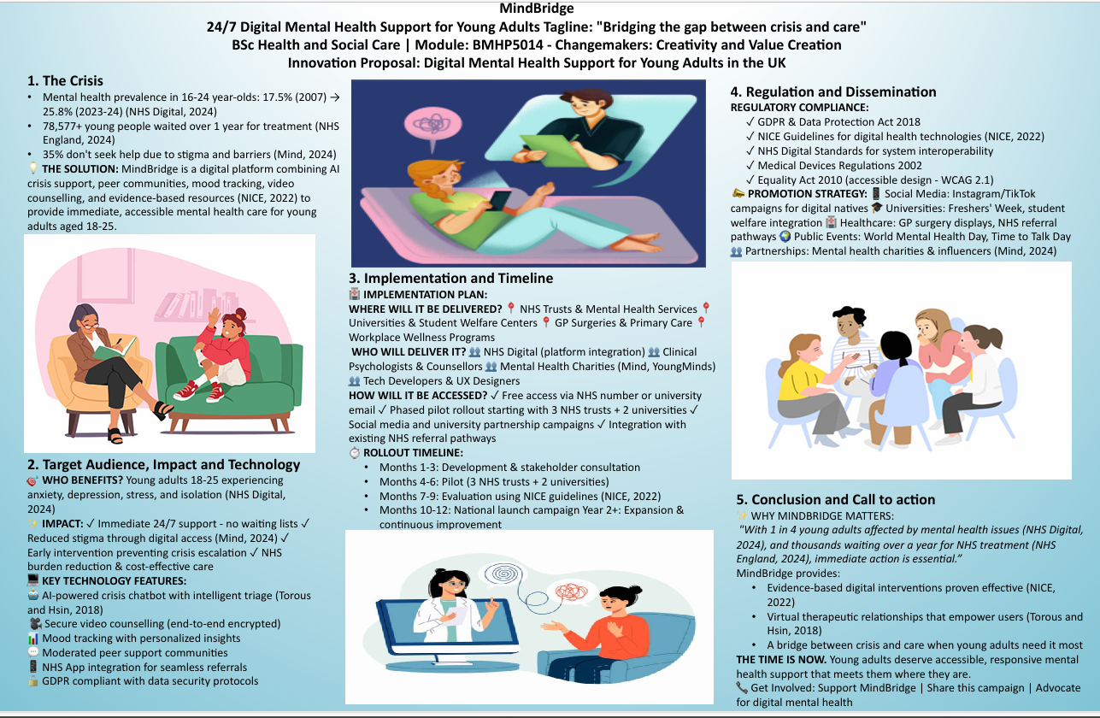

POSTER PITCH
The situation with the mental health crisis in young adults in the United Kingdom has never been as high as it is now, and it needs innovative and prompt intervention. The level of mental health among young people aged 16-24 has grown significantly over the years with 17.5% in 2007 to 25.8% in 2023-24 with one in every four young adults having mental health (NHS Digital, 2024). Such an alarming increase is linked to the presence of acute capacity restraints in the National Health Service where 78,577 youths had been waiting longer than a year to access mental health care in 2023/24 (NHS England, 2024). Moreover, Mind (2024) also indicates that 35 percent of young adults (18-25 years old) with mental health problems do not seek any formal or informal assistance, which is mostly because of stigma and barriers to access and a lack of awareness of available services. MindBridge fills these significant gaps through offering a multifaceted digital mental health platform that integrates artificial intelligence, peer support, evidence-based interventions and professional counselling to offer instant, easily accessible, and stigma-free support to young adults when they need it the most. The present situation in the mental health services provision of the young adults in the UK shows that there is a system that is under significant pressure. According to the NHS England (2024) statistics, young adults are showing a 10 percent increase in emergency mental health referrals over the past years, both in terms of need and worsening mental health among this population group. The conventional mental health is characterised by high challenges, such as long waiting queues, inadequate facilities to address increasing demand, and lack of resources to handle more demand (Mind, 2024). Adolescents leaving the Child and Adolescent Mental Health Services (CAMHS) to adult services are likely to have care access disparities, whereas those who seek mental health services in the first stage face issues of accessing assessment and care promptly. The young adult with age between 18-25 years has different pressures that make them special in terms of mental health requirements compared to other age groups. This is a period of great change, with higher education, employment, forming relationships, identity among others, and it all takes place in an increasingly challenging socioeconomic environment that accounts pressure on the cost of living, housing insecurity and stressors related to social media (NHS Digital, 2024). Such aspects bring about increased susceptibility to the mental health problems, but the conventional face-to-face services might not support the preferences, lifestyles, or comfort of young adults. MindBridge provides a smooth user experience by entering the portal and continuing to use it, as well as being connected to traditional NHS services, when required. When registered with an NHS number or university email, users are provided with a short mental health assessment which creates personalised resources recommendations and creates a baseline wellbeing measure. The evidence-based chatbot, which uses AI, offers 24/7 crisis support on the platform, and the intelligent triage abilities identify high-risk circumstances and report the case to human professionals accordingly (Torous and Hsin, 2018). Once the user needs the assistance of a professional, MindBridge helps to make safe video counselling sessions with certified therapists and counsellors, registered by Health and Care Professions Council. The platform will be connected with NHS systems, which will facilitate the seamless referral to NHS mental health services, GP notification with user consent, and coordination of care between providers. This integration will mean that MindBridge will be used as an addition to, and not instead of, the services that already exist in the NHS, as a transition between self-management and specialist intervention. Protecting is of utmost priority during the user experience. The site uses advanced risk evaluation algorithms and identifies users who use suicidal thoughts, self-harm or any other high-risk detail and proceeds to directly refer them to crisis services such as the Samaritans, NHS 111, or emergency services as needed. The processing of all data is consistent with the General Data Protection Regulation and the Data Protection Act 2018, as all information is effectively encrypted, stored, and the consent of the user is clearly defined, ensuring privacy and allowing continuity of care simultaneously MindBridge is an excellent example of innovativeness and creative thinking in health and social care that has reconsidered the process of delivering mental health care in the contemporary digital age. Conventional models of care, though useful, are incapable of meeting the quanta and urgency of the present need. Through the fusion of technological advancement and human understanding and clinical skills, MindBridge can generate value in various forms. In young adults, it offers access to prompt support that is less stigmatising and respectful of their preferences and enables them to be active in their mental health process. In the case of the NHS, it can be used as a cost-effective model of prevention and early intervention that would decrease the need to address the emergency service and specialist services and enhance the outcome due to early assistance (NICE, 2022). The platform illustrates entrepreneurial thinking, characterised by the identification of an unmet market need, the creation of a solution that is scalable and a sustainable service model by proposing the collaboration of NHS and the possibility of accessing the service through the employer. It represents ideals of social entrepreneurship in terms of focusing on social impact and common good rather than profit maximisation, health disparities, and a healthier and more resilient society. The innovation is in line with the current conceptualization of value creating beyond the economic indicators to the social, health and wellbeing outcomes. The prevalence, acceptance, and use of digital mental health innovation among young adults as well as the overall public acceptance and use of MindBridge are factors that contribute to its success. The engagement with the public has several functions: stigma reduction in seeking mental health assistance, making the use of digital mental health products a social norm, providing social pressure to ensure that the necessary services are provided, and establishing a culture of service-seeking in the mental health of the youth. Consumers can contribute to MindBridge by promoting the idea of digital mental health funding, spreading mental health awareness programmes, motivating the youth to seek help when it is required, and joining in the efforts to eliminate mental health stigma. With the communities acknowledging mental health as a social issue that needs to be addressed collectively, solutions such as MindBridge will realise their full potentials in changing the lives of young adults.

PITCH REFERNCES
PITCH REFERENCES Mind (2024) We're in Crisis: The state of mental health services in England. London: Mind. Available at: https://www.mind.org.uk/media/15168/were-in-crisis-report.pdf NHS Digital (2024) Mental Health of Children and Young People in England 2023: Wave 4 follow up to the 2017 survey. Available at: https://digital.nhs.uk/data-and information/publications/statistical/mental-health-of-children-and-young-people-in england/2023-wave-4-follow-up NHS England (2024) Mental Health Services Monthly Statistics, Performance August, Provisional September 2024. Available at: https://www.england.nhs.uk/statistics/statistical work-areas/mental-health-services-monthly-statistics/ National Institute for Health and Care Excellence (NICE) (2022) Digital health technologies for mental health problems: early value assessment. NICE guideline [HTE9]. Available at: https://www.nice.org.uk/advice/hte9 Torous, J. and Hsin, H. (2018) 'Empowering the digital therapeutic relationship: virtual clinics for digital health interventions', npj Digital Medicine, 1(16), pp. 1-3. doi:10.1038/s41746-018 0028-2 POSTER REFERENCE Mind ((2024)) We''re iin Crisis:: The state off mental health services iin England.. London:: Mind.. NHS Digital ((2024)) Mental Health off Children and Young People iin England 2023.. NHS England ((2024)) Mental Health Services Monthly Statistics.. NIICE ((2022)) Digital health ttechnologies ffor mental health problems.. NIICE guideline [[HTE9]].. Torous,, J.. and Hsin,, H.. ((20118)) ''Empowering tthe digital ttherapeutic rrelationship ',, npj Digitall Medicine,, 11((116)),, pp.. 11--3..

