HNC Process Operations Engineering –
Plant Maintenance and Asset Care
PCPO4003

Luke Vaughan
155448

Jake Mowbry

Contents
Introduction 3
Task 1 – Maintenance Strategies 4
Task 2 – Asset Care Assessment 6
Task 3 – Maintenance Strategy 9
References 12

Figure 1 - FMECA Table for a Turbine Driven Pump 6
Figure 2 - FMEA Table for a Turbine Driven Pump 7
Figure 3 - Cooling Water Supply System 9

Introduction
In this document research has been carried out in finding out about different maintenance strategies and how they can be combined together to optimise an assets utilisation. For the second task an FMEA and FMECA table have been made for an asset at my workplace, these are used for determining the maintenance required for the asset. The final task requires exploring which monitoring equipment can be used for the given system, and the different maintenance strategies that can be used and which one would be most suitable.

Task 1 – Maintenance Strategies
There are different maintenances strategies that can be used when optimising the utilisation of an asset for its operation requirements.
Optimisation of asset utilisation is important for a workplace to increase efficiency of its assets, reduce costs, and enhance the reliability and life span of their equipment. A strategic approach can be used that combines different maintenance methods, such as unscheduled corrective maintenance (UCM), planned preventive maintenance (PPM), and condition based maintenance (CBM) to form a maintenance strategy. Each method has different advantages that can combine together to ensure optimal asset utilisation.
UCM is a reactive maintenance, this involves repairing or replacing components only after they have failed or shown signs of failure. This approach can be cost effective in short term maintenance for its non-critical assets, relying solely on UCM can lead to increased downtime, higher long-term costs, and potentially unsafe conditions.
PPM is a scheduled maintenance, this involves regular, pre-planned maintenance activities designed to prevent failures before they can happen. PPM helps in extending the life of equipment, improving safety on site, and ensures compliance with the legal standards. The main limitation is that it does not account for the actual condition of the asset, which can lead to over maintenance or under maintenance.
CBM involves monitoring the actual condition of assets using data that is being collected, this could be from built in sensors such as pressure sensors or by using other tools such as a temperature gun or vibration tool, to detect when maintenance is necessary. This approach aims to prevent unplanned downtime and unnecessary maintenance activities. CBM requires the need to invest in sensors and collecting data required to identify problems.
Combining these methods allows organisations to balance the need for immediate corrective actions (UCM) with the benefits of preventive (PPM) and predictive strategies (CBM). This balanced approach across the three can help reduce downtime, enhance the asset’s reliability, and ensure continuous operation can be carried out, benefitting the operational needs of the business.
While PPM and CBM require upfront investment, they can significantly reduce any long term costs that would come with unscheduled downtime and extensive repairs due to bigger failures. A combined strategy leverages the strengths of each method to optimise maintenance costs over the asset's lifecycle.
Legal and regulatory requirements often mandate regular inspections and maintenance of certain assets to ensure safety and environmental compliance. PPM needs to ensure that assets are maintained according to statutory requirements. Combining the three maintenance strategies ensures not only compliance but also operational safety and reliability.
Different assets may have different criticalities and roles. A combined maintenance strategy allows for the flexibility to apply the most appropriate maintenance approach to the asset being worked on.
Combinig the real-time monitoring of CBM with the more structured approach of PPM and the reactiveness of UCM enables a more data driven approach to maintenance management. This integration can lead to more informed decisions regarding the lifecycle of the equipment, and knowing when they need to be swapped out for a new piece of equipment.
In summary, combining UCM, PPM, and CBM will allow organisations to create a more flexible maintenance strategy that maximises an assets utilisation, whilst being able to ensure that it is compliant with legal requirements, and also will optimise costs, and be effective in the overall running of its system. This combined approach provides a balanced and adaptable framework for asset management, crucial for operational excellence and competitive advantage.

Task 2 – Asset Care Assessment
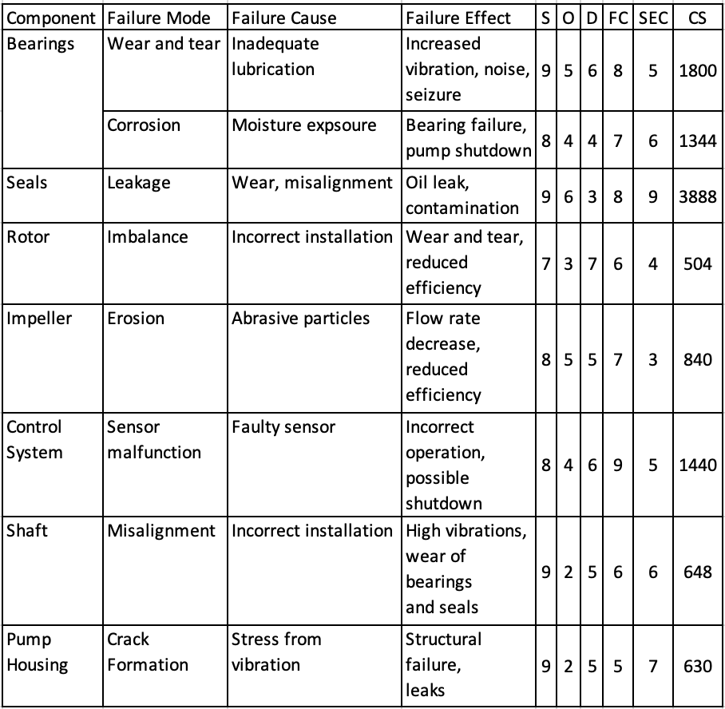
Figure 1 - FMECA Table for a Turbine Driven Pump
A FMECA can be used to find and determine different failures that could happen to an asset, they can be used for making a maintenance plan by looking into what has a high criticality score. The score is determined across severity, occurrence, detection, failure criticality and safety and environmental criticality to give an overall criticality score. High priorities are components and failure modes with the highest CS values, such as seal leakage due to its high environmental and operational impact. Medium Priority are issues like sensor malfunctions and bearing corrosion due to their significant but less catastrophic impacts. Lower priority problems such as impeller erosion and shaft misalignment, where the operational impact is less severe or less frequent.
This FMECA provides a structured approach to understanding and mitigating risks associated with each component of the turbine driven pump, focusing efforts where they will have the greatest impact on safety, environmental compliance, and operational continuity.

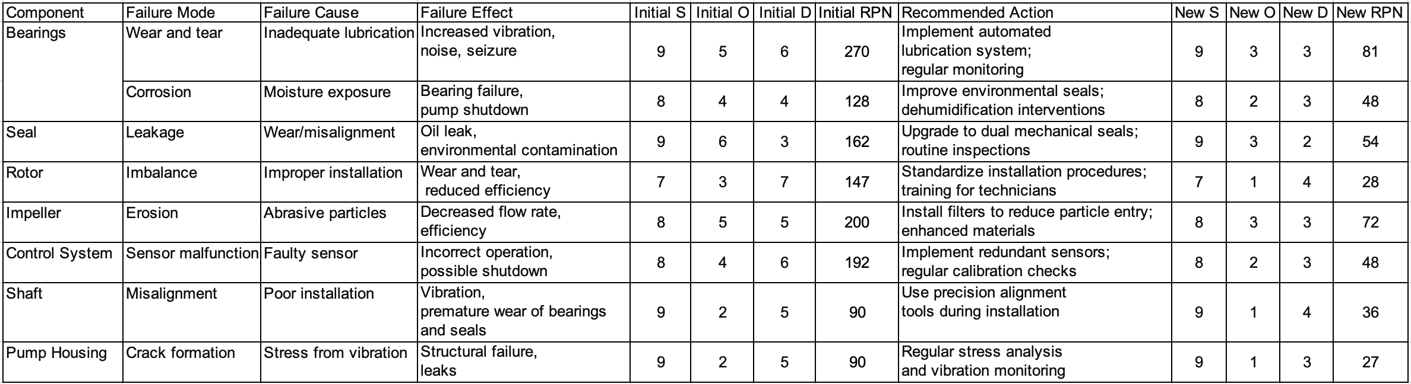
Figure 2 - FMEA Table for a Turbine Driven Pump
An FMEA table can be used for finding failures for components of an asset and what the effects will be, a score is given for the severity, occurrence and detection these are multiplied to give a risk priority number, a recommended action is given, this being implemented will reduce the occurrence and detection which will then reduce the risk priority number.
The FMEA can then be used for analysing the failure modes with higher risk priority numbers, so that they can be investigated, and maintenance can then be planned on them.
This FMEA has identified several critical areas requiring attention to minimise downtime and improve operational efficiency. Implementing targeted improvement plans based on RPN will enhance reliability and safety, directly impacting overall productivity. This analysis should be revisited regularly or when process conditions change, ensuring that the mitigation strategies evolve with the operating environment.
By systematically implementing this asset care improvement plan, the refinery can enhance operational efficiency, reduce downtime, and improve safety, ensuring sustainable and reliable operation of the turbine driven pump.
Developing an asset care improvement plan from the results of the FMEA and FMECA involves several strategic and operational steps. The goal is to enhance the reliability, efficiency, and safety of the turbine driven pump in an oil refinery by addressing the risks identified. The improvement plan includes prioritising actions based on criticality, implementing technical solutions, and establishing ongoing monitoring protocols. This is done by ranking the components and failure modes based on their risk priority number and criticality score can be done to determine on what to focus on first, being the high risk areas such as bearing wear and tear, seal leakage, and sensor malfunction. Solutions can be implemented such as installing sensors to provide data, this can be used for implementing PPM strategies. With this a proper PPM strategy can be made from collecting the data and then looking at maintenance records over time as the maintenance is being implemented following the use of both the FMEA and the FMECA.

Task 3 – Maintenance Strategy

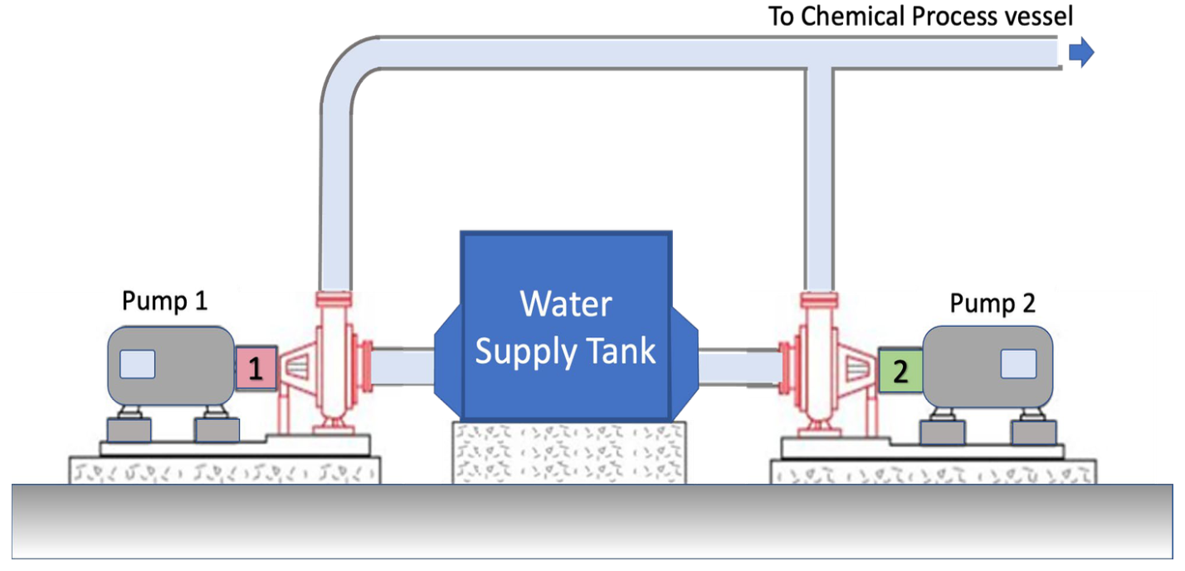
Figure 3 - Cooling Water Supply System
With these pumps operating in a duty/standby configuration it allows there to be an opportunity for one of the pumps to be receiving any required maintenance whilst the other one is online.
Having a proper maintenance schedule for this equipment is important to make sure that the two pumps do not clash when the maintenance is required as they are needed in the duty/standby configuration so that there is always one available for use.
For a system like this different types of monitoring equipment can be used to gather operational data, ensuring the system functions efficiently and safely. A flow meter can be used for measuring the amount of water moving through the pumps, providing continuous data to ensure that the flow rate matches the system's requirements for efficient heat removal from the chemical process. These can be fitted on the inlet and outlet of the cooling water pumps can help detect any discrepancies in flow which might indicate blockages, leaks, or pump degradation. A pressure sensor is another piece of detection equipment that can be used for finding a maintenance strategy, a pressure sensor can detect changes in pressure which can indicate different issues including pump failure, pipe blockages, or breaches in the system integrity. These sensors should be fitted both upstream and downstream of the pumps to detect differential pressure and at critical bends or junctions in the piping to ensure that the entire system maintains its structural integrity under operational pressures.
Temperature sensors can be used for monitoring the cooling water as this could need to be at a required temperature to ensure that it can absorb the heat from the exothermic reaction without reaching temperatures that could damage the chemical process or equipment. Installing temperature sensors at the water input and output points allows for a gradient analysis which helps in assessing the efficiency of the heat exchange process within the vessel.
Vibration sensors are used to help find mechanical issues in the pumps, higher vibrations could be an indicator of there being misalignment, imbalance, or bearing wear, all of these could lead to failure of the pump. Placing vibration sensors directly on the pump housings provides real-time data on the operational health of the pumps, facilitating early maintenance interventions.
A power meter can be used on these pumps to see the amount of power the pump is using, these are good for seeing what the efficiency of the pump is and whether it is straining or able to keep a constant flow. Continuous monitoring of electricity use helps in optimising pump operation and scheduling maintenance before efficiency drops lead to higher operational costs.
All of these sensors can be used as an aid in deciding which maintenance is best for the pumps in this configuration. The two options of maintenance are run to failure and planned preventative maintenance (PPM). Each strategy has implications based on different considerations.
There are safety standards that must be followed as this is at a COMAH site, the site needs to follow these standards to prevent any incidents that could have any severe consequences to any workers or that could cause environmental issues. Given these potential issues adopting a PPM strategy would be more beneficial as run to failure could cause big issues if left to deteriorate too much.
The reliability of the cooling water system is vital for the continuous operation of the chemical processes, particularly because it manages the temperature of exothermic reactions. Any interruptions could lead to process failures, safety issues or the need to have an unexpected shutdown.
Maintenance costs and the potential financial impact of unplanned downtime need to be considered carefully. While run to failure might have lower initial costs, it could have higher overall costs due to emergency repairs and possible process shut downs.
The complexity of the system and the critical nature of its requirements mean a proactive approach to maintenance is needed. The potential consequences of a system failure not only include operational disruption but also significant safety risks.
Both maintenance strategies have their advantages and disadvantages, PPM can extend the lifespan of equipment through regular repairs and early detection of potential issues, maintenance schedules reduce the risk of unexpected failures, ensuring operations can continue. Having a plan in place can ensure that there is always one of the pumps available and should be running fine whilst the other is being maintained. The main disadvantage of PPM is there being higher upfront costs due to more regular maintenance.
Run to Failure can have lower costs if the maintenance is being carried out less often only when failure occurs, however there is an increased chance of there being a higher or catastrophic failure with these having greater costs or there being severe safety and environmental consequences.
In this scenario at a COMAH site, PPM is the recommended strategy. The main reason is the need for safety and reliability in this environment. Regular maintenance helps in maintaining continuous and safe operations but also aligns with the site’s legal requirements.
PPM allows for scheduled interventions that can be planned during optimal times, this minimises operational disruptions and ensures that the system operates at peak efficiency. This strategy also reduces the risk of unexpected failures, which is essential in maintaining the integrity and safety of the process. Overall, while PPM may require a greater initial investment, the longer term benefits of ensuring safety, compliance, and operational continuity outweigh the costs, making it the most suitable maintenance strategy for this scenario.

References
(No date a) What is FMEA? failure mode & effects analysis | ASQ. Available at: https://asq.org/quality-resources/fmea (Accessed: 20 March 2024).
(No date b) Maintenance strategy selection (PDF download available). Available at: https://www.researchgate.net/publication/267298504_Maintenance_Strategy_Selection (Accessed: 17 January 2024).
FMECA: Failure mode, Effects & Criticality Analysis: Quality-one (2022) Quality. Available at: https://quality-one.com/fmeca/ (Accessed: 20 March 2024).
Gillis, A.S. and Schuchart, W. (2022) What is FMEA (Failure Mode and effects analysis)? A definition from techtarget.com, CIO. Available at: https://www.techtarget.com/searchcio/definition/FMEA-failure-mode-and-effective-analysis#:~:text=FMEA%20(failure%20mode%20and%20effects%20analysis)%20is%20a%20step%2D,which%20something%20might%20break%20down. (Accessed: 20 March 2024).
Gwilliam, A. (2023) What is condition-based maintenance? – maintainx: Learning center: Maintainx, Learning Center RSS. Available at: https://www.getmaintainx.com/learning-center/condition-based-maintenance/ (Accessed: 13 April 2024).
MaintenX (2020) The Pros and cons of a run-to-fail maintenance strategy, Maintenx. Available at: https://maintenx.com/the-pros-and-cons-of-a-run-to-fail-maintenance-strategy/ (Accessed: 01 February 2024).
SFG20 (2023) Finding a balanced maintenance strategy , SFG20. Available at: https://www.sfg20.co.uk/blog/finding-a-balanced-maintenance-strategy (Accessed: 19 January 2024).
Sse (no date) 7 drawbacks of a run to failure maintenance strategy, Concentric and Southern States Enterprises. Available at: https://www.ssents.com/blog/drawbacks-of-a-run-to-failure-maintenance-strategy#:~:text=While%20run%20to%20failure%20is,failure%2C%20take%20your%20typical%20lightbulb. (Accessed: 01 February 2024).
What is corrective maintenance? (definition, Pros, cons and examples) (no date) TWI. Available at: https://www.twi-global.com/technical-knowledge/faqs/what-is-corrective-maintenance#:~:text=Unscheduled%20corrective%20maintenance%20tasks%20can,order%20as%20quickly%20as%20possible. (Accessed: 13 April 2024).

