University of Wales Trinity Saint David
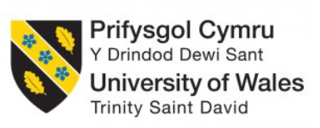

Title: Assessment component 1: Individual Report
Item | Description
Student Name: | Salah Mheidean
Student ID: | 2109425
Module: | Human Capital Management
Module Code: | LCMB7023
Lecturer: | Ejike Udeogu (Birmingham)
Internal Verifier: | Vasilios Tavlaridis  Hoang Nguyen
Word count

Contents
Introduction 1
1. Technological advancements reshaping labour markets, and their implications for HRM and IHRM strategies 1
2. Demographic and geopolitical factors influencing employment markets 3
3. Addressing persistent skills gaps and talent shortages 6
3.1 Strategic Workforce Planning and Data-Driven Anticipation 6
3.2 Building Talent through Reskilling, Upskilling, and Apprenticeships 7
3.3 Expanding the Talent Pool through Innovative Acquisition and Retention 7
4. Reflective Report on International Capabilities in a Globalised Workplace 8
4.1 Executive Summary 8
4.2 Technological Proficiency and Adaptation 8
4.3 Cross-Cultural Communication and Teamwork 8
4.4 Leadership and Self-Directed Learning 9
5. Conclusion 9
References 11

List of Tables
Figure 1 Demographic and geopolitical factors influencing employment markets 3
Figure 2 Employment by Age-ONS UK 4
Figure 3 Working age population, aged 15–64, growth rate (percent) 5
Figure 4 Skills Gaps and Talent Shortages 6

Introduction
The global labour market is in a serious change whereby the forces of technological innovation, demographic changes, and geopolitical changes are great forces, which are reconfiguring the world labour market. Industries are radically transforming due to the use of technologies like artificial intelligence, automation, and digital platforms that create demand and required new skills, rendering the old ones unnecessary. Such developments exacerbated by ageing populations and tighter immigration laws are giving business and their human resource management a complex multitude of challenges. This changing environment is explored in this analysis with regards to the strategic approaches required to overcome the prevalent skills shortages, as well as the assessment of the personal skills required to be successful in a more unpredictable and globalised workplace environment; the digital fluency, to the intercultural skills.

Technological advancements reshaping labour markets, and their implications for HRM and IHRM strategies
The technological advances and, in particular, artificial intelligence (AI), automation, and digital systems are radically transforming the labour markets around the world, and it is making a significant change in the nature of work and the skills that employees need. Routine and repetitive, physical and mental, is always being absorbed by the spreading application of automation and Robotics Process Automation (RPA) (Yakovenko, Y. and Shaptala, R., 2023). This causes job polarisation, a scenario where the medium-skilled jobs are on the downwards growth and the highly-skilled positions in analytical jobs are on the upwards growth and low-skilled jobs that are in the service sector that are difficult to automate (Al Zarooni and El Khatib, 2023). In the UK, this is exemplified by Ocado's highly automated fulfilment centres, where AI-powered robots handle grocery picking, fundamentally changing the warehouse workforce's skill requirements (Oxford Economics, 2019). Concurrently, digital platforms are fostering the growth of non-standard gig and remote work, dissolving traditional organisational boundaries and creating a more fluid, project-based economy, as seen with the UK's expansive gig economy workforce, estimated to be over 4.4 million people (IPSE, 2023). This digital transformation is not merely a disruptor but a critical enabler of operational excellence. For instance, studies within the UAE context demonstrate that the integration of information technologies and robust business process management (BPM) capabilities significantly enhances process performance and overall firm competitiveness (Akour et al., 2022; Alshurideh et al., 2022), a lesson applicable to UK multinationals like HSBC, which has leveraged digital transformation to streamline its global operations (HSBC, 2023).
These seismic shifts demand a strategic and proactive evolution in Human Resource Management (HRM) and International Human Resource Management (IHRM). For HRM, the mandate is to transition from an administrative function to a strategic architect of talent. This involves a fundamental recalibration of talent acquisition, development, and retention strategies. With an estimated 60% of process-centric tasks being automated (Al Zarooni and El Khatib, 2023), reskilling and upskilling initiatives become paramount to cultivate a future-ready workforce proficient in digital literacy, complex problem-solving, and creativity. For example, BT Group has embarked on a major reskilling programme, ‘Skills for Growth’, aiming to future-proof its workforce against technological obsolescence (BT Group, 2024).
The impact on International Human Resource Management is particularly significant. The adoption of technology introduces greater complexity in overseeing a worldwide employee base. IHRM approaches must manage the difficulties of coordinating teams that are culturally diverse and spread across different locations, yet connected through digital tools (Gupta, N. and Gupta, A.K., 2025). This necessitates creating advanced digital communication guidelines and building a unified company culture internationally. The need for global movement of talent and sharing of knowledge intensifies, but this must be weighed against the requirement to adapt to local conditions. IHRM also faces the challenge of differing national laws regulating digital work, data protection, and the classification of gig economy workers (Pareekh, S., 2025). Aligning IHRM with the broader business strategy is vital, as shown by studies connecting international expansion and operational adaptability to improved company worth in small and medium-sized enterprises (Alshurideh et al., 2023). For a UK multinational such as Unilever, this involves using centralised HR systems to manage its 148,000 global employees while tailoring recruitment and development approaches to specific countries like Brazil or India (Unilever, 2023). In this technological era, an organization's people remain its key asset. Consequently, HRM and IHRM plans that skillfully use technology while also focusing on employee development, promoting flexible structures, and managing international regulations will be essential for long-term success.

Demographic and geopolitical factors influencing employment markets

Figure 1 Demographic and geopolitical factors influencing employment markets
Current labour markets are experiencing a significant transformation, influenced by the combined influence of demographic changes and rising international political tensions. These large-scale external factors are creating a complicated and unpredictable business environment, which poses various difficulties for Human Resource managers responsible for finding and retaining workers. In demographic terms, the worldwide situation is divided into two distinct parts (Alshurideh et al., 2023). Advanced economies and major emerging markets are grappling with rapidly aging populations and declining birth rates, leading to a constriction of the prime-age workforce. According to the World Bank, the global population growth rate has fallen below 1% annually, with over 60 countries, including Japan, Germany, and China, experiencing a projected decline in their working-age populations (World Bank, 2023).
The United Kingdom exemplifies this challenge. The Office for National Statistics (ONS) projects that the number of people aged 65 and over will grow by 25% between 2020 and 2045, while the population aged 16-64 will grow by less than 2%, sharply increasing the old-age dependency ratio (ONS, 2023). This is compounded by economic inactivity; as of late 2024, over 3.5 million working-age adults in the UK were economically inactive due to long-term sickness, a record high that severely constricts the domestic talent pool (CIPD, 2023). Consequently, sectors like healthcare and social work face crippling vacancies, consistently exceeding 100,000 unfilled posts in the NHS England alone, while the tech sector struggles with a shortfall of skilled digital professionals.
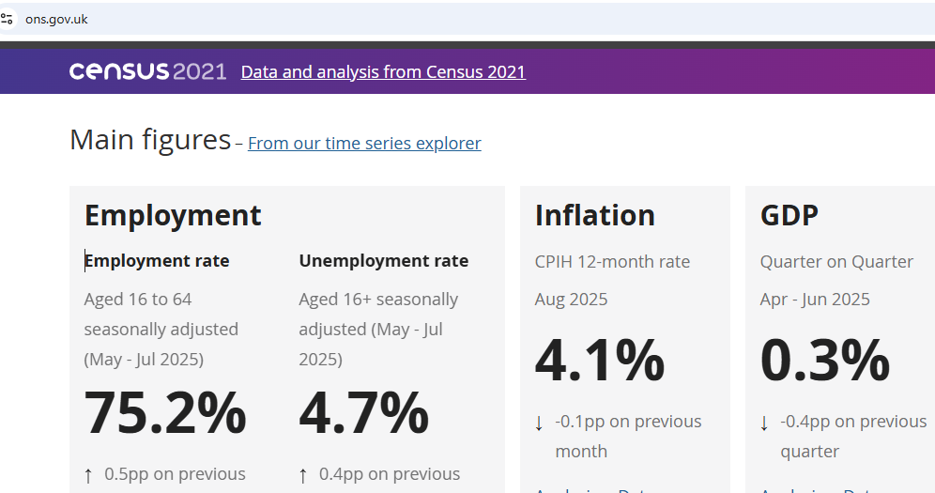
Figure 2 Employment by Age-ONS UK
Conversely, many developing nations, particularly in Sub-Saharan Africa and parts of South Asia, face a youth bulge, with the International Labour Organization (ILO) reporting that youth unemployment rates are consistently two to three times higher than those for adults, posing a significant challenge of productive absorption into the labour market (ILO, 2023).
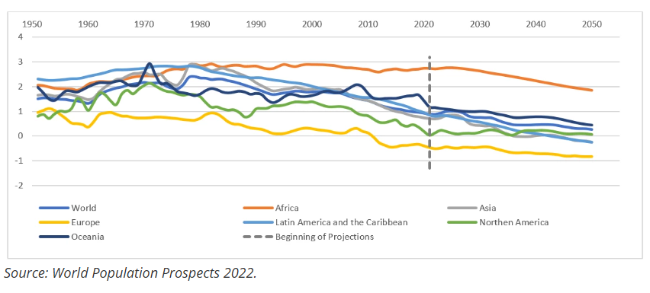
Figure 3 Working age population, aged 15–64, growth rate (percent)
Simultaneously, the geopolitical environment has become a dominant determinant of labour market stability and fluidity. The resurgence of great power competition, trade protectionism, and regional conflicts has disrupted global supply chains, which in turn dictates labour demand in manufacturing, logistics, and related sectors. The World Economic Forum (2025) identifies geopolitical volatility as a top-five risk for business leaders, directly impacting strategic planning and market operations. This fragmentation is reversing decades of globalization, prompting a corporate strategy of "friend-shoring" and supply chain diversification. For the UK, the geopolitical realignment was acutely accelerated by Brexit, which fundamentally reshaped its access to the European labour market. The introduction of the points-based immigration system has created significant barriers for employers (Morris, M., 2019) in sectors traditionally reliant on EU nationals, such as hospitality and food manufacturing, where the number of EU workers fell by 36% in the two years following the new regulations (UK Government, 2023). For HR, this necessitates a fundamental rethinking of talent sourcing and deployment. Restrictions on the mobility of people, such as tightened visa regimes and immigration policies, directly impede the ability to fill skill gaps with international talent, thereby intensifying the war for domestic skills.
The convergence of these demographic and geopolitical factors creates a suite of critical challenges for HR professionals (Tilikina, N., et al., 20250. Primarily, they must develop robust strategies to combat the pervasive skills scarcity. This involves not only aggressive external recruitment but also significant investment in internal reskilling and upskilling initiatives; the World Economic Forum (2025) estimates that 60% of workers will require retraining before 2027. In the UK, this is reflected in a push for higher-quality apprenticeships, with the government aiming to reach 90,000 starts in the 2024/25 academic year to build a home-grown skills pipeline (Skills England Report, 2024). Secondly, HR must design and implement sophisticated Diversity, Equity, and Inclusion (DEI) strategies to leverage underutilized talent pools, such as older workers, women, and global migrants, to mitigate domestic workforce shortfalls. This involves implementing adaptable work models to encourage economically inactive individuals to return to employment and establishing fair hiring methods.

Addressing persistent skills gaps and talent shortages

Figure 4 Skills Gaps and Talent Shortages

3.1 Strategic Workforce Planning and Data-Driven Anticipation
The essential first step in addressing skills shortages across industries is to move from reactive hiring to forward-looking, evidence-based workforce strategy. Lasting shortfalls in key sectors like technology, hospitality, and healthcare are not temporary issues but permanent characteristics of today's economy, made worse by fast technological progress and population changes (CIPD, 2023). Companies need to use advanced prediction methods to compare future skill needs with their employees' current abilities. This methodical process helps identify missing skills before they harm business operations. As noted in the UK government's review, successful planning requires a clear distinction between "skills gaps" (current employees needing better skills) and "skills shortages" (too few qualified job applicants), as each problem needs different solutions (UK Government Literature Review, 2020). By aligning human capital strategy with long-term business objectives, HRM can pinpoint precise vulnerabilities and allocate resources with surgical precision.

3.2 Building Talent through Reskilling, Upskilling, and Apprenticeships
While external hiring remains a component, a strategic over-reliance on the competitive open market is a high-risk strategy in sectors experiencing universal talent shortages. The most sustainable solution is to cultivate talent internally through robust investment in reskilling and upskilling initiatives. This involves creating a culture of continuous learning, supported by dedicated Learning & Development (L&D) frameworks that are directly tied to strategic goals. For instance, in the hospitality sector, which faces a labour shortage crisis, targeted upskilling in digital literacy, revenue management, and advanced customer service can enhance productivity and employee retention (Moore KS, 2023).

3.3 Expanding the Talent Pool through Innovative Acquisition and Retention
Strategic HRM must also innovate in talent acquisition by looking beyond traditional candidate profiles. This entails forging strategic partnerships with educational institutions, coding bootcamps, and community organizations to access non-traditional talent streams. In the technology sector, this could mean prioritizing demonstrable competencies and portfolio work over formal degree requirements, thereby tapping into a wider and more diverse pool of skilled individuals (LinkedIn Article, 2024). Concurrently, addressing retention is paramount; it is economically irrational to focus solely on recruitment if talent is leaking from the organization. In hospitality, for example, where high staff turnover is endemic, improving retention by just 10% can save a business up to 80% of a leaver's salary in replacement costs (Moore KS, 2023). A strategic focus on enhancing the overall Employee Value Proposition (EVP)—through competitive remuneration, flexible working arrangements, clear career pathways, and purposeful work—is essential to secure and retain the critical skills necessary for organizational resilience and growth in a talent-constrained environment. This holistic, tripartite strategy—encompassing anticipatory planning, internal development, and innovative sourcing—creates a virtuous cycle of attraction, development, and retention. By systematically implementing these integrated approaches, organisations can transform talent scarcity from a critical vulnerability into a sustained competitive advantage, building a resilient and future-proof workforce capable of navigating evolving market demands.

Reflective Report on International Capabilities in a Globalised Workplace

4.1 Executive Summary
This report provides a critical self-assessment of my capabilities for operating effectively in an international context, drawing on my professional experiences at Tesco PLC. This evaluation assesses my capabilities across five critical areas—technology, communication, collaboration, leadership, and independent learning—pinpointing both strong points and development needs. It then outlines a specific plan for ongoing growth, designed to meet the requirements of a globalised, technology-focused business world.

4.2 Technological Proficiency and Adaptation
My position at Tesco, a major international retailer, has given me significant experience with corporate-level technology systems. I have improved my skills in using advanced data analysis tools within our supply chain systems to monitor global inventory and product movement. This hands-on experience has improved my ability to use technology to enhance operational effectiveness, which supports the research of Akour et al. (2022) on how IT skills improve business process management. A current limitation is my knowledge of the core systems, like the AI that drives our demand prediction tools. To improve this, I have begun an independent online course on AI basics in supply chains, with the goal of moving from a competent user to a more knowledgeable one who can help improve these systems.

4.3 Cross-Cultural Communication and Teamwork
A key strength I have cultivated is proactive communication within diverse teams. Tesco’s operational structure necessitates collaboration with colleagues and suppliers from Eastern Europe and Asia. I have learned to consciously adjust my communication style, favouring clearer, more explicit language and confirming understanding to bridge cultural and linguistic divides. This aligns with the principle that effective collaboration in virtual organisations is paramount for quality outcomes (Al Shuweihi, Al Zaabi and El Khatib, 2023). My area for development is a deeper, more systematic knowledge of the specific business etiquettes of our key partner regions. While I navigate interactions effectively, a more formal understanding of cultural nuances would enhance relationship building. I plan to address this by participating in cross-cultural training workshops offered internally and seeking mentorship from senior colleagues with extensive international experience.

4.4 Leadership and Self-Directed Learning
My leadership experience has been largely project-based, where I have demonstrated strength in coordinating tasks and ensuring alignment with strategic objectives, a skill vital for managing functions in complex organisations (El Khatib et al., 2024). For instance, while leading a small-scale initiative to improve a reporting process, I successfully integrated feedback from a geographically dispersed team. My primary developmental need is gaining experience in leading through significant ambiguity or crisis, a common challenge in the volatile global geopolitical landscape. To develop this resilience, I am pursuing opportunities to manage projects with greater uncertainty. Additionally, my dedication to independent learning is fundamental to my professional approach. I regularly allocate time to review industry analyses on global retail trends and new technologies, recognising that ongoing skill development is mandatory for capitalising on new possibilities and preserving a company's competitive edge (Alshurideh et al., 2023).
Although I have a strong base in international technical and collaborative skills, my growth plan concentrates on enhancing my technical and cultural understanding and seeking demanding leadership roles. This intentional focus on my development is intended to ensure I am completely prepared to support and guide teams within Tesco’s worldwide activities.

Conclusion
In summary, today's job market is characterized by a permanent shift where fast technological change, demographic trends, and global political divisions are constant realities. Companies cannot depend on conventional sources for talent anymore and must instead implement a strategic, comprehensive method. This demands that HRM shifts to an administrative position to a workforce potential designer, strategist, prodigal in generating power by doing workforce planning in detail, a program of specific training and a superior employee value proposition. Ultimately, it is long-term success, which will go to those companies and individuals, who embrace continuous learning and adaptability, that will be able to deal with this new era of unpredictability and opportunity.

References

- Akour, et,al (2022) ‘Impact of information technologies capabilities and information system capabilities on business process management’, International Journal of Business Analytics and Security (IJBAS), 1(1).
- Al Shuweihi, S., Al Zaabi, M. and El Khatib, M. (2023) ‘The sustainability of TQM in an innovative environment: The quality of virtual organization’, International Journal of Business Analytics and Security (IJBAS), 3(1).
- Alshurideh, M., Al Kurdi, B., Alrawabdeh, W. (2023) ‘Enhancing manufacturing competitiveness in UAE SMEs: The influence of process quality improvement and lean practices’, International Journal of Business Analytics and Security (IJBAS), 3(2).
- Al Zarooni, L. and El Khatib, M. (2023) ‘Robotics Process Automation (RPA) and Project Risk Management’, International Journal of Business Analytics and Security (IJBAS), 3(1).
- Bibi, A., Al-Ibbini, T. and Alzoubi, F. (2023) ‘Intricate interplay between knowledge management and creative organizational climate effecting smart organization’, International Journal of Business Analytics and Security (IJBAS), 3(2).
- CIPD (2023). Devolution and Evolution: The case for a more responsive and accountable skills system in England. London: Chartered Institute of Personnel and Development.
- CIPD (2023). Labour Market Outlook. London: Chartered Institute of Personnel and Development.
- Gupta, N. and Gupta, A.K., 2025. International Human Resource Management. In Human Resource Management for Organisational Success: Volume II (pp. 315-344). Singapore: Springer Nature Singapore.
- International Labour Organization (ILO) (2023) World Employment and Social Outlook: Trends 2023. Geneva: ILO.
- LinkedIn Article (2024). Bridging the Skills Gap: Proven HRM Strategies to Address Talent Shortages. Available at: https://www.linkedin.com/pulse/bridging-skills-gap-proven-hrm-strategies-address-g6rwf/ (Accessed: 3 October 2025).
- McKinsey & Company (2023). Beyond hiring: How companies are reskilling to address talent gaps. Available at: https://www.mckinsey.com/capabilities/people-and-organizational-performance/our-insights/beyond-hiring-how-companies-are-reskilling-to-address-talent-gaps (Accessed: 3 October 2025).
- Moore KS (2023). Addressing Labour Shortages in the Hospitality Sector. [online] Moore KS. Available at: https://mooreks.co.uk/insights/addressing-labour-shortages-in-the-hospitality-sector/ (Accessed: 12 October 2025).
- Morris, M., 2019. IMMIGRATION SYSTEM.
- Office for National Statistics (ONS) (2023). *National population projections: 2021-based interim. Available at: https://www.ons.gov.uk/peoplepopulationandcommunity/populationandmigration/populationprojections/bulletins/nationalpopulationprojections/2021basedinterim (Accessed: 5 October 2025).
- Pareekh, S., 2025. Human Resource management in the global era. Academic Guru Publishing House.
- Skills England Report (2024). Skills for an Uncertain Future: Building a World-Class Education and Skills System. London: HM Government.
- Tilikina, N., Wang, Z., Korol, M., Abdekirov, A. and Alybaeva, G., 2025. Human Resource Development Management in the Context of Current Migratory and Security Threats.
- UK Government (2023). UK Immigration System Statistics. Available at: https://www.gov.uk/government/collections/migration-statistics (Accessed: 6 October 2025).
- UK Government Literature Review (2020). Understanding skills gaps and shortages in the UK economy. Available at: https://assets.publishing.service.gov.uk/media/5fb50f37d3bf7f63e9033189/131120_FINAL_literature_review_for_publication.pdf (Accessed: 8 October 2025).
- Yakovenko, Y. and Shaptala, R., 2023. Intelligent process automation, robotic process automation and artificial intelligence for business processes transformation. Publishing House “Baltija Publishing”.
- World Bank (2023) World Development Report 2023: Migrants, Refugees, and Societies. Washington, DC: World Bank.
- World Economic Forum (WEF) (2025) Future of Jobs Report 2025. Geneva: World Economic Forum.

