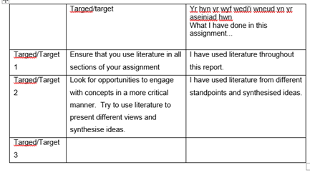

How School develops one aspect of its SDP: a report that critically reflects on the actions, impact and evidence base.

Table of Contents
Introduction…………………………….2
Literature review……………………….2
Developing an action point…………..4
Reflection and evaluation……………6
Conclusion…………………………….7
References…………………………….9
Appendices……………………………13

Introduction
For the purpose of this assignment, it was necessary to gain consent and approval from the school to use policy documents, data and images. I will refrain from naming individuals or the school in order to respect their rights to confidentiality and anonymity (British educational research association, 2019). This written report is focused on how School X develops one strand of its school development plan (SDP). I will critically reflect on a specific target from the priorities within the SDP. The Schools first strategic target ‘to raise standards and improve progress in three skills of literacy; oracy, reading and writing will be analysed throughout. Therefore, the literature review will focus on one of the professional development needs (actions) that are related to the priority target 1.
The latest ERW report (2019/20) categorises School X as a ‘yellow’ school, with 276 pupils on roll. This primary school is situated in a deprived village in Swansea with a high percentage of pupils entitled to free school meals. The school is extremely committed to supporting families, offering excellent care and guidance through a range of inclusive, community engagement opportunities (Estyn, 2018). According to my local schools (2019) there are fifty-four percent of pupils with additional learning needs, twenty-two percent with a school action plan and over six percent requiring a statement of educational needs. Most of the pupils that are statemented are taught within the specialist teaching facility which embraces the pupils in a mainstream environment (ERW,2019/20).
Literature Review
Firstly, this literature review will provide a brief overview of the literature relating to the school development process and then proceed to the chosen priority of the SDP, target 1: ‘to raise standards and improve progress in the three skills of literacy; oracy, reading and writing (see appendix 2). With focus on raising standards in boys’ literacy skills.
In compliance with the Education SDP Wales Regulations 2014, all maintained Welsh schools must have a school development plan which operates over a three-year period (Welsh Government, 2016). As it is the process where a school strategically plans for improvements, through identifying the school's priorities, establishing specific actions to take to ensure progress in learner outcomes, implementing the actions together with the resources needed to support them and reviewing the overall outcomes (Department of Education n.d.; Welsh Government 2014 p.3; Welsh Government 2016, p.5). Although it is down to each school to decide upon their approach to development planning (which improvement cycle to use), the implementation of a robust development plan is essential, as it could result in improved learner outcomes, a higher quality of teaching, staff development and whole school success (Xaba 2006; Department of Education 2010; Estyn 2017; Welsh Government, 2019). One effective approach used by many schools is the ‘school development planning cycle’, (see appendix 1) as it recognises four sections (self- evaluation, strategic planning, making improvements and reviewing impact) to ‘raising standards and improving learner outcomes’ (Welsh Government, 2014 p.7). This cycle is determined by the school’s vision, which should be developed, understood and shared by all involved with the school, representing the values of pupils, parents, governors and staff members within the schools community in order to provide the foundations for continuous improvements (Department of Education 2010; Welsh Government 2014;The Open University 2017; Estyn, 2018). According to Brighouse and Woods (1999) governors are an asset to schools for the reason that they act as a ‘critcal friend’ through providing support and advice when informing schools on their strengths and weaknesses. Through the self-evaluation stage, schools are reflecting on their overall performance, assessing what needs to be improved and how to do so. However, the Welsh Government (2014) stresses that school development planning should also identify and share the strengths and practices of the school and not only focus on the school’s developmental needs. Significant evidence supports this, revealing that the implementation of effective self-evaluation that celebrates the strengths of a school can improve educational experiences for learners and the community. Additionally, if good practice is shared, it may improve outcomes in other schools within the cluster (Estyn 2013;2018).
School X is addressing the national priority of raising standards in literacy within its SDP (Welsh Government, 2014). Moreover, Maynard (2002) states that boys’ literacy should be one of the main action points in a school improvement plan due to the national concerns of literacy attainment (OECD 2019; Stainthorp 2010; Brozo, 2019) The school's self-evaluation process identified under-achievement in boys’ reading skills. School X stressed that there was a common relationship in the school between the boys with low reading ages and the boys who were entitled to free school meals. Research resembles this, with a correlation between poorer language, literacy and communication skills and children who live in disadvantaged areas in Wales (Save the Children, 2015), therefore, the Welsh Government administered a main priority to raise literacy standards in Wales, through encouraging parental engagement through reading campaigns (Make time to read), implementing policies and frameworks (LNF) and through new personalised reading assessments (National online reading assessments) (Welsh Government 2008; Welsh Government 2015; ITV News 2015). Research suggests that the most successful strategies in improving boys’ literacy skills are through effective teacher modelling, using writing partners for support, allowing boys opportunities to give input about their writing and reading tasks, using engaging and interesting texts for reading, establishing a successful reading culture, implementing rigorous intervention programmes, engaging in activities to develop speaking and listening skills and through teachers setting high expectations for their learners (Moss 2002; Ontario Ministry of Education 2004; The national strategies 2011; Ofsted, 2011; Brozo 2019). However, Ofsted (2010) stated that schools must try harder to overcome the challenges that pupils face with reading and writing, as evidence suggests that schools are not consistent or persistent enough in their approach to improving literacy and language skills to those with low social, economic status, additionally, these circumstances should not limit the opportunities that children have to learn to read and write ( Ofsted 2010; Save the Children, 2015). Substantial evidence concludes that the best schools implement a systematic synthetic phonics scheme to teach children how to read due to it being a successful approach to raising standards, also, studies have proven it is more effective than non-systematic approaches for teaching reading, with learners achieving higher results in reading, spelling and phonemic awareness (Graaff et al 2009; Ofsted, 2010). However, The University of Queensland reported negative views on pre-packed literacy schemes as they are outdated and promote a deficit model of teaching and learning (Fisher, Brooks and Lewis 2002). Having said this, School ‘X’ has recently implemented synthetic reading intervention programmes such as ‘project code x’ and ‘read write inc’ to develop children’s literacy skills. The school reported good progress in the targeted groups of boys that engaged with the programme ‘project code x’. However, Fisher, Brooks, and Lewis (2002) stress that it is important for schools to not solely depend on literacy schemes and suggest that pupils develop their language and literacy skills through the breadth of the curriculum. The new curriculum for Wales stresses that reading, writing, speaking and listening skills should be addressed holistically across the curriculum and that the four LLC statements of what matters should enable learners ‘to develop towards the four purposes’ (Welsh Government, 2020).
Developing an Action Point
Both staff members and the headship team contributed to the development of the school vision and mission statement, with family and inclusivity being core values. According to the SDP cycle, after developing a whole school vision, self-evaluation is the next step in the process of effective improvement planning (Welsh Government, 2014). The self-evaluation processes of School X are strong and meaningful, involving all stakeholders which have resulted in enhanced teaching standards and provision in all classes (ERW 2019/20). However, it is argued that schools should use a top-down approach to SD planning as it involves the required knowledge, training, and skills for its application (Xaba, 2006). Having said this, research suggests otherwise, strategic planning is more effective and robust if it is planned on a 'school level' through the bottom-up approach by capturing the views of pupils, parents, governors, staff, the local authority, and challenge advisors to plan for future improvements (Zhu 2009; WG, 2014). Furthermore, teacher questionnaires revealed that interview methods, discussions and listening to the opinions of others are most effective when formulating an SDP (Zhu, 2009, p. 40). Concerning the chosen priority, School X used mostly systematically collected data to inform the self-evaluation process. Using data to set instructional goals for pupil progress and achievement is an effective strategy in SD planning however, there should not be an over-reliance on assessment data (ShildKamp, 2018). School X reviewed mostly quantitative data from reading age tests, teacher assessments and national reading test scores to identify that the lower aged readers in KS2 were boys. However, it is argued that both effective qualitative and quantitative data should inform the self-evaluation process to ensure a more robust SDP. (WG 2014; ShildKamp, 2018; ERW, 2019).
The fundamental parts to the strategic planning stage is approving the spending plans, targets, community links and resources (DE 2010; WG,2014) School X produced a spending plan within the SDP, which states the purpose of the Regional Consortia Schools Improvement and the PDG is to ensure learners profit from excellent teaching and learning, focusing on improving literacy, staff development and breaking the link between the disadvantaged and educational attainment (SDP 2018/19). WG (2014) agrees how effective use of funding ensures the professional development in all teaching staff. School X’s priority was to improve progress in oracy, reading and writing, through eight action points, however, the action points that will be discussed are; engaging parents as reading helpers and rolling out project code X reading scheme in ks2 to target boys with very low reading ages (see appendix 2 & 3). It was considered vital that the governing body approved the targeted actions and addressed improvements through community engagement (DE 2010; WG, 2014). Therefore, School X ensured that one of its action points encouraged parental engagement through supporting with reading. Research has proven that there are a range of benefits to parental engagement in learning, such as higher student achievement, enhanced literacy skills, reducing barriers to poverty, improved attendance and pupil well-being (Moss 2002; Estyn, 2013; Estyn 2015; Victoria State Government, FaCE 2016). Moreover, parental engagement promotes positive reading behaviours in children (Ontario Ministry of Education, 2004). Having said this, Fullan (2019) highlights that parental engagement does not come without its own potential complications, such as possible mistrust between parents and the school. Therefore, I recommend that the school develops close relationships with parents, built on mutual respect and trust to ensure the best outcomes for the learners (Ofsted 2011; Epstein, 2018).
When planning for the ‘project code x roll out’ it was important for School X to organize the appropriate staff, timescales, resources and deliberate how to best monitor progress (WG 2014) therefore, within the next stage of SD planning (making improvements) the plans were put into action; an LSA conducted intervention sessions twice a week with the targeted boys and had weekly progress meetings with the LLC lead. The meetings were an effective way of providing updates about learners’ progress and the high-quality leadership from the LLC practitioner was deemed essential to supporting the professional development of the LSA (Education Improvement Commission 2000; WG, 2014). Lastly, to measure the impact of the action points, the LLC lead would monitor progress termly through the RAG rating system, both action points received green for on track. Data revealed an increase in boys’ reading ages which proved that both action points were a success. Erw (2019) reported that pupil progress reviews is a regular feature to School X’s improvement plan. Furthermore, regular and thorough monitoring of progress is an essential part to the cyclical process of the SDP (Brighouse and Woods 2013; WG, 2014).
Reflection and evaluation
Although School X used effective quantitative data to identify improvements for boys’ reading levels in the self-evaluation process, research suggests that pupil questionnaires surveys and interviews are also successful ways of accumulating more personal data (Muijs 2004; Greene and Hill, 2005). Sufian et al (2011) state that these methods combined provide essential information for the evaluation process. School X could have given pupils questionnaires based on their attitudes to reading in school and reading behaviours at home to conclude whether the school was implementing a positive reading culture for its students and whether they would benefit from more parental engagement. Research indicates that once schools are committed to establishing a successful reading culture, all learners will benefit, as it will impact on levels of reading engagement and reading achievement across the whole school (Moss 2002 and Ontario Ministry of Education, 2004). Additionally, pupil voice surveys could also inform the school on pupil reading preferences and dislikes. If this information is taken on board, the school could benefit from increased levels of learner engagement (Ontario Ministry of Education, 2004).
The school's strategic planning phase addressed how they would involve the community and enlist parent volunteers as responsible reading supporters. To further develop how the governing body works with the community I recommend that the school involves fathers or grandfathers to achieve the improvement priority of raising literacy standards. This has been very effective in other schools where evidence shows that boys are more responsive to male role models and therefore, male role models have a more substantial impact on the improvement of boys’ literacy skills (Estyn, 2015). Younger et al (2005) reports on successful case studies where schools worked in a triad system to improve literacy standards in Boys. Considerable evidence supports school cluster partnerships to develop, improve and strengthen self- evaluation and strategic planning (Education Improvement Commission 2000; Brighouse and Woods 2013; Estyn, 2019). Therefore, I recommend that School X builds partnerships with other cluster schools, to collaborate and share good practice in relation to SD planning.
I also advise that the school establishes more efficient timescales for their action points, especially their literacy interventions. Research suggests that short, high-quality daily interventions are proven to be more effective than hourly blocked sessions across the week, due to long periods of withdrawal from the classroom harming learners’ self-esteem (National Educational Psychological Service, 2019). To ensure high-quality teaching of literacy for all staff members there should be opportunities to develop professionally through regular training (Education Improvement Commission, 2000). In agreement, the Welsh Government (2014) states that schools should plan to develop a workforce with the required skill set to meet pupils’ individual needs. Furthermore, evidence showed that staff training in teaching literacy resulted in higher-performing teachers, a reduction of variations in teaching standards, and improved learner outcomes (Ofsted 2011; ERW, 2019). Therefore, School X could distribute their grant funding effectively to support the professional development of their staff members.
Conclusion
In conclusion, this report has focused on School X’s development process and the steps taken to ensure improvements. Upon reflection of this report, it is evident that School X has implemented a robust development plan by following the cyclical approach to raising standards and improving learner outcomes (WG, 2014). School X has shown strength in each of the four stages to improvement, however, the school should consider the proposed recommendations to the self-evaluation and strategic planning process. By creating professional partnerships with other schools, they are strengthening their SD planning, raising teaching standards, and sharing good practice. I have realised that to make significant differences in closing the literacy gender gap, schools should implement a synthetic phonics scheme from an early age, use high-quality staff members as a resource to provide frequent interventions for targeted groups of learners, establish a positive classroom reading culture with reading resources based on pupil interests and create opportunities for parental engagement in learning. Therefore, I will use this knowledge to develop my professional practice and improve literacy outcomes for learners. I will take on board the valuable process of self-evaluation used in schools and consider utilizing this to reflect upon my teaching performance.

References
BERA, 2018. Ethical Guidelines for Educational Research. 4th ed. [pdf] London: BERA. Available at: <https://www.bera.ac.uk/publication/ethical-guidelines-for-educational-research-2018-online> [Accessed 7 April 2020].
Brighouse, T. & Woods, D. (1999), How to improve your school, London ; New York: Routledge.
Brighouse, T. & Woods, D. (2013), The A-Z of school improvement principles and practice, London; New York: Bloomsbury Education.
Brooks, G., Fisher, R. and Lewis, M., 2002. Raising Standards In Literacy. 1st ed. London: Routledge, pp.1-51.
Brozo, W., 2019. Engaging Boys In Active Literacy: Evidence And Practice. Cambridge: Cambridge University Press, pp.1-44.
Department of Education, n.d. School Development Planning. [online] Education. Available at: <https://www.education-ni.gov.uk/articles/school-development-planning> [Accessed 16 April 2020].
Department of Education, 2010. School Development Planning: Every School a Good School. [pdf] Available at: < https://www.education-ni.gov.uk/sites/default/files/publications/de/every-school-a-good-school-school-development-planning-guidance-2010-english-version.pdf> [Accessed 16 April 2020].
Education Improvement Commission, 2000. School Improvement Planning: A Handbook For Principals, Teachers And School Councils. [ebook] Toronto: Education Improvement Commission, pp.1-95. Available at: <http://www.edu.gov.on.ca/eng/document/reports/sihande.pdf> [Accessed 16 April 2020].
Epstein, J., 2018. School, Family, And Community Partnerships. 2nd ed. New York: Routledge, pp.1-525.
ERW, 2019. Education Through Regional Working Report School X. Support Visit 1. Swansea: ERW, pp.1-11.
Estyn, 2013. Parents Take An Active Part In School Life | Estyn. [online] Estyn.gov.wales. Available at: <https://www.estyn.gov.wales/effective-practice/parents-take-active-part-school-life> [Accessed 17 April 2020].
Estyn, 2015. Using Male Role Models To Improve Boys’ Writing Skills | Estyn. [online] Estyn.gov.wales. Available at: <https://www.estyn.gov.wales/effective-practice/using-male-role-models-improve-boys’-writing-skills> [Accessed 17 April 2020].
Estyn, 2018. A Report on Cwmglas Primary School Colwyn Avenue Winchwen Swansea SA1 7EN. [pdf] Swansea: Estyn, pp.1-10. Available at: <https://e28bae51-bff8-492f92f01b2b2219a01b.filesusr.com/ugd/e37e98_e4146cf3f01c4a5eb45e7e4264cffa13.pdf> [Accessed 7 April 2020].
Estyn, 2018. Reshaping The School Vision. [online] Estyn.gov.wales. Available at: <https://www.estyn.gov.wales/effective-practice/reshaping-school-vision> [Accessed 16 April 2020].
Estyn, 2019. Working Collaboratively on School Improvement. [online]. Availabe at: https://www.estyn.gov.wales/effective-practice/working-collaboratively-school-improvement [Accessed 17 April 2020].
Family and Community Engagement (FaCE), 2016. Theme 3: Welcoming Families to Engage with The School Resources 1–9. [pdf] Cardiff: Welsh Government, pp.1-100. Available at: <https://gov.wales/sites/default/files/publications/2018-12/theme-3-welcoming-families-to-engage-with-the-school-resources-1-9.pdf> [Accessed 7 April 2020].
Fullan, M., 2016. The New Meaning Of Educational Change. 5th ed. New York: Teacher College Press, pp.150-164.
Graaff, S., Bosman, A., Hasselman, F. and Verhoeven, L., 2009. Benefits of Systematic Phonics Instruction. Scientific Studies of Reading, 13(4), pp.318-333.
Greene, S. and Hill, M. 2005. “Researching children's experience: methods and methodological issues”. In Researching children's perspectives: approaches and methods, Edited by: Greene, S. and Hogan, D. 1–21. London: Sage.
ITV News, 2015. Raising Literacy Standards A 'Major Welsh Government Priority'. [online] ITV News. Available at: <https://www.itv.com/news/wales/update/2015-09-22/raising-literacy-a-major-welsh-government-priority/> [Accessed 18 April 2020].
Maynard, T., 2002. Boys And Literacy: Exploring The Issues. London: RoutledgeFalmer, pp.1-10.
Moss, G., 2002. Raising Boys’ Attainment in Reading: some principles for intervention. Reading, 34(3), pp.101-106.
Muijs, D. 2004. Doing qualitative research in education with SPSS, London: Sage.
My Local School, 2019. My Local School. [online] Mylocalschool.gov.wales. Available at: <http://mylocalschool.gov.wales/School/6702077?lang=en> [Accessed 16 April 2020].
National Educational Psychological Service, 2019. Effective Interventions For Struggling Readers. [online] National Educational Psychological Service, pp.1-110. Available at: <https://www.education.ie/en/Education-Staff/Information/NEPS-Literacy-Resource/neps_literacy_good_practice_guide.pd> [Accessed 17 April 2020].
OECD, 2019. Programme For International Student Assessment Results From PISA 2018. [ebook] OECD, pp.1-5. Available at: <http://www.oecd.org/pisa/publications/PISA2018_CN_GBR.pdf> [Accessed 17 April 2020].
Ofsted, 2010. Reading By Six: How The Best Schools Do It. [ebook] Ofsted, pp.1-10. Available at: <https://assets.publishing.service.gov.uk/government/uploads/system/uploads/attachment_data/file/379093/Reading_20by_20six.pdf> [Accessed 17 April 2020].
Ofsted, 2011. Removing Barriers To Literacy. [ebook] Manchester: Ofsted, pp.1-5. Available at: <https://assets.publishing.service.gov.uk/government/uploads/system/uploads/attachment_data/file/413747/Summary_-_Removing_barriers_to_literacy.pdf> [Accessed 20 April 2020].
Ontario Ministry of Education, 2004. A Practical Guide To Improving Boys' Literacy Skills. [ebook] Ontario: Ontario Education, pp.1-52. Available at: <http://edu.gov.on.ca/eng/document/brochure/meread/meread.pdf> [Accessed 18 April 2020].
Save the Children, 2015. Ready To Read Closing The Gap In Early Language Skills So That Every Child In Wales Can Read Well. [ebook] Save the Children, pp.1-10. Available at: <https://www.savethechildren.org.uk/content/dam/global/reports/education-and-child-protection/ready-to-read-wales.pdf> [Accessed 17 April 2020].
Schildkamp, K., and C. L. Poortman. (2015), “Factors Influencing the Functioning of Data Teams.” Teachers College Record 117 (4). Available at: https://eric.ed.gov/?id=EJ1056710 [Accessed 15 April 2020).
School Development Plan (2019). Swansea.
Stainthorpe, R. (2002). Raising Literacy Standards for All? The National Literacy Strategy: An experiment in change in England and Wales. Educational Psychology, 22:4, 473-487. DOI: 10.1080/0144341022000003141.
Sufian, M., Grunbaum, J., Akintobi, T., Dozier, A. and Eder, M., 2011. Program Evaluation and Evaluating Community Engagement. In: CTSA Comittee Task Force, ed., Principles of Community Engagement, 2nd ed. [online] Department of Health & Human Services, pp.161-170. Available at: <https://www.atsdr.cdc.gov/communityengagement/pce_program_methods.html> [Accessed 17 April 2020].
The National Strategies, 2011. Improving Writing, With A Particular Focus On Supporting Boys' Writing Development. [ebook] The National Strategies, pp.1-6. Available at: <https://www.primarysupportteam.co.uk/files/improving_writing_with_a_particular_focus_on_supporting_boys__writing_development.pdf> [Accessed 17 April 2020].
The Open University, 2017. Perspective on Leadership: Building A Shared Vision For Your School: 1 The Importance Of Having A Clear Vision For Your School. [online] Open.edu. Available at: <https://www.open.edu/openlearncreate/mod/oucontent/view.php?id=57508&section=3> [Accessed 16 April 2020].
Victoria State Government Educational Board Improvement Cycle (2016). Available at: https://www.education.vic.gov.au/school/teachers/management/improvement/Pages/improvement-cycle.aspx [Accessed 15 April 2020].
Welsh Government (2016). Family and community engagement toolkit Theme 1: Leadership for a self-improving system Resources 1–7. Available at https://gov.wales/sites/default/files/publications/2018-12/theme-1-leadership-for-a-self-improving-system-resources-1-7.pdf [Accessed 10 April 2020].
Welsh Government (2014). School Development Plans. Available at: <https://gov.wales/sites/default/files/publications/2018-03/school-development-plans.pdf> [Accessed 16 April 2020].
Welsh Government (2019). Draft evaluation and improvement arrangements for Wales. [pdf]. Available at: < https://gov.wales/sites/default/files/publications/2020-01/draft-evaluation-and-improvement-accountability-arrangements-for-wales-1.pdf> [Accessed 18 April 2020].
Xaba, M., 2006. The Difficulties of School Development Planning. South African Journal of Education, 26(1), pp.15–26.
Younger, M., Warrington, M., Gray, J., Rudduck, J., McLellan, R., Bearne, E., Kershner, R. and Bricheno, P., 2005. Raising Boy's Achievement. Cambridge: Department for Education and Skills, pp.36-137.
Zhu, Z., 2008. Trade-Offs Between the Top-Down and Bottom-Up School Education Management Models: The Implementation of School Development Planning in Western China. Chinese Education & Society, [online] 41(5), pp.36-57. Available at: <https://web-b-ebscohost-com.ezproxy.uwtsd.ac.uk/ehost/pdfviewer/pdfviewer?vid=1&sid=196b7a5c-0ca1-40b2-b699-057282d0b750%40pdc-v-sessmgr01> [Accessed 16 April 2020].

Appendices
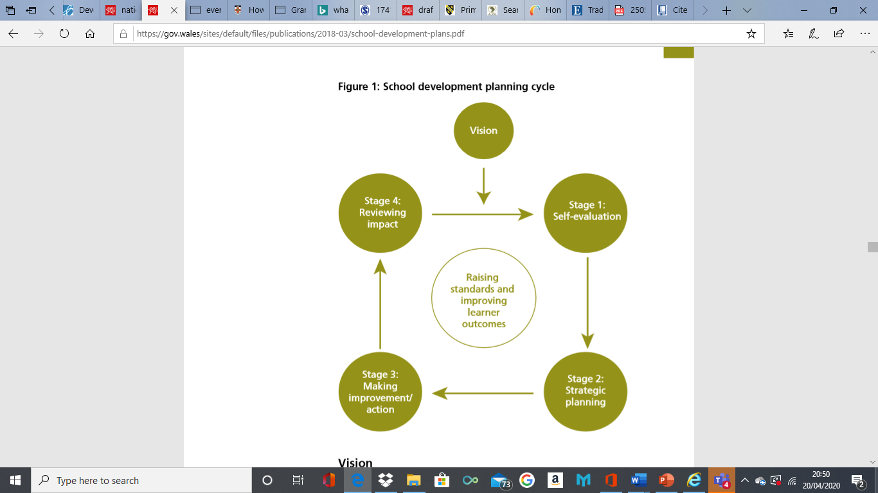

Appendix 1- School development planning cycle, image extracted from the Welsh Government document (2014) School development plans.
Appendix 2- Priority, SDP Target 1 with action points.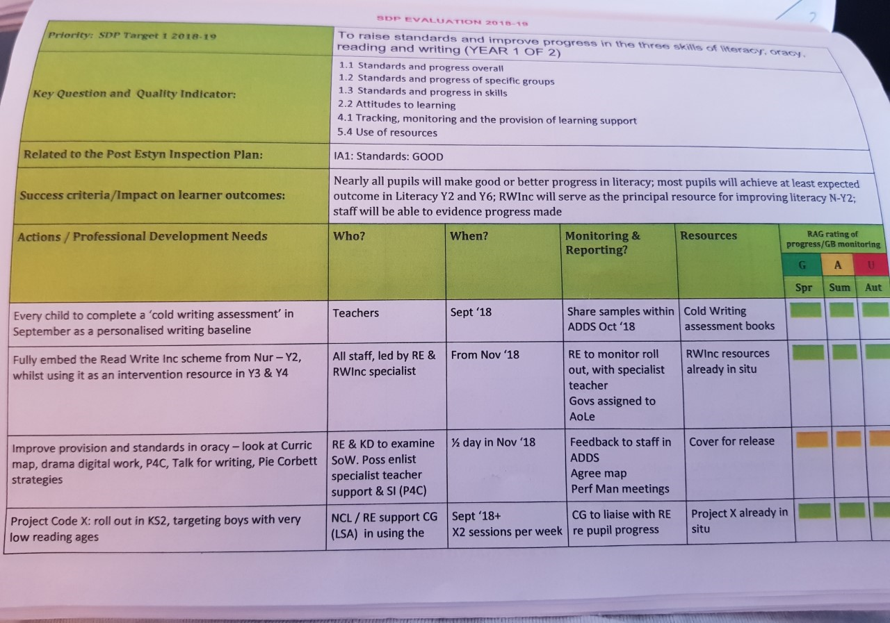
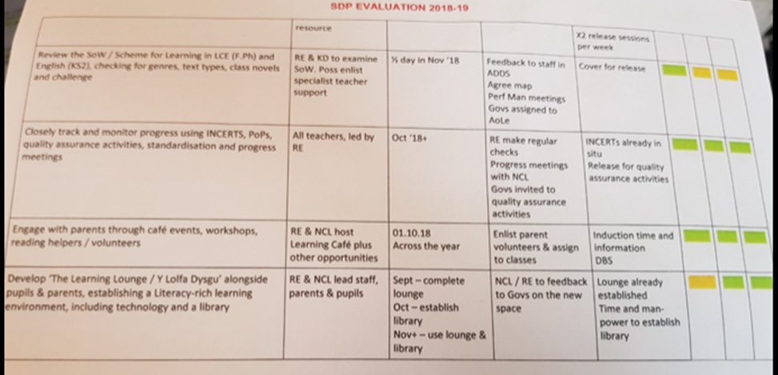
Appendix 3- SDP

