Use funerary evidence associated with a pre-Roman Iron age site to discuss how evidence can be used to identify differences in social status.
In this essay, I will be examining pre-Roman Iron age funerary evidence to be found at the King Harry Lane site, immediately outside the walls of Verulamium, which itself is the site and remains of an old Roman town in the Verulamium Park, in St Albans, Herefordshire. The issue with this site is that the finds of this site and area are unlikely to remain entirely within the boundaries of the pre-Roman Iron age but continue into the Roman Iron age. Fortunately, there are graves that are clearly marked as pre-Roman iron age burials, which will be the focus point in examining differences in social status that can be found- from only a brief observation of these, there does not yet seem to be any clear differences. This is a point of further examination.

The site was found by accident during excavating an extramural settlement alongside the Silchester road. Clear borders to the cemetery were found on the North and East sides. In the North-West the burials slowly petered out. The South side was bounded by a large ditch, with no burial within at least 4m from the ditch.
It was discovered that ditched enclosures with one central grave surrounded by others were prominent. The central grave tends to be a larger hole, and to contain more grave goods than those in its ditched perimeter (Stead, 1989). This indicates the use of status in burial.

The grave rites used fit Aylesford-Swarling/Belgic Cremations: a standard rite that was introduced or adopted in Kent and North Chiltern areas in the mid-1st Century BC and spread to adjacent areas of eastern England.
In this rite, the corpse is cremated, occasionally in the grave, and the calcined remains are buried in some container in cemeteries. The King Harry Cemetery has over 472 burials. In larger cemeteries the previously mentioned internal arrangement in clusters is explained and theorised as being that of families, and possibly lineages.
Much of this makes the King Harry Lane Cemetery a major source for information to study. Research puts the cemetery as a burial ground for a population of around 200 people. There is bias of 3 to 1 in favour of males, with very few pre-adults (children, teens, etc). This is explained, generally, as a burial rite being adopted by a, typically, male-dominated social group, which opened to women and children in the Roman period (Wait, 2005).

A clear examination of the King Harry Lane graves is clearly needed. Please note that all the pictures used below are noted in their origin in the source list below as they will now be examined.

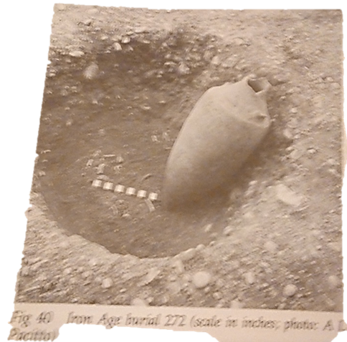 (Stead, 1989)
Here is Iron Age Burial 272. The scale of each grave is in inches. Please do not expect a deeper investigation of the measurements used here- it is not a strong point. However, it does seem to be more of a pit than the conventional grave type used today. The ashes being buried in a container seems irregular- typically, one buries the full body or scatters the ashes, though burying ashes still occurs.
This grave itself is a basic one. All it contains is the large pot- evidently the urn, as there are no other bodily remains, and the container is certainly large enough to hold the ashes of a person. Other than its size, the piece is in good shape, though the top is clearly damaged and no longer sealed. This is one of the central burials with partly defined borders (Stead, 1989).

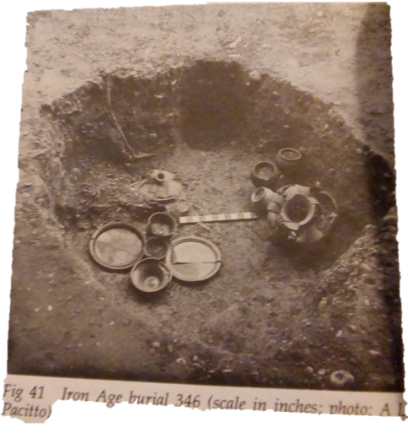 (Stead, 1989)

Burial 346 is noted as a major burial but seems to only have more minor graves grouped around it. Such groups have been classified as ‘Family Groups’ (Stead, 1989).
There is clearly more grave goods shown here than the previous one, and it appears to be larger and have more depth. There are plenty of containers, none of which are entirely intact. The urn itself- the largest container in the grave, in the right of the picture- is intact at its base, but the top has clearly sustained much damage, braking the pottery into pieces and breaking any seal there was. Other grave goods shown here are plates and bowls of an unknown metal- clearly either Bronze or Iron. However, this indicates an expectation of them being needed or used, as typical with grave goods, meaning that it is believed that the deceased in person will be expected to be able to consume some level of food after death. This indicates a level of afterlife and transition of contents of the grave to whatever afterlife there may be, and a level of religion to complement this.

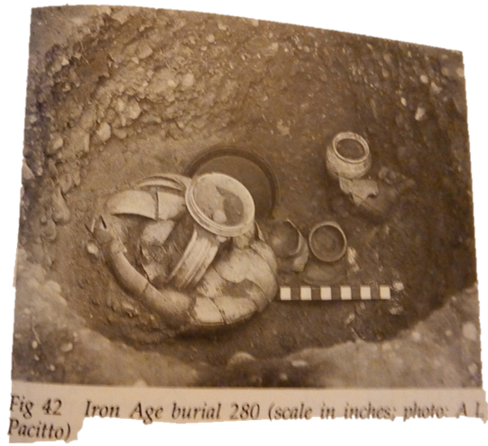 (Stead, 1989)

Burial 280 is clearly deep, and contains much the same as Burial 346, with the nine pots visible here. There is also a similar piece to be found in the urn, which is also in the same state as the urn in the previous grave. This indicates a similar or equal level of status between the two occupants. It appears that this burial was in a gap between two groups of enclosures. By not being in a clear group, this leads to the thought that this person was the only one in their ‘Family Group’. Despite this, the level of grave goods equals wealth, and that this person was interred in the graveyard tells us that they were not on some level an outcast.
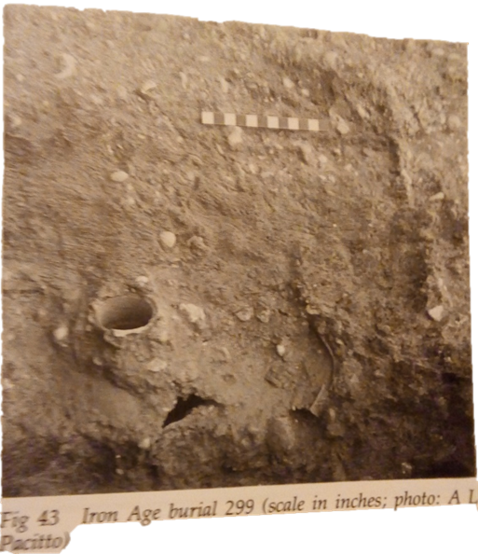(Stead, 1989)

This burial is clearly the least excavated in the images used. This unfortunately leaves us with very little to work with in order to read this grave. With no clear boundaries to see, we have no way of knowing the depth and breadth of the burial. There is the outline of a container visible, but beyond that there is nothing to see. That the container- possibly by the urn by a guess to its size- is open and has a hole in the side indicate that it was damaged.

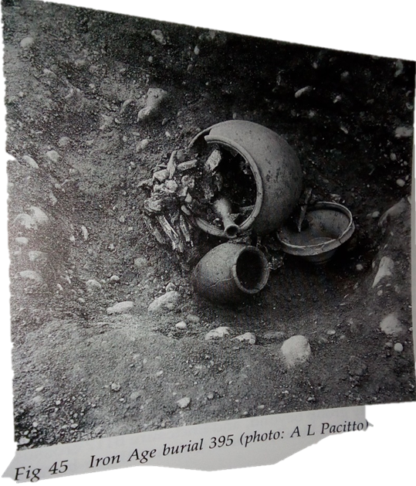(Stead, 1989)

Burial 394 is clearly a very basic grave. The excavation of this grave was either not completed, the grave was very shallow, or the picture is from a strange angle. The cremation is to the point of having calcined bones sealed into a pot, not turned to complete ashes. The container is clearly no longer sealed, and their only seems to be one other pot as a Grave Good. All of this points to a grave of low status, that does not fit with the others.

A standard procedure for the burials has clearly been used, even from a basic glance. The procedure and typicality of it does correlate with Aylesford-Swarling/Belgic Cremations, as first thought. There are clearly differences between the burials of the time and the burials now. For us, graves have a standard size, depth, and marker. Bodies are buried in coffins. Cremations occur and the ashes can be buried in family areas but can now kept or scattered as per the preferences of the deceased or their family. Grave goods are also no longer a typical practice, though generally one is buried in their best. There are little differences in grave goods to define a difference in status and is nothing to indicate the gender, age, or occupation of the deceased. There are no feminine items to be found- jewellery, etc- giving us little to no clues. Further, there is nothing to be seen in any of the graves that clearly indicates the age or occupation of the occupant. With the lack of clarity concerning age, gender, and with a bare difference in grave goods, any difference in status there might have been is near impossible to determine.

Word Count: 1250

Source List:

Stead, I.M. & Rigby, V., 1989. Verulamium: the King Harry Lane site, London.
Chapter 4: The Iron Age cemetery

Wait, G.A., 2005. The Celtic world M. J. Green, ed., London: Routledge.
PART VIII: PAGAN CELTIC RELIGION Chapter 26: Burial and the Otherworld

