Using loops (1) – While (SOLUTIONS)

1. Ask the user to enter their age, which must be 18 or more. If they enter something out of range, keep prompting them to enter a number. Don't forget to test on the boundary (exactly 18)

Sample output:

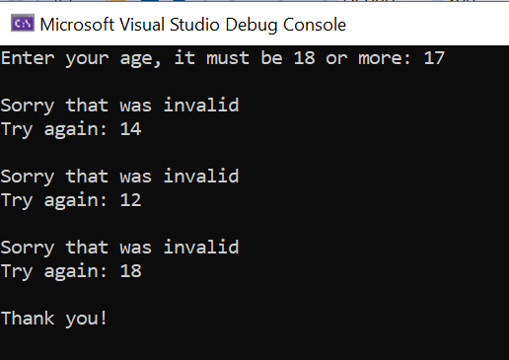

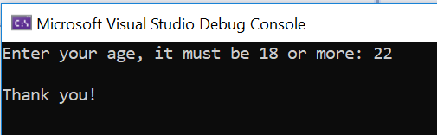

Solution:

#define _CRT_SECURE_NO_WARNINGS
#include <stdio.h>

void main()
{
int userAge;
printf("Enter your age, it must be 18 or more: ");
scanf("%d", &userAge);

while (userAge < 18)
{
printf("\nSorry that was invalid\n");
printf("Try again: ");
scanf("%d", &userAge);
}

printf("\nThank you!\n\n");
}

2. Ask the user to choose a number – this time, it must be between 1 and 10. Any numbers outside that range should trigger a "Try again" message.

Sample output:

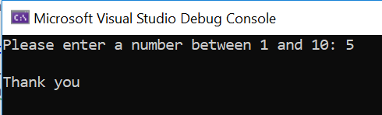

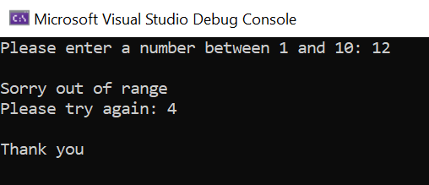

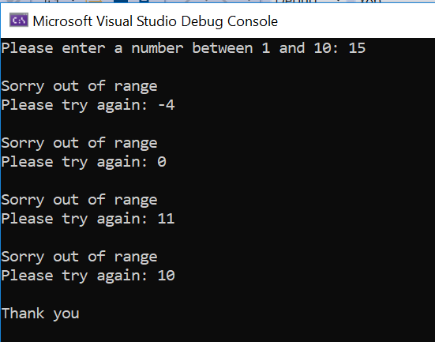

Solution:

#define _CRT_SECURE_NO_WARNINGS
#include <stdio.h>

void main()
{
int userNumber;
printf("Please enter a number between 1 and 10: ");
scanf("%d", &userNumber);

while (userNumber > 10 || userNumber < 1)
{
printf("\nSorry out of range\nPlease try again: ");
scanf("%d", &userNumber);
}

printf("\nThank you\n\n");
}

3. Write a program to count up from 1 using a while loop. The user will decide where we stop.

Sample output:

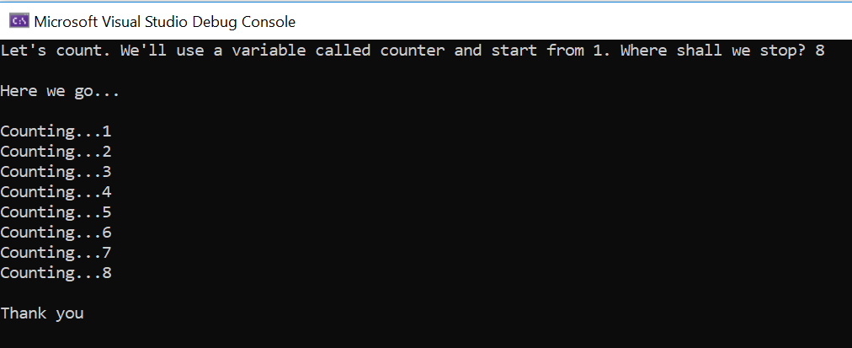

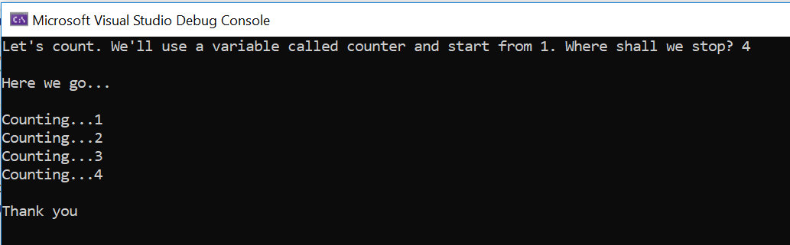
Solution:

#define _CRT_SECURE_NO_WARNINGS
#include <stdio.h>

void main()
{
int counter=1, userStop;
printf("Let's count. We'll use a variable called counter and start from 1. Where shall we stop? ");
scanf("%d", &userStop);

printf("\nHere we go...\n\n");

while (counter <= userStop)
{
printf("Counting...%d\n", counter);
counter = counter + 1;
}

printf("\nThank you\n\n");
}

4. This time, count down. The user will decide where to start the countdown (use a variable called counter) and we will finish at 1.

Sample output:

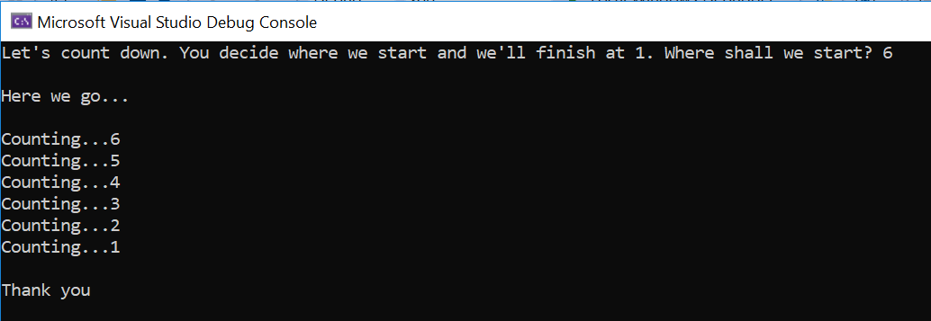

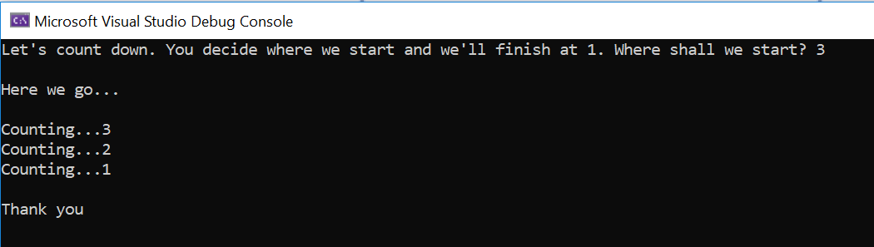

Solution:

#define _CRT_SECURE_NO_WARNINGS
#include <stdio.h>

void main()
{
int counter, userStop = 1;
printf("Let's count down. You decide where we start and we'll finish at 1. Where shall we start? ");
scanf("%d", &counter);

printf("\nHere we go...\n\n");

while (counter >= userStop)
{
printf("Counting...%d\n", counter);
counter = counter - 1;
}

printf("\nThank you\n\n");
}


5. Mrs Doyle (pictured right) likes her employer, Father Ted Crilly, to drink tea. She will not take no ('n') for an answer. Write a program that will not exit until you agree ('y') to have a cup of tea.

Note: This is a reference to the classic Channel 4 comedy Father Ted.

Sample output:

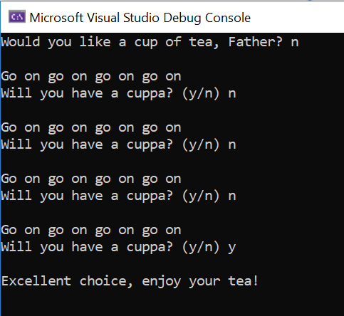

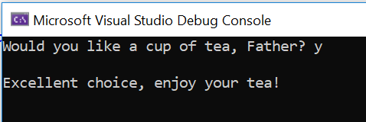

Solution:

#define _CRT_SECURE_NO_WARNINGS
#include <stdio.h>

void main()
{
char choice;

printf("Would you like a cup of tea, Father? ");
scanf(" %c", &choice);

while (choice != 'y' && choice != 'Y')
{
printf("\nGo on go on go on go on\n");
printf("Will you have a cuppa? (y/n) ");
scanf(" %c", &choice);
}

printf("\nExcellent choice, enjoy your tea!\n\n");
}
6. Write a calculator program to add two numbers. Let the user add as many sets of numbers as they like, until they decide to stop (use a while loop for this)

Note: Break the problem down by doing the calculator program on its own first (no loop). Once it is working, add the loop on.

(Note: there is a tiny sting in the tail with this one. There is a bit of logic to getting the program to enter the loop in the first place – everything else behaves as normal)

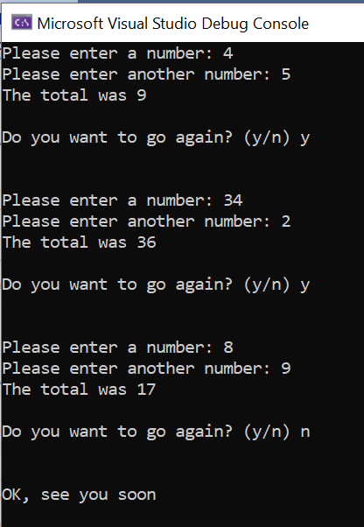

Solution:

#define _CRT_SECURE_NO_WARNINGS
#include <stdio.h>

void main()
{
int number1, number2, total;
char choice = 'y';

while (choice == 'y')
{
printf("Please enter a number: ");
scanf("%d", &number1);

printf("Please enter another number: ");
scanf("%d", &number2);

total = number1 + number2;

printf("The total was %d\n\n", total);

printf("Do you want to go again? (y/n) ");
scanf(" %c", &choice);
printf("\n\n");
}

printf("OK, see you soon\n\n");

}

7a. Write a program to allow the user to guess my age (we'll set this as 21 years)

Sample output:

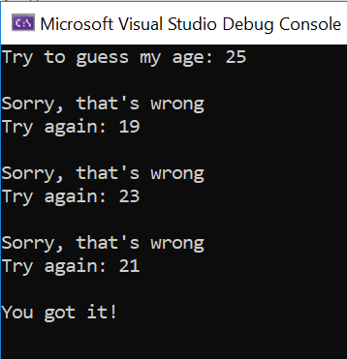

Solution:

#define _CRT_SECURE_NO_WARNINGS
#include <stdio.h>

void main()
{
int myAge = 21, guess;

printf("Try to guess my age: ");
scanf("%d", &guess);

while (guess != myAge)
{
printf("\nSorry, that's wrong\n");
printf("Try again: ");
scanf("%d", &guess);
}

printf("\nYou got it!\n\n");

}

7b. For fun, put in an extra insult to the user if they enter a number that's is too old – let's say over 70.

(Hint: use an if statement to do this. Think carefully about where to place it.)

Sample output:

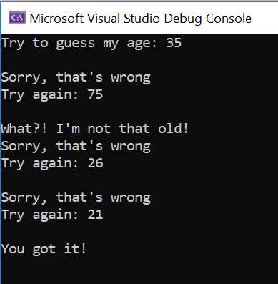

Solution:
#define _CRT_SECURE_NO_WARNINGS
#include <stdio.h>

void main()
{
int myAge = 21, guess;

printf("Try to guess my age: ");
scanf("%d", &guess);

while (guess != myAge)
{
if (guess >= 70)
{
printf("\nWhat?! I'm not that old!");
}
printf("\nSorry, that's wrong\n");
printf("Try again: ");
scanf("%d", &guess);
}

printf("\nYou got it!\n\n");

}

7c. (Harder) Allow a maximum of 3 guesses (I put this one in as an extra stretch question!)

Sample output:

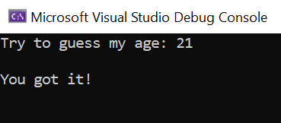

Guess on the last turn:
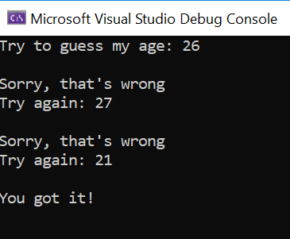

Out of turns:
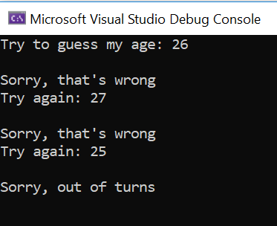

Solution:

#define _CRT_SECURE_NO_WARNINGS
#include <stdio.h>

void main()
{
int myAge = 21, guess, tries = 0;

printf("Try to guess my age: ");
scanf("%d", &guess);
tries += 1;

while (guess != myAge && tries < 3)
{
if (guess >= 70)
{
printf("\nWhat?! I'm not that old!");
}
printf("\nSorry, that's wrong\n");
printf("Try again: ");
scanf("%d", &guess);
tries += 1;
}

if (guess == myAge && tries <= 3)
{
printf("\nYou got it!\n\n");
}
else
{
printf("\nSorry, out of turns\n\n");
}

}

