Marketing Essentials
Module Code: M4X 01916_LON
Student: Monica Bono
Written Assignment Part 2
Student number: 1818860

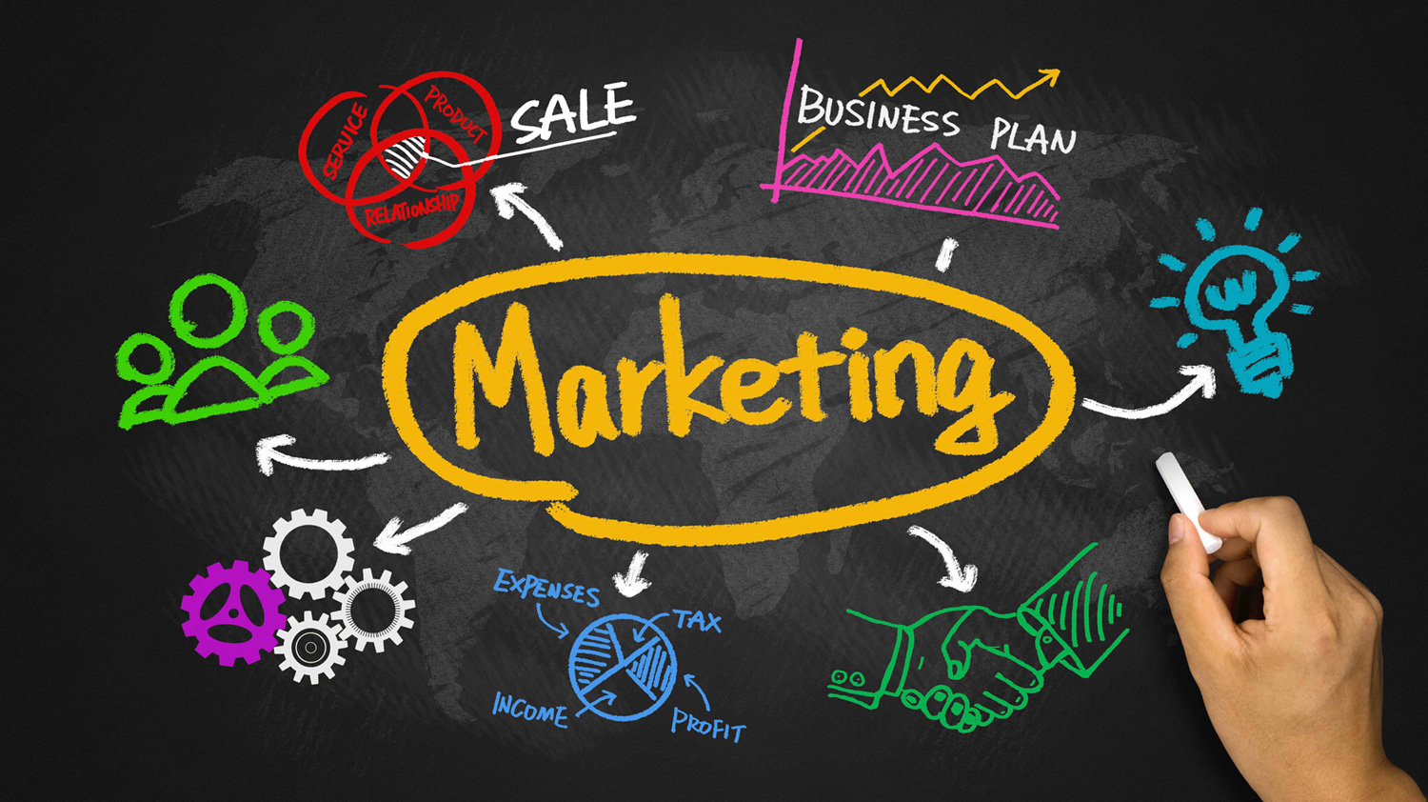

Table of Contents

- Introduction 3
- Gathering Information 3-4
- Marketing within MIS 4
- Communication 4-5
- Effectiveness within Eco world hotel 5
- Conclusion 6
- Reference 7

Introduction
In the following assignment I was asked to analyze and understand how the market of the hotel industry uses marketing and how it collects all information and communications inside and outside a company in order to achieve the final goal: customer loyalty through effective marketing strategies. Marketing is the name of the activities that take place between an organization and its customers, in order to satisfy them. The only tool of interest for marketing is one: the customer. Concorde with Sam Walton, founder of Wal-Mart Stores, says: "There is only one person on the bridge, and he is the customer. He has the power to fire anyone in the company, from the president down, he's just going to spend his money from somewhere else "therefore, we can deduce that the customer is the basis for winning business along with ideas, goods, people, organizations and innovations. as he defines (American Marketing Association) "Marketing is the process that plans and implements planning, pricing, promotion and distribution of ideas, goods and services aimed at creating market and goals". Jim Blythe, Elena Cedrola (2013) The marketing environment is always looking for innovations that always try to be one step more than competitions. Market research helps identify, collect, detect and identify customer needs.
The MIS (information on the marketing system) collects all this information and adopts it to develop marketing strategies, using communication tools, sales, promotions aimed at satisfying and retaining customers.
In the second part of my assignment I will examine the Eco World hotel as an example, analyzing MIS and its market strategies.

Information gathering
Within a company, there are many IT streams that facilitate an organization's information management. Information is an unusual product; it is intact and different from material and consumer goods. Stonecash (1981) defines information in this way: "information is simply symbols (data, text, images, voices, etc.) that convey meaning through their order, timing, form, context, etc. They are the first materials for make decisions create knowledge and nurture the modern organization ". The MIS is a thematic platform that helps the management of a company through data and information. Every marketing decision is based on internal and external company data and information. Marketing experts need adequate information on the market environment, the task of the MIS is to facilitate their work, to use the information gathered and to confront them with the right marketing strategy.
The marketing intelligence system, on the other hand, collects all the primary information that will be collected for the purpose of commercial decision and response to daily market changes. we can therefore state that "Market Intelligence is information about a company's markets, collected and analyzed in order to make accurate market opportunities, market penetration strategy and market development metrics”. Innovation is a key word within a company, the overview of DVL Smith and JH Fletcher in the market research sector in 20083 describes the convergence of market surveys and market information over the last ten years: "The recent years have seen the arrival of "new" market research. Gone are the days when market research presented itself as a quasi-academic activity that flirted only with corporate decision-making. more focused on improving and innovating the quality of corporate decision-making. ”(Matthew Harrison and Julia Cupman)
Eco world hotel focuses precisely on this: innovation. is the first Italian hotel group linked to the environment, with over 130 hotels throughout Italy. Its main market objective is to safeguard the world through the "GREEN" philosophy, reducing the impact on the environment and on sustainable tourism, using organic products, energy and water savings thanks to sustainable energy.
Its main market objective is to attract as many customers as possible, while offering different positions, services and brands.
Offer the customer the opportunity to safeguard the world and the pocket. On the one hand, conservation of cultural heritage and, on the other, cost optimization.
Within a company, after analyzing, visualizing all the data to act on the marketing field and defining the product, we proceed to the design of a strategic activity, given by a series of actions linked together. As you develop a marketing strategy, the marketer examines the external environment in which you want to invest, analyzing not only the opportunities but also the risks, up to the last stage: the decision-making process. The final action, after using all the techniques available in marketing, is to launch the new product on the market, focusing on consumer satisfaction and the success of the product / service.

MARKETING WITHIN MIS
The marketing, therefore, is an analysis that aims, through services and products, at customer satisfaction, focusing on innovation and identifying possible threats (such as competitors), realizing and anticipating consumer needs. The "guru" of marketing Kotler defines marketing within the company as a "social process through which individuals and groups get what they need through the creation, supply and exchange of valuable products and services" . Marketers need information from the MIS to create this offer and new products. marketing strategy plans the final and decision-making process. Following Sudharshan (1995), we define a firm’s marketing strategy as the development of and decisions about a firm’s relationships with its key stakeholders, its offerings, resource allocation, and timing.

Communication
Communication has been defined as a transaction process between two or more parties in which meaning is exchanged through the intentional use of symbols. (Engel, J.E., Warshaw, M.R. and Kinnear, 1994.)
As far as marketing communication is concerned, we can say that it is the area of ​​communication that governs the relationship with the market. To develop a marketing communication we need, first of all, to identify the customers to whom we want to address the commercial message, what kind of response we want to obtain from the customer, decide the type of message, which communication channel we want to use to disseminate the message, understand the characteristics and quality of the producer who wants to communicate and finally collect all the feedback obtained with market research.
The first responsibility of marketing is to capture the attention of customers, making the offer message interesting, increasing the consumer's desire and purchase. The marketing mix is ​​not a scientific theory, but only a conceptual structure that identifies you the main decision makers make their offers in order to meet consumer needs. The tools can be used developing long-term strategies and short-term tactical programs (Palmer, 2004).

The main items that make up the marketing mix are the 4Ps:
• Product
• Price
• Place
• Promotion
- The product: that is the "set of benefits, which includes not only the physical characteristics, but the image, the brand, the packaging, the color and the envelope. Marketers must be able to understand the changes that occur in consumer needs through research, and use these changes in favor of benefiting the customer.
- Place :the second lever of the marketing mix and distribution. The distribution channel is the passage of goods and services from one organization to another for the distribution of the product or service to the customer. The choice of channels (direct, indirect, short and long) depends on market research.
- Price: is correlated based on product request. To fix the price we must take into account the competition, the price affects the customer's qualitative perception. Usually a quality product at a high price. In addition to the basic price, the various promotional discounts must also be considered.
Price fixing is the most complex activity, we must consider several factors: internal costs of the company, the market, adopted strategy, geographical positioning.
- Promotion: Advertising, specialized fairs, public relations, direct marketing, media.

Effectiveness inside the eco world company
The hotel industry is now inserted in one of the strongest, ever growing, innovative markets. It offers many services, products and locations, mainly for leisure, business and events. Being such a vast field, the use of marketing and mis techniques is now essential.
Increasingly attentive and meticulous consumers, the wide range of services offered, makes sales more difficult. Nowadays consumers are looking for sophisticated services, suitable only for their needs, always looking for something new.
For example, eco world hotel uses important marketing strategies such as: • Being an eco-sustainable hotel, exhibiting logos like Ecolabel, ISO14001, are quality brands, Logos that can also be used as marketing tools. • From the point of view of information and management economics, it guarantees the hotelier a lower price. • The website guarantees online booking with very low commission for the hotelier. • For the customer a loyalty sector is used through the "Eco-cards", giving the customer the possibility to have discounts and points. • The advertising and communication materials used are vacation attendance, co-marketing with other companies, advertising spots, cultural initiatives and promotions. Hotel initiatives such as eco-rooms and eco-packages .
within the 4P model of the marketing mix we have unconcealed the product. as for 4C, attention is focused on the consumer.
for 4 C means
- Costumer need: through analysis and testing, is the impersonation of the potential buyer in order to have a purchase during the launch of new products and for the differentiation of a new product with respect to competition.
- Cost the consumer: know the price at which the customer will be satisfied from a financial point of view.
- Convenience: distributive methods, convenient to the consumer with respect to the company, not aimed at the structure but the needs of the customer.
- Communication. which does not mean advertising or merchandising, but the term means a broad conception aimed at building a brand, a name and a lasting bond with the customer. (Spinosi Marketing)
Conclusion
We can conclude by saying that the customer is the most important element within the company. in this assignment I examined the marketing arguments, how to transform the information and data that the customer provided us, collecting them in the MIS. We examined the data that most closely matches the creation of a final decision on the market, to launch a new product in the field. Marketing activities require constant information on the market, the MIS plays a significant role in market research, since they gather all the information that helps marketers to establish an effective marketing strategy, guaranteeing the goal: customer loyalty and results in the market.
Marketing studies the needs and preferences of the consumer and ensures that the company adequately satisfies them. stating what (Philip Kotler, Marketing from A to Z) says «Marketing is not the art of finding smart ways to get rid of what it produces. The job of marketing is to transform people's changing needs into profitable opportunities; its purpose is to create value by offering better solutions, saving the purchaser fatigue and time for research and transactions and offering the community maximum well-being »
Respect for the environment, culture and society increasingly characterize the activities of companies and new strategies. The Eco world hotel, aimed at innovation, has activated the strategies and current values ​​of our decades. The environmental alarm is a danger that has now been declared even by the mass media, the interest for the environment and sustainability and now known to all. Eco world through its online portal and the 130 structures scattered throughout Italy, was the first company in Italy to include this type of sustainable tourism, taking advantage of the benefits that this type of tourism can give to both the environment and the consumer. offering customers, the awareness of our environment and an exceptional quality / price ratio, respecting the world, offers hoteliers an increase in tourists over the past 3 years.

.

References

- Engel, J.E., Warshaw, M.R. e Kinnear, T.C., Promotional Strategy, Irwin, Chicago 1994.
- Jim Blythe ,Elena Cedrola (2013) Marketing fundamentals, third edition, chapter 1, pp2.
- Matthew Harrison e Julia Cupman, using marketing intelligence e competitive intelligence to add value to your business, available at https://www.greenbook.org/Content/B2B/market_intelligence.pdf , Access at 20/07/2019
- Palmer, A. (2004). Introduction to Marketing - Theory and Practice, UK: Oxford University Press.
- Philip Kotler, Il marketing from A to Z, available at http://tesi.cab.unipd.it/54251/1/Moro_Marta.pdf , access 19/07/2019
- Stonecash, J.C. (1981), “The IRM showdown”, Infosystem, Vol. 28 No. 10, pp. 42-8.
- Spinosi marketing strategies, The 4C alternative marketing model to the 4P marketing mix,available at https://www.spinosimarketing.com/it/consulente-societa-consulenza-marketing/strategie-di-vendita-tecniche/marketing-mix-marketing-4p-marketing-4c.html , access 20/07/2019
- Sudharshan, D. (1995), Marketing Strategy: Relationships, Offerings, Resource Allocation and Timing. Prentice-Hall: Englewood Cliffs, NJ
- Varey, R., Marketing Communications: A Critical Introduction, Routledge, London 2002.

