Hannah Marie Hatherall (2012129)
2012129@Student.uwtsd.ac.uk
Ian Standen
BSc Architecture
Architecture in Newport South Wales
History and Theory
Hannah Hatherall

Contents
Introduction 2
Comparison of Two Grand Houses in Newport 4
Plan and Section 4
Materials and Light 10
Use 11
Conclusion 12
References 13
Bibliography 13

Introduction
This essay will endeavour to explore and compare two historical buildings in Newport South Wales.
In the below map view Tredegar House is shown with a yellow place marker and Malpas Court with a blue place marker.
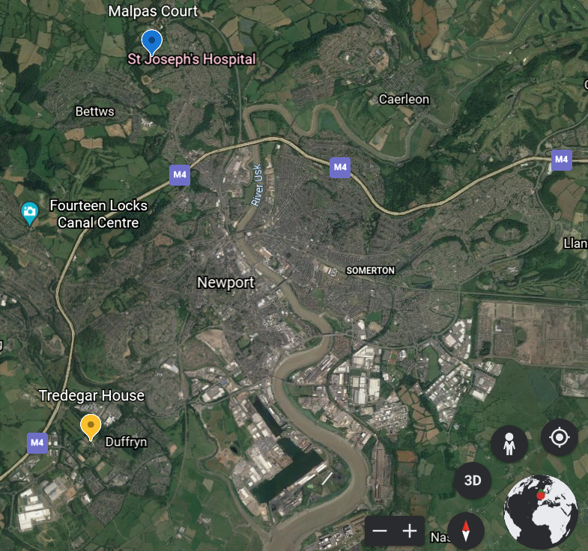
The capture was taken by Hannah Hatherall from Google Earth
Tredegar House
The building as it stands today was completed in 1672 and took approximately 8 years to build for Sir William Morgan, in the Restoration Style, also known as the Carolean style. Unfortunately, there are no surviving plans or documents to confirm the Architect however, it is believed to be Roger and William Hurlbutt as there are many similarities with other homes they designed. Much of Newport was then owned by the Morgan family including over 40,000 aches to Brecon, Monmouth and Glamorgan. It was designed to entertain, the Morgan Family were renowned for their extravagant parties with guests including royalty. The house is perfectly oriented for this with servants areas separate but close to the reception rooms allowing for seamless service that is hidden from guests.
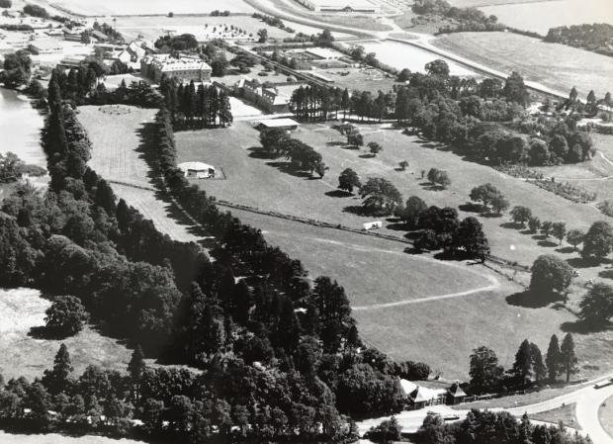
Aerial View of the house and grounds were taken in 1980 Figure 1 (Unknown, 1980)
Malpas Court
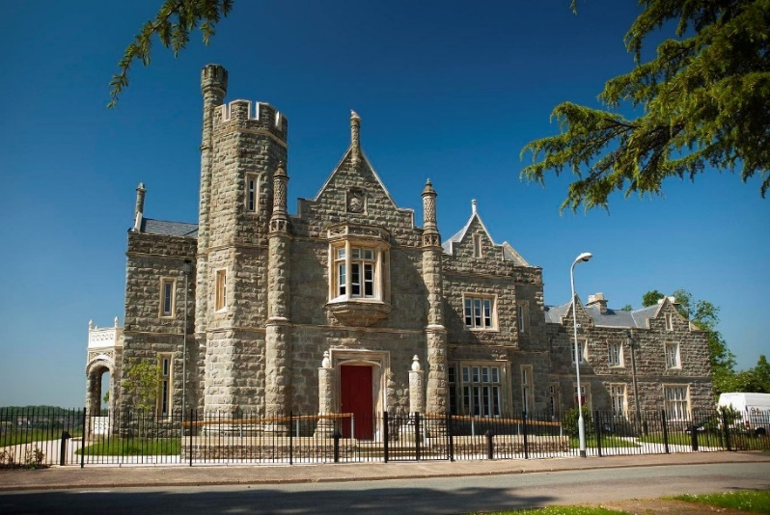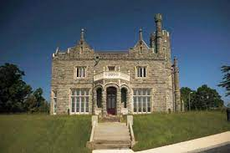
Figure 2 Malpas Court Side Aspect (Unknown, 2015) Figure 3 – Front Aspect (Newport, n.d.)
The Architect was Thomas Henry Wyatt who designed the Tudor style house for Thomas Prothero. The building took over 2 years to build and was completed in 1838. Set on a slight elevation the house looks over the city and was said to have been visible from the town centre. In contrast to Tredegar House, Mapas court was built for a business-minded man who dedicated a large area of the house to a study and meeting room as opposed to the grand hall and dining room of Tredegar.
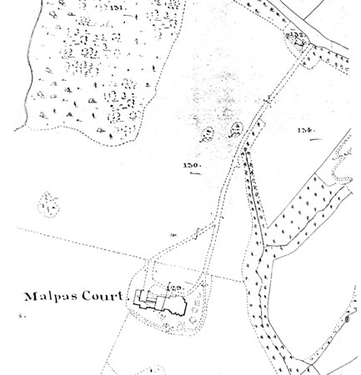
Figure 4 - Orginal Site Plan (Wyatt, 1841)
Both Houses are set in the suburban areas of Newport on large grounds. They were both intended to showcase the wealth and power of their owners with an emphasis on opulent grandeur. However, they were used in different ways, Tredegar for entertainment and Malpas for a Business Establishment.

Comparison of Two Grand Houses in Newport

Plan and Section
Exterior Photographs of Tredegar House
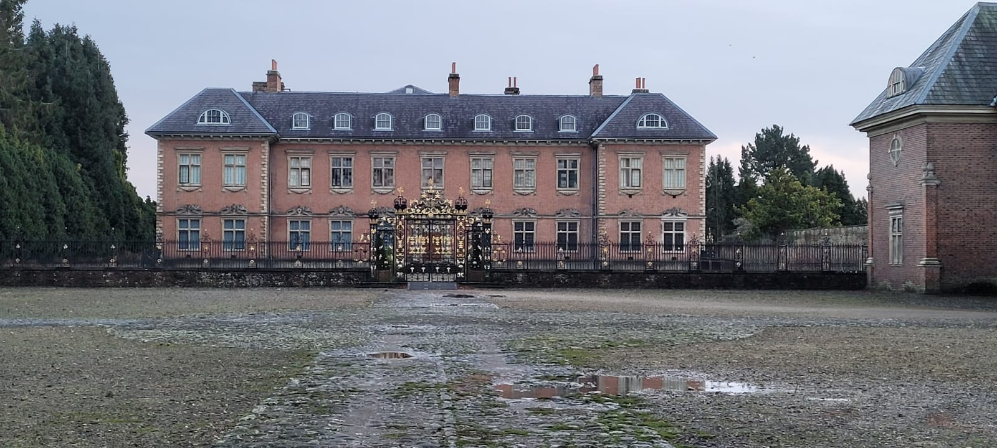
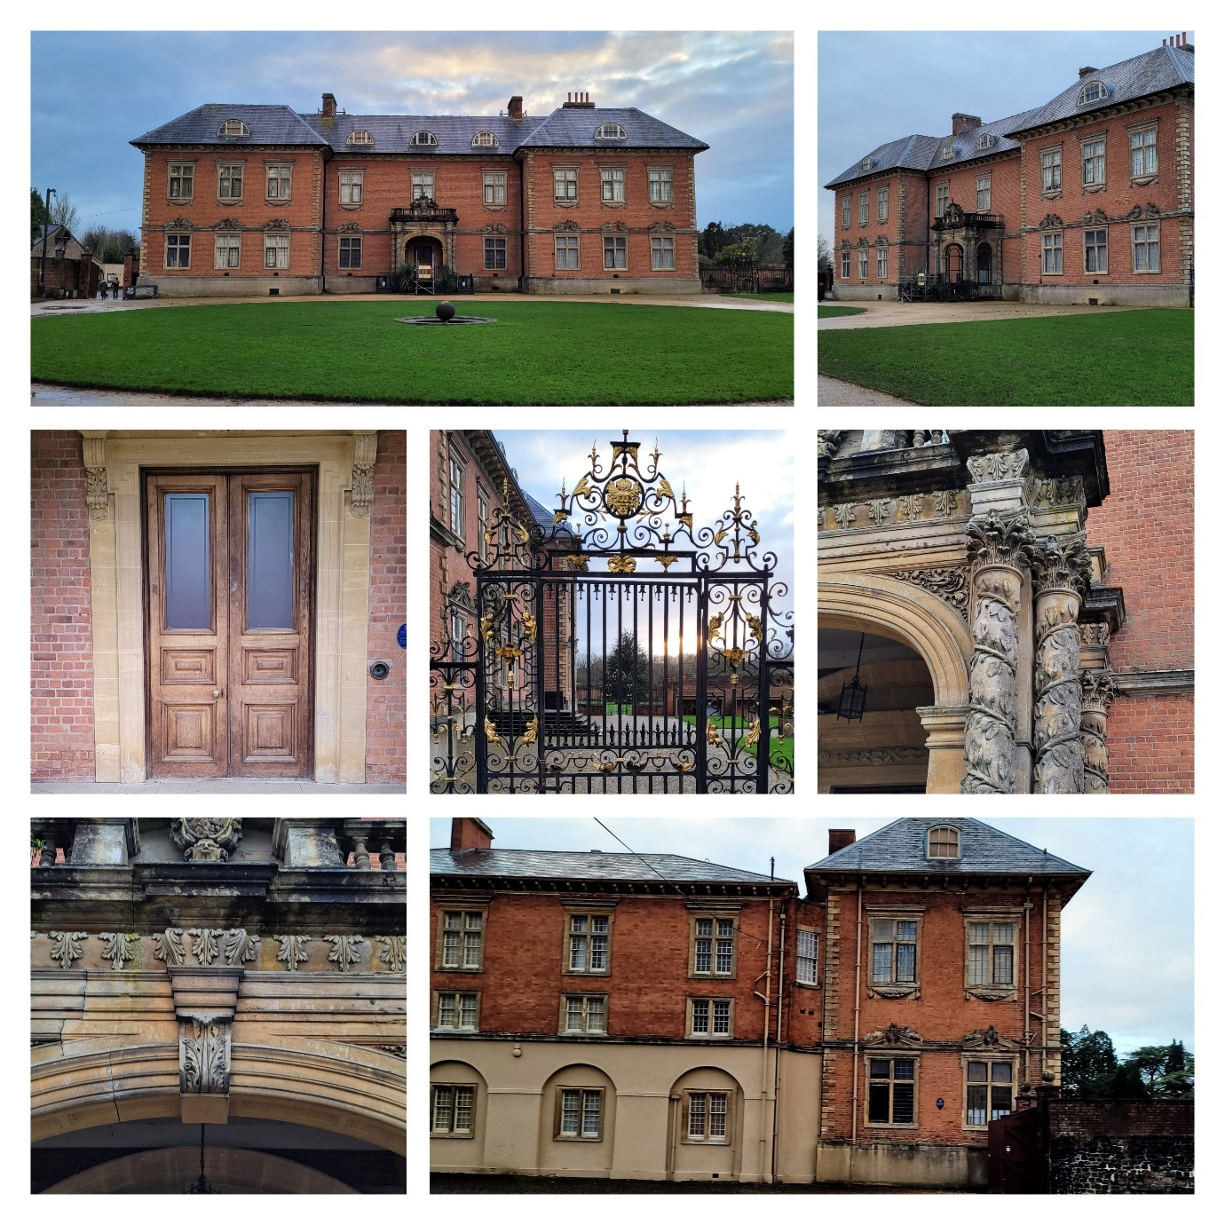
Pictures were taken by Hannah Hatherall
Drawings of Tredegar House
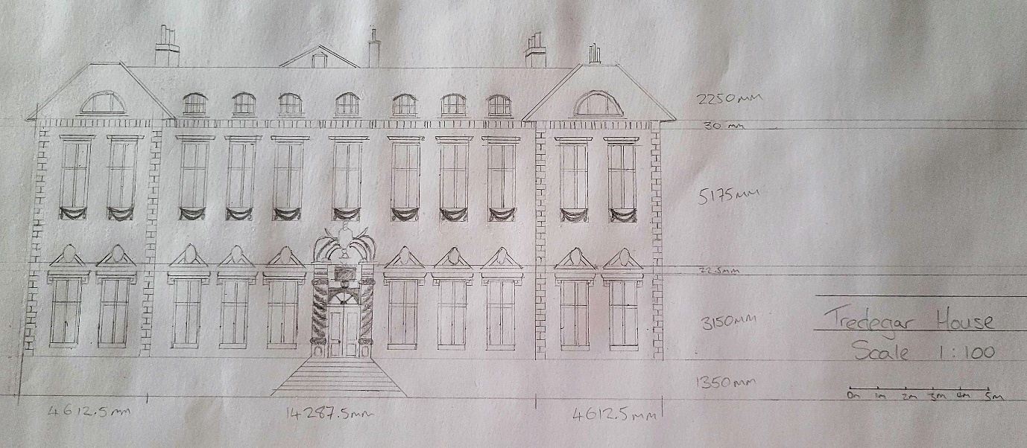
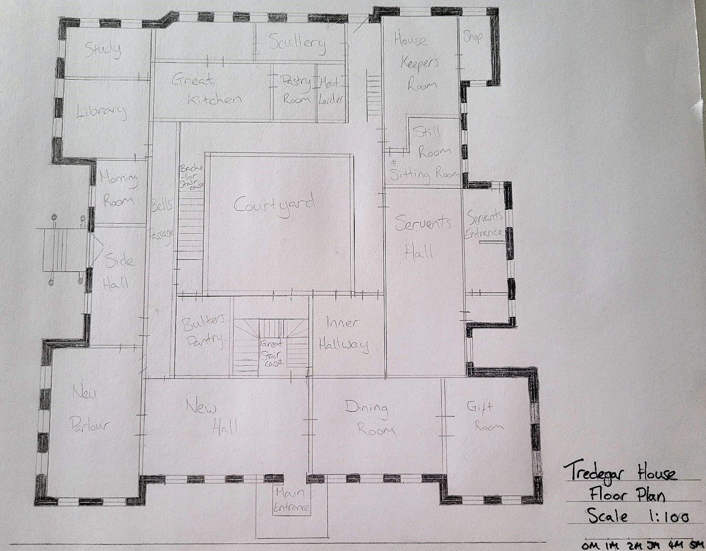
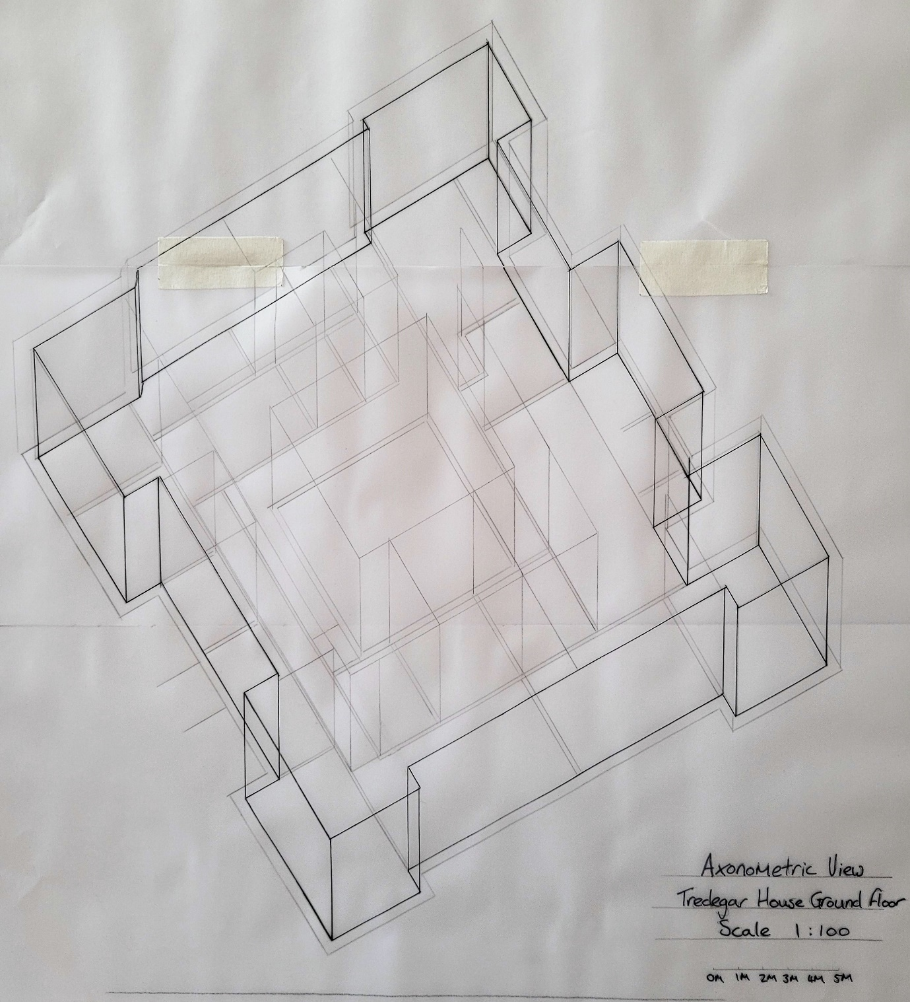
Exterior Photographs of Malpas Court
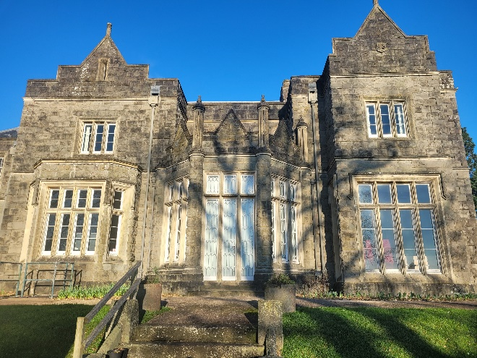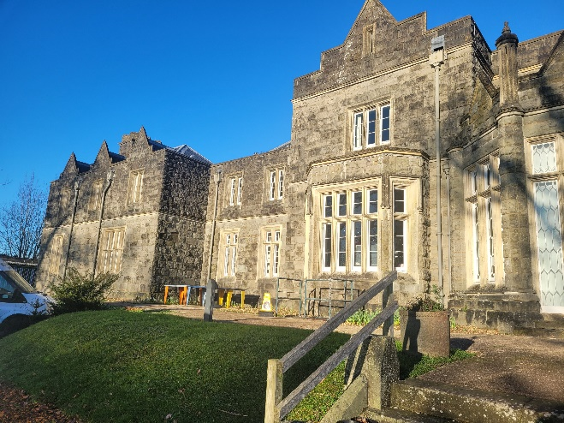
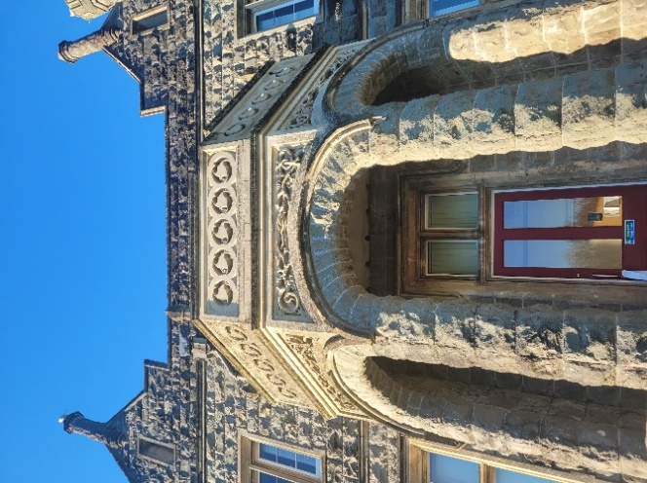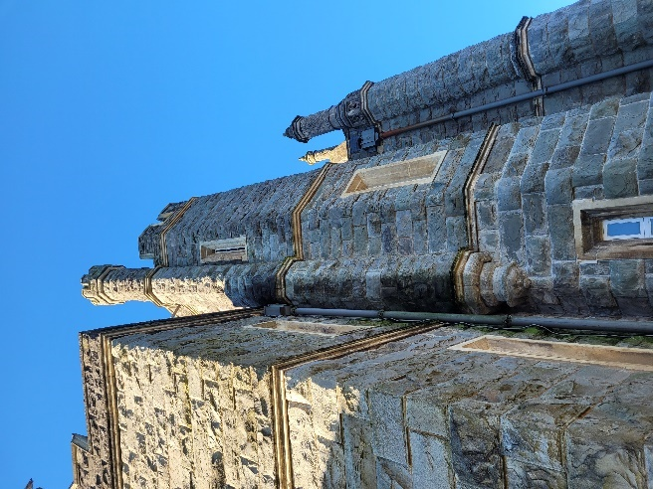
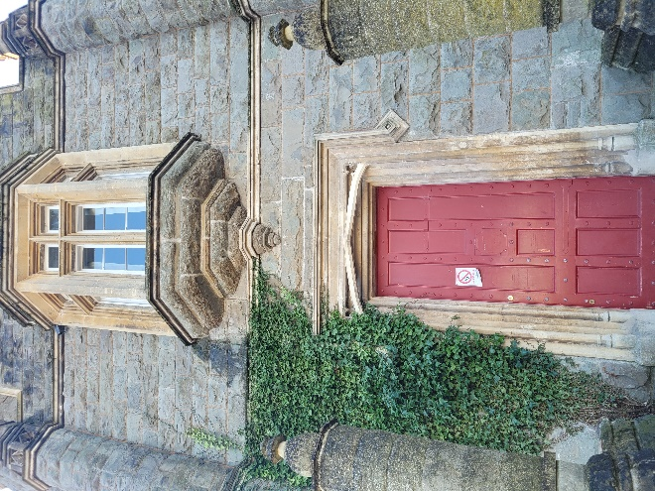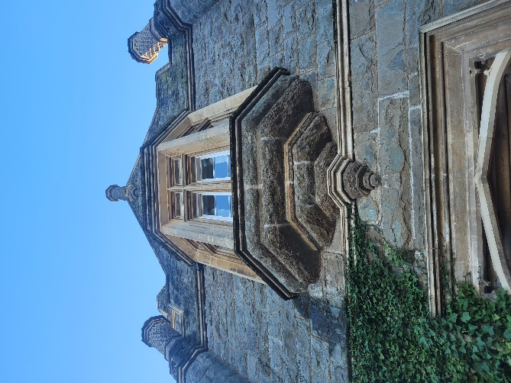
Pictures were taken by Hannah Hatherall
Interior Photographs
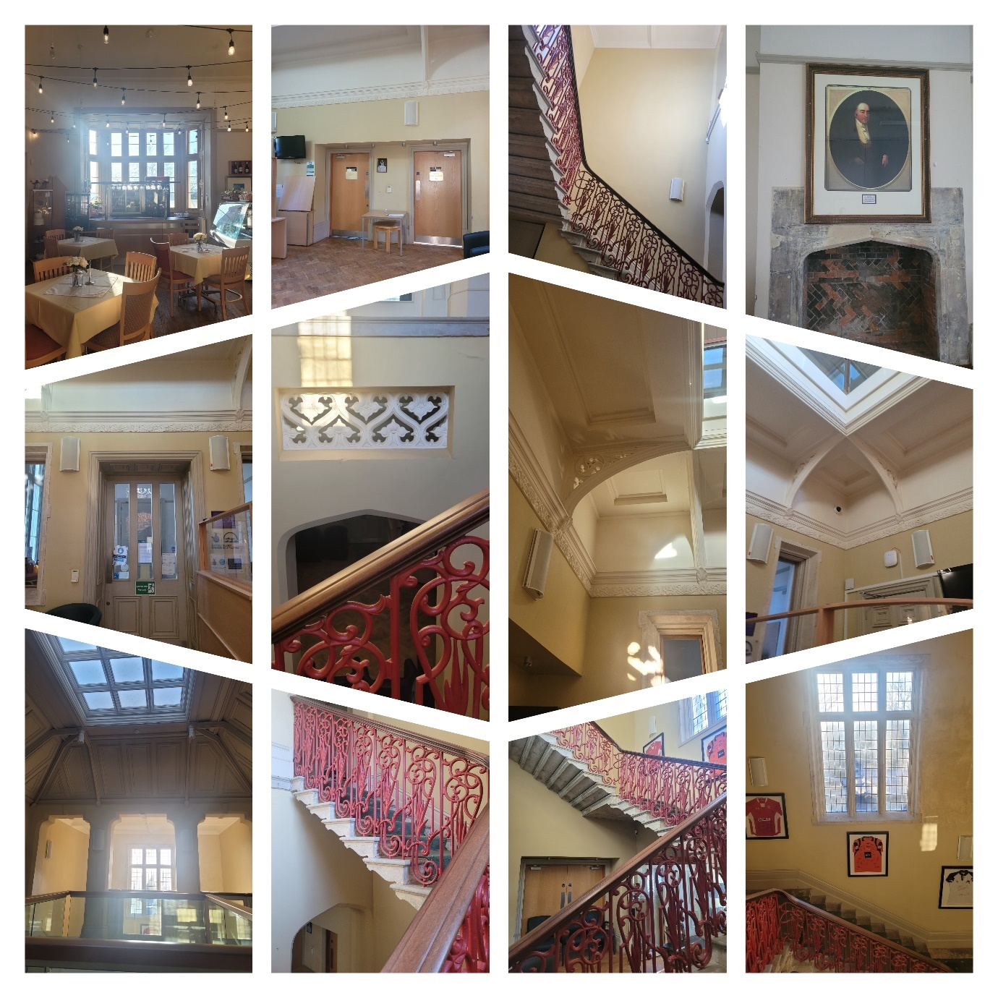
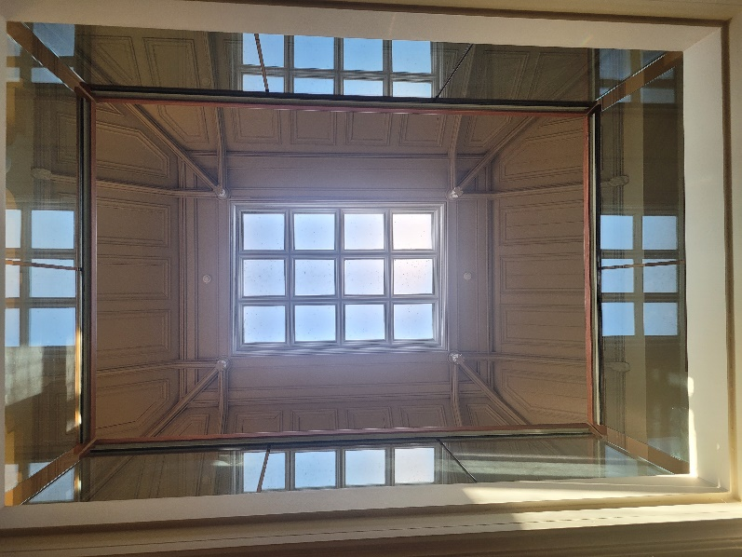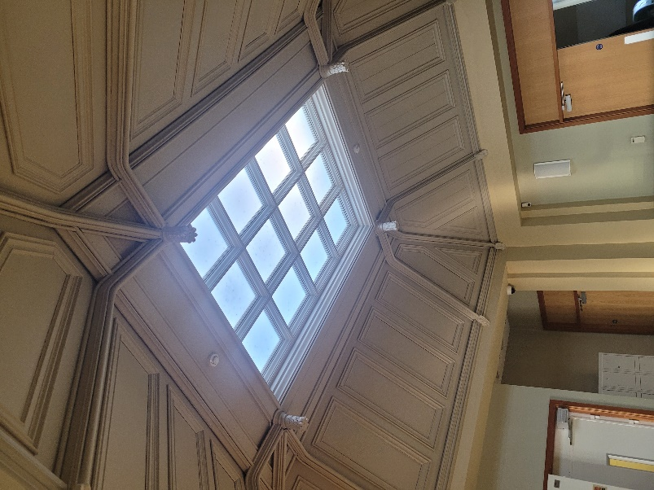
Pictures were taken by Hannah Hatherall

Interior Floor Plan of Malpas Court
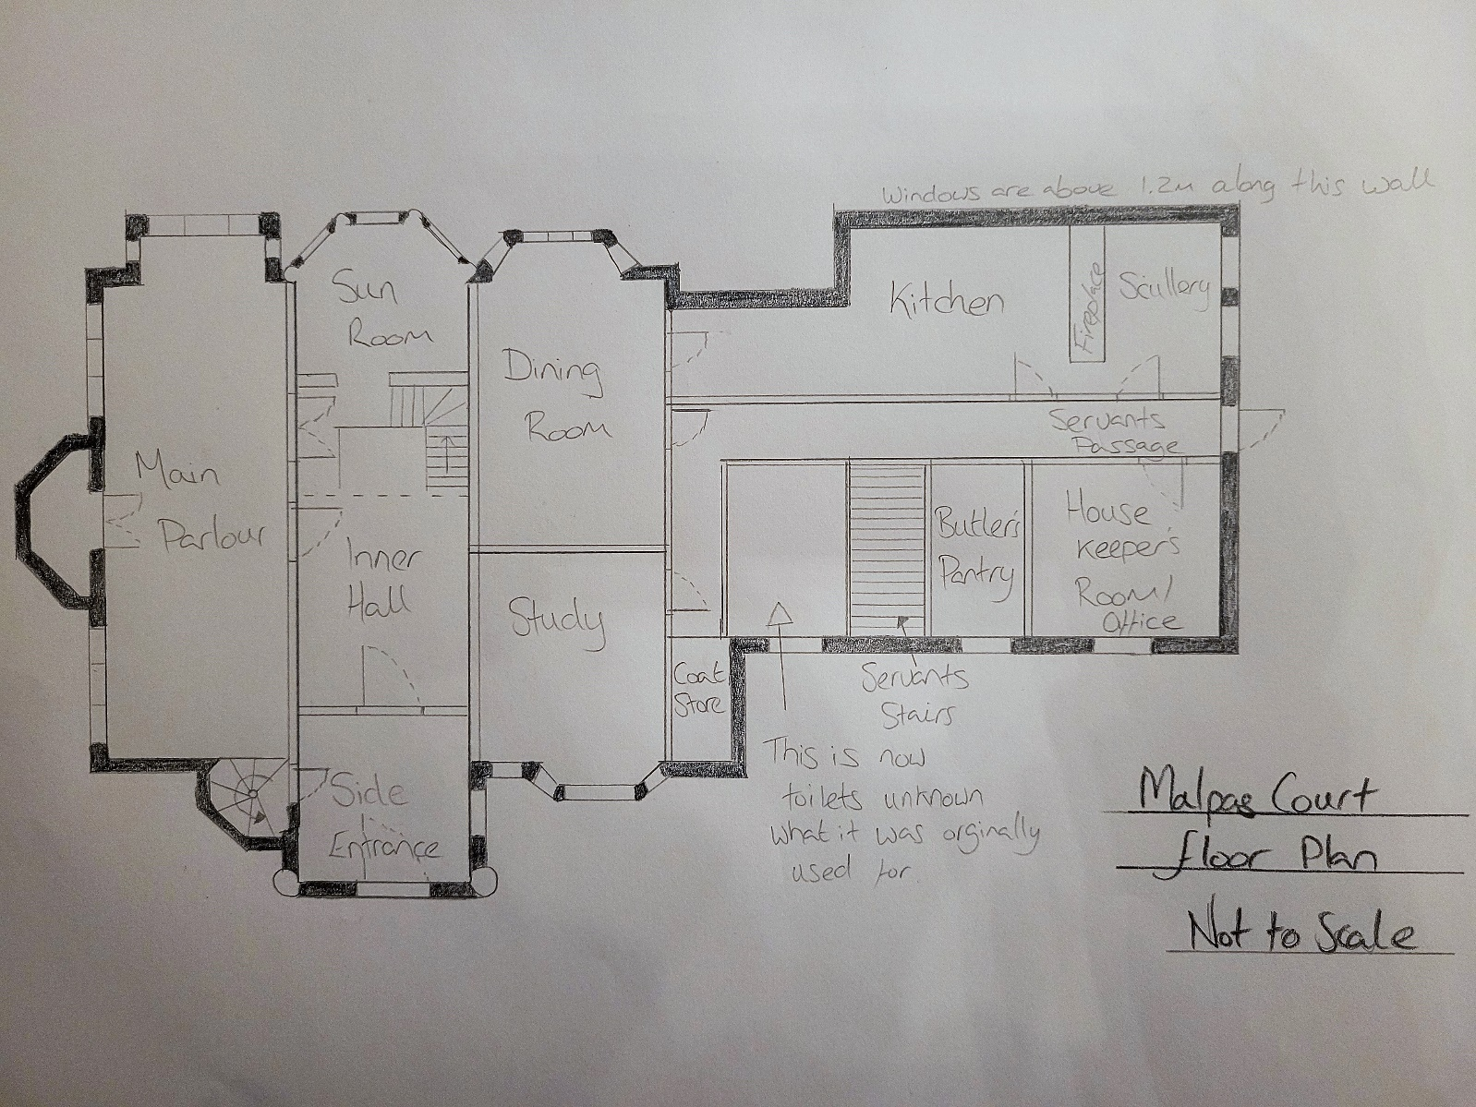
Figure 5 - Floor plan of Malpas Court

Materials and Light
Tredegar House – The original building is believed to have been built in 1402 and was made of stone but was rebuilt in red brick which was thought of as a new and modern building material at the time and was quite rare in Wales. The interior of the mansion is decorated in ornate plasterwork and fine carving with solid oak panelling throughout most rooms. The overall impression is of affluence and magnificence. The tree-lined driveway which would have originally led from the road would have taken the visitor directly towards the front entrance which was surrounded by beautiful gardens with sculptures and fountains. All set to impress and awe.

Malpas Court - The stone for the mansion was rough-faced Pennant sandstone which was brought from Breconshire via the Canal. This was chosen as Thomas Prothero wanted it to be seen as a castle and called it this, although this was not taken up by others. Bath Stone was used for the windows and mullions to contrast the rough stone walls. The principal rooms were located on the south side of the building to make use of the morning and midday sun, which is when Thomas would have visitors. Also, this showcased incredible views of the Welsh mountains of Twyn Barlmn and Machen.

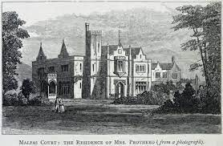
Figure 6 - Malpas Court 1872 from "The Annals and Antiquities of the Counties and County Families of Wales" (Nicholas, 1872)
Although both houses were made to display the owner's wealth and power they were made from very different materials. Malpas Court in the traditional sandstone quarried in Wales whereas Tredegar House was revolutionary within Newport and it was commented to be “the most splendid brick house of the seventeenth century in Wales” (Smith, 1975)

Use
Tredegar House was used as a residential property for over 500 years. In 1951 the house was purchased by the Catholic Church and used as a Convent which later became St Joseph’s Comprehensive School before being sold to Newport Borough Council in 1974 started the extensive task of restoring the building. To generate funds the Council would hire out the house for Weddings and conferences in the large elaborate rooms which were used by the Morgans. The house was also used for a great deal of filming and has featured in many period dramas as well as programmes such as the Antiques Roadshow and Doctor Who, which used the servant's areas as well as the luxurious rooms.
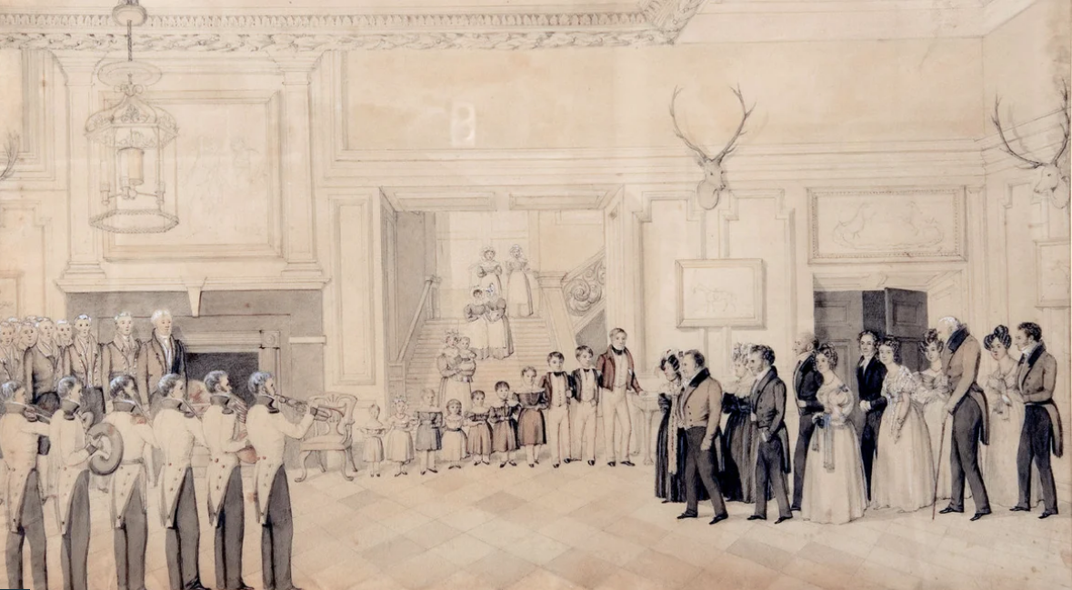
Figure 7 - The New Hall at Tredegar House (Unknown, n.d.)
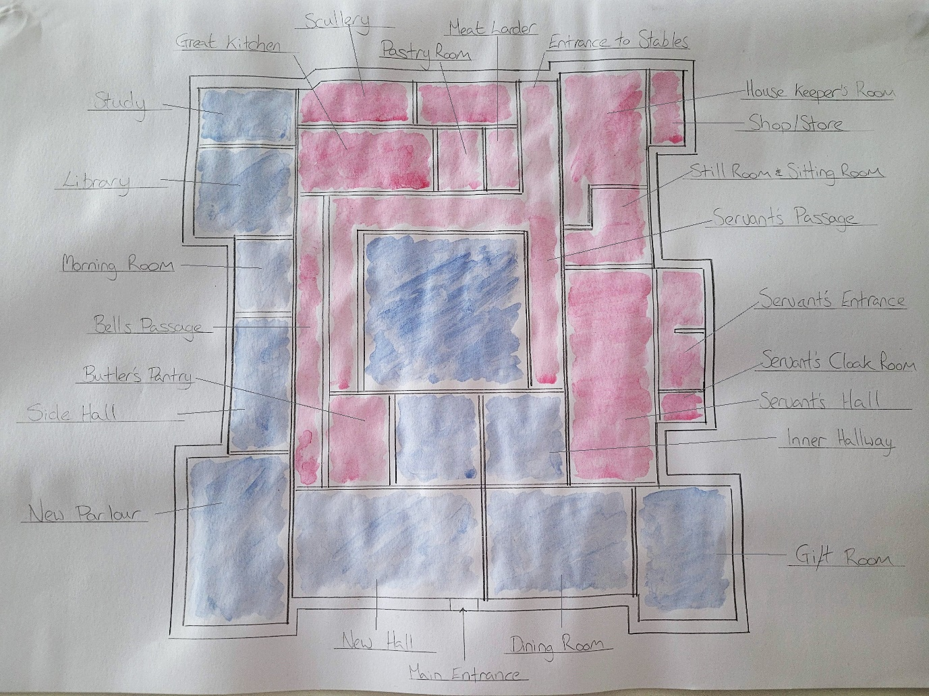
Figure 8 - Occupancy of Tredegar House (Residential - Blue Servant - Red)
This was a clear divide with the larger picturesque rooms for the recreational use of the owners with large windows to admire the beautifully landscaped gardens and the servant's sections with much smaller windows at the rear of the house overlooking the stables and rear access road (which was only to be used by the servants.)
Malpas Court has had many varied uses since it was built. Beginning its life as a grand mansion for the Prothero Family until 1924 after which it was empty for 15 years. In 1939 the American Army took ownership and placed over 100 huts surrounding the grounds also accommodating a recreational theatre, Motor Hall, Cookhouse and mess hall. After the war, the house was designated as a Rest Centre which soon developed into a social club. In the 1980s only a small portion of the building was in use as commercial premises, the rest of the house fell into disrepair. It wasn’t until 2008 that funding was received from the Heritage Lottery Fund and the European Regional Development Fund to restore the building to its former glory. It is now a multifunctional centre, containing a Café/Restaurant, Communities first centre and Conference Rooms. As the footprint of Malpas is considerably smaller than the Tredegar there is less separation of servants areas and residential with only the Kitchen, pantry and one room for the housekeeper and butler to share.

Conclusion
Although the buildings were built hundreds of years apart the overall purpose and use of the buildings were the same just on different scales. Malpas Court almost looks modest in comparison to Tredegar House but both were built to highlight the wealth and power of their owners. They were designed to highlight the views and impress their guests with ornate decoration and vast grounds. There is a difference in the use of sunlight as Malpas court is specifically placed to face the south/south-west and the large glass sunroom would maximise the evening sun, Tredegar house however has its main entrance facing north-west which seems to be a design flaw.
If this study were to be repeated it would be improved by gaining additional information and drawings of the interior for Malpas Court, unfortunately, due to Covid-19 restrictions, this was not possible and access was not granted to many areas of the buildings so an accurate floor plan could not be completed. It would also have benefited from further information on the actual build aspect, sadly, there were no responses to emails sent to National Trust, NewportPast.com or Newport City Council.

References
Newport, n.d. Malpas Course Leaflet. [Art] (Newport City Council).
Nicholas, T., 1872. The Residence of Mrs Prothero. [Art].
Roderick, G., 2015. Malpas Court. In: Newport: Newport City Council, p. 5.
Smith, P., 1975. Houses of the Welsh Countryside. 2nd edition 1988 ed. Swansea: The History and Law Committee of the Board of Celtic Studies.
Unknown, 1980. Tredegar House Years. [Art] (South Wales Argus).
Unknown, 2015. Malpas Court Side Aspect. [Art] (Newport City Council).
Unknown, 2016. NewportPast.com. [Online]
Available at: http://www.newportpast.com/houses/malpas_court/index.php
[Accessed 20th December 2021].
Unknown, n.d. The Regency New Hall. [Art] (Dulwich Picture Gallery).
Wyatt, T. H., 1841. Section of the Orginal Site Plan. [Art] (Newport Past).

Bibliography
Anon., 2018. Riches and Rebellion at Tredegar House. The National Trust, 01 June.
BBC, 2017. Roof of Newport's Tredegar House 'fully restored'. BBC News, 23rd November.
Council, N. T. a. N. C., 2021. Information gathered during site visits - from information boards at the poperties. Newport: s.n.
Cox, A. &. J., 2022. Managemnet team at Malpas Court [Interview] (14th January 2022).
Ellis, S., 2012. tredegarhouse.wordpress.com. [Online]
Available at: https://tredegarhouse.wordpress.com/2012/01/
[Accessed 28th December 2021].
National Trust, n.d. nationaltrustcollections.org. [Online]
Available at: https://www.nationaltrustcollections.org.uk/place/tredegar-house
[Accessed 20th December 2021].
Roderick, G., 2015. Malpas Court. In: Newport: Newport City Council, p. 5.
Unknown, 2016. NewportPast.com. [Online]
Available at: http://www.newportpast.com/houses/malpas_court/index.php
[Accessed 20th December 2021].

