Assessment 1

LCBB4004 – Marketing Fundamentals
KFC Marketing Strategies during Covid-19 pandemic (7 blog posts)

Student ID: 2021007
BA Business Management
University of Wales

Date of Submission: 06.01.2022
Number of words: 2363

I declare that this assignment is all my own work and that I have acknowledged all materials used from the published or unpublished works of other people. All references have been duly cited.

Table of Contents

Blog Post 1 3
Making Fast Food Better in a Pandemic World with KFC 3
Blog Post 2 5
How KFC Remodelled Service Delivery during pandemic 5
Blog Post 3 7
How KFC Used Technology during pandemic as a marketing tool 7
Blog Post 4 9
How KFC changed during Covid-19 pandemic 9
Blog Post 5 11
KFC’s approach during Covid-19 pandemic 11
Blog Post 6 13
KFC’s best practices in marketing during pandemic 13
Blog Post 7 15
KFC’s performance during pandemic 15
References 17

Blog Post 1

Article Title:

Making Fast Food Better in a Pandemic World with KFC

Article featured Image:
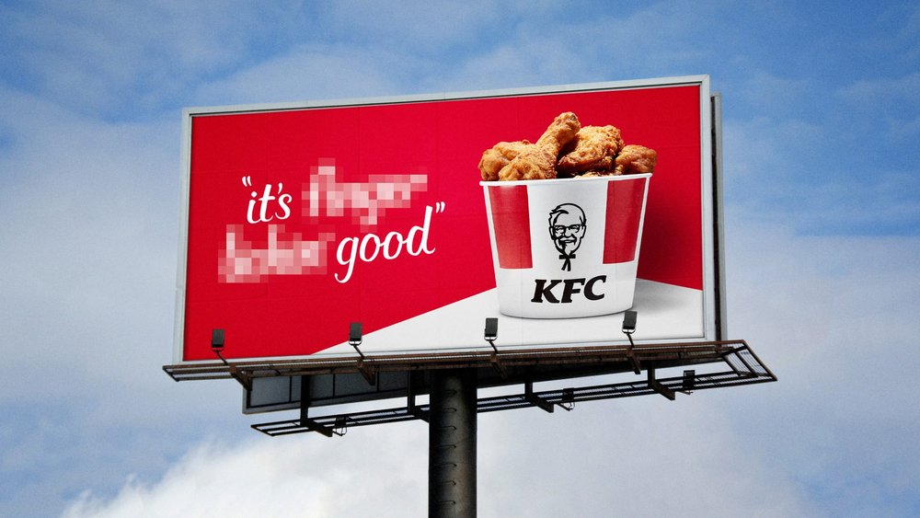
Image source: (Contagious , 2020)

Article Content:

Every CIO has a difficulty as a result of the coronavirus outbreak. When it comes to Kentucky Fried Chicken (KFC), the world's second-largest fast-food restaurant chain, the enormity of this problem has necessitated a substantial technical shift in organisations and new business models and methods of functioning (Chen, 2020). In the last year, KFC has witnessed fast digital development as it finds inventive methods to continue servicing its millions of consumers - directly or through new services from delivery - according to Nitin Chaturvedi, Chief Digital Officer and Technology Officer at KFC Global. It also changed Chaturvedi's perspective on the importance of digital technology in driving corporate transformation, even though he joined KFC in September of 2021.
His first task was to persuade the corporation of the importance of digital and the necessity of preparing for the future. However, today he has a lot less on his plate. As a result of the success of Covid-19, digitalization has become one of the company's main priorities, and practically everyone in the company can confirm that (KFC, 2022).
According to Chaturvedi, KFC is adjusting its business strategies, operations, restaurant design, and IT infrastructure throughout the world as a result of various Covid-19 circumstances.
He cites as an example the near-universal adoption of contactless payment. When it came to serving meals, "even where we could, we had to work without any human interaction."
As a result, alternative tactics are required because of the company's global reach (approximately 85% percent of sales are produced outside of the United States, with China currently being the largest market). in light of local conditions.
In many regions of the world, KFC went from having no delivery, click, or pickup to having all of these options overnight (KFC, 2022).

Blog Post 2

Article Title:

How KFC Remodelled Service Delivery during pandemic

Article featured Image:
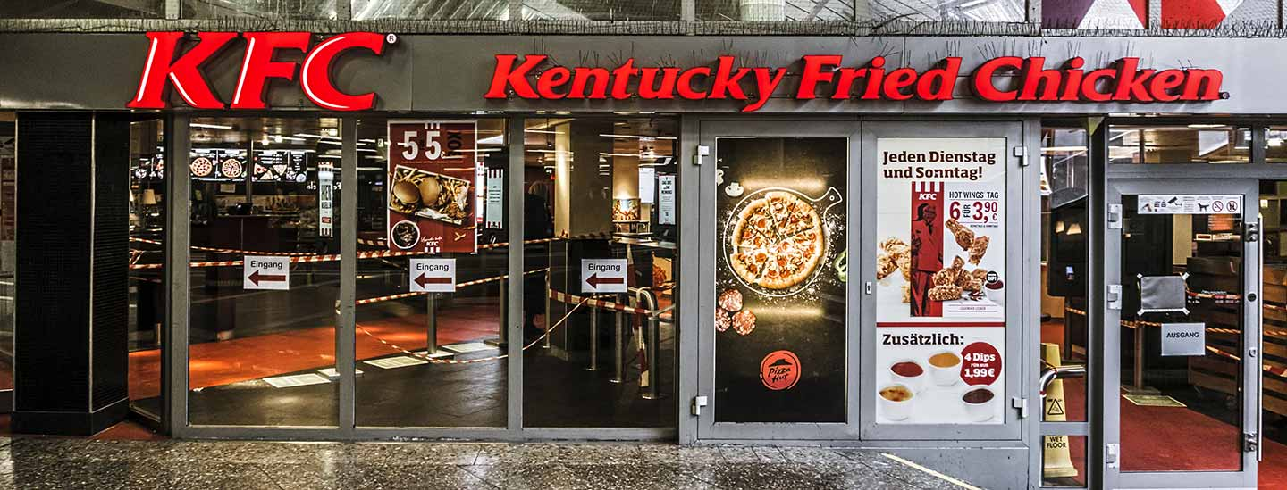
Image source: (KFC, 2022)

Article Content:

The corporation extended its transportation and delivery services and remodelled restaurants in areas where consumers couldn't eat. Rather of relying on only a few third-party suppliers like Uber Eats and Just Eat, the firm now has "complete aggregator penetration" around the globe. They have to be overcome to reroute thousands of non-traditional food supply pathways from China and Japan to the United Kingdom and South Africa (KFC, 2022).
In addition, KFC has improved its own digital platforms. A click, click, and raise barrier has boosted the amount of people who visit the company's website. As for business model adjustments, KFC has gone from not offering delivery, click and pickup or pick up in many regions of the world to offering all three in as little as a few months. This was a very, very huge transformation in terms of the business and the operational strategy (Campaign, 2021).
Each market's operational model dictates the rate of change. The degree of change varies by region, but in many areas of the world it has been fairly significant. KFC had to make those pivots faster and on a much greater scale in places where they were heavier around the table. However, even in locations where KFC had a number of drive-through restaurants, the digital hub was still necessary (KFC, 2022).
There are three ways that KFC envisioned this change taking place. A far superior "strategy" that could combine the two swiftly replaced KFC's conventional reliance on strategic planning and phased implementation. It was all about doing, testing, improving, and repeating.
Second, KFC is being remodelled to cater to a more solitary clientele. Off-site channels were created, storefronts were redesigned, and the way the company communicated with customers altered overnight (KFC, 2022).
There has also been a transition in leadership style, from one that is more directive to one that is more empathic. The organisation has long taken pride in its "heart-driven leadership," which encourages openness and acknowledges the human condition. Back when more individuals were working remotely, KFC’s management noticed that there was a lot more attention on heart concerns such as mental health and wellbeing (KFC, 2022).

Blog Post 3

Article Title:

How KFC Used Technology during pandemic as a marketing tool

Article featured Image:
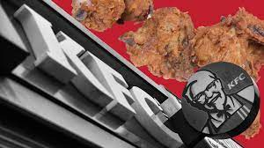
Image Source: (KFC, 2022)

Article Content:

The pandemic was a chance for organisations to create the culture and attitude that will help them succeed long-term (Chen, 2020).
It's not only a reaction to the crisis. Thinking about how to do better in the future was the focus. Decision-making systems have also become less hierarchical as a result of the current scenario. As leaders, some naturally want to take charge and manage things, but you frequently get a stronger response when you let go of power (Kotler & Armstrong, 2005). For the most of the epidemic, this approach worked for KFC.
One area where a more open-minded approach has yielded remarkable success is innovation. Despite KFC's ability to generate new ideas, the company often struggled to implement them. To illustrate that a corporation may rapidly transition from a concept to actual expansion, see "Lift the Curb". It's become the norm to encourage creative thinking at all levels of the organisation or location.
The response to the crisis was a search for strategies for a better future. KFC’s management has seen more ideas from their markets because of this, and it has accelerated the pace of invention.
Technological advancements epitomised this idea of distributed creativity best of all other fields. KFC has used IoT augmented reality, robots, and computer vision to address the pandemic's issues during the last year. Need has led to inventiveness (KFC, 2022).
Because of the crisis and the necessity to service clients without personal touch and in a socially distant fashion, KFC looked at all of this. Conveyor belts and robotic arms, for example, are being studied by the corporation to see if they might be utilised to better service clients (KFC, 2022).
Goal was to make KFC a brand that other people turn to for digital inspiration.
Google Glass is being used by KFC in Latin America as a training tool and business management tool for employees (KFC, 2022).
Such inventions will continue to exist. Is KFC's business model shifting? Most likely. As a result, they'll have a lot more points of contact with clients, all focused on trust and security.

Blog Post 4

Article Title:

How KFC changed during Covid-19 pandemic

Article featured Image:
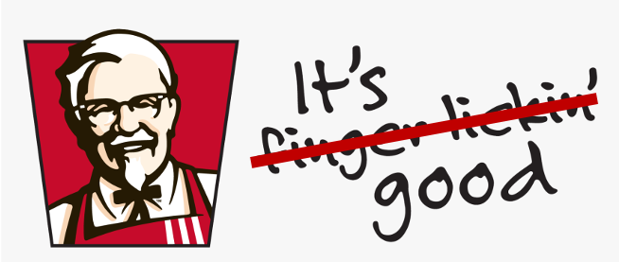
Image source: (Hansen, 2020)

Article Content:

One of UK's most well-known brands when it comes to fried chicken is KFC. However, COVID-19 has had a negative impact on the company's marketing strategy, forcing it to completely rethink its strategy (Hansen, 2020). It had to respond rapidly to the shifting requirements of its customers as the epidemic progressed, all the while devising new ways to keep in touch with them. KFC got first prize in the "Excellence in Gamification" category at MARKETING-Marketing INTERACTIVE's Excellence Awards 2020. "Excellence in (virtual) event marketing" was also awarded a bronze medal.
Good fried chicken is more than just finger-licking good. Known for its comfort and clever feeding ideas, KFC is a popular choice for families with young children. In today's competitive marketplace, people are more concerned with a brand's image than the quality of their food. KFC is searching for methods to alleviate the pressures and demands of daily life, as well as to liven things up a bit (Kelso, 2021).
With this in mind, KFC has come up with a variety of new and exciting dishes, such as Kentaco and Mac N' Cheese Zinger, to keep their customers coming back for more. In addition to food, they are searching for methods to safeguard the environment and get people involved (KFC, 2022). They’ve done things like stop using straws in KFC restaurants and include gamification into their KFC app so that customers can have fun and earn rewards while interacting with us.
With social isolation and different table constraints, running a restaurant is one of the more challenging endeavours this time around. In the wake of COVID-19, we must have rethought our plans for 2020 to the point of near-extinction. As government policies and consumer habits changed, KFC had to adapt rapidly. In the meanwhile, the company places a high value on the health and safety of its customers and staff, even before it opens for business.
It was KFC’s mission to provide customers their favourite roast chicken for convenience, safety and value for money during the pandemic's circuit interruption (KFC, 2022). A focus on bringing back well-known inventions from the past that were highly welcomed, such as Hot Devil Drumlets, KFC Meltz and Double Down, took precedence over introducing luxury advancements. They have also moved their communication focus from product advertising and dinners to delivering and bundling and leveraging KFC on all of their orders.

Blog Post 5

Article Title:

KFC’s approach during Covid-19 pandemic

Article featured Image:
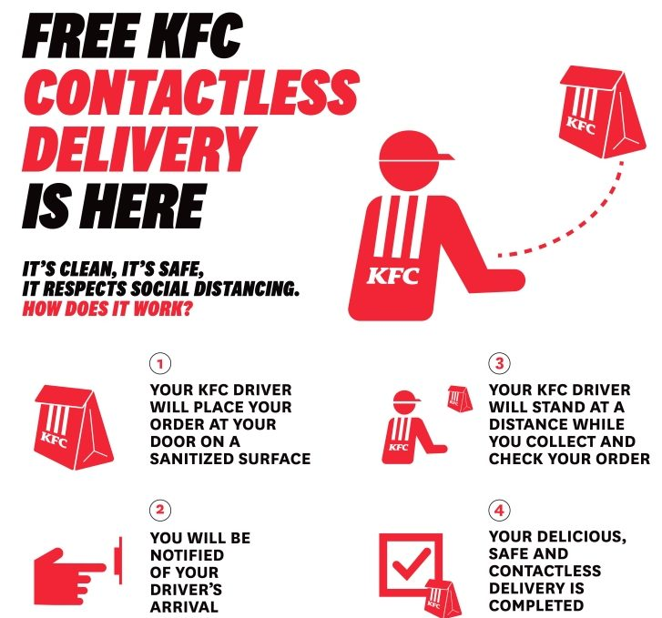
Image source: (Campaign, 2021)

Article Content:

There was an uptick in consumer demand for a value proposition as COVID-19 began its second phase in UK and many people sought to rev up daily routines. Their initial iteration of the Spin N Win app was published in August, allowing people to play for free and win cash, vouchers, and a variety of delectable culinary prizes (KFC, 2022).
Grocery delivery has become increasingly popular among customers in the midst of this epidemic and the subsequent shift. All of the food and beverage units that had not yet delivered moved up to resume their work. Post-COVID meal delivery will continue to expand as people become acclimated to the convenience of the food supplied, and this trend is expected to continue Fortunately, KFC has a well-established meal delivery service and has collaborated with many of the main food manufacturers. KFC delivery will be enhanced in the future by collaboration with their operations team and aggregator partners, who will work together to develop new promotions and menus (KFC, 2022).
Faster uptake of digital orders and electronic payments has been another major shift in customer behaviour. Many firms have created their own applications in response to the increasing demand for supply. KFC will not be pleased if the number of app downloads and use increases. As a result, they are working hard to make KFC an attractive and useful app for their customers. When you're hungry or craving fried chicken, they'll come right out of the woodwork. "KFC Spin N Win" was KFC’s first step into gamification, and KFC fans may look forward to more in the future (KFC, 2022).

Blog Post 6

Article Title:

KFC’s best practices in marketing during pandemic

Article featured Image:
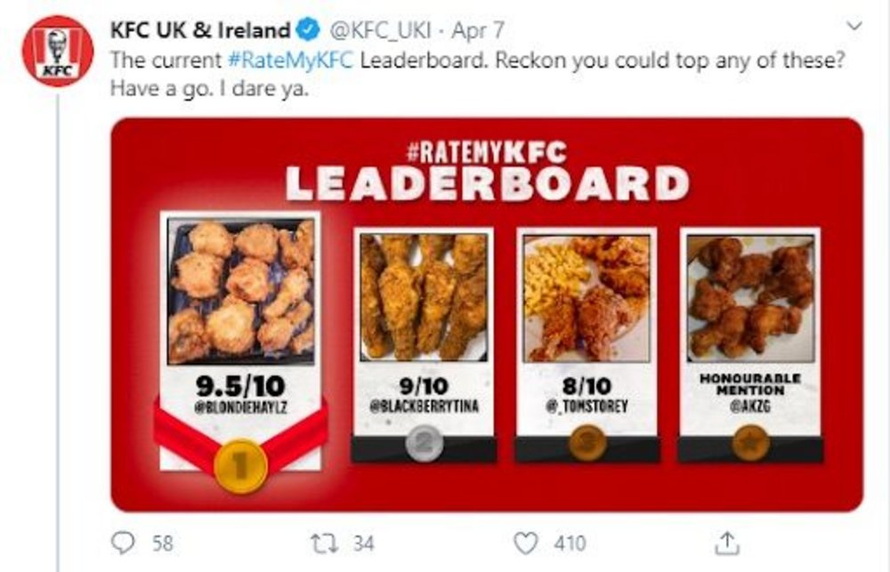
Image source: (Contagious , 2020)

Article Content:

For KFC, great marketing is the ability to blend science and creativity in order to achieve goals and establish a brand that resonates with the company’s target market (Kotler & Armstrong, 2005).
Marketers can now make more reasoned and predicted judgments thanks to greater data availability and a larger variety of data tools. However, this data set is typically limited in its ability to generate KPIs that are solely relevant to a certain industry. Building a brand and a successful campaign both require the capacity to understand the emotional requirements of customers, to craft messages that speak to those needs, and to have the proper intuition (Chaffey & Ellis-Chadwick, 2019).
The reappearance of COVID-19 in a number of nations serves as a stark reminder of the ever-changing nature of our world. Never let your guard down, even if the situation in UK appears to be improving. Keep the customers and workers safe and healthy was KFC's number one priority in 2021. Whether they're dining with KFC or not, KFC’s management wants their customers to be able to enjoy their favourite piece of fried chicken without worry (KFC, 2022).
As one of the UK’s most popular fried chicken fast food chain, the company will continue to bring their customers mouth-watering fried chicken, innovative new dishes, and excellent bargains. Because of this, they must be alert, adaptable, and ready to change their plans as necessary so that British consumers may enjoy their favourite fried chicken for many years to come (Chen, 2020).

Blog Post 7

Article Title:

KFC’s performance during pandemic

Article featured Image:
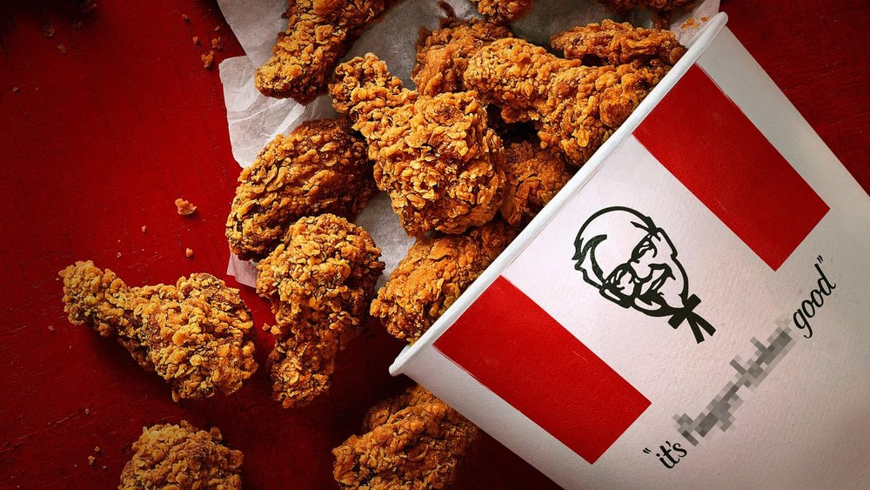
Image source: (Contagious , 2020)

Article Content:

KFC was compelled to withdraw its tagline "excellent finger licking" last year after the Advertising Standards Authority received a complaint about the coronavirus. In May of 2021, when limits were loosened and vaccines were opened up to more Britons and "fingers stuck," suggesting less risk to public health, the company brought them back in a new TV commercial for the first time in their history (YouTube, 2021).
KFC's awareness scores (which evaluate whether individuals have seen an advertisement for a brand in the previous two weeks) have grown from 19.8 to 25.5 since the campaign debuted on May 10. (moving average for June 10 - 1 week).
So far, it looked like a recipe for success. Negative or positive sentiments about a company's brand impression score increased from 4.5 to 10.1 (June 8) before falling slightly to 5. 7 (June 10). In the first month following debut, the product's value rose from a score of 5.7 to a score of 9.0. (May 10 - June 10). Between May 10 and June 4, count points rose from 20.1 to 25.8 - and even continued on May 10 - despite a short surge in count points (KFC, 2022).
Public appreciation for KFC's attempts to evoke memories of pre-pandemic living was a positive sign for KFC. Of course, KFC has a strong reason for wanting to return to pre-blockade life ASAP (KFC, 2022).
It has been some time after the first blockage, but many existing customers who check to verify if consumers purchased brand name foods or beverages in the last 30 days are gradually recovering from the epidemic. A year later, on March 23, 2020, they had only climbed back to an average of 8.5. It may take some time for the public to forget about the relationship between COVID-19 and finger licking, but KFC's future seems bright.

References

Campaign, 2021. How KFC is managing through the crisis. [Online]
Available at: https://campaignme.com/how-kfc-is-managing-through-the-crisis/
[Accessed 01 01 2022].
Chaffey, D. & Ellis-Chadwick, F., 2019. Digital Marketing. Strategy Implementation and Practice. 7th ed. s.l.:Pearson.
Chen, M., 2020. Fast Food Industry in the Post-pandemic Era — A Case Study of KFC. EDP Sciences, Volume 218(E3S Web of Conferences).
Contagious , 2020. A banjo among violins: the strategy behind KFC’s pandemic marketing. [Online]
Available at: https://www.contagious.com/news-and-views/a-banjo-among-violins-the-stratkfcs-pandemic-marketing
[Accessed 01 01 2022].
Hansen, J. B., 2020. This is how marketing has changed during the Covid-19 crisis. [Online]
Available at: https://medium.com/@jonasbladthansen/this-is-how-marketing-has-changed-during-the-covid-19-crisis-db89d5a2b9f
[Accessed 01 01 2022].
Kelso, A., 2021. Operational Efficiencies And Digital Growth Bolster Yum Brands’ Q4. [Online]
Available at: https://www.forbes.com/sites/aliciakelso/2021/02/05/operational-efficiencies-and-digital-growth-bolster-yum-brands-q4/
[Accessed 01 01 2022].
KFC, 2022. KFC. [Online]
Available at: https://www.kfc.co.uk/
[Accessed 01 01 2022].
Kotler, P. & Armstrong, G., 2005. Principles of Marketing. 11th ed. New Jersey: Prentice Hall.
YouTube, 2021. KFC - Love You Too. [Online]
Available at: https://www.youtube.com/watch?v=G6AP3nGF4GI
[Accessed 01 01 2022].

