THE IMPORTANCE OF MARKETING INFORMATION SYSTEM 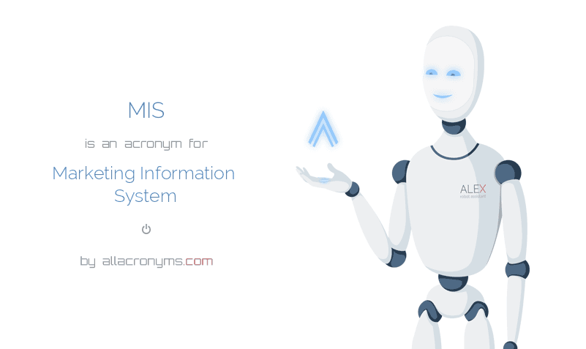



  - Lecturer dr.olu adegbite
STEFAN ILIE 1815223| MARKETING ESSENTIALS | 26/05/2019

CONTENTS

INTRODUCTION…………………………………………………Page 1
DISCUSSION/EVALUATION/CRITICAL ANALYSIS………………Page 2-5
CONCLUSION…………………………………………………………………Page 6
REFERENCES……………………………………………………………………Page 7

As well as the official definition of the information system in marketing, the following is a good idea: "A marketing information system (MIS) consists of people, equipment and ways of collecting, selecting, analyzing, evaluating and distributing in real time the exact information necessary for the factors decision from the marketing department of an organization. "
• In an absolutely normal way. M.I.S starts and ends with marketing managers. This system assesses information needs and at the same time provides vital information from the company's internal audit through market surveillance and marketing research. Analyze the information and contribute to its processing, so that it is as useful as possible. last but not least, M.I.S distributes to managers the information in real time and in optimal format, so that they can be used in the identification, implementation and control of marketing activities MARKETING INFORMATION SYSTEM

This essay attempts to treat in an efficient way how RITZ-CARLTON uses this system to collect real-time processing and vital information implementation to meet and improve the quality of travel and customer service.
Ritz-Carlton has managed to become one of the undisputed leaders in luxury accommodation through the rigorous observance of his own principles and is the company that has twice won the prestigious Malcolm Baldridge Award, and the specialist magazines have named them the most Good US Company for Employee Training. The uniqueness of his culture begins with a well-known motto that reveals the true RITZ mentality of "quality people for quality people." One of the smart sales strategies is to empower each employee to allocate a significant amount of money so that each guest is very satisfied. Ritz-Carlton instructs his 38,000 employees in their service after the two "Travel and Customer Service Libraries" "The 12 Values ​​of Service," "Credo," which Ritz-Carlton does and defines in the same time Ritz. < Sasser, W. Earl, Thomas O. Jones, and Norman Klein 1999>

RITZ-CARLTON focuses on the three basic criteria, namely:
LOCATION: choosing an optimal location ensures the clients' desire to stay in that place.
The construction of a suitable physical product to satisfy the clients' wish that what they want today will also like tomorrow as well, and this leads to significant investments from RITZ-CARLTON investments ranging between 500,000 usd and over 1,000,000 usd
This is the base platform from which to start and work.
People or better say the human factor.
"Ladies and gentlemen"
People give life and translate into reality the principles of this platform
It is very clear that if you do not have the first two points insured and very well put into value you cannot have the desired success, so in essence everything is reduced to the principle "The right man in the right place with the right means".
Now is the time to see RITZ-CARLTON's work in-depth, and I chose an example in their own universe.

How is RITZ-CARLTON ensured that each employee is actually "on the same page"? The answer is disarmingly simple and efficient by using the "LINE UP" method. This concept has very ancient origins in the early French restaurants where the cook chef gathers everyone involved in the activities of that venue and communicates important information such as what will be served including customer details.
RITZ-CARLTON has the determination to implement for every hotel anywhere in the world and at the same time each partner adhere to this "BRIEFING" policy prior to commencement of activity, namely the accurate and real-time information of all involved in customer service and MOTIVATION of staff by compliments brought to them for fantastic work done inside the company
Through this method, the staff is well motivated so that each department within the company puts the company's message into practice. < Christian Fredrik B Mathisen 2008>

If we ask ourselves how RITZ-CARLTON synthesizes all these components of the informational marketing system I can say that everything is based on the human factor and mutual trust on the accuracy of the information. I trust only for the simple fact that, for example, every employee involved in contact directly with a customer RITZ-CARLTON is empowered to invest up to $ 2,000 for that client without the approval of the general manager. This amount may increase with approval and everything only for customer satisfaction for the RITZ-CARLTON culture. In essence, the concept is: do your best to create the perfect stay of a guest in the hotel.
A good example: you can find a guest's birthday and gift a champagne gift and a glorious birthday cake and / or a photo of your favorite pet that the customer will find in his room.
For the perfect leadership of RITZ-CARLTON staff, they listen to the favorable and unfavorable arguments of each issue, make the right choices and move on to the next topic.
Ritz-Carlton, sets trends, no tendencies.

RITZ-CARLTON, apart from its own marketing department, engages in prestigious magazines in the field to interview our customers for us, asking questions like: How was the table? if the food was warm enough? Was the service at height? Was the menu the customer's pleasure? room service was up to your expectations? Was the bedroom clean? For example, the prestigious Gallup magazine has created a scoring system for both functional and emotional questions
The maximum score for each question is 5 points

Voluntary turnover is the most important internal measure for employees, which RITZ-CARLTON measures, and at the same time it is a very important indicator of talent acquisition and training. RITZ-CARLTON typically hires about 2% of people who want to work with us. Training is very important and keeping staff satisfied is a priority for RITZ-CARLTON

RITZ-CARLTON has already understood that they no longer represent a brand, but rather more and more complex, they already represent a lifestyle.

More than 3,000 people have bought tourist packages from and within RITZ-CARLTON, and for RITZ-CARLTON those people represent devoted clients for life.

The secret of success of RITZ-CARLTON?
SIMPLY AND CLASSIC
because it is built based on trust. And if the senior management departments within the company do not live up to the values that the personal employee requires, then this is only the fastest way to sabotage the culture. All the time they need to be the first model to be copied by all the employees through all what they do and the most important thing is the fact that they need do be “The hands-on” in order to make every single one of their subordinates to see, think and act in their manner. This method it is very well known as the “Follow me” method used mainly in the second world war by the American military officers in the process of military training .
< Edward Horrell,2006>< Okonkwo, U. 2010).

CONCLUSION:

It does not matter if the level of customer service provided by a company is perfect if the delivery of customer service is not original, for example scripts, style or variety is not possible to interact with current time customers. Today's customers of all categories, including all ages representing the important customer generation of the decade, are looking for an authentic experience. They are quick to reject any service that they perceive as inadequate and without originality. Ritz-Carlton has become a real-world leader in the field of hospitality industry revolution through high standardization of employee recruitment criteria, and more. Today, you can cross the world, compare a consistent standard of service with what you have experienced at Ritz-Carlton where you've stayed, and quickly come to the conclusion that the guest is the KING

REFERENCES:

Author | Christian Fredrik B Mathisen
Year published: | 2008
Book title: | Ensuring evolution
City: | Oxford
Publisher: | Oxford Brookes University
Author | Peter Johnson
Year published: | 1991
Book title: | Leadership and Motivation. Supervisory Management Module. Operational Management Programme. Third Edition
Publisher: | Hotel and Catering Training Company
Author | Peter Johnson
Year published: | 1991
Year published: | n.d.
Book title: | Business of catering
City: | [Place of publication not identified]
Publisher: | American Express Hotel & Restaurant Business Support Services
Author | Doug Davies
Year published: | 2011
Book title: | Human resources management in China
City: | Oxford, UK
Publisher: | Chandos Pub.
Author | Edward Horrell
Year published: | 2006
Book title: | The kindness revolution
City: | New York
Publisher: | Evans, J. and Lindsay, W. (2002). The management and control of quality. Cincinnati, Ohio: South-Western.  Miller, M. and Conley, L. (n.d.). Legacy in the making.  Okonkwo, U. (2010). Luxury online. Basingstoke: Palgrave Macmillan.  Swink, M. (2011). Managing operations across the supply chain. New York: McGraw-Hill

Author | Christian Fredrik B Mathisen
Year published: | 2008
Book title: | Ensuring evolution
City: | Oxford
Publisher: | Oxford Brookes University
Author | Peter Johnson
Year published: | 1991
Book title: | Leadership and Motivation. Supervisory Management Module. Operational Management Programme. Third Edition
Publisher: | Hotel and Catering Training Company
Author | Peter Johnson
Year published: | 1991
Year published: | n.d.
Book title: | Business of catering
City: | [Place of publication not identified]
Publisher: | American Express Hotel & Restaurant Business Support Services

