
Student name: Teodor Katrandzhiev
Student ID number: 2124415
Programme: BA Business Management

Module: Data Handling and Business Intelligence
Module code: LCBB5000
Contribution to Overall Module Assessment (%): 25%
Assignment Title: Written Report
Word count (or equivalent): 1250 words

Data warehousing and business intelligence: Current trends and the benefits to the enterprise

In the 21st century, every little aspect of the business world has been put into high gear, forcing a drastic change in the way managers to need to think, the way decisions need to be made and the speeds at which changes need to be implemented. These rapid technological changes have made the market incredibly challenging for small and medium enterprises. To gain a competitive advantage, modern-day organisations are utilising intelligent technologies and IT systems that allow the business to anticipate the future. When a possible problem is discovered, they rapidly establish the root cause and propose an alternative course of action. (Olszak, 2021) Many argue that technology is the force behind all the changes in the business environment, all the new business practices, fierce competition and improved customer satisfaction. Understanding and applying these technologies is the basis for improving customer relationships and optimising organisational efficiency. (Rivard et al., 2004)

Data warehousing

Information is one of the most valuable assets in our day and age. Using it intelligently in decision-making can enormously impact the organisation’s functioning. Data warehousing is a technology developed to store and interpret data quickly and efficiently for decision-making activities. (Inmon, 1992) Most business decisions are influenced by information gathered from previous experiences, and data warehousing is the tool that stores all of this data for when the organisation needs to analyse it. (Hammergren, 2009)

Business intelligence

Business intelligence is the technology that turns the data in the Data Warehouse into helpful information that guides the organisation. The term can be defined as various mathematical and analytical methodologies, architectures and algorithms that interpret the available data and create useful information and knowledge to support the organisation in strategic decision-making. This data can be used for various aspects of the business, for example, marketing, sales, promotion, spending habits and many more. (English and Hoffmann, 2018)

Importance of DW and BI, including the DW architecture

What makes Business intelligence an absolute must-have is the unmatched time efficiency and overall effectiveness it can provide for the organisation. The thorough analysis of the collected data creates reliable information and knowledge. As a result, the company can make better, timely decisions and develop effective plans to reach organisational objectives. The algorithms used by business intelligence can go through millions of different scenarios and action plans to present us with the one most likely to succeed. However, what ultimately changed the game is the speed we can gather all of this information, allowing the enterprise to make timely decisions in today’s highly dynamic business world. Furthermore, this constant data analysis can give managers an in-debt awareness and a deeper understanding of business models and practices. (Vercellis, 2009)

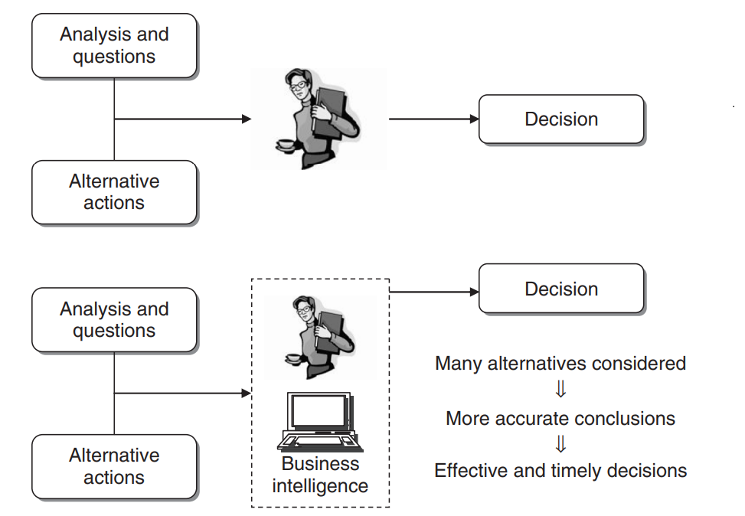
Fig 1.1 Benefits of a business intelligence system (Vercellis, 2009)

Data warehousing (DW)

Everyone has heard the expression, "knowledge is power". Furthermore, this is precisely what data warehousing can provide for the organisation. The process of collecting information, especially before the invention of the computer, has always been time-consuming. Still, in the present day, with data warehousing, all the information we need is correctly and systematically organised to be used to make better business decisions. (Hammergren, 2009)

Data warehousing architecture

Regarding computer systems, architecture can be defined as the style or method of arranging parts in an orderly fashion. The data warehousing architecture’s primary goal is to create information that is accurate and easily accessible to the members of the enterprise. The architecture is, in essence, a plan for delivering the organisation's objective for the data warehouse. Different architectures will enable us to utilise other business and decision-making functions. (Vercellis, 2009)

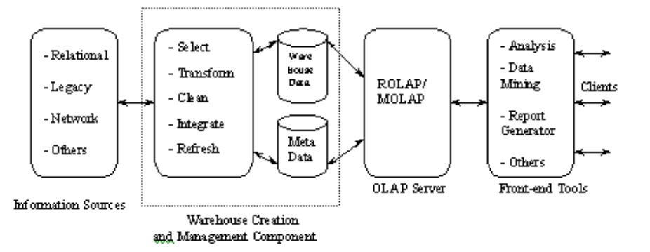
Figure 1.2 A Conceptual data warehousing architecture (Becker, 2002)

Business Intelligence (BI) Tools

Business intelligence tools vary greatly, from simple tools like Microsoft Excel to extremely sophisticated data warehousing and mining processes. The early stages of BI consisted of reports produced by IT departments to fulfil specific requests by managers, which had to be manually inspected and interpreted. Today’s BI tools can find patterns in data in near-real-time and produce actionable information for managers. This information then provides an opportunity to quickly evaluate marketing and advertising campaigns, point-of-sale, spending habits, transaction volumes and overall effectiveness of the business based on specified key indicators. (Herschel, 2012)

Impact of DW and BI on modern businesses

In 2005 research conducted among IT and business professionals in the U.S. working for organisations with 500+ employees showed that 86% of participants believe the management of data warehousing and Business intelligence is critical or highly critical for organisational success. (CNET, 2005). There is no doubt that data will become increasingly crucial for business, and Business intelligence will be a primary source of insight for the most successful enterprises in the future. As we already mentioned, having large amounts of data is one thing, but being able to extract meaningful and consistent information is quite another. Most big organisations have numerous data sources, all analysed, making them usable for different needs. Data warehousing ensures data quality and consistency, creating a framework capable of providing valuable insights for everyone using it. (Herschel, 2012)

In the 21st-century business environment, most successful companies invest in business intelligence to gain insight into market trends and business model improvements. Enhanced customer service and satisfaction are also ways business intelligence can support the business. In the end, the failure of the company depends on the customers. Modern-day companies use BI to collect and organise data on repeated buyers, purchase choices, and spending habits and devise strategies to attract new customers. These strategies based on accurate information give businesses an essential advantage against competitors. (Vercellis, 2009)
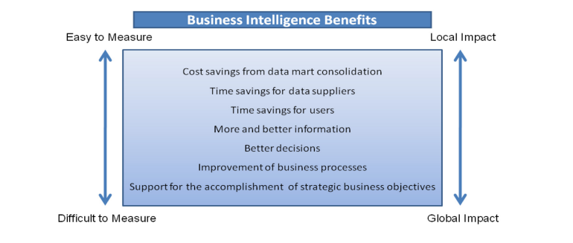
Figure 1.3 impact of Business Intelligence (Herschel, 2012)

Business intelligence is often used to enhance a company's marketing strategy, increase sales and maximise profit margins. When the correct tools are used, the enterprise will have a higher chance of successfully marketing its product and services to a more extensive customer base. By carefully evaluating the existing data, the enterprise’s management team will be able to assess the demand for a specific pro particular service accurately. Understanding new markets and potential customers will significantly empower the company to increase sales and create a true impact with its marketing efforts. (Vercellis, 2009)

Conclusion

Data is readily available to the businesses of the 21st century, but just having gigantic amounts of data is not helping a business thrive without the ability to extract the knowledge out of it, find the patterns and do all that promptly; this data is all but useless. This paper argues the case of Data warehouse and Business intelligence to improve business decisions in all enterprises, including small and medium businesses. The discussion helped clarify the meaning of DW and BI and the strategic advantage of utilising these technologies in any enterprise. These ever-developing technologies are fantastic tools for making informed decisions as a manager. Gathering important market information time-efficiently will create a competitive advantage for any business that invests in DW and BI. In conclusion, all evidence suggests that enterprises using Business Intelligence stand a better chance of achieving better customer satisfaction and maximising profit margins. Business intelligence can significantly contribute to companies' decision-making and support strategic planning, and at least a basic understanding of DW and BI is essential for decision-makers. This paper aims to introduce the basic model and provide insight into the possibilities that BI can provide for an enterprise. The main argument of this paper is that no matter how big or small a company is, just by analysing and interpreting data, we can significantly increase our chance of gaining an advantage over our competitors. (Vercellis, 2009)

References

Becker, S.A. (2002) Data warehousing and web engineering. Hershey, PA: IRM Press

CNET (2005) Networks TechRepublic Community Research Programs and Sybase. Information Management Trends in 2005.

English, V. and Hoffmann, M. (2018) ‘Business Intelligence as a Source of Competitive Advantage in SMEs: A Systematic Review’, DBS Business Review, 2.

Hammergren, T. (2009) Data warehousing for dummies. 2nd ed. / Thomas C. Hammergren. Hoboken, N.J: For Dummies.

Herschel, R.T. (2012) Organizational applications of business intelligence management emerging trends. Hershey, Pa: Business Science Reference.

Inmon, W.H. (1992). Building the Data Warehouse. John Wiley.

Olszak, C.M. (2021) Business intelligence and big data : drivers of organisational success. Boca Raton, Florida: CRC Press.

Rivard, S. B., Aubert, B. A., Patry, M., Pare, G., & Smith, H. A. (2004). Information technology and organizational transformation , London: Elsevier.

Vercellis, C. (2009) Business intelligence: data mining and optimization for decision making. 1st ed. Chichester, West Sussex, United Kingdom: Wiley.

