
Human resource strategies of Wells Fargo.

Name: Swetha Baske
Student No: 2130060
Module: LCMB7000
Lecturer: Gladius Kulothungan
Course: Masters in Marketing Management
Submission date: 14/09/2022
Assignment – 2 (50%)

The report covers the below contents:
- Human resource strategies - Introduction
- Overview of Wells Fargo
- Change management strategies
- Staffing retention strategies
- Leadership strategies
- Discussions to support valuing and appreciating Team members and developing the sense of belonging to the organization strategies

- Principles, models and concepts of current Human Resource Management and International Human Resource Management theories

- Conclusions

- Recommendations

References

Human resource strategies – Introduction:

Human Resource strategy approach is long-time period and makes a speciality of staff making plans and staff improvement from a forward-questioning perspective. This form of HR control affords worker education and improvement to put together the staff for employer growth, in addition to the worker's expert growth. A powerful manner to method strategic HR control is for HR management to take part in or lead high-degree or govt discussions approximately the strategic path of the employer and the way to make certain the staff meets the employer desires. Human useful resource approach is important in each the personal region and in the general public region. Specific enterprise desires can also additionally vary among the sectors; however, the want for a strategic imaginative and prescient wherein human assets are concerned are universal (through Ruth Mayhew, Published on 12 Jun 2018)



Wells Fargo & Company is virtually called Wells Fargo, stays one of the maximum reputable logo names withinside the international finance industry. It is presently a revered “monetary offerings conserving employer” (Wells Fargo, 2016, para. 3). The employer’s human useful resource (HR) practices are important closer to empowering extra workers. However, there are precise gaps that make it not possible for the HR leaders to align worker overall performance with the corporation’s approach. Competent leaders must be recruited to put into effect a brand new extrade wherein the corporation aligns the modern HR practices with its enterprise approach. This new improvement will make certain the personnel recognition on the task to help the corporation’s enterprise approach.

Overview of Wells Fargo

Wells Fargo has a long statistics withinside the industry. The organization’s website page suggests that it turn out to be commenced withinside the twelve months 1852 through partners named William Fargo and Henry Wells. The important aim pursued through the latest organization turn out to be to provide banking products to potential customers in California (Wells Fargo, 2016). Within a duration of ten years, Wells Fargo had managed to increase its profits. This increase made it much less tough for the company to acquire “Overland Mail and Holladay in 1866” (Wells Fargo, 2016, study corgi, Nov 15th, 2020).

By the twelve months 1950, Wells Fargo had grown significantly to become a prime logo name withinside the American monetary marketplace. In the modern-day past, this massive employer has acquired a few of agencies inclusive of American Trust Company, Union Trust, and First Security Corporation (Geisst, 2014). By 2009, the company had mounted Wells Fargo Securities (Wells Fargo, 2016). Because of its powerful enterprise model, Wells Fargo has persisted to attract stakeholders and customers from unique regions. This flow into explains why the organization has remained aggressive and successful withinside the investment banking subsector. With over 265,000 personnel, Wells Fargo operates many branches in North America (Wells Fargo, 2016, study corgi, Nov 15th, 2020).

Wells Fargo’s Strategy

In order to stay a hit, Wells Fargo makes use of an effective enterprise approach guided through its task and imaginative and prescient statements. These statements are typically geared toward selling the excellent enterprise practices which could empower extra clients and help their monetary desires (Wells Fargo, 2016). On pinnacle of that, the organization makes use of effective techniques to help the workers. The personnel are geared up with the maximum suitable skills, competencies, and assets so that you can supply capable offerings to the clients. Specific ideas along with teamwork, management, collaboration, and decision-making outline the employer’s enterprise approach (Geisst, 2014) (study corgi, Nov 15th, 2020).

Research and development (R&D) are taken significantly to help the corporation’s approach. This method makes it possible for Wells Fargo to provide advanced monetary merchandise which could cope with the converting monetary desires of the centred clients. The corporation’s advanced merchandise along with “banking, mortgage, and funding help the implemented approach” (Wells Fargo, 2016, para. 3). Wells Fargo’s international approach performs an important position closer to making sure that the merchandise is brought to the finest range of consumers. The corporation makes use of its centre values to sell precise motion plans along with company social responsibility (CSR). These approaches synergistically to outline Wells Fargo’s enterprise approach (study corgi, Nov 15th, 2020).

Change management strategies

Systematic approach and application of right knowledge to the resources, tools lead to the Change in the management. It involves adopting and redefining corporate strategies, policies, procedures, structures and technologies to handle changes in outdoor or external conditions and in the internal business environment as well.

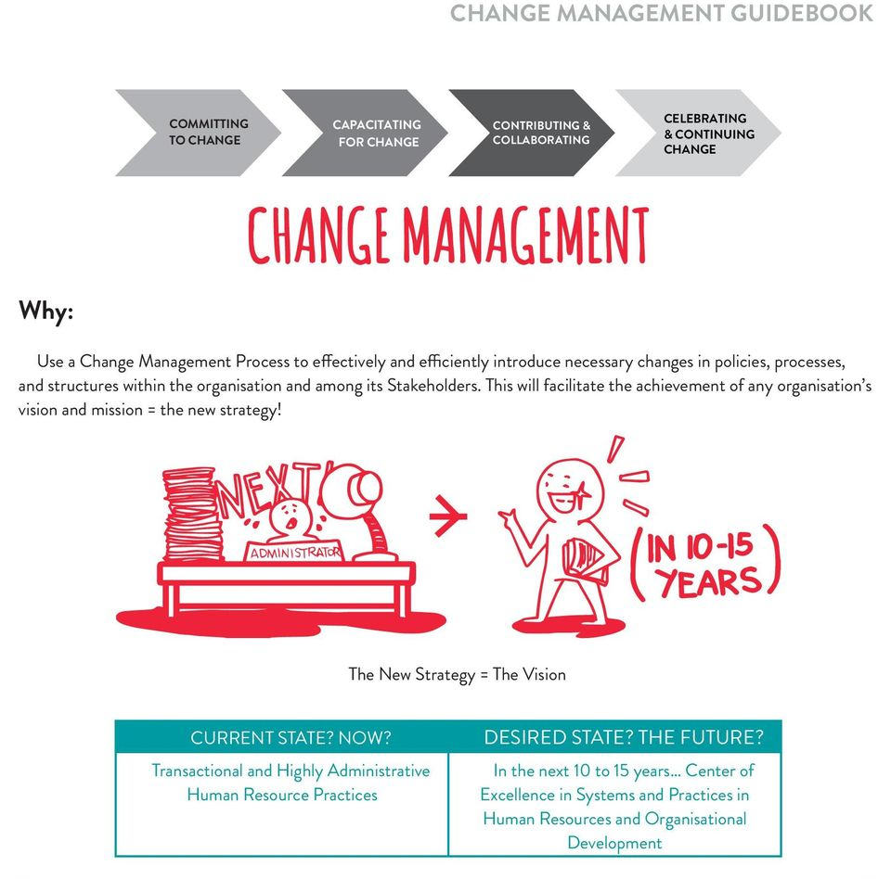

Source: docplaye.net

Wells Fargo Present (past five years 2016 – 2021):

Transformation is a continuous process in Wells Frago to become to be the maximum purchaser or the customer -focussed, innovative, efficient and revolutionary Wells Fargo ever. They are committed to transparency, repair the problems they find, and make matters solved. They are simple and much less complex, and have got made essential modifications to the risk management control. Their progress is actual and continuing (Learning from the past, transforming for the future, page 103, Business Standards Report issued Jan 30, 2019).

New organizational structure: Centralized traditionally decentralized running structure, delivered new leaders in key positions (many from out of doors the company) (Learning from the past, transforming for the future, page 103, Business Standards Report issued Jan 30, 2019).

Reduced threat: Enhanced threat control framework, laboured to enhance threat culture, decreased high-threat asset categories, divested non-middle businesses (Learning from the past, transforming for the future, page 103, Business Standards Report issued Jan 30, 2019).

Revised incentives: Eliminated product income desires for retail bankers in financial institution branches and name centres, created a brand-new repayment and overall performance control plan targeted on the purchaser revel in and crew overall performance, instituted more potent oversight and controls (Learning from the past, transforming for the future, page 103, Business Standards Report issued Jan 30, 2019).

Improved Customer experience: In the Community Bank, instituted Change for the Better to recognition on conversations geared toward supporting Wells Fargo higher recognize customers’ economic needs; emphasis on new systems, processes, and equipment so crew individuals can higher serve customers (Learning from the past, transforming for the future, page 103, Business Standards Report issued Jan 30, 2019).

Customer-targeted improvements. Introduced product and carrier improvements which includes actual-time stability alerts, Overdraft Rewind℠, economic training equipment, fee-saving features, a digital providing for the ones new to investing, a stepped forward on-line loan application (Learning from the past, transforming for the future, page 103, Business Standards Report issued Jan 30, 2019).

Team member retention: In 2018, decreased voluntary crew member attrition to its lowest degree in six years, multiplied minimal base pay withinside the U.S., granted constrained inventory rights to about 250,000 crew individuals. Annually make investments about $13,000 in line with U.S. crew member to offer low-cost fitness care alternatives and different benefits (Learning from the past, transforming for the future, page 103, Business Standards Report issued Jan 30, 2019).

Strengthened culture: Created and disseminated a simplified Vision, Values & Goals crew member booklet. In 2018, brought a clean set of behavioural expectancies for crew individuals, better duty via management goal this is a part of each crew member’s annual overall performance plan (Learning from the past, transforming for the future, page 103, Business Standards Report issued Jan 30, 2019).

Community support: Increased our dedication to philanthropy ($444 million in 2018, up from $286.five million in 2017), once more making Wells Fargo one of the pinnacle company givers withinside the U.S. persisted our ancient recognition on crew member giving and volunteerism (Learning from the past, transforming for the future, page 103, Business Standards Report issued Jan 30, 2019).

Financial overall performance: Generated stable economic effects and sturdy capital returns (Learning from the past, transforming for the future, page 103, Business Standards Report issued Jan 30, 2019).

Staffing retention strategies:

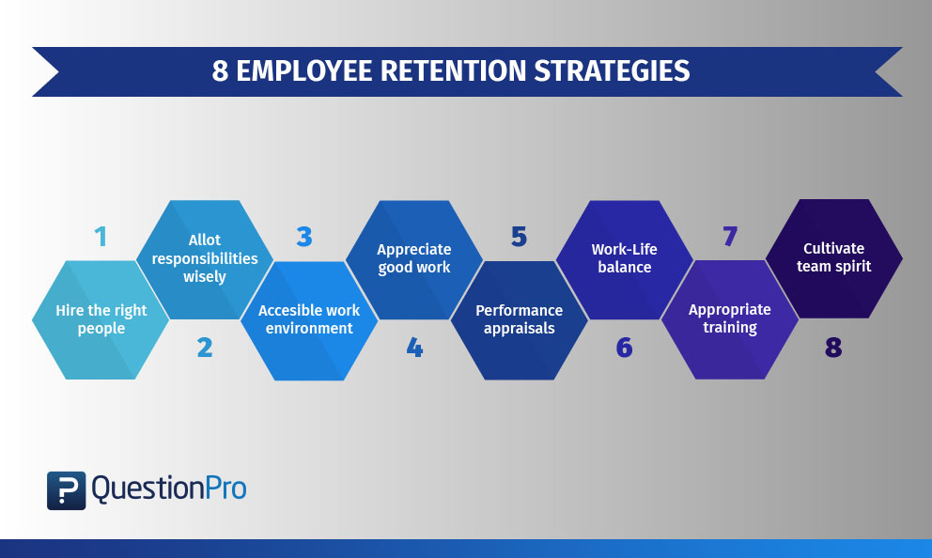
Ensure the proper human beings are employed:
Every organisation could need to lease the proper human beings to make certain it doesn’t take a toll at the budget of the employer. A lot of businesses have flair checks or pre-placement checks to recognize the quality of to-be-employed personnel. Some groups additionally behaviour persona checks to make certain no stone is left unturned in evaluating applicants (by questionspro).
Allot duties as in step with worker’s pastimes and specializations
A worker appears ahead to attending a day’s labour whilst the assigned responsibilities fit their interest. Designing milestones through incorporating worker pastimes and likings will move a protracted manner as it’ll be a motivational issue for personnel to return back to labour. They’ll recognize the efforts the organisation is installing to make certain the personnel are satisfied to be running with the employer (by questionspro).
Avoid hierarchical shape and create a handy labour environment
A lot of groups expect that high-strain can get the nice out of the personnel however sadly, that isn’t the truth. Around 80% of health practitioner visits take place because of pressure and 80% of injuries at labour additionally take place at high-strain jobs (by questionspro).
Appreciate exact work to inspire them to stay for longer
It’s referred to withinside the current instances that 69% of personnel say that they could labour more difficult if their work is appreciated and valued (by questionspro).
Performance value determinations and different perks are key to satisfied personnel
The personnel are continually keen to know whether or not they’re handing over in line with their manager’s expectations. For them to be confident in their work, the managers want to have normal performance evaluate meetings, steady training and remarks sessions (by questionspro).
Ease personnel’ work-existence balance
Due to the steady demanding situations that personnel face day in and day out, it appears not possible for them to now no longer think approximately work after leaving office. Most overworked and exhausted personnel talk approximately work-existence balance (as they don’t have it!) (by questionspro).
Come up with suitable schooling packages for worker growth
Hiring the proper applicants is simply work 1/2 of done, it’s what comes after hiring that matters. Training the personnel continuously in line with the brand-new traits withinside the employer is what is going to keep them from leaving (by questionspro).
Cultivate Team Spirit
Introduce the personnel to a subculture where they are able to percentage their mind approximately subjects under dialogue without hesitation. This will carry out exclusive work cultures to the desk and inspire them to be authentic to their work styles (by questionspro).

Wells Frago’s staffing and retention:

Well Fargo, below Sloan’s tremendously brief tenure, observed what proactive HR leaders and employment specialists have expressed all along, Employees​ are an organization’s maximum treasured assets.



Employers can draw from the mistakes of Wells Fargo and different places of work on the way to placed personnel first. This calls for making an investment in worker improvement for the lengthy term, paying them a first-rate wage, facilitating their engagement and demonstrating the best moral conduct in any respect ranges withinside the organization. Often, this calls for a stage of dedication from high-stage leaders to concentrate to personnel in any respect ranges and to be obvious approximately organization workings while possible.

To counteract low ranges of engagement, a few employers are turning to giving stated workers greater autonomy and specializing in enhancing the management features of centre managers (Contributor: By Valerie Bolden-Barrett, Published May 3, 2017)
Leadership strategies (Wells Fargo):
Engage in honest, open communication: There are many leadership styles, there’s no proper and wrong, but there’s genuine, and there’s fake. There’s no following to fake leadership (Skye Schooley, Staff writer, Business News Daily Staff, Updated Jun 29, 2022)
Connect together along with your group members: Leading a set of people calls for a mutual experience of believe and knowledge among the chief and their group members. To attain this, leaders need to discover ways to connect (Skye Schooley, Staff writer, Business News Daily Staff, Updated Jun 29, 2022).
Encourage private and expert increase: When leaders consider of their personnel and deliver them the possibility to examine and develop, they could be amazed how a whole lot they could accomplish. Don’t be afraid to delegate obligations and inspire freedom and creativity (Skye Schooley, Staff writer, Business News Daily Staff, Updated Jun 29, 2022).
Keep a superb attitude: Creates a greater engaged and efficient workforce. By showing enthusiasm and confidence, an awesome chief will see the effect that they could have of their running surroundings (Skye Schooley, Staff writer, Business News Daily Staff, Updated Jun 29, 2022).
Teach personnel in place of giving orders: Leaders need to inspire increase via way of means of coaching. People wouldn’t develop if leaders by no means taught them anything. Leaders want to be coaching if you want to develop new leaders to take their place (Skye Schooley, Staff writer, Business News Daily Staff, Updated Jun 29, 2022).
Set clean worker desires and expectations: Setting clean desires and worker expectations for your group is prime to worker success. When putting those objectives, inspire worker questions and remarks. Including them withinside the system can growth engagement (Skye Schooley, Staff writer, Business News Daily Staff, Updated Jun 29, 2022).
Give direct remarks approximately performance: Acknowledging successes via way of means of outlining the way it affects the business, instead of with indistinct pats at the back, isn't best encouraging however additionally facilitates someone work higher withinside the lengthy run (Skye Schooley, Staff writer, Business News Daily Staff, Updated Jun 29, 2022).
Ask for remarks in your leadership: Coaching permits leaders to make the relationship and apply in a real-existence. Time to integrate, system and reflect, and until you move through the ones steps won’t have sustainable alternate (Skye Schooley, Staff writer, Business News Daily Staff, Updated Jun 29, 2022).
Be open to new thoughts: Leaders have the emotional intelligence to recognize and take delivery of that alternate is inevitable. Instead of seeking to keep a standing quo only for the sake of consistency, include alternate and innovation. Be open to new thoughts and opportunity methods of thinking. Everyone brings a completely unique attitude to the table, and that is something to take gain of, now no longer discourage (Skye Schooley, Staff writer, Business News Daily Staff, Updated Jun 29, 2022).
Understand your personal motivation: If someone in a leadership role perspective their position as only a job, it’s going to be a show. To be a powerful chief, proper motivation is needed (Skye Schooley, Staff writer, Business News Daily Staff, Updated Jun 29, 2022).
- Discussions to support valuing and appreciating Team members and developing the sense of belonging to the organization strategies

Feeling valued at work place will increase extra than simply a worker’s process satisfaction. The effect of reputation and appreciation has a profound effect at the whole enterprise and brings withinside the experience of belonging to the organization.

Improves worker engagement: When leaders fail to recognize and respect their humans, personnel are 42% much less probably to be engaged.

Boosts productivity: There is an 18x boom withinside the chance of top notch whilst personnel are known at work.

Strengthens agency culture: Employee reputation has a remarkable effect at the six critical factors of a thriving organisational culture

Helps to hold personnel: Consistent appreciation and reputation can upload 3.5 years to an worker’s tenure.

Impacts backside line consequences: Organisations that exercise reputation efficaciously are 12x much more likely to have robust commercial enterprise consequences like will increase in shareholder return.

Below are the Strategies or techniques to make personnel experience favoured and valued.

1. See the good.

Valuing personnel withinside the administrative centre begins with an easy mind-set shift. And, even as it’s clean for plenty leaders to fall into the awful addiction of handiest correcting poor behaviours, the quality leaders actively search to look the high quality change their humans are making (O.C. Tanner Institute, 2021 Global Culture Report).

2. Seek worker input.

Employee appreciation comes whilst leaders in reality care what personnel assume. When you ask personnel for his or her thoughts you now no longer handiest gain perspective, insights, and probable solutions, however you furthermore might find out how that worker feels approximately their position (O.C. Tanner Institute, 2021 Global Culture Report).

3. Be specific.

Acts of appreciation at work must element what the worker did that made a difference. General, transactional appreciation isn’t significant or effective. Give actual reputation for each measurable criteria (consequences, metrics, top notch work) in addition to intangible behaviours (creativity, having a high-quality attitude, assisting out a group member, staying past due to complete an assignment, etc.).

4. Encourage attempt.

Employees experience valued whilst their efforts are recounted alongside the way. Sometimes it calls for a remarkable quantity of strength earlier than a aim is reached, so make certain to cheer personnel on. Encouraging attempt for the duration of a assignment allows extra well timed appreciation than ready till the end (O.C. Tanner Institute, 2021 Global Culture Report).

5. Reward consequences.

There are several approaches to reveal appreciation for each massive and small consequences—a honest thanks letter, a small gift, or an extra tremendous worker reward (O.C. Tanner Institute, 2021 Global Culture Report).

6. Celebrate careers.

This isn’t simply recognising their wide variety of years of service. Valuing personnel withinside the administrative centre method additionally valuing all the revel in, insight, and understanding they’ve won that enables them be their quality of their contemporary position and additionally enables your group (O.C. Tanner Institute, 2021 Global Culture Report).

7. Help personnel be visible and grow.

Show gratitude in the direction of your group participants through in reality turning into an suggest for his or her growth. Employee reputation can assist with visibility and profession improvement through permitting personnel to shine (O.C. Tanner Institute, 2021 Global Culture Report).

8. Show you Value them for who they are.

Employees aren’t simply crucial due to the consequences they achieve. They be counted due to who they are. Employee appreciation shows you feel your personnel for his or her unique, real selves. Peer-to-peer reputation can play a crucial position in constructing that experience of belonging at workplace (O.C. Tanner Institute, 2021 Global Culture Report).

9. Care about their entire employee experience.

Feeling worth work is ready extra than simply the work personnel do. It’s approximately enhancing the whole worker revel in: the worker’s work environment, work-existence balance, their interplay with others, and their revel in at workplace, each day (O.C. Tanner Institute, 2021 Global Culture Report).

10. Build connections.

Employees experience maximum favoured whilst you assist them experience connected to purpose, accomplishment, and one another. Communicate their actual position to your enterprise’s more purpose how they make a difference and contribute. And how they suit into their groups and the wider enterprise. When personnel connect with organisational purpose, top notch work, and their teammates, they experience a better experience of belonging at work. Successful corporations display personnel how their efforts play a component in something a whole lot larger than themselves, so that they experience extra valued through their leaders and through their enterprise (O.C. Tanner Institute, 2021 Global Culture Report).
- Principles, models and concepts of current Human Resource Management and International Human Resource Management theories

Concept:

The primary idea of the Human assets is, it's miles a method of using or hiring people, growing and the use of their abilities as assets, retaining and compensating their services, with the activity and the necessities if the company with an opinion to make a contribution to the company dreams, company’s vision, to the individuals & the society (Human aid library).

Principles:

The primary first precept is the Recruitment and selection this includes the method of choosing the proper talent to healthy in the company via way of means of thinking about the information and previous abilities of the applicants

Second precept is the Performance management, because of this that handling his overall performance to degree if the candidate is assembly the dreams and is suiting the given position and responsibilities (ICEHRM, sixteen June 2021).

This is an essential precept, Learning and development this allows the personnel to analyse greater to hold themselves influenced and retain withinside the company for a protracted period (ICEHRM, sixteen June 2021).

The fourth one is Succession planning which manner supplying the comments to the applicants on their overall performance to assist them obtain achievement on the set targets (ICEHRM, sixteen June 2021).

The 5th is Compensation and benefits to hold the personnel satisfied, those are the introduced benefits, that is the precept that contributes to it (ICEHRM, sixteen June 2021).

The 6th is Human resources information systems recording the desired facts into the facts structures to abide via way of means of company guidelines and regulations (ICEHRM, sixteen June 2021).

The ultimate one is HR data and analysis the facts assist to examine the employee’s behaviour closer to the company (ICEHRM, sixteen June 2021).

Model:

The Harvard HRM version is taken into consideration one of the maximum influential ‘gentle HRM’ methods because of its recognition on humans instead of effects. The Harvard HRM version seeks to offer a most suitable context for humans to do their great works.

The version itself dates returned to 1984 and springs from Managing Human Assets through Michael Beer, Richard E. Walton and Bert A. Spector. The Harvard HRM Model in Practice

Taking a study, the instance underneath, the Harvard HRM version shows its far HR’s obligation to don't forget all stakeholders while preparing coverage and making plans for a long-time period future.

Then, it proposes that HRM should make coverage alternatives through assessing stakeholder pursuits and situational factors. These alternatives bring about HR effects to be able to have long-time period results for personnel, the enterprise and society.

The version is in the end divided into 5 unique sections and consists of comments loops to reveal that each detail of the version influences or interplays with different factors.

The 5 vital factors of the Harvard HRM version consist of:

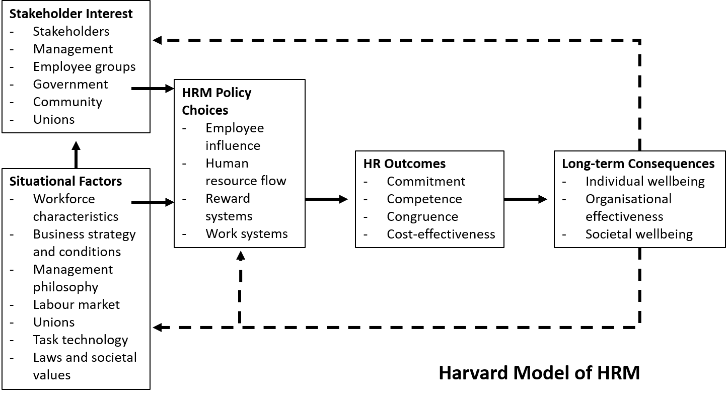

1. Stakeholder Interest

The version proposes that more than one stakeholder’s values, enter and views should be taken into consideration earlier than developing any rules. These stakeholders consist of control, worker groups, government, the network and even unions.

2. Situational Factors

Before making coverage alternatives, each inner and outside factors need to be taken into consideration as all of them have an impact on how people operate. The version shows searching at the subsequent situational factors: workforce characteristics, enterprise method and conditions, control philosophy, labour marketplace, unions, tasks, technology, regulation and societal values.

3. HRM Policies and Policy Choices

The diagram underneath indicates the manner HRM coverage regions interconnect:

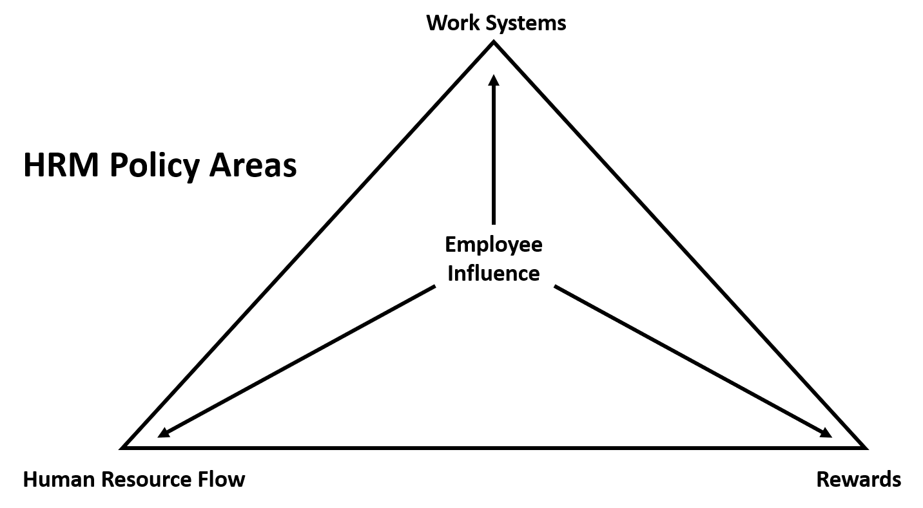

HR rules require each paintings structures and praise structures to function. In different words: HR coverage determines the method control will take to paintings, rewards, how HR features and the way personnel are influenced. Employees paintings efficiently while those factors locate stability.

4. HR Outcomes

One of the maximum thrilling and probably great-regarded components of the Harvard HRM Framework is the listing of HR effects (the 4Cs): Commitment, Congruence, Competence and Cost-effectiveness.

5. Long-Term Consequences

In essence, in case you use the Harvard HRM version to put together and execute HRM method, the perception is that there may be far-reaching, long-time period results. The version argues that if an HRM method meets personnel’ needs, this can assist the enterprise compete with the outside marketplace at the same time as reaping rewards society and the network.

IHRM concept covers ‘The idea of IHRM International HRM theory (with the aid of using Nankervis et al., 2012) emphasises or focusses at the demanding situations related to the transference or the interference of the techniques of Western control and their structures to non-Western and developing frameworks’

IHRM principles:

They are four primary precept which can be taken into consideration in worldwide Human aid management:

The first guideline is The Cultural factors consists of the beliefs, norms, ethical with the aid of using the people (written by Medallia, theintactone).

The subsequent precept is the Economic conditions consists of monetary differences (written by Medallia, theintactone).

The 0.33 one is the Labour fee factors consists of labours performance and their costs (excessive and low) (written by Medallia, theintactone).

The ultimate one is Labour members of the family factors consists of the relationships among the employees, employers and the government (written by Medallia, theintactone).

The Models of IHRM encompass procure, allocate and utilize.

Procurement offers with the recruitment and picks manner of the labours (written by Medallia, theintactone).

Allocate offers with the allocation or distribution of labour to exclusive department consistent with their ability they’re given with their roles and responsibilities (written by Medallia, theintactone).

Utilization delas with their ability to position into exercise to achieve the favoured goals (written by Medallia, theintactone).

Conclusion

Although Wells Fargo is one of the main gamers withinside the America’s monetary marketplace industry, it faces stiff opposition from exceptional companies along with Citigroup. Additionally, its modern HR practices are unsustainable and incapable of assisting the corporation’s enterprise model. Any try and enhance Wells Fargo’s HR schedule will make a large distinction and sooner or later make the corporation a hit. Wells Fargo must recruit capable HR specialists who've the ability empower the workers. By so doing, the leaders will make certain the fans are privy to the centered organizational objectives (Hunt, 2014). Consequently, the HR tactics will bring about overall performance functionality and sooner or later make Wells Fargo the maximum a hit employer withinside the industry. The corporation will use its new function to provide advanced offerings and monetary merchandise to the centered clients throughout the globe (study corgi, Nov 15th, 2020).

Recommendations

Attracting the right talent - Recruit new personnel who can aid the company’s business goals. Training the employees that allows you to aid the applied strategy.

Building effective organizational tradition - The leaders withinside the corporation must collaborate to expand a brand-new organizational tradition. The tradition will dictate the performance, behaviours, and attitudes of the employees

Establishing performance capability - Create brand-new surroundings wherein the personnel paintings optimally to maximise performance. Promote collaboration and teamwork withinside the organization (Walsh et al., 2010).

Transforming management Create a brand-new management able to riding performance. Ensure personnel are mentored and guided to supply advantageous results. Improve the character and degree of problem-solving. Deliver advantageous organizational results.

References
- ·Colby, S., & Ortman, J. (2015). Projections of the scale and composition of the U.S. population: 2014 to 2060. Web.
- ·Geisst, C. (2014). Encyclopedia of American enterprise history. New York, NY: Facts on File Incorporation.
- ·Hunt, T. (2014). Common experience skills control. Hoboken, NJ: John Wiley and Sons.
- ·Loshali, S., & Krishnan, V. (2013). Strategic human useful resource control and firm overall performance: Mediating position of transformational management. Journal of Strategic Human Resource Management, 2(1), 9-19.
- ·Nigam, A., Nongmaithem, S., Sharma, S., & Tripathi, N. (2011). The effect of strategic human useful resource control at the overall performance of corporations in India: A observe of carrier region corporations. Journal of Indian Business Research, 3(3), 148-167.
- ·Oxelheim, L., Randoy, T., & Stonehill, A. (2011). What can global finance add to global method? IFN Working Paper, 1(8), 1-28.
- ·Sluijs, E., & Kluytmans, F. (2012). Business method and human useful resource control: Setting the scene. Business Strategy and Human Resource Management, 1(1), 1-23.
- ·Walsh, K., Sturman, M., & Longstreet, J. (2010). Key troubles in strategic human resources. The Scholarly Commons, 1(1), 1-30.
- ·Wells Fargo. (2016). Our method. Web
- ·Bolea, A., & Atwater, L. (2016). Applied management development: Nine factors of management mastery. New York, NY: Routledge.
- ·Capozzi, R. (2018). The increase mindset: Leadership makes a distinction in wealth control. Hoboken, NJ: New Jersey Wiley.
- ·Izzo, J. B., & Vanderwielen, J. (2018). The reason revolution: How leaders create engagement and aggressive benefit in an age of social good. Oakland, CA: Berrett-Koehler Publishers.
- ·Johnson, D.W., & Johnson, F.P. (2013). Joining together: Group principle and organization skills (11th ed.). Upper Saddle River, NJ: Pearson.
- ·Kelly, B. (2015). The bit coin large bang: How opportunity currencies are approximately to alternate the world. Hoboken, NY: John Wiley & Sons.
- ·Klepper, W. M. (2019). The CEO’s boss: Tough love withinside the boardroom. New York, NY: New York Columbia University Press.
- ·Kunreuther, H., & Useem, M. (2018). Mastering catastrophic risk: How businesses are coping with disruption. New York, NY: Oxford University Press.
- ·Malcher, M. (2016). User organization management. Apress, New York, NY: Springer.
- ·Pottruck, D. S. (2015). Stacking the deck: How to steer step forward alternate towards any odds. San Francisco, CA: Jossey-Bass.
- ·Puzzanghera, J. (2019). Wells Fargo reaches $240-million agreement in accounts-scandal lawsuits. Los Angeles Times. Web.
- ·Stachowicz-Stanusch, A., & Amann, W. (Eds.). (2018). Management schooling for company social overall performance. Charlotte, NC: Information Age Publishing, Inc.
- ·Wilson, R. M. (2014). Stagecoach robberies in California: A entire record, 1856/1913. Jefferson, NC: McFarland & Company, Inc., Publishers.

