10/30/2025
Module Title: PRINCIPLES OF HEALTH AND SOCIAL CARE PRACTICE
Module Code: (BMHP5016)
Component 2: Written Assignment (Report)
Lecturer: Farah ISLAM
Student Name: Mohamad Sediq Ehssan
Student Number: 2017880

Word Count: 2146
UNIVERSITY OF WALES TRINITY SAINT DAVID – BIRMINGHAM

Table of Contents
Person-Centred Care and Partnership Working in a Care Home for Older Adults 2
Introduction 2
Definition and Benefits of Person-Centred Care 3
Person-Centred Care through Bronfenbrenner’s Ecological Systems Theory 4
Partnership Working in Health and Social Care 5
Partnership Working in a Care Home for Older Adults 7
Theoretical Model Underpinning PCC 8
Ethical Fundamentals of Health and Social Care 9
Policy and Legislation 11
Recommendations for Future Development 12
Conclusion 13
References 14

Person-Centred Care and Partnership Working in a Care Home for Older Adults

Introduction

This report evaluates the concepts of (PCC) Person-Centred Care and (PW) Partnership Working in a care home for older adults. It explains what PCC means, its benefits and limitations, and the theories that support it. It also discusses the main ethical principles in health and social care, such as autonomy and justice. The report evaluates how partnership working helps to improve care and discusses some of the barriers that can occur. It examines key policies and laws such as the Care Act (2014), Health and Care Act (2022), and the Human Rights Act (1998). Finally, the report provides recommendations on how PCC and PW can be improved in care homes through better staff training, stronger communication, and improved leadership.
In the health and social care, it is important to focus on the needs and wishes of the person receiving care. Person-Centred Care (PCC) means putting individuals at the centre of all decisions and treating them with dignity and respect. Partnership Working (PW) means that professionals, families, and service users work together to deliver care that meets people’s needs.
The aim of this report is to explore and evaluate both PCC and PW, focusing on their role in a care home for adults. Older people living in the care homes often need long-term support with personal care, medication, and daily activities. Therefore, it is essential that their care is individualised and based on collaboration between staff, families, and health professionals. The report defines PCC, discusses theories, ethics, partnership approaches, legislation, and ends with recommendations for future practice.

Definition and Benefits of Person-Centred Care

Person-centred care (PCC) means putting the person at the heart of their care. People feel respected and listened, Care is more tailored and effective. Building trust between staff and service users.
Person-Centred Care is an approach where care and support are built around what matters most to the person (Health Foundation, 2016). It means understanding people as individuals, listening to their wishes, and embrace them in decision making about their health care.
In a care home, PCC might include asking residents when they would like to wake up or what meals they prefer, instead of following a fixed routine. It focuses on choice, respect, and dignity (NHS England, 2021).
Benefits:
Improved well-being: When residents feel listened to, they are happier and more comfortable.
Better relationships: PCC encourages open communication between staff and residents, which builds trust (Brooker and Latham, 2015).
Higher quality of care: When care is based on individual needs, mistakes are reduced, and satisfaction improves (CQC, 2021).
Encourages independence: Residents are supported to make their own choices and maintain daily routines.
Limitations:
Staffing shortages: Many care homes are understaffed, so it can be hard to spend time with each resident (Skills for Care, 2022).
Lack of training: Not all carers are trained in communication or dementia care.
Resistance to change: Some staff prefer traditional, task-based care.
Cognitive impairment: Residents with dementia may struggle to express their wishes, making it harder to deliver PCC.
These limitations show that PCC requires commitment, teamwork, and good leadership to succeed in practice.

Person-Centred Care through Bronfenbrenner’s Ecological Systems Theory

Person-Centred Care is an approach where the individual is placed at the heart of all decisions, relationships, and care processes. The ecological model helps us understand how multiple layers of environment influence a person’s health, well-being, and care experience (Bronfenbrenner, 1979).
Individual (Center of the Model), Microsystem (Immediate Relationships), Mesosystem (Connections Between Microsystems), Exosystem (Indirect Influences), Macrosystem (Societal Values and Policies),
(Islam, 2025)
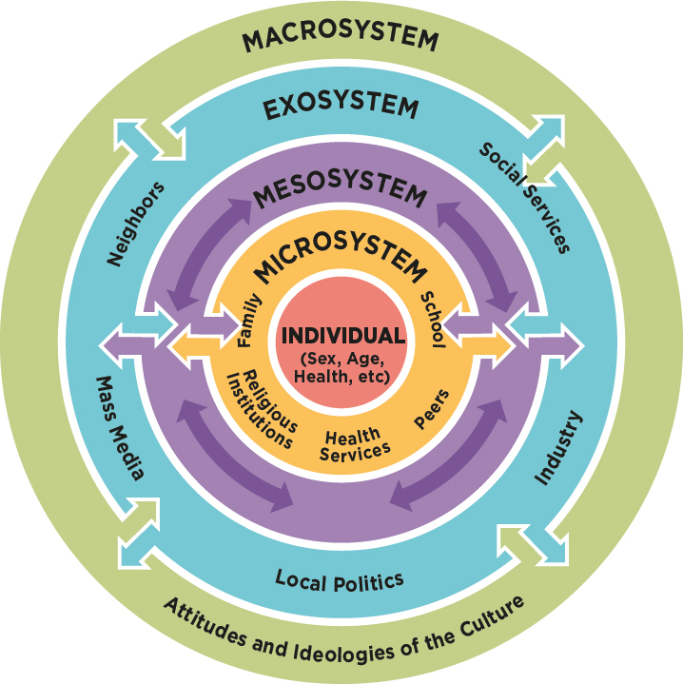

Partnership Working in Health and Social Care

Partnership working involves different people and many services working jointly to support someone. This might include doctors, nurses, social workers, and family members.
Partnership Working means different professionals and organisations cooperating to achieve the best outcomes for service users (Glasby and Dickinson, 2014). In a care home, PW includes teamwork between carers, nurses, GPs, social workers, families, and local authorities.
Benefits:
Everyone shares information and works toward the same goal.
It helps avoid mistakes or repeated work.
The person gets more complete and joined-up care.
Better coordination: Working together avoids duplication of tasks and ensures everyone knows the care plan.
Holistic care: Health and social needs are addressed together, leading to better outcomes (Leathard, 2003).
Shared expertise: Staff learn from each other and make more informed decisions.
Empowerment: Residents and families feel more involved in the care process.
Challenges:
Poor communication can cause confusion.
Different teams may have different priorities.
Power imbalances can affect decisions.
Poor communication: Misunderstandings can occur between agencies.
Different priorities: Health and social care professionals may have different goals.
Lack of time: Coordinating meetings and information sharing can be difficult.
Confidentiality concerns: Sharing sensitive information must follow legal frameworks.
Even with challenges, partnership working is vital in ensuring continuity of care and improving residents’ experiences. Regular meetings and clear communication policies can reduce most of these problems.
Partnership Working in a Setting, (Islam, 2025)
GPs and district nurses make regular visits to check on care home residents with long-term conditions and update their care plans.
Families meet with staff to review care plans and share helpful details about the residents’ preferences.
Physiotherapists support rehabilitation of home residents recovering from surgery.
Social workers work with staff to review a resident’s financial situation and funding options.
A partnered pharmacy supplies medication and carries out routine medicine reviews.
Staff receive dementia training from the Alzheimer’s Society to strengthen their support for residents.
A CMHT nurse visits each month to help residents with mental health needs.
A hospice team assists with end-of-life care and emotional support for residents and families.
Hospital discharge teams coordinate with the home to ensure residents return safely after a hospital stay.

Partnership Working in a Care Home for Older Adults

In the care homes, partnership working is seen every day. For example, staff work with GPs to review medication, district nurses for wound care, and social workers for safeguarding concerns. Families are also key partners in planning and reviewing care.
A good example of partnership in action is the Integrated Care Systems (ICSs) created by the Health and Care Act (2022). These systems encourage hospitals, GPs, local councils, and care homes to plan services together. This helps residents get the right support at the right time and reduces unnecessary hospital admissions.
Another example is end of life care, where care home staff, doctors, and families collaborate to make sure the person’s wishes are respected. Regular communication and shared documentation ensure everyone understands the agreed plan.
Effective partnership working in care homes leads to safer, more coordinated, and compassionate care. However, it requires good leadership and an open culture where every partner’s voice is valued.
Example of Partnership Working: Cancer Care Teams
In cancer care, doctors, nurses, social workers, and others meet regularly to plan treatment. They:
Share updates and ideas.
Involve the patient in decisions.
Make sure care is smooth and well organised.
This teamwork helps the person feel supported and improves their experience.

Theoretical Model Underpinning PCC

The theory that strongly supports PCC is Carl Rogers’ Humanistic Theory of Care (Rogers, 1959). Rogers believed that every person has the ability to grow and make choices if they are treated with empathy and respect. His main ideas, empathy, genuineness, and unconditional positive regard, fit closely with the principles of PCC.
Empathy: understanding how someone feels.
Respect: accepting people as they are.
Honesty: being real and open.
This theory supports PCC because it encourages care workers to build strong, trusting relationships and focus on the whole person, not just their illness.
In a care home, this means carers should listen to residents’ feelings, show understanding, and treat them as equals. For example, when an older adult feels anxious about moving into a care home, staff should respond with patience and compassion, helping them adjust at their own pace.
Another model linked to PCC is Tom Kitwood’s Model of Personhood in dementia care (Kitwood, 1997). Kitwood argued that people with dementia are still individuals with emotions, memories, and preferences. His model focuses on maintaining personhood through respect, trust, and meaningful relationships.
In practice, staff may use life-story work, where residents share their experiences and interests. This helps carers understand personal values and design activities that are meaningful to each resident. These theories show that PCC is not only about physical care but also about emotional connection and dignity.

Ethical Fundamentals of Health and Social Care

Ethics are rules about what is right and fair. In care, the main ethical ideas are:
Respecting choices, letting people decide for themselves.
Doing good, helping people improve their health and wellbeing.
Avoiding harm, not causing pain or distress.
Fairness, treating everyone equally.
These guide how care workers act and make decisions every day.
((NHS,2012); Islam, F. (2025)
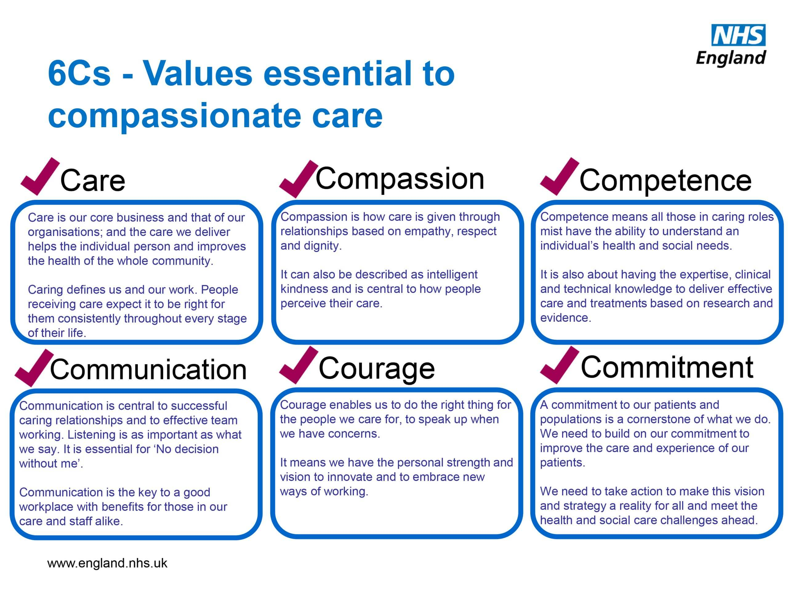

Ethics guide professionals to make fair and responsible decisions. Four main ethical principles are often used in health and social care (Beauchamp and Childress, 2013):
Autonomy: Respecting the person’s right to make their own decisions.
Beneficence: Acting in the person’s best interests.
Non-maleficence: Avoiding harm.
Justice: Treating everyone fairly and equally.
In a care home, these ethics appear in many daily situations. For instance, if a resident refuses medication, carers must respect their autonomy but also think about beneficence and safety. The Mental Capacity Act (2005) supports this by ensuring people are helped to make decisions whenever possible.
Another ethical issue involves confidentiality. When working in partnerships, staff must share only relevant information with others involved in the residents’ care home, following data protection rules (NHS Digital, 2022). Maintaining ethical standards protects residents’ rights and builds trust between professionals and families.

Policy and Legislation

Policies and laws set the standards for PCC and PW in the UK; These rules help make sure PCC and partnership working are part of everyday care.
Care Act (2014): Focuses on individual well-being and personal choice. It requires care providers to involve people in decisions about their support.
Health and Social Care Act (2012): Encourages integration between NHS and social care services.
Health and Care Act (2022): Establishes Integrated Care Systems that promote partnership working across sectors (DHSC, 2022).
Human Rights Act (1998): Protects people’s right to dignity, privacy, and respect, core values of PCC.
Equality Act (2010): Ensures fairness and prohibits discrimination in care.
Mental Capacity Act (2005): Protects people who lack capacity and promotes decision-making support.
Health and Social Care Act 2008 requires care to be safe and person-centred.
NHS Long Term Plan, aims to give people more control and improve teamwork between services.
These policies work together to create a framework for delivering respectful, safe, and inclusive care. In a care home, they ensure that residents are treated as individuals, supported by making choices, and protected from harm.
However, applying these policies can be challenging due to funding shortages and heavy workloads (Glasby, 2017). Care homes need ongoing training and strong management to meet legal and ethical standards.

Recommendations for Future Development

Based on this evaluation, several recommendations can help improve PCC and PW in care homes:
Staff Training: Regular workshops should focus on communication, empathy, and dementia awareness to help staff provide better person-centred support.
Digital Record Systems: Using shared electronic care plans can improve communication between NHS teams and care homes.
Resident and Family Involvement: Families should be invited to take part in care reviews to make decisions together.
Leadership Development: Managers should promote a culture that values teamwork, respect, and openness.
Policy Support: Local councils and Integrated Care Boards should provide more funding and resources for staff development.
Ongoing Research: More studies are needed to measure how PCC and PW improve residents’ quality of life and reduce hospital admissions.
Implementing these recommendations could make care homes more person-focused and better connected with health services. Barriers such as staff shortages and financial pressures must be addressed at national and local levels for these improvements to succeed.

Conclusion

This report has explored (PCC) Person-Centred Care and (PW) Partnership Working within the setting of the care home for older adults. PCC focuses on the individual’s needs, dignity, and autonomy, while PW ensures professionals and families work together to provide coordinated and holistic support.
Both approaches are essential to high-quality health and social care. Theories such as Carl Rogers’ Humanistic Model and Kitwood’s Model of Personhood show that good care depends on empathy, respect, and meaningful relationships. Ethical principles guide staff to act fairly and protect residents’ rights.
Partnership working, supported by policies like the Care Act (2014) and Health and Care Act (2022), is key to improving the coordination of services. However, challenges such as limited resources and communication gaps remain.
Future success will depend on continuous staff training, better communication systems, and leadership that promotes collaboration and respect. By strengthening PCC and PW, care homes can offer safer, kinder, and more effective care for older adults in the UK.

References

- Islam, F. (2025) Principles of Health and Social Care Practice: BMPH 5016. UWTSD Module. University of Wales Trinity Saint David.
- Beauchamp, T.L. and Childress, J.F. (2013) Principles of Biomedical Ethics. 7th ed. Oxford: Oxford University Press.
- Bronfenbrenner, U. (1979) The ecology of human development: Experiments by nature and design. Cambridge, MA: Harvard University Press.
- Brooker, D. (2017) Person-Centred Dementia Care: Making Services Better. 2nd ed. London: Jessica Kingsley Publishers.
- Brooker, D. and Latham, I. (2015) Person-Centred Dementia Care. London: Jessica Kingsley Publishers.
- Carnwell, R. and Carson, A. (2011) Effective Practice in Health and Social Care. 2nd ed. Oxford: Oxford University Press.
- Care Quality Commission (CQC) (2021) What We Do. [Online] Available at: https://www.cqc.org.uk/ [Accessed 10 November 2025].
- Department of Health and Social Care (DHSC) (2017) People at the Heart of Care. London: DHSC.
- Department of Health and Social Care (DHSC) (2022) Health and Care Act 2022: Overview. London: DHSC.
- Equality Act (2010). London: The Stationery Office.
- Glasby, J. (2017) Understanding Health and Social Care. 3rd ed. Bristol: Policy Press.
- Glasby, J. and Dickinson, H. (2014) Partnership Working in Health and Social Care. 2nd ed. Bristol: Policy Press.
- Health Foundation (2016) Person-Centred Care Made Simple. London: The Health Foundation.
- Human Rights Act (1998). London: The Stationery Office.
- Kitwood, T. (1997) Dementia Reconsidered: The Person Comes First. Buckingham: Open University Press.
- Leathard, A. (2003) Interprofessional Collaboration: From Policy to Practice in Health and Social Care. London: Routledge.
- Mental Capacity Act (2005). London: The Stationery Office.
- NHS (2020) The NHS Long Term Plan. London: NHS England.
- NHS Digital (2022) Information Governance. [Online] Available at: https://digital.nhs.uk/ [Accessed 10 November 2025].
- NHS England (2021) What is Person-Centred Care? [Online] Available at: https://www.england.nhs.uk/ [Accessed 10 November 2025].
- Skills for Care (2022) The State of the Adult Social Care Sector and Workforce in England. Leeds: Skills for Care.

