BMMB7013D STRATEGIC MANAGEMENT – ASSIGNMENT

Report on Charles Morgan Law Ltd – Legal Sector

BY AURANG ZEB SADDIQ – 1906993
MBA PART TIME
16 DECEMBER 2022
Table of Contents
1. Executive Summary 3
2. Introduction 4
3. Analysis and Review of the Organisation 4
4. Stakeholders Analysis 9
5. Developing the Strategy…….. 11
5.1 Swot Analysis ……………….……………………………..…………………………………………………………………………………….11
5.2 Porter 5 Forces ………….….…………….……………………..……………………………………………………………………………..12
5.3 Porter Generic strategies……………..……………………………………………………………………………………………..…….14
5.4 Sustainable Competitive Advantage……………..……………………………………………………………………………..…….14
6. Conclusion……………………………………….……………………………………………………………..……………………………………16
7. Recommendation……………………….……………………………………………………………………….……………………………….17
8. Biblography……………………………..………………………..…………………………………………………………………………………18

- EXECUTIVE SUMMARY
In March 2020, Charles Morgan Law was severely affected by the Covid-19 pandemic, as result of the UK wide lockdowns. In December 2022 there was a need to review and formulate a strategy focussed on customer care, competitive advantage and future resilience of the organisation post- pandemic. This report considers the strategy process and a review of the organisation with a focus on customer care.

The organisation outlined its mission statement and objectives. It conducted an analysis of it resources and identified that they were the brand and reputation. The employees were also considered to be a resource.

The stakeholders were identified and mapped on a Stakeholder grid and the two main categories to consult with were identified. The organisation conducted a swot analysis to consider the aspects of the business to identify strengths and weaknesses. Following this an analysis was conducted using the Porter 5 Forces to identify the forces where competitive advantage could be ascertained.

Using Porters Generic Strategies, the organisation considered the best strategy to adopt in relation to the business. The recommended strategy was to reduce the areas of practice and focus on the well performing areas and to follow a differentiation strategy of the organisation’s products

The recommendation outcome was to agree upon a strategy to improve competitive advantage by investing and improving the technology systems at the Organisation.
The proposed strategy at business level would be:
  - Invest in new technology throughout the organisation
  - Integrate the case management systems with the email and diary systems
  - Provide training to the employees
At corporate level, the steps would be:
  - Refine the areas of practice
  - Determine if there are sufficient employees with the required knowledge
  - If necessary, hire more employees with the requisite knowledge
  - Formulate and implement a marketing strategy
It should commence this strategy incrementally in Nottingham and the Midlands initially, to see if this can be successfully implemented and rolled out across the organisation without loss of productivity and ideally to increase profits. The organisation needs to ascertain what is the optimum environment to improve services and client care whilst adding competitive advantage and value.

- INTRODUCTION
Charles Morgan Law Ltd (trading as Charles Morgan lawyers) is a private limited company incorporated in England and Wales and is not listed on the London Stock exchange. In this report the company shall be referred to as the Organisation.
The Organisation operates as a law firm providing legal services to the general public. The Directors/ owners and principal managers are Barristers. There are shareholders of the company. As the company provides legal activities reserved to lawyers it is regulated by the Bar Standards Board (A front line regulator for legal services).

The company’s principal activities are to provide legal services in the areas of Civil litigation, Immigration, Commercial landlord & tenant along with other legal services to clients in England & Wales. In December 2022, the operations consisted of three offices located in London, Birmingham, Nottingham. The brand of the organisation consists of Charles Morgan lawyers which also incorporates Invictus Lawyers, Nottingham. In Nottingham, the organisation has been trading since February 2007 and is well established under the Invictus name.
The Organisation consisted of Barristers, Solicitors, Paralegals along with administration staff located at the 3 offices. The staff are office based albeit operating on a hybrid work consisting of a mixture of remote working and office working.
This report will examine the Organisation’s strategic purpose and direction post Covid-19 focusing on how to improve customer care, competitive advantage and provide future resilience using strategic theory and models.

3. Analysis and review of the Organisation
In order to develop a strategy for the organisation, it will be necessary to ensure that the organisation’s purpose is clear. Purpose is often simplified to ‘profit maximisation’ by writers such as Michael Porter or ‘survival’ by Oliver Williamson.

Purpose is fundamental to the strategy of the organisation and needs to be sufficiently narrow to be achievable and broad enough to allow scope for development. It will develop from a consideration of the organisation’s customers and its competitive resources. The organisation does not have a single purpose. It would be expected for it to have purpose for to increase profits and grow as an organisation. Generally, an organisation could have several purposes and a simplified definition of purpose is desired in order to focus on specific objectives and communicate those within.

3.1 Mission Statement and Objectives

The Mission
Provide outstanding legal services that deliver the best possible client outcomes.

The Vision
- To be the go-to firm for clients
- To be a great place to work
- To be a successful firm
- To have an outstanding reputation
- To be the premier law firm in the Midlands
- Trusted advisors: we are more than just lawyers – our clients come to us because we are people, they can talk to about what matters to them; we are ethical; we focus on our chosen markets to achieve excellent brand awareness; we are outward-looking.
- A great place to work: we reward our people competitively; we inspire, lead and manage our people so they value and enjoy their work; we are committed to their continuing professional development and continuous improvement of our systems and our technology.
- A profitable firm: we make a fair profit that secures the sustainability and viability of the firm; we meet our business objectives; we are here for the long term.
- Outstanding reputation: we recruit high calibre people; clients and other professionals recommend and champion us; legal directories and other market influencers praise us.

The Values
The values illustrate what the clients can expect from the Organisation
- Specialist
- Intuitive
- Trustworthy
- Personable
Some examples of what this means in reality
- Specialist: we are experts in our field; we know our clients’ needs; we are innovative in the solutions.
- Intuitive: we understand our clients and are able to tailor to their needs.
- Trustworthy: we are honest, reliable and understand our clients’ aims, objectives and goals.
- Personable: we are passionate about our clients and protecting their interests; we treat people fairly.

Organisation Objectives
- Identify the areas where the organisation must perform as a whole in order to achieve its strategic and economic objectives.
- Manage and develop performance in the organisation’s practice areas.
- Invest in technology, training, and employee knowledge to improve client care and service standards
- Encourage a culture with high employee engagement and high priority on client care.

The objectives and strategy need to encompass the key factors for success in the industry. The areas that need to be considered are the resources of organisation and the competitive environment in which the organisation operates.

  - The Organisation’s Resources and capabilities
The resources of an organisation are those assets that deliver value added in the organisation. The capabilities of an organisation are the skills that generate value from the resources of the organisation. The organisation needs to identify where value is added and to explore and enhance the competitive advantages of its resources.

There are tangible and intangible resources. The tangible resources are the physical resources. These have been identified to be the offices (or locations thereof), the technology and equipment. One could argue that the employees are also a tangible resource.

The intangible resources are those that do not have a physical presence such as branding, reputation. For the organisation, it has a recognised brand in Nottingham and has established a good reputation over 15 years of operation. These would be significant resources.

In order to create value and competitive advantage, the organisation must also be able to deploy and share these resources, and to co-ordinate the activities effectively across the organisation.

3.3 Knowledge of the Organisation as a resource
Organisational knowledge can be a basis of competitive advantage. This is organisation-specific, collective intelligence, accumulated through formal systems and people’s shared experience.

It could achieve competitive advantage in the method of managing and developing organisational knowledge. It is likely to be about how they draw on and develop the accumulated and dispersed experience-based knowledge in the organisation.

There are different types of knowledge, explicit and tacit. Explicit or ‘objective’ knowledge is transmitted in formal systematic ways. It can take the form of a codified information resource such as a systems manual or files of market research and intelligence. Tacit knowledge is more personal, context-specific and therefore hard to formalise and communicate.

There is a distinction between explicit and tacit organisational knowledge (made by Ikijuro Nonaka and Hiro Takeuchi) and this helps to explain why it is important in terms of achieving competitive advantage.

For this organisation, it could be the knowledge of highly experienced lawyers or management team that are distinctive, but likely to be difficult to imitate or obtain. For example, there are commercial property lawyers with over 15 years of experience that would be hard to replace or recruit as very few law firms are practising in commercial property in Nottingham. The knowledge and experience would be unique to the lawyers, and it would not be very easy for rival firms to compete in commercial property.

3.4 Value of the Organisation
The primary activities of an organisation are:

• Inbound logistics - receiving the goods from suppliers, handling and transporting them within the company.

• Operations. This is the production area of the company. (e,g, room service, restaurant, in a hotel)

• Outbound logistics. These distribute the final product to the customer. (For a service company, the means of bringing customers to the service)

• Marketing and sales - brings to the attention of customers the products or services the company has for sale.

• Service - Before or after a product or service has been sold.

According to Michael Porter, these activities will add value to the organisation. These can be assessed for its contribution to sustainable competitive advantage

3.5 ENVIRONMENTAL ANALYSIS
The organisation should start with some basic factors that can divide the into three areas:

1 Market definition and size;
2 Market growth;
3 Market share.

Market definition and size – ‘What is the size of the market?’ It would be fair to say that the market share is not large compared to the very large law firms that have offices in most cities

Market growth - In establishing the size of the market, it is also common practice to estimate how much the market has grown over the previous period. Post Covid-19 the market has not grown but remained fairly stagnant

Market share - There are problems here defining market share as it depends on the perspective. The organisation may have a large share of the commercial property market as there are less firms offering this service

Whilst such an environmental analysis can be useful in defining strategy, it is difficult to provide figures other than best estimates. The overall strategy has to consider other factors discussed below.

3.6 Methods to improve customer/client care

According to Mckinsey and Company in the report “the Care of One – Hyper Personalization of Customer Care” (2020) it states that to improve and deliver hyperpersonalised customer care:
“….companies will need to elevate their game with new strategies, technologies, and processes that tailor the care experience to each customer’s needs and journey..”.

Hyperpersonalization of customer care consists of four elements:

  - Knowing your customers—Companies that can aggregate all customer information will be able to engage much more effectively.

  - Reacting to customers before they even know they need you. Data and analytics can enable contact centre agents to predictively identify opportunities to delight, pre-emptively solve issues based on personalized needs

  - Integrating technologies and contacts across all channels. A seamless customer experience throughout the journey requires better alignment and collaboration of customer care, product development, marketing, and operations.

  - Implementing real-time agent tools. Companies that incorporate added functionality and eliminate cumbersome platforms can reduce barriers to addressing customer needs and resolving problems.

Whilst these concepts are targeted towards the retail sectors and organisations that perhaps sell products, there is no reason why the ideas could not be applied to the legal sector and law firms.

The technology could be implemented for getting to know clients, integrating across all channels for clients to be provided real time information. This process can be incorporated within the case management systems to provide client contact and real time updates. Predicting a client’s needs would be more difficult as legal services are provided and it is not a predictive science.

4. Stakeholders and SWOT Analysis

a) Stakeholder Map

The Stakeholder analysis can be seen in the table below:

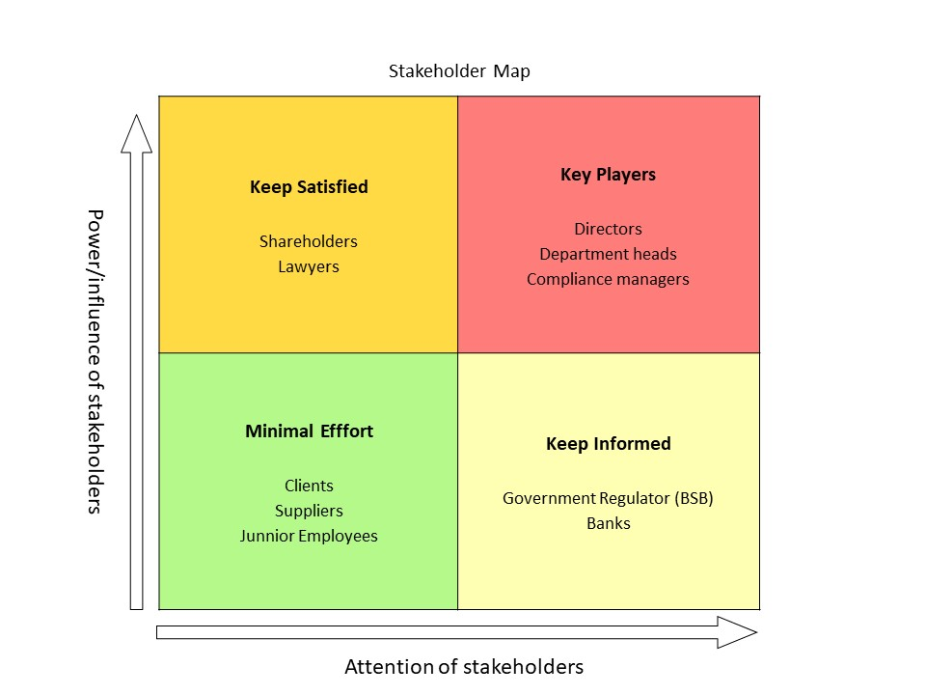

b) Analysis of the Stakeholder Map

The Stakeholders of an organisation are any individuals or groups having a vested interest in the organisation’s functioning and objectives. (Cummings & Worley, 2015:791). It is necessary to identify the stakeholders who have an interest in the organisation and, therefore, may wish to influence aspects of its mission, objectives and strategies.

Stakeholder power is their ability to influence, and interest is their willingness to influence the organisation. There can be internal (Directors, managers, and employees) and external stakeholders (clients, suppliers, bank manager). The organisation is not a large organisation so there is not a huge number of stakeholders. The main stakeholders are marked on the power/interest grid (map) above.
The purpose of analysing and applying stakeholder power is to identify the influence of stakeholder power on the direction of the organisation. Those with the most power therefore need to be considered most carefully. A stakeholder power study needs to be undertaken as defined by INSERT. There are six major steps:

  - Identify the major stakeholders.
  - Establish their interests and claims on the organisation.
  - Determine the degree of power that each group holds through its ability to force or influence change as new strategies are developed.
  - Development of mission, objectives and strategy possibly prioritised to minimise power clashes.
  - Consider how to divert trouble before it starts, possibly by negotiating with key groups.
  - Identify the sanctions available and, if necessary, apply them to ensure that the purpose is formulated and any compromise reached.

The stakeholders with the highest power and highest level of attention are the "Key players” who are the key players and the most focus is on this group. They are the Directors, Head of Legal, Head of Finance along with the compliance mangers. This group will be involved in governance and decision making.

The Stakeholders at the top left of the grid are high power/low attention and are in the “Keep Satisfied” category. The organisation would engage and consult on any proposed strategy. These have been identified as the company shareholders, qualified lawyers (such as solicitors/Barristers) who are in charge of a specific field. For example, the solicitor responsible for Civil litigation.

For the “Keep Informed” stakeholders, the organisation will keep informed and consult where necessary. These stakeholders are the bank manager and the organisation’s government regulator, The Bar Standards Board as they would be interested in the changes but have little say within.

The “Minimal Effort” stakeholders require minimum effort, and these just need to kept informed through general communications. These would be the junior employees such as admin/secretarial staff, clients and suppliers of the organisation.

The groups that the Organisation should be concerned with are the Key Players and the keep Satisfied stakeholders that wield the most power. They should be consulted with to ensure that there is no resistance or conflict with any proposed strategy

5. DEVELOPING THE STRATEGY

5.1 SWOT Analysis
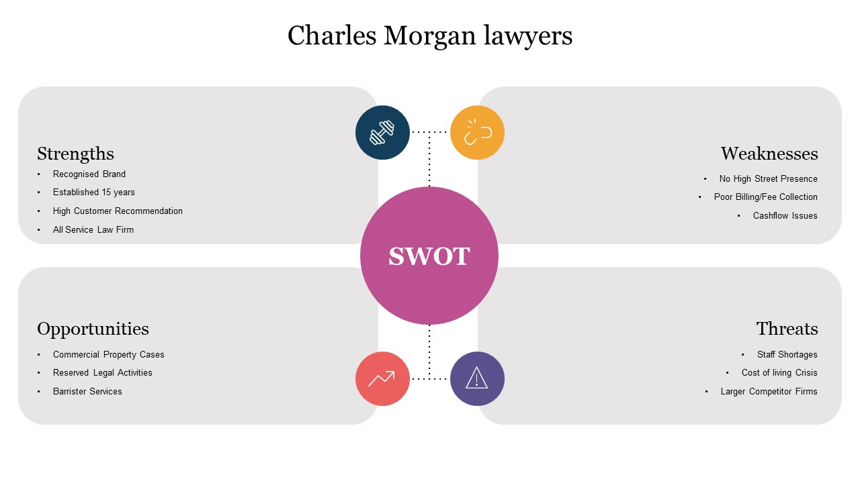
Strengths
There are a number of strengths that the organisation can rely and build upon. The organisation has a good reputation and is well recognised in Nottingham (as Invictus Lawyers). It has been operating for over 15 years (established in February 2007). Client satisfaction is high, and recommendations are a good source of new clients and cases.
Weaknesses
A major weakness is that there has historically been poor billing/invoicing (prior to Covid-19) which resulted in weaker cash flow. This is being rectified by better management oversight and the introduction of a case management system that allows better automation of accounting practices. Cashflow should become better.
Another weakness is the lack of a High Street presence as the offices are based in Business centres and there is no option for advertising outside, such as, a billboard with the company name. To overcome this, it will be necessary to incorporate a marketing strategy in the overall strategy.
Opportunities
There are several opportunities to take advantage of. The organisation could focus on those areas that other firms do not provide well (or at all). It should enhance the practice in the areas of Commercial Property as less firms undertake this area. Focus should also be placed upon providing more Barrister services and other activities reserved to practising lawyers.

Threats
The biggest threat that has emerged is the cost-of-living crisis. Higher bills and increased mortgage payments mean that less clients are going to want to pay for costly lawyers or they may wish to hold back until the situation becomes better. In both cases, this could affect the organisation.
Another threat from the pandemic is that it has resulted in staff shortages which will affect the organisation’s ability to provide services and ultimately customer care.

5.2 CONSIDERING THE COMPETITIVE ENVIRONMENT
In order to formulate a strategy an analysis has to be undertaken of the forces influencing the organisation. This analysis is often undertaken by utilising the Porter’s Five Forces Model (Michael Porter 1981).

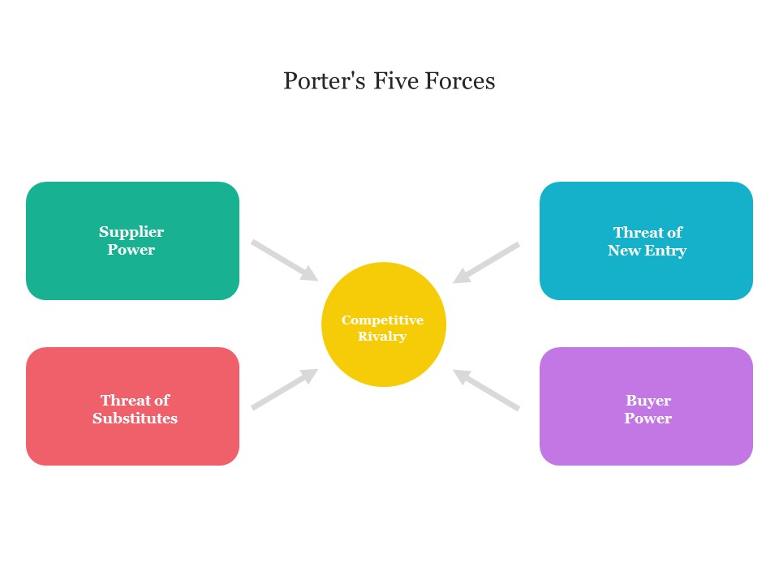He identifies five basic forces that can act on the organisation:

1 the bargaining power of suppliers;
2 the bargaining power of buyers;
3 the threat of potential new entrants;
4 the threat of substitutes;
5 the extent of competitive rivalry.

Supplier Power - The bargaining power of suppliers
Whilst virtually every organisation has suppliers of raw materials or services which are used to produce the final goods or services, our organisation does not rely on suppliers. Porter suggested that suppliers are more powerful if there are only a few suppliers. As the organisation supplies legal services, there are no real external suppliers. Perhaps the lawyers could be construed to be suppliers as without the lawyers the organisation could not really supply any legal services. In the current climate it is not particularly difficult to hire more lawyers. Further, the owners and managers of the organisation are lawyers and could provide some legal services even if there were no other lawyers.

Threat of substitutes
This equates to where else can the clients go for some or all of the services the organisation provides. In Nottingham and the Midlands, there are plenty of firms providing some of the same legal services. There will always be a viable alternative for many of the cases the clients bring. Here, the best strategy would be to reduce some of the work the substitutes are taking such as residential property and focusing on the services where the organisation performs well. An example of this would be commercial property or Civil litigation.

The bargaining power of buyers
Porter used the term buyers to describe what might also be called the clients of the organisation. At present, the organisation operates with many clients and does not rely upon a few clients. If this changed then it could be faced with little option but to negotiate because it would be in a weak position.

The organisation offers legal services which can only be provided by firms regulated by a legal regulator. There are areas of law the organisation is stronger than rivals, and the services are differentiated, e.g., commercial leasing and specialised litigation, where fewer firms offer this service in the local area and even less that can cater for the language skills needed for the ethnic minority clients. The organisation should focus more on the differentiated services to create better competitive advantage. This force should encourage the organisation to consider what is needed to provide buyers a better service and perceived value.

Threat of new entry- Potential New Entrants
New firms could become threats to the organisation if it was easier to set up. Porter argued that there were seven major sources of barriers to entry: Economies of scale, Product differentiation, Capital requirements, Switching costs, Access to distribution channels, Cost disadvantages, Government policy.

For a law firm, the major considerations would be obtaining Government Regulator approval (without which it would not be possible to practise) and cost disadvantages such as compulsory insurance and hiring new lawyers. This force is likely to be weak in the legal sector market since the industry is facing increasing competition, but a high degree of strength among rivals will have a significant impact on the strategic planning. The organisation is strong in particular practice areas, reputation, and has retained client loyalty from 15 years practice in Nottingham. There is some threat from other law firms in immigration and residential property, and it may need to do some additional investigation into the competitive advantages of rivals.

Extent of Competitive rivalry:
This force can be treated as the sum of the other four forces, although competitive rivalry is a separate force. It is inevitable that the organisation will be in competition with other legal firms that provide the same services.
From the analysis above, the two weakest forces are the threats of new entrants and buyer power. In devising the strategy, the main focus should be on the remaining three forces. The first stage would be to establish a strategy to improve value and competitive advantage. It also needs to incorporate a differentiation strategy to provide services that are clearly different to those provided by competitors, rather than at a cheaper price. This will enable the organisation to focus on providing better services and improved client care with increased revenue.

5.3 Porters Generic Strategies
To expand the strategy further, the Organisation needs to consider Porters Generic Strategies developed by Michael Porter in 1985. He noted that there was higher profitability with high or low market share, and the least profitable were those with a moderate market share. Long term strategic advantage would come from strategies in the fields of cost leadership or differentiation. This is shown on the diagram below:

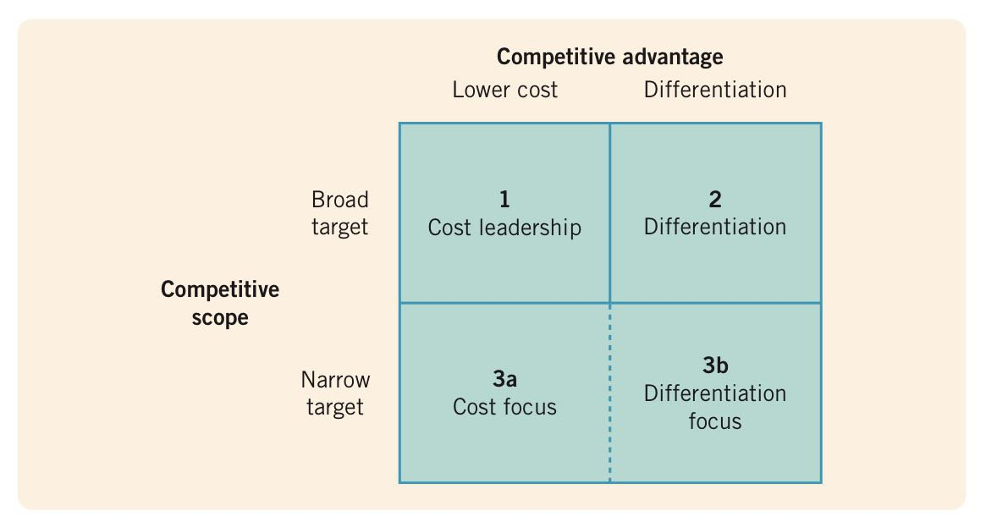

Source: Johnson, G., Whittington, R., Scholes, K., Angwin, D., Regner, P., (2017), Exploring Strategy Text and Cases

Broad Cost Leadership – being the leader in low costs in your industry
Broad Differentiation – selling a unique product or service to your customer

Focus – cost leadership or differentiation for a target segment

Examples of cost leadership would be Poundland or Aldi which are leaders of low-cost items in the UK. Organisations using a differentiation strategy would be Apple or Emirates Airline.
For the organisation, a Costs Leadership strategy would mean providing the services at a lower cost than competitors, which would result in the ability to reduce charging rates. This could be achievable by reducing staff costs or by investing in technology which improves the process to provide services. This may not be the best strategy for business image as the Organisation may be seen as the “Poundland” of law firms.

A better strategy that the organisation should consider is a Differentiation Strategy which focuses on quality, exclusivity, high client-care levels. If the organisation can create a service, which is difficult or expensive for rivals to replicate then it would increase competitive advantage.

In order to pursue this strategy, it will be necessary to understand the value placed on the legal services provided and by training employees to deliver skilled and experienced services.

If the organisation chooses a Focus strategy it will need to decide if there is knowledge or expertise that will add value for niche clients that isn’t available in the broad market. The strategies will be similar to those in cost leadership and differentiation but focussed on niche clientele.

The most appropriate strategy for a law firm would seem to be a differentiation strategy. The organisation should focus on the areas of law that achieve good results such as commercial property, civil litigation and some immigration service in any proposed strategy.

5.4. SUSTAINABLE COMPETITIVE ADVANTAGE

To identify those resources of the organisation that are most likely to deliver Strategic Competitive advantage involves a degree of judgement. A number of strategists have suggested some possible areas for consideration–namely, distinctive capabilities, core competencies and knowledge.

In the analysis of resources, John Kay argued that the distinctive capabilities of an organisation’s resources are particularly important in delivering competitive advantage. Distinctive capabilities relate to three possible unique resource areas in an organisation: architecture, reputation and innovative ability.

  - Architecture is the network of relationships and contracts both inside and outside the firm. Its importance lies in its ability to create knowledge and routines, to respond to market changes and to exchange information both inside and outside the organisation.

  - Reputation is the strategic standing of the organisation in the eyes of its customers and other stakeholders.

  - Innovative capability is the special talent possessed by some organisations for developing and exploiting innovative ideas.

There are three principal areas that need to be analysed. (Ohmae’s three Cs)

Customers - What do customers want?
    - Identify who the existing and potential customers are. Why do they utilise the firm and not competitors.

Competition - How can the organisation beat or at least survive against competition?
    - Who are the main competitors and why do clients go to them?

Corporation - What special resources does the company itself possess
    - how do they compare with those of competitors?

The organisation needs to focus on the key factors for success to maintain Sustainable Competitive Advantage in the future and maintain resilience against competitors.

6. CONCLUSION

From the analysis above, it can be seen the organisations strengths are brand and reputation established for 15 years which could be built upon to focus on improved client care and to improve competitive advantage in the marketplace.

In formulating any strategy there must be consultation with the stakeholders identified as having the most power in order to avoid resistance and conflict. The organisation should proceed with a broad differentiation strategy (rather than a focused) targeted at clients in Nottingham and the Midlands in the first instance and then throughout England & Wales. The strategy would be to concentrate on reduced areas of law and focus on the most profitable areas of practice.

There should be a targeted focus on the main resources which are the employees and the technology as well as the organisation’s brand and reputation. This focus should be on investing and improving technology to better service clients. With improved computer systems it will be able to provide better operational efficiency and deliver higher standard client service.

The organisation should improve on the specialist knowledge and skills possessed by the current employees. It may need to consider employing staff with the required knowledge and skills to enable the organisation to provide superior legal services and client care

With this strategy, the organisation can improve its brand image or reputation and competitive advantage. If it can succeed in providing superior client care, then it can add value to the organisation which can increase revenue and ultimately profitability.

7. RECOMMENDATIONS
The recommendation is to agree upon a strategy to improve competitive advantage by investing and improving the technology systems at the Organisation.
The proposed strategy at business level would be:
  - Invest in new technology throughout the organisation
  - Integrate the case management systems with the email and diary systems
  - Provide training to the employees
At corporate level, the steps would be:
  - Refine the areas of practice
  - Determine if there are sufficient employees with the required knowledge
  - If necessary, hire more employees with the requisite knowledge
  - Formulate and implement a marketing strategy
It should commence this strategy incrementally in Nottingham and the Midlands initially, to see if this can be successfully implemented and rolled out across the organisation without loss of productivity and ideally to increase profits. The organisation needs to ascertain what is the optimum environment to improve services and client care whilst adding competitive advantage and value.

8. BIBLOGRAPHY
BOOKS
Dess, G. G., Eisner, A., McNamara, G., (2016), Strategic Management: Texts and Cases, McGraw-Hill

Hayes, J. (2022): The Theory and Practice of Change Management, 6th Edition, Bloomsbury

Johnson, G., Whittington, R., Scholes, K., Angwin, D., Regner, P., (2017), Exploring Strategy Text and Cases 11th edition, Pearson: Harlow

Lynch, R., (2018), Strategic Management 8th edition, Pearson: Harlow

Websites
https://info.mycase.com/rs/196-INY-394/images/MyCase_2021-Industry-Report.pdf
The future of work after COVID-19 | McKinsey
Generic Strategies 101 | Knowledge for Lawyers (knowledge4lawyers.com)
Business Briefing for Lawyers: Checking out the Competition | LawWare
Ansoff's matrix (kaplan.co.uk)
The Five Forces: A different way of looking at your firm's practice (thomsonreuters.com)
The Applicability of Porter’s Generic Strategies in the Digital Age: Assumptions, Conjectures, and Suggestions - Eonsoo Kim, Dae-Il Nam, J. L. Stimpert, 2004 (sagepub.com)

