


Building a secure home network
by dawid trochim
Supervisor: Dr Kapilan Radhakrishnan

Project submitted as part of the requirements for the award of BSc (Hons) Computer Networks

Declaration of Originality

I, Dawid Trochim declare that I am the sole author of this Project; that all references cited have been consulted; that I have conducted all work of which this is a record, and that the finished work lies within the prescribed word limits.

This work has not previously been accepted as part of any other degree submission.

Signed : Dawid Trochim

Date : 28.04.2022

FORM OF CONSENT

I Dawid Trochim hereby consent that my Project, submitted in candidature for the B.Sc.(Hons) Computer Networks degree, if successful, may be made available for inter-library loan or photocopying (subject to the law of copyright), and that the title and abstract may be made available to outside organisations.

Signed : Dawid Trochim

Date : 28.04.2022

Copyright Acknowledgement

I acknowledge that the copyright of this project report, and any product developed as part of the project, belong to University of Wales Trinity Saint David, Swansea.

Table of Contents
Copyright Acknowledgement 2
Chapter 1 7
1.1 Introduction 7
1.2 Aim 8
1.3 Objectives 8
1.4 Structure Of The Project 9
Chapter 2 - RESEARCH & REVIEW OF LITERATURE 10
2.1 Introduction 10
2.2 National Security Agency Cyber Security Information 10
2.3 Security & Home network attacks 13
2.3.1 home network attacks 14
2.3.2 Phishing 15
2.3.3 DOS Attack 16
2.3.4 DDoS Attack 18
2.3.5 Password cracking – dictionary attack 19
2.3.6 Encryption 19
2.5 RELATED WORKS 20
2.6 Conclusion 22
2.7 How is the work going to be presented? 23
Chapter 3 - RESEARCH METHODOLOGY 24
3.1 Research Overview 24
3.2 Gantt Chart 27
3.3 Conclusion 28
Chapter 4 - DESIGN & IMPLEMENTATION 28
4.1 Introduction 28
4.2 Problem Formulation 28
4.3 Design 29
4.4 Implementation 30
4.4.1 Credential Harvester Attack 30
4.4.2 How to stay away from credential harvester attack? 31
4.4.3 Man in the middle attack 32
4.4.5 DoS Attack 37
4.4.6 How to stay away from DOS attack? 40
4.4.7 DDOS Attack 41
4.4.8 Password cracking – dictionary attack 43
4.4.9 Conclusion 45
Chapter 5 – Evaluation 46
Chapter 6 - CONCLUSIONS AND RECOMMENDATIONS 48
6.1 Summary 48
6.2 Conclusion 49
6.3 Recommendations for Further Research 51
Chapter 7 – Reflection 53
chapter 8 - REFERENCES 58

List of figures
Figure 1 19
Figure 2 23
Figure 3 28
Figure 4 29
Figure 5 30
Figure 6 31
Figure 7 32
Figure 8 32
Figure 9 33
Figure 10 33
Figure 11 34
Figure 12 35
Figure 13 36
Figure 14 37
Figure 15 38
Figure 16 38
Figure 17 39
Figure 18 39
Figure 19 40
Figure 20 41
Figure 21 42
Figure 22 43
Figure 23 43
Figure 24 44

Abstract

The purpose of this project is to build a secure home network and then test against the real attacks in the real-time environment. This document is meant to cover the basics of securing the networks and advanced level of securing it. This document is also going to analyse the modern threats in the cyber security world and solution to these threats. The attacks will be executed in a real-time safe environment using VMware which allows to replicate the actions that would have been done in a real network. The software needed to conduct these attacks are Kali Linux, Windows Operating System, and Android system just to replicate the current modern home network as closely as possible where the Kali Linux is the attacking machine and other operating systems on the network are just normal operating systems and machines that we can see in the modern home network. The software and applications that was used to carry out the first Man in the middle attack was Ettercap and tcpdump, in order to create a fake website with fake login page; Social Engineering Toolkit was used, DoS was done thanks to Metasploit, DDoS was carried out using many consoles and terminals on Kali Linux and Windows 10 in order to DDoS windows 8 and in the real-time scenario there would be multiple machines infected by the malware doing the attack instead of just two, the last one was gmail-hack that allowed to Brute-force the Gmail account that was created for the purpose of this project.

The literature review was done to gain knowledge about the subject so the theory can be put into practice later. The literature review is an especially important part of this project because it is the foundation of everything, the attacks were carried out based on the knowledge gained from the literature review. The Gantt Chart was created at the very start of the journey and the current one after everything is done was also created just to show how the journey has changed over the time and how it turned out.

The methodology used to carry out the research is called “Exploratory research”, this particular methodology suits the needs of this project because it helps to improve understanding about the subject and helps the investigator to understand why certain things happened and how it happened and allows the investigator to create a very informative conclusion about the subject or topic. Saunder’s Research onion also helped a lot to do the research and methodology as it was a guidance to successful research.

The results turned out to be as expected, there were issues during the process but a good analysis of why it happened and how to fix it was done and the problems were solved. All the attacks worked out as they should and the results for every single attack were met.

Chapter 1

Introduction

The problem that will be tackled is the current security level in the modern home network as it is not enough these days and people are unaware of how damaging and dangerous it can be until it hits them. People usually pay for the internet and leave their router and machine either unsecured or have a very little security applied that can be easily tackled with a bit of knowledge and the only way to solve it is to educate the population on staying safe online and doing the basic steps that will be described later in the document so people can stay safe. The main purpose of this project is to build a secure home network and provide a general overview on a home security such as avoiding attacks, staying safe and being aware of the actions online and also protect it from any attacks such as Man-in-the-middle attack where the intruder controls both end points and just gathers the information, DDoS where the large amount of packets is sent to the router or server to the point where connection is lost due to inability to handle that many packets because of multiple machines that are attacking the target etc. and also DoS where one individual is being targeted. Password cracking will be included as well. Once the network is built; it will be tested by trying to penetrate the network and by breaking in. Another important aspect of this project is to simply expand the knowledge about cyber-attacks, threats and how to protect the network from any kind of attacks and how to implement it step-by-step. The implementation of security described later step-by-step should be easy to do for any home user.

A quick explanation on how to avoid the most common and simple attacks such as “Phishing” will be provided and clearly explained. An explanation of all the methods used to fix the security gaps and any vulnerable spots in the network will be explained. A firewall will also be used later in the project, at the moment not much is known about advanced features of several types of firewalls so this will be something new that will be implemented as the project goes. Simple steps that can be done right away to secure the router such as changing the SSID which is the name of the router that appears in the list when trying to connect, changing the password, enhancing the encryption etc. The expected outcome of this project is to have five attacks tested against the network and make them successful and secure the network against these attacks after they have been carried out and deeply analyse them and explain what has been done and how it was done.

Aim

The main aim of this report is to create a secure home network so it can be penetrated and tested to see if the network is fully secured and vulnerable to any type of attacks, if so then it will be fixed and prevented. However, the clarification of the issue and of how it was fixed will be provided and deeply explained.

Objectives

The objectives are to:
- Gain a broad knowledge about the main subject of this project which is securing the home network and about vulnerable spots of the network as well as fixing the security gaps.
- Establish understanding of all the possible attacks that can happen at any time and find out which are the most common ones and provide a brief and clear solution to them and how to avoid them in the future by applying a few simple steps and features.
- Provide a critical literature review of the aim, objectives, and current research with the aim of providing the level of existing knowledge about the subject.
- Use and present the assets gathered from the research and literature review to produce a secure home network by creating a VMware network to try to break in and penetrate with all the possible attacks and resources so the weak spots are discovered and fixed as soon as possible. This will be approached in a few ways; phishing commonly known as creating a fake website, DoS attack which sends an enormous amount of packets towards victim’s router, DDoS where multiple machines are being used to send a large amount of packets against the server / router, Man-in-the-middle attack where the attacker gets in between the victim and application and finally password cracking and also create a Gantt Chart.
- Gain a broader understanding of all the methods used such as simple troubleshooting to fix the issues with the network, such as going back, troubleshooting every single device, and checking the configuration just to find the error, understand how it happened and fix it and avoid it in the future.
- Provide a brief and clear instruction and recommendation on how to avoid cyber-attacks and loss of sensitive, important, and valuable data and fully secure the network and devices connected to the network step-by-step and also provide a clear reflection on how the project went.

Structure Of The Project

The project is essentially in three parts. Firstly, the theoretical work such as describing the attacks, literature review, methodology etc.. The theoretical work relates to teaching and learning approaches both in and outside the classroom. The second part is the implementation and practical part where the attack are being executed. Finally, the third part is a section where the reflection, conclusion, evaluation, appendix and references are located.

Chapter one illustrates an overview of the report. It details the aims and objectives that once achieved will bring success to this research.

Chapter two concentrates on the critical literature review and the research methodology that will be used to execute the research and task properly.

Chapter three focuses on research methodology and deeply describes the approach that has been done to finish the research.

Chapter four reviews the design and implementation of the attack and the whole structure of the network where the attacks are being executed.

Chapter five puts the evaluation and summary together where the whole project and its journey is being described and discussed.

Chapter six focuses upon giving any recommendations and what could have been done better in the first place.

Conclusion
This chapter focused on getting the foundation of the project done, clearly describing what needs to be done and how is it going to be done, and what are the main goals and outcomes of this project. It is like a solid foundation of what to expect and how to follow the project.

Chapter 2 - RESEARCH & REVIEW OF LITERATURE

2.1 Introduction

We live in a world full of technology [1], and hundreds of electronic devices surround us every day such as – phones, security cameras, laptops, printers, computers, cars and even more. In order to achieve a good understanding of security measures and structure, the three different perspectives will be compared and a conclusion will be drawn.

2.2 National Security Agency Cyber Security Information

According to “National Security Agency Cyber Security Information” [2] The collection of all these devices and names is called “IoT” which stands for “Internet of Things”. There are many actions that can be taken in order to protect the “Internet of Things” devices from being accessed by an unauthorised person such as:
- Upgrading to the newest operation system and keep it updated at all times

It is crucial to keep the system updated at all times because the updates will contain security improvements that will make the network / device even more safe to use without putting in effort, this will minimise the risk of being hacked. It is a good habit to always set the updates to automatic during the night or hours when the device is not in use.

- Do small things such as disconnecting external devices from the computer / laptop when not in use to minimise the risk.

Another important aspect of minimising the risk of unauthorised access is simply adapting to good secure habits such as disconnecting the external drive, USB and other types of external devices that could be connected to the PC, the reason for that is ransomware attack, this attack became very popular lately because it requires the user to pay the certain amount of money in order to unlock the files, otherwise they will be deleted. Turning off the PC instead of putting in in sleep mode, disconnecting internet connection etc.

- Invest in a good paid security software

A good security software is the first step to great defense. Security software such as “Malwarebytes” or “Kaspersky” will protect the device from malware, phising, dangerous browsing and viruses in general. The software could also be capable of doing a full disk encryption just in case the device gets stolen so the thief will not decrypt the disk and access the information that is on it.

- Unplug digital assistants such as “Alexa” made by Amazon or “Google Nest” and “Google Nest Mini” made by Google in order to prevent spying.

There is a rumour that digital assistants are always listening, even when they are not activated to follow people’s instructions. It is a good habit to cover the webcam in laptop to prevent people from spying on the other person. Even toys for kids have their own “small digital assistant” built in and there were many cases where the toy was spying on the child and parents by listening to the conversation.

- Have a good set of and strong passwords and make sure that every account has a different password.

Another simple action that can be done is keeping password secure, every password should be strong and different for every account, it is a good habit to encrypt them.

- Modify the permissions of the Administrator account to make sure nothing harmful can be done but the control remains as it was

By default, the administrator account has the power to do everything and nothing can stop that. However, it can be changed to limit the rights to do everything and only allow to do stuff that needs to be done. It can also be prevented by making another account that is not going to have all the privileges commonly known as a “Non-privileged user”. To surf the web, write documents, send emails etc. Only administrator account and other privileged account will in power to make any changes to the system and install software.

- Configure Firewall to protect the network and WAP which stands for “Wireless Access Points”.

It is important to also check that the firewall is enabled and properly configured in order to prevent outside connections from accessing the network.

- Enable the strongest possible encryption and security on the Wireless Network such as WPA2 and AES.

Another great idea is to enable the strongest possible encryption which is WPA2 with a strong password. Most devices will support WPA2 encryption nowadays. Changing the SSID is also the first step to secure the router so the hacker will not see the network and vulnerable and untouched.

- Restrict the access to accessing remote control on the routing device.

Restrict the access to the network from home and only allow to access the network inside the physical building when the user is connected to the internal network.

2.3 Security & Home network attacks

However, diving into a unique perspective and source opens some options to discuss such as [3] authentication and wireless network security which needs to be included because a lot of home networks use Wi-Fi.

Some home network owners decide to use “Open Authentication System” which means that anyone can access the network without password which is strongly not advised and never used unless the network is meant to be public such as a public cafeteria Wi-Fi. The safer method of authentication advised to use is “Shared Key Authentication” because it is a way of verifying if the person is allowed to access the network by using WEP which stands for “Wired Equivalent Privacy.” The person requesting to access the wireless network has the shared secret key ready to provide to pass the authentication process, but this is just the basic and standard configuration when it comes to wireless networks.

According to National Institute of Standards and Technology [4] there are three main terms and each one of them has important meaning to the network and it all falls into “802.11 Security standard” category.

Confidentiality was developed in order to achieve privacy and prevent people from eavesdropping, confidentiality makes sure that the data is only viewed by the person that is meant to see it.
Authentication was developed in order to identify whether the person trying to request the access to the network is authorised and has permission to join the network or view certain data.
Integrity is the final component of the 802.11 security standard because it makes sure that the data and messages sent are not touched and modified in any way. It makes sure that the user receives the data that was originally sent.

Modern home network [4] mostly consists of wire connected devices and mostly wireless devices such as phones, tablets, TVs, smartwatch, there are many devices connected to one access point where Wi-Fi comes from, every device has different security measures applied which means it is easy for the attacker to break in through the device and this is also why people should be aware of what they are doing online by visiting only trusted websites and not clicking anything that seems suspicious, however the router’s security when it is first powered is configured but it is a very basic security such as password and that could be it, it could be avoided by enabling WPA2/WPA3 encryption through admin portal, there are also devices such as Alexa, Google nest, CCTV and much more which also enables the attacker to hack the network.

2.3.1 home network attacks

There are many home network attacks that can be executed but the three most common ones are: Man in The Middle Attack, Phishing, DoS, DDoS and Password Cracking.

Man in the middle attack [5] is becoming more popular these days and can be executed in 15 minutes or less, to check which ports are open, Ip, firmware, version and it is just a massive port scanner which allows people to see devices that are easy to attack and it allows people to search for servers, routers, webcam and overall IoT devices. However, there are many types of this attack such as [6]:
- Packet injection
- HTTPS address request
- Session Key
Packet injection is one of the many MiTm attacks because it allows the attacker to blend malicious packets with valid data packets and communication streams.
Attackers also use HTTPS address request to sniff the endpoint which is the destination, and they force the host to redirect the original request to the server which is unsafe and unencrypted.
Most websites create a temporary session key that is used whenever the user visits the website again so there is no need to type in the credentials all the time, the attacks can sniff that session key and make actions on the behalf of the user.

How to stay away from Man in the middle attack?

The best way to defend against this type of attack is to use VPN [7], change basic router settings such as SSID, password, strengthen WAP and WEP encryption and use public key pair authentication and train members of stuff to look out for any red flags related to man in the middle attack e.g. look out for fake links that redirect to a fake website asking to enter the credentials and also setup the firewall to accept only certain connections.

2.3.2 Phishing

Phishing [8] is one of the most common social engineering attacks and it includes the attacker making original things look fake in a way that it is impossible to tell the difference so the victim can fall for it, fake emails, websites, text messages and much more to get information. There are many types of phishing attacks, however the three most common ones are:
- Email phishing
- Spear phishing
- Whaling
Email phishing has been around for an exceptionally long time and the purpose of it is to send a legitimate looking email to make victim believe that the email is real.
Spear phishing is an advanced version of email phishing because attackers use OSINT to get as much information about the victim as possible and then use it against them in an email and talk about work, phone numbers, bank details etc
Whaling is the type of attack where the attackers are trying to find out the name of the CEO or another person that can do similar things as the CEO and send an email to the employee pretending to be the CEO and requesting the money transfer or telling the employee to download the document.

How to stay away from phishing?

The best way to start it is by simply [9] training people to look out for the red flags that certain emails, websites and pop ups and things in general might have so the people can be aware every time they think something does not look right. Multi-factor authentication is a good way to prevent hackers from accessing the account even if they know the password and login, multi-factor authentication requires the user to additionally such as Face ID, a passphrase or even an authentication app made by Google for example that allows you to connect accounts and use it whenever there is an authentication needed.

Attackers really like to hide information inside the documents such as PDF or DOC where the macros are included and installing the right filter can help the user to not even think about danger like that because the filter will take care of it. Regular updates contain the most recent security updates that will fix any gaps in the network. Regular data backups are essential because it allows to recover the lost or encrypted data which will avoid falling for ransomware as we both know is encrypting the files and telling the user to pay to restore the files.

2.3.3 DOS Attack

A denial-of-service stands for DOS [10] and this type of attack is responsible for crashing and taking down network which will turn them into unavailable network as there will be no connection. Everything that is connected to the network – phones, digital assistants, computer, laptop all these devices would not have the internet connection when the DOS attack is being executed. Hackers have many purposes for launching the DOS attack and the most popular one is financial damage. The company needs to spend a lot of money and time to recover the network so it works again which will lead to worse reputation, not satisfied customers etc.

The way this attack work is not that complicated because there are quite a few types of DOS attack:
- Network layer or protocol – Hackers send enormous number of packets to network infrastructure and their management tools.
- Volume attack – Hackers send enormous number of packets to overload the server or website or just a computer.
- Application layer attack – This type of DOS attack is similar to Volume attack but instead of targeting server, websites, computers etc. it targets applications sending infected requests.
However, hackers tend to target banks, popular organisations, and government as well. There are two ways to attack banks, organisations, government websites etc. and it is done by either data that contains bugs which will lead to a crash or by sending an enormous amount of packets which will overload the network with fake traffic, the result will be the same – the network, machine or website will be taken down and unavailable.

How to stay away from DOS attack?

There are many ways to prevent the DoS attack [11] one of them is simply strengthening the security measures that are already applied or adding extra. For example, firewalls are extremely important because they control what is coming in and out so properly configuring the firewall to stop DoS attacks and to filter out the traffic that is not needed will surely increase the protection against DoS attacks. Monitoring traffic is another solution to stay away from DoS attacks, companies can buy a service where the DoS attack is being detected and all the fake and unwanted traffic that was meant to hit the network will be redirected somewhere else. Network administrators can also create protocols and rules if there is any unusual traffic detected, for example the packets will be rejected if the packet meets the rules that the administrator set.

2.3.4 DDoS Attack

DDoS also known as Distributed Denial-of-service [12] the main purpose of this attack is to stop the normal flow of the traffic through the server that is being attacked or the network in general by sending unnecessery packets which will flood and disrupt the whole infrastracture and mechanism of the network. There are many types of DDoS Attack such as SYN Flood, UDP Flood, NTP Amplification and also DNS Amplification, all of these attacks are a bit different but every attack mentioned above has the same purpose and outcome – to disrupt the flow of traffic in the network causing additional financial damage. The process behind this attack is to get many devices that have been infected by malware which allows the attack to remotely control every device that was infected and that leads to a complete control. The hackers then is using all of the devices and their power to group them up, that is called a botnet and then botnet then is receving the tasks from the attacker to carry out the attack, if the target receives packets from that many devices, there is a possiblity that it will go down.

How to stay away from DDoS attack?

First of all, the company can create [13] something called “blackhole”. The blackhole is like a bin for the malicious traffic sent by the attacker, it has to be properly configured in order to separate the traffic that is legit and the malicious one, otherwise it will get mixed up and everything will end up in blackhole making the network unavailable. Rate limiting is another option, it will limit the amount of request that the server is capable of accepting during the certain amount of time, this is also good to stop hackers from brute forcing, it might not be the most efficient way to stop the attack and might not always work but it can really stop the attacker sometimes. A web Application Firewall known as WAF is a very efficient way of preventing the layer 7 DDoS attack. WAF is being put between the server and internet and the network administrators can quickly react and change the settings applied to the WAF. WAF is like a proxy but reversed proxy where it protects the target from the attack and this is done by using filters.

2.3.5 Password cracking – dictionary attack

A dictionary attack [14] is a common way of getting into someone’s account by compromising the password. There are many password cracking tools with an option to do dictionary attack, the way it works is that the user gives the word list nad password list to the tool and the tool starts going through every single username and password to see if there is a match, if there is then the user is notified about the findings. Many people use very easy passwords such as 12345 or “password” on its own and this is the reason why the dictionary attack still works very well to the present day, this is why the tech world started introducting random password such as jd%812jj@0931 because it is not likely for this password to be in the list.

How to stay away from Password cracking dictionary attack?

First thing [15] that can be done right away is simply modifying the password policy which will require the user to enter the password based on the requirements given, otherwise the password will not be set. The password policy can be modified to something like using uppercase, special signs, numbers, minimum length, maximum length and it could even time out the attacker if there is a certain amount of unsucessfull attempts. Enabling 2 factor authentication where the user is required to enter the password and then ther the one-time passcode in order to log in successfully. Regularly changing the passwords and using the website https://haveibeenpwned.com to check if anything such as the email, password etc. has been leaked somewher.

2.3.6 Encryption
The most important part of securing anything is to use the encryption because that is the first line of defence which stops attackers from accessing the information. There are many types of encryption and here are the most common ones [16]:
- WPA
- WPA2
- WPA3
- WEP
WPA stands for „Wi-Fi Protected Access” and was created in 2003 by Wi-Fi Alliance and consists of many encryption aspects such as generating a key that was unique for every single packet, it also checked for message integrity, used 256-bit keys, and had an option to automatically broadcast the updates keys.
WPA2 [17] was invented in 2004 and was known as 802.11i and it came with two modes and one of them was just for home network users and the other was for companies. WPA2 also comes with RC4 which is a better version of TKIP that is used by WPA. RC4 consists of AES that stands for „Advanced Encryption Standard” and „Cipher Block Chaining Message Authentication Code Protocol”.

WPA3 was invented in 2018 by Wi-Fi Alliance and is being considered one of the most security standards nowadays and is being recommended by all Wi-Fi devices and supports an option of „Protected Management Frames” that helps with eavesdropping and has a feature to enable 192-bit security encryption.
WEP again created by Wi-Fi Alliance, it was the first ever encryption and was only created to stop attackers from viewing data that was transferred wirelessly, however the encryption was not strong enough after some time when hackers started to develop new ways of breaking in.

2.5 RELATED WORKS

This section will discuss a few general articles related to the subject of this project and explain how these general articles helped to expand the knowledge about the subject and apply it to the project.

The first article [18] was a helpful source of information that brought a lot of facts and knowledge that unknown of and really helps to get an idea of how certain home network attacks work and what countermeasures should be applied to prevent that from happening. This article is targeting threats to wireless networks, and something called “Rogue Access Point” which is not knowingly breaking the rules and creating an effortless way for the attacker to break in, the attacker might also plant the rogue access point within the facility. It also covered many home network attacks such as Rogue Access Point, Denial of Service, Configuration problem, Passive Capturing, Unauthorised access, Warchalking and Man-in-the-middle attack. The attacks have been deeply explained which helped to understand how vulnerable wireless and wired connections are.

The second article [19] has taught a lot about integrity, availability and also authenticaion and access controls which is extremely important when it comes to home network security and integrity is a must to make sure that the attacker cannot infect our network with some malicious code, availability is also required to make sure that the attacker cannot access the network and steal data that is being transmitted over wireless network and this can be done by making sure that access controls is properly set up. Authentication is also important because it makes sure that the attacker cannot replace information on the network with infected information that is exactly the same as the original information. This article in general helped to understand that people really need to take these assets mentioned above into consideration in order to keep the network safe, assign adequate roles to correct users and give them correct permissions to make sure that they are only accessing information that is meant to be accessed by them.
Home networks are pretty much everywhere now and most devices that are connected to the network fail to meet basic security requirements or changes which makes them really vulnerable to outside threats. Home network owners need to make sure that authentication, integrity and availability is taken into consideration when building a secure home network.

This book presented an overview about how to manage and setup the basic security measures. I've explored how Windows maintains access privileges as well as how User Accounts and Security Groups, along with file and folder safety, would be used to control access and guard the system. I've also discovered of Windows services and how it can switch off those users don't even use, including the dangers regarding secret file extensions and how they can be targeted over people. Passphrases are one of the most important components of data security. Throughout this book, explanation of the significance behind passwords as well as some of repercussions which may arise once the security breach occurs. A study on what to do to establish better, increasingly challenging passwords as well as how to use passwords to construct far more strong and unique passwords which you can memorise to prevent any intruder from finding or breaking passwords. At last, this section presents that the security of the machine can be increased via using a BIOS passphrase.

This book has also taught a lot about viruses, worms and other malware out there because they are a cause of many problems everyday. This book allowed to widen the knowledge about viruses and worms to the point where it is enough for this project so people can use their computers safely everyday. I’ve learned about several types of malware and also their differences and how they were created. Importance of using antivirus software and configuring it properly was also included in this book which helps to understand how to properly configure it because most people just download it so it is there if anything happens but there are much more to it.

Conclusion

The second chapter focuses on some key points such as critical literature review which consists of many concepts such as giving advice by National Security Agency Cyber Security on how to stay secure online and not find yourself as one of the victims of cyber-attack and it also focuses on home network security and the most common security attacks explaining how are they carried out and what steps are needed to be taken in order to prevent the network from being a victim of the attacks mentioned in chapter 2. The future work and steps are also explained and clearly outlined as well as the methodology used to approach this project and carry out the research properly thanks to “Saunders Research Onion” technique which allows the researcher to approach the research in many different ways thanks to its six layers of which “Saunders research onion” consists.

The Gantt chart that shows the progress throughout the journey is also included in the appendix, it clearly outlines what has been done and what is due to be done before the project ends, it clearly shows dates of events that will happen on certain dates such as final report, final viva etc. The second chapter also outlines how important it is to use the encryption because that is the first line of defence when it comes to attacking because it prevents hacker from accessing the network by asking for password and much more but that depends on the type of encryption. Chapter two also consists of some pictures that clearly explain the logic behind the “Sanders research onion” and deductive approach process to help the viewer or reader understand what is meant by these terms in relation to this specific project. Additionally, the topic called “RELATED WORKS” was also included in this literature review because it describes the academic sources that have been used to improve knowledge about the subject and help with the project to fill out any knowledge gaps.

2.7 How is the work going to be presented?

The original and initial idea is to present the practical part of the project through using VMware where the network will be created, and the attacks mentioned in the project will be carried out live if possible but that is due to be tested and checked if it is possible because of limitations (if there are any) that can occur due to VMware. The required machines will be running e.g., target machine and attacking machine where all the work will be done through attacking machine and the target machine will be used just for presentation to confirm whether the attack attempt was successful.

Chapter 3 - RESEARCH METHODOLOGY

3.1 Research Overview

After deeply analysing and understanding the “research onion” which explains all the stages that the researcher has to go through in order to carry out the research properly, a decision to use [20] “Pragmatism” research methodology have been made and it suits the needs of this project because pragmatism is mainly focusing on using the best possible resources such as tools in order to carry out the best investigation about phenomena. This research methodology is approaching the task from a practical point of view, additionally the knowledge about the subject or task is questioned and interpreted constantly.

This project is focusing on getting the network to work and conduct essential tests to see if it is secured which means that practical part is extremely important. This research methodology is good because it is not bonded to any solid definitions, explanations, and understandings. Additionally, the data needed to gain knowledge about the subject and the project can be found in different forms such as reports, videos, questionnaires etc. and is also spread across various sources. Pragmatism is known for its specific definition of working – pragmatism is a research philosophy that states the idea can only be considered as done or successful only if the idea has been proven in a practical way or experiment and this project is focused on getting the network physically to work.

Figure 2

Saunders research onion explanation

When it comes to the approach [21], deductive type of approach suits the needs of this project better than inductive and the reason behind it is the nature of this project – doing research based on what others have done, gain knowledge and experience from reading theories and then carry out some tests that were created based on the research that others have done which is exactly what is happening is this project.
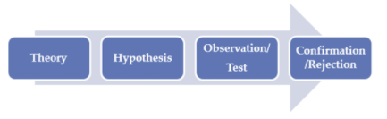

Deductive approach process Fig 2
The image above illustrates the process of deductive approach, the researcher has to create a theory about the task and then the hypothesis based on the research has to be created, the theory then is being put to the test to check if it works and once it works, the confirmation is needed, otherwise it is going to be rejected. This type of approach has helped to get a better and broader understanding about the subject from the results that have been collected and better confidence has been ruled out in the conclusion.

Archival research is [22] the strategy that suits the nature of this project because the research is based on the use of archived documents and information such as journals, books etc. that already exist and was written by others, however this type of strategy also allows the researcher to explain changes that might happen as the time flows and also explore the changes that can happen as the time flows as well.

The fourth layer of the research onion will cover whether it would be a better decision to mix two methodologies – quantitative and qualitative or if it is better to stick to one methodology. This layer of the research onion is called “research choice.” Mono method is the type of choice that suits the needs and nature of a project because mono method allows the researcher to only use of type of data and it is either “qualitative” or “quantitative.” In this case, qualitative data type will be used to conduct the research properly. E.g., of qualitative data type – If someone needs to fix their car and needs community’s opinions on a specific car repairs place, then the researcher could use previous customers’ opinions and views about that place. The reason why mono method suits the needs of this project is because only gathering of one type of data is essential and that are opinions of experts and scientists related to the nature of a project which is cyber security and home networks attacks.

There are two options when it comes to the fifth layer of research onion process which is called [23] “Time Horizon” and the options are “longitudinal” and “cross-sectional”. In this case, longitudinal is the option that suits this project best because longitudinal option allows the researcher to gather data over a certain period of time – weeks, months and years and it suits the project because the data and research gathered in order to finish this project has been gathered from different periods of time e.g. 2020, 2017, 2002 etc. whereas cross-sectional allows the researcher to only gather data at one point in time so for example the data could gathered only from year 2020 and this is it. The type of data that is being gathered can either be qualitative, quantitative, or even a mix.

Finally, the last and most important layer of “research onion” process [24] is data collection and data analysis because if the data is collected and analysed properly then the research question or the project can be answered and done. There are two types of data – primary and secondary. The type of data that is going to be collected is secondary data as it comes from others which means it will be collected thanks to reports, books, journals, articles etc. instead of first-hand information such as questionnaires, interviews, surveys etc. because that is primary data. A secondary data type suits the need of this project and the reason behind it is its nature where information, data and research must be gathered from others to gain knowledge and apply it to the project.
The research onion process is a technique that explains all the stages that the researcher must go through to conduct the research, there are six layers of that “onion” and each layer offers the researcher to conduct research in different form, so it is not strict but flexible.
The methodology that will be used is called “Exploratory research” [25] which offers many popular research methods and one of them is “literature search” as this is one of the most efficient types of researches that can be done in case of this project because and the information will be gathered through newspapers, magazines, journals, academic literature and the investigator is able to go through the sources mentioned above in order to find the information about certain topics.

How it suits this project and why?

Exploratory research suits this project well because it helps to improve understanding about the subject and helps the investigator to understand why certain things happened and how it happened and allows the investigator to create a highly informative conclusion about the subject or topic. An explorative approach is a form of research approach which just seeks to explain the several aspects of the research project. Throughout this methodology, the researcher will begin with just a broad concept and afterwards applies their findings as one resource that led towards upcoming subjects. It suits the project because knowledge improving about the subject is extremely important in case of this project and allows to draw some very useful conclusions and the subject of this project has not been really properly discussed before as attacks still happen all the time, the aim is to not to provide a solid proof but gain some knowledge about the issue.

That technique supports mostly in supply of essential insights in scenarios where the researcher has quite a small amount of information. To present the idea during creating of research proposal, individuals should first define an overview for the study.

Exploratory research is being done with the aim of discovering an issue that has not previously been properly examined because most home networks are still not properly secured. It is also not meant supply solid proof, but more to assist in the proper knowledge of the issue.

Exploratory research does not quite attempt to provide clear answers to research questions, but it really does guide the researcher throughout investigating the matter at various levels of depth. Then it assists him with establishing the data gathering strategy as well as testing philosophy.

3.2 Gantt Chart
Please see appendix

3.3 Conclusion

This chapter focused on getting the methodology clearly described the name of the methodology and the research onion method was discussed. The methodology used to conduct the research is exploratory research, a valid points of why this certain methodology suits the project have also been outlined and described in detail. In general, this chapter was a guidance to conduct a good piece of research on the most popular home network attacks, its causes, solutions, and mitigations strategies.

Chapter 4 - DESIGN & IMPLEMENTATION

4.1 Introduction

This chapter will focus on putting theory into practice where the network will first be created in packet tracer just to have a general overview of what is going on and then it will be created using VMware where the environment is safe and nothing dangerous or illegal can happen due to the attacks that will be executed. This chapter will also carefully explain the stages of design and how the network was implemented, will be implemented. Any errors or issues will be discussed – why they happened and how it was fixed.

4.2 Problem Formulation

The problem that will be approached is building a secure home network because many home network users are still not aware of how vulnerable their lives are with the amount information available out there that can be accessed by hackers. First, a draft network in Cisco Packet Tracer which is a safe simulation software and once the decision is made that this is the final draft and that is how the network is going to look and then put the theory will be put into practice.

Practical part will be approached by using VMware because it allows us to create virtual machines and virtual network and virtual environment which is completely safe, and nothing can go wrong. There will be quite a few software used to approach this chapter:
- Windows OS
- Android
- Kali Linux
- Antivirus to secure the network after the attacks
- Firewall to secure the network after the attacks
- Ettercap and tcpdump – Man in the middle attack
- Suited Packet Sniffer - Man in the middle attack
- Phishing tools (Many tools will be evaluated and the best one will be used)
- VMware
The design of the network might still change.

4.3 Design

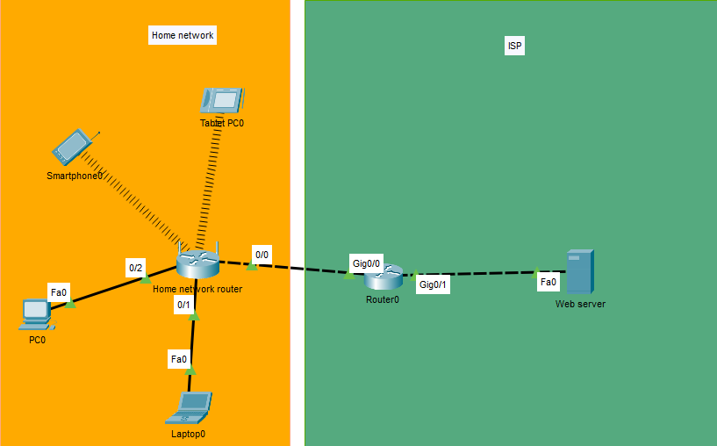
Figure 3

This diagram created in Cisco Packet Tracer shows a typical modern home network where there are wireless and wired devices connected to the router that gives out IP automatically thanks to the DHCP service and then then it communicates through the router to access the web server. A web server [26] is responsible for running the websites. The main objective of web server is to display and deliver web pages to the users, process and store the data and all of that happens thanks to the Hypertext Transfer Protocol (HTTP). There is another version of HTTP, and it is HTTPS which is a better secured version of HTTP. Web server is responsible for handling and accepting the request through the HTTP. Once the request is accepted, the response will be sent back displaying the content that the user asked for or an error message informing the user what went wrong.

The decision to design it that way was because of the research that have been done in literature review and according to literature review, that this is how most likely a modern home network looks like where the home network owner has a few wireless and wired devices connected to the home network router that gives out the IPs automatically thanks to the DHCP service and then goes through the router to access the web server so the user can access the information that is needed.

4.4 Implementation
This section will explain and evaluate all the five attacks that have been done. There will be an explanation of the process to execute the attack and mitigation strategies on how to stay away from these attacks.

4.4.1 Credential Harvester Attack

This is a fake facebook login page that was created thanks to Social Engineering ToolKit that comes with Kali Linux, simply the original link to the page was copied and pasted into the tool which ten hosted this fake website on the IP given during the process of creation.
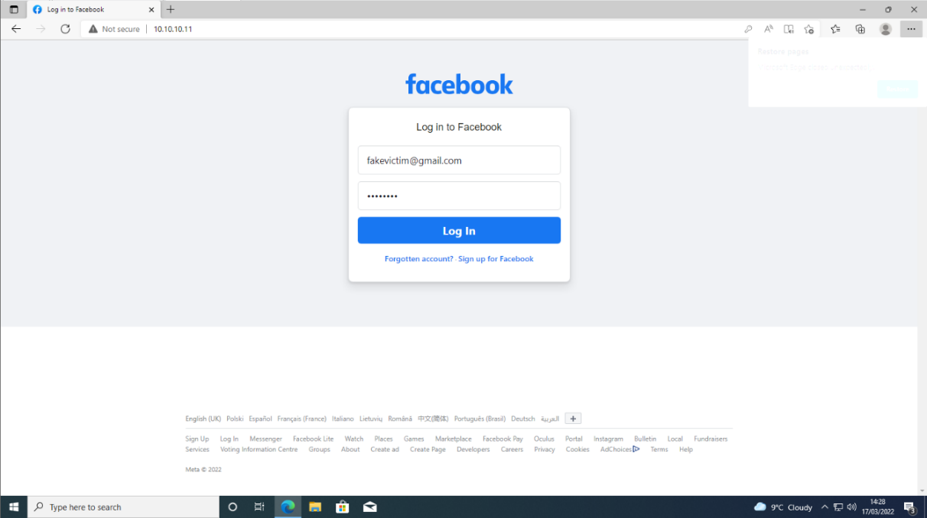
Once the user enters credentials, all information is being sent to the attack which in this case is Kali Linux machine and the attackers is able to see everything that was entered on that page, the tool also allows to generate a report which is shown below and it shows the email that was entered along with the password.
Figure 4
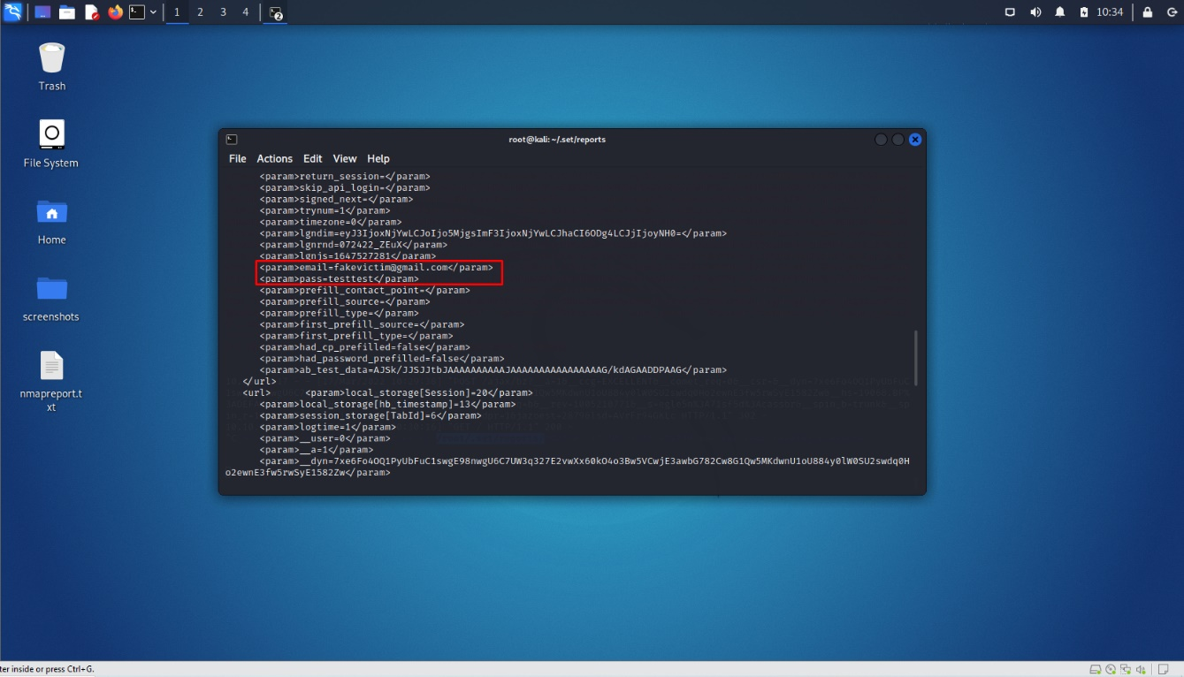
Generated report
Figure 5

4.4.2 How to stay away from credential harvester attack?

There are many things that can be done to stay away from spear phishing attack and overall phishing attacks. Antivirus was installed to block any suspicious website or traffic in general, browser extension has been installed as well and the operating system is being updated because the newest update might contain some important security patches and features for Microsoft Defender.

4.4.3 Man in the middle attack

Man in the middle attack allows the hacker to sniff the packets that are being sent between the user and the application. The hacker just sits there and listens without any notification to the user.

This is a beginning of the attack where the command to enable packet forwarding must be enabled because the machine will reject any packets that are not intended for it and IP forwarding is turned off by default. The reason for IP forwarding is to accept packets that are meant for the victim, the machine automatically will drop any packet that is not intended for the host machine.
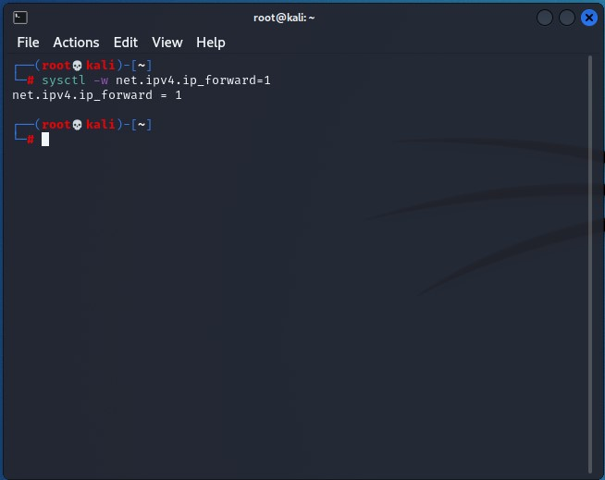
Figure 6
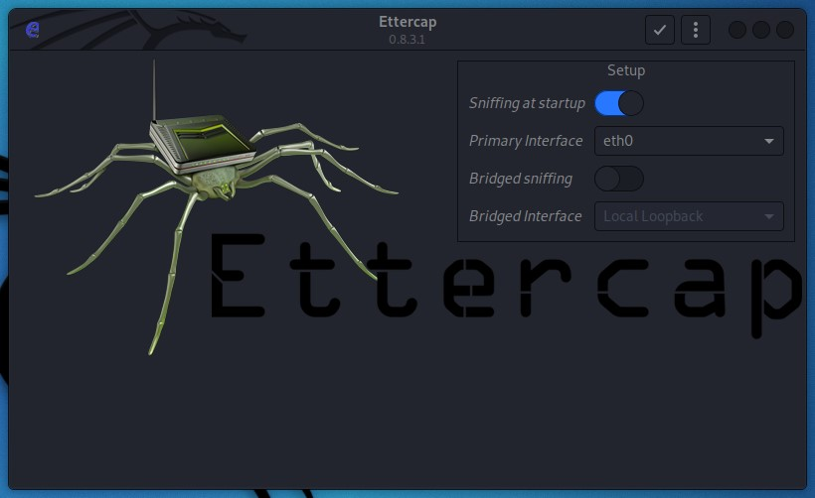
Here is Ettercap GUI which is the tool used to conduct Man in the middle attack, we can see that it will automatically start sniffing and the interface used is eth0.
Figure 7
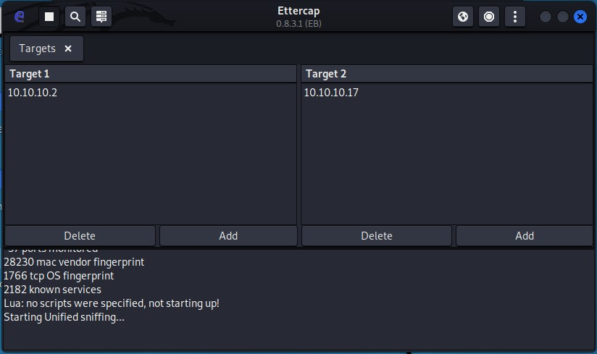
Here we can see that Target 1 is the victim’s IP and Target 2 is the gateway of the victim.
Figure 8
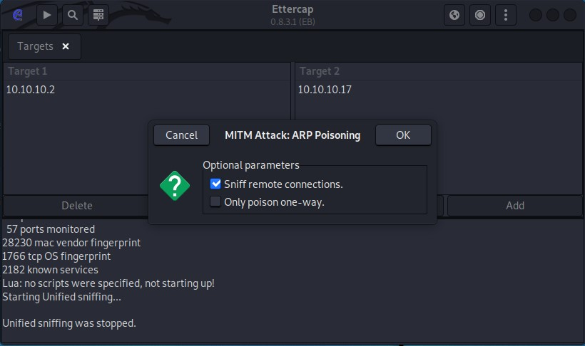
ARP poisoning started and it will only sniff remote connections
Figure 9
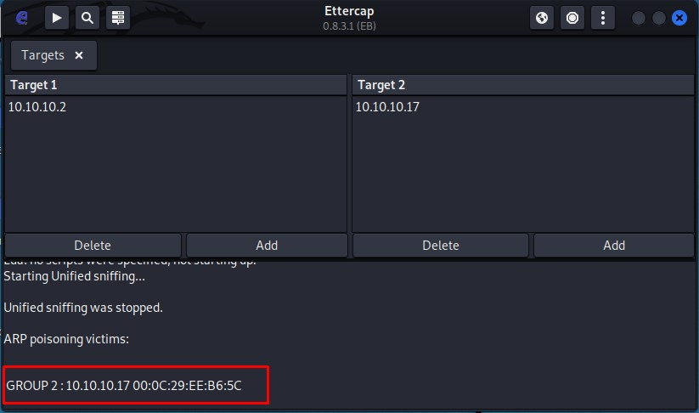
Here we can see that the ARP poisoning is currently running.
Figure 10

Here Tcpdump is one of the tools that can be used to sniff the packets, the command shown below says that the tcpdump will sniff eth0 interface using port 80 and the IP is 10.10.10.17 which is the victim and right below we can see the packets flowing through.
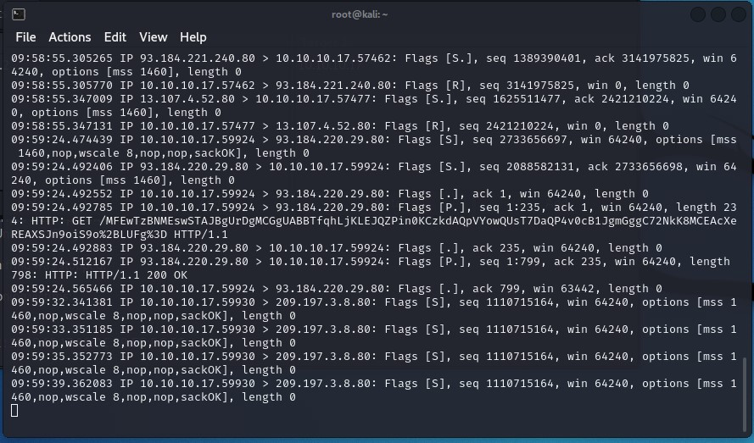
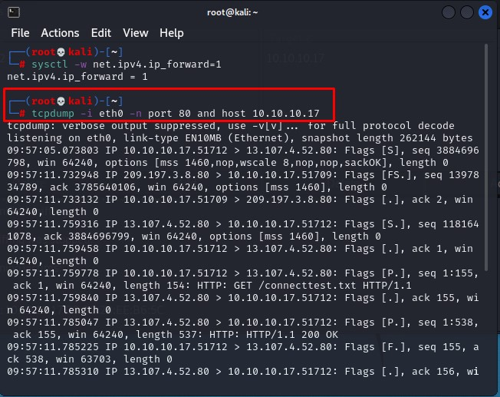
Here is the result of the victim accessing certain websites such as reddit which was accessed in this case
Figure 11
More packets are being captured
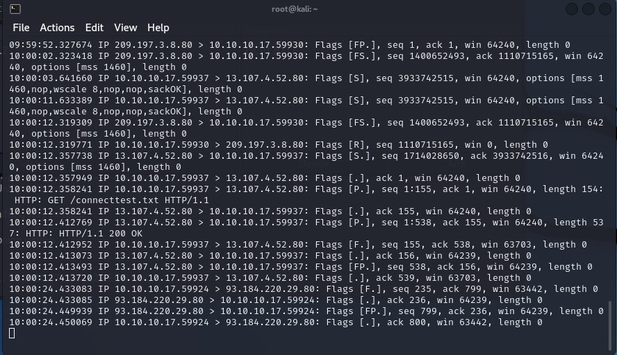
Figure 12
Dog picture downloaded
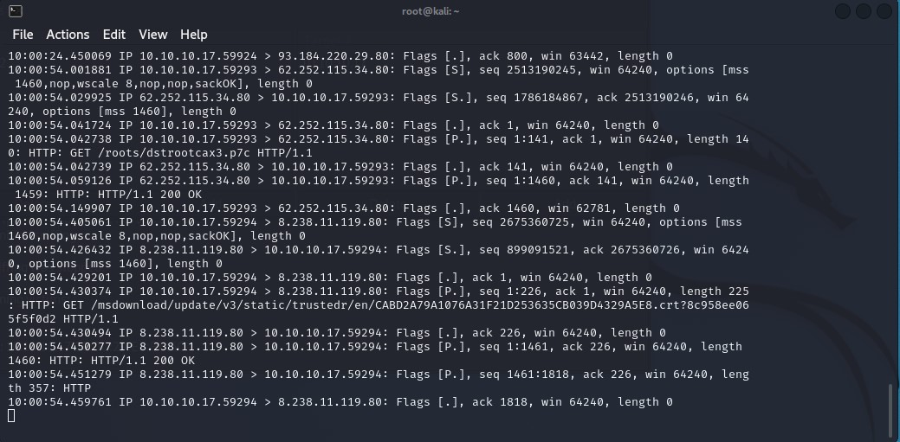
4.4.4 How to stay away from Man in the middle attack?

A simple VPN has been downloaded – Windscribe. It is a free VPN that has a limited amount of data of 10 GB monthly. There are many better VPNs such as ExpressVPN, CyberGhost etc. VPN will not make the network completely safe, but it is going to make it difficult for the attacker to sniff the packets as the victim is connected to the private server. Firewall has been also enabled because it provides that extra layer of security when the victim would go outside to use a public Wi-Fi.

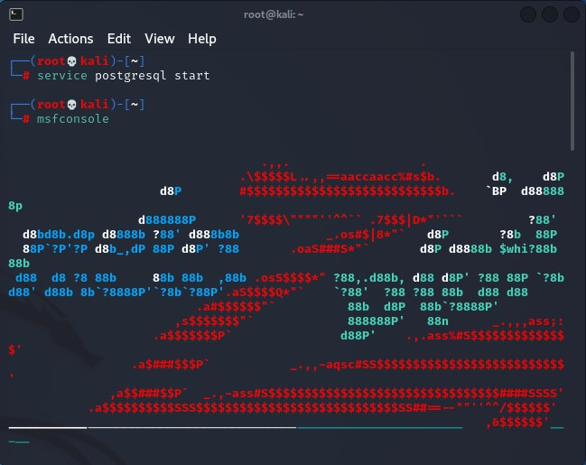
4.4.5 DoS Attack
Figure 13

Here, the service called “postgresql” had to be enabled for the msfconsole to start properly and then the tool is being launched.

Here, the command search synflood was used to locate where that certain feature used to conduct the attack is.
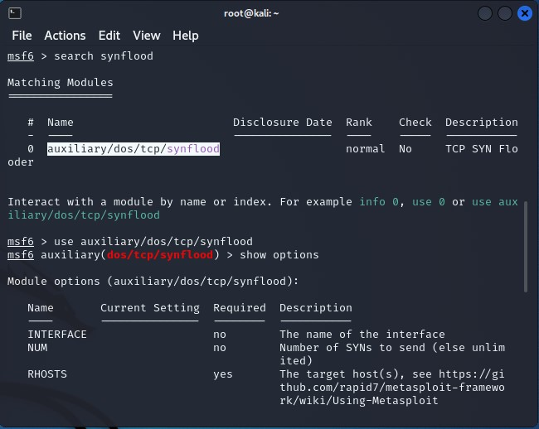
Figure 14

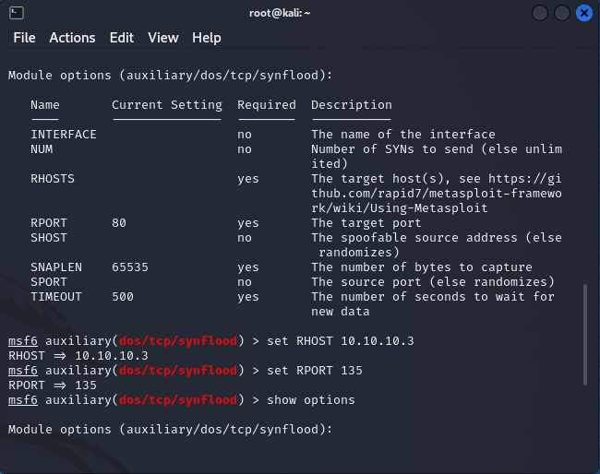
Here the module has been accessed and the host has been set to 10.10.10.3 using RHOST command, also the port used is 135 and it was set using the RPORT command.
Figure 15

Running show options command to see again if the settings got applied and running exploit using “exploit” command.
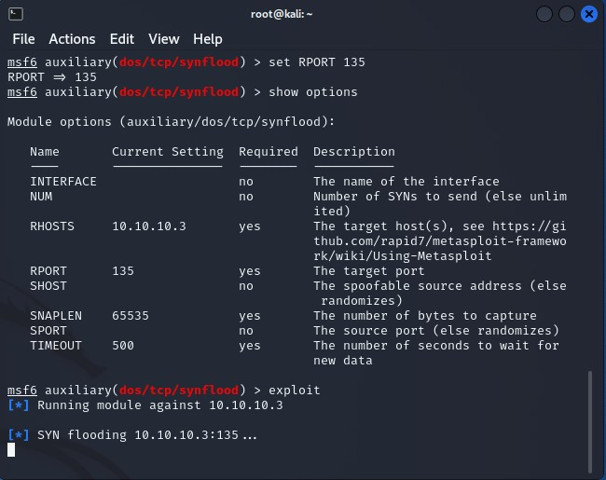

Figure 16
Wireshark capturing the packets
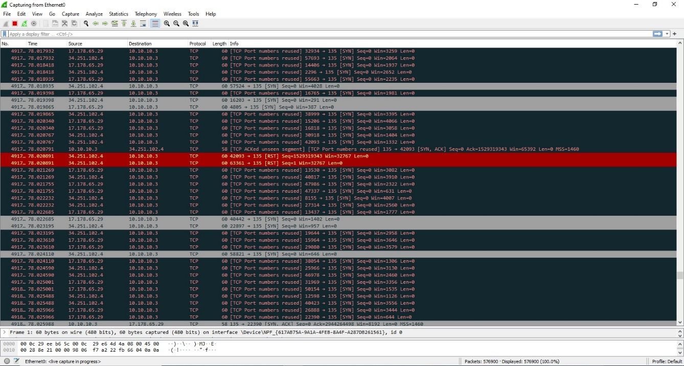
Figure 17
Connection is lost due to enormous number of packets sent


4.4.6 How to stay away from DOS attack?
Figure 18

The IPv6 could be turned on since it is a home network and there is no broadcast in IPv6, it is not recommended to enable it in a large network since it might go wrong when asking users for the IP address. The Dial in firewall has been modified to limit ingress and egress traffic on the network

4.4.7 DDOS Attack

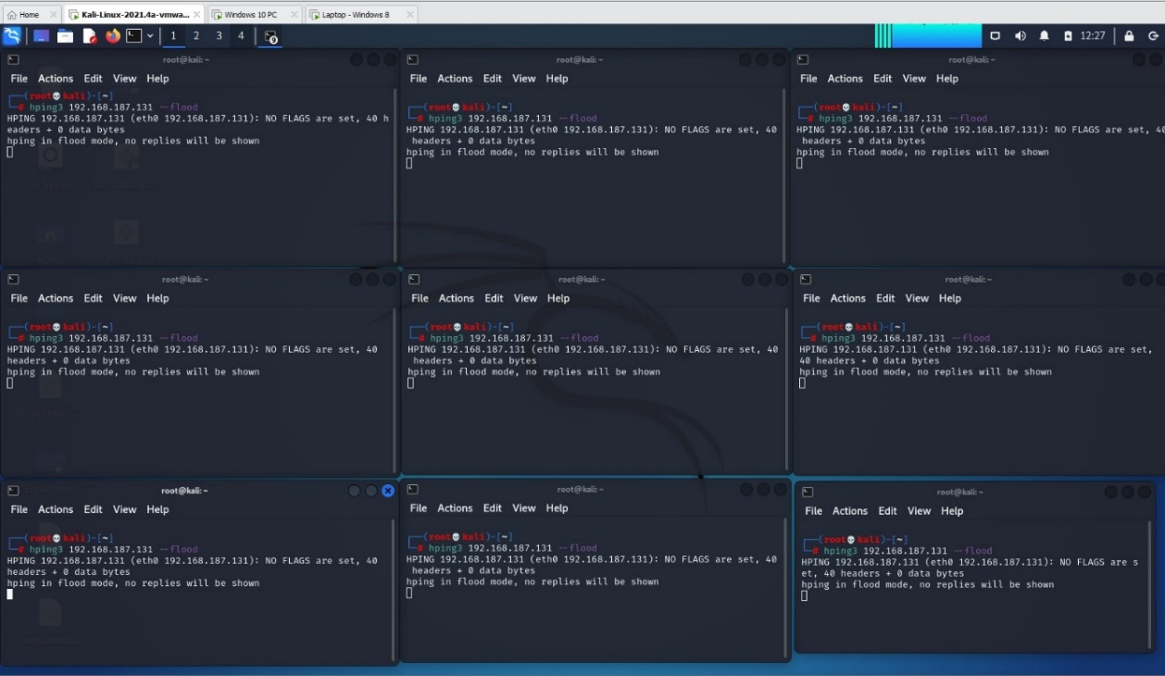
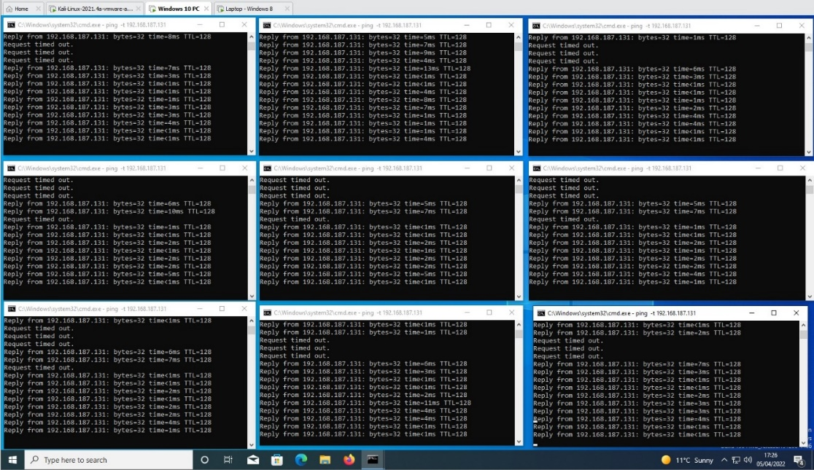
First, the real time scenario would be a multiple computers running, and it would be at least five of them and doing the attack but since the availability and resources are limited, only two machines are used to attack another machine. This screenshots shows hping3 command used to flood the victim which is windows eight machine.
Figure 19
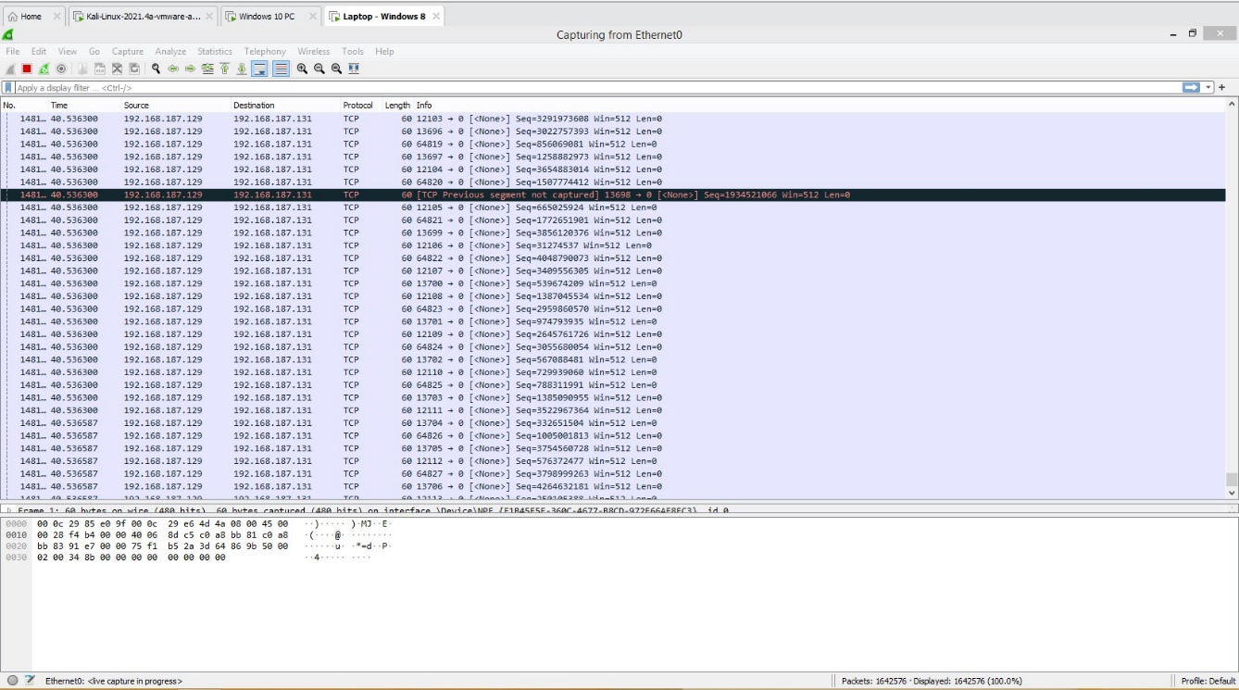
Figure 20

Packets in windows 8 are being received
This screenshot below shows windows 10 machine running the ping command against the victim

Figure 21

Here is a screenshot of facebook.com not responding when trying to access it after the attack was executed.

How to stay away from DDoS attack?
Egress and ingress filtering has been configured. Egress filtering protects other domains from attacks and allows only certain IP addresses space will be able to leave the network and to do that outbound filter is being used. However, ingress filtering will also prevent DoS attacks because of IP spoofing and additionally, it will locate the source of the attack but that will depend on the Internet Service Provider whether they have ingress filtering enabled rather than customer links. Ingress router sets to deny the traffic with any IP address that does not match the prefix assigned to the domain.

4.4.8 Password cracking – dictionary attack

This attack has been executed using hack-Gmail script to conduct the dictionary attack and it was created in python 3.
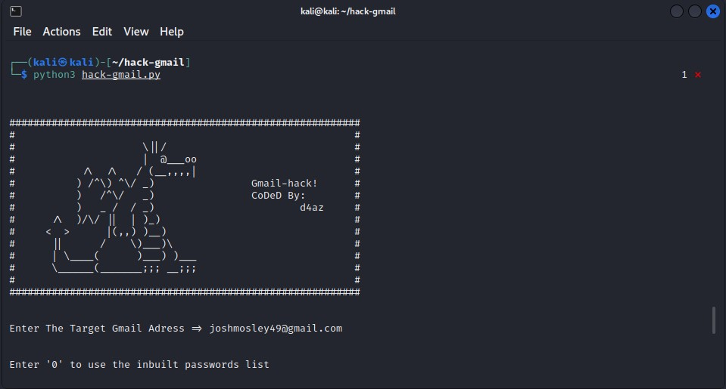
To execute the attack above, it was required to run it using python3 hack-gmail.py command and enter the target Gmail address that was created for the purpose of this attack. Also, the username list and password list has also been created for the purpose of this attack, so the tool has something to go through.
Figure 22
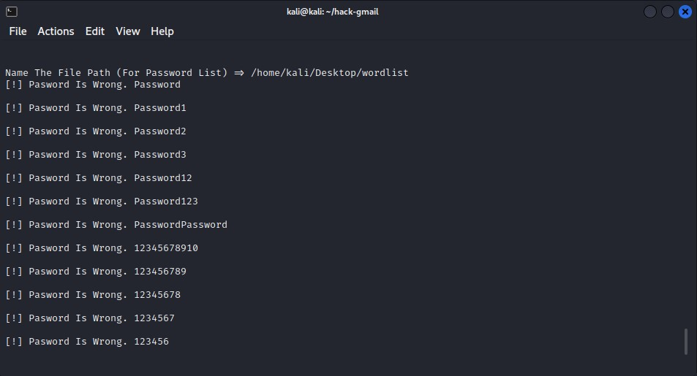
Figure 23
The screenshot above shows the script going through the list of passwords provided before the attack started and some of them are wrong.

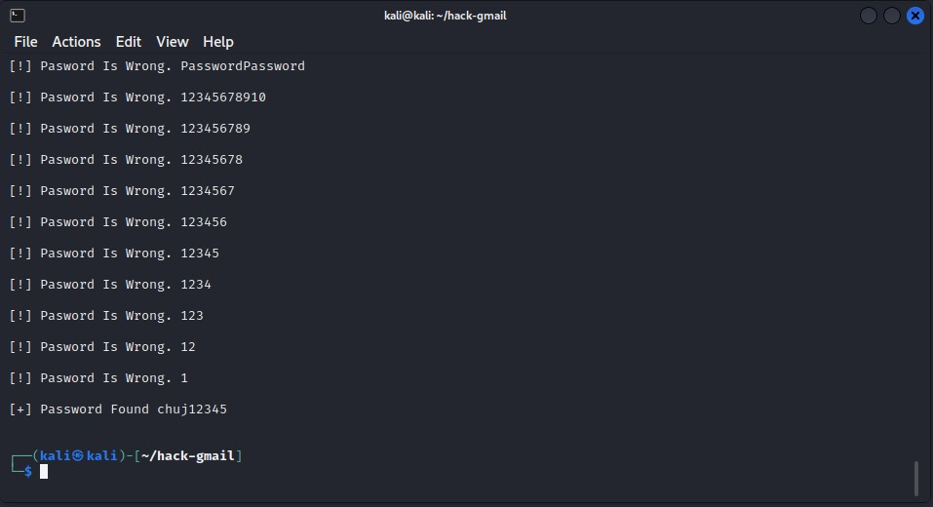
The script keeps going until the right password has been found, the password found at the bottom is the one that was set which is the right password, now all that needs to be done is access that Gmail account as the hacker using the password above.
Figure 24

How to stay away from dictionary attack?
If it were in the industry, the company would have set up multi factor authentication so even if the attackers manage to crack the password, it will still require that additional one-time passcode sent to the owner’s phone. The number of unsuccessful attempts was limited to a smaller amount, the password was changed to an extremely complicated ones that includes ten character mixed with capital letters, numbers, and special signs because it is not likely for random passwords like that to be included somewhere in the list on the internet.

4.4.9 Conclusion

It is essential to make sure that the attacks conducted are legitimate and done correctly and this is the reason why the outcome of the attacks are going to be discussed.

In general, it is possible to state that this chapter was the hardest to finish as it required knowledge and practical skills. Before the attack was attempted, the plan was clearly analysed and how it is going to go and how it will be approached, any issues or risks were thought of ahead if there were any to happen so the attack can be approached in a way to avoid any issues in the first place.

The hardest attack to approach was definitely man in the middle attack as it required IP forwarding and a little bit of knowledge about the tool that was used which is Ettercap, this tool allowed to execute the ARP poisoning on the victim and then another tool called tcpdump had to be used in order to sniff the traffic flowing through between the victim and the application. There were some issues as well such as unknown and unexplainable errors, VMware would not cooperate and the connection would be randomly lost after 1-2 minutes of using the network, the network settings had to be restored to default, since it was done, there were no issues with the connectivity. All the attacks have been executed successfully and the literature review goals have been met with each of the attacks. The issue with VMware connectivity had some serious delay but everything went well, this issue really developed the problem-solving skills.

Chapter 5 – Evaluation

It is essential to make sure that the attacks conducted are legitimate and done correctly and this is the reason why the outcome of the attacks will be compared to the literature review done in this report.

First, credential harvester attack and specifically “spear phishing” is based on creating a fake website to get victim’s credentials. The screenshots above clearly present that the fake website was created using the Social Engineering toolkit, the victim has accessed the website that was hosted on a local network, in the real-time scenario it would be a weird looking link and entered the credentials which then results in hacker knowing the password and the username straight after the credentials have been entered which was exactly the main goal of the literature review related to this attack and the goal has been reached.

The second attack was man in the middle attack, the main purpose of this attack is to get in between the victim and the application. As we can see, the screenshots above that are related to man in the middle attack are clearly showing the use of the tool called “Ettercap” which is used to sniff the traffic between the attacker and the application, the literature review related to this attack stated that the main goal is to sniff the packets and know the traffic between the attacker and the application, the outcome has been successful and goals have been reached, the packets are clearly visible and the connection has been established which results in the attacker seeing all the traffic thanks to using tcpdump tool, many other tools could have been used such as Wireshark.

The third attack is DoS attack which stands for Denial-of-Service attack and the main purpose of this attack is to disrupt the performance of the network by sending a large number of packets. This was done thanks to the Metasploit SYN Flood feature which sent a large number of packets, and the number of packets is clearly visible in the Chapter 4 where the implementation was done. According the screenshots above we can see that the goal mentioned in the literature review which is sending the packets and taking down the connectivity has been reached successfully, the packets have been sent and the victim could not access the internet.

The fourth attack is DDoS attack, and it is quite like DoS attack but instead of one computer it uses many but for the purpose of this project and limited resources and availability, only two machines have been used – in real life scenario it would be many computers infected with the malware. The main goal of this attack was to use multiple machines such as windows 10 and Kali Linux to attack the victim which is windows 8 client in this case and it was done thanks to many consoles and terminals that have sent packets to the victim, the attack have been carried out successfully and the victim could not access the website, additionally the packets were shown in Wireshark software so the goal has been reached successfully.

The fifth attack is password cracking and to be exact – dictionary attack where the attacker is giving the username and password list to the tool which is Gmail-hack in this case, and it was found on GitHub and the way it works is clear. The tool goes through the password list and username list, as soon as it finds a match, the attacker will be notified and the log in will be granted. The main goal of the literature review related to this specific attack was to use a tool, give it a wordlist such as password and usernames and let it go through to get a hit. The screenshots above that are related to this attack are clearly showing that the victim’s email have been used and the list of password have been provided as well, the tool went through all the password, and it found a match, the attackers was notified.

Chapter 6 - CONCLUSIONS AND RECOMMENDATIONS

6.1 Summary

The whole report is focused on getting to know the most popular home network attacks, how they are being carried out and what to do to prevent them. There are five attacks that are being discussed in this report – Man in the middle attack, Phishing attack (Spear phishing), DDoS Attack, DoS attack and password cracking dictionary attack. Each of the attack has a description and mitigation strategies and how to prevent them from happening. Some of the general steps that can be done right away by the user such as enabling firewall, changing the SSID of the router were discussed as well.

The aim and objectives achieved and were a great guidance to the project, informative and to the point so the outcome of the report is known. A draft network has also been provided that consists of the router that has access to the internet and a few wired/wireless devices connected to the router. The Gantt Chart that shows the journey throughout the project has also been included in the report and really helped to manage the project and stay on track with everything that was done and needs to be done.

The methodology also played a big part in the report and project in general, the methodology used was exploratory research and the reasons why it suits the project were also clearly outlined. The research onion method to conduct the research was especially useful and supportive when it came to executing the research as well.

There is also a section where related works was included and outlined, the purpose of this section is to show which articles helped to gain knowledge about the subject and project and provide a general overview of how everything works.

The way of presenting the report and the project has also been included in the report as well as the encryption methods that are being used to present day – some of them are not used that often now and the other are used all the time.

6.2 Conclusion

The journey with the project started by coming across the data of how unsecured the modern home networks are. The main aspects and key points have been gathered and what needs to be done, how it will be done and what is the expected outcome. The whole project started with outlining the aim and objectives as they are the foundation to this project because if the aim and objectives are not met, then the project is not finished. It started with doing the academic research and critical literature review to gather more knowledge about the subject and specifically this project just to make sure that it will be right. Once the literature review was done, it was time to put theory into practice and use the knowledge gathered from the research to do the attacks. The attacks were done successfully using different tools and different techniques. Many skills have been learned during this project and practical skills such as using the tools that are not similar and each tool required different level of knowledge. Time management and project management are the skills that have been developed the most during this project as the project required these skills to be at a satisfactory level to succeed.

The whole research focused on gaining the knowledge about the current situation of the most popular home network attacks, the main output of this research was the clear outline every single attack that will be attempted, steps to prevent these attacks, methodology, Gantt Chart and aim and objectives as well as conclusions for each chapter. The main output of this research is to successfully expand the knowledge about the subject, apply that knowledge to the project and then put theory from the research into practice and discuss, evaluate the attacks. The aim and objectives have been a great guidance throughout the journey of this great project, they really helped to stay on track and keep everything nice and neat to make sure nothing is missing. The research discussed in detail the modern home network setup, the purposes behind the attacks, their detailed mitigation strategies and how to apply these strategies. The main outputs of the research have been met.

There were many conclusions drawn in each chapter, the first conclusion that was drawn. The first conclusion that was drawn was conclusion related to chapter 1, this conclusion described the foundation of the project and analysed what needs to be done to successfully finish the project, what are the aim and objectives, and it was a guidance of going through each thing one by one to make sure that nothing is missed.

The second conclusion that was drawn was related to chapter 2, this chapter was a particularly important chapter since it outlined every single attack that was attempted in this project in detail, its mitigation strategies and how to apply them and how the project is going to be presented. The Gantt Chart showing the journey at that time where it was created also helped to understand how the work is being done and at what pace the work needs to be done. This chapter had significant effect on the outcome of this project because it decided what the practical part is going to be.

The third conclusion that was drawn was related to chapter 3 which was all about the methodology used to carry out the research, the research onion has been talked about and discussed in detail, each was discussed and analysed to check which options are suitable for the nature of this project, the name of the methodology has been mentioned as well which is exploratory research along with the reason why this certain research methodology suits the project very well and stands out from many other options that are available out there.

The fourth conclusion focuses on the practical part and it is related to chapter 4, this conclusion really talked about the attacks, how they have been carried out and which one was the most difficult and also why, the tools that have been used and also some issues that were faced along the way of doing the project such as VMware connectivity issue where the VMware would randomly drop a stable connection and never reconnect, the solution to that was to restore the network setting in virtual network editor to default. This conclusion really sums up the practical part where the attacks were executed. That chapter play an especially important in showing and giving the evidence in form of screenshots that the attacks were done successfully and met the goals related to the literature review.

The fifth conclusion discusses the conclusion of the fourth chapter and shows how the attack were related to the literature review and how the knowledge gained from the literature review research was applied to help in completion of the attacks.

The sixth conclusion discusses what has been done in this research and what were the main outputs of the research, and it gives a general overview of the advantages and benefits gained out of this project such as problem-solving skills that were improved etc.

6.3 Recommendations for Further Research

The research that has been done has many great ways of improving it and developing even further. There are many areas that could be improved and would require further research so this chapter will focus on recommendation on what areas can be improved and why.

The first area that could be improved is password cracking area because there are many options of brute forcing the password and the one described in the report is the one used against home networks which is dictionary attack.

Another great area that could be improved is encryption area because the details described in this report about the encryption is just a bit more than standard description due to the nature and requirements of this project, there are many great encryptions that could be applied on home networks but that would require networking knowledge.

The third area that is due to be further discussed is phishing area in the report, the phishing that has been described is credential harvester attack known as spear phishing when one single individual is being targeted or one single network. There are many other ways of executing a phishing attack such as whaling, email phishing, malware, pop up phishing, watering hole phishing, vishing, HTTPS phishing and the list could go on and on.

DDoS section is another area which has way more to it rather than what is described here, DDoS attacks are enormously powerful attacks as it can cause serious damage when it comes to customers, financial and reputation or the company might never recover due to the data and funds loss.

The last area that could be further developed is methodology section because there are tens or hundreds of methodologies that can be used to conduct the research. Surely, this project would be suitable to use many methodologies, however the one that has been chosen which is exploratory research suits this project the best.

Chapter 7 – Reflection

I am extremely satisfied with how this project went and with the entire process and effort that had to be put into this project to successfully meet the aim and objectives that were set. A lot of practical skills have been learned because this project is allowing to work with many different tools and each tool worked a bit different and had different purpose. It is impossible to avoid any issues or problems on the way but I have managed to overcome these problems such as VMware dropping the connection for no reason even when the network was properly configured and work out the solution so I can state that my problem-solving skills have improved thanks to this project. I have also learned how to present the data in a readable format such as PowerPoint presentation and the correct structure and layout of the document which makes it easy to read. My project management skills have improved as well because this was my biggest and the longest project that I have ever challenged, and it turned out as expected which is a success. My time management skills were extremely important as it allowed me to divide project work and assignments work into equal time slots so a good amount of work can be done continuously not just for the project but also for other modules and assignment that I had.

This section discusses to what extent the aim and objectives of this research has been achieve. It reflects how well the objectives have been achieved and what could have been done to address any shortcomings. The reflections drawn during this research are also brought together under the umbrella of the objectives.

In general, I can state that this project went well, however there were some issue, but all the issues have been fixed and everything is working as it should be. Some valuable and extremely useful knowledge has been absorbed and this project made it possible to run the attack in the real-time environment too see how it really looks like, not just theory but practice.

The first objective was:
- Gain a broad knowledge about the main subject of this project which is securing the home network and about vulnerable spots of the network as well as fixing the security gaps.
The objective above has been successfully completed, the knowledge about the subject of study and about the project has been widened and a lot more knowledge has been absorbed. The vulnerable spots such as lack of firewall, no anti-virus installed, no VPN etc have been fixed. (Whole report in general)

The objective below was achieved as well because there has been some deep research done about other attacks that can happen at any time, however the most common ones have been identified and the solution on how to stay away from them has been provided as well and also what steps have been taken in order to fix the security gaps. (Chapter 4)

- Establish understanding of all the possible attacks that can happen at any time and find out which are the most common ones and provide a brief and clear solution to them and how to avoid them in the future by applying a few simple steps and features.

The objective below has been achieved as well as the aim and objectives have been revised and a critical literature review related to the project has been done and provided. (Chapter 1 & 2)

- Provide a critical literature review of the aims, objectives, and current research with the aim of providing the level of existing knowledge about the subject.

This objective below has been achieved as well because the knowledge gathered from the research has been put into practice and the virtual network using VMware has been created, the attacks mentioned in the objective below have been executed successfully. (Chapter 4)

- Use and present the assets gathered from the research and literature review to produce a secure home network by creating a VMware network to try to break in and penetrate with all the possible attacks and resources so the weak spots are discovered and fixed as soon as possible. This will be approached in a few ways; phishing commonly known as creating a fake website, man in the middle attack, DoS attack, DDoS attack and password cracking and to be precise – dictionary attack with a word list, the account that will be attempted is going to be Gmail account.

The objective below has also been achieved because there were a lot of troubleshooting required such as fixing the VMware connectivity issue where the network connection would be dropped after 1 or 2 minutes of using the network for no reason. The fix was to restore the network settings to default and that fixed everything along with still assigning IP properly thanks to DHCP. There were a lot of problems, and it has all been fixed thanks to the knowledge gathered from the literature review.

- Gain a broader understanding of all the methods used such as simple troubleshooting to fix the issues with the network, such as going back, troubleshooting every single device, and checking the configuration just to find the error, understand how it happened and fix it and avoid it in the future.

The objective below has been fully achieved and some simple steps that can be done right away to avoid these attacks have been described briefly and as simple as possible. (Chapter 2, 2.2)
- Provide a brief and clear instruction and recommendation on how to avoid cyber-attacks and loss of sensitive, important, and valuable data and fully secure the network and devices connected to the network step-by-step.

Appendix

Old Gantt Chart

The Gantt chart above shows the journey throughout the project that has not finished yet. It clearly shows the start and end of the project which is literature review because it is an on-going process. This is the Gantt Chart that was created at the beginning of the project and was meant to outline the original path.

New Gantt Chart
The Gantt chart above shows how the journey throughout the project has changed. Some of the dates had to be extended due to additional amount of work that had to be done, some points have been also added with the dates. The Gantt Chart above is the most recent and updated chart which shows how it all went.

chapter 8 - REFERENCES

[1] I. F. Norbert Nthala "Home Network Security", w European Workshop on Usable Security (EuroUSEC) 2018, London 2018.

[2] NATIONAL SECUIRTY AGENCY CYBERSECURITY INFORMATION. "csi-best-practices-for-keeping-home-network-secure" 18 September 2018. [Online]. Available: https://www.nsa.gov/portals/75/documents/what-we-do/cybersecurity/professional-resources/csi-best-practices-for-keeping-home-network-secure.pdf?v=1. [Accessed: 09 December 2021].

[3] M. Shin, J. Ma, A.Mishra i W.Arbaugh, "Wireless network security and authentication," Wireless Network Security and Interworking, vol 94, issue 2, pp. 455-466, 2006.

[4] L.O. Tom Karygiannis, "802.11 WLAN security," Wireless Network Security 802.11, Bluetooth and Handheld Devices, pp. 3-13.

[5] [3] K. J. T. L. Eric D, Industrial Network Security (Second Edition), Syngress, 2015.

[6] M. Erbschloe, "Phishing - solution," in Social Engineering Hacking Systems, Nations and Societies, Boca Raton, CRC Press, 2019, pp. 180-208.

[7] D. R. M. A. e. al, Hack Proofing Your Network, Syngress, 2002.

[8] [5] M. Erbschloe, Social Engineering Hacking Systems, Nations and Societies, Boca Raton: CRC Press, 2019.

[9] M. Erbschloe, "Phishing - solution," in Social Engineering Hacking Systems, Nations and Societies, Boca Raton, CRC Press, 2019, pp. 180-208

[10] Bogdanoski, Mitko and Suminoski, Tomislav and Risteski, Aleksandar (2013) Analysis of the SYN Flood DoS Attack. International Journal of Computer Network and Information Security (IJCNIS), 5 (8). pp. 1-11

[11] P. L. Qijun Gu, "DoS Prevention," Denial of Service Attacks , pp. 4-28.

[12] R. Fujdiak et al, "Generator of Slow Denial-of-Service Cyber Attacks," Sensors, vol. 21, (16), pp. 5473, 2021. Available: https://www.proquest.com/scholarly-journals/generator-slow-denial-service-cyber-attacks/docview/2565704039/se-2. DOI: http://dx.doi.org/10.3390/s21165473.

[13] M. S. Deepika Mahajan, "DDoS Prevention," DDoS Attack Prevention and Mitigation, vol. 67, no. 19, pp. 0975-8887, 2013.

[14] J. S. B. B. L. Bosnjak, "Dictionary Attack," w Brute-force and dictionary attack on hashed real-world passwords, 2018.

[15] B.O. Folasade Ayankoya, "Dictionary attack prevention," Brute-Force Attack Prevention in Cloud Computing Using One-Time Password, vol 17, issue 2, pp.7-17, 2019.

[16] J. P. G. A. Rūdolfs Kalniņš, "Wi-Fi types of encryption," Security Evaluation of Wireless Network Access, vol. 21, pp. 38-45, 2017

[17] D. Chandler, "Wi-Fi Encryption Vulnerability Highlights Value of Industrial IoT Security Practices," Electrical Marketing, 2017. Available: https://www.proquest.com/trade-journals/wi-fi-encryption-vulnerability-highlights-value/docview/1953333348/se-2?accountid=130472.

[18] D. Bhatt i M.Sharma, "General article 1 - Overall information about the home security," Security in Wireless Home Networks - The emerging Trends and Existing Problems, vol 6, issue 3, pp. 1-6, 2012.

[19] W. M. Kang, S. Y. Moon and J. H. Park, "Second article - related works," An enhanced Security framework for home appliances in smart home, vol 1, issue 7, pp. 1-12, 2017.

[20] R. Alturki, "Research onion - (pragmatism part), "Research Onion For Smart IoT-Enabled Mobile Applications, 2021, p. 2.1, 2021.

[21] M. Z. W. AbuSneineh, "Deductive Appraoch," w An Evaluation Framework for E-Learning Effectiveness in the Arab World, Elsevier Science, 2010.

[22] "Georgia State University," 4 March 2021. [Online]. Available: https://research.library.gsu.edu/archivalresearch. [Accessed: 12 February 2022].

[23] A. Sahay, "Time Horizon - Research onion," Peeling Saunder's Research Onion, 2016.

[24] A. Melnikovas, "Data Collection & Data Analysis," Towards an explicit research methodology: Adapting research onion model for future studies 2019, vol 23, pp. 39-41, 2018.

[25] C. Elman, "Exploratory research," in The Production of Knowledge - Strategies for Social Inquiry, Cambridge University Press, 2020, pp. 17-19.

[26] R. E. M. Nancy J. Yeager, "Web Server," in Web Server Technology, San Francisco, United States, Elsevier Science & Technology, 1996, pp. 1-8.
Bring together conclusions drawn in each chapter and summarise here.

