Slide 1

Slide 2

Hotel Premier Inn is a British hotel chain that also operates in more than one country. There are 800 hotels of Premier Inns in the world. The presentation discusses the analysis of macro, micro, and digital marketing of Premier Inn

Slide 3

The 4Ps of marketing of Hotel Premier Inn are:
- Product: To accommodate a variety of guests, Premier Inn provides many room categories. As an illustration, its family suites include a separate bedroom for parents, two pull-out or lounge beds for children, and a traveling cot for a newborn. For families to keep a watch on their children, several hotels feature rooms that link. Solo, twin, and viewable rooms are the most common types of rooms. likewise, to this, practically all Premier Inn hotels offer a pub and a cafeteria on the premises so that visitors do not need to travel far for beverages and meals. To assure the security and comfort of the visitors, all hotels allow bikes and follow a strict daily cleaning schedule.
- Pricing: There are several pricing options offered by Premier Inn, including Flexible, Semi-Flexible, Prepaid, Regular, and Non-Flexible rates. These give clients a variety of choices. The most preferable choice is Flexible, which allows them to change or terminate their visit up until 1 o’clock on the same day they are scheduled to arrive. Generally speaking, the hotel has a discount pricing strategy designed to give its guests excellent for their dollars. Similarly to that, it also uses price competition, with its cheapest deal frequently being for stays on Friday, Saturday, and Sunday evenings.
- Place: In addition to the UK, Premier Inn also operates over 800 hotels abroad in places including Germany, Qatar, Ireland, and the United Arab Emirates. Through the hotel's official site and mobile app, guests can make direct reservations for rooms.
- Promotion: In Premier Inn, promotion plays a crucial part. The hotel makes significant financial investments in its marketing efforts across a variety of media, including broadcast, newspaper, internet, and social networks. With a specific focus on increasing its digital reach, it plans to invest £20 million in advertising in 2022. The Premier Inn Facebook page has more than 325,000 followers. But just over 22,000 people follow its Instagram account. As a result, the business needs to improve its social media profiles.

Slide content
Premier Inn utilizes a marketing mix to effectively compete in the hospitality sector (Putra, et al, 2020). The 4Ps of the marketing mix of Premier Inn is (Išoraitė, 2016):
- Product
- Pricing
- Place
- Promotion

Slide 4

The SWOT analysis for the Premiere Inn Hotel is provided below:
- Strengths: One of the many advantages of the Premier Inn is the vast amount of locations that it has, which helps to satisfy guests. Consumers would be able to fulfill their financial demands with the help of a variety of services that are accessible on the web, particularly in light of the economic difficulties brought on by COVID-19. Clients who anticipate a positive environment and a reduction in COVID-19 releases would be more likely to choose environmentally friendly solutions.
- Weaknesses: Unlike other major hotel companies, the hotel doesn't have a strong presence abroad. People are staying in hotels more often during the pandemic because they miss out on the diversity of services that are offered that are accessible at home. Due to the pandemic restrictions on people's travels, the hotel is also facing increasing rivalry and a constrained return.
- Opportunities: Three crucial possibilities exist for Premier Inn. The brand, particularly in Germany and Ireland, has engaged in several strategic mergers with companies from around the world. Utilizing cutting-edge technologies in Europe and other regions of the world for online marketing is yet another potential. Last but not least, there is the chance to commercialize satisfied customers as a result of excellent customer service offered across numerous sites.
- Threat: The contention between lodges and privately owned accommodations companies like Airbnb is developing each day. Padstow Townhouse, Bovey fort, and The St. Mawes lodge are some examples of competing accommodations. The premier inn hotel is receiving extra purchaser complaints because of data breaches, which is predicted to damage the lodge's recognition.

The analysis of the marketing environment (Micro) of Premier Inn is done by analyzing the four aspects (Bowie, et al, 2016).
- Strength
- Weakness
- Opportunities
- Threat

Slide 5

The PESTLE analysis of Premier Inn hotel is done below:
- Political factors: The regulations put out by legislative politicians have a considerable effect on the UK hospitality industry. Taxation, competition, and visa limitations have a direct effect on the daily operations of the Premier Inn Hotel. The present legislation that has had the biggest impact on the hotel industry is the travel warnings for pandemics. Many tourists and residents have been discouraged from using the hotel amenity by the restricted movement covid-19 restrictions. Because of its low taxes, the Premier Inn Hotel has been able to survive the negative impacts of the pandemic.
- Economical: Premier Inn Hotel reservations have been impacted by the economy, a strong British currency, lockdown, and limitations. But because the U.K. government is currently relaxing its travel advice, some travelers who needed high-end hotels were able to reserve rooms in the hotel.
- Social: The desire for private rooms over hotels is a result of socioeconomic issues currently facing the United Kingdom. A large number of customers of the Premier Inn Hotel have shifted to Airbnb. The hotel has added more services, as a consequence, to get some of the customer’s wants.
- Technological factors: The Premier Inn Hotel is able to enhance the reservation process and other customer services by utilizing top-notch technology, such as 5G. Online operations are increasing people's desire for hotels. However, security and privacy are frequently violated by hacking and revealing customer confidential details to the wrong parties. Because internet hotel operations are not secure, high-end customers are more concerned about their safety.
- Legal: Legal issues have persisted in the day-to-day activities of the Premier Inn Hotel due to changes in the legal landscape. A common legal issue is security leak allegations made through the hotel's online channels. Customers frequently complain about data breaches using the "General Data Protection Regulation Act", which protects UK citizens and foreign visitors.
- Environmental: The Premier Inn Hotel's smart use of technology has reduced U.K. demand on the available resources. There are several environmentally friendly practices implemented, including energy-efficient lighting, renewable energy, and efficient showers. Due to its usage of green electricity, the hotel has attracted numerous guests. Rather than its activities, the hotel is presently seeing the effects of climate change from other areas.

Slide content

In the macro environment, the analysis is done based on external factors (Fallon, 2016). The analysis of external factors is done through these factors (George, 2021):
- Political
- Economical
- Social
- Technological
- Legal
- Environmental

Slide 6

The Premier Inn values its customers and increases customer engagement with them by focusing on these tips:
- By adding a personal touch: The era of data is now. By storing guest information in your hotel management system, you can give both new and returning customers a more individualized experience. The personal information (likes and dislikes) of potential customers of Premier Inn is advantageously saved in the software. A personal touch that guests appreciate is knowing about a guest's favorite suite at the time of booking.
- Exciting offers: In the hospitality sector, exciting offerings are quite important for exceeding guests' expectations. To entice new visitors to become devoted patrons, the Premier Inn offers enticing discounts and fantastic incentives. Consider more than just the free meals and drinks provided at check-in.
- Amazing guest experience: Even before checking in, the guest experience begins. The organizational culture that Premier Inn developed places the needs of the customer first. Connect with their visitors online once the reservation is made. Send out emails with pertinent information; highlight upcoming events in the area, well-liked hangouts, and other information that would be of interest to the visitor.
- Exceeds customer expectations: Because they prioritize meeting and exceeding guests' expectations, Premier Inn stands out from the competition. Recognizing that each guest has a unique set of expectations is the first step in making this a success. If your goal is to consistently outperform your clients' expectations, you must thoroughly research and comprehend your clients' visitors.
- Value feedback: It's possible that unhappy guests won't always express it verbally when they're there. It is crucial to actively and thoughtfully solicit input before, during, and after a stay for this reason. Premier Inn appreciates all input, both favorable and negative, and works to strengthen its areas of weakness.

Premier Inn is the most popular hotel brand in the world (Zhang, et al, 2017). It is the go-to brand for tourists (Taheri, et al, 2017). Premier Inn values its customers and develops engagement (Tarrant, 2018 ):
- By adding a personal touch
- Exciting offers
- Amazing guest experience
- Exceeds customer expectations
- Values feedback

Slide 7

The Premier Inn can make its marketing activities more effective by utilizing digital marketing, such as:
- Content marketing: A strong audience, cultivated relationships with current clients, increased brand confidence, and higher booking rates can all be attributed to good content. High-quality content is a critical component of certain other kinds of digital marketing, and content marketing may draw individuals in at different stages of the customer journey. Podcasts, quick films, and e-books can all be used to accomplish this.
- Social media marketing: Social media marketing is the most effective marketing strategy because with the help of this hotel can reach a large audience. There are several channels to do social media marketing such as Facebook, Instagram, Twitter, and YouTube. These platforms have daily used by large a amount of individuals.
- Email marketing: Today's majority of people are familiar with email, which makes it easy, quick, and inexpensive for you to engage with visitors directly. You can quickly customize and focus your content with email marketing tools, and you can track the results of your marketing campaigns after that.
- Search engine optimization: Search engine optimization is something Premier Inn needs to prioritize if they want to attract more and higher-quality visitors from Google and other search engines to their hotel website. SEO entails activities like conducting keyword research, producing quality content, obtaining links from other websites, and ensuring that your website is quick and responsive across all platforms.

The hotel can use digital marketing in its marketing activities (Alghizzawi, 2019):
- Content marketing
- Social media marketing
- Email marketing (Buttle, et al, 2016)
- Search engine optimization (Slivar, and Bayer, 2017)

Slide 8

Premier Inn can improve its marketing strategies and get high bookings by focusing on some tips such as:
- Optimize their official website (Pandey, 2021)
- Create loyalty programs (Hofman-Kohlmeyer, 2016)
- Understand your target audience (Cetin, and Walls, 2016)
- Collaborate with local vendors (Adongo, and Kim, 2018)

Slide 9

This presentation concludes that operating a business is crucial but also analyzes the business environment (Micro and Macro) in which the business operates. And to perform effectively in the competitive world by utilizing some strategies and upskilling your services.

Slide 10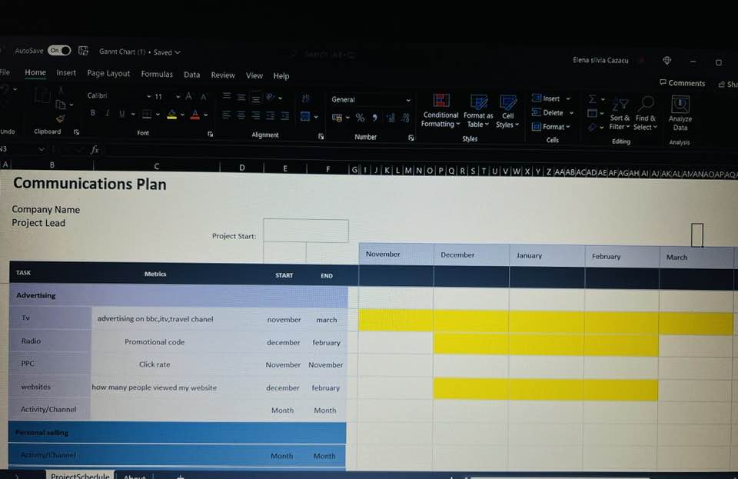

Slide 11
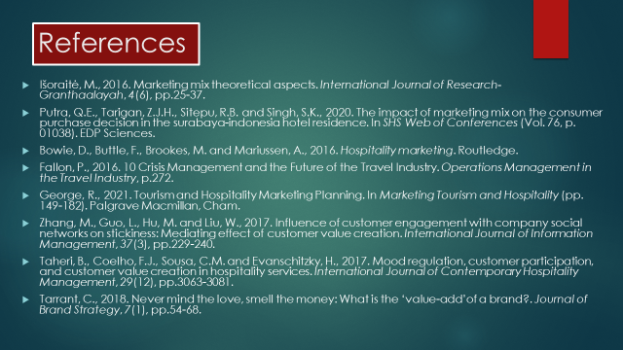

Slide 12


