Kelsee Gwyther
Student Number: 1702748
Course Title: BA Hons Photography in The Arts
Word Count: 2137
Tutor: Paul Duerinckx

Using at least 3 examples, consider how image makers have
utilised digital technology to explore one of the following: Conflict,
Identity, the Surveillance State, the Technological World?

Using at least 3 examples, consider how image makers have utilised digital technology to explore one of the following: Conflict, Identity, the Surveillance State, the Technological World?
For this essay I will be considering how two image makers have used digital technology to explore the surveillance state and exploit their methods of monitoring us. I will also be discussing how the surveillance technology and techniques are getting more advanced and national surveillance controls how image makers produce work. I have chosen Alphonse Bertillon who is an important figure in the early stages of the surveillance state when, secondly, I have chosen Mishka Henner, who is a contemporary photographer that exploits the technology we are being monitored by. I plan to put the two types of surveillance against each other to compare how they’ve affected us and how they will continue to influence the way we live.
National Surveillance constantly watches us through the cameras in the sky, our smart phones and other means, knowing they are watching, people act differently. People often put on a front or change their behaviour to fit in, what interest me most is that we do it mostly subconsciously. I plan to explore two types of the surveillance state from different time periods, compare them and see how image makers have incorporated that into their work.
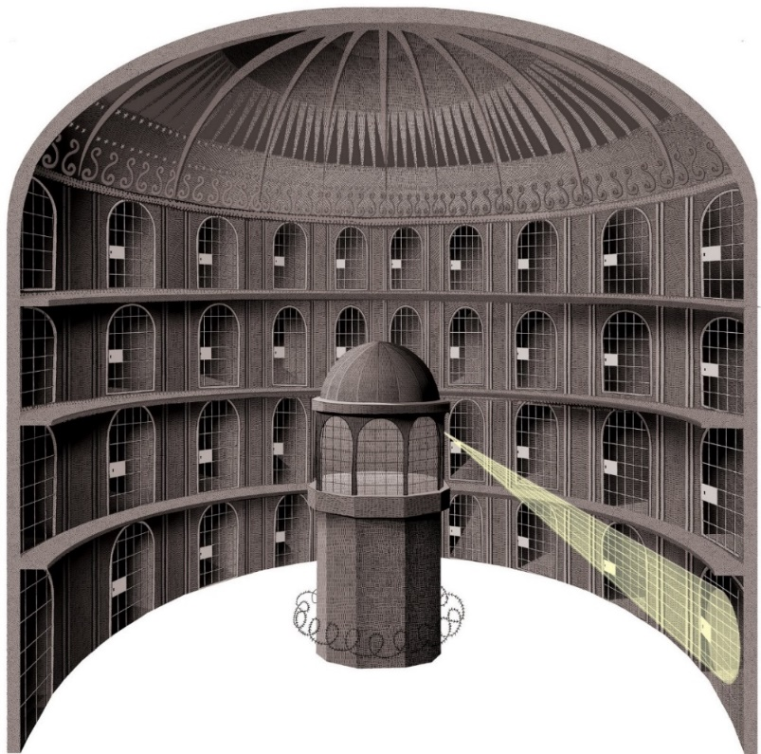
Using the panopticon as an example, the guards in the prison were able to monitor inmate’s behaviour from one tower that overlooked the entire prison, the prisoners couldn’t see the guards so always had to assume there was an unwavering gaze, so adjusted their actions accordingly. Michel Foucault (1926-1984) was the founder of the panopticon, the original idea was for the building to be used for ill people, to separate them from the outside world to create a clean community of sorts. The idea developed greatly, the knowledge of someone watching from the tower has been applied to many different scenarios, to create new ways of monitoring society. We know that there is someone watching but don’t know who or when, so we act differently in different settings, at home where we assume no one is watching we tend to act in any manner we see fit, in a public situation we tend to mimic the behaviour of those around us to fit in and not stick out. Nothing is as off the grid as it seems. Jeremy Bentham was the British philosopher that published this plan for the experimental Panopticon penitentiary on 1791, it was the first all-seeing surveillance, and although Bentham couldn’t persuade the British Government to invest in the idea, the principles of the Panopticon had an extensive influence for the future of the surveillance state. The government takes our consent of having technology and interacting in the world outside of our homes as us accepting that they are ‘keeping an eye on us’ at every turn. Using satellite images and surveillance cameras before mobile phones were made, there was little worry about being observed, in today’s day and technological age things are different. People are far more conscious about the way they act in public or in front of a camera, gps tracking in our smartphones, laptops and other gadgets fills people with a sort of paranoia.
This brings me to my first image maker, Alphonse Bertillon (1853-1914), he was the first to create a system that monitored people, people altered their behaviour according to the system. The system was a starting point for the surveillance society. Alphonse Bertillon (1853-1914), a French police officer that created the identification system, ‘Anthropometry’ created in approximately 1871, to capture criminals. Anthropometry is a form of measuring, created to measure every aspect of an offender, the height, head length, size of their nose to the layout of their teeth. The criminal had a card with a front and side profile photograph, with the measurements written above and below. Bertillon believed that that by giving all of this information, the authorities looking for the criminal could measure the offender against the characteristics on the card. He thought that people that were more likely to be repeat offenders could be identified as having similar characteristics and would therefore be easier to catch.
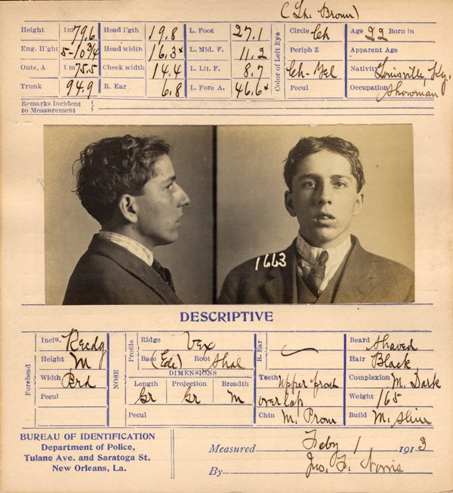
By creating this system, people were constantly monitored by the authorities, however in one case, the system had some serious faults. The “West Brothers” case was one of the most advanced cases, William West was a wanted criminal who had been put in a penitentiary upstate without the status of his arrest being updated. Will West was an innocent man arrested for crimes he hadn’t committed, despite continuously denying the allegations, he was jailed. The men had almost identical measurements, so the wrong man was convicted, after that incident, the criminal brother was found incarcerated and the fingertips were analysed so the innocent man was released from custody.

He exploited the technology and authority he had as a police officer to gain a level of control over the public. Having the ability to take photographs, measurements ad fingerprints of people gave not only him, but the state the upper hand because they could monitor us more closely. A fail this big caused some doubts that the system would let criminals slip through, so after the incident, the surveillance state changed. It made fingerprinting the new age, Bertillon’s anthropometric measuring system was used alongside fingerprints to get a more accurate system for filing criminal information. This system was used up until the late 20th century, however, the techniques had developed enough to get considerably better results. In 1959, satellite images of the Earth were being taken by the Soviet satellite, Luna 3, although blurry, a new age was upon us.
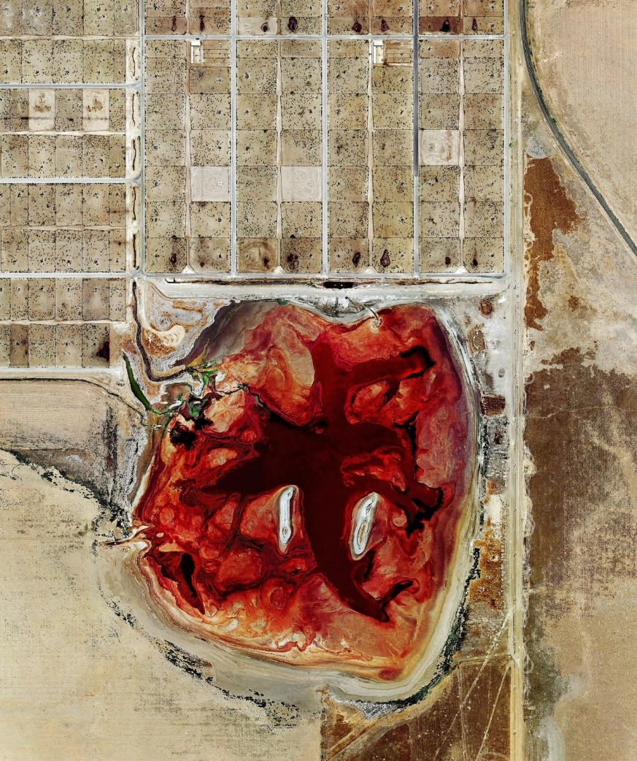
The years following were quite the same, but in 1972, Apollo 17 captured on of the most fascinating images of the Earth: The Blue Marble. The images using satellite were quickly developing but they weren’t used to monitor us just yet, they were used to keep an eye on the development of the planet. It wasn’t until 2005 when Google Maps was created that it could be used to view the Earth in great detail. This brings me to my second image maker, Mishka Henner. Mishka Henner uses Google Street View on Google Earth to create aesthetic, surreal images that provoke thought into how these images were produced to begin with.

Mishka Henner, “Coronado feeders, Delhart, Texas, 2012” with cattle rendered like an expressionist painting.
The image has what seems to be plots of land at one end of the waste pool, looking closer I can see small buildings that look like specs of dust compared to the giant lake of red acid. This red lake sticks out like a sore thumb against the dull beige landscape that surrounds it, the image itself grabs the attention of anyone looking. However, even if I had not known the intentions of this artist, I would have understood the context of this image as well as the rest in the series, he makes it clear that this is something out of the ordinary. This isn’t something people see every day, Google Earth has put it for everyone to see but haven’t advertised it. I like the way that there are multiple shades of red within the pool, almost highlighting different levels of danger. The images he creates are that of a different nature, they are full of things that could never have been caught on camera showing the full scale or make such an impact on anyone that sees the series. I think the image shows just how close the government are watching but by using Google Maps, Henner (2012) has continuously used their means against them to gain some control in the situation.
Using the surveillance state as an active participant, he creates art from some of the most secret places in the world without actually using a camera or leaving his own home. I chose this image as I feel it represents how anyone can access any part of the world at the click of a button, Henner uses the age of digital technology to show the public that we’re being watched, one way or another. The surveillance state means that everything is watched, it strikes a certain amount of fear into people knowing they’re being monitored, so we see a change in behaviour in different situations and settings. This is how artists are making work now, using this technology that has been made to monitor our very existence to use it to make people aware of the things the state has seen while monitoring us. Henner (2012) uses the images on Google Earth website to highlight how closely we are being watched, he does so without fear to exploit them the way they have us, to show us what they didn’t want us to see what they were hiding in plain sight.
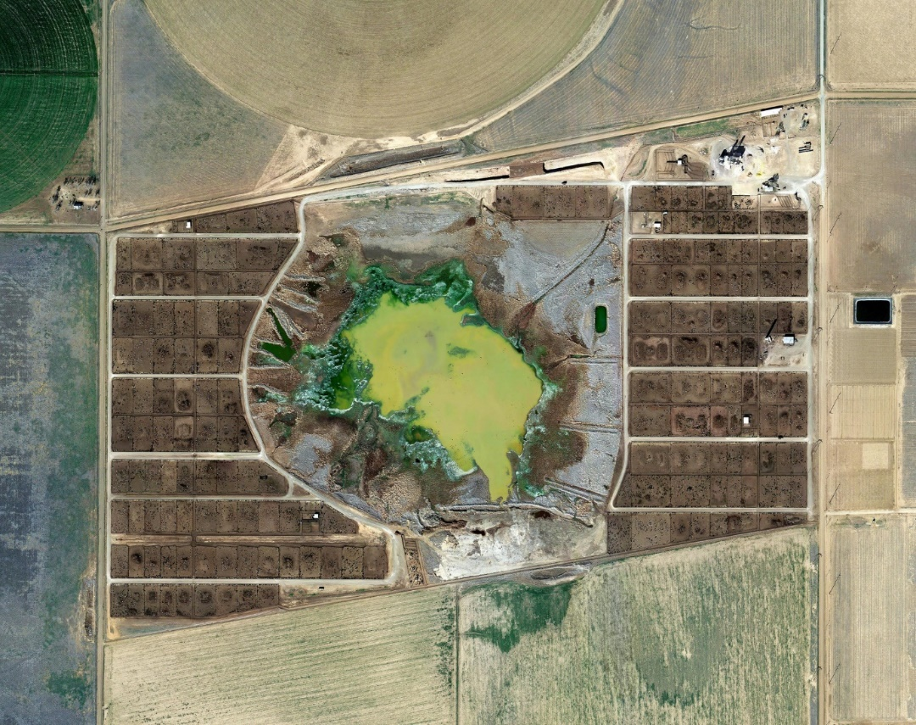
Mishka Henner, “Tascosa Feedyard, Bushland, Texas” (2013)
This photograph is just one of many, demonstrating how easy it is to access these landscapes, I chose Henner (2013) because of the nature of his work, I wanted to showcase how he utilises the means of monitoring against the government that uses them to regulate us. Society views surveillance as a way to keep an eye on everything but they don’t understand that there are a million types of surveillance, satellite imagery isn’t the only way of watching. The government uses the internet to access personal data, what websites we shop at, what we put in our search engines to push us towards what they think we want to see and try to influence what we do next, what we do for the rest of our lives. Henner uses mainly Google Earth to showcase how they watch us so closely but fail to cover up things they don’t want us to see like, acid waste pools that are surrounded by cattle farming land. His series of work ‘Feedlots’ displays the cattle farming industry for it’s truth, in an interview with Op- Ed, LA Times, Mishka Henner (2013) tells us “It used to take five years for a cow to reach its mature weight, ready for slaughter and processing. Today, since the structures and processes of feed yards have been perfected, that has been reduced to less than 18 months.” that the average time for cows to reach its maturity is five years. Even with modern technology, for this to happen, the feeder pools need to be next to the lands. Google Earth pixelates military lands and bases but leaves areas like these exposed for photographers like Henner (2013) to stumble upon. It almost feels like they were left deliberately for people to find, using the technology provided by the surveillance state, we’re allowed to delve into what feels like private land and invade peoples personal space to exploit for our own pleasure. There is nowhere to hide anymore, not in the open or even in our own homes, the surveillance state has succeeded in its task of securing the means of monitoring the nation entirely, even down to what we eat.
In conclusion, the surveillance state has become an incredibly advanced system that is always going to keep developing, it has the chance to grow because of the way it is being utilised by the government, to maintain the control and keep people altering their behaviour to fit into the system, the surveillance society will continue evolve. Looking at how the surveillance system really started, I would say the panopticon was an enormous influence in how the state would monitor and encourage the alteration of behaviour to follow rules, however, not many people would agree. It would seem that Bertillon’s (1853-1914) anthropometry system of measuring was another huge step into the right direction, while a different technique of monitoring the nation, despite its faults, was one that stuck. I believe that this system was the starting point for the age of technology being used to monitor people, taking mugshots of criminals and listing their measurements was unheard of and became a pillar in the surveillance community. Then we watch as it develops in the years after, fingerprinting, the age of digital criminal filing, satellite imagery and ‘Big Brother’s’ watchful eye, there are countless examples of the evolution of national surveillance. However, the most used instrument by the government and the public, is the internet, taking advantage of this tool, people have been able to explore things that wouldn’t normally be allowed, artists like Henner (2013) have learned to exploit this way of monitoring people to create interesting work, that sometimes pushes boundaries.
If image makers are willing to push the boundaries and explore the unknown, how far are the state willing to go to develop their resources and continue to be one step ahead at all times?
References
Mishka Henner, (n.d.), Interview with Op-Ed, LA Times (original unavailable), Available at: https://mishkahenner.com/Feedlots. (Accessed on: 10 November 2018)
Bibliography
Websites -
Digital Museum, (n.d.), Available at: http://dh.dickinson.edu/digitalmuseum/exhibit-artifact/babes-in-the-woods/nailing-down-identities. (Accessed: 1 November 2018)
Melinda Laituri, (June 4 2018), Satellite imagery is revolutionizing the world. But should we always trust what we see?, Available at: https://theconversation.com/satellite-imagery-is-revolutionizing-the-world-but-should-we-always-trust-what-we-see-95201. (Accessed: 1 November 2018)
National Law Enforcement Museum, (November 2011), Bertillon System of Criminal Identification, Insider Volume 3, Issue 9, Available at: http://www.nleomf.org/museum/news/newsletters/online-insider/november-2011/bertillon-system-criminal-identification.html. (Accessed on: 3 November 2018)
Brought to Life Science Museum, (n.d.), Alphonse Bertillon (1853-1914), Available at: http://broughttolife.sciencemuseum.org.uk/broughttolife/people/alphonebertillon. (Accessed on: (3 November 2018)
Books –
David Lyon, (1994), The Electronic Eye: The Rise of Surveillance Society, Blackwell Publishers.

