

Case Study

By: Ashley David John
Student Number: 1704970

Site Production and Project Management
Module Code: M5X01875
Dr Juan A Ferriz-Papi
University Wales Trinity Saint David
Swansea, Uk
2018/2019

Table of Contents

Introduction……………………………………….P3

Case Study………………………………………...P3

Method……………………………………………..P4

Discussion………………………………………...P5

Conclusion………………………………………...P6

References………………………………………...P6

Appendices………………………………………..P7

Introduction

The construction industry is one of the most complicated industries around. Certain builds provide new and interesting challenges to overcome and at times create innovative designs and ideas to overcome certain dilemmas. Typically, construction has been perceived as simple placements of rock or cement and it’s done, those in the industry understand this is a false statement. Using the Spon's architects' and builders' price book 2011 (Spon’s), calculations and pricing of a bridge to be built will be shown and understood.
Showing that the complexity of construction is more than we understand on a basic level. It’s important to understand what is involved in construction processes and why it is complex even with the end result looking easier to understand, as information on site has to be delegated and easily readable so tasks can be completed. This will include operations such as labour hours, cost of procedures, time to complete.

Case Study

This paper needs to be able to calculate the costs and time of many activities of the following statement:
A bridge crossing the river Loughor is needed to be built. Four Piers are required to support the deck, two are inside the river. The deck is 15m over the river level. The river depth is 3m at each of the piers location (Figure 1.1 below). The soil is a large layer of lime and mud, more than 4m thick up to the bearing layer. The best construction method is needs to be defined.
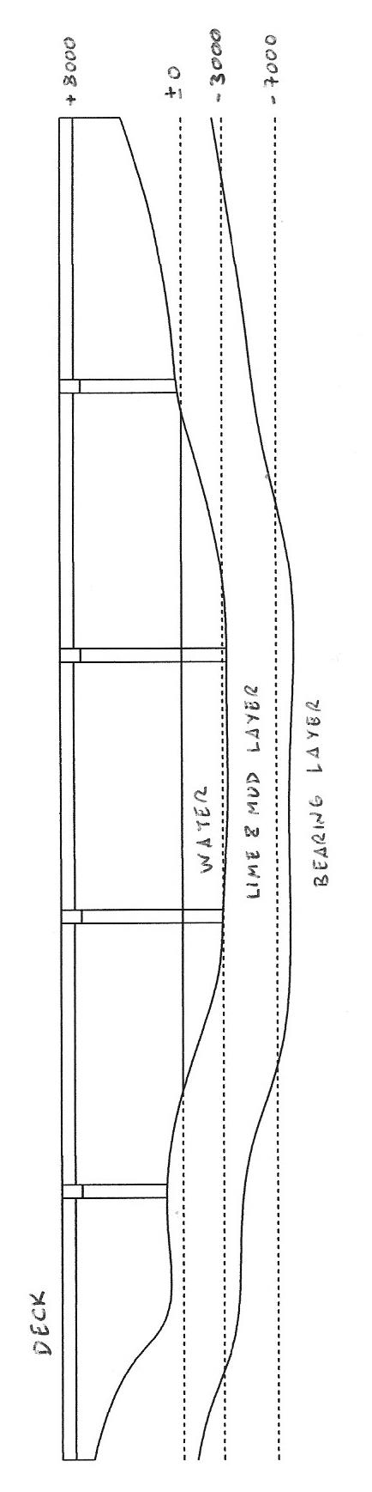
Construction methods are needed to be identified and calculated for 4 different piers, while also identifying which type of materials are required for 3 sections of the bridge in:
- Foundation
- Substructure
- Superstructure
Along with the figures to be generated, calculation of labour cost and time is to be identified and presented within a Gantt chart for easier viewing and interpretation.
(Figure 1.1)

Method

The methods used in completing these tasks along with the labour costs can be shown with an example such as the piers.

The piers were measured as 4m by 1.5m and need to reach around 11m high.
Beginning with working out the cubic metre of the concrete required for 1 cubic metre.

(Figure 2.1 – Pier Cap + Piles & Pier example)
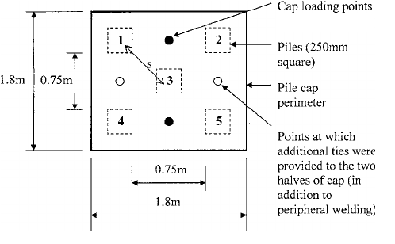
L = 1.5m
W = 4m
H = 11m

A = 1.5 x 4 x 11 = 66m3

A x 2 = 66 x 2 = 132m3 of concrete to create 2 piers for the inner section of the drained river bed.

Having this number we are able to calculate the duration of the work for the 2 river bed piers, while then being able to calculate the duration for each worker that is assigned that task.
(Labour Hours X Unit) / Labourers
4.07 X 66 = 268.62
268.62 / 3 = 89.54 = 90 hours for 1 pier
A concrete gang is required to fill these pier sections which apparently will take around 25/26 hours each, the next calculation is:
Labour Rate X Amount of Hours
A single concrete gang will require £59.01 an hour, although, only 1 foreman and 3 skilled labourers are needed. This will need to be further broken down for each member. The gang consists of a Foreman at £14.57 an hour and 3 Skilled Labourers at £11.11 an hour each.
In this case a Skilled Labourer earns £11.11 an hour therefore:
£11.11 X 89.54 = £994.79
£994.79 X 3 = £2,984.37 for 3 Skilled Labourers
While the Foreman will be earning:
£14.57 X 89.54 = £1,311.30
So the estimated total for this particular work should be:
1,311.30 + 2,984.37 = £4,295.67 for this one gang to complete 1 pier of the river bed. So combining both piers and just this one gang:
1 pier per gang = £4,295.67
1 pier = 66 X 132.25 = £8728.5
Total cost to build 1 pier = £13,023.67

Discussion

Working with Spon's architects' and builders' price book 2011 has presented complications and abnormalities within this paper. While being able to understand the cost and hours involved in a pier, it creates issues while trying to understand and calculate as in appendices 1 with the highlighted pink sections. Spon’s doesn’t identify the dimensions of a straight girder, except giving 40kg/m while giving its Units in the form of Tonne. While using an internet search can make the understanding easier, there are various degrees of girders from 40kg/m or lower. With different types of flanges and widths and depths, making calculation of these girders non-existent for this paper.
Additionally, looking away from Spon’s, missing data in the forms of vehicles required, storage, insurance for works or employees, lighting and power for the works, small plant and tools. The list is large, granted the end result is looking for a Gantt chart, but cost is still required to be calculated.
Additionally, certain elements inside of the Spon’s price book leave out elements such as time on rentals for items such as the Cofferdam. It’s given £3467.50 for 1500m2 which includes extraction, maintenance, erection and dismantling. This though is priced as an item and typically, these are priced for a period of time which isn’t given to calculate with. This provided confusion and uncertainty how to implement within the works.
While on site a Formwork gang is required to be able to erect their structures in aiding with the concrete and unfortunately inside of Spon’s it became a significant challenge to price or find suitable methods that could be used to create work essentially for the Formwork gang.

Conclusions/Summary

Using Spon’s 2011 specifically as that was the access present at the time of writing this paper, creating accurate pricing and detail towards specific tasks, has created a larger challenge than seems to have been necessary. Such as compiling work for Formwork gangs was difficult to price or include within the paper, as information related to the gang to price up works couldn’t be uncovered or included, as Spon’s included dimensions and prices for a series of different materials and processes but not giving enough information related to what is needed for the activities of the bridge.
Additionally, it has given more easier solutions to some aspects such as the deck construction, but eluding to the costs and time associated with it for the team which is being used, there being a lot of ups and downs to how this works and creating abnormalities in how the bridge is to be constructed, such as are these prices including labour costs for a team that would be included outside of the existing team, along with the duration that would be involved is not mentioned.

References

Assaflex UK. (n.d.). Assaflex UK | Bridge Expansion Joints & Bearing Pads Manufacturer. [online] Available at: http://www.assaflex.co.uk/.
Cottingham, D. (2019). How wide are roads?. [online] Highway Code Resources. Available at: https://mocktheorytest.com/resources/how-wide-are-roads/.
Cmu.edu. (n.d.). Project Management for Construction: The Design and Construction Process. [online] Available at: https://www.cmu.edu/cee/projects/PMbook/03_The_Design_And_Construction_Process.html
Intergraph.com. (n.d.). [online] Available at: https://www.intergraph.com/assets/global/documents/SPC_LaborFactors_WhitePaper.pdf.
Slideshare.net. (n.d.). Case study bridge construction upto pier and road construction. [online] Available at: https://www.slideshare.net/SatishKambaliya1/case-study-bridge-construction-upto-pier-and-road-construction-68691504.
Steelconstruction.info. (n.d.). Bridges - initial design. [online] Available at: https://www.steelconstruction.info/Bridges_-_initial_design.
.

Appendices:

1.A Gantt Chart (See email)

1.B Spreadsheet of calculations:
Groundwork Gang | Rate | Total |  | PC £ | L. Hours | Labour £ | Material £ | Unit | Total £ | Cost £ | Calc. Total | Duration |  | Labour Pay
1 Ganger | 11.11 | 11.11 |  |  |  |  |  |  |  |  | Lab Hour x Unit | Divide by labs.
6 Labourers | 10.29 | 61.74 |  | Groundworks - Excavations by machine/preservation of topsoil |  |  |  |  |  |  |  |  | Ground Work Gang
 |  | 72.85 |  | 8m | 0.12 | 1.38 | 1.35 | m3 | 2.73 |  | 2.4 | 4.8 |  | Ganger | 207.1778
 |  |  |  | 150mm | 0.02 | 0.23 | 0.65 | m2 | 0.88 |  | 0.0226 | 0.0452 |  | Labourer | 191.8865
Concrete Gang |  |  |  | 8m | 0.12 | 1.38 | 1.35 | m3 | 2.73 |  | 2.4 | 4.8 |  | labourers | 1151.319
1 Foreman | 14.57 | 14.57 |  | 600mm | 0.08 | 0.23 | 0.65 | m3 | 0.88 |  | 13.504 | 9.002666667 |  | Total | 1358.497
4 Skill. Labourers | 11.11 | 44.44 |  | Site Works -Single 7.30m wide carriageway |  |  |  |  |  |  |  | 18.64786667
 |  | 59.01 |  |  |  |  |  | m | 1125 | 168750
 |  |  |  | Site Works - Reinforced concrete bridge with precast beams
Steel Fixing Gang |  |  |  | 30m Span |  |  |  | m2 | 1125 | 1265625
1 Foreman | 14.57 | 14.57
4 Steelfixers | 13.76 | 55.04 |  | Structual/Carcassing metal - Girders Straight
 |  | 69.61 |  | Girders |  |  |  | tonne | 1489
Formwork Gang |  |  |  | Structual/Carcassing metal - Framing, erection
1 Foreman | 14.57 | 14.57 |  |  |  |  |  | tonne | 200
10 Carpenters | 13.76 | 137.6
1 Labourer | 10.29 | 10.29 |  | Brick/Walling |  |  |  |  |  |  | 31.79 | 21.19333333 | Bricklaying Gang
 |  | 162.46 |  | 15.3 | 0.85 | 17.25 | 16.56 | m2 | 33.71 | 1260.754 | 31.79 | 21.19333333 |  | Foreman | 308.7869
 |  |  |  | Groundworks - Steel Piling Cofferdam |  |  |  |  |  |  |  |  |  | B.layers | 1749.722
Bricklaying Gang |  |  |  | Leader rig |  |  |  | Item | 3467.5 | 3467.5 |  |  |  | Labourers | 0
1 Foreman | 14.57 | 14.57 |  | Sheet Piling - Cofferdam + Leader rig w/ hammer |  |  |  |  |  |  |  |  |  | Total | 2058.508
6 Bricklayers | 13.76 | 82.56 |  | Pier Bank |  |  |  | m2 | £172.62 |  |  |  | Formwork Gang
3 Labourers | 10.29 | 30.87 |  | Pier River |  |  |  | m2 | £172.62 | 121373.4 |  |  |  | Foreman
 |  | 128 |  |  |  |  |  |  |  |  |  |  |  | Carp.
 |  |  |  |  |  |  |  |  |  |  |  |  |  | Carps.
 |  |  |  | Land Drainage |  |  |  |  |  |  |  |  |  | labourer
 |  |  |  | Up to 1200mm |  |  |  | m | 130 | 130000 |  |  |  | Total
 |  |  |  | Concrete/Precast Concrete |  |  |  |  |  |  |  |  | Concrete Gang X2
 |  |  |  | Pier | 4.07 | 54.69 | 77.56 | m3 | 132.25 | 12696 | 195.36 | 65.12 |  | Foreman | 948.7984
 |  |  |  | Pile Cap | 0.1 | 1.14 | 1.55 | m3 | 97.34 | 9344.64 | 2.4 | 1.2 |  | S.Labour | 2458.476
 |  |  |  | Pile(s) | 8 |  |  | m3 | 1350 | 13500 | 20 | 40 |  | S.Labs. | 29501.72
 |  |  |  | Pier Cap | 1.13 | 15.15 | 83.39 | m3 | 98.54 | 17737.2 | 50.85 | 25.425 |  | Total | 30450.51
 |  |  |  | Pier | 4.07 | 54.69 | 77.56 | m3 | 132.25 | 17457 | 268.62 | 89.54
 |  |  |  |  |  |  |  |  |  |  |  | 221.285
 |  |  |  |  |  |  |  |  |  | Total H. |  | 247.2783333 |  | lab. Total | 33867.52
 |  |  |  |  |  |  |  |  | Total £ | 1622381 |  |  |  | Totals £ | 1656249

