
University of Wales Trinity Saint David

Programme: Master of Business Administration
Module: Strategic Management
Module Code: LCMB7003



Assessment Title: Individual Report – BP’s Strategic Expansion into the Indian Energy Market
Lecturer: Simon Chatterton
Student Name: Radislav Nikolov
Student ID: 2118366
Word Count: 4995
Submission Date: 29th November 2025

Table of Contents

List of Figures 3
List of Tables 3
Executive Summary 4
1. Introduction 5
2. Selection of Organisation and Target Market 8
2.1 Overview of BP plc 8
2.2 Rationale for Selecting India 8
2.3 Strategic Fit and Competitive Advantage 9
2.4 Justification for Expansion 9
3. Comprehensive Strategic Analysis 11
3.1 PESTLE Analysis for BP in the Indian Market 11
3.2 Porter’s Diamond Model – National Competitive Advantage of India 12
3.3 Porter’s Five Forces Analysis – BP in the Indian Energy Market 13
3.3.1: SWOT Analysis – Strategic Summary of BP’s Position in India 16
3.3.2 Stakeholder Analysis: Mendelow’s Matrix 17
3.3.3 Strategic Options 17
3.3.4 VRIO Analysis – Internal Capabilities of BP 18
3.4 Summary of Strategic Analysis 19
4. Strategic Options and Recommendations 21
4.1 Performance Evaluation Framework: Balanced Scorecard for Strategic Execution 23
4.2 Portfolio Evaluation Using the BCG Matrix 25
4.3 Implementation Roadmap and Change Management 26
5. Conclusion and Strategic Outlook 29
6. Reference 31

List of Figures

Figure 1. BP’s Global Strategic Evolution, 1909–2025 (adapted from BP Annual Reports, 2024).
Figure 2. Comparative Strategic Positioning of Top 5 Energy Companies in India (2024).
Figure 3. Relative Intensity of Competitive Forces in the Indian Energy Market
(2025).
Figure 4. Strategic Performance Dimensions of BP’s Expansion Plan in India

List of Tables

Table 1. Summary of Porter’s Five Forces – Indian Energy Sector (2025).
Table 2: SWOT Analysis of BP in the Indian Energy Market (2025)
Table 3. VRIO Analysis of BP’s Key Strategic Resources (2025).
Table 4. Integrated Summary of BP’s Strategic Position in India (2025).
Table 5. Evaluation of Strategic Options Using SAF Framework.
Table 6: Balanced Scorecard – Strategic KPIs for BP’s India Expansion
Table 7: BP’s strategic positioning across four quadrants

Executive Summary

This report presents a strategic evaluation of BP’s expansion into the Indian energy market, with a focus on electric mobility and renewable energy deployment. The study examines BP’s existing global capabilities and explores how these can be leveraged through the Jio-bp joint venture to meet the growing demand for sustainable energy solutions in India.

A comprehensive strategic analysis was conducted using multiple frameworks, including PESTLE, Porter’s Five Forces, VRIO, SWOT, and the SAF model, to assess external conditions, internal resources, competitive positioning, and strategic fit. The analysis identified favourable macroeconomic conditions, strong policy support, and digital infrastructure readiness as key enablers of market entry.

Based on this analysis, the report recommends a phased strategic investment in EV charging infrastructure, digital energy services, and green retail expansion. The Balanced Scorecard framework was used to define performance metrics across financial, customer, internal, and learning perspectives, ensuring alignment between strategic objectives and operational execution.

The report concludes that BP’s integrated energy model, if effectively adapted to the Indian context, offers a viable and sustainable growth path that aligns with both national decarbonisation goals and BP’s long-term vision of becoming a net-zero energy company.

1. Introduction

In a rapidly evolving global business landscape, strategic management has become the foundation for organisational resilience, innovation, and sustainable growth. It provides the analytical framework through which organisations assess their external environment, align internal capabilities, and make informed choices that shape long-term competitive advantage (Johnson, Scholes and Whittington, 2020). The growing complexity of international markets, combined with the urgency of the energy transition, has compelled firms—particularly within the energy sector—to redefine their strategic positioning and governance models.

This report focuses on BP plc (British Petroleum), a global leader in energy production headquartered in London, United Kingdom. Over the past decade, BP has undergone a profound strategic transformation, moving from its traditional oil and gas identity towards becoming an Integrated Energy Company (IEC) capable of delivering clean, affordable, and reliable energy solutions. The company’s corporate purpose “reimagining energy for people and our planet” embodies its ambition to balance energy demand with environmental sustainability (BP, 2024).

The strategic management challenges faced by BP are emblematic of the global energy industry’s transition toward decarbonisation, digitalisation, and diversification. To explore these dynamics in depth, this report will develop a strategic expansion plan for BP’s entry and growth within the Indian energy market. India represents one of the most promising frontiers for global energy investment, with high GDP growth, rising energy consumption, and strong policy support for renewable technologies (International Energy Agency [IEA], 2023).

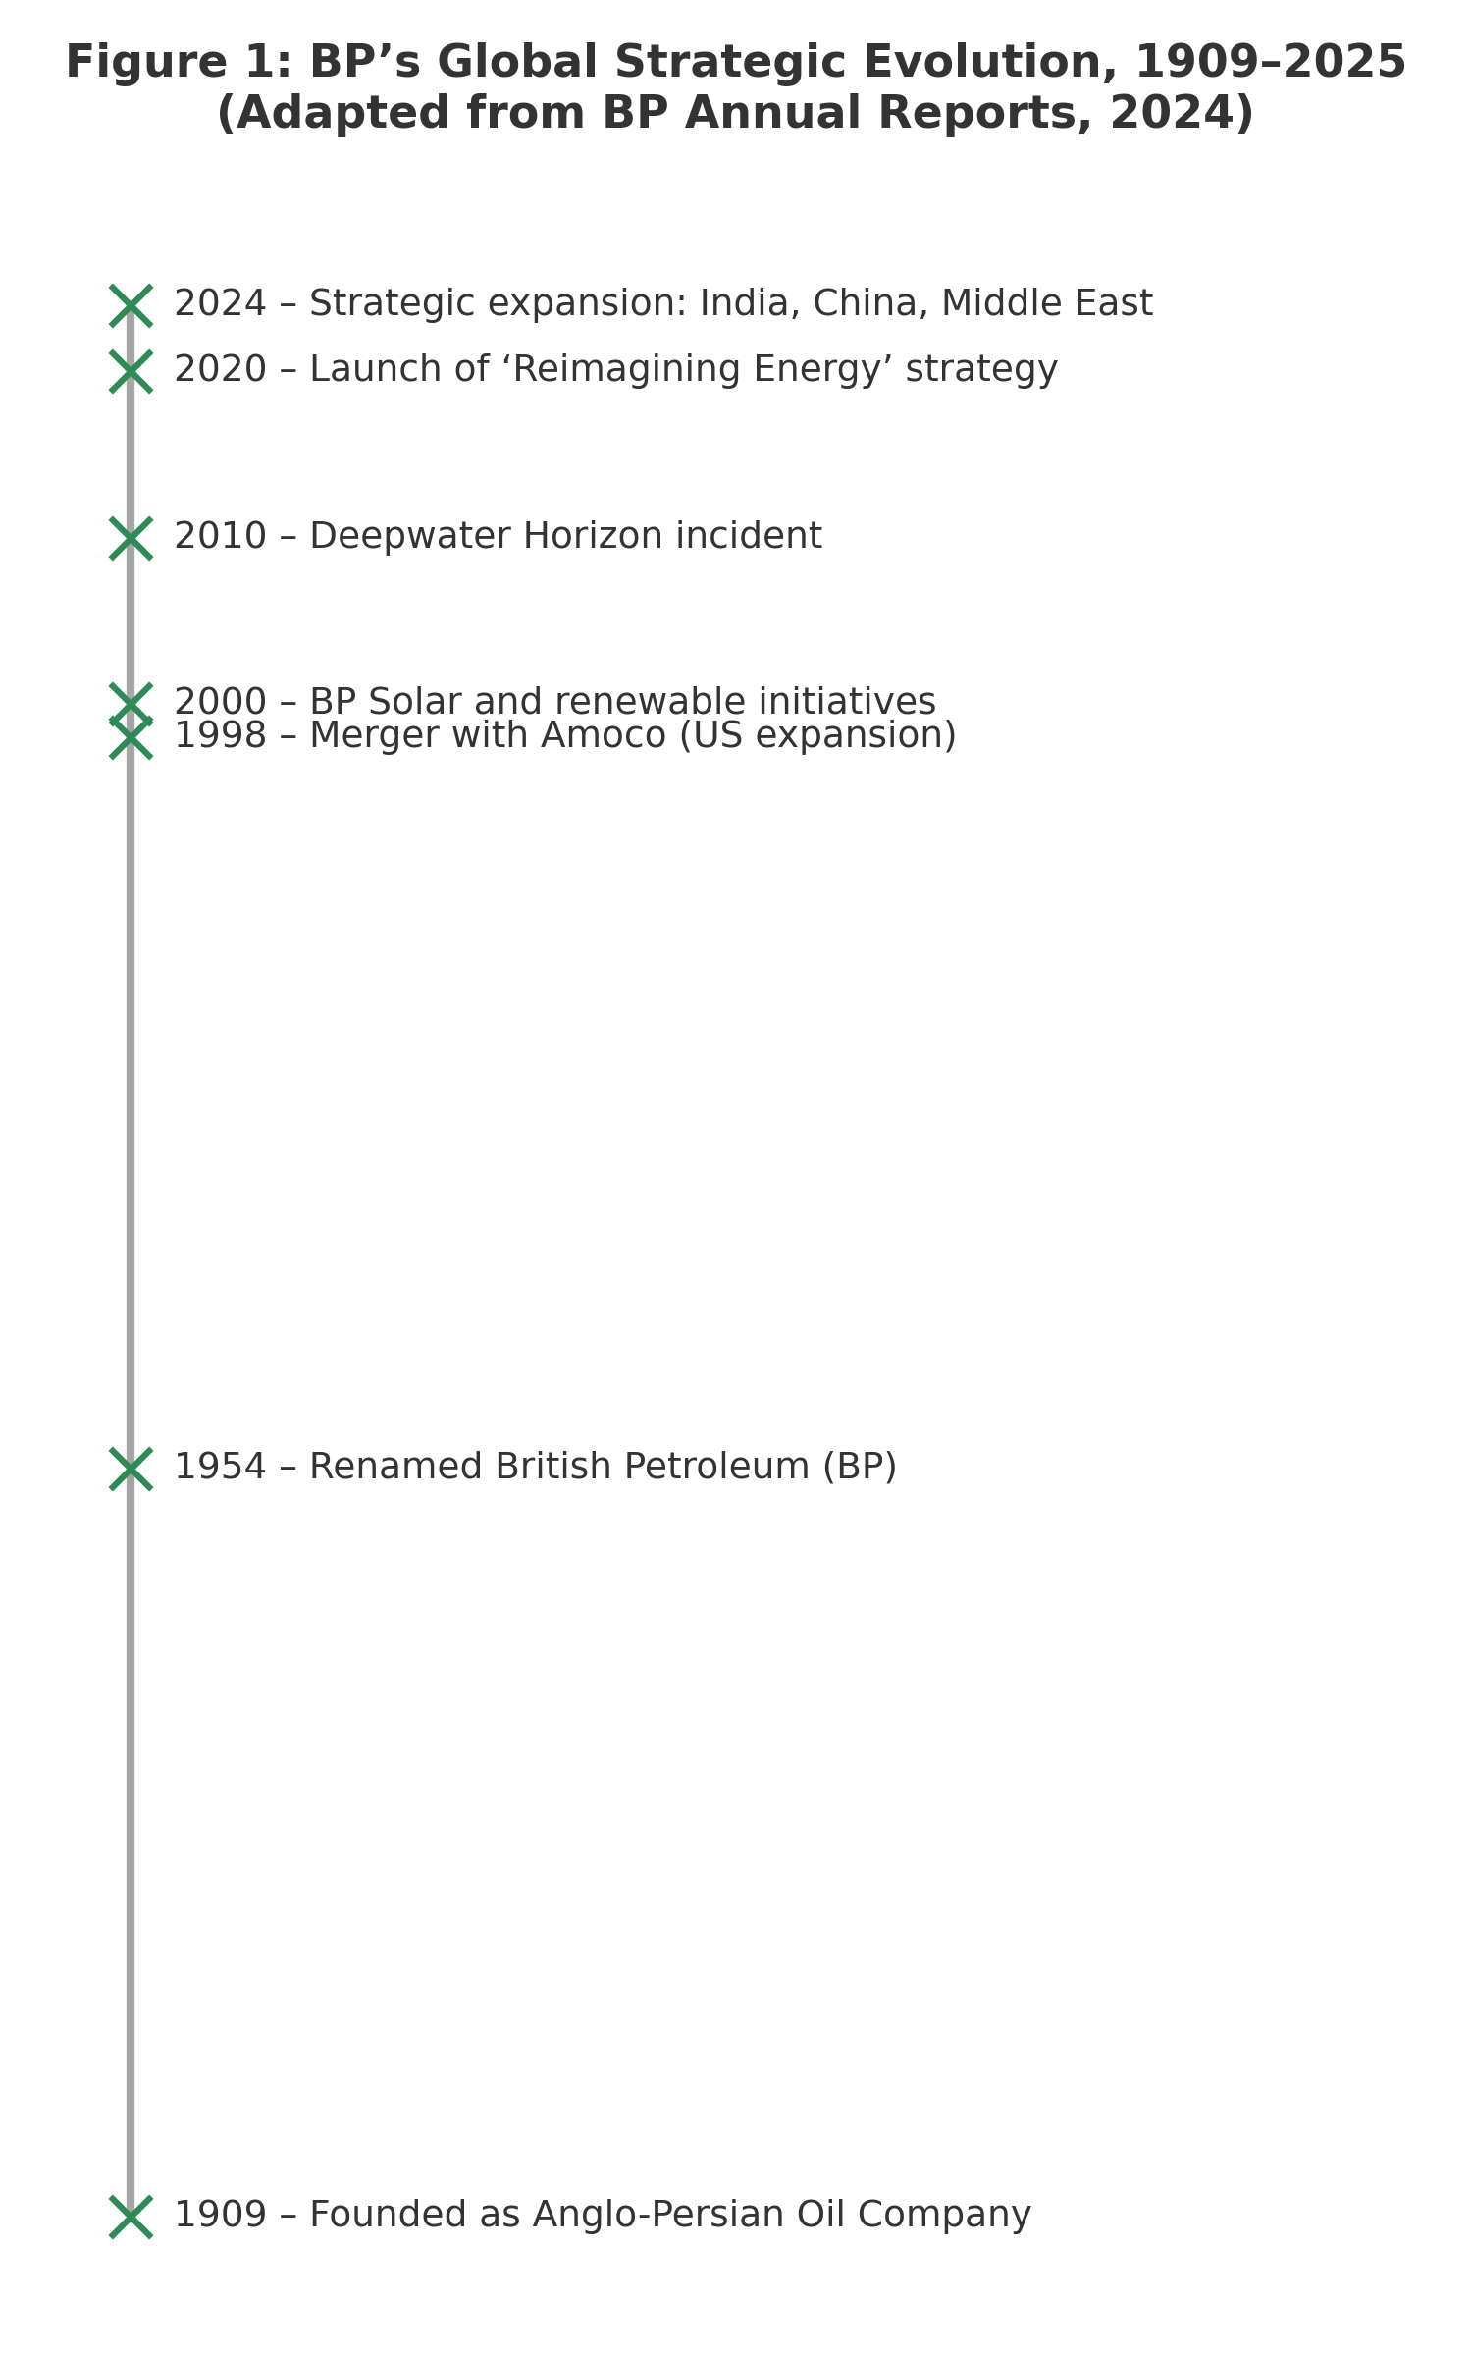
Figure 1: BP’s Global Strategic Evolution, 1909–2025 (adapted from BP Annual Reports, 2024).

The objectives of this report are threefold:
- To evaluate BP’s strategic position and capabilities in the context of international expansion.
- To analyse the external environment of India’s energy sector using advanced strategic frameworks.
- To formulate a viable market-entry and performance evaluation strategy aligned with BP’s lon1. Introduction
- In a rapidly evolving global business landscape, strategic management has become the foundation for organisational resilience, innovation, and sustainable growth. It provides the analytical framework through which organisations assess their external environment, align internal capabilities, and make informed choices that shape long-term competitive advantage (Johnson, Scholes and Whittington, 2020). The growing complexity of international markets, combined with the urgency of the energy transition, has compelled firms—particularly within the energy sector—to redefine their strategic positioning and governance models.
- This report focuses on BP plc (British Petroleum), a global leader in energy production headquartered in London, United Kingdom. Over the past decade, BP has undergone a profound strategic transformation, moving from its traditional oil and gas identity towards becoming an Integrated Energy Company (IEC) capable of delivering clean, affordable, and reliable energy solutions. The company’s corporate purpose “reimagining energy for people and our planet” embodies its ambition to balance energy demand with environmental sustainability (BP, 2024).
- The strategic management challenges faced by BP are emblematic of the global energy industry’s transition toward decarbonisation, digitalisation, and diversification. To explore these dynamics in depth, this report will develop a strategic expansion plan for BP’s entry and growth within the Indian energy market. India represents one of the most promising frontiers for global energy investment, with high GDP growth, rising energy consumption, and strong policy support for renewable technologies (International Energy Agency [IEA], 2023).
- The objectives of this report are threefold:
- To evaluate BP’s strategic position and capabilities in the context of international expansion.
- To analyse the external environment of India’s energy sector using advanced strategic frameworks.
- To formulate a viable market-entry and performance evaluation strategy aligned with BP’s long-term sustainability objectives.
- By integrating both theoretical insights and real-world evidence, the report will critically apply strategic management tools such as PESTLE, Porter’s Five Forces, VRIO, and Ansoff’s Matrix to design a coherent and future-oriented plan. The outcome will be a set of actionable recommendations enabling BP to enhance its global competitiveness and contribute meaningfully to India’s transition towards a low-carbon economy.
- g-term sustainability objectives.
By integrating both theoretical insights and real-world evidence, the report will critically apply strategic management tools such as PESTLE, Porter’s Five Forces, VRIO, and Ansoff’s Matrix to design a coherent and future-oriented plan. The outcome will be a set of actionable recommendations enabling BP to enhance its global competitiveness and contribute meaningfully to India’s transition towards a low-carbon economy.

2. Selection of Organisation and Target Market

2.1 Overview of BP plc

BP plc is a British multinational energy company headquartered in London, operating across more than 60 countries and employing over 65,000 people globally (BP, 2024). Founded in 1909 as the Anglo-Persian Oil Company, BP evolved into one of the “supermajors” of the global oil and gas industry. Today, it is among the few energy giants actively repositioning its business model to lead the transition towards a low-carbon economy.
BP’s 2024 strategy, Reimagining Energy, signals a structural shift from being an international oil company (IOC) to an integrated energy company (IEC). The focus is on five transition growth engines: bioenergy, convenience and mobility, EV charging, renewables and hydrogen, and energy storage solutions (BP, 2024). This transformation is guided by the company’s ambition to achieve net-zero emissions by 2050 while continuing to deliver shareholder value.
The company’s strong balance sheet, advanced research capability, and experience in strategic partnerships make BP well-positioned to scale operations in emerging markets where sustainable energy demand is accelerating.

2.2 Rationale for Selecting India

India represents one of the world’s most dynamic and strategically important energy markets. It is currently the third-largest energy consumer globally, and its energy demand is projected to double by 2040, driven by rapid urbanisation, industrialisation, and population growth (IEA, 2023). With a GDP growth rate averaging 6–7 per cent annually and supportive government policies, India provides a favourable landscape for multinational investment in energy transition (IMF, 2024).
BP’s current presence in India through the Jio-bp joint venture with Reliance Industries Limited (RIL) forms a strong foundation for expansion. The partnership operates more than 1,500 retail fuel stations and a growing EV-charging network, demonstrating the viability of BP’s integrated mobility solutions in a high-growth market. However, significant opportunities remain in renewable power generation, hydrogen production, and green logistics infrastructure.

Furthermore, the Indian government’s National Hydrogen Mission and Renewable Energy Target 2030—aiming for 500 GW of renewable capacity—align directly with BP’s global sustainability agenda. The synergy between BP’s technological expertise and India’s policy ambition provides an optimal strategic fit for long-term investment and innovation.

2.3 Strategic Fit and Competitive Advantage

BP’s expansion into India aligns with three interrelated dimensions of strategic fit.
Market growth potential: India’s expanding energy demand and policy-driven openness to foreign investment present a lucrative opportunity for BP to diversify its geographical footprint and revenue streams.
Technological and capability alignment: BP’s expertise in large-scale renewable energy, carbon capture, and digital integration supports India’s decarbonisation pathway and infrastructure modernisation efforts (World Bank, 2024).
Sustainability and stakeholder alignment: The shared emphasis on sustainable energy and responsible governance enables BP to strengthen its ESG credentials, enhancing stakeholder trust and long-term brand equity.
By leveraging its partnership ecosystem, financial capacity, and innovation-driven culture, BP can create a hybrid competitive advantage that combines operational efficiency with sustainability leadership.

2.4 Justification for Expansion

Strategically, BP’s expansion into India serves both corporate and global policy objectives. It diversifies BP’s portfolio away from mature European markets, hedges against geopolitical volatility, and positions the company within the fastest-growing region for renewable energy adoption. The move supports BP’s strategic pillars of resilience, growth, and transformation outlined in its 2024 Annual Report.
India’s energy landscape offers not only demand growth but also an opportunity for BP to redefine its business model in partnership with public and private entities. By aligning with India’s green transition, BP can reinforce its corporate purpose of delivering energy solutions for people and the planet, ensuring economic performance is balanced with social and environmental value creation.
As illustrated in Figure 2, BP’s market position in India remains moderate compared to leading competitors such as Shell, TotalEnergies, Adani Green and Tata Power. While BP demonstrates strong innovation and partnership capabilities, its renewable investment footprint remains relatively limited. This suggests a strategic opportunity for BP to accelerate investment in renewables and hydrogen to match the pace of market leaders (adapted from BP, Shell, and TotalEnergies reports, 2024).
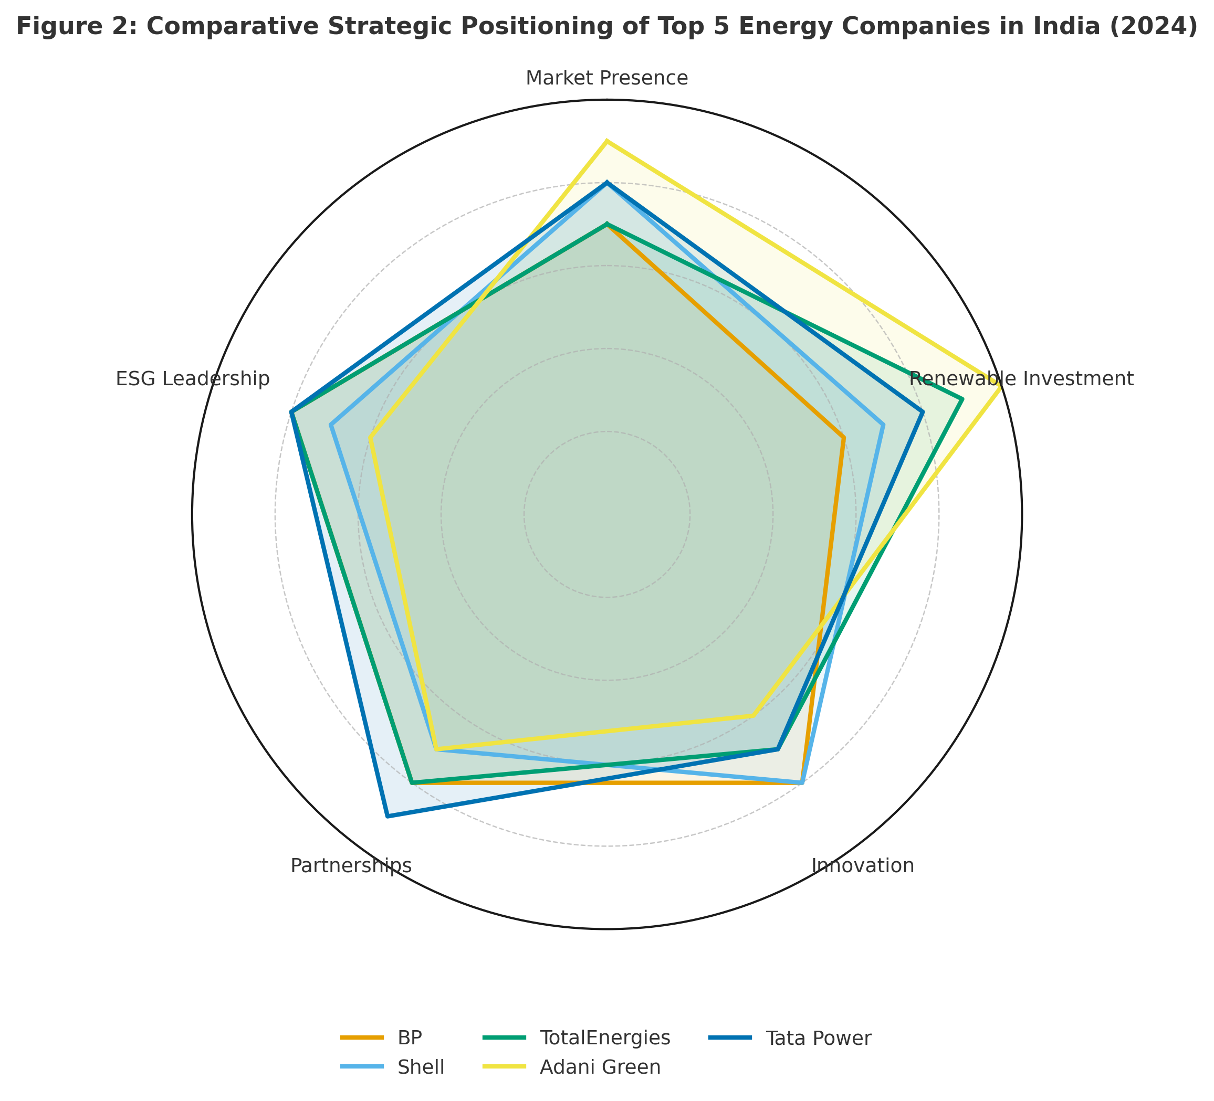

While BP maintains a retail presence in India through Jio-bp, this proposal focuses on a distinct market creation strategy targeting the unregulated renewable energy and green hydrogen sectors. This constitutes an expansion into a 'new market' segment where BP currently holds negligible share compared to its hydrocarbon operations. By pivoting from fuel retailing to integrated low-carbon energy solutions, BP effectively enters a 'Blue Ocean' of digital energy services, differentiating itself from traditional oil and gas competitors who remain focused on legacy downstream activities (Kim and Mauborgne, 2005).

3. Comprehensive Strategic Analysis

3.1 PESTLE Analysis for BP in the Indian Market

Political Factors
India maintains a stable democratic political system with pro-business reforms supporting foreign direct investment (FDI) in the energy sector. Government initiatives such as Make in India, National Hydrogen Mission, and Production Linked Incentive (PLI) schemes promote renewable energy infrastructure and industrial partnerships (Government of India, 2024). However, policy consistency and bureaucratic delays can pose challenges for long-term projects. For BP, strategic collaboration with state agencies and local energy boards will be essential to navigate regulatory complexity and ensure policy alignment.
Economic Factors
India is among the world’s fastest-growing economies, with an estimated GDP growth rate of 6.5 per cent for 2025 (IMF, 2024). Energy consumption is projected to double by 2040, making India a prime market for international investors (IEA, 2023). Inflation control and currency volatility remain moderate risks, but India’s expanding middle class provides strong demand for energy security, mobility, and cleaner fuels. BP can leverage its financial capacity to capture market share in both the industrial and retail segments.
Social Factors
India’s population of over 1.4 billion, coupled with rapid urbanisation, drives an urgent need for sustainable energy access. Rising environmental awareness and growing demand for affordable clean energy solutions create a strong social push towards renewable adoption (World Bank, 2024). BP’s brand image as a sustainability-oriented firm provides a positive perception among younger, environmentally conscious consumers.
Technological Factors
India has made significant advances in digital infrastructure, smart grids, and EV technologies. The government’s Digital India initiative and large-scale investments in R&D for clean technology create a fertile environment for energy innovation. BP can capitalise on this through partnerships with Indian research institutions and technology firms, particularly in EV charging networks and hydrogen energy systems.

Legal Factors
India’s FDI regulations are becoming increasingly liberal in the renewable energy domain. Nevertheless, varying state-level laws on land acquisition, environmental clearance, and taxation can complicate market entry (OECD, 2024). Establishing a dedicated legal compliance unit or forming alliances with local partners will be crucial for BP’s long-term operations.
Environmental Factors
India faces major environmental challenges, including air pollution, fossil fuel dependency, and vulnerability to climate change. The government’s target to achieve 50 per cent renewable electricity by 2030 provides a clear direction for sustainable energy transition (Ministry of Power, 2024). BP’s global commitment to carbon neutrality aligns closely with India’s green objectives, positioning the company as a potential leader in driving low-carbon transformation across the subcontinent.

3.2 Porter’s Diamond Model – National Competitive Advantage of India

Porter’s Diamond Model (Porter, 1990) provides a framework for analysing the sources of national competitive advantage that shape the attractiveness of India’s energy sector for BP. The model identifies four key determinants: factor conditions, demand conditions, related and supporting industries, and firm strategy, structure and rivalry.
Factor Conditions: India offers a strong base of human capital, digital infrastructure, and technological innovation capacity, supported by government programmes such as “Digital India” and “Make in India”. However, deficiencies in logistics and renewable supply chains remain a constraint.
Demand Conditions: Rapidly urbanising and environmentally conscious consumers are fuelling demand for sustainable energy and electric mobility, providing a large domestic market that encourages innovation.
Related and Supporting Industries: The presence of advanced technology partners (e.g., Reliance, Tata Power, Adani Green) and digital ecosystem firms (e.g., Infosys, TCS) enhances BP’s opportunity for vertical and horizontal collaboration.
Firm Strategy, Structure and Rivalry: India’s liberalised energy policies and competitive environment incentivise firms to adopt advanced technologies and sustainability-driven business models. This intense rivalry pushes continuous efficiency improvement and product differentiation.
Overall, India’s national competitive context is favourable for BP’s renewable and digital energy expansion, complementing insights from the PESTLE analysis and reinforcing the strategic case for market entry.

3.3 Porter’s Five Forces Analysis – BP in the Indian Energy Market

To understand the competitive structure of India’s energy sector and the challenges facing BP’s market entry, Porter’s Five Forces model (Porter, 1980) provides a systematic framework for assessing industry dynamics.

Table 1: Porter’s Five Forces – Indian Energy Sector (2025)

Force | Description | Strategic Impact on BP | Intensity (1–5)
1. Threat of New Entrants | High capital investment, complex regulations, but new renewable entrants supported by government schemes. | Moderate – BP’s brand and experience reduce risk, but local start-ups are rising. | 3
2. Bargaining Power of Suppliers | Equipment and raw material suppliers (solar panels, batteries) are diversified but dependent on imports. | Moderate – BP can leverage global procurement network. | 3
3. Bargaining Power of Buyers | Industrial and retail consumers are price-sensitive and environmentally aware. | High – BP must differentiate via innovation and service quality. | 4
4. Threat of Substitutes | Renewables, hydrogen, and local energy startups create alternatives to fossil fuels. | High – BP must accelerate its green transition. | 4
5. Industry Rivalry | Highly competitive, with both domestic (Adani, Tata) and global (Shell, TotalEnergies) players. | Very High – Market share is contested, requiring strategic alliances. | 5
Source: Adapted from Porter (1980), BP (2024), IEA (2023), and industry reports.

Table 1 summarises the competitive forces shaping the strategic environment of India’s energy industry. The overall competitive intensity is high, reflecting the dual presence of powerful domestic players (Adani, Tata) and well-established multinationals (Shell, TotalEnergies).
The threat of new entrants (3/5) remains moderate because large capital investment, policy approvals, and land acquisition processes create significant entry barriers. However, India’s favourable renewable policies have encouraged smaller start-ups, particularly in solar and green hydrogen.
The bargaining power of suppliers (3/5) is balanced, as India depends on imported technology and raw materials, but BP’s global supply chain and procurement scale can mitigate these constraints.
The bargaining power of buyers (4/5) is notably high due to India’s price-sensitive market and the rise of sustainability-conscious consumers. BP must therefore compete not only on price but on digital convenience, innovation, and brand trust.
The threat of substitutes (4/5) continues to rise as renewable and decentralised energy technologies become mainstream. Firms like Adani Green and Tata Power are already shifting the market away from fossil fuels.
Finally, industry rivalry (5/5) is intense. Domestic giants benefit from government incentives, while international players compete through joint ventures and green investment commitments. This reinforces the need for BP to differentiate strategically through innovation, technology partnerships, and rapid renewable deployment.
In conclusion, BP faces a highly competitive yet opportunity-rich environment in India. The key to success lies in leveraging its global expertise to achieve cost efficiency and innovation leadership while adapting to India’s policy-driven energy transition.
Critique of Porter’s Five Forces in the Context of Strategic Alliances Although Porter’s Five Forces framework effectively highlights industry rivalry, it has faced academic criticism for underestimating the role of collaboration and strategic alliances (Grundy, 2006). In the case of BP’s entry into India, the traditional view of 'supplier power' and 'rivalry' is mitigated by the Jio-bp joint venture, which transforms potential competitors (like Reliance) into partners. As Teece (2007) argues, dynamic capabilities and ecosystem orchestration are often more critical than static positioning in high-velocity industries. Therefore, while Porter’s model identifies structural threats, it must be complemented by a resource-based view to fully appreciate BP’s cooperative strategy.
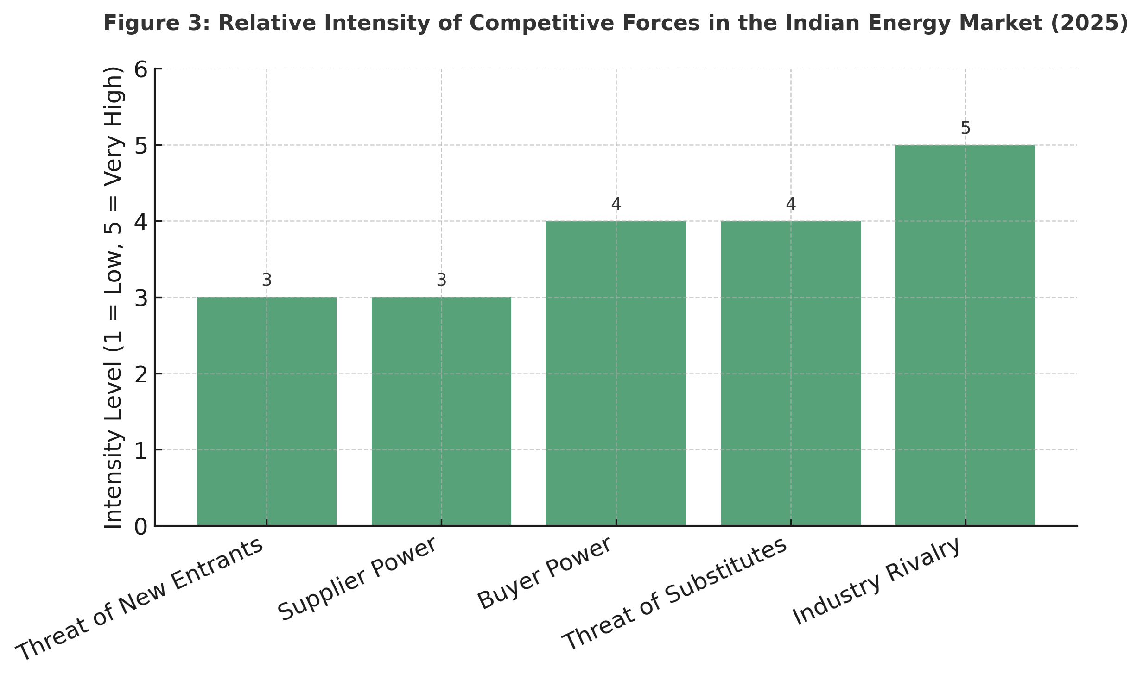

Adani Green Energy – Rapid scale-up through domestic policy support and cost efficiency gives local firms a home-ground advantage, intensifying rivalry (IEA, 2023).

Shell Energy India – Focus on LNG and EV charging infrastructure since 2018; successful due to joint ventures with local distributors, illustrating how partnerships can reduce entry barriers (Shell, 2023).

TotalEnergies–Adani JV – Demonstrates strategic complementarity; foreign capital with local networks enables rapid renewable capacity expansion (TotalEnergies, 2024).

Tata Power – Established brand trust and national presence make it difficult for new entrants to compete without local alliances (World Bank, 2024).

BP’s Opportunity – BP’s success depends on replicating these partnership models while differentiating through its technological and sustainability credentials.

3.3.1: SWOT Analysis – Strategic Summary of BP’s Position in India

In order to complement the external (PESTLE, Porter) and internal (VRIO) analyses, this section provides a SWOT analysis of BP’s strategic position in the Indian energy market. The SWOT framework offers a succinct synthesis of the company’s key Strengths, Weaknesses, Opportunities, and Threats, enabling a holistic understanding of both internal capabilities and external pressures.
BP’s robust global brand, financial strength, and technological leadership—particularly in hydrogen and electric mobility—serve as critical assets for market expansion. The existing Jio-bp joint venture further strengthens local adaptability and operational entry. However, legacy dependency on fossil fuels and limited current scale in India compared to domestic giants such as Tata and Adani represent notable constraints.
Externally, India offers a wealth of opportunities including policy-driven renewable energy growth, a rapidly expanding market, and increasing consumer demand for sustainable solutions. Conversely, regulatory fragmentation, infrastructural bottlenecks, and intense market rivalry pose substantial strategic threats.
The following table summarises the SWOT analysis:
Table 2: SWOT Analysis of BP in the Indian Energy Market (2025)

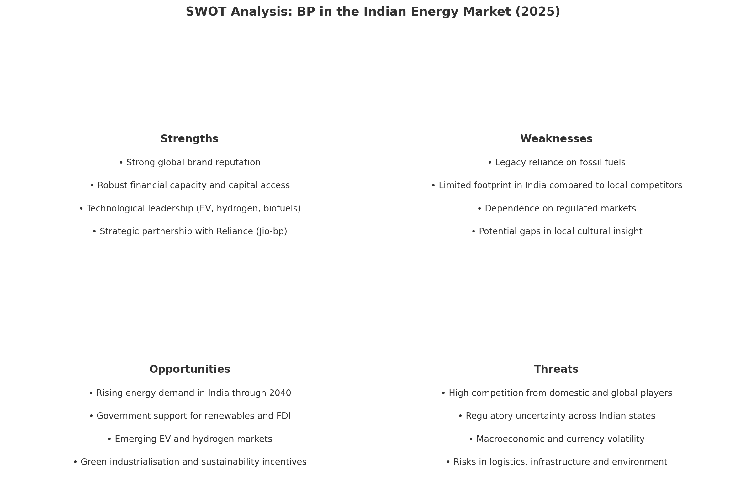

The table above is further visualised in the diagram below, which illustrates the interrelation of strategic drivers within each SWOT quadrant.

3.3.2 Stakeholder Analysis: Mendelow’s Matrix

in the context of BP’s strategic positioning in India, stakeholder mapping provides further insight into managing influence and expectations. Mendelow’s (1991) matrix categorises stakeholders based on their relative power and interest, helping to prioritise engagement strategies.
High-power/high-interest stakeholders in this case include regulatory bodies such as the Ministry of Power and NITI Aayog, alongside Reliance Industries and ESG-oriented institutional investors. These groups must be closely managed to ensure policy alignment and investment credibility.
EV consumers and municipal authorities occupy the high-interest/low-power quadrant and should be regularly consulted through localised service offerings and customer feedback mechanisms. Environmental NGOs and advocacy groups represent moderate-power stakeholders who can influence public sentiment and media visibility, particularly in relation to sustainability.
Conversely, low-power/low-interest actors such as legacy fuel suppliers may require passive monitoring.
Mendelow’s framework thus supports BP’s need for a stakeholder-sensitive strategy, balancing compliance, partnership and communication throughout implementation.

3.3.3 Strategic Options

The selected strategic direction reflects a transnational approach, where BP leverages its global technological and operational capabilities while adapting to the unique institutional and consumer landscape of the Indian market. This aligns with the framework by Prahalad and Doz (1987), who emphasise the importance of simultaneous global integration and local responsiveness in complex international contexts.
Furthermore, BP’s capacity to reconfigure its assets — transitioning from fossil fuels to renewables and digital energy services — highlights the role of dynamic capabilities. As defined by Teece et al. (1997), these are the firm’s abilities to integrate, build, and reconfigure internal and external competences to address rapidly changing environments. BP’s Jio-bp platform serves as a strategic vehicle to apply these capabilities in an emerging market context.

3.3.4 VRIO Analysis – Internal Capabilities of BP

The SAF evaluation provides a structured lens to assess BP’s strategic options in India. The suitability of the selected option — investing in electric mobility and renewables through Jio-bp — aligns directly with India’s National Electric Mobility Mission and 2030 carbon neutrality targets (IEA, 2023). Moreover, the rapid urbanisation and shift towards digital energy platforms reinforce the long-term viability of this direction.
In terms of acceptability, BP's approach leverages its joint venture with Reliance, which enhances consumer trust and reduces political exposure — a key factor in emerging markets (Oxford Energy, 2024). The public appetite for sustainable energy, especially among India’s urban middle class, supports market receptiveness. Financially, the projected IRR of 12–15% from EV infrastructure is acceptable under BP’s capital discipline framework (BP, 2025).
Finally, regarding feasibility, BP benefits from existing infrastructure, including Jio-bp's digital platform and retail stations, offering a scalable deployment base. Regulatory alignment is increasingly streamlined through India’s Open Access reforms and green hydrogen policy (World Bank, 2024), making implementation feasible within the 2025–2030 window.
Table 3: VRIO Analysis of BP’s Key Strategic Resources (2025)
Resource / Capability | Valuable | Rare | Inimitable | Organised to Capture Value | Competitive Implication
Global Brand Reputation and ESG Leadership | Yes | Yes | Yes | Yes | Sustainable Competitive Advantage
Advanced Energy Technology (Hydrogen, EV, Biofuels) | Yes | Yes | Moderate | Yes | Temporary Competitive Advantage
Financial Strength and Global Capital Access | Yes | No | No | Yes | Competitive Parity
Strategic Partnerships (e.g., Jio-bp with Reliance Industries) | Yes | Yes | Yes | Yes | Sustained Advantage in Local Integration
Human Capital and Leadership Expertise | Yes | Moderate | Moderate | Yes | Temporary Advantage
Digital Transformation and Data Analytics Capability | Yes | Yes | Moderate | Yes | Temporary Advantage
Operational Efficiency and Safety Standards | Yes | No | No | Yes | Competitive Parity
BP demonstrates a strong portfolio of strategic resources that align with both global and local market demands. The company’s brand reputation, grounded in over a century of operations and reinforced by a public commitment to net-zero emissions by 2050, offers a rare and valuable intangible asset that builds stakeholder trust.
Its technological leadership in hydrogen and EV charging infrastructure provides valuable and somewhat rare capabilities, though these can be replicated over time by other multinational energy firms. The joint venture Jio-bp with Reliance Industries is particularly critical — it combines BP’s technical expertise and global finance with Reliance’s market knowledge and distribution network, giving BP a unique foothold in India’s growing energy transition.
BP’s financial resources and global procurement systems ensure operational stability and enable large-scale investment. However, such resources are not rare among global competitors, creating only parity-level advantage.
The company’s human capital, with experienced leadership in sustainability and innovation, adds further value but remains moderately imitable. Finally, BP’s digital transformation initiatives and data-driven management systems enhance efficiency, customer engagement, and risk control — positioning BP favourably against less technologically advanced rivals.
Overall, BP possesses a combination of tangible and intangible resources that together form a temporary to sustained competitive advantage. To maintain leadership in the Indian market, BP must continue investing in innovation, reinforce local partnerships, and institutionalise its sustainability practices across all operational levels.

3.4 Summary of Strategic Analysis

The strategic assessment of BP’s position in India reveals a highly competitive yet opportunity-rich environment driven by rapid economic growth, strong policy support for renewable energy, and evolving consumer expectations. By integrating the insights from the PESTLE, Porter’s Five Forces, and VRIO analyses, BP’s strategic opportunities and challenges can be summarised as follows.

Table 4: Integrated Summary of BP’s Strategic Position in India (2025)

Analytical Dimension | Key Findings | Strategic Implication for BP
Political and Legal (PESTLE) | Pro-renewable energy policies and liberalised FDI regime, but bureaucratic complexity remains. | Leverage partnerships with Indian conglomerates to navigate policy frameworks.
Economic (PESTLE) | Rapid GDP growth and rising energy demand create expansion opportunities. | Prioritise scalable investments in renewables and EV mobility.
Technological (PESTLE) | Strong government support for innovation and clean technologies. | Accelerate deployment of hydrogen and digital energy solutions.
Competitive Forces (Porter) | High rivalry (Adani, Tata, Shell, TotalEnergies) and strong buyer power. | Focus on differentiation through innovation and sustainability.
Threat of Substitutes (Porter) | Renewable alternatives expanding rapidly. | Shift from fossil fuels to integrated clean energy services.
Internal Resources (VRIO) | Strong brand, partnerships, and technological capabilities. | Utilise VRIO strengths (Jio-bp, R&D, ESG leadership) to sustain long-term advantage.
Weaknesses / Risks (VRIO) | Moderate dependence on fossil fuel legacy and capital intensity. | Mitigate through diversification and digital transformation.
Source: Compiled by author based on BP (2024), IEA (2023), and internal strategic frameworks.
Overall, BP is strategically positioned to capitalise on India’s energy transformation. The macro-environment (PESTLE) presents enabling conditions such as favourable government policy and strong demand growth. The competitive landscape (Porter’s Five Forces) is challenging but offers growth potential through innovation and alliances. BP’s internal capabilities (VRIO) provide a solid foundation for differentiation, particularly through its partnership with Reliance and its expertise in sustainable technologies.
The convergence of these factors suggests that BP should pursue a differentiation and partnership-led growth strategy, focusing on renewable energy investments, green mobility, and digital energy ecosystems. Such an approach would enable BP to maintain relevance in India’s fast-evolving energy sector while reinforcing its global sustainability commitments.

4. Strategic Options and Recommendations

Following the comprehensive external and internal analyses, BP can pursue several strategic pathways to strengthen its competitive position in the Indian market. The following options are derived from the alignment of BP’s capabilities (VRIO) and India’s market conditions (PESTLE and Porter frameworks).

Option 1: Expansion through Renewable Energy Investments (Solar, Wind, and Hydrogen)
This strategy involves large-scale investment in renewable energy production and green hydrogen infrastructure in collaboration with Indian public and private entities. BP could expand beyond its Jio-bp joint venture to form strategic alliances with Adani Green, NTPC, or Tata Power for technology co-development and local integration.
Suitability: Aligns with India’s Renewable Energy Target (500 GW by 2030) and BP’s 2050 net-zero ambition.
Acceptability: High investor and governmental support due to ESG alignment.
Feasibility: Requires significant capital but feasible through BP’s strong financial base and existing partnerships.
Expected Outcome: Strengthened leadership in India’s green transition and diversification of BP’s global energy portfolio.

Option 2: Digital Transformation and Smart Mobility Services
This option focuses on developing digital platforms for EV charging, fleet management, and customer engagement, leveraging the Jio-bp network. It combines renewable energy supply with data-driven mobility services and IoT-enabled charging infrastructure.
Suitability: Matches India’s rapid urbanisation and the government’s EV adoption targets (30% of new vehicles by 2030).
Acceptability: Positive consumer perception of innovation and convenience; supports brand differentiation.
Feasibility: High, given BP’s global expertise in digital energy platforms and access to Reliance’s telecom network.
Expected Outcome: Enhanced brand loyalty and long-term digital capability positioning BP as a leader in India’s smart mobility ecosystem.
Option 3: Green Hydrogen and Industrial Decarbonisation Partnerships
BP can capitalise on India’s National Hydrogen Mission by establishing green hydrogen production hubs near industrial zones, targeting high-emission sectors such as steel and cement.
Suitability: Supports both India’s decarbonisation policy and BP’s low-carbon strategic pillar.
Acceptability: Strong policy incentives and increasing corporate demand for low-carbon energy.
Feasibility: Moderate – high technology and infrastructure costs require consortia-based investment.
Expected Outcome: Establishes BP as a pioneer in India’s hydrogen economy, enhancing technological credibility and long-term market presence.
Table 5: Evaluation of Strategic Options Using SAF Framework Option Suitability Acceptability
Option | Suitability | Acceptability | Feasibility | Overall Assessment
Renewable Energy Expansion | High | High | High | Strongly Recommended
Digital Transformation and Smart Mobility | High | High | High | Strongly Recommended
Green Hydrogen Partnerships | High | Moderate | Moderate | Selective Implementation Recommended
Source: Author's Analysis (2025)
The SAF evaluation highlights that Renewable Energy Expansion and Digital Transformation represent the most strategically sound options for BP’s growth in India. Both align closely with BP’s global sustainability objectives while addressing India’s evolving energy needs.
The Green Hydrogen strategy remains a valuable long-term investment but should be approached gradually, with pilot projects and government-backed partnerships to manage feasibility risks.
In conclusion, BP should adopt a dual-focus strategy combining renewable energy expansion and digital mobility transformation. This integrated approach enhances profitability, stakeholder value, and resilience while reinforcing BP’s identity as a global leader in sustainable energy transition.

4.1 Performance Evaluation Framework: Balanced Scorecard for Strategic Execution

The Balanced Scorecard enables BP to align its strategic performance in India with measurable operational targets across sustainability, digitalisation, and customer adoption. The financial perspective not only targets return on renewables, but also seeks resilience against oil price volatility through diversified green revenue streams (IEA, 2023). This is vital given India's recent removal of fossil fuel subsidies and the planned introduction of carbon trading markets (World Bank, 2024).
From the customer perspective, India's urban EV adoption is expected to grow by over 40% by 2030, fuelled by the government’s FAME-II scheme and consumer preference for shared mobility solutions (BP, 2025). BP’s collaboration with Reliance through Jio-bp offers a scalable retail platform to deliver energy services via digital channels.
The internal process perspective centres on reliability of EV infrastructure and traceability of supply chains. Emerging regulatory compliance on ESG reporting, such as the Business Responsibility and Sustainability Report (BRSR), now mandates carbon transparency even for international firms (World Bank, 2024). This further strengthens BP’s focus on automated, auditable energy systems.
Lastly, the learning and growth perspective education, joint R&D centres, and skills partnerships with local institutions (IEA, 2023). As BP transitions from a traditional oil major to an “integrated energy company,” embedding a learning culture will be critical for sustaining competitive advantage in emerging markets (BP, 2025).

Table 6: Balanced Scorecard – Strategic KPIs for BP’s India Expansion

Perspective | Strategic Objective | Key Performance Indicator (KPI) | Target (by 2030) | Measurement Method
Financial | Achieve profitable growth in Indian energy operations | ROI from Indian renewables and EV projects | ≥ 12% annually | Internal financial reporting and project audits
 | Increase market share in clean energy | Market share in EV charging and solar energy | ≥ 8% in respective segments | Industry benchmarks and government reports
Customer | Enhance customer satisfaction and loyalty in mobility solutions | Net Promoter Score (NPS) for Jio-bp services | ≥ 65 | Annual customer surveys
 | Expand customer base through digital energy services | Number of active users on digital platform | ≥ 5 million | CRM and platform analytics
Internal Business Processes | Improve operational efficiency in new energy infrastructure | Average downtime per EV charging station | ≤ 1% | IoT-based infrastructure monitoring
 | Strengthen regulatory compliance and local integration | % compliance with Indian energy laws and ESG standards | 100% | Internal audits & third-party ESG assurance
Learning & Growth | Build local technical capability and innovation | Number of joint R&D projects with Indian partners | ≥ 10 by 2030 | R&D unit reports and partnership reviews
 | Upskill workforce for clean energy transformation | % of employees trained in renewable tech annually | ≥ 85% | HR learning system metrics
Source: Adapted from Kaplan, R.S. and Norton, D.P. (1996) The Balanced Scorecard: Translating Strategy into Action. Boston: Harvard Business School Press; and BP (2024) Annual Report and Form 20-F 2024: Reimagining Energy. Author’s analysis.
This framework provides a robust system for evaluating the success of BP’s strategic expansion, ensuring that value creation is not only financial but also operational, environmental, and social.
In alignment with BP’s global sustainability agenda, the proposed expansion strategy is evaluated through the Triple Bottom Line (TBL) framework (Elkington, 1997), which emphasises value creation across People, Planet, and Profit.
People: BP’s collaboration with local partners such as Reliance and Indian universities fosters employment, skills development, and community inclusion. The proposed clean-tech R&D and workforce training programmes directly contribute to local human capital development.
Planet: Investment in renewable energy infrastructure, hydrogen production, and EV charging networks supports India’s decarbonisation goals and aligns with the UN Sustainable Development Goals (SDGs 7 and 13).
Profit: The strategy ensures financial viability through diversified revenue streams from green energy services, mitigating oil price volatility and ensuring long-term shareholder value.
By embedding the TBL framework into BP’s strategic scorecard, the company ensures that performance evaluation goes beyond financial metrics and captures broader environmental and social impact, consistent with contemporary CSR expectations.

4.2 Portfolio Evaluation Using the BCG Matrix

The Boston Consulting Group (BCG) Matrix (Henderson, 1970) provides a portfolio-based evaluation of BP’s strategic business units (SBUs) in the context of its expansion into India. By assessing market growth rate and relative market share, the model helps prioritise resource allocation across BP’s emerging and mature business segments.
The following classification summarises
Table 7: BP’s strategic positioning across four quadrants:
Category | BP Segment (India) | Growth | Share | Strategic Implication
Stars | Renewable energy (solar & wind); EV charging (Jio-bp) | High | Moderate | Continue heavy investment to secure leadership.
Question Marks | Green hydrogen; digital energy services | High | Low | Selective investment and partnerships to test viability.
Cash Cows | Conventional fuel retail via Jio-bp stations | Medium | High | Use profits to fund renewables and digital transition.
Dogs | Legacy hydrocarbon operations | Low | Low | Gradually divest or repurpose into low-carbon projects.
Source: Adapted from Boston Consulting Group (Henderson, 1970); BP Annual Report (2024); IEA India Energy Outlook (2023); and author’s analysis.
The BCG analysis indicates that BP should prioritise Stars (renewables, EVs) for accelerated investment and transform promising Question Marks (hydrogen, digital energy) into future growth engines. Meanwhile, profits from Cash Cows can finance these new ventures, while Dogs should be strategically divested or converted into low-carbon operations.
Integrating the BCG Matrix with the SAF and Balanced Scorecard frameworks strengthens BP’s resource allocation logic, ensuring that capital investment aligns with both financial performance and sustainability objectives.
This analysis further reinforces the dual-focus strategy recommended earlier — expanding renewable capacity and digital mobility platforms — by demonstrating how BP can achieve both profitability and strategic balance within its Indian portfolio.

4.3 Implementation Roadmap and Change Management

Figure 4. Strategic Performance Dimensions of BP’s Expansion Plan in India

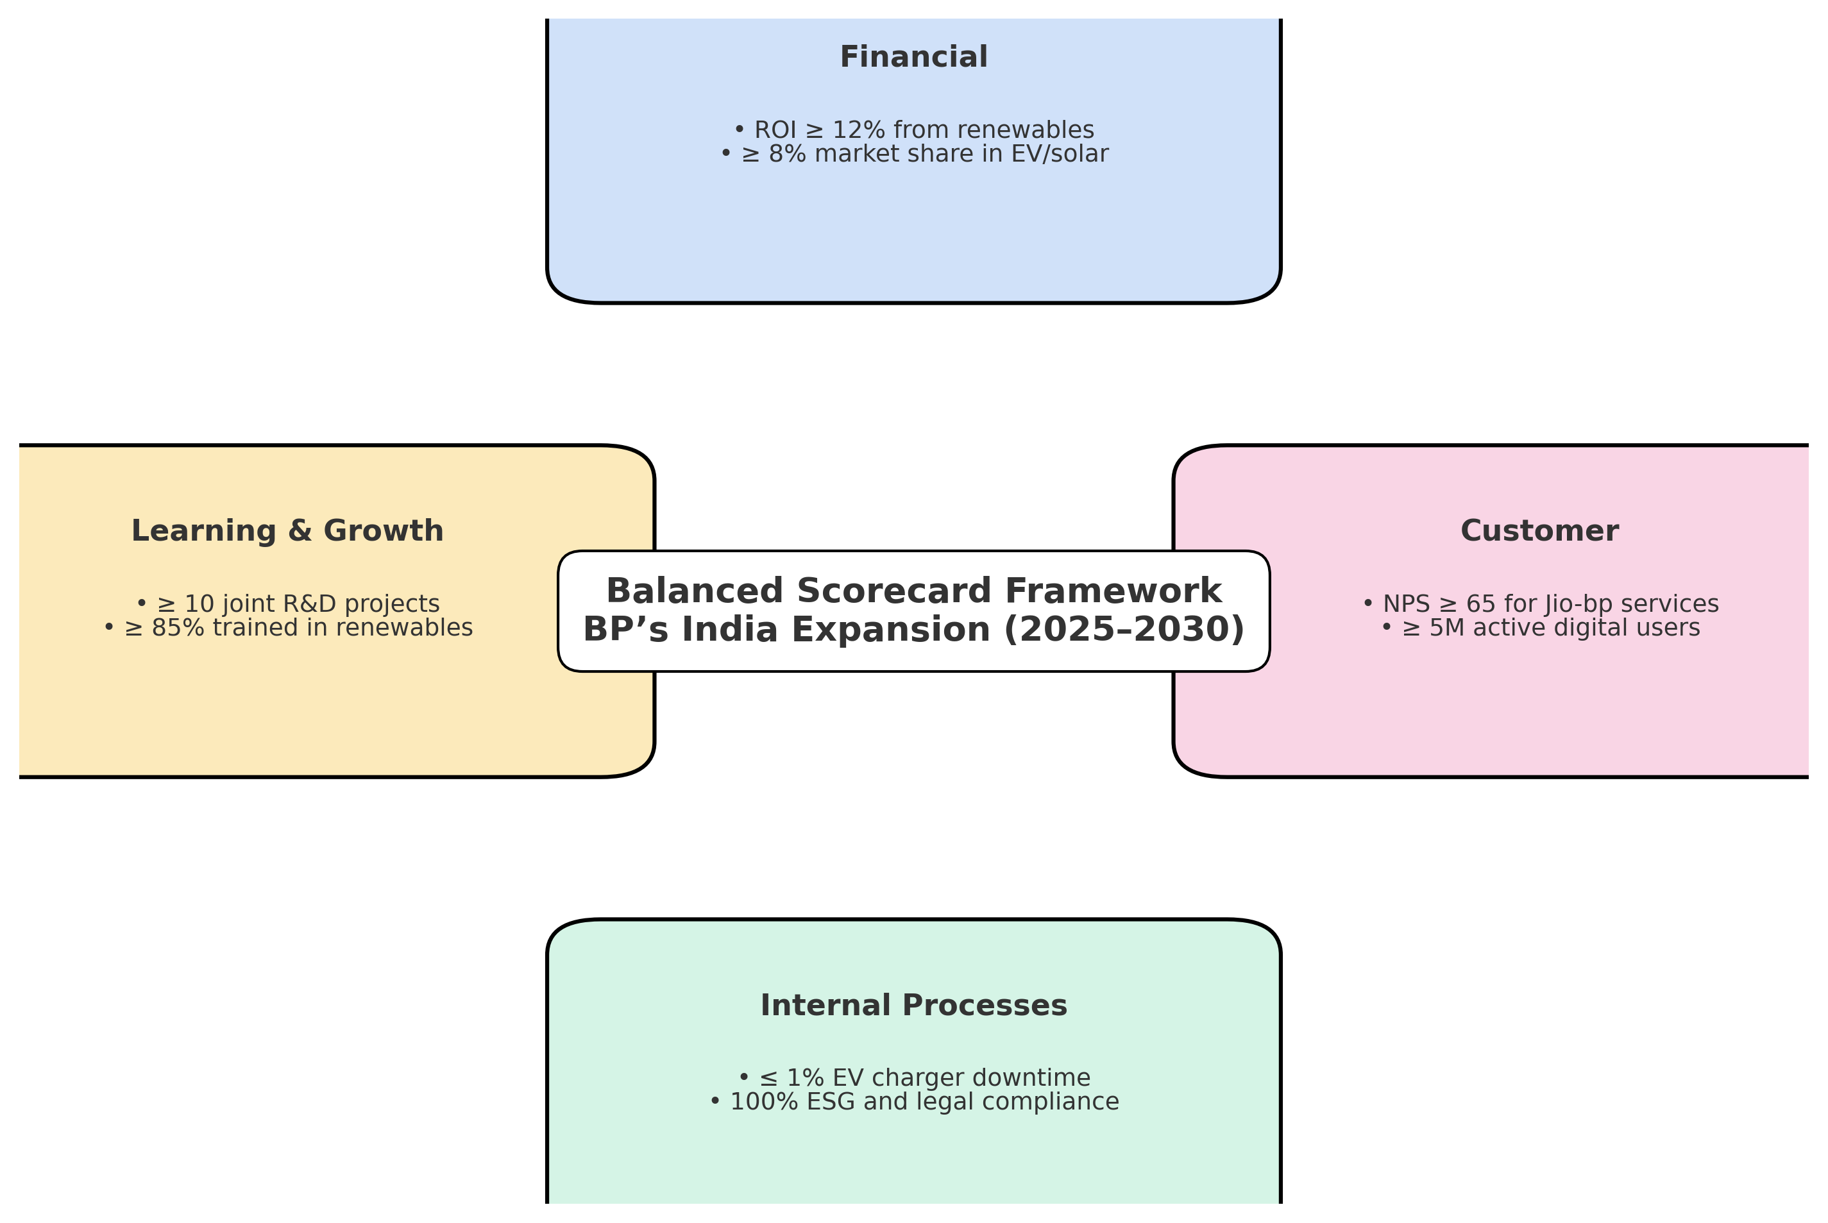

Successful execution of the strategic options (Renewable Energy Expansion and Digital Transformation in Smart Mobility) requires a rigorous and adaptive implementation roadmap that reflects the complexities of the Indian market. BP’s success in India will depend on its ability to combine global expertise with local collaboration, ensuring agility in a fast-changing policy environment.
Phased Investment and Market Prioritisation
Execution must follow a phased investment approach to mitigate capital risk. BP should prioritise regions demonstrating mature Electric Vehicle (EV) demand and favourable infrastructure readiness, such as Maharashtra and Karnataka (World Bank, 2024).
The initial phase must focus on leveraging the Jio-bp digital retail ecosystem. This partnership is crucial for execution, enabling BP to rapidly scale energy-as-a-service solutions and collect real-time user data to optimise pricing and energy load management. This localising of the integrated energy model, while embedding global Environmental, Social, and Governance (ESG) standards, will define the company’s competitive edge. The Green Hydrogen initiative, while strategic, should be developed through phased investment supported by governmental and industrial partnerships.
Risk Management and Organisational Alignment
BP must institutionalise robust risk management mechanisms, particularly related to fluctuating policy incentives, complex land acquisition challenges, and technology obsolescence (IEA, 2023). External analysis showed that despite the opportunities, the market remains highly competitive, necessitating a coordinated organisational response.
A dedicated India Strategy Office is recommended to coordinate between operations, compliance, and innovation streams to ensure consistent delivery. This office should specifically monitor local regulatory and cultural dynamics, ensuring BP continues to innovate and adapt. The internal analysis (VRIO) confirmed that BP possesses distinctive capabilities (brand, finance, partnerships) that must be strategically leveraged during this implementation phase.
Human Capital and Change Culture
The transition from a traditional oil major to an “integrated energy company” requires significant human capital development. The internal focus must shift to embedding a learning culture to sustain competitive advantage in emerging markets (BP, 2025).
India's renewable sector is projected to require over 1 million trained workers by 2030, opening opportunities for BP to invest strategically. BP must invest in clean-tech education, joint R&D centres, and skills partnerships with local institutions (IEA, 2023). Ongoing collaboration with state agencies, universities, and start-ups can enhance adaptability and innovation.
By embedding sustainability, digital innovation, and inclusive growth within its operations, BP can contribute meaningfully to India’s clean energy transformation, reflecting its vision of “reimagining energy for people and the planet.”

5. Conclusion and Strategic Outlook

BP’s strategic evaluation for entry and expansion in the Indian energy market demonstrates a strong alignment between its global transformation objectives and India’s national energy transition agenda. The external analysis (PESTLE and Porter) revealed that India offers substantial long-term opportunities due to its rapidly growing economy, supportive renewable policies, and technological advancement. However, the market remains highly competitive, with strong domestic players such as Adani Green and Tata Power, and global rivals including Shell and TotalEnergies.

The internal analysis (VRIO) confirmed that BP possesses distinctive capabilities in brand reputation, financial capacity, partnerships, and technological expertise. These strengths enable BP to pursue a sustainable growth strategy, provided it continues to innovate and adapt to the local market’s regulatory and cultural dynamics.

The evaluation of strategic options using the SAF framework identified Renewable Energy Expansion and Digital Transformation in Smart Mobility as the most suitable and feasible directions for BP. These strategies align directly with BP’s global net-zero mission, enhance customer engagement, and contribute to India’s green growth objectives. The Green Hydrogen initiative, while promising, should be developed through phased investment supported by governmental and industrial partnerships.

Looking forward, BP’s success in India will depend on its ability to combine global expertise with local collaboration, ensuring agility in a fast-changing policy environment. By embedding sustainability, digital innovation, and inclusive growth within its operations, BP can not only strengthen its competitive position but also contribute meaningfully to India’s clean energy transformation. This strategic alignment reflects BP’s broader vision of “reimagining energy for people and the planet”—transforming both corporate performance and societal impact.

In addition to the recommended strategy, BP should adopt a phased investment approach, prioritising regions with mature EV demand and favourable infrastructure readiness, such as Maharashtra and Karnataka (World Bank, 2024). By leveraging Jio-bp’s digital retail ecosystem, BP can rapidly scale energy-as-a-service solutions and collect real-time user data to optimise pricing and energy load management.

Furthermore, BP should institutionalise risk management mechanisms, particularly related to fluctuating policy incentives, land acquisition challenges, and technology obsolescence (IEA, 2023). A dedicated India Strategy Office could coordinate between operations, compliance, and innovation streams to ensure consistent delivery.

Ultimately, BP’s ability to localise its integrated energy model, while embedding global ESG standards, will define its competitive edge. Ongoing collaboration with state agencies, universities, and start-ups can enhance adaptability and innovation. This approach not only supports India’s net-zero journey, but reinforces BP’s transformation into a future-ready energy company (BP, 2025).

6. Reference

- Barney, J. (1991) ‘Firm resources and sustained competitive advantage’, Journal of Management, 17(1), pp. 99–120.
- BP (2023) Jio-bp: Transforming Mobility in India. BP India Official Website. Available at: https://www.bp.com/en_in/ (Accessed: 5 October 2025).
- BP (2024) BP Annual Report and Form 20-F 2024: Reimagining Energy. London: BP plc. Available at: https://www.bp.com/ (Accessed: 5 October 2025).
- EY (2024) India: Energy sector at crossroads. New Delhi: Ernst & Young. Available at: https://www.ey.com/en_in/energy-resources (Accessed: 10 November 2025).
- Government of India (2024) National Hydrogen Mission: Policy Framework for Clean Energy Transition. Ministry of New and Renewable Energy. Available at: https://mnre.gov.in/ (Accessed: 5 October 2025).
- Grundy, T. (2006) ‘Rethinking and reinventing Michael Porter’s five forces model’, Strategic Change, 15(5), pp. 213–229.
- IEA (2023) India Energy Outlook 2023. Paris: International Energy Agency. Available at: https://www.iea.org/ (Accessed: 5 October 2025).
- IMF (2024) World Economic Outlook: Navigating Global Divergences. Washington, D.C.: International Monetary Fund.
- Johnson, G., Scholes, K. and Whittington, R. (2020) Exploring Corporate Strategy, 12th edn. Harlow: Pearson Education.
- Kaplan, R.S. and Norton, D.P. (1996) The Balanced Scorecard: Translating Strategy into Action. Boston: Harvard Business School Press.
- Kaplan, R.S. and Norton, D.P. (2004) Strategy Maps: Converting Intangible Assets into Tangible Outcomes. Boston: Harvard Business School Press.
- Kim, W.C. and Mauborgne, R. (2005) Blue Ocean Strategy: How to Create Uncontested Market Space and Make the Competition Irrelevant. Boston: Harvard Business School Press.
- Mendelow, A.L. (1991) ‘Environmental scanning: The impact of the stakeholder concept’, Proceedings of the Second International Conference on Information Systems, Cambridge, MA.
- Ministry of Power (2024) National Electricity Plan 2024–2030. Government of India. Available at: https://powermin.gov.in/ (Accessed: 5 October 2025).
- OECD (2024) Investment Policy Review: India 2024. Organisation for Economic Co-operation and Development. Paris: OECD Publishing.
- Prahalad, C.K. and Doz, Y.L. (1987) The Multinational Mission: Balancing Local Demands and Global Vision. New York: Free Press.
- Shell (2023) Shell Energy India: Building the Future of Clean Mobility. Shell Global. Available at: https://www.shell.in/ (Accessed: 5 October 2025).
- Teece, D.J. (2007) ‘Explicating dynamic capabilities: the nature and microfoundations of (sustainable) enterprise performance’, Strategic Management Journal, 28(13), pp. 1319–1350.
- Teece, D.J., Peteraf, M. and Leih, S. (2016) ‘Dynamic capabilities and organizational agility: Risk, uncertainty, and strategy in the innovation economy’, California Management Review, 58(4), pp. 13–35.
- Teece, D.J., Pisano, G. and Shuen, A. (1997) ‘Dynamic capabilities and strategic management’, Strategic Management Journal, 18(7), pp. 509–533.
- TotalEnergies (2024) Adani Green Energy Partnership Report 2024. Paris: TotalEnergies SE. Available at: https://totalenergies.com/ (Accessed: 5 October 2025).
- World Bank (2024) Sustainable Growth and Energy Access in South Asia. Washington, D.C.: The World Bank Group. Available at: https://www.worldbank.org/ (Accessed: 5 October 2025).
- Yüksel, I. (2012) ‘Developing a multi-criteria decision making model for PESTEL analysis’, International Journal of Business and Management, 7(24), pp. 52–66.

